**1.Write a program that takes two or more sets as input and produces set operations like union, intersection, difference and symmetric difference as its output.**

Source code:

#include<stdio.h>

#include<stdlib.h>

int set_union(int setA[], int m, int setB[], int n, int UNION[])

{

int i,j,k=0;

for(i=0;i<m;i++){

UNION[k]=setA[i];

k++;

}

for(i=0;i<n;i++){

int flag=1;

for(j=0;j<m;j++){

if(setA[j]== setB[i]){

flag = 0;

break;

}

}

if(flag ==1){

UNION[k] = setB[i];

k++;

}

}

return (k);

}

int Intersection(int setA[],int m,int setB[],int n,int INTER[]){

int i,j,k=0,l;

for(i=0;i<m;i++){

for(j=0;j<n;j++){

if(setA[i]==setB[j]){

INTER[k]=setA[i];

k++;

}

}

}

return k;

}

int Difference(int setA[],int m, int setB[],int n,int DIFF[]){

int i,j,k=0;

for(i=0;i<m;i++){

int flag=0;

for(j=0;j<n;j++){

if(setA[i]==setB[j]){

flag =1;

break;

}

}

if (flag == 0){

DIFF[k++]=setA[i];

}

}

return k;

}

int Symmetric(int setA[],int m,int setB[],int n,int SYMM[]){

int k = set_union(setA,m,setB,n,SYMM);

}

int element(int set[],int size){

int i;

for(i=0;i<size;i++){

scanf("%d",&set[i]);

}

}

void display(int set[],int size){

int i,j,k;

printf("{");

for(i=0;i<size;i++){

if(i<size-1){

printf("%d, ",set[i]);

}

else if (i==size-1){

printf("%d",set[i]);

}

}

printf("}\n\n");

}

void bubblesort(int set[], int size){

int i, j,temp;

for(i=0;i<size-1;i++){

for(j=0;j<size-i-1;j++){

if ( set[j]>set[j+1]){

temp = set[j+1];

set[j+1] = set[j];

set[j] = temp;

}

}

}

}

int main(){

int m,n,i,j,UNION[40],INTERSECTION[40], DIFFA[40],DIFFB[40], SYM[40], INTER[40],SYMM[40];

int union_num,inter_num,diff_numA,diff_numB,symm_num;

printf("Enter size of set A: ");

scanf("%d",&m);

printf("Enter size of set B: ");

scanf("%d",&n);

int setA[m], setB[n];

printf("Enter the elements of setA: \n");

element(setA, m);

bubblesort(setA,m);

printf("Enter the elements of setB: \n");

element(setB, n);

bubblesort(setB,n);

//displaying the elemensts of set A and set B

printf("The Elements of the setA: \n");

display(setA,m);

printf("The Elements of the setB: \n");

display(setB,n);

//union set operation

printf("The union of setA and setB: \n");

union_num = set_union(setA,m,setB,n,UNION);

bubblesort(UNION,union_num);

display(UNION,union_num);

//intersection set operation

printf("The intersection of setA and setB: \n");

inter_num = Intersection(setA,m,setB,n,INTER);

bubblesort(INTER,inter_num);

display(INTER,inter_num);

//difference set operation

printf("The difference of setA and setB (SetA - SetB): \n");

diff_numA = Difference(setA,m,setB,n,DIFFA);

bubblesort(DIFFA,diff_numA);

display(DIFFA, diff_numA);

//difference set operation

printf("The difference of setA and setB (SetB - SetA): \n");

diff_numB = Difference(setB,m,setA,n,DIFFB);

bubblesort(DIFFB,diff_numB);

display(DIFFB,diff_numB);

//symmetric difference set opration

printf("The symmetric difference of setA and setB ((SetA - SetB) U (SetB - SetA)) : \n");

symm_num = Symmetric(DIFFA,diff_numA,DIFFB,diff_numB, SYMM);

bubblesort(SYMM,symm_num);

display(SYMM, symm_num);

}

Output:

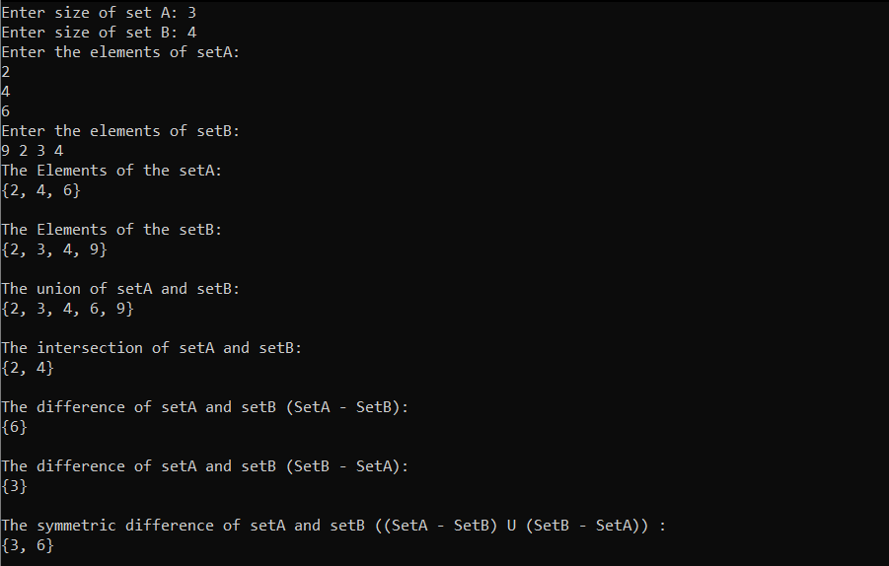

**2.Write a program that takes two or more sets as input and produces their Cartesian product as output.**

Source code:

#include<stdio.h>

#include<string.h>

#include<stdlib.h>

void CartProduct(int arr1[],int arr2[],int n1, int n2){

int i,j;

printf("{");

for(i=0; i < n1; i++){

for(j=0; j < n2; j++){

if (j<n2-1){

printf("(%d,%d), ",arr1[i],arr2[j]);

}

else if (j== n2-1){

printf("(%d,%d)",arr1[i],arr2[j]);

}

}

}

printf("}\n");

}

void display(int set[],int size){

int i,j,k;

printf("{");

for(i=0;i<size;i++){

if(i<size-1){

printf("%d, ",set[i]);

}

else if (i==size-1){

printf("%d",set[i]);

}

}

printf("}\n\n");

}

int main(){

int n1,n2,i,j;

printf("Enter the size of Set A : ");

scanf("%d",&n1);

printf("Enter the size of Set B: ");

scanf("%d",&n2);

int setA[n1],setB[n2];

printf("Enter the elements of Set A:\n");

for(i=0; i<n1; i++){

scanf("%d",&setA[i]);

}

printf("Enter the elements of Set B :\n");

for(j=0;j<n2;j++){

scanf("%d",&setB[j]);

}

printf("The elements of setA: \n");

display(setA,n1);

printf("The elements of setB: \n");

display(setB,n2);

printf("The Cartesain Product of Set A and Set B is: \n ");

CartProduct(setA,setB,n1,n2);

return 0;

}

Output:

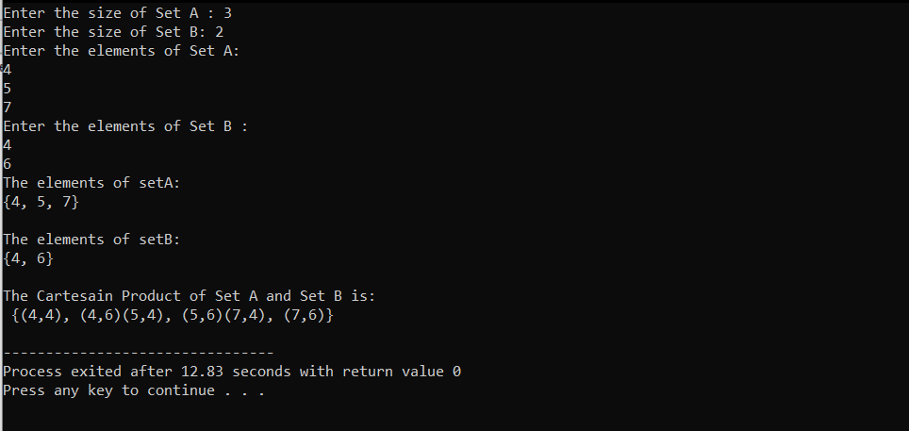

**3.Write a program that takes a real number and produces is ceiling and floor integers as output.**

Source code:

#include<stdio.h>

int floorValue(float num){

if (num == (int)(num)){

return num;

}

else if (num>=0){

return (int)(num/1);

}

else{

return (int)(num-1);

}

}

int CeilValue(float num){

if(num == (int)(num)){

return num;

}

else if(num>=0){

return (int)((num/1)+1);

}

else{

return (int)(num);

}

}

int main(){

float x;

int ceil,floor;

printf("Enter the number: ");

scanf("%f",&x);

ceil = CeilValue(x);

floor = floorValue(x);

printf("The Ceiling value of %.2f: %d\n",x,ceil);

printf("The Floor value of %.2f: %d\n", x ,floor);

if ( (int)(x) != x)

{

printf("\n|-(%d)\n|\n|-(%.2f)\n|\n|-(%d)\n\n",ceil,x,floor);

}

}

Output:

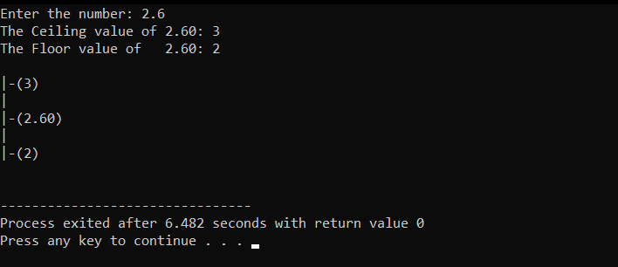

**4.Write a program that takes name and age of a 5 person as an input and gives the degree of membership of the person as its output according to following membership functions.**

**a. Degree of membership = 1 if age<=20**

**Degree of membership = (30-age)/10 if age>20 and age<=30**

**Degree of membership = 0 if age>30**

**b. Degree of membership = 1 if age<=15**

**Degree of membership = (35-age)/20 if age>15 and age<=35**

**Degree of membership = 0 if age>35**

**Perform set operations according to rules of fuzzy sets, on these**

**two sets.**

Source code:

#include<stdio.h>

#include<stdlib.h>

float degree_of_membershipA(int age){

if (age <=20) return 1;

else if(age<=30) return (float)(30-age)/10;

else return 0;

}

float degree_of_membershipB(int age){

if (age <=15) return 1;

else if(age<=35) return (float)(35-age)/20;

else return 0;

}

/******************************************Fuzzy Union********************************************/

void fuzzy_union(char Name[40][40],float MembershipA[40], float MembershipB[40]){

float union_Set[20];

int i,j;

for(i=0;i<5;i++)

{

if(MembershipA[i]>MembershipB[i])

{

union_Set[i]=MembershipA[i];

}

else if(MembershipA[i]< MembershipB[i])

{

union_Set[i]= MembershipB[i];

}

else

{

union_Set[i]=MembershipA[i];

}

}

printf("The result of the union fuzzy operation is : \n {");

for(i=0;i<5;i++){

if(i<4){

printf("%.2f/%s,",union_Set[i],Name[i]);

}

else if(i == 4){

printf("%.2f/%s",union_Set[i],Name[i]);

}

}

printf("}\n\n");

}

/**************Fuzzy intersection**************/

void fuzzy_intersection(char Name[40][40],float MembershipA[40], float MembershipB[40]){

float intersection_set[20];

int i,j;

for(i=0;i<5;i++)

{

if(MembershipA[i]>MembershipB[i])

{

intersection_set[i]=MembershipB[i];

}

else if(MembershipA[i]< MembershipB[i])

{

intersection_set[i]= MembershipA[i];

}

else

{

intersection_set[i]=MembershipA[i];

}

}

printf("The result of the intersection fuzzy operation is : \n {");

for(i=0;i<5;i++){

if(i<4){

printf("%.2f/%s, ",intersection_set[i],Name[i]);

}

else if(i==4){

printf("%.2f/%s",intersection_set[i],Name[i]);

}

}

printf("}\n\n");

}

/***************Fuzzy Complement*********************/

void fuzzy_complement(char Name[40][40],float MembershipA[40], float MembershipB[40]){

float complement_SetA[20],complement_SetB[20];

int i,j;

for(i=0;i<5;i++)

{

complement_SetA[i]=1-MembershipA[i];

complement_SetB[i]=1-MembershipB[i];

}

printf("The result of the Complement fuzzy operation of first set is : \n {");

for(i=0;i<5;i++){

if(i<4){

printf("%.2f/%s, ",complement_SetA[i],Name[i]);

}

else if(i==4){

printf("%.2f/%s",complement_SetA[i],Name[i]);

}

}

printf("}\n\n");

printf("The result of the Complement fuzzy operation of second set is : \n {");

for(i=0;i<5;i++){

if(i<4){

printf("%.2f/%s, ",complement_SetB[i], Name[i]);

}

else if(i==4){

printf("%.2f/%s",complement_SetB[i],Name[i]);

}

}

printf("}\n\n");

}

int main(){

int age[40],i=0;

char name[40][40];

float membershipA[20],membershipB[20];

for(i=0;i<5;i++){

printf("Enter the name: "); scanf("%s",name[i]);

printf("Enter age: "); scanf("%d",&age[i]);

}

for(i=0;i<5;i++){

membershipA[i]= degree_of_membershipA(age[i]);

membershipB[i]= degree_of_membershipB(age[i]);

}

printf("First Set is: \n {");

for(i=0;i<5;i++){

if(i<4){

printf("%.2f/%s, ",membershipA[i],name[i]);

}

else if(i==4){

printf("%.2f/%s",membershipA[i],name[i]);

}

}

printf("}\n\n");

printf("Second Set is: \n {");

for(i=0;i<5;i++){

if(i<4){

printf("%.2f/%s, ",membershipB[i],name[i]);

}

else if(i==4){

printf("%.2f/%s",membershipB[i],name[i]);

}

}

printf("}\n\n");

fuzzy_union(name, membershipA, membershipB);

fuzzy_intersection(name,membershipA,membershipB);

fuzzy_complement(name,membershipA,membershipB);

}

Output:

