<https://www.youtube.com/watch?v=CEyymB-vta8&list=PLZoTAELRMXVPBaLN3e-uoVRR9hlRFRfUc&index=4>

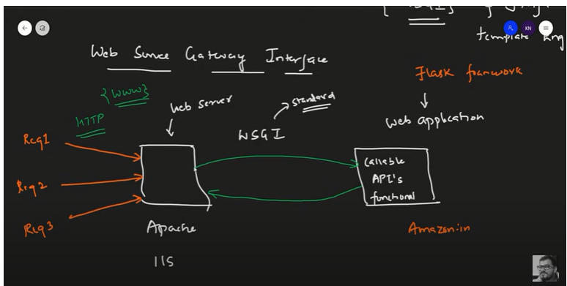WSGI Protocolis used to communicate between Web application and Web server

Jinja 2: template engine , web templating system ,combines a web template along with Data source to render dynamic Pages

Every Python module has it’s *_name_* defined and if this is ‘__main__’, it implies that the module is being run standalone by the user and we can do corresponding appropriate actions. If you import this script as a module in another script, the *_name_* is set to the name of the script/module. Python files can act as either reusable modules, or as standalone programs. if *_name_* == “main”: is used to execute some code only if the file was run directly, and not imported.

from flask import Flask

### WSGI Application

app = Flask(__name__)

**@app.route**('/') ### Decoreator

def **welcome**():   ## Decorator come with a function

    return "Welcome Flask toout "

**@app.route**('/members') ### Decoreator

def **members**():   ## Decorator come with a function

    return "Hi Flask Memebers "

if __name__=='__main__':

    app.run(debug=True)

Building URL Dinamically

from flask import Flask,redirect,url_for

### WSGI Application

app = Flask(__name__)

**@app.route**('/') ### Decoreator

def **welcome**():   ## Decorator come with a function

    return "Welcome Flask toout "

**@app.route**('/success/<int:score>') ### String  <score>

def **success**(score):   ## Decorator come with a function

    return "The Person has passed and the marks is  "+str(score)

**@app.route**('/fail/<int:score>') ### String  <score>

def **fail**(score):   ## Decorator come with a function

    return "The Person has failed and the marks is  "+str(score)

**@app.route**('/results/<int:marks>') ### String  <score>

def **results**(marks):   ## Decorator come with a function

    results=""

    if marks<50:

        results = 'fail'

    else:

        results = 'success'

    ###return "The Person has "+ results +" and the marks is  "+str(score)

    return redirect(url_for(results,score=marks))

if __name__=='__main__':

    app.run(debug=True)