$env:FLASK_ENV="development"

$env:PYTHONDONTWRITEBYTECODE=1

JWT

json web token

it is encrypted string

for encrypt we need encryption key

key encryption algorithm

login

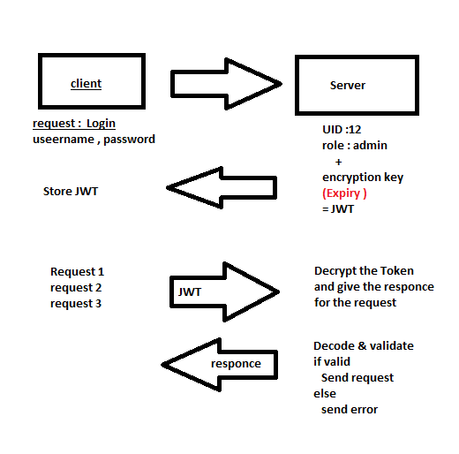

**Authentication** Users login is authentication

**Authorization:** check the user role if he can authorize to access the page

Guest --- >user -- > you are not a created

User

|  |  |
| --- | --- |
| User | Roleid |
| Sujan | 1 |
| User1 | 3 |
| User2 | 3 |

Roles (from e Learning platform)

|  |  |
| --- | --- |
| Id | Tile |
| 1 | Superadmin |
| 2 | Instructor |
| 3. | Learner |
| 4 | moderator |
|  |  |

End points

|  |  |  |
| --- | --- | --- |
| Id | End point | Method |
| 1 | /video/upload | POSt |
| 2. | /course/Create | POST |
| 3. | /course/getall | GET |
|  |  |  |

Accessibility

|  |  |  |
| --- | --- | --- |
| ID | Endpoint | Roles |
| 1 | 3 | [1,2,3,4] |
| 2 | 1 | [2] |
| 3 | 2 | [2] |

