Terminal output

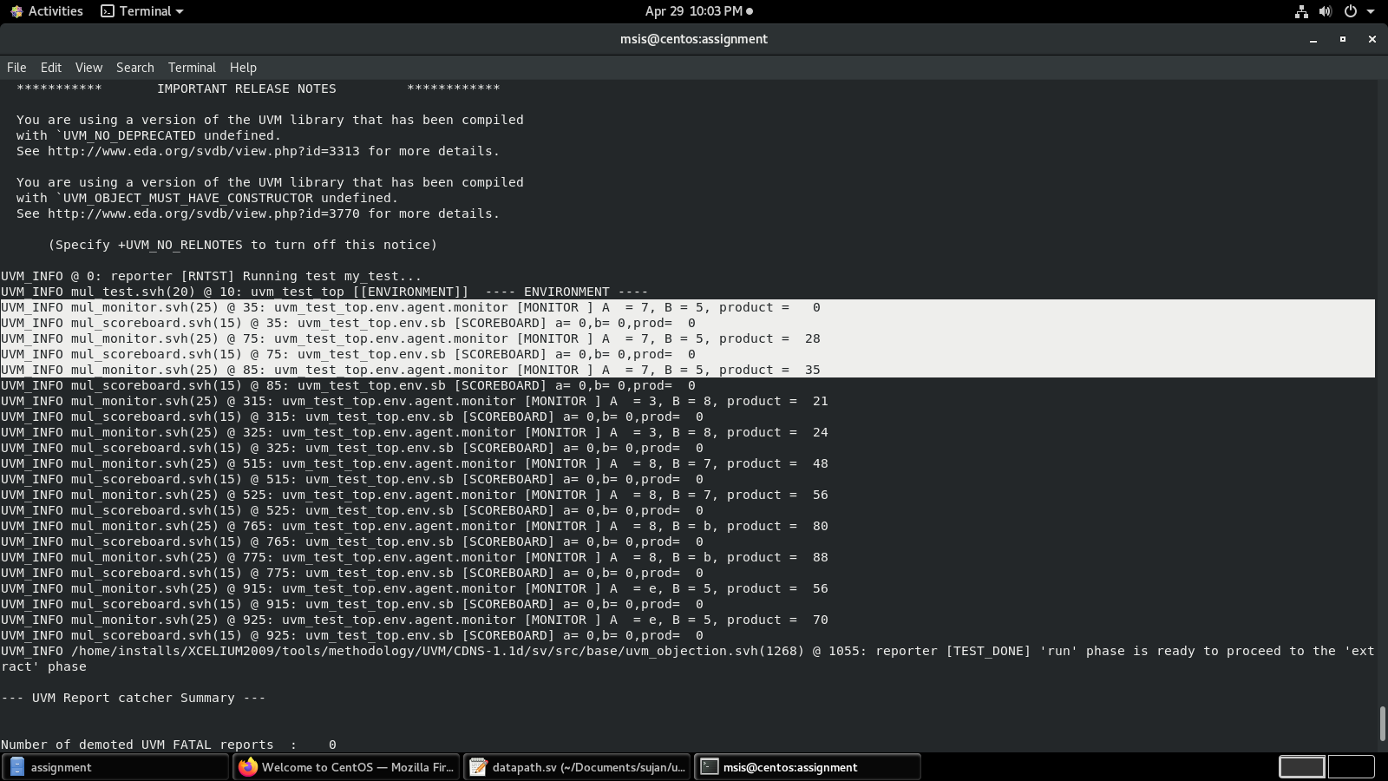since its a sequential multiplier, product bits are filled sequentially. So consider the last product for each output.

Scoreboard have some errors, working on it.

GUI

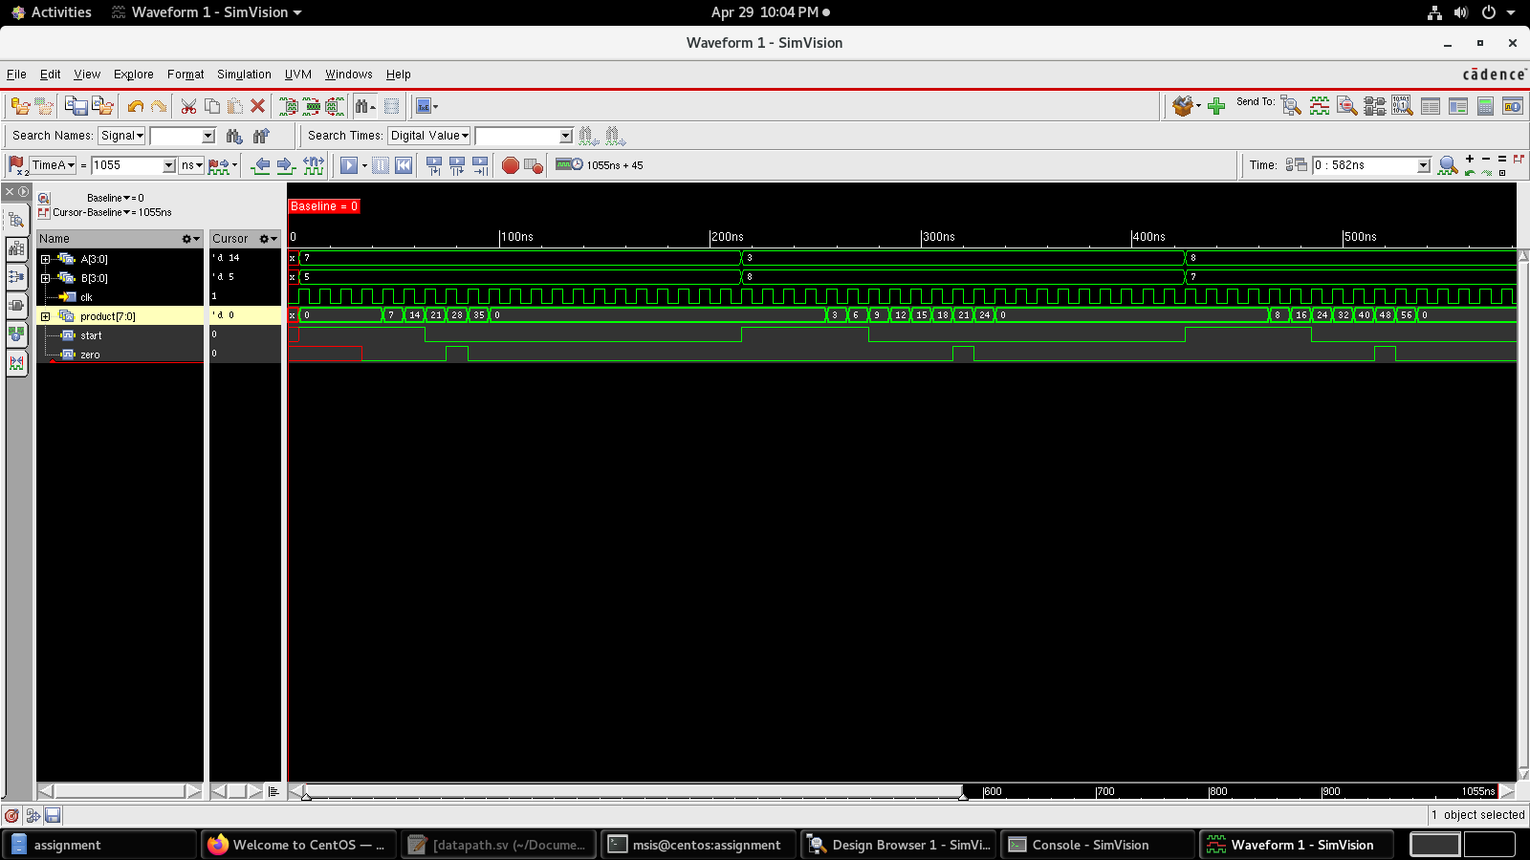

Coverage

