Implemented the solution using Web(Angular), Backend(Java, SpringBoot)

Type below url to start the application

http://localhost:4200

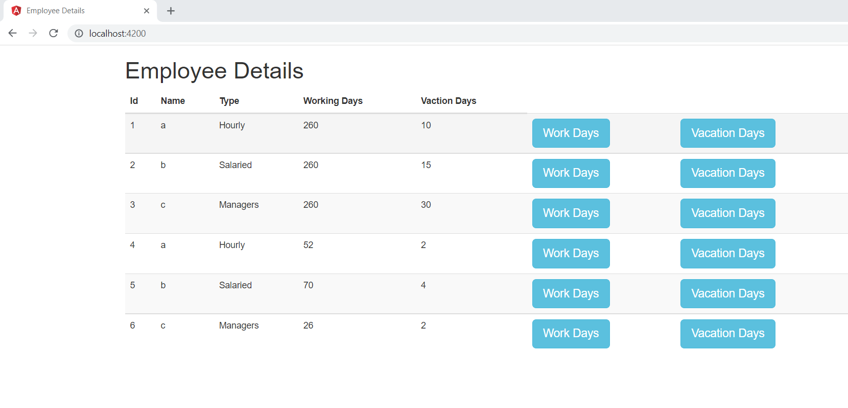

Whenever user clicks on “Work Days” button, we can update the data. It will update work and vacation details

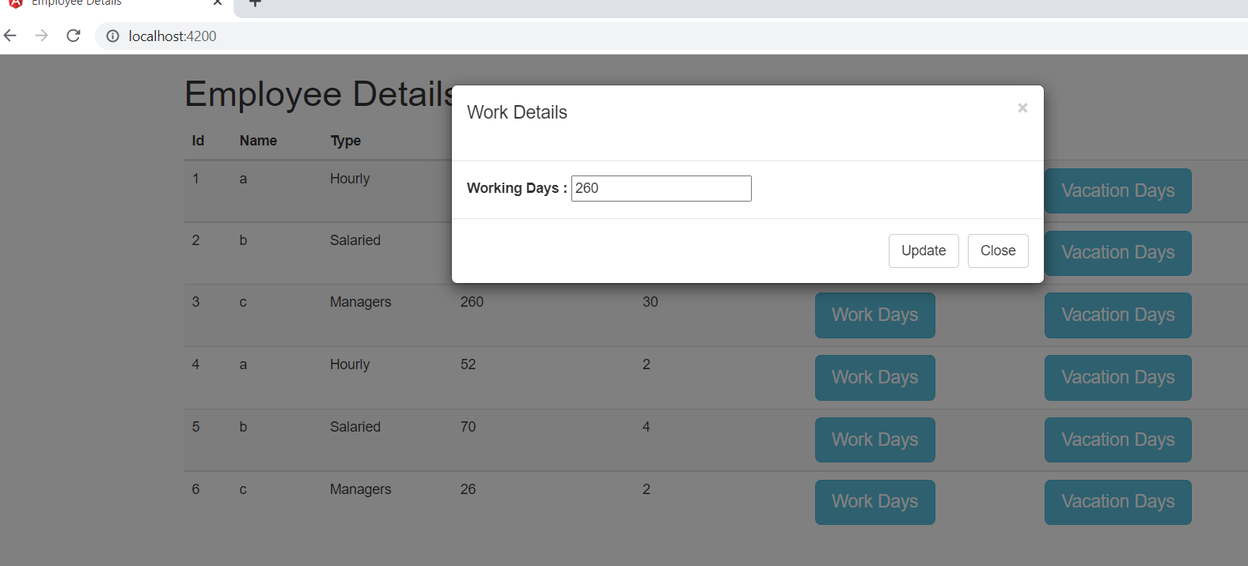

Whenever user clicks on “Vacation Days” button, we can update the data. It will update vacation details

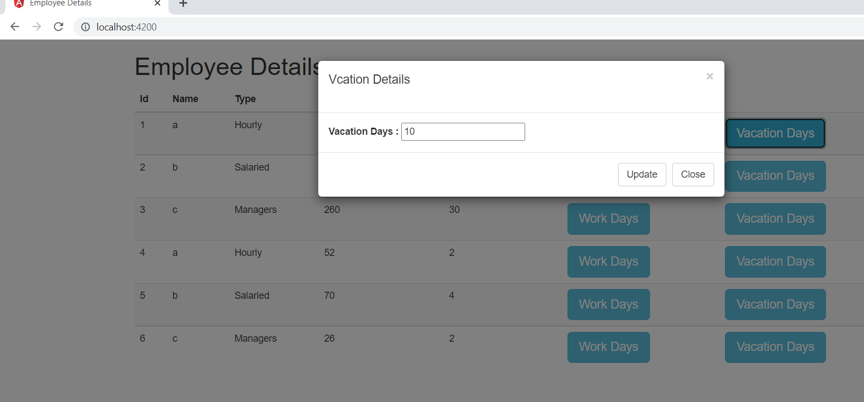

We have different end points to get the data

/ getEmployees

/ getEmployee/{id}

/ updateWorkDays/{id}/{days}

/ updateVacationDays/{id}/{days}