**REST API using Java Spring Boot**

**Dependencies Used:**

* Spring Data JPA to persist data in SQL
* MYSQL JDBC for backend
* Lombok library to reduce boilerplate code

**Test Scenario of APIs Using POSTMAN:**

1. Test Get All Students REST API

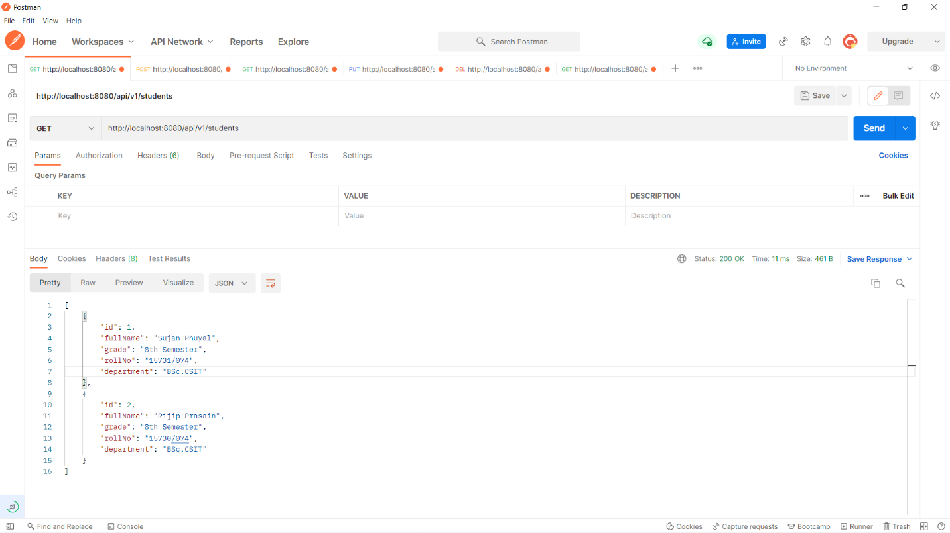

1. Test Create Student REST API

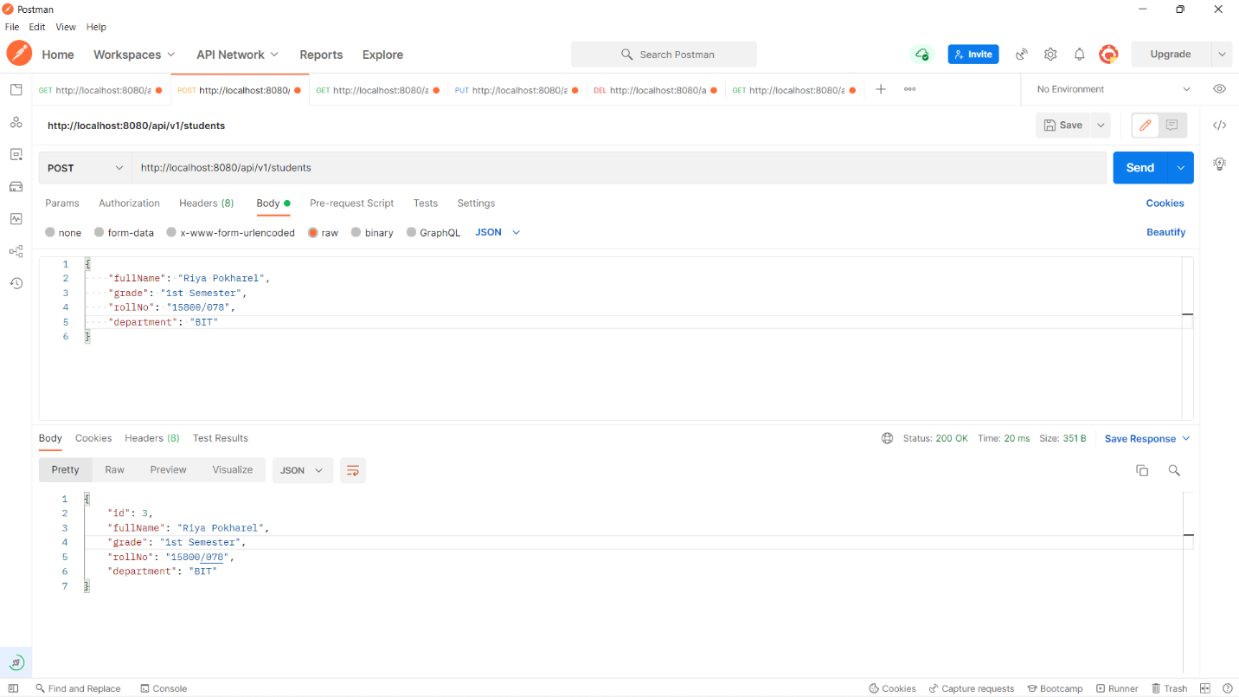

1. Test Get Student by Id REST API

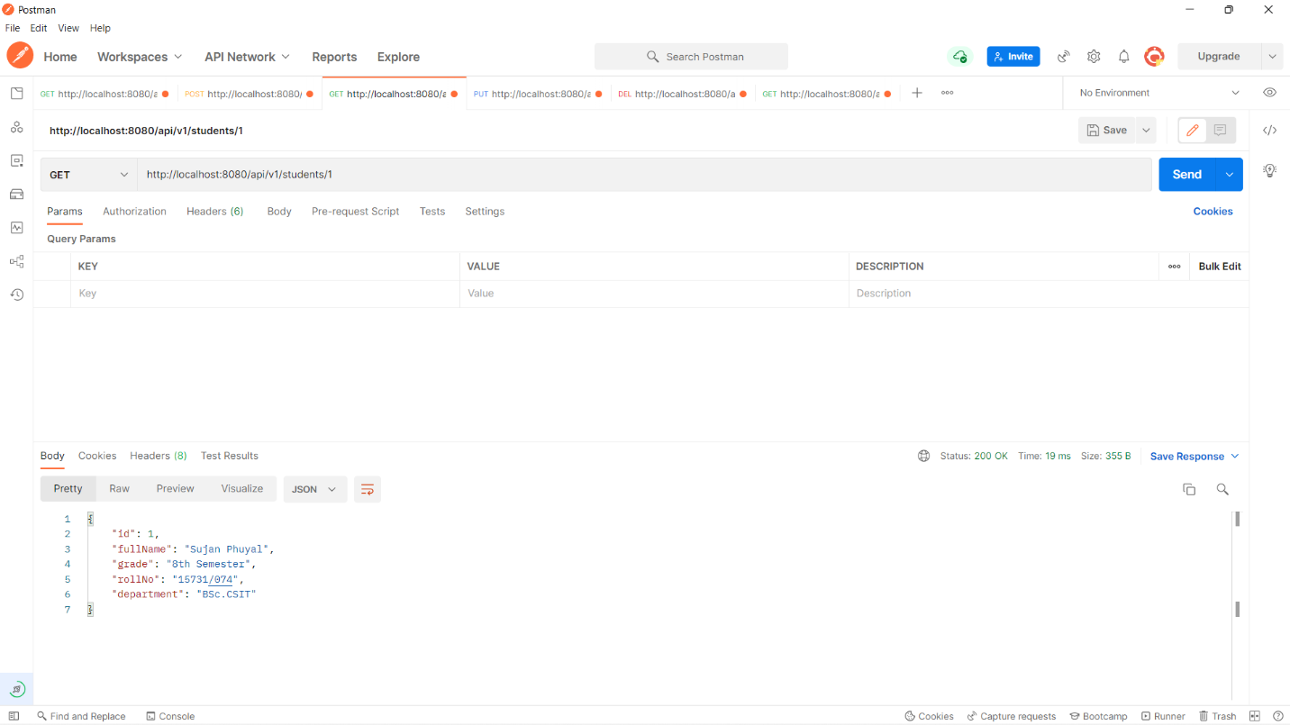

1. Test Update Student REST API

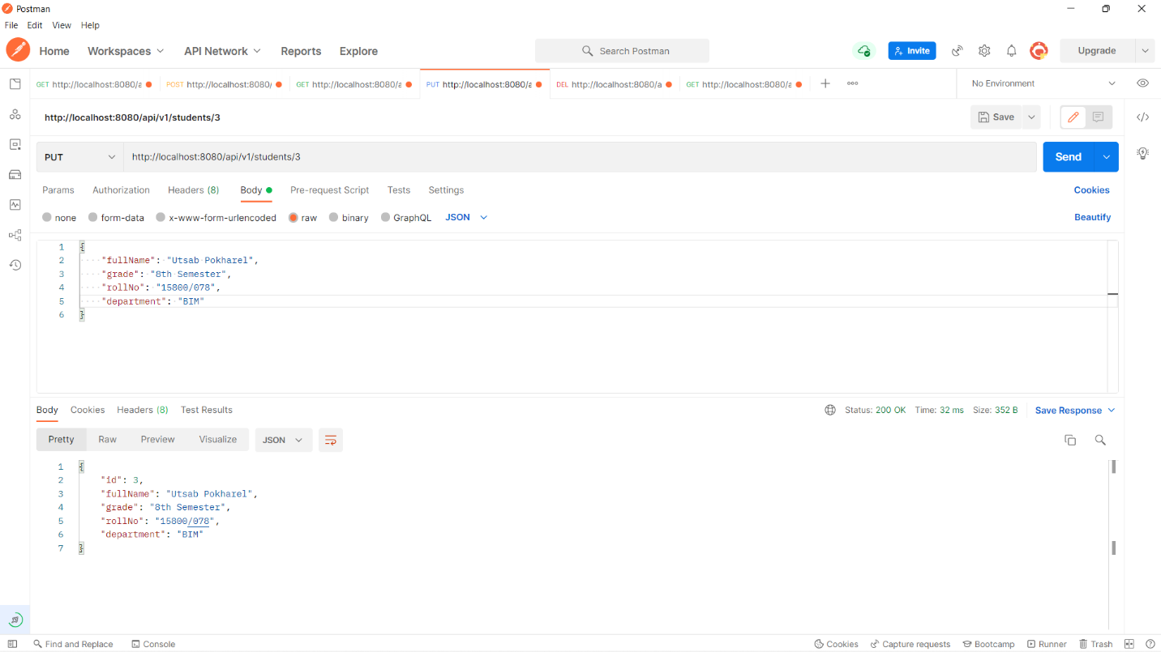

1. Test Delete Student REST API

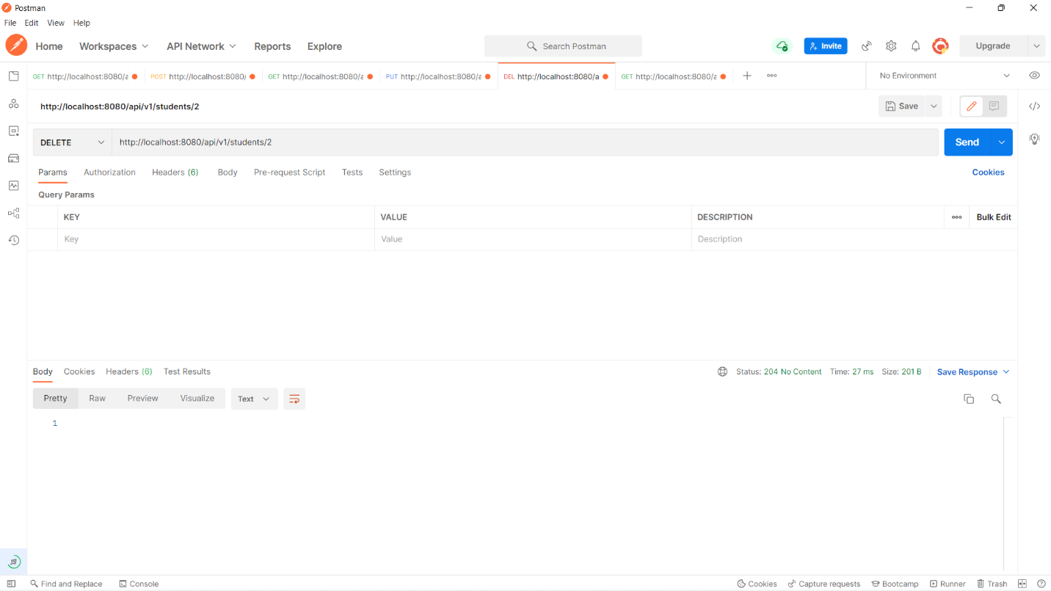

Confirming deletion through GET method.

