SMART INDIA HACKATHON
Kabadiwala Connect
APP FLOW DOCUMENT
Complete end-to-end navigation, interaction, state and recovery flows

Field | Value
Project Name | Kabadiwala Connect
Product Name | Kabadiwala Connect
Document | App Flow Document
Version | 1.0
Date | 20 September 2026
Status | Comprehensive working document
SIH Problem Statement ID | 26229
Problem Statement Title | Kabadiwala Connect – Bringing the Informal Collector into the Formal Recycling Chain
Prepared By | Kabadiwala Connect SIH Team
Reviewed By | Project review pending / team confirmation
Approved By | Not specified

Document Control
Version | Date | Change | Status
0.1 | 20 Sep 2026 | Initial flow structure and source-aligned visual diagrams | Draft
1.0 | 20 Sep 2026 | Comprehensive app flow document with visual diagrams, mapping and audit | Working / review-ready

1. App Flow Objective
This document describes how a real person moves through Kabadiwala Connect: entering the system, resolving a role, completing the collector/recycler/administrator workflows, handling location/AI/voice/offline conditions, and reaching a traceable outcome. It complements the PRD, SRS, TRD, Architecture, UI/UX and Development documents rather than replacing them.
- Primary users: Collector, Recycler/Aggregator, and Administrator.
- Primary use: move a material lot from collector creation through recycler interaction, handover confirmation, completion, payment recording and history.
- The flows preserve documented constraints: assistive AI, explicit location, offline queueing, server-authoritative validation, and safe recovery.
- Where an implementation provider or exact screen is not established by the approved material, this document uses a functional flow label rather than inventing a vendor or unsupported feature.

2. Flow Legend
Notation | Meaning
START / END | Entry or terminal point of a user journey
SCREEN | User-visible application screen
USER ACTION | Tap, enter, capture, select, confirm or submit
SYSTEM | Validation, routing, state update or other system response
DECISION | A condition that changes the path
SUCCESS | Successful completion or recovered state
FAILURE | Controlled failure / error path
SERVICE | External capability such as GPS, speech recognition or an integration boundary
OFFLINE | Local/offline operating state
SYNC | Queued synchronization / reconciliation state

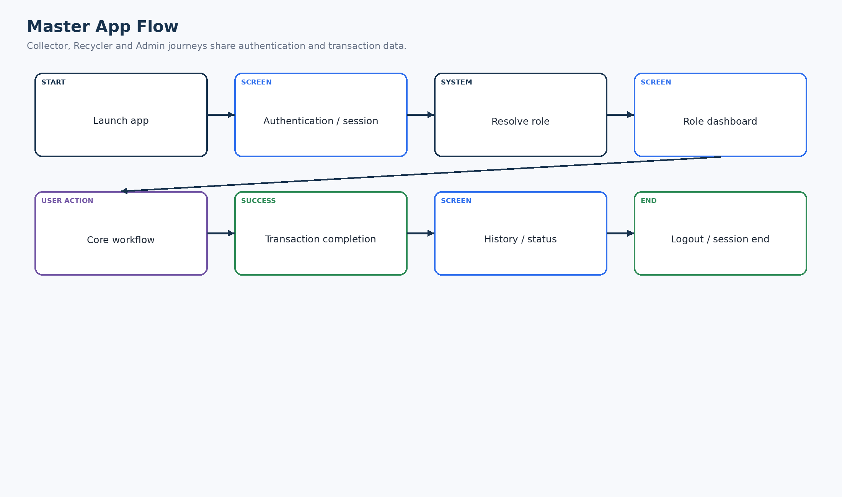
Figure 1. Legend example / master flow notation
The diagrams in this document use the same visual vocabulary throughout.

3. Complete Application Master Flow
Figure 2. Master App Flow
The complete product is a shared authentication-to-dashboard journey followed by role-specific work, completion, history and logout.

4. First-Time User Flow
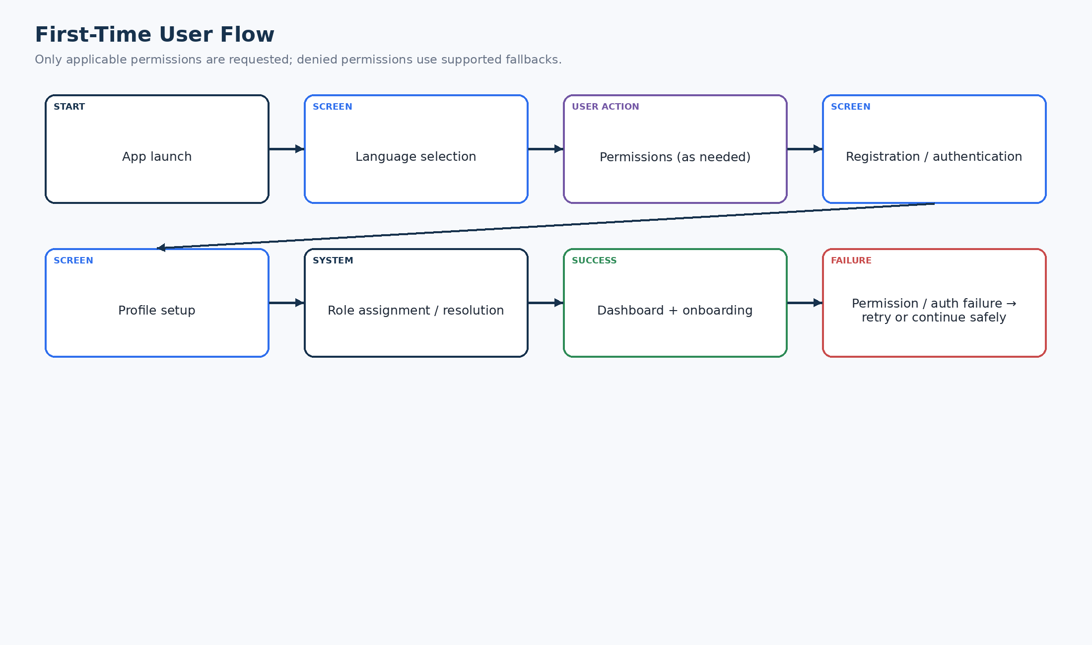
Figure 3. First-Time User Flow
First-time entry establishes language, required permissions, identity/profile information and role routing before onboarding ends at a usable dashboard.

5. Returning User Flow
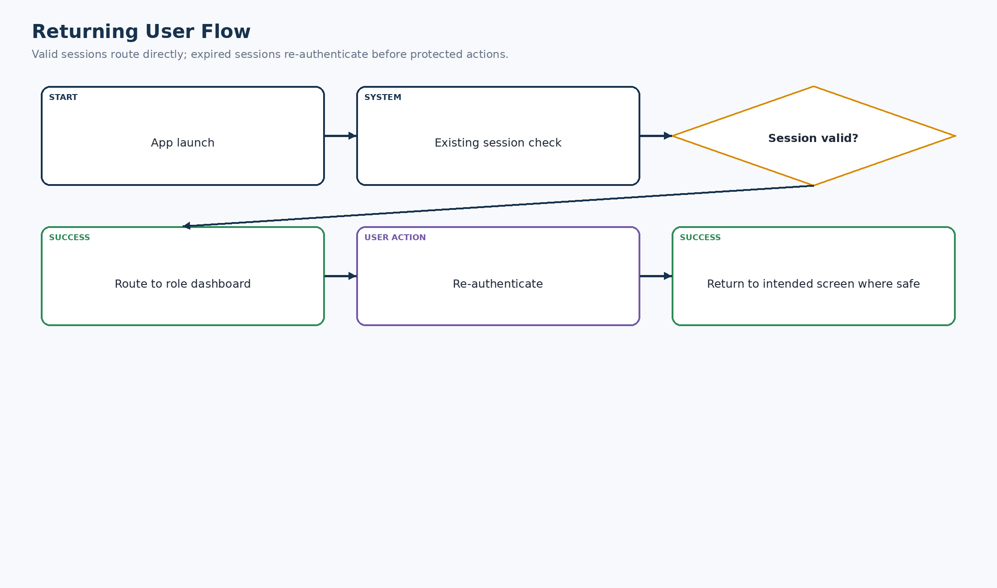
Figure 4. Returning User Flow
A valid session minimizes unnecessary navigation; an expired session re-enters authentication before protected operations.

6. Authentication Flow
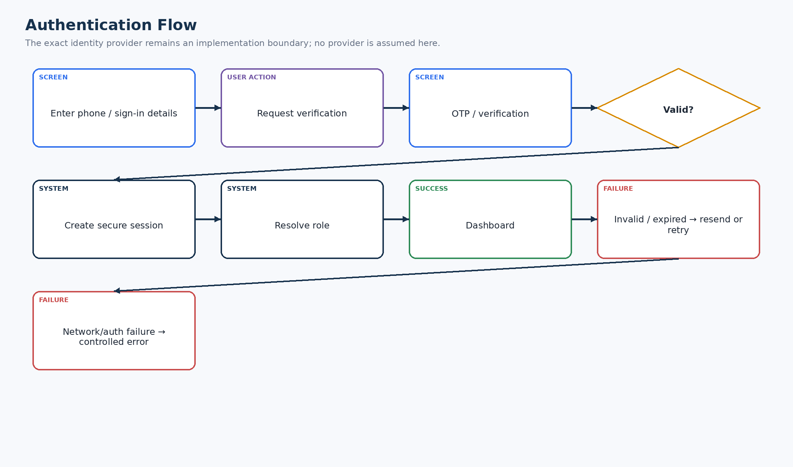
Figure 5. Authentication Flow
The project documentation supports phone/OTP-style authentication as a functional flow, while the exact provider remains a replaceable implementation boundary.

7. Role Resolution Flow
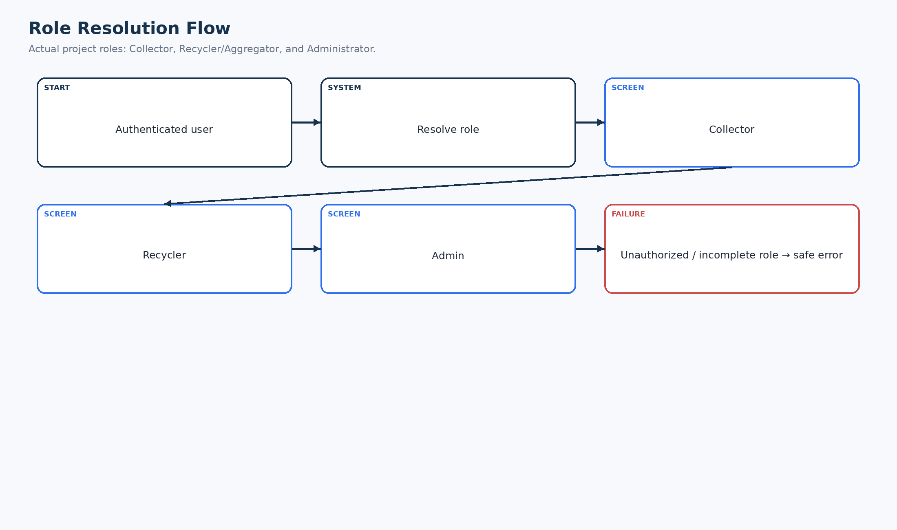
Figure 6. Role Resolution Flow
After authentication, the system routes the user to the application area associated with Collector, Recycler/Aggregator or Administrator.

8. Collector Flow
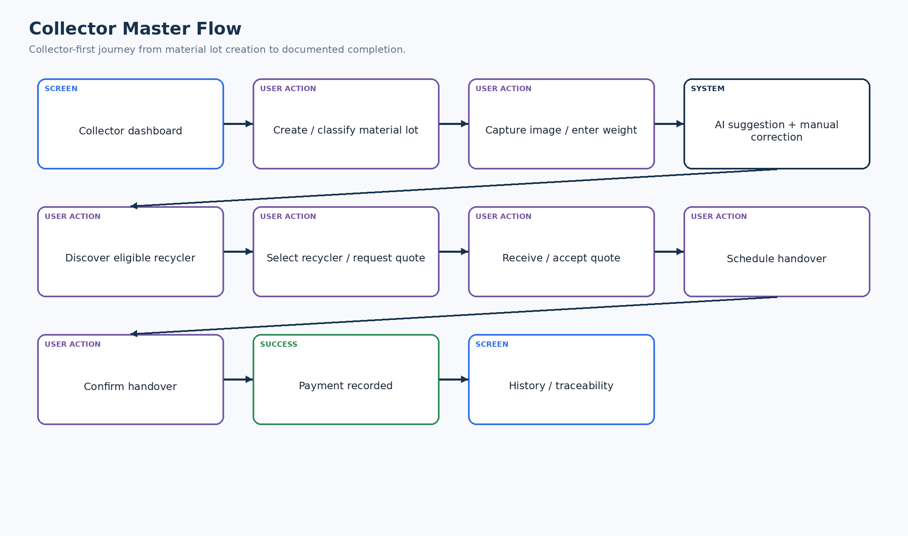
Figure 7. Collector Master Flow
The collector-first flow begins with material capture/classification and ends with a documented transaction and traceability history.

9. Recycler Flow
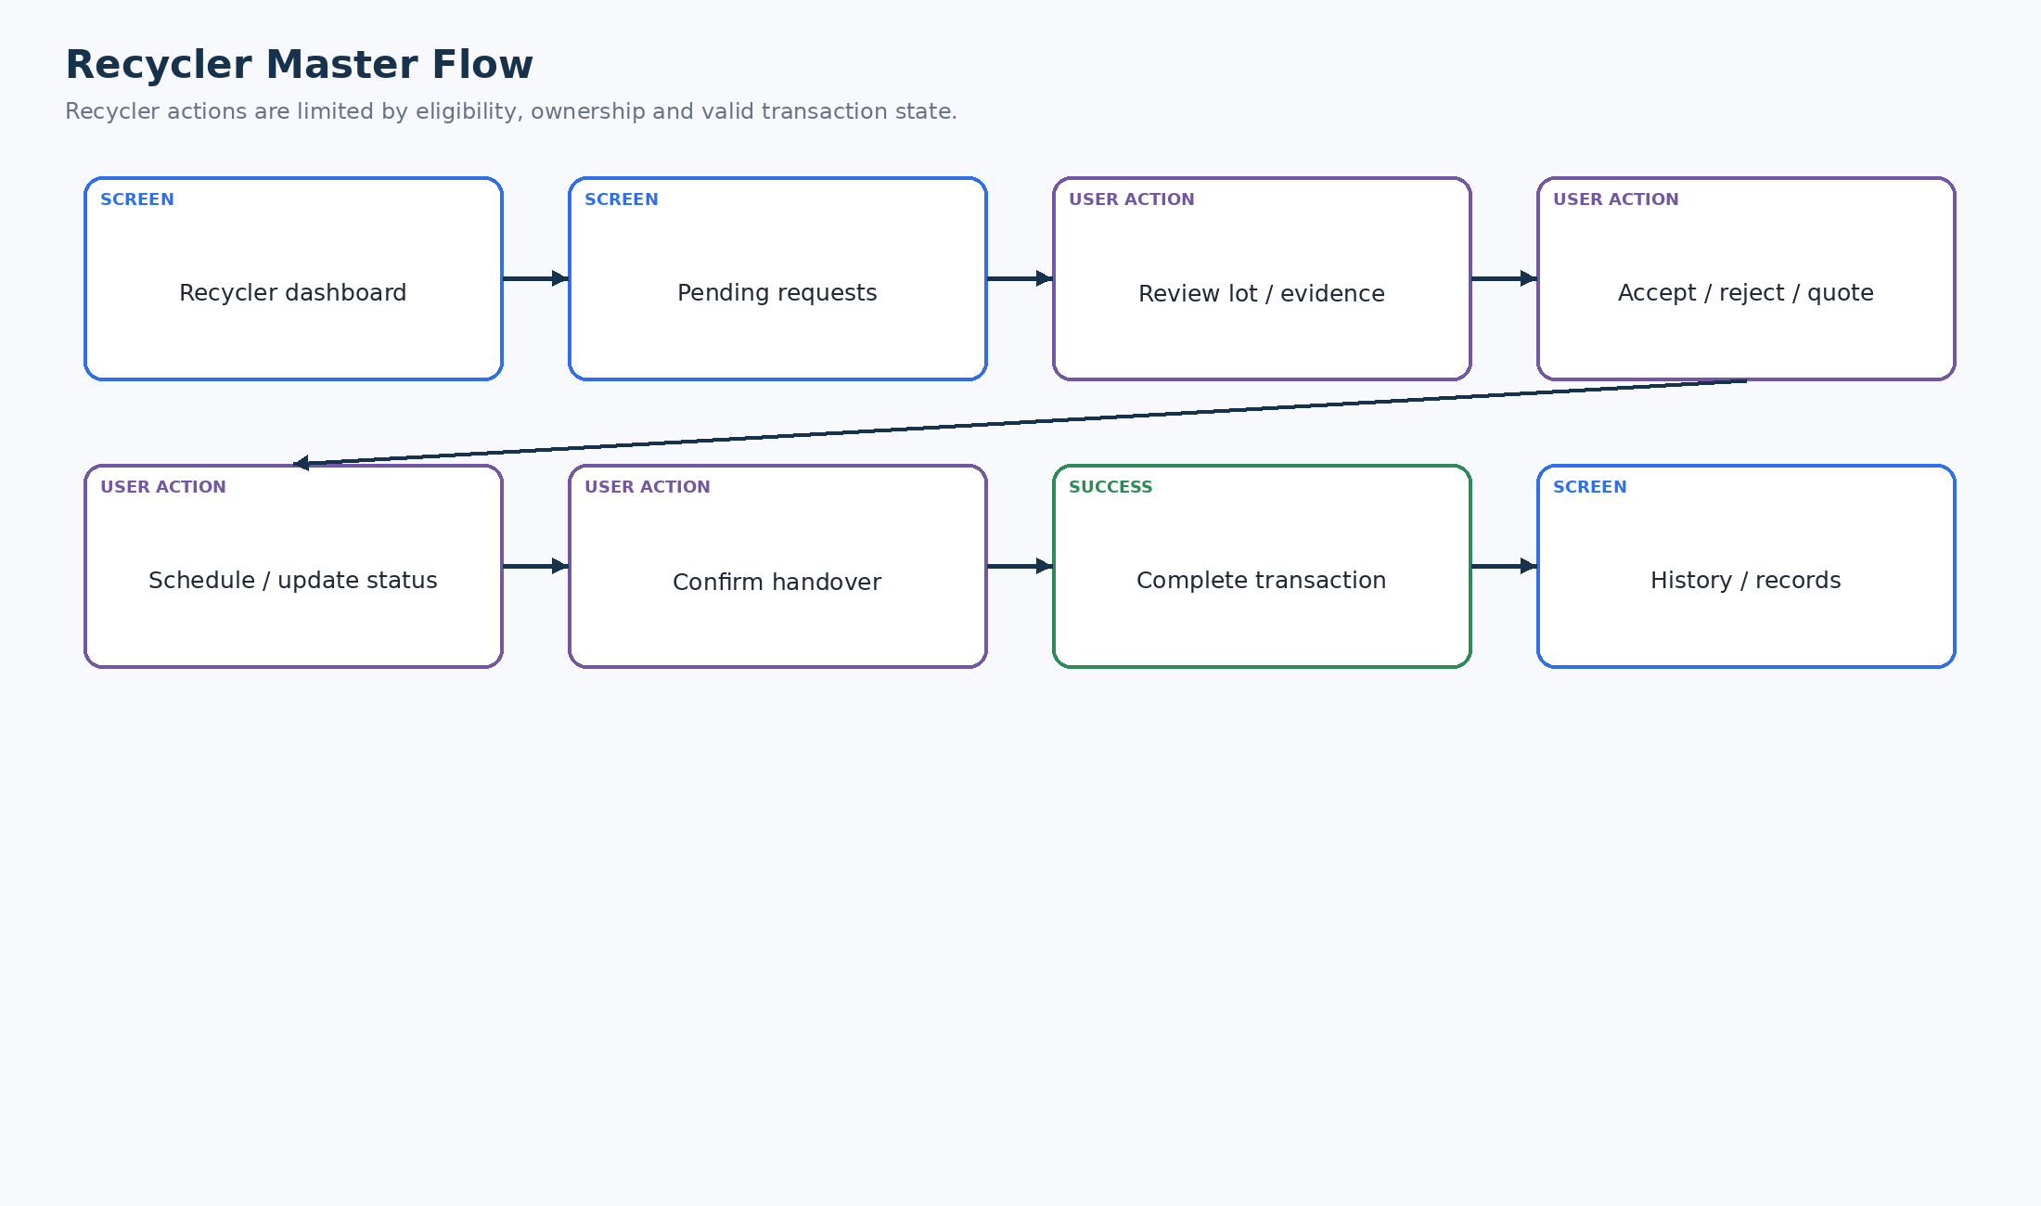
Figure 8. Recycler Master Flow
Recycler users review eligible requests, respond, schedule/update the transaction, confirm handover and retain history.

10. Admin Flow
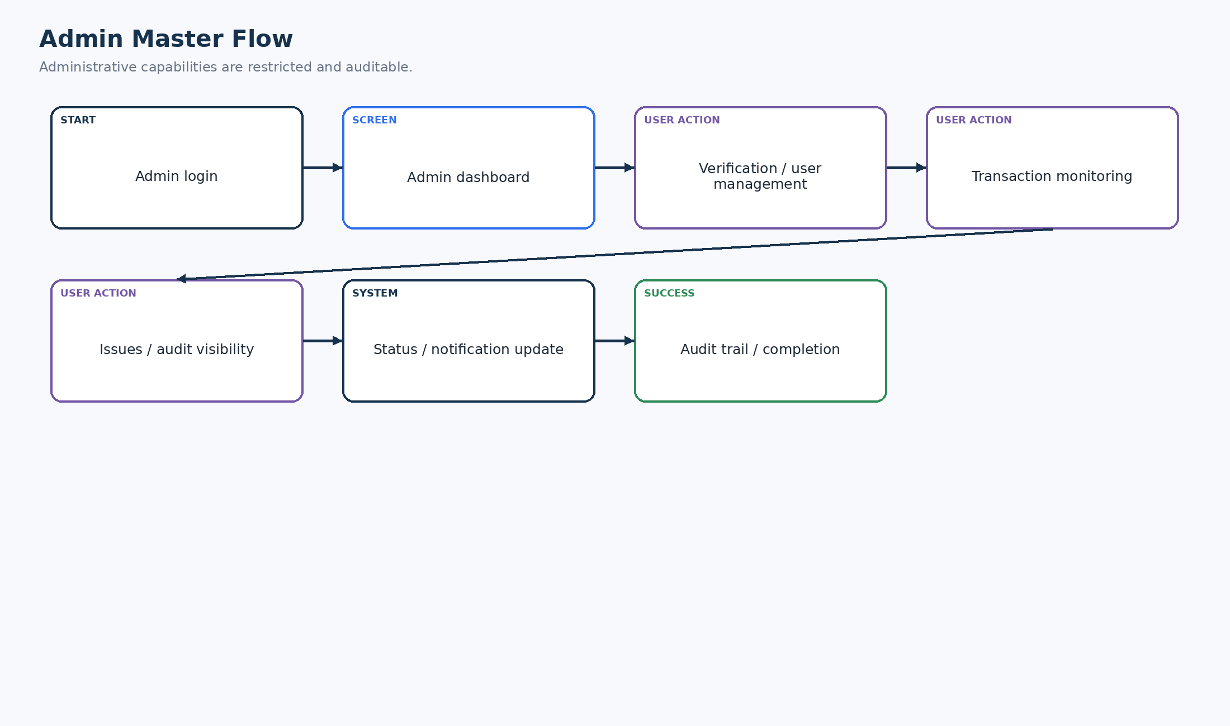
Figure 9. Admin Master Flow
Administrative activity centers on verification, user/transaction visibility, issue handling and auditability.

11. Material Identification Flow
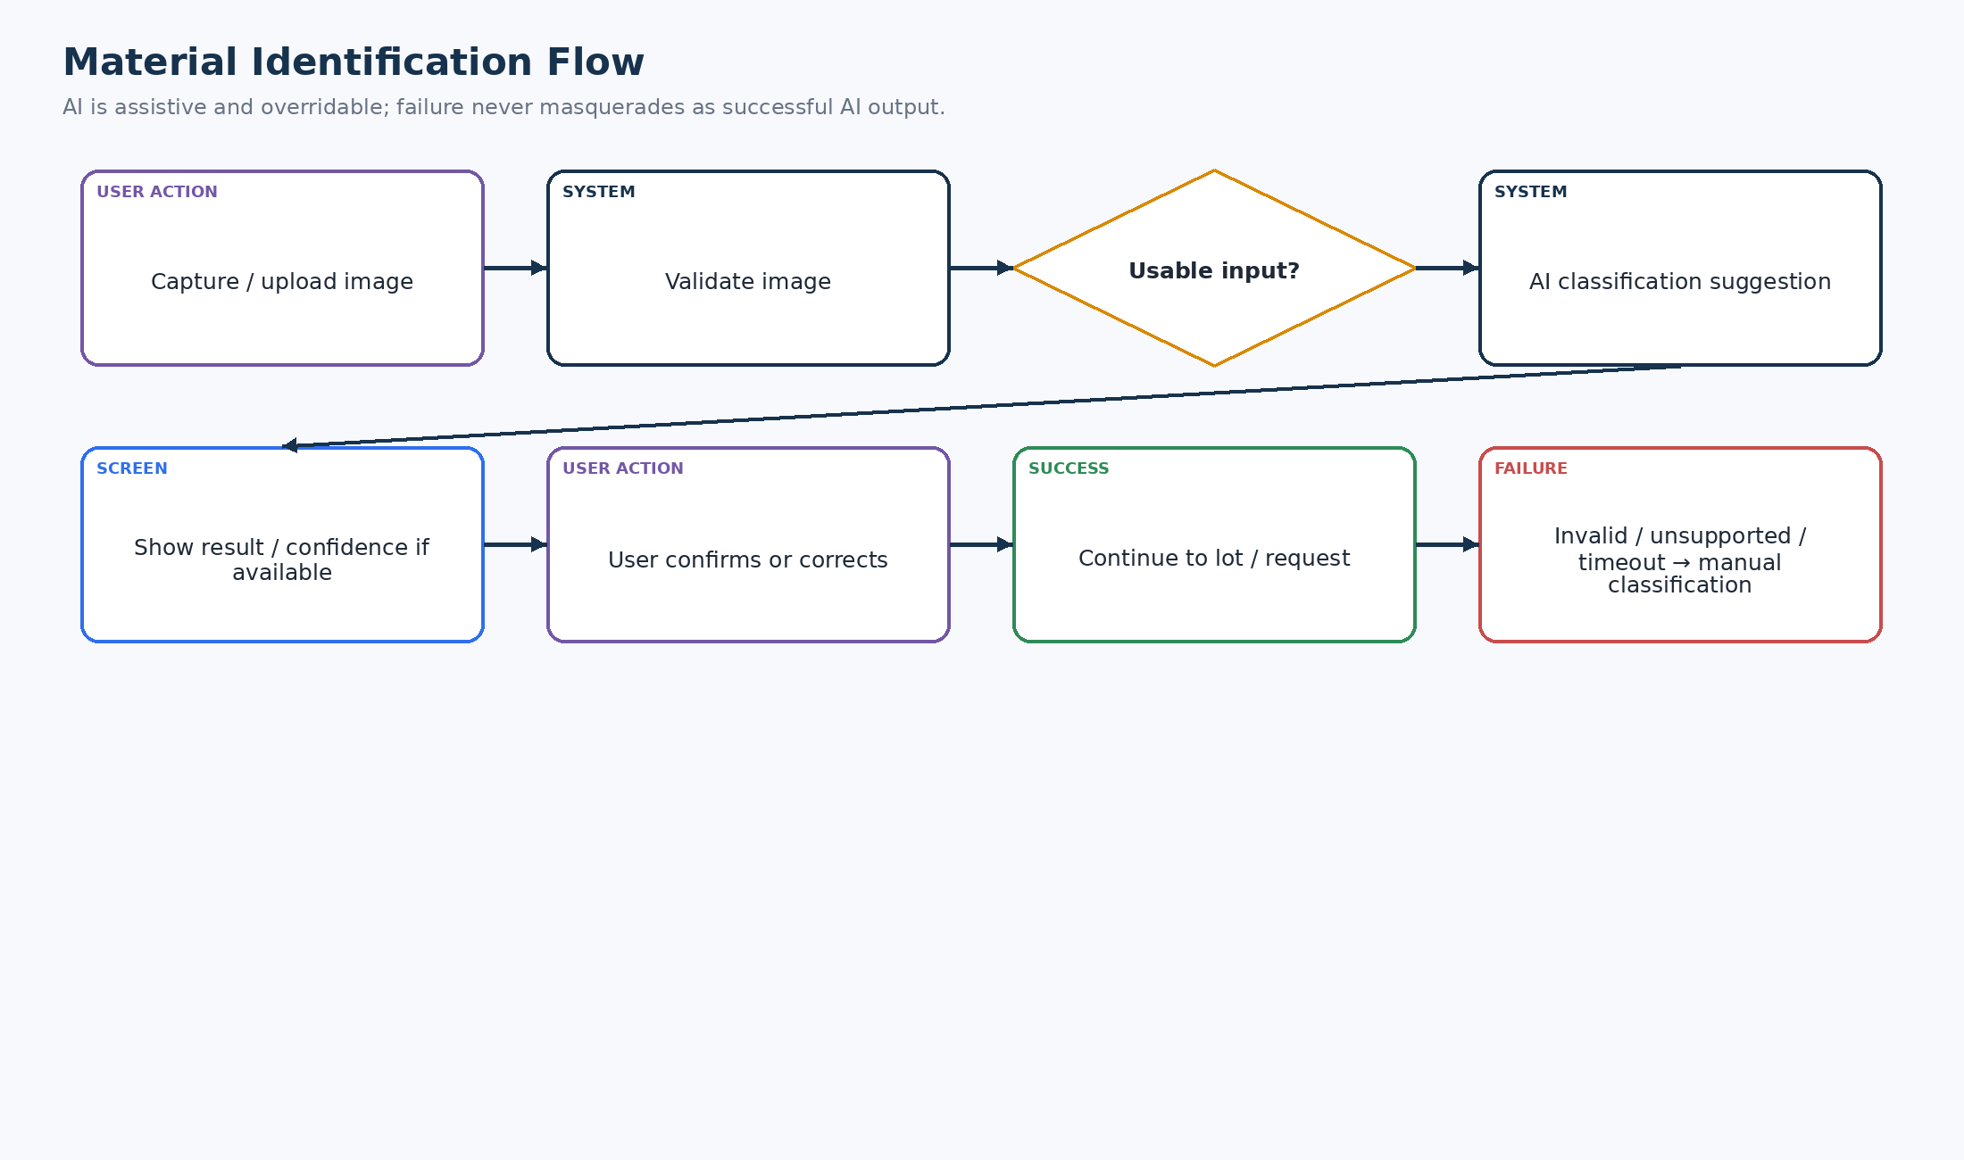
Figure 10. Material Identification Flow
AI provides an assistive suggestion only. Unusable input, AI timeout or provider failure routes to manual classification rather than fabricating a result.

12. Recycler Discovery Flow
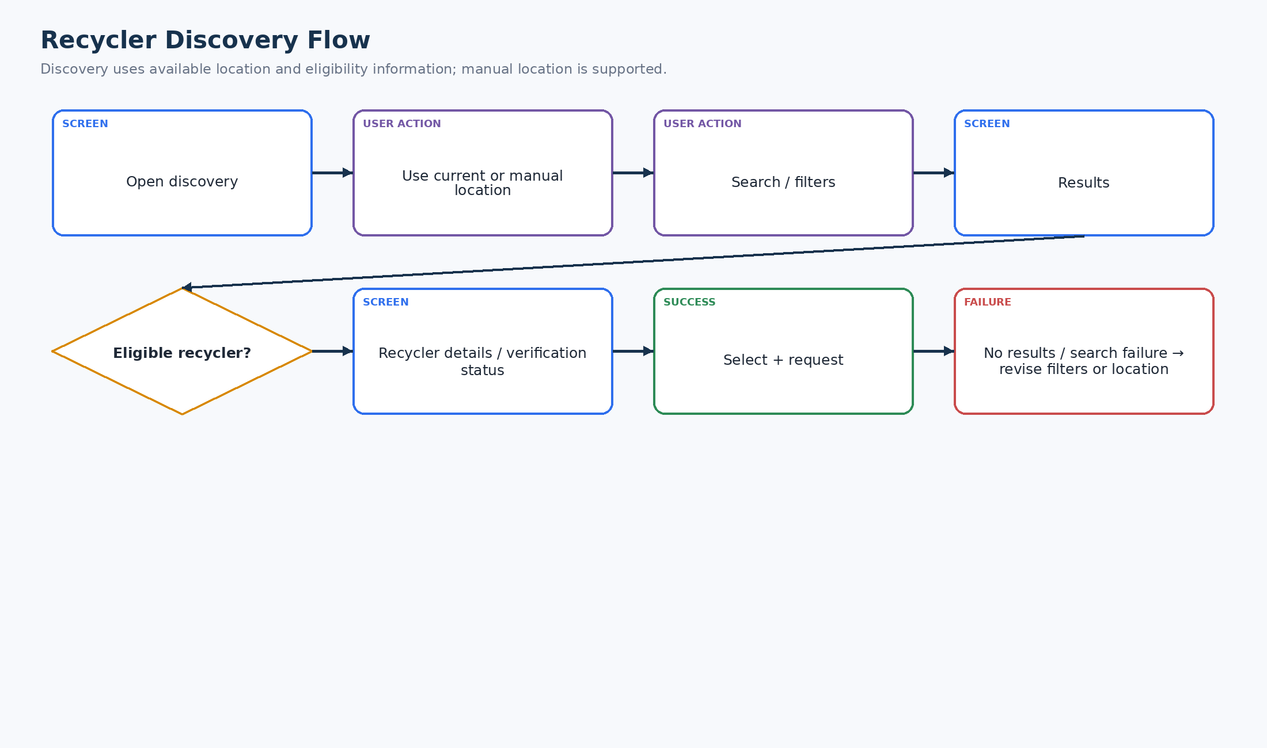
Figure 11. Recycler Discovery Flow
Discovery uses search, filters, location and eligibility/verification information. No-results and location failures remain recoverable.

13. Location Flow
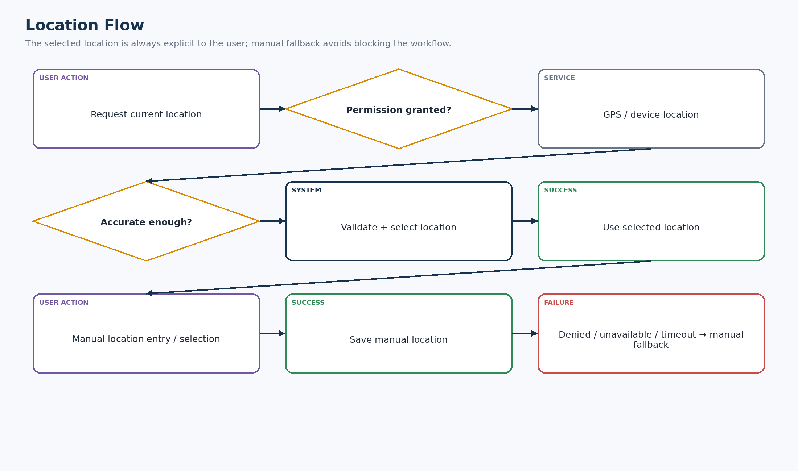
Figure 12. Location Flow
Current location and user-defined location are separate paths; permission denial, GPS failure, poor accuracy and timeout converge on an explicit manual fallback.

14. Request Creation Flow
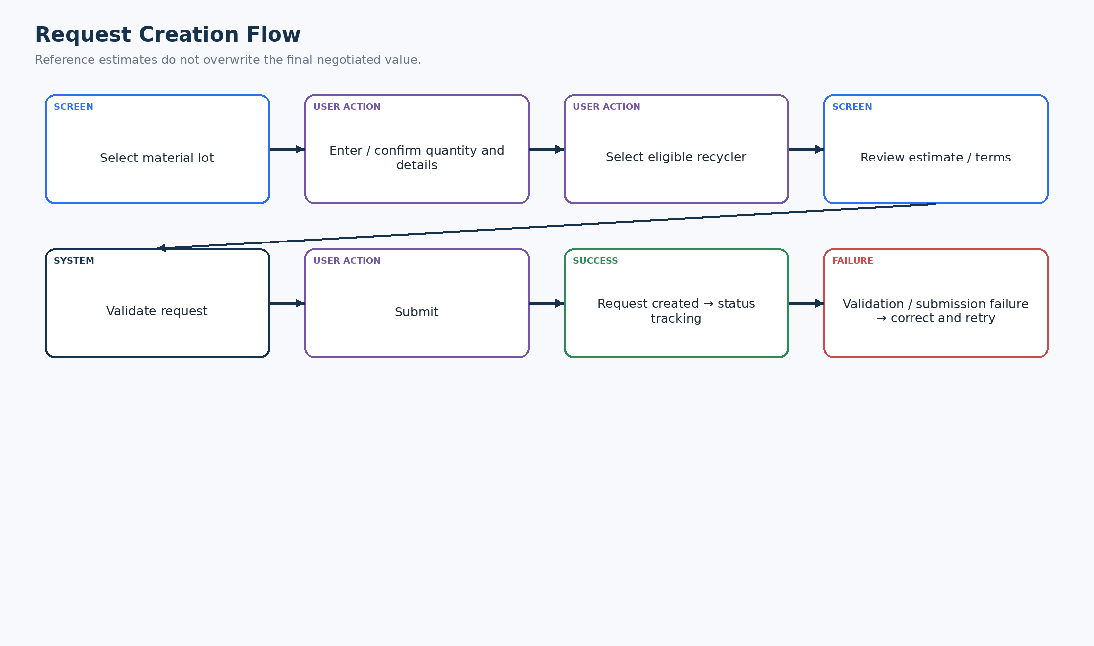
Figure 13. Request Creation Flow
The request is built from a material lot, quantity/details and an eligible recycler, then validated before submission.

15. Core Transaction Flow
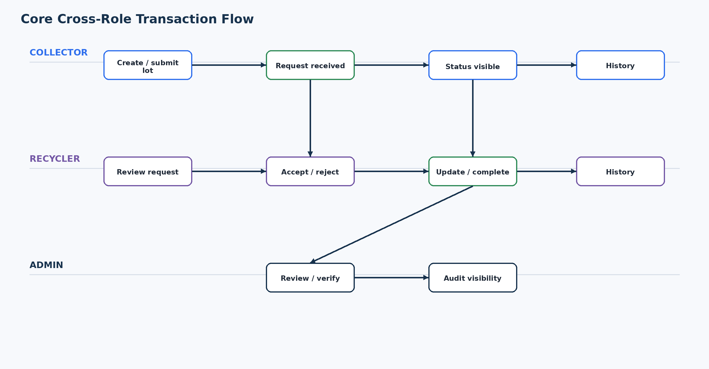
Figure 14. Core Cross-Role Transaction Flow
This is the principal cross-role journey: collector creates/submits, recycler responds and completes the transaction, and administrative visibility is retained where applicable.

16. Cross-Dashboard Flow
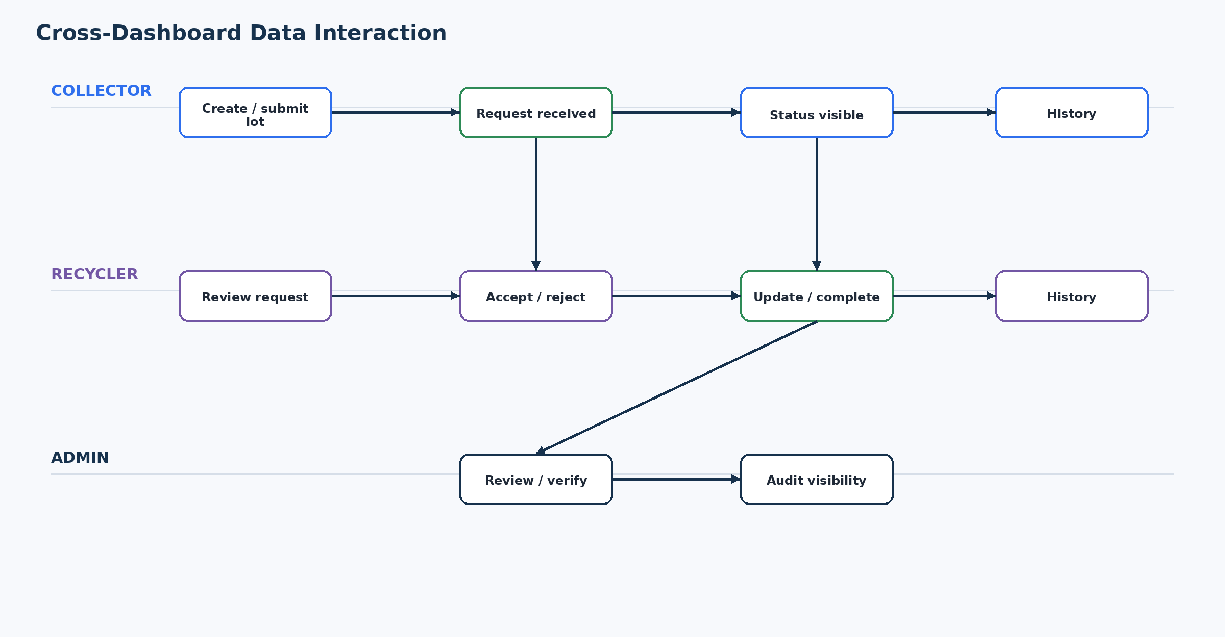
Figure 15. Cross-Dashboard Data Interaction
An action by one role becomes visible to the appropriate other role through shared application data; this is a UX/data interaction view, not a technical architecture diagram.

17. Transaction Status Flow
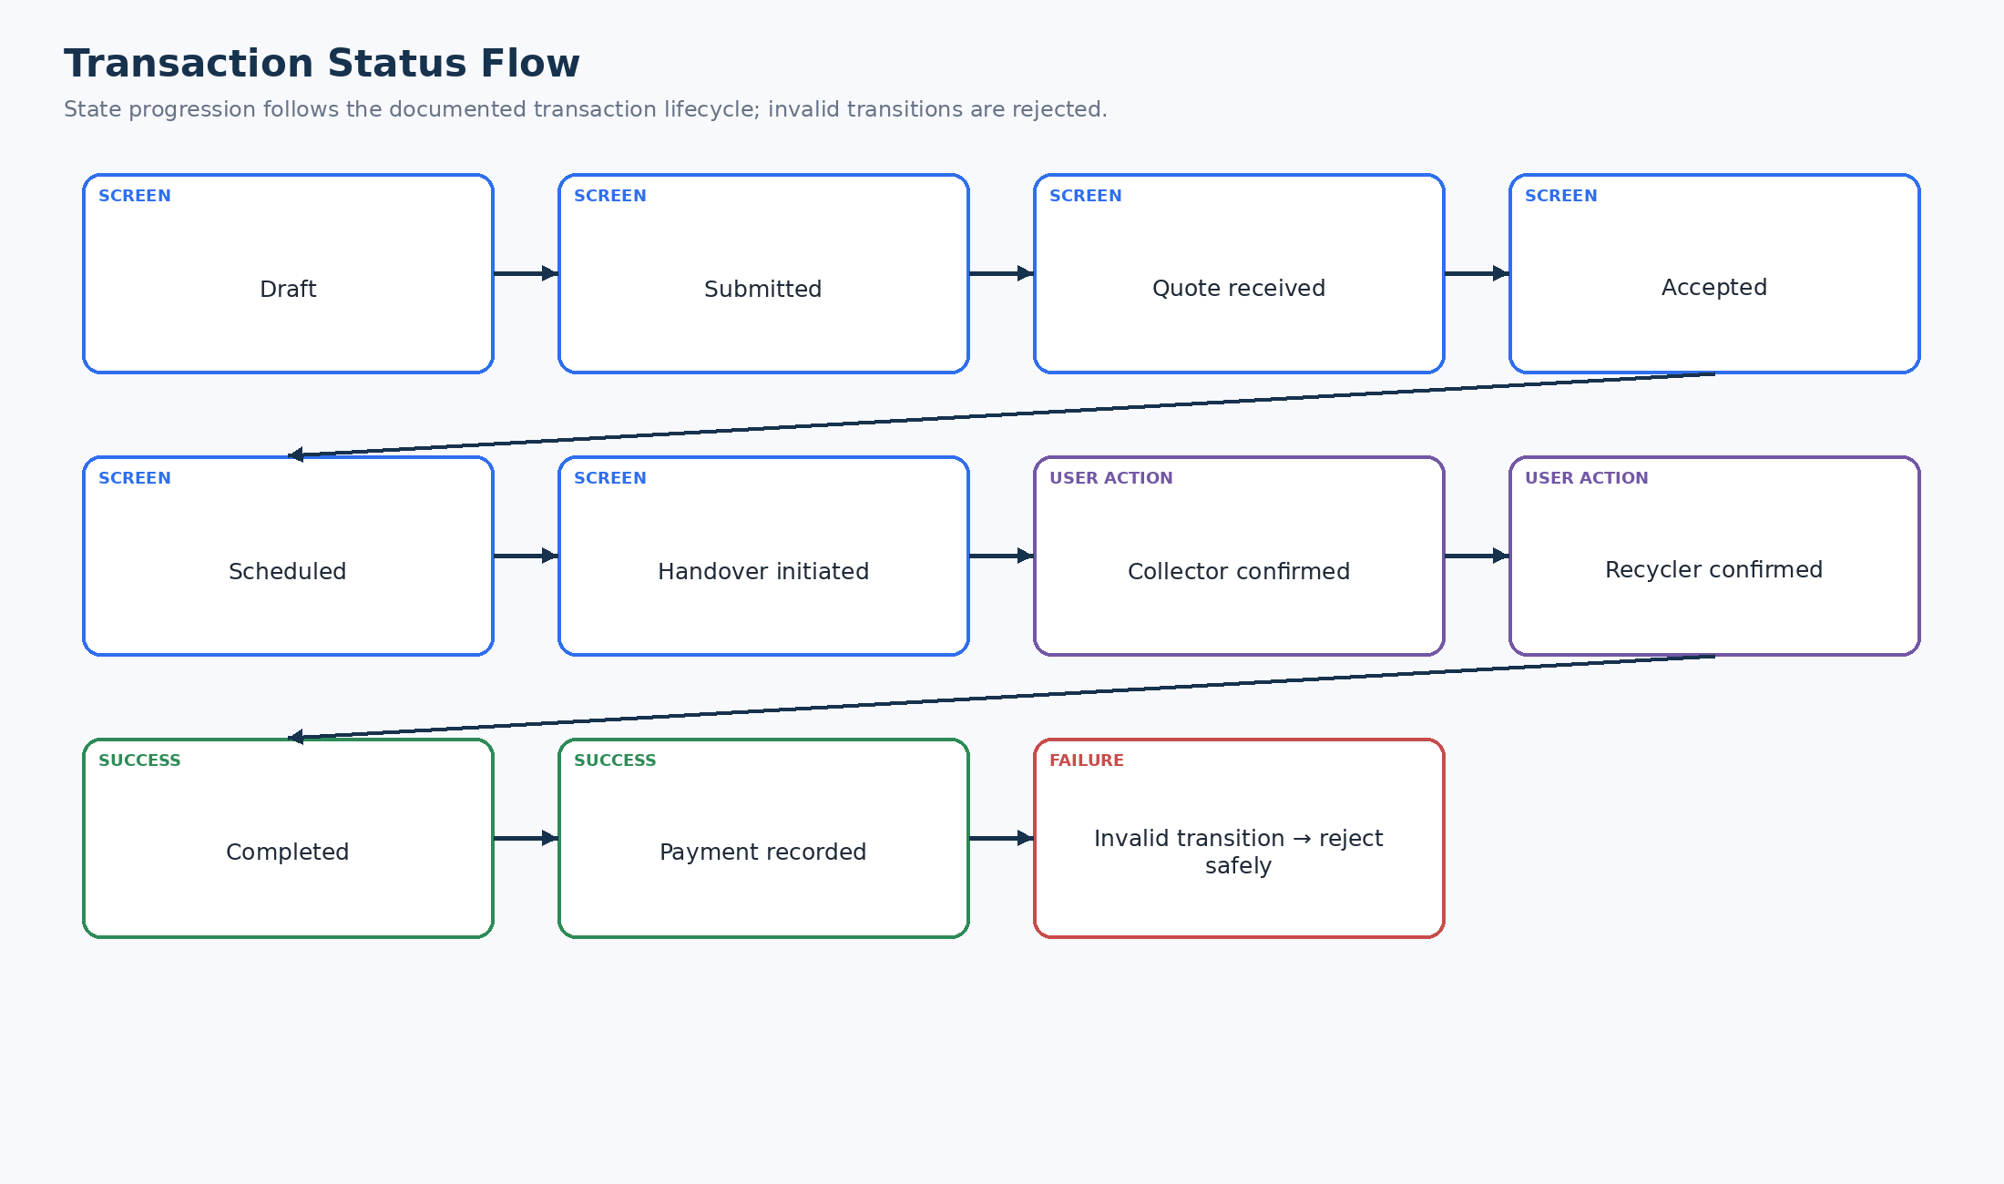
Figure 16. Transaction Status Flow
The documented lifecycle is Draft → Submitted → Quote Received → Accepted → Scheduled → Handover Initiated → Collector Confirmed → Recycler Confirmed → Completed → Payment Recorded. Invalid transitions are rejected.

18. History / Traceability Flow
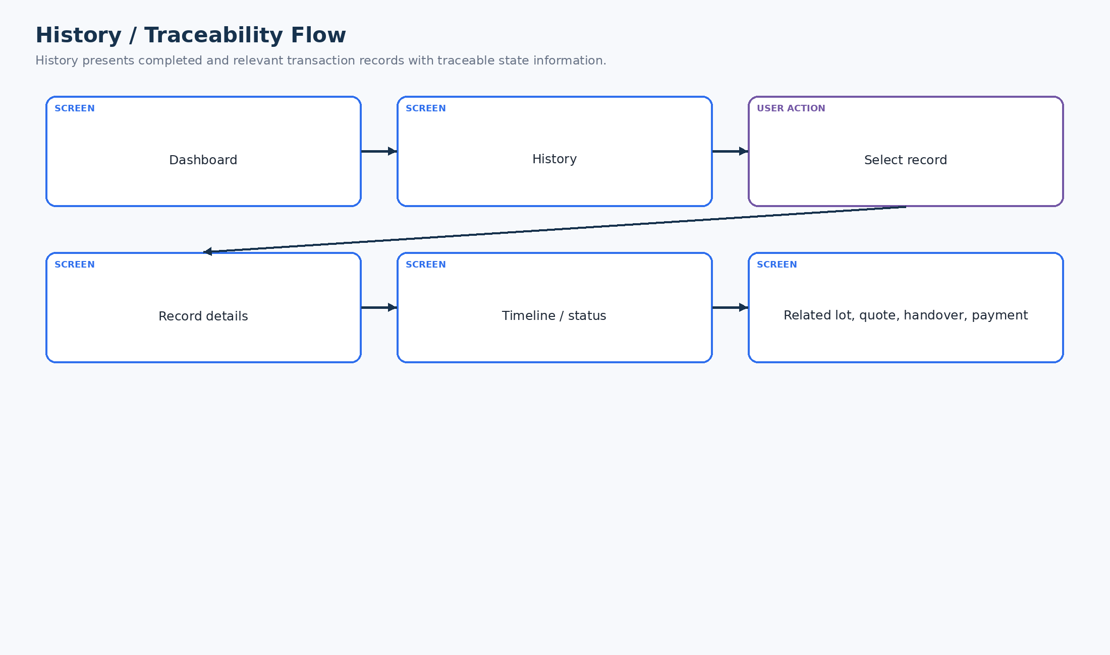
Figure 17. History / Traceability Flow
Users reach a record from history and can inspect status/timeline and related transaction information supported by the application.

19. Notification Flow
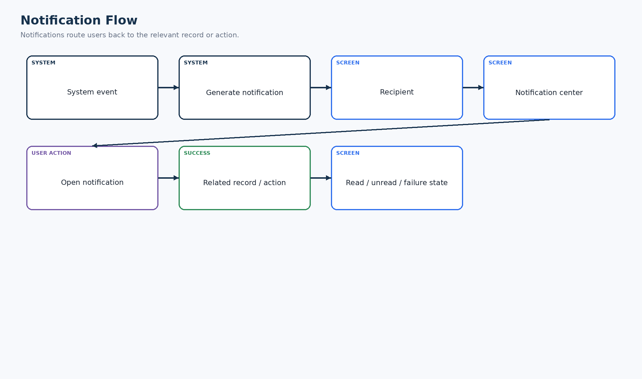
Figure 18. Notification Flow
System events produce recipient-facing notifications that route back to the relevant record or action.

20. Voice Assistance Flow
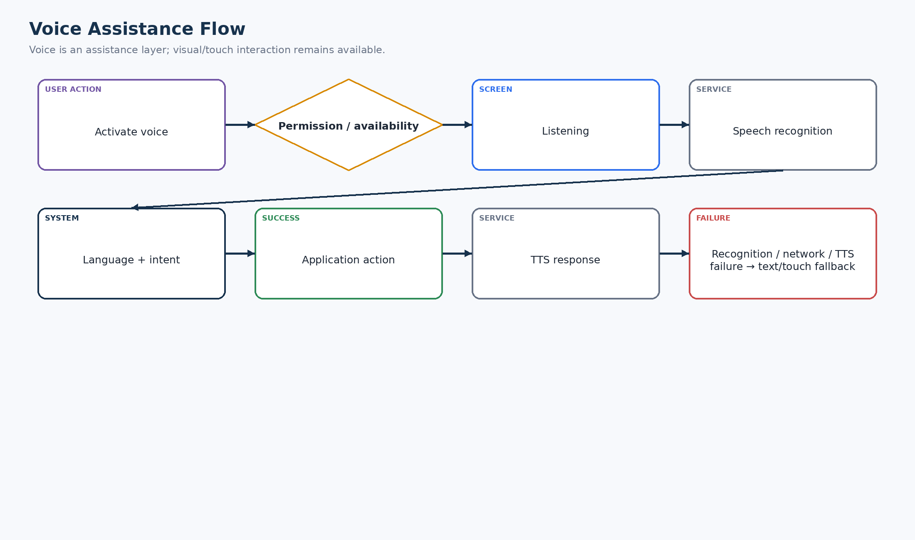
Figure 19. Voice Assistance Flow
Voice is an assistive layer. Permission, recognition, language, network and text-to-speech failures fall back to visual/touch interaction.

21. Regional Language Flow
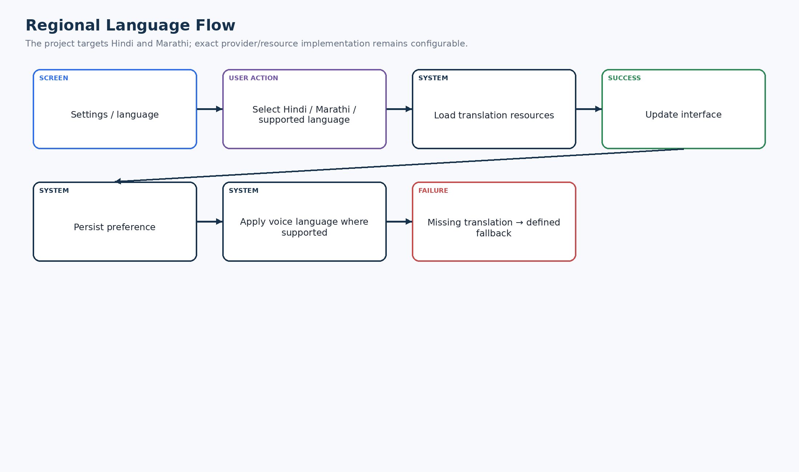
Figure 20. Regional Language Flow
The product targets Hindi and Marathi, with a persisted language preference and a defined fallback for unavailable translation resources.

22. Offline Flow
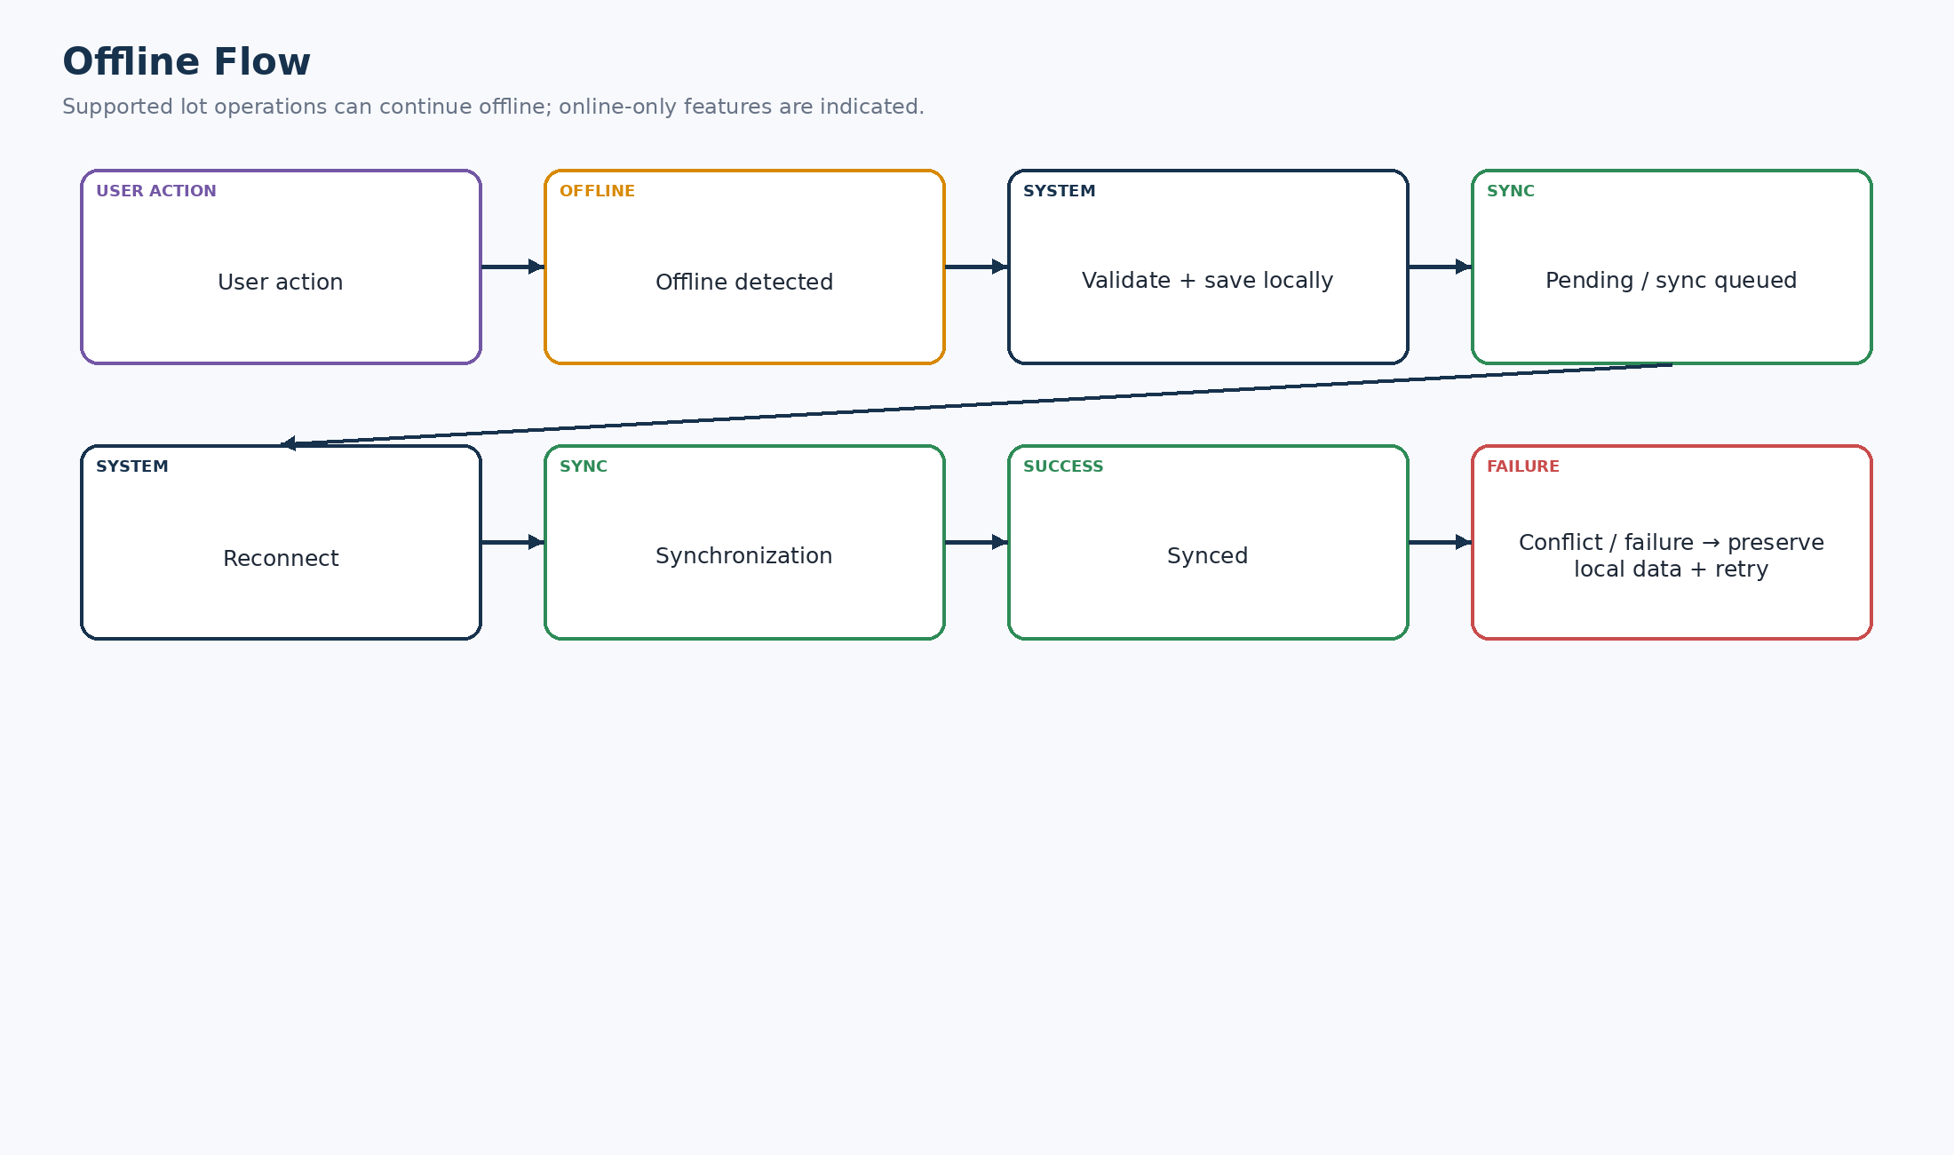
Figure 21. Offline Flow
Supported local operations are saved locally, queued and synchronized after reconnection. The user sees offline/pending/sync states.

23. Synchronization Flow
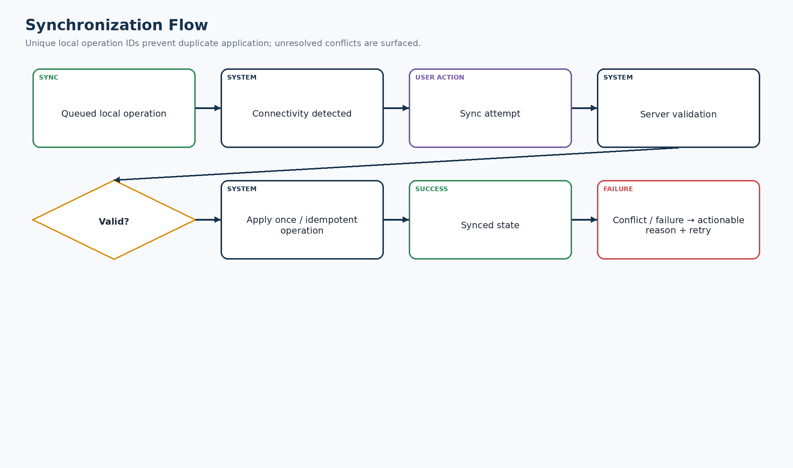
Figure 22. Synchronization Flow
Queued operations use server validation and unique local operation identifiers so retry does not silently create duplicates; conflicts remain visible.

24. AI Failure Flow
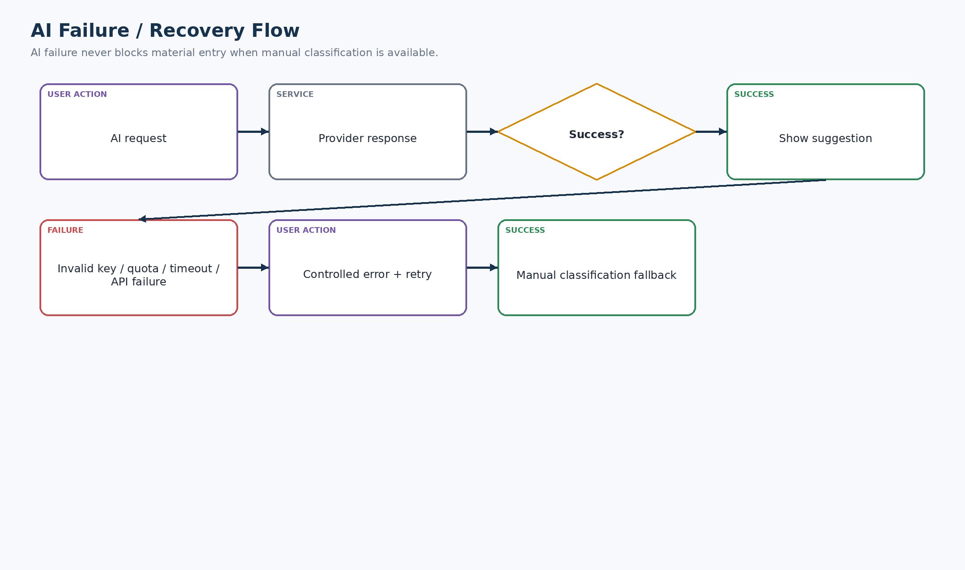
Figure 23. AI Failure / Recovery Flow
Invalid credentials, quota exhaustion, timeout and API failures are handled as failures, with retry and manual classification fallback.

25. Location Failure Flow
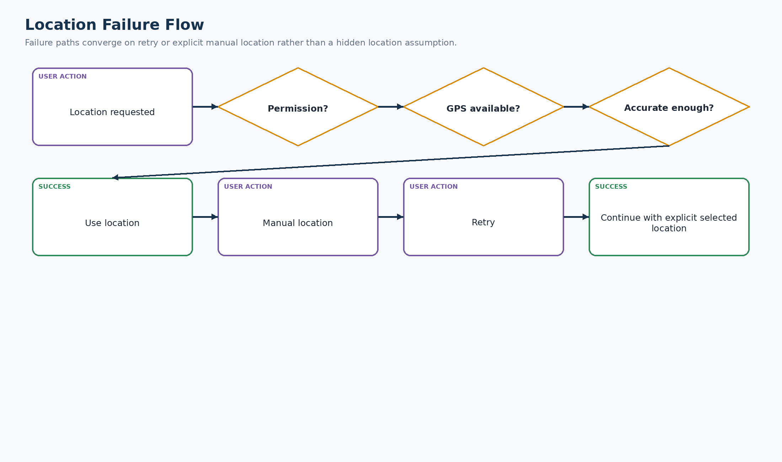
Figure 24. Location Failure Flow
The user is not trapped by location permission or GPS failure; retry and explicit manual location are available.

26. Voice Failure Flow
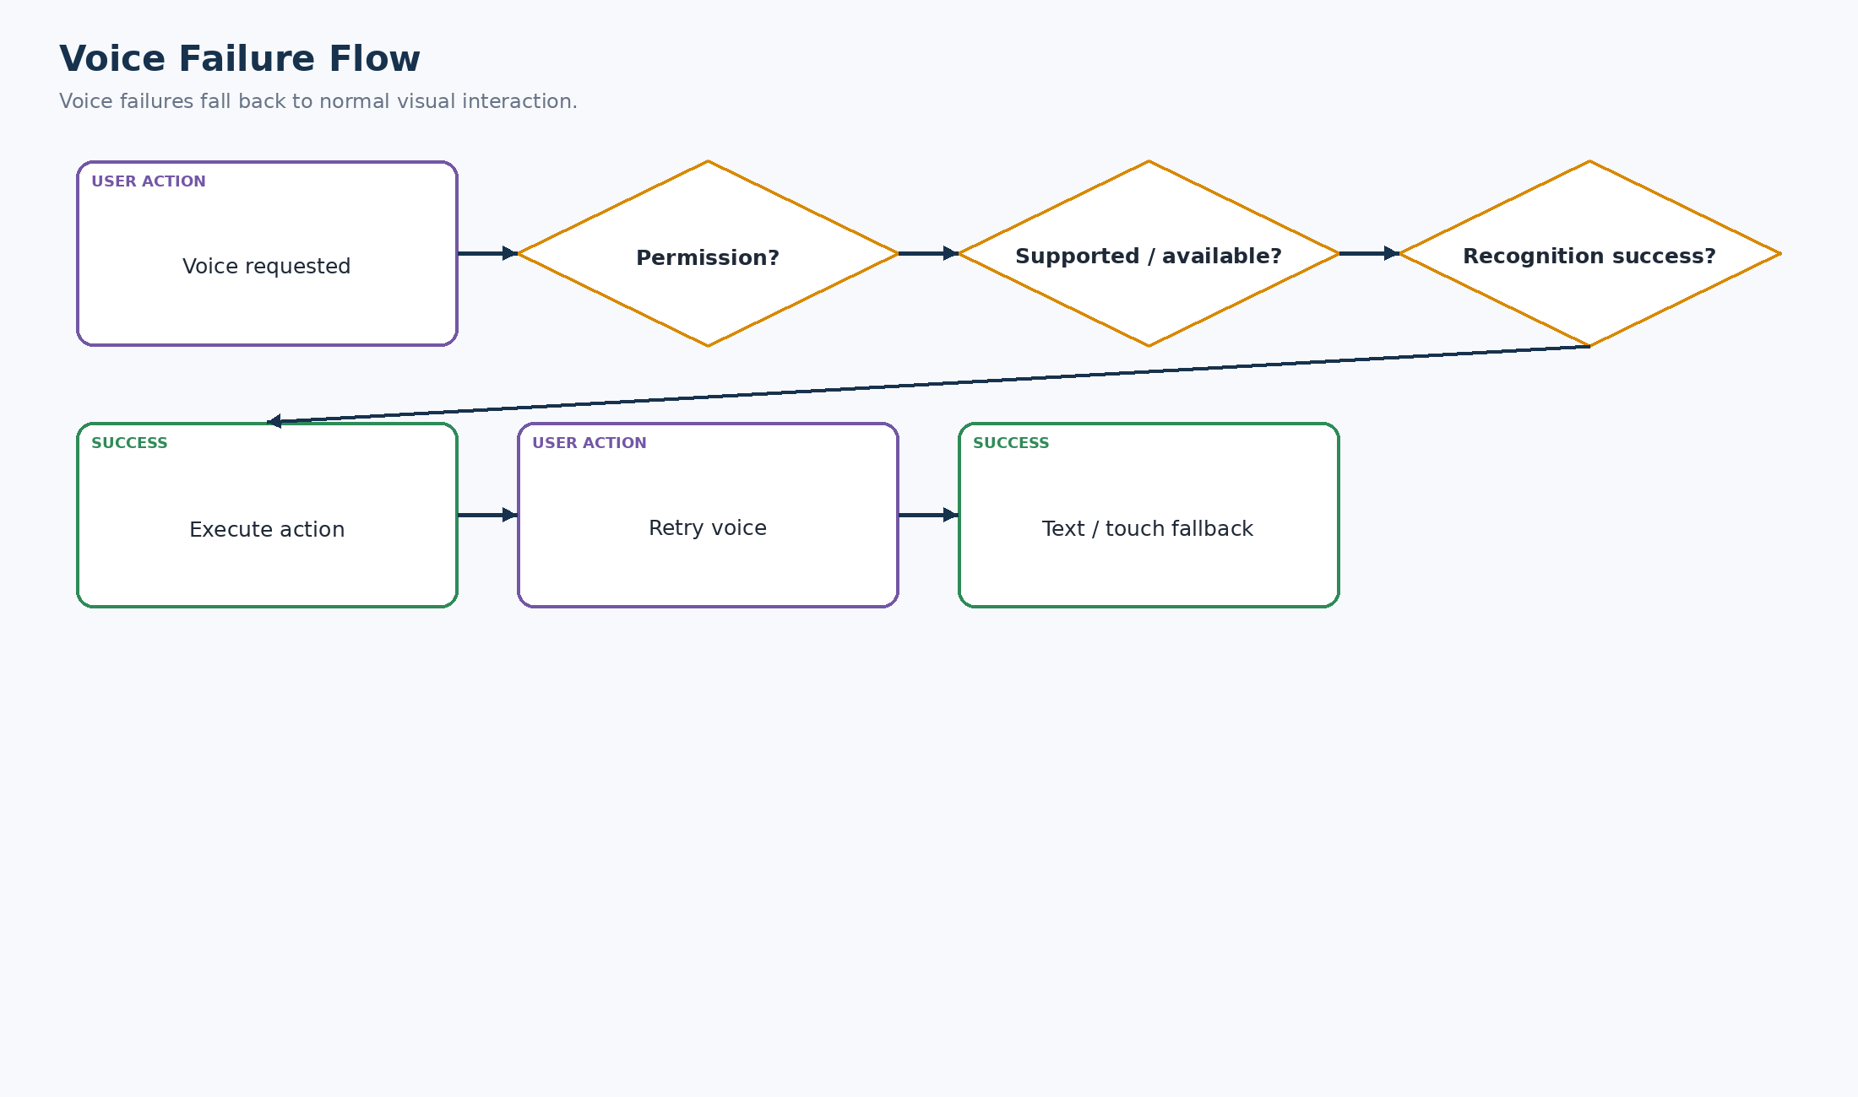
Figure 25. Voice Failure Flow
Voice failure does not block the underlying task; the application provides a normal text/touch route.

27. Authorization Failure Flow
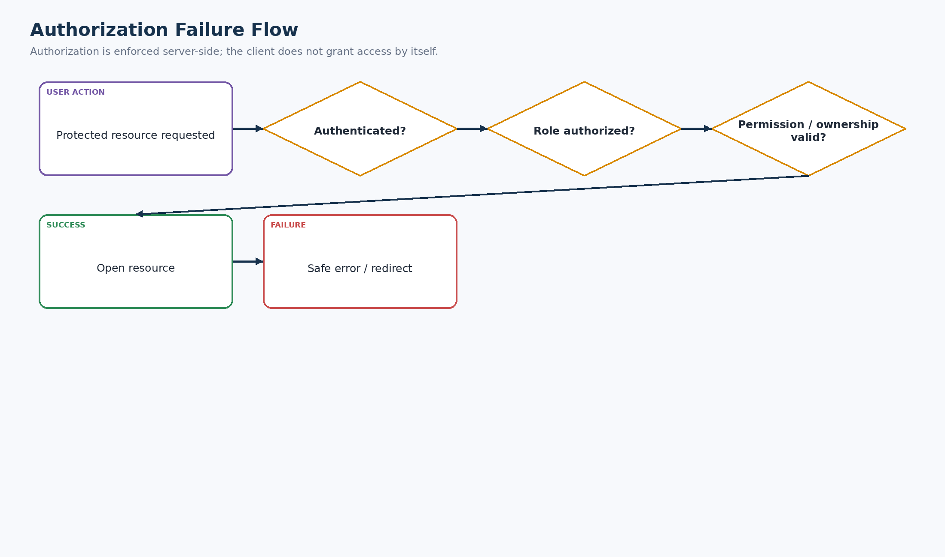
Figure 26. Authorization Failure Flow
Protected resources require authentication, role authorization and valid permission/ownership. Otherwise the system returns a safe error/redirect.

28. Session Expiry Flow
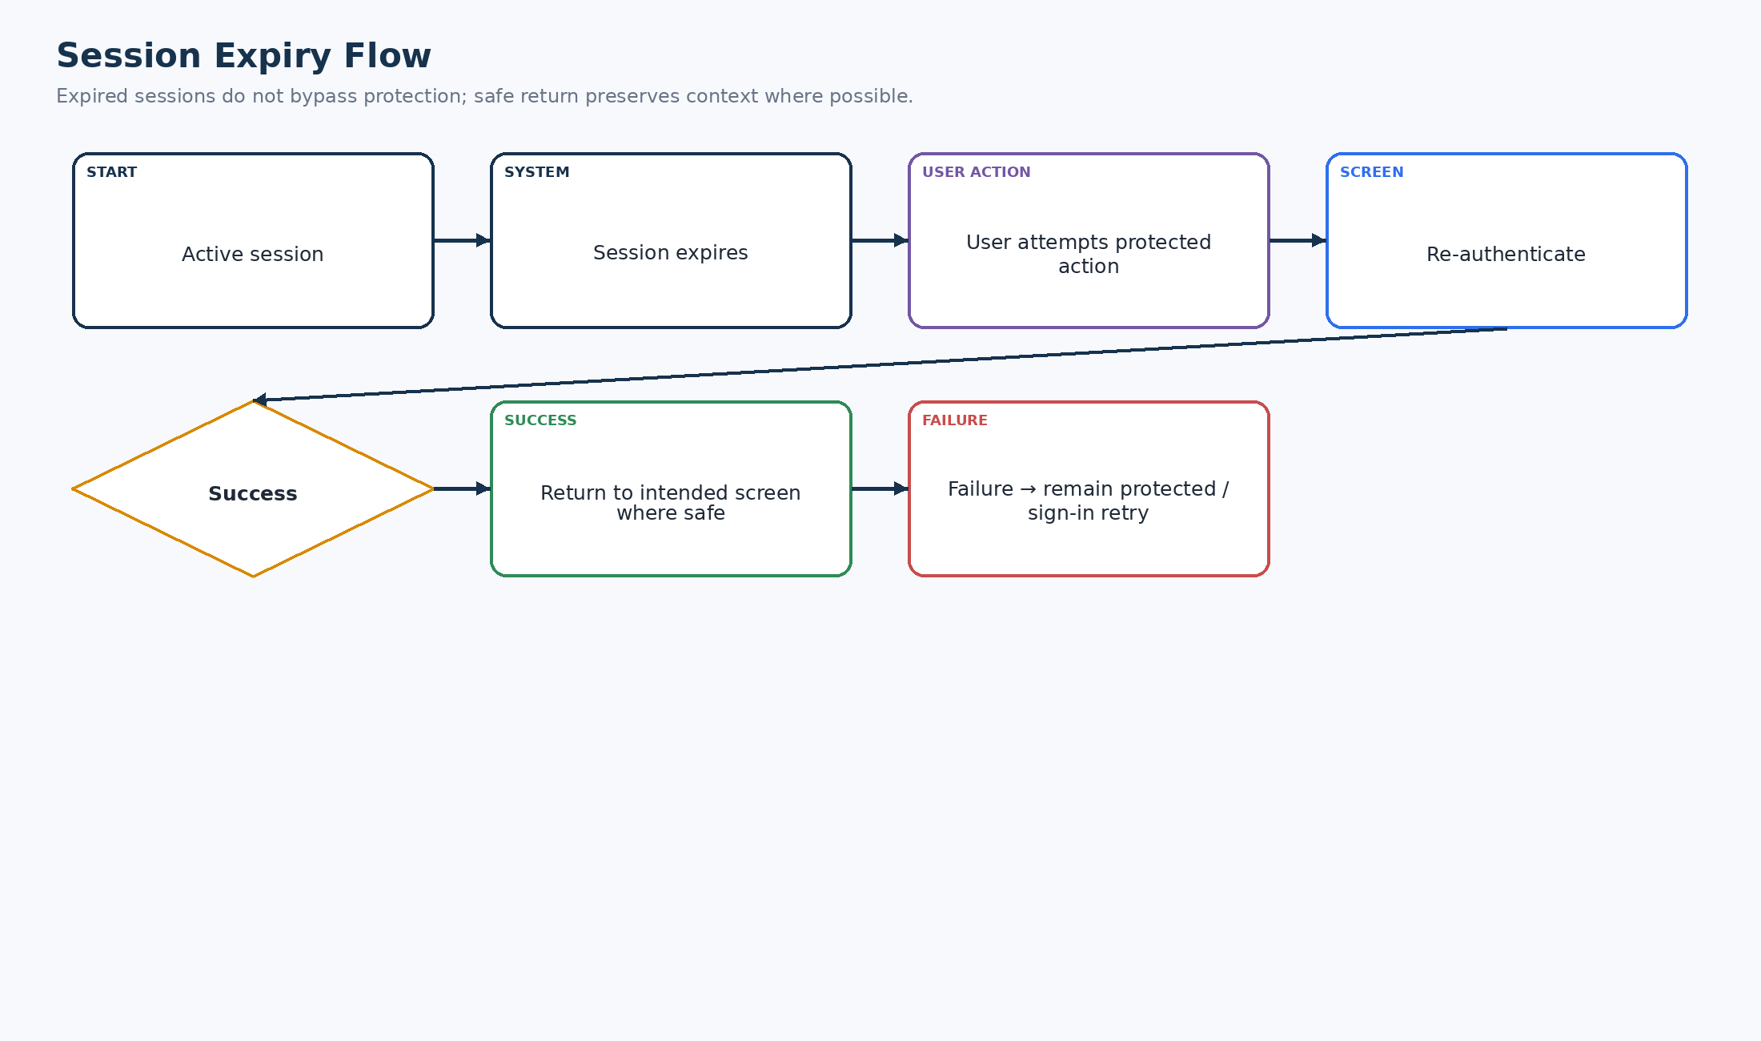
Figure 27. Session Expiry Flow
Expired sessions re-authenticate before protected actions and return to the intended screen only where it is safe to do so.

29. File / Document Upload Flow
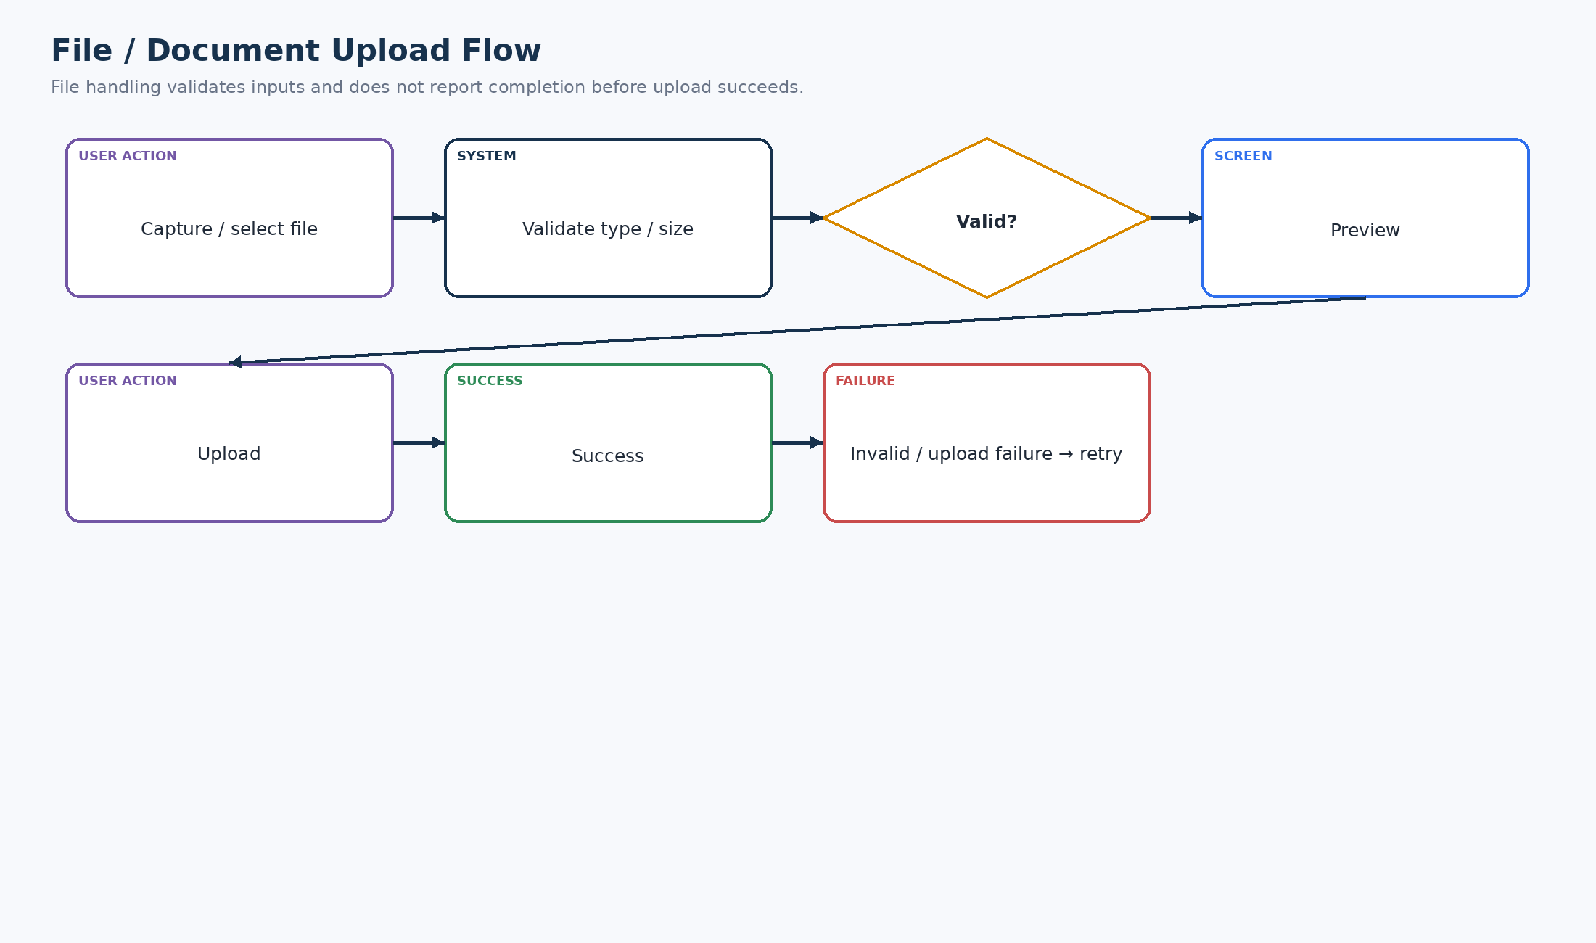
Figure 28. File / Document Upload Flow
Image/document inputs are validated and previewed before upload; invalid type/size and upload failure are recoverable.

30. Profile Flow
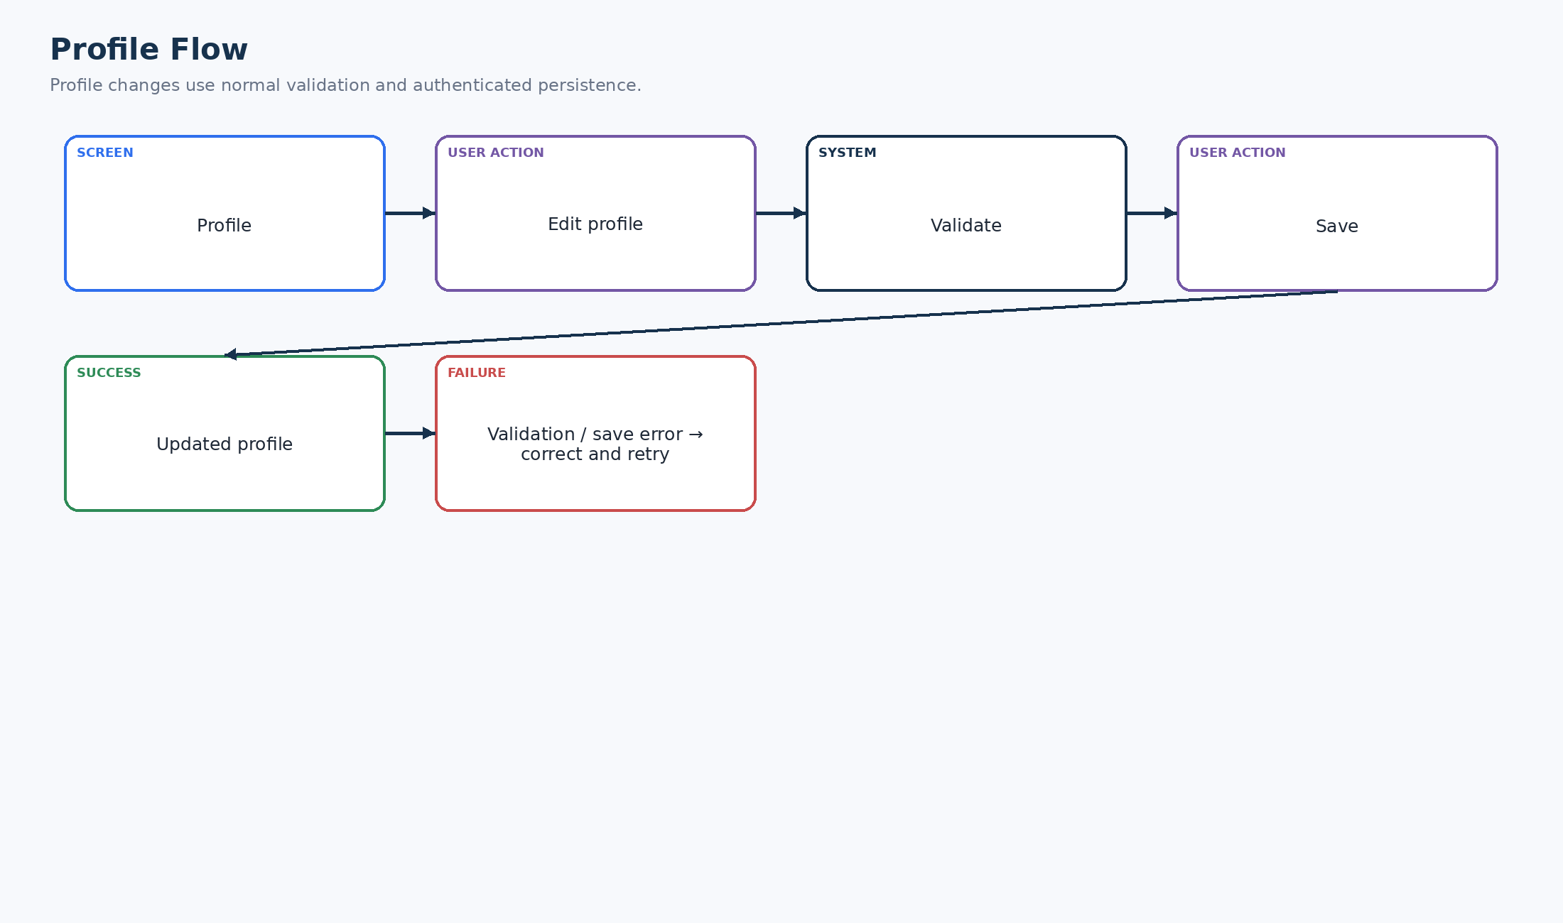
Figure 29. Profile Flow
Profile changes follow edit → validate → save → success/error, without bypassing authentication or validation.

31. Settings Flow
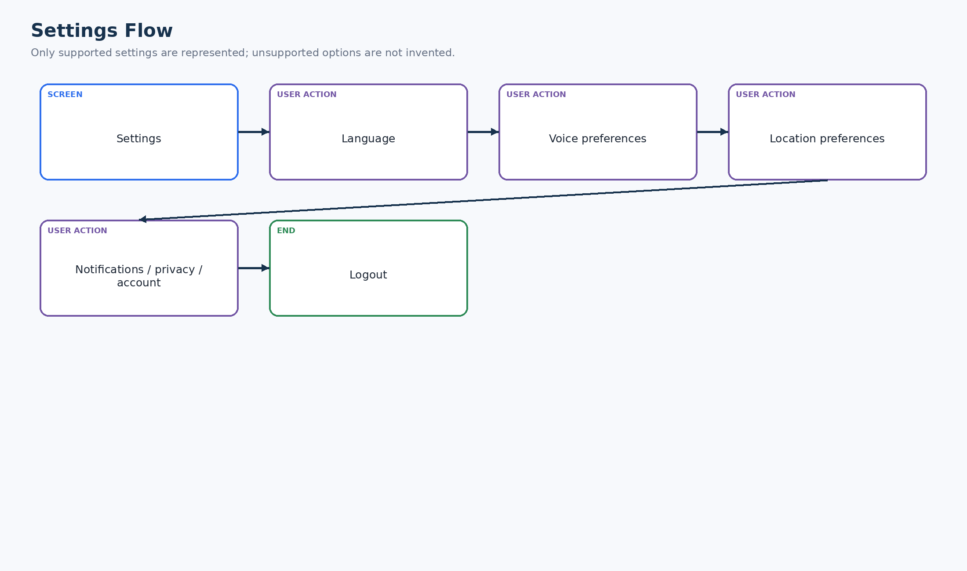
Figure 30. Settings Flow
The settings path groups supported language, voice, location, notifications/privacy/account controls and logout.

32. Help / Support Flow
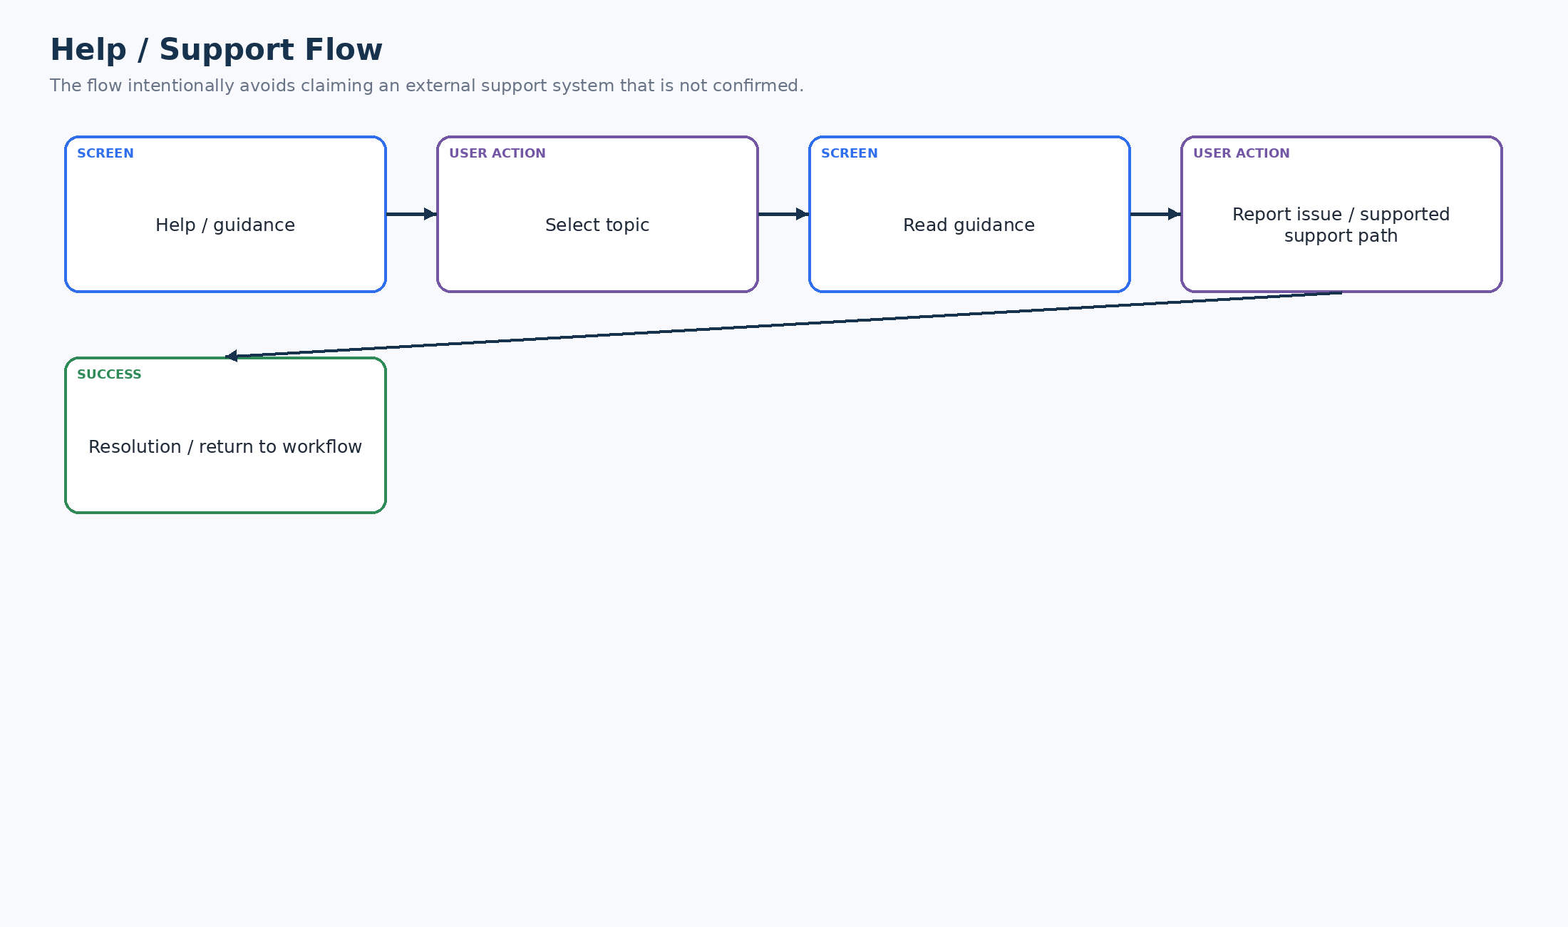
Figure 31. Help / Support Flow
Guidance is topic-based. A supported issue-reporting path may be used; the flow does not claim an unconfirmed external support system.

33. Error Recovery Flow
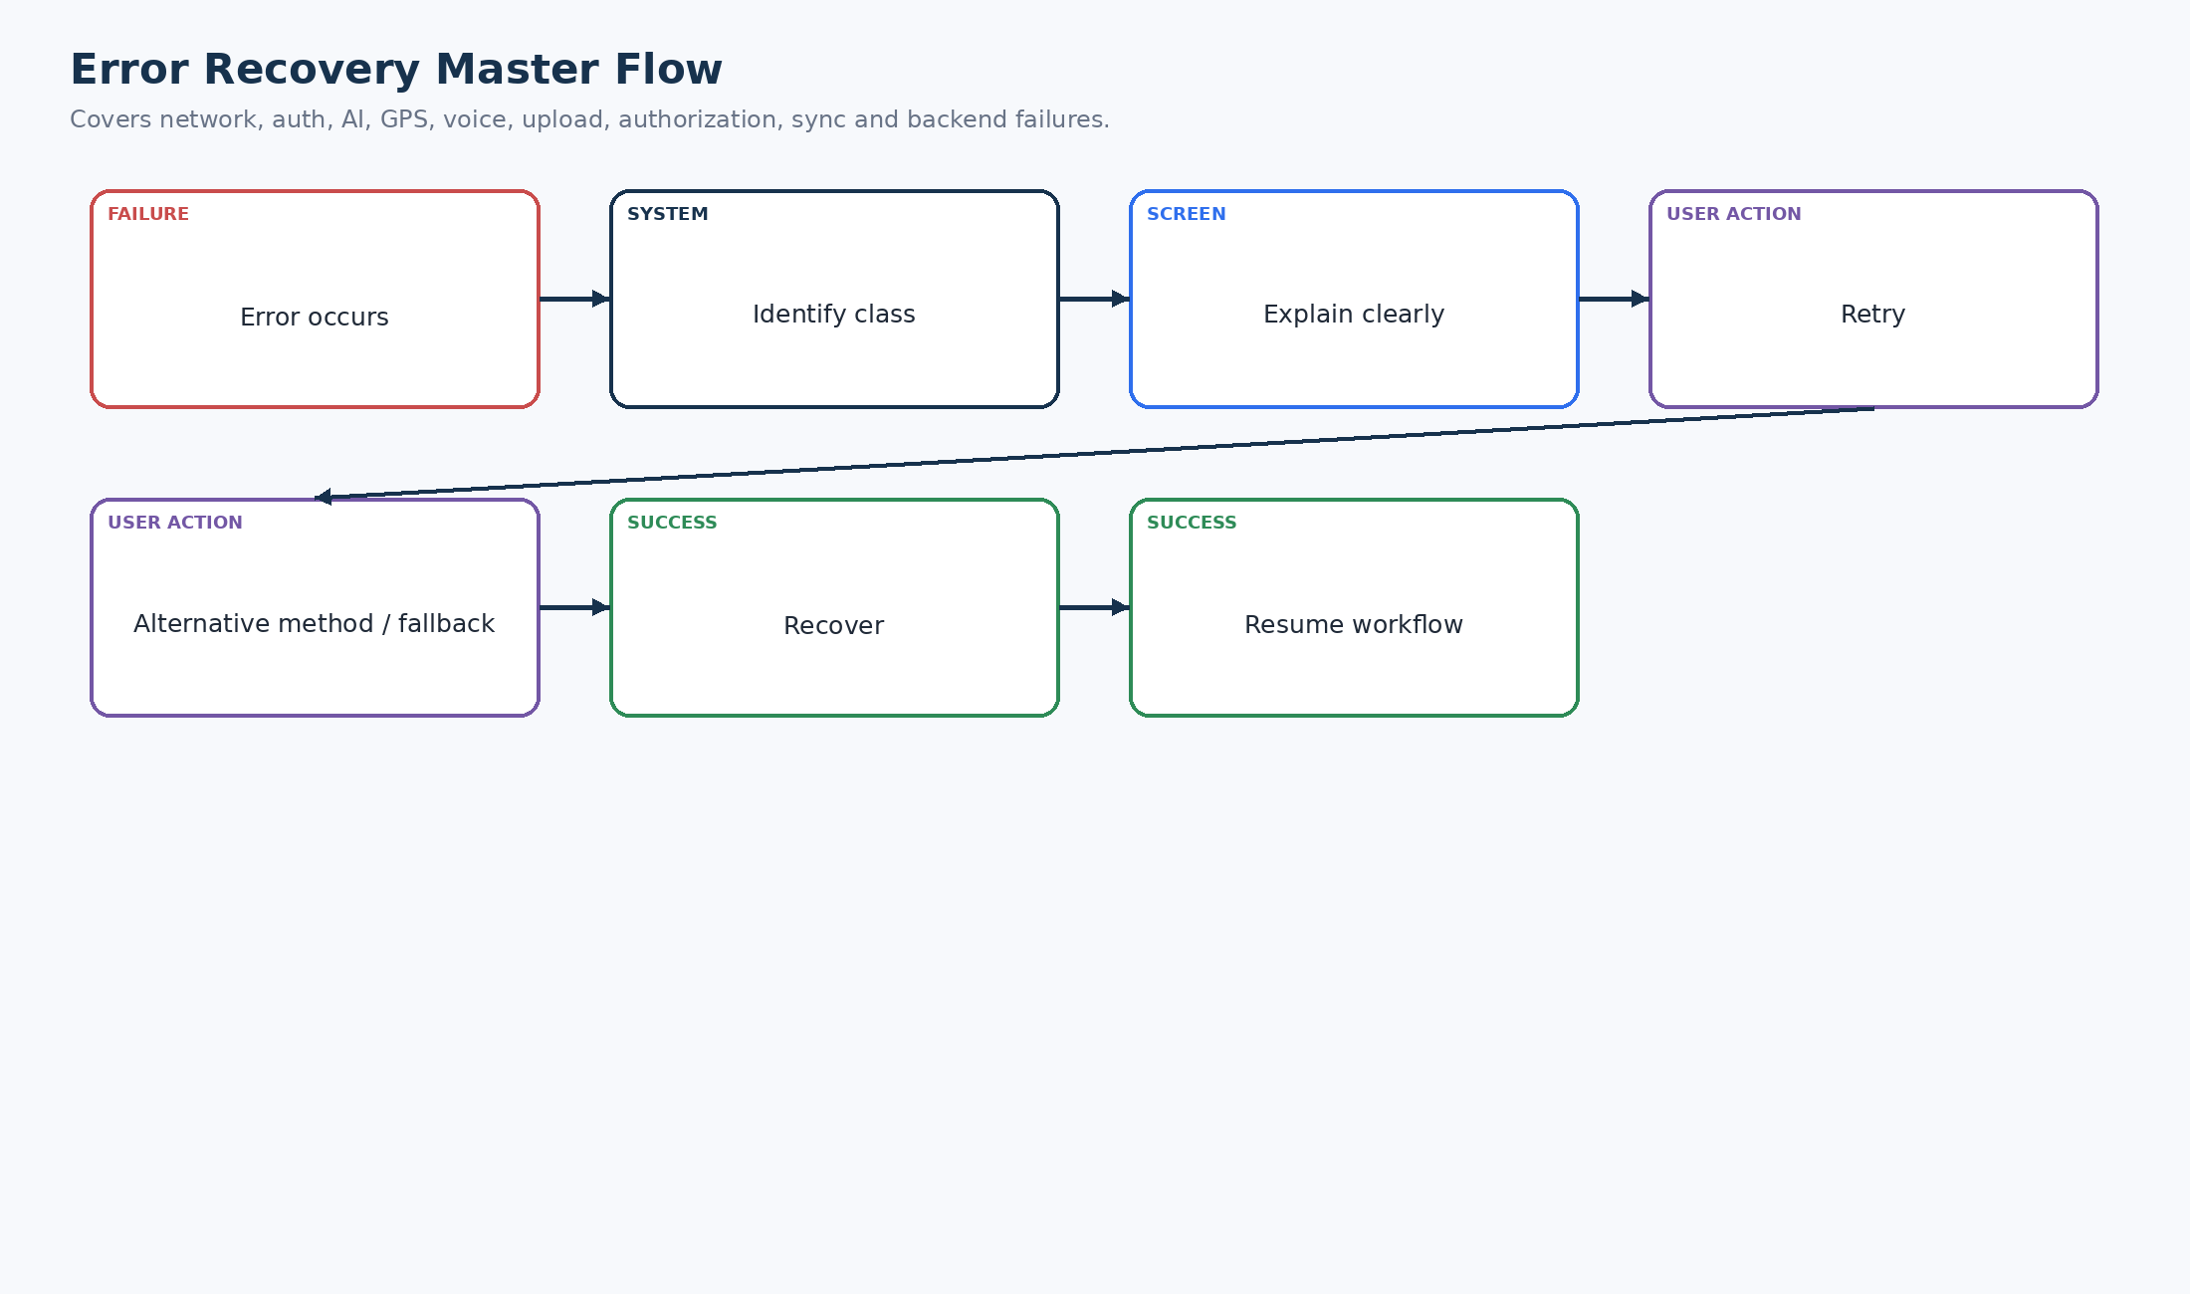
Figure 32. Error Recovery Master Flow
Across network, authentication, AI, GPS, voice, upload, authorization, synchronization and backend errors, the intended pattern is identify → explain → retry/fallback → recover → resume.

34. Empty-State Flow
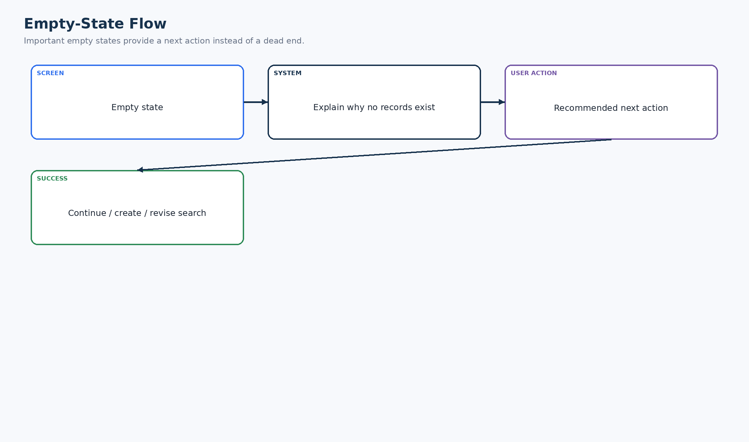
Figure 33. Empty-State Flow
Empty states should explain why there is no data and provide a useful next action, such as creating a request or revising a search.

35. SIH Evaluator Flow
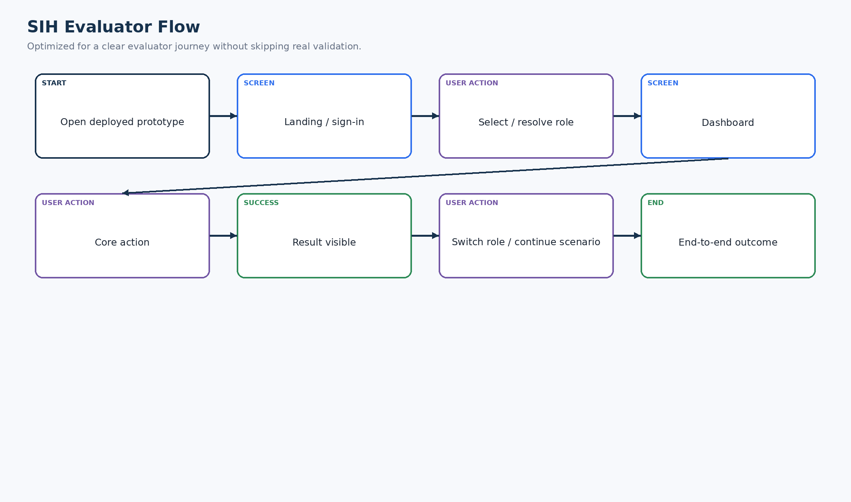
Figure 34. SIH Evaluator Flow
The evaluator can enter the deployed prototype, resolve a role, execute the core action, observe the result and continue into another role without unnecessary detours.

36. SIH Demo Master Flow
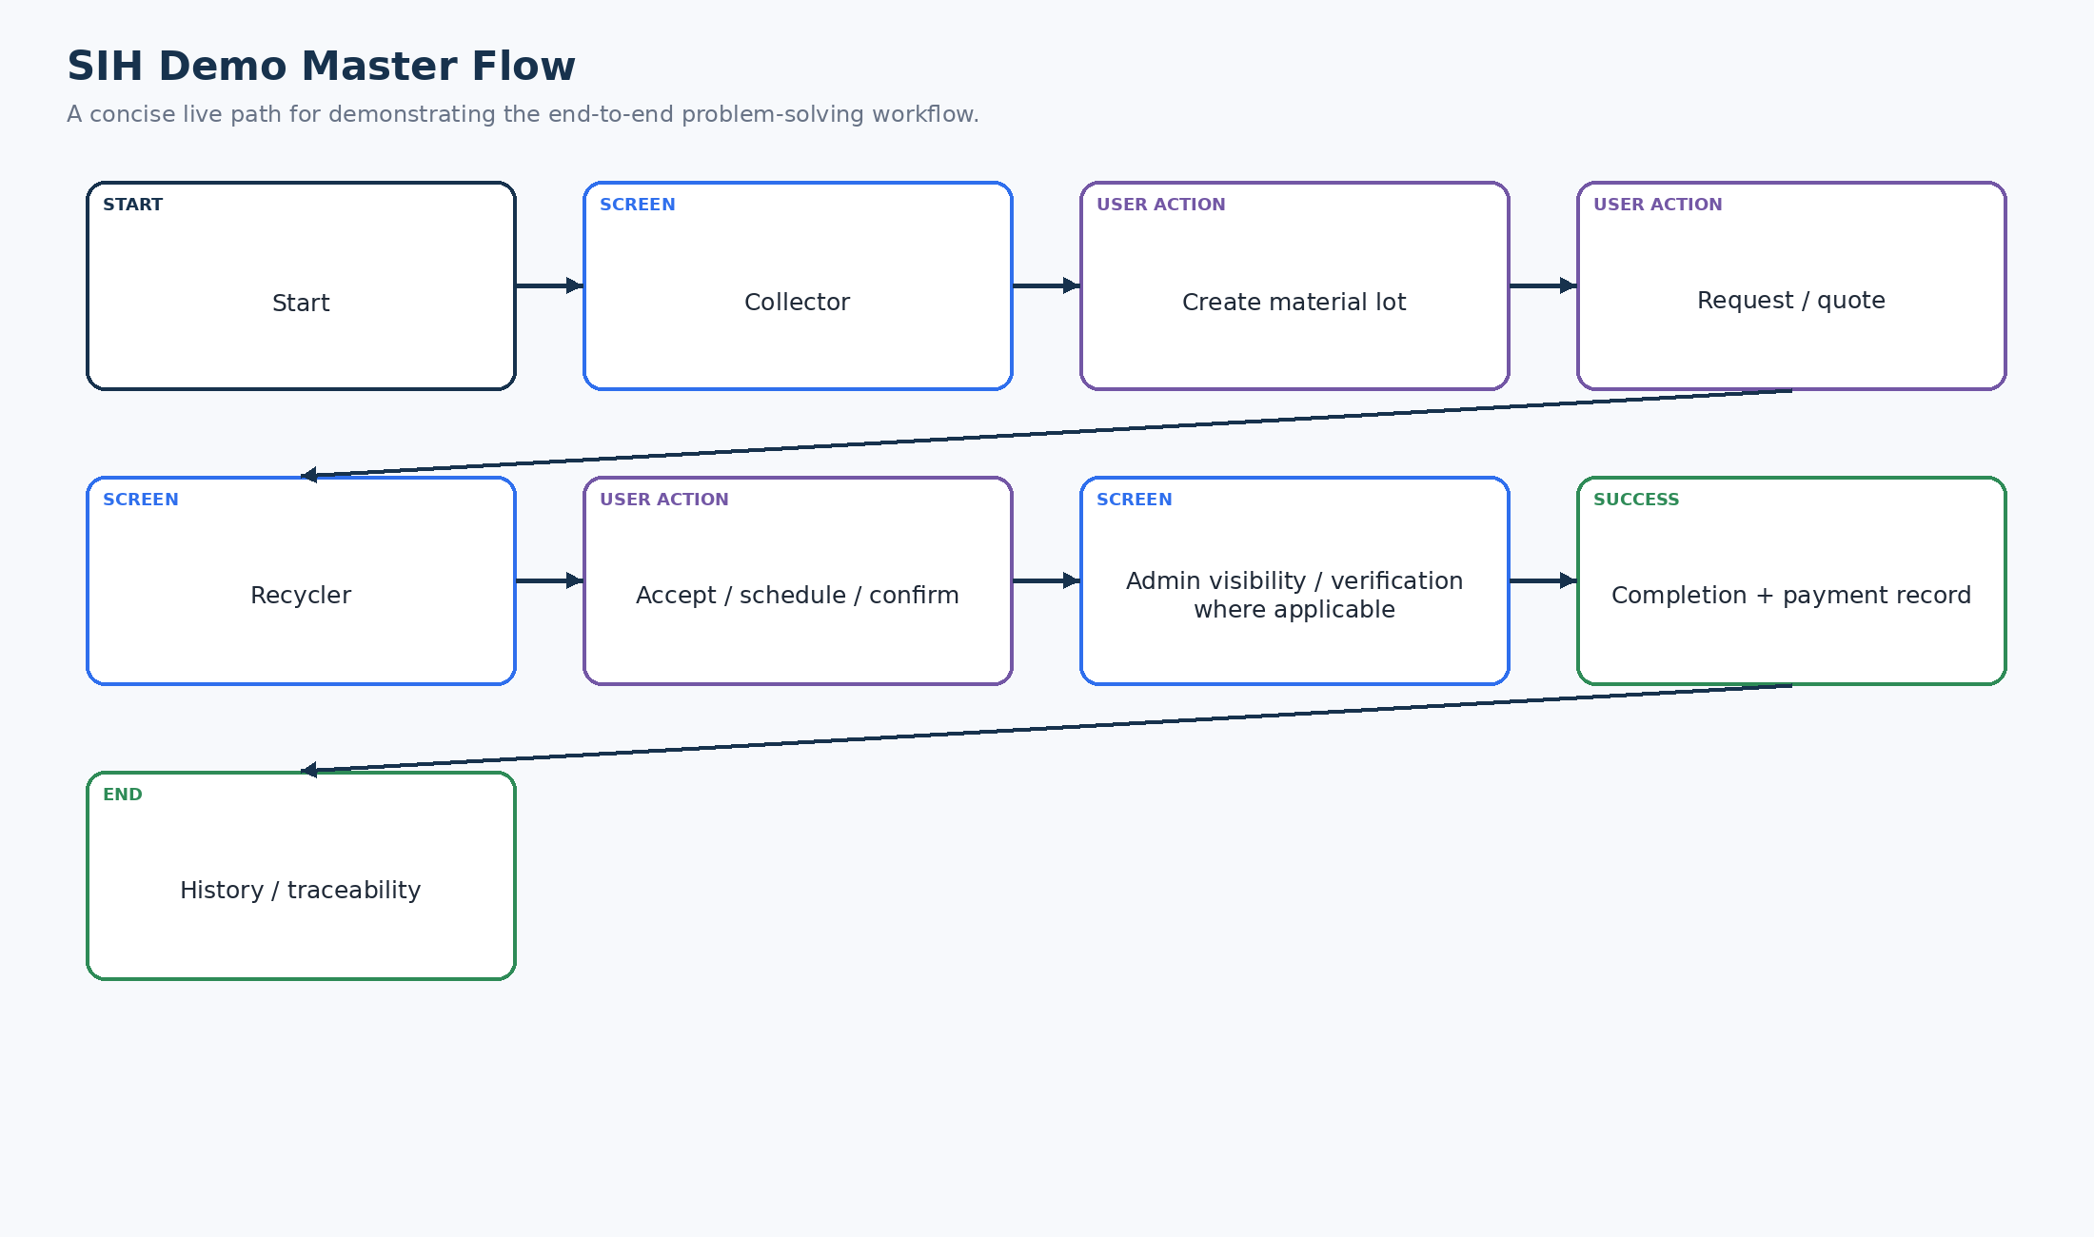
Figure 35. SIH Demo Master Flow
The concise live path demonstrates the actual problem-solving loop: Collector → core material/request workflow → Recycler action → Admin visibility where applicable → completion → history.

37. Complete Role Flow Map
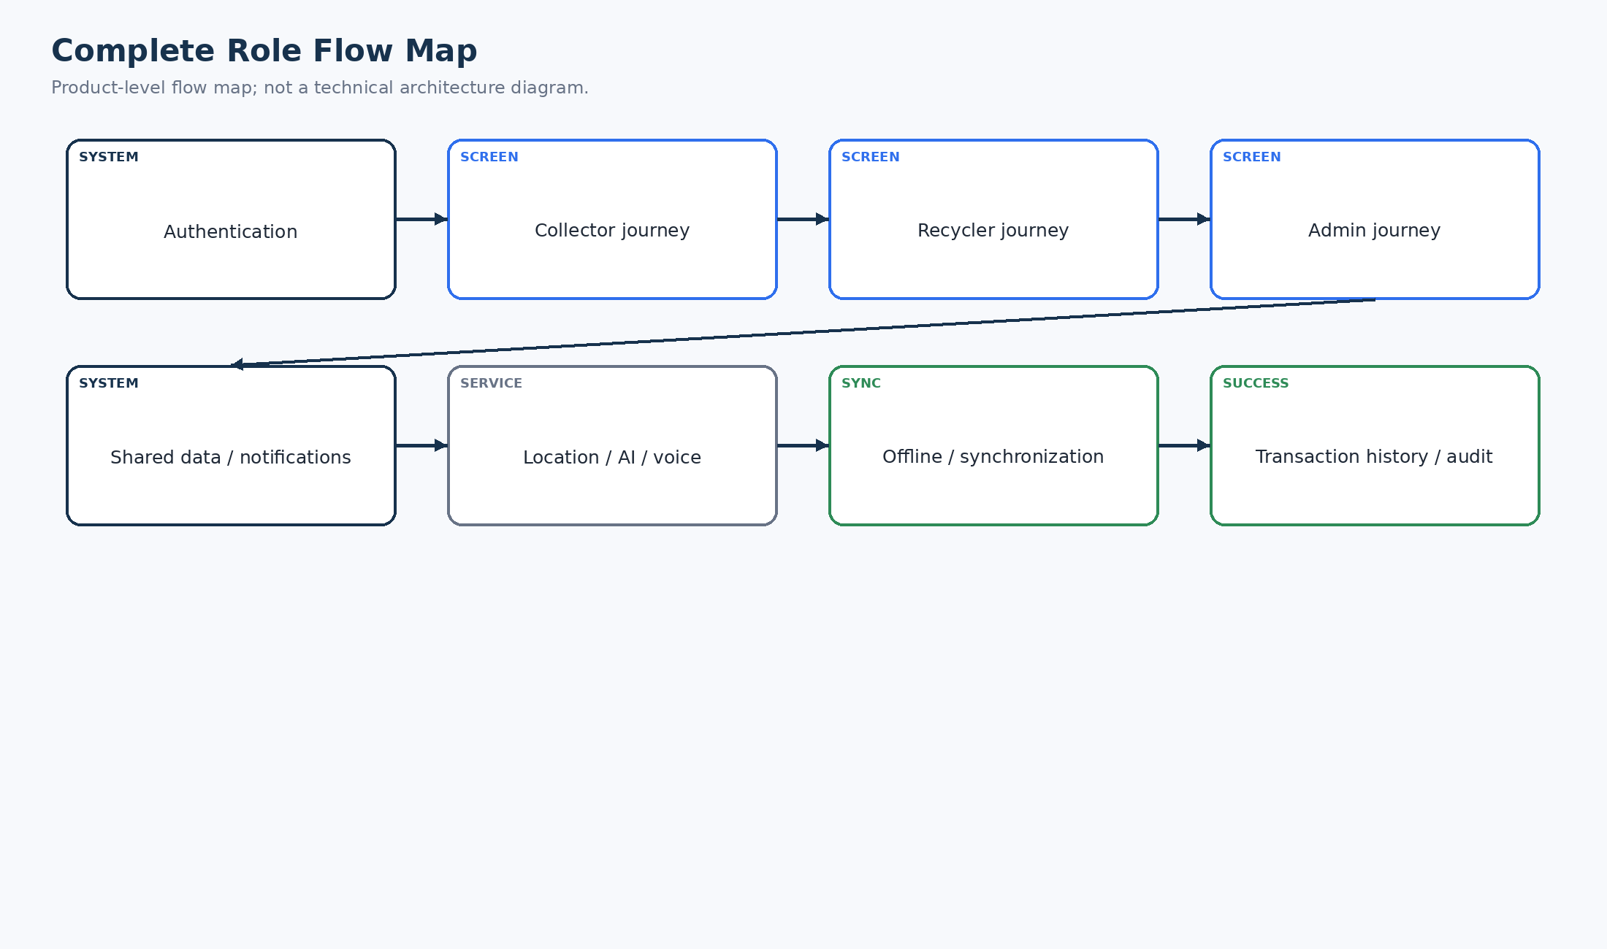
Figure 36. Complete Role Flow Map
Collector, Recycler and Admin journeys are connected by authentication, shared data, notifications, location, AI, voice, offline operation, synchronization and transaction history.

38. Screen-to-Flow Mapping
The approved material establishes functional screen families rather than a final implementation-specific screen ID catalogue. The matrix below therefore uses stable functional screen identifiers and marks implementation-specific naming as a mapping task.
Flow ID | Screen ID | Screen Name | Role | User Action | System Response | Next
FL-01 | AUTH-01 | Authentication / OTP | All | Sign in / verify | Session created or error | ROLE-01
FL-02 | ROLE-01 | Role Routing | All | Resolve role | Role area selected | DASH-01/02/03
FL-03 | COL-01 | Collector Dashboard | Collector | Choose core action | Relevant workflow opens | COL-02
FL-04 | COL-02 | Material Lot / Identification | Collector | Capture image / enter data | Lot draft / AI suggestion | COL-03
FL-05 | COL-03 | Recycler Discovery | Collector | Search/filter/select | Eligible recycler selected | COL-04
FL-06 | COL-04 | Request / Quote | Collector | Submit / accept | Transaction status advances | COL-05
FL-07 | REC-01 | Recycler Dashboard | Recycler | Review pending requests | Request details | REC-02
FL-08 | REC-02 | Request Detail / Response | Recycler | Quote/accept/reject | Collector-visible update | REC-03
FL-09 | ADM-01 | Admin Dashboard | Admin | Review verification/transactions | Administrative action | ADM-02
FL-10 | HIS-01 | History / Record Detail | All applicable | Open record | Timeline / related data | —

39. Flow-to-Requirement Traceability
SRS Requirement | Feature | Flow ID | Screen/Area | Expected Outcome | Test Case
BR-001..012 | Core transaction rules | FL-06/07/08/15 | COL-04 / REC-02 | Valid ownership/state transitions | QA transaction tests
AI-001..009 | Assistive material classification | FL-04/23 | COL-02 | Suggestion, confidence if available, manual override/fallback | AI failure tests
OFF-001..008 | Offline operation | FL-21 | COL-02/04 | Local save, pending queue, visible state | Offline tests
SYNC-001..007 | Synchronization | FL-22 | Sync status / relevant record | Idempotent server validation, retry/conflict handling | Sync tests
SEC-001..010 | Authentication, authorization, secure data | FL-05/26/27 | Protected screens | Server-authoritative access control | Security tests
NFR-P-001..005 | Performance/fallback behavior | FL-04/21/23 | Core screens | Responsive/offline/AI fallback behavior | Performance tests
BR-006 | Completion requires confirmations | FL-15/16 | Transaction status/history | Completion only after required confirmations | Workflow tests
BR-007 | Payment linked to valid transaction | FL-15/17 | History / payment record | Payment record tied to completed transaction | Data integrity tests

40. Flow Consistency Audit
Audit Area | Result | Action / Note
PRD alignment | Pass | Collector-first problem-solving journey retained.
SRS transaction lifecycle | Pass | State sequence and invalid-transition handling represented.
Architecture alignment | Pass | Flows expose user/system boundaries without turning into architecture diagrams.
UI/UX alignment | Pass with mapping task | Functional screen families are represented; exact final IDs should be synchronized with the implemented prototype.
Development alignment | Pass with implementation verification | Provider-specific details remain abstract where not established.
AI behavior | Pass | AI is advisory and failure-safe.
Offline/sync | Pass | Local queue, visible status, retry and conflict path included.
Role transitions | Pass | Collector, Recycler/Aggregator and Admin represented.
Dead ends | Controlled | Important failures have retry/fallback; unsupported capabilities are not claimed.
Unconfirmed support systems | Controlled | No unsupported government verification or external support system is asserted.

41. Flow Optimization
Workflow | User Actions | Decisions | Optimization
Collector lot → request | Capture/classify, confirm data, discover, select, submit | Input validity, eligibility | Keep draft creation local/offline where supported; avoid duplicate data entry.
Recycler request | Open, review, respond, schedule/update, confirm | Eligibility/state | Keep request detail as a single decision surface.
Core transaction | Request, response, schedule, confirmations | Valid state transitions | Expose status prominently; avoid hidden state changes.
AI classification | Capture, wait, confirm/correct | Usable image, AI result | Never block manual classification on AI.
Location | Permission/use GPS or manual selection | Permission, availability, accuracy | Show selected location explicitly.
Offline sync | Continue locally, reconnect, sync | Connectivity, server validation | Show queue/sync state and actionable errors.

42. Mobile / Desktop Considerations
- Mobile is the primary interaction context: touch targets, camera capture, voice, keyboard forms, maps and offline status must remain visible and usable.
- Back navigation should return to the previous logical workflow step without silently discarding unsaved local work.
- Dialogs should be reserved for decisions/errors; routine actions should remain in the main flow.
- Desktop/tablet can present denser request/history/admin information, but must preserve the same role permissions and state rules.
- Responsive layouts should not remove critical status information merely to fit a smaller viewport.

43. Accessibility Considerations
- Keyboard navigation and visible focus should be supported on desktop/tablet interfaces.
- Status must not depend on color alone; use text/icon/state labels.
- Voice assistance is an accessibility aid but not the only interaction method.
- Hindi/Marathi localization must remain understandable in forms, errors, empty states and confirmations.
- Failure messages should identify the problem and the next recoverable action.

44. Final Flow Summary
Flow Area | Coverage
Major visual flows | 35 diagram figures
Collector | Material lot → AI/manual classification → recycler discovery → request/quote → handover → payment record → history
Recycler | Pending requests → review → response → scheduling/status → confirmation → completion → history
Admin | Verification/user/transaction visibility → issue/audit handling
Authentication | Session entry, verification, expiry and controlled re-authentication
Core transaction | Cross-role request/response/state/handover/completion
AI | Assistive classification plus explicit failure/manual fallback
Voice | Permission/listening/recognition/action/TTS plus fallback
Location | Current location plus manual fallback and failure recovery
Offline | Local supported operations, pending queue, reconnect
Synchronization | Validation, idempotency, success/conflict/failure/retry
Verification | Admin-controlled review/status update without unsupported certification claims
SIH demo | Concise end-to-end evaluator path

45. Diagram Index
Figure | Diagram Name | Purpose | Role | Section | Status
Fig 1 | Master App Flow | Navigation / interaction / recovery | All | Applicable | Embedded visual
Fig 2 | First-Time User Flow | Navigation / interaction / recovery | All | Applicable | Embedded visual
Fig 3 | Returning User Flow | Navigation / interaction / recovery | All | Applicable | Embedded visual
Fig 4 | Authentication Flow | Navigation / interaction / recovery | All | Applicable | Embedded visual
Fig 5 | Role Resolution Flow | Navigation / interaction / recovery | All | Applicable | Embedded visual
Fig 6 | Collector Master Flow | Navigation / interaction / recovery | Collector | Applicable | Embedded visual
Fig 7 | Recycler Master Flow | Navigation / interaction / recovery | Recycler | Applicable | Embedded visual
Fig 8 | Admin Master Flow | Navigation / interaction / recovery | Admin | Applicable | Embedded visual
Fig 9 | Material Identification Flow | Navigation / interaction / recovery | Collector | Applicable | Embedded visual
Fig 10 | Recycler Discovery Flow | Navigation / interaction / recovery | Collector | Applicable | Embedded visual
Fig 11 | Location Flow | Navigation / interaction / recovery | Collector | Applicable | Embedded visual
Fig 12 | Request Creation Flow | Navigation / interaction / recovery | Collector | Applicable | Embedded visual
Fig 13 | Core Cross-Role Transaction Flow | Navigation / interaction / recovery | Cross-role | Applicable | Embedded visual
Fig 14 | Cross-Dashboard Data Interaction | Navigation / interaction / recovery | Cross-role | Applicable | Embedded visual
Fig 15 | Transaction Status Flow | Navigation / interaction / recovery | All | Applicable | Embedded visual
Fig 16 | History / Traceability Flow | Navigation / interaction / recovery | All | Applicable | Embedded visual
Fig 17 | Notification Flow | Navigation / interaction / recovery | All | Applicable | Embedded visual
Fig 18 | Voice Assistance Flow | Navigation / interaction / recovery | All | Applicable | Embedded visual
Fig 19 | Regional Language Flow | Navigation / interaction / recovery | All | Applicable | Embedded visual
Fig 20 | Offline Flow | Navigation / interaction / recovery | All | Applicable | Embedded visual
Fig 21 | Synchronization Flow | Navigation / interaction / recovery | All | Applicable | Embedded visual
Fig 22 | AI Failure / Recovery Flow | Navigation / interaction / recovery | Collector | Applicable | Embedded visual
Fig 23 | Location Failure Flow | Navigation / interaction / recovery | Collector | Applicable | Embedded visual
Fig 24 | Voice Failure Flow | Navigation / interaction / recovery | All | Applicable | Embedded visual
Fig 25 | Authorization Failure Flow | Navigation / interaction / recovery | All | Applicable | Embedded visual
Fig 26 | Session Expiry Flow | Navigation / interaction / recovery | All | Applicable | Embedded visual
Fig 27 | File / Document Upload Flow | Navigation / interaction / recovery | All | Applicable | Embedded visual
Fig 28 | Profile Flow | Navigation / interaction / recovery | All | Applicable | Embedded visual
Fig 29 | Settings Flow | Navigation / interaction / recovery | All | Applicable | Embedded visual
Fig 30 | Help / Support Flow | Navigation / interaction / recovery | All | Applicable | Embedded visual
Fig 31 | Error Recovery Master Flow | Navigation / interaction / recovery | All | Applicable | Embedded visual
Fig 32 | Empty-State Flow | Navigation / interaction / recovery | All | Applicable | Embedded visual
Fig 33 | SIH Evaluator Flow | Navigation / interaction / recovery | All | Applicable | Embedded visual
Fig 34 | SIH Demo Master Flow | Navigation / interaction / recovery | All | Applicable | Embedded visual
Fig 35 | Complete Role Flow Map | Navigation / interaction / recovery | All | Applicable | Embedded visual

46. References
- Official SIH Problem Statement: ID 26229, “Kabadiwala Connect – Bringing the Informal Collector into the Formal Recycling Chain.”
- Approved Kabadiwala Connect PRD.
- Approved Kabadiwala Connect SRS.
- Approved Kabadiwala Connect TRD.
- Approved Kabadiwala Connect System Architecture Document.
- Approved Kabadiwala Connect UI/UX Design Document.
- Approved Kabadiwala Connect Software Development / Implementation Document.
- App Flow specification supplied with this task.
Source note: the supplied specification requires actual visual diagrams, screen mapping, requirement traceability, consistency auditing and a final quality review. This document follows those requirements. fileciteturn11file0L17-L35

47. Appendix A — Final Quality Control
- ☐ Master app flow exists
- ☐ First-time user flow exists
- ☐ Returning user flow exists
- ☐ Authentication flow exists
- ☐ Role routing exists
- ☐ Collector flow exists
- ☐ Recycler flow exists
- ☐ Admin flow exists
- ☐ Core transaction flow exists
- ☐ Location flow exists
- ☐ AI flow exists
- ☐ Voice flow exists
- ☐ Language flow exists
- ☐ Offline flow exists
- ☐ Synchronization flow exists
- ☐ Verification path exists
- ☐ Error recovery exists
- ☐ Empty-state flow exists
- ☐ SIH evaluator flow exists
- ☐ SIH demo flow exists
- ☐ All major flows are visual images
- ☐ No ASCII diagrams remain
- ☐ No Mermaid source remains
- ☐ No intentional impossible transitions are shown
- ☐ Every major flow maps to functional screens
- ☐ Every major flow maps to requirements
- ☐ Every major role is represented
- ☐ Important failure paths are handled
- ☐ Mobile usability considered
- ☐ Accessibility considered
- ☐ Diagrams designed for PDF readability
- ☐ Terminology is consistent
- ☐ No unsupported government certification claim
- ☐ No unsupported external support-system claim

48. Appendix B — Critical Final Review
Review Question | Assessment
Can a first-time user understand where to go? | Yes: language → authentication → role → dashboard → guided core action.
Can each role complete its core task? | Yes at the functional-flow level; exact prototype screen IDs require final implementation synchronization.
Is there a dead end? | Major failures provide retry or fallback; unsupported functions are not presented as available.
Are errors recoverable? | Yes for network, auth, AI, GPS, voice, upload, authorization and synchronization.
Is offline behavior understandable? | Yes: local save → pending → reconnect → sync → success/conflict/failure.
Is synchronization visible? | Yes: offline/pending/sync/synced states are explicitly represented.
Is location understandable? | Yes: current location and manual location are separate, explicit paths.
Is AI failure handled? | Yes: retry plus manual classification; no false AI success.
Is voice failure handled? | Yes: retry plus text/touch fallback.
Can one role affect another correctly? | Yes: shared transaction/status flow connects Collector ↔ Recycler with Admin visibility.
Can the core workflow be demonstrated live? | Yes: the SIH Demo Master Flow is designed as a concise end-to-end scenario.
Does the flow match the deployed prototype? | Must be re-checked immediately before demo/release against the final code and screen IDs.

49. Appendix C — Implementation Synchronization Checklist
- Replace functional Screen IDs with the final implemented IDs once the prototype is frozen.
- Verify every button/route named in the diagrams exists in the deployed build.
- Verify role assignment and authentication behavior against the final auth implementation.
- Verify the transaction lifecycle exactly matches backend transition rules.
- Verify AI/manual fallback behavior against the deployed AI adapter.
- Verify offline queue and sync status against the deployed client storage implementation.
- Verify location permissions and manual location behavior on target Android devices.
- Verify Hindi/Marathi strings and voice language behavior in the final build.
- Run the SIH Demo Master Flow on the exact environment used for judging.
- Update this document if implementation changes materially.

