SMART INDIA HACKATHON
Kabadiwala Connect
BACKEND TECHNICAL DESIGN / BACKEND SCHEME
Implementation blueprint for backend modules, APIs, data, security and workflows
Field | Value
Project Name | Kabadiwala Connect
Product Name | Kabadiwala Connect
Document Name | Backend Technical Design / Backend Scheme
Version | 1.0
Date | 20 September 2026
Status | Working / review-ready
Prepared By | Kabadiwala Connect SIH Team
Reviewed By | Project review pending / team confirmation
Approved By | Not specified
SIH Problem Statement ID | 26229
Problem Statement Title | Kabadiwala Connect – Bringing the Informal Collector into the Formal Recycling Chain

Document Control
Version | Date | Change | Status
0.1 | 20 Sep 2026 | Initial backend blueprint and visual technical diagrams | Draft
1.0 | 20 Sep 2026 | Comprehensive implementation-oriented backend design | Working / review-ready

Table of Contents
- 1 Backend Objective
- 2 Backend Scope
- 3 Backend Architecture Overview
- 4 Backend Technology Stack
- 5 Backend Components
- 6 Backend Module Visual Map
- 7 Request/Response Lifecycle
- 8 API Design Principles
- 9 Complete API Inventory
- 10 Authentication Backend Design
- 11 User Account Model
- 12 RBAC / Authorization Design
- 13 Database Design
- 14 Database ERD
- 15 Database Access Control
- 16 Database Constraints
- 17 Database Indexing
- 18 Transaction Management
- 19 Business Logic Service
- 20 Request Management Backend
- 21 Transaction Backend
- 22 Recycler Discovery Backend
- 23 Location Backend
- 24 AI Backend Integration
- 25 AI Response Validation
- 26 Voice Backend Integration
- 27 Multilingual Backend Design
- 28 File/Image/Document Storage
- 29 Storage Access Control
- 30 Verification Backend
- 31 Notification Backend
- 32 Realtime Backend
- 33 Offline Sync Backend
- 34 Sync Operation Model
- 35 Idempotency
- 36 Conflict Resolution
- 37 API Error Design
- 38 API Rate Limiting
- 39 Caching
- 40 Background Jobs
- 41 Audit Logging
- 42 Security Architecture
- 43 Secret Management
- 44 Data Privacy
- 45 Logging & Monitoring
- 46 Database Migration
- 47 Backup & Recovery
- 48 Performance
- 49 Scalability
- 50 Failure Handling
- 51 Backend Testing
- 52 API Test Cases
- 53 Security Test Cases
- 54 Data Consistency Testing
- 55 Deployment
- 56 Development Environment
- 57 Production Environment
- 58 API Versioning
- 59 Backward Compatibility
- 60 Backend Source Structure
- 61 Service/Controller/Data Access Responsibility
- 62 Backend Configuration
- 63 Feature Flags
- 64 Technical Diagram Set
- 65 SIH Prototype Backend
- 66 Production Evolution
- 67 Backend Traceability
- 68 API-to-Database Matrix
- 69 Role-to-API Matrix
- 70 Data-Access Matrix
- 71 Risk Register
- 72 Open Decisions
- 73 Final Review
- 74 Final Backend Readiness
- 75 Final Summary

1. Backend Objective
The backend is the authoritative enforcement and persistence layer for Kabadiwala Connect. It receives authenticated requests, enforces role and ownership rules, validates data, executes domain transitions, persists transaction state, integrates with replaceable external services, records audit events and supports offline synchronization.
- Frontend owns presentation and user interaction; it does not own critical business rules.
- Relational persistence is the system of record; object storage is used for file/image content.
- External providers are behind replaceable integration boundaries where the approved material has not fixed a vendor.
- The backend preserves the collector-first workflow while enforcing Recycler and Administrator permissions.
The supplied specification explicitly requires the backend design to remain traceable to PRD/SRS/TRD/Architecture/UI/UX/App Flow and to mark undefined choices as TBD rather than inventing them. fileciteturn12file0L65-L84

2. Backend Scope
Scope | Essential backend capabilities | Status
SIH Screening Prototype | Authentication boundary, RBAC, users/profiles, material lots, requests/quotes, transaction state, verification workflow, storage metadata, notifications, audit, supported offline sync, AI adapter, location/discovery | Required
Pilot / Production | Hardened identity, managed deployment, production backup/recovery, observability, stronger rate limits, operational support, scale testing, provider SLAs | Production/Future
Future | Larger-scale search/matching, advanced analytics, higher-volume async processing, broader integrations where justified | Production/Future

3. Backend Architecture Overview
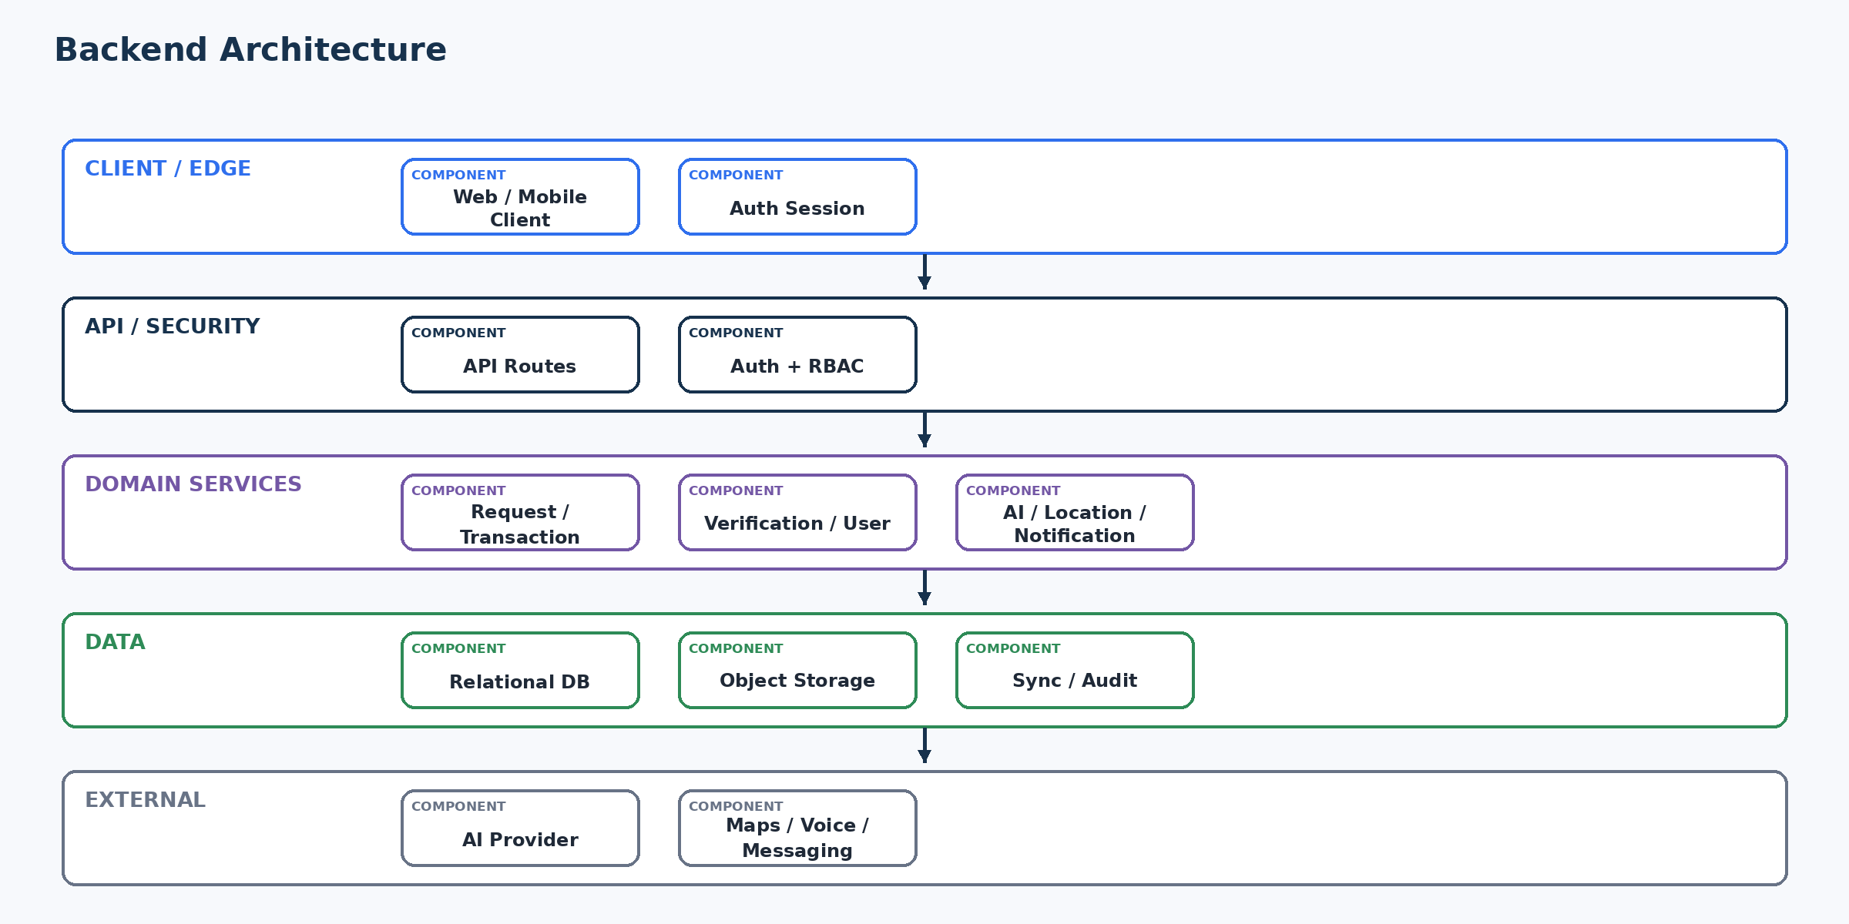
Figure 1. Backend Architecture
Layered modular-monolith backend with API/security, domain services, data access, database/storage and replaceable external integrations. This reflects the approved architecture direction rather than introducing unnecessary microservices.

4. Backend Technology Stack
Layer | Technology | Purpose | Version | Reason | Scope | Status
Backend runtime | TBD — Verify prototype codebase | Run backend application | TBD | Actual implementation not established in source material | Prototype/Production | TBD — Backend Decision Required
API framework | TBD — Verify prototype codebase | HTTP API and middleware | TBD | Must match actual implementation | Prototype/Production | TBD — Backend Decision Required
Database | Relational DB; engine TBD | System of record | TBD | Supports integrity/stateful transactions | Prototype/Production | Proposed
Authentication | Managed authentication boundary | Identity/session | TBD | Provider not established | Prototype/Production | TBD
Object storage | Separate object/file storage | Images/documents | TBD | Protect binary data from relational records | Prototype/Production | Proposed
AI | Replaceable AI adapter | Material classification suggestion | TBD | Provider/model not fixed | Prototype | TBD
Voice | Client/provider abstraction | Voice assistance | TBD | Backend only when required | Prototype | TBD
Maps/location | Provider abstraction | Location/discovery | TBD | Avoid provider lock-in | Prototype/Production | TBD
Realtime | Selective realtime mechanism | User-visible state changes | TBD | Only where justified | Prototype/Production | TBD
Notifications | Application notification service + delivery boundary | Event-to-user updates | TBD | Provider not fixed | Prototype/Production | TBD
Logging | Structured application logs | Diagnostics/audit support | TBD | Avoid sensitive data | Prototype/Production | Proposed
Monitoring | Error/performance monitoring | Operations | TBD | Production hardening | Production/Future | Proposed
Testing | Unit/integration/API/security tests | Quality assurance | TBD | Framework follows backend stack | Prototype/Production | Required

5. Backend Components
ID | Module | Purpose | Responsibilities | Inputs | Outputs | Dependencies | Entities | APIs | Auth | Failure
BE-01 | Authentication | Identity/session boundary | Validate identity; issue/verify session; logout/expiry | Auth request | Authenticated principal | Auth provider | users | Auth APIs | Public sign-in / protected APIs | Controlled error; rate limit
BE-02 | User/Profile | Application identity | Create/read/update profile; language/status | User context | Profile | DB | users, profiles, locations | User APIs | Owner/admin | Validation failure
BE-03 | Role/Permission | RBAC | Resolve role and permission/ownership | Principal/resource | Allow/deny | DB/policy | roles | Protected APIs | Server-side role check | 403/ownership denial
BE-04 | Collector | Collector workflow | Create material lots; submit requests; view owned records | Collector input | Lot/request | Request/Transaction | material_lots, requests | Collector APIs | Collector owner | Validation/state error
BE-05 | Recycler | Recycler workflow | View eligible requests; quote/respond; schedule; confirm | Recycler action | State update | Request/Transaction | requests, transactions | Recycler APIs | Eligible recycler | State/eligibility error
BE-06 | Admin | Administrative workflow | Review verification; monitor records; audit | Admin action | Admin result | Verification/Audit | verification_requests, audit_logs | Admin APIs | Admin only | Unauthorized/review error
BE-07 | Request/Transaction | Core domain | State machine, atomic updates, idempotency | Validated command | State change | DB | requests, transactions | Core APIs | Role/ownership | Conflict/invalid state
BE-08 | Verification | Recycler verification | Evidence metadata, review state, decision | Submission/review | Verification status | Storage/DB | verification_requests, verification_documents | Verification APIs | Recycler/admin | Invalid evidence/state
BE-09 | AI Adapter | Assistive classification | Validate input, call provider, validate response | Image/material | Suggestion | AI provider | ai_results | AI endpoint | Authenticated collector | Fallback/manual
BE-10 | Location | Location/discovery | Validate/store minimal location; query eligible recyclers | Coordinates/manual location | Results | DB/map boundary | locations, recyclers | Discovery APIs | Authenticated where needed | Manual fallback
BE-11 | Notification | Business event delivery | Create notification records and delivery tasks | Domain event | Notification | DB/delivery provider | notifications | Notification APIs | Recipient/admin | Retry/failure
BE-12 | Storage | Binary content | Validate, store, authorize retrieval | File | Object + metadata | Object store | verification_documents, media metadata | Upload APIs | Owner/admin by policy | Reject/retry
BE-13 | Sync | Offline operations | Accept operation ID; validate; apply once; report conflict | Sync payload | Sync result | DB | sync_operations + target entity | Sync APIs | Authenticated owner | Conflict/retry
BE-14 | Audit | Traceability | Record sensitive state changes/security events | Event | Audit record | DB/logging | audit_logs | Internal/admin | Restricted

6. Backend Module Visual Map
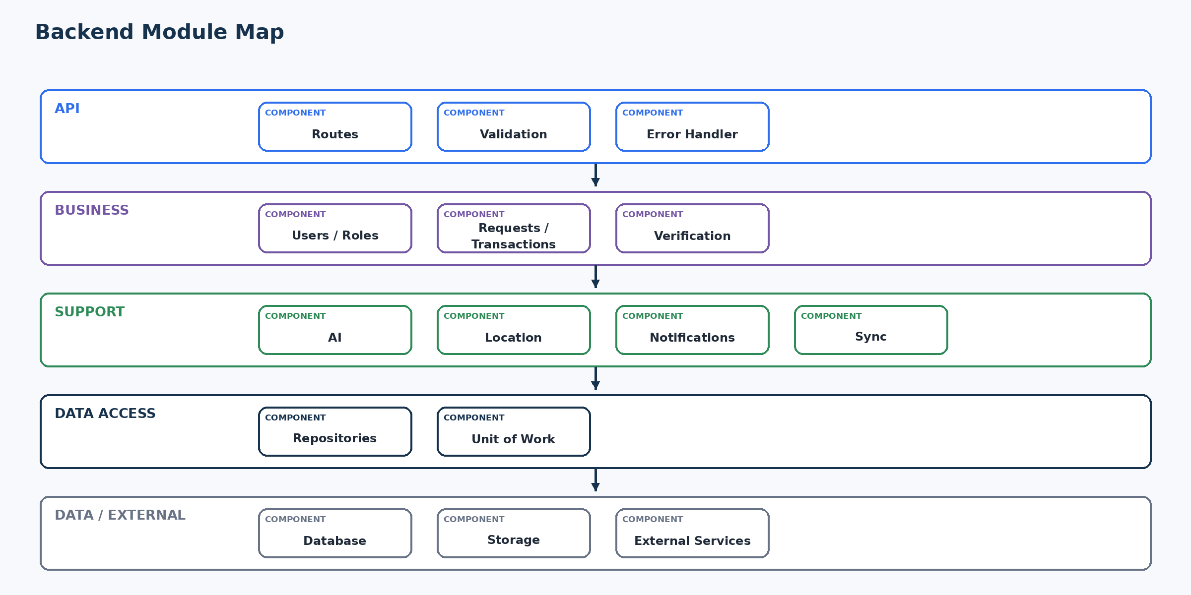
Figure 2. Backend Module Map
The module map keeps API handlers thin and concentrates domain rules in services/repositories, with external integrations isolated behind adapters.

7. Request/Response Lifecycle
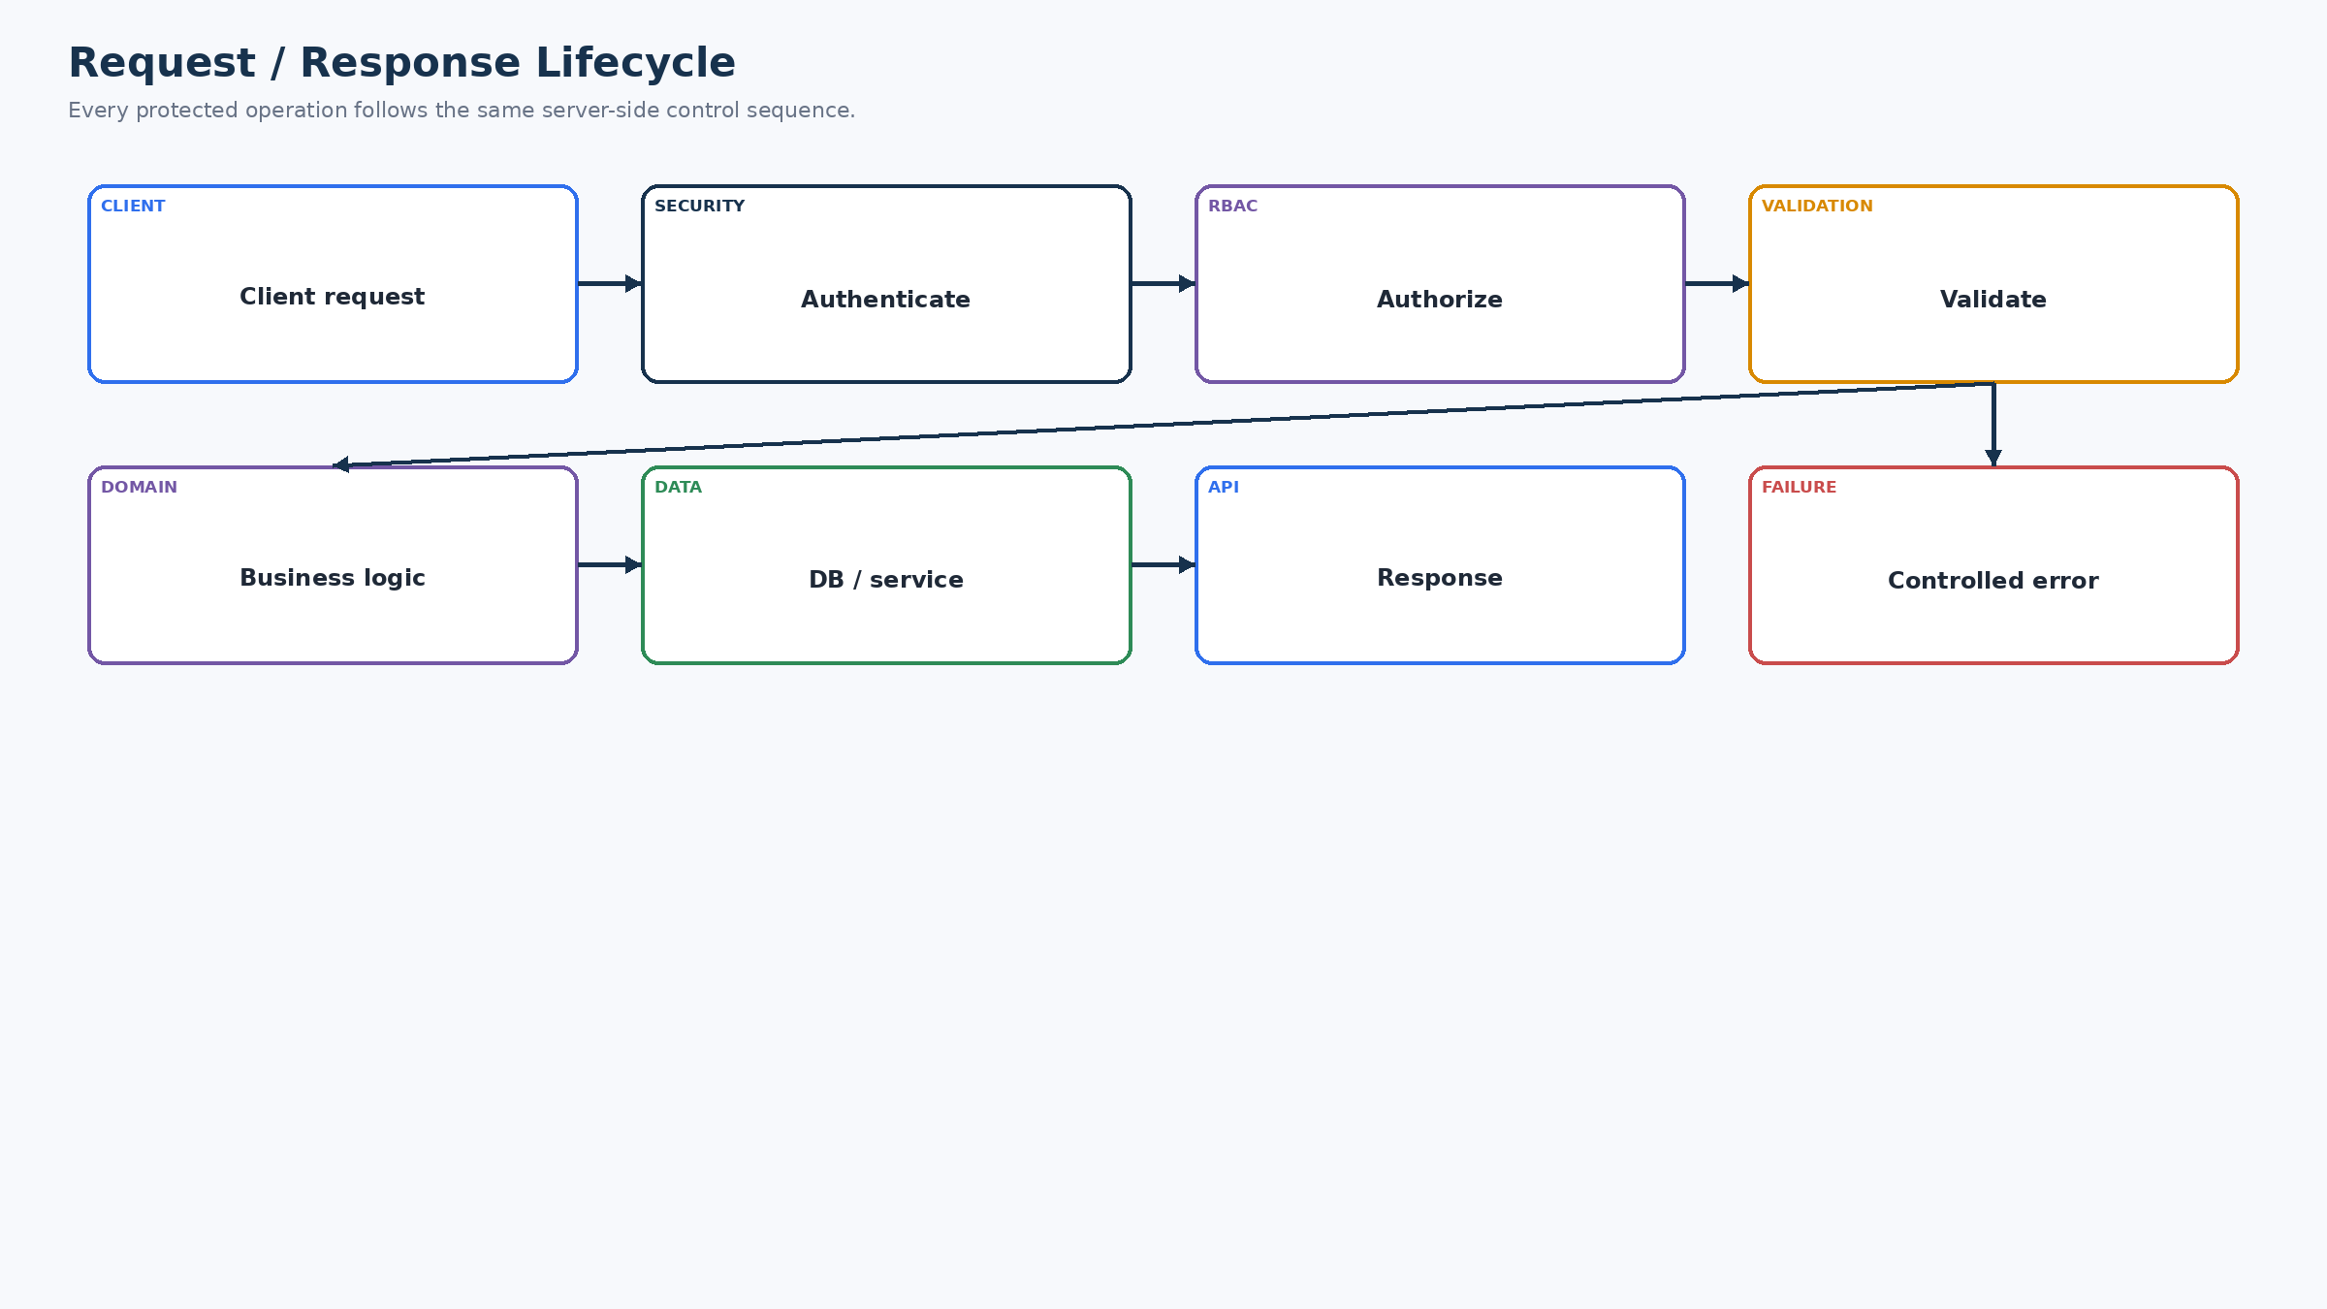
Figure 3. Request / Response Lifecycle
Every protected API should authenticate, authorize, validate, execute domain logic, persist or call an external service, then return a controlled response. Errors follow the same pipeline with safe logging.
Stage | Purpose | Validation | Failure | Security
Authentication | Identify caller | Session/token | 401 | Never bypass
Authorization | Check role/ownership | Policy + resource | 403 | Server-side
Validation | Protect data/domain | Schema + business input | 400/422 | Reject malformed input
Business logic | Apply domain rules | State/ownership | 409/422 | Rules not frontend-only
Persistence/external | Commit or call service | Constraints/timeouts | 5xx/502 | Secrets server-side
Response | Return stable contract | Output shape | Controlled error | No sensitive leakage

8. API Design Principles
Area | Backend rule
Style | REST-like HTTP APIs for resource workflows; exact framework TBD.
Naming | Stable plural resources and action endpoints only when resource semantics do not fit a simple CRUD operation.
Methods | GET for reads; POST for create/commands; PATCH for permitted updates; DELETE only where actual product rules support deletion.
Response | Stable JSON envelope with data/result and machine-readable error fields.
Errors | Standard error code, message suitable for client display, retryability and correlation/request identifier where available.
Pagination | Cursor/page pagination for potentially growing histories/requests; exact strategy TBD after prototype query review.
Filtering/sorting | Only supported fields; server validates allowed values.
Idempotency | Client-generated operation IDs for offline/retry-sensitive commands; unique server constraint.
Versioning | Prototype may use one stable API surface; introduce explicit versioning when compatibility needs justify it.
Timeout/retry | Bound external calls; retry only safe/idempotent operations.
Rate limiting | Sensitive/high-cost operations rate-limited; exact thresholds TBD.

9. Complete API Inventory
ID | Method | Endpoint | Purpose | Actor | Auth | Authorization | Request | Validation | Business Logic | DB | External | Response | Errors | Idempotency | Status
API-001 | POST | /auth/verify or provider callback | Complete authentication | User | Auth boundary | Auth provider | Credential/OTP | Validate identity | Create/resolve user | users | Auth provider | Session | 401/429 | Idempotency where applicable | TBD
API-002 | GET | /me | Get current profile | All | Yes | Own profile | Session | Resolve user | Read profile | users/profiles | — | Profile | 401/404 | No | Required
API-003 | PATCH | /me | Update own profile/preferences | All | Yes | Owner | Session | Validate fields | Update profile | profiles/locations | — | Profile | 400/403 | Operation ID if sync | Required
API-004 | POST | /material-lots | Create material lot | Collector | Yes | Collector | Lot payload/image metadata | Validate weight/material | Create draft | material_lots | Storage/AI optional | Lot | 400/409 | Yes | Required
API-005 | POST | /material-lots/{id}/classify | AI-assisted classification | Collector | Yes | Lot owner | Image reference | Validate file/lot | Call AI adapter | ai_results | AI provider | Suggestion | 502/504 | Safe retry | Required
API-006 | GET | /recyclers | Discover eligible recyclers | Collector | Yes | Discovery | Location/filter | Validate filters | Query eligible recyclers | recyclers/locations | Map boundary optional | Results | 400/503 | Read-only | Required
API-007 | POST | /requests | Create request/quote request | Collector | Yes | Lot owner | Lot/recycler/details | Validate ownership/eligibility | Create submitted request | requests | — | Request | 400/409 | Yes | Required
API-008 | GET | /requests | List relevant requests | Collector/Recycler/Admin | Yes | Role + scope | Filters/pagination | Validate filters | Scoped query | requests | — | List | 403 | No | Required
API-009 | POST | /requests/{id}/quote | Recycler quote/response | Recycler | Yes | Eligible participant | Quote data | State/ownership | Update request | requests | Notification | Status | 409 | Yes | Required
API-010 | POST | /requests/{id}/accept | Collector accepts quote | Collector | Yes | Lot/request owner | Acceptance | State/owner | Advance state | requests | Notification | Status | 409 | Yes | Required
API-011 | POST | /transactions/{id}/schedule | Schedule handover | Authorized participant | Yes | Participant/state | Schedule details | State validation | Update transaction | transactions | Notification | Status | 409 | Yes | Required
API-012 | POST | /transactions/{id}/confirm | Record role confirmation | Collector/Recycler | Yes | Participant | Confirmation | State/participant | Advance state | transactions | Notification/audit | Status | 409 | Yes | Required
API-013 | POST | /transactions/{id}/payment | Record payment | Authorized participant/admin | Yes | Valid completed transaction | Payment record | Transaction state | Create payment record | transactions/payment fields | — | Payment | 409 | Yes | Required
API-014 | GET | /history | List history | Authenticated | Yes | Scoped | Filters | Scope | Query history | transactions/requests | — | History | 403 | No | Required
API-015 | POST | /verification-requests | Submit recycler verification | Recycler | Yes | Applicant | Metadata/doc refs | File/status validation | Create pending verification | verification_requests | Storage | Pending | 400/409 | Yes | Required
API-016 | POST | /verification-requests/{id}/decision | Approve/reject verification | Admin | Yes | Admin only | Decision | State/evidence | Update status | verification_requests | Notification/audit | Status | 403/409 | Yes | Required
API-017 | POST | /files | Create/upload file metadata | Authenticated | Yes | Policy | File metadata/object | Type/size/access | Store object metadata | file metadata | Object storage | Reference | 400/413/503 | Idempotent upload token | Required
API-018 | POST | /sync/operations | Apply offline operation | Authenticated | Yes | Operation owner | Operation payload | Schema/role/idempotency | Apply target change | sync_operations + target | — | Sync result | 409/422 | Required | Required
API-019 | GET | /notifications | List notifications | Authenticated | Yes | Recipient scope | Pagination | Scope | Read notifications | notifications | — | List | 403 | No | Required
API-020 | POST | /notifications/{id}/read | Mark notification read | Recipient | Yes | Recipient | — | Ownership | Update read state | notifications | — | Read state | 403/404 | Idempotent | Required
API-021 | GET | /audit | Admin audit query | Admin | Yes | Admin | Filters | Admin scope | Query audit | audit_logs | — | Audit list | 403 | No | Required

10. Authentication Backend Design
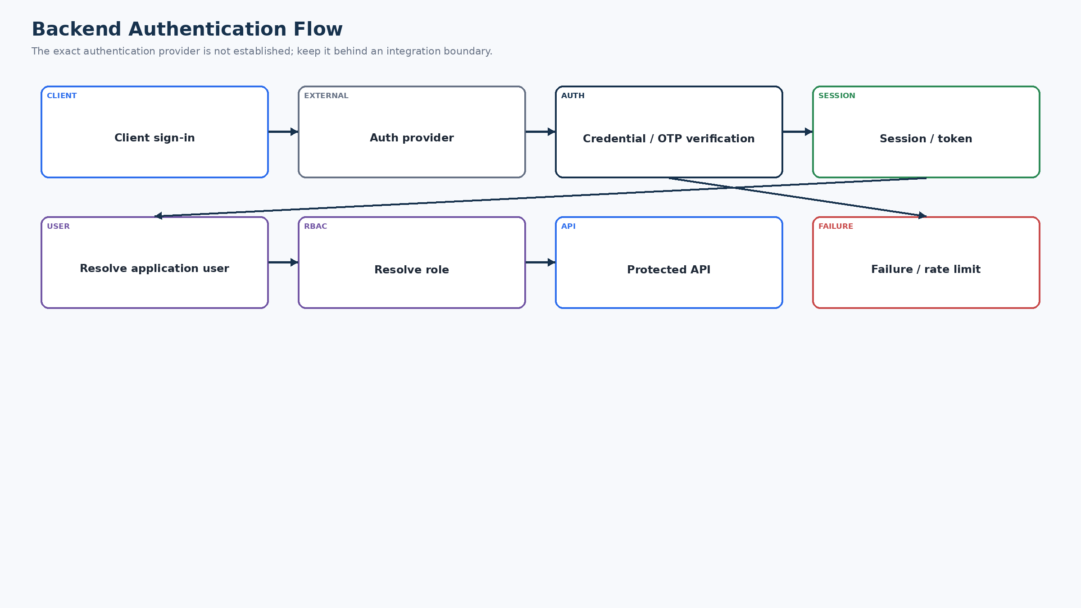
Figure 4. Backend Authentication Flow
The approved material does not establish a specific authentication vendor. Therefore the design separates external identity verification from the application user/profile and role model.
- Authentication identity and application profile are separate concerns.
- Token/session validation must happen before protected service execution.
- Logout/session expiry invalidate or stop accepting the relevant session according to the selected provider.
- OTP attempts, resend and login attempts are rate-limited; exact limits are TBD — Benchmark/Threat Model Required.
- Account recovery behavior is provider-dependent and must not be invented until the identity provider is selected.

11. User Account Model
Entity | Purpose | Key fields | Relationship | Access
users | Application identity linked to authentication identity | id, auth_reference, status, created_at | 1:1 profile; 1:N owned records | Own/admin scoped
profiles | Human-facing application details | user_id, display_name, language, location_ref | FK users | Owner/admin policy
roles | Role definitions | id, name | User-role relation | Server-controlled
recyclers | Recycler-specific attributes/status | user_id, status, verification_status | FK users | Recycler/admin
collectors | Collector-specific attributes if needed | user_id | FK users | Collector/admin
locations | Minimal reusable location record | id, lat/lng or manual representation | Referenced by profile/discovery | Policy-scoped

12. RBAC / Authorization Design
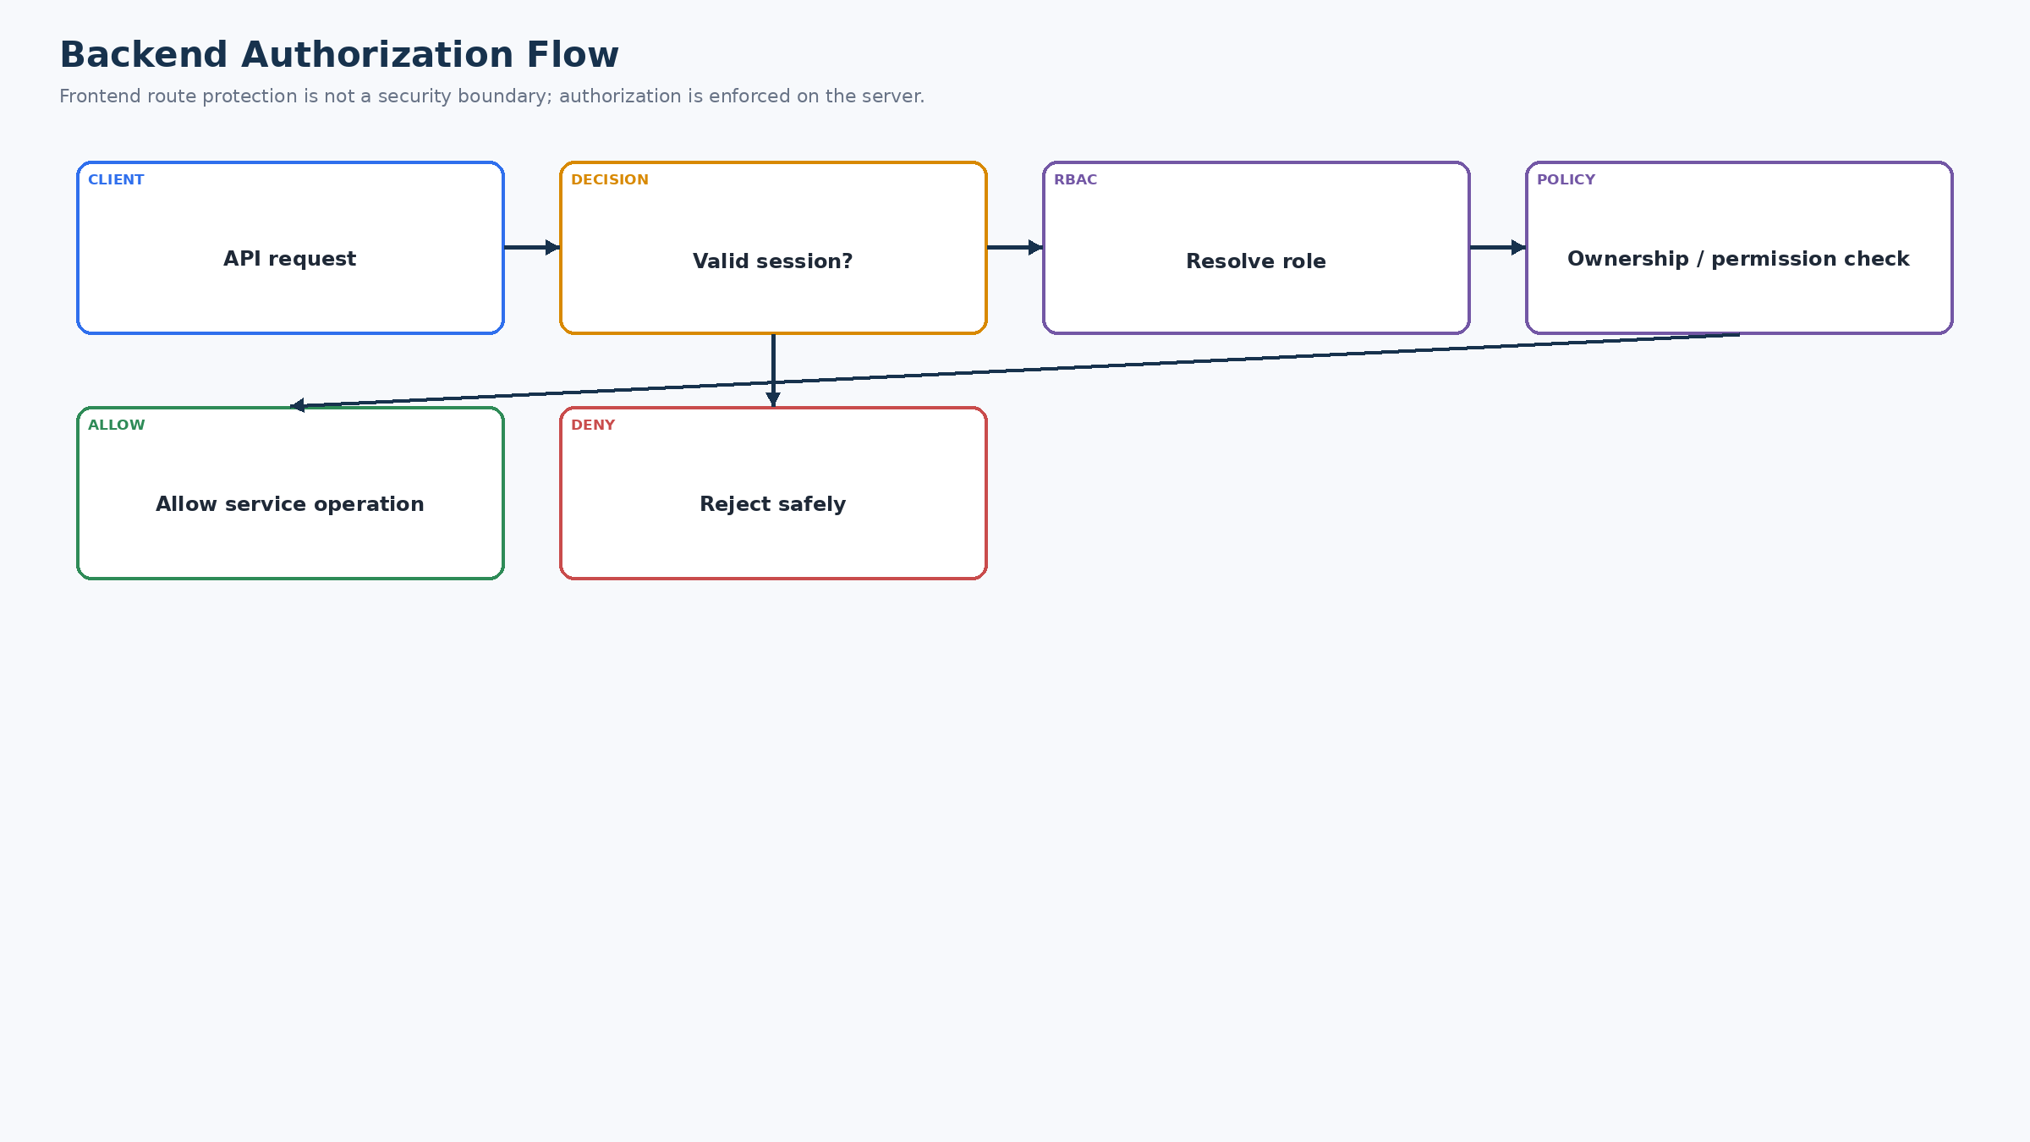
Figure 5. Backend Authorization Flow
Authorization is layered: authenticated principal → role → ownership/eligibility → permission → service execution.
Capability | Collector | Recycler | Admin
Read own profile/history | Read | Read | Manage where permitted
Create material lot | Create | — | Manage/support where required
Create request | Create own | — | —
Respond/quote | — | Create/update eligible requests | —
Accept quote | Own request | — | —
Schedule/update transaction | Participate | Participate | Monitor/support where defined
Confirm handover | Participate | Participate | —
Payment record | Participate/record where allowed | Participate/record where allowed | Manage/monitor where defined
Verification submit | — | Create own | —
Verification approve/reject | — | — | Approve/reject
Audit read | — | — | Admin
User management | — | — | Admin

Exact CRUD granularity must be implemented in service policies and database access controls; frontend visibility is not considered authorization.

13. Database Design
Entity | Purpose | Primary Key | Important Fields | Foreign Keys | Ownership | Access Rules
users | Application user | id | auth_ref,status,language,created_at | — | User | Self/admin
profiles | Profile/preferences | user_id | name,language,location_ref | users,locations | User | Owner/admin
roles | Role definition | id | name | — | System | Server controlled
collectors | Collector attributes | user_id | collector-specific fields | users | Collector | Owner/admin
recyclers | Recycler attributes | user_id | status,verification_status | users | Recycler | Owner/admin/discovery
verification_requests | Verification workflow | id | recycler_id,status,submitted_at,decision | recyclers | Applicant | Applicant/admin
verification_documents | Document metadata | id | verification_id,object_ref,type,status | verification_requests | Applicant | Restricted
material_lots | Collector material lot | id | collector_id,material,weight,status,ai_result_ref | collectors | Collector | Owner/authorized
requests | Collector↔Recycler request | id | lot_id,collector_id,recycler_id,status,quote | lots/users/recycler | Participants | Participant/admin
transactions | Handover/completion | id | request_id,state,timestamps,payment | requests/users | Participants | Participants/admin
locations | Minimal location | id | lat,lng/manual_text,source | users optional | User/policy | Need-to-use
notifications | Recipient messages | id | recipient_id,type,status,read_at | users | Recipient | Recipient/admin policy
ai_results | AI suggestion metadata | id | lot_id,classification,confidence,model_ref,status | material_lots | Collector workflow | Owner/admin policy
audit_logs | Sensitive action history | id | actor_id,event,target,timestamp | users | System | Admin/restricted
sync_operations | Offline operation record | operation_id | user_id,entity,action,status,retry_count | users | Operation owner | Owner/service

14. Database Entity Relationship Diagram
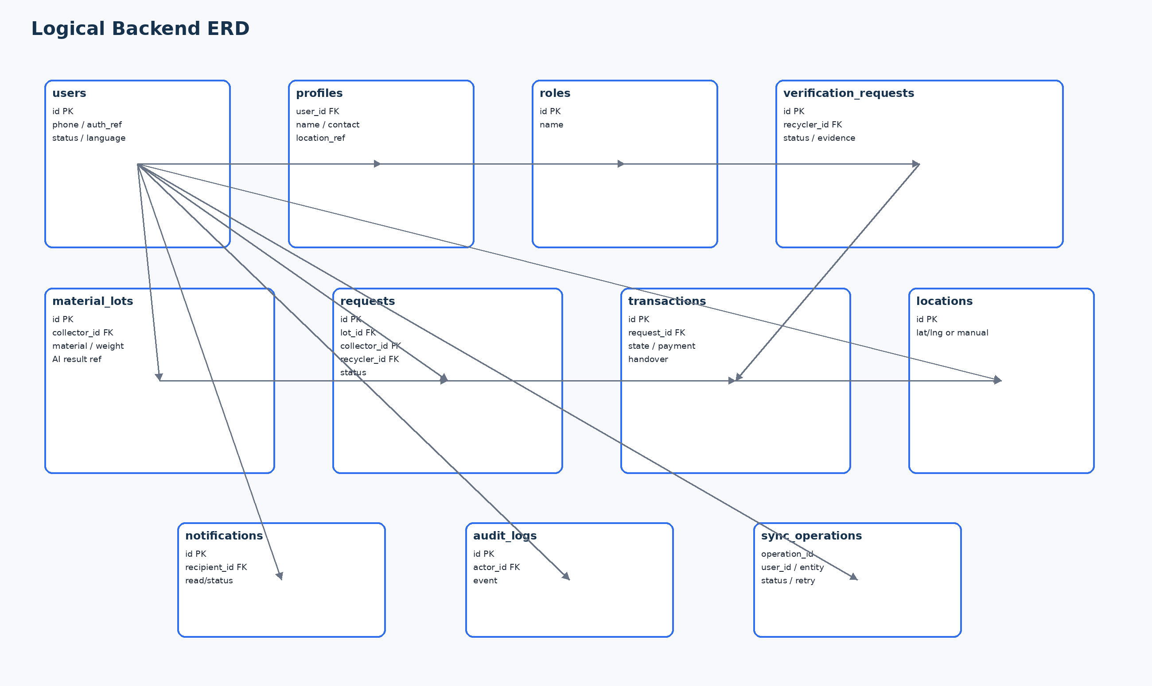
Figure 6. Logical Backend ERD
The ERD is logical rather than vendor-specific. Exact column types and normalization should be finalized when the database engine and prototype schema are confirmed.

15. Database Access Control
- Ownership is checked in the backend service layer and, where the selected database supports it, reinforced with row-level policies.
- Admin access is explicit and should not be inferred from client route visibility.
- Sensitive verification documents and file objects require authorization before retrieval; no unrestricted public access is assumed.
- If PostgreSQL/Supabase is selected, RLS/policies should be implemented and tested; current source material does not verify an existing RLS policy set, so this document does not claim one exists.

16. Database Constraints
Constraint | Backend rule
Required fields | Reject incomplete commands before persistence.
Foreign keys | Prevent orphan requests, transactions, verification records and notifications.
Unique operation ID | Prevent duplicate offline/retry application.
Ownership | Request/transaction updates must match authorized participant or admin policy.
State constraints | Only valid lifecycle transitions are accepted.
Duplicate request prevention | Use command idempotency and relevant business uniqueness where applicable.
Nullability | Optional fields are explicit; required transaction fields cannot be silently null.
Audit integrity | Sensitive state changes produce attributable audit events.

17. Database Indexing
Index candidate | Purpose | Query
users.auth_reference | Resolve application user | Authentication callback/session resolution
requests.collector_id + status | Collector active requests | Dashboard/history
requests.recycler_id + status | Recycler pending work | Recycler dashboard
transactions.request_id | Resolve transaction | Transaction detail
transactions.created_at | History ordering | History
verification_requests.status | Admin pending queue | Verification
locations location fields | Discovery | Nearby/filtered recycler search
sync_operations.operation_id | Idempotency | Sync apply
notifications.recipient_id + read/status | Notification center | Unread/notification list

Composite and geospatial indexes remain implementation-dependent; create them only after confirming the actual query pattern and database engine.

18. Transaction Management
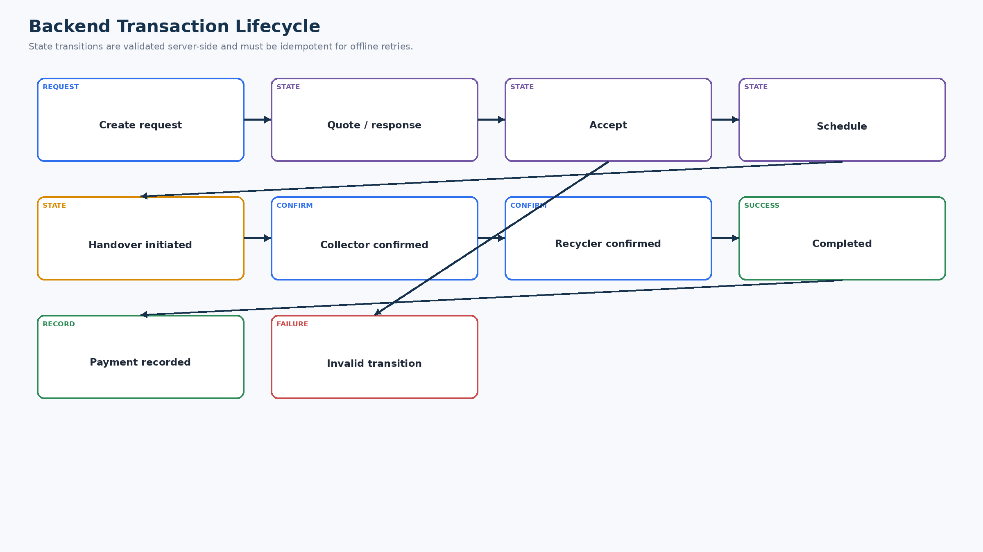
Figure 7. Backend Transaction Lifecycle
Core state changes should be atomic where multiple records must remain consistent. Invalid transitions are rejected, and offline retries reuse an operation identifier.

19. Business Logic Service
Rule ID | Condition | Action | Service | Entities | Failure
BR-SVC-01 | Collector owns material lot | Create/update only when actor owns lot | Collector/Request | material_lots | 403/409
BR-SVC-02 | Recycler must be eligible | Recycler can respond only when eligible | Recycler/Verification | recyclers,verification_requests | 403/409
BR-SVC-03 | Only request owner accepts quote | Actor matches collector owner | Request | requests | 403
BR-SVC-04 | Completion requires required confirmations | Required participant confirmations exist | Transaction | transactions | 409
BR-SVC-05 | Payment links to valid transaction | Transaction state permits payment record | Transaction | transactions | 409
BR-SVC-06 | AI is advisory | User can correct AI suggestion | AI/Lot | ai_results,material_lots | Never block manual
BR-SVC-07 | Offline operation idempotent | Operation ID has not already been applied | Sync | sync_operations | Return prior result / conflict
BR-SVC-08 | Verification restricted | Only admin can approve/reject | Verification | verification_requests | 403

20. Request Management Backend
Operation | Actor | Authorization | Validation | DB changes | Notification | Audit | Failure
Create | Collector | Own lot | Lot exists, eligible recycler, required data | Create request | Recycler notification | Request created | 400/403/409
Read | Participant/Admin | Scoped | Filter/pagination | Read only | — | Optional access event | 403
Update | Owner/eligible participant | State-dependent | Allowed fields/state | Patch request | Relevant recipient | State change | 409
Accept | Collector | Own request | Quote/state valid | Advance state | Recycler | Acceptance | 409
Reject | Recycler/allowed actor | Eligible request | State valid | Advance/reject state | Collector | Rejection | 409
Schedule | Authorized participant | Valid state | Schedule fields | Transaction/request update | Other participant | Schedule | 409
Complete | Participants | Required confirmations | Valid state | Complete transaction | Participants | Completion | 409

21. Transaction Backend
- Transaction records represent the handover/completion lifecycle tied to a valid request.
- Participants, state and timestamps are persisted so history can explain what happened.
- A transaction cannot be created or altered by an actor who fails authentication, role, ownership or state validation.
- Payment information is recorded only against a valid transaction; the reference estimate does not overwrite the final negotiated value.

22. Recycler Discovery Backend
Input | Processing | Output | Fallback
Location + filters | Validate filters; query eligible/appropriate recycler records | Scoped recycler results | Manual location / revise filters
Verification/status | Exclude pending/rejected recyclers from verified discovery claims | Eligibility/status information | No result
Material/category where supported | Apply supported matching fields | Relevant recyclers | Broaden/revise supported filter
Network/provider issue | Controlled service error | Explicit failure | Manual continuation where possible

23. Location Backend
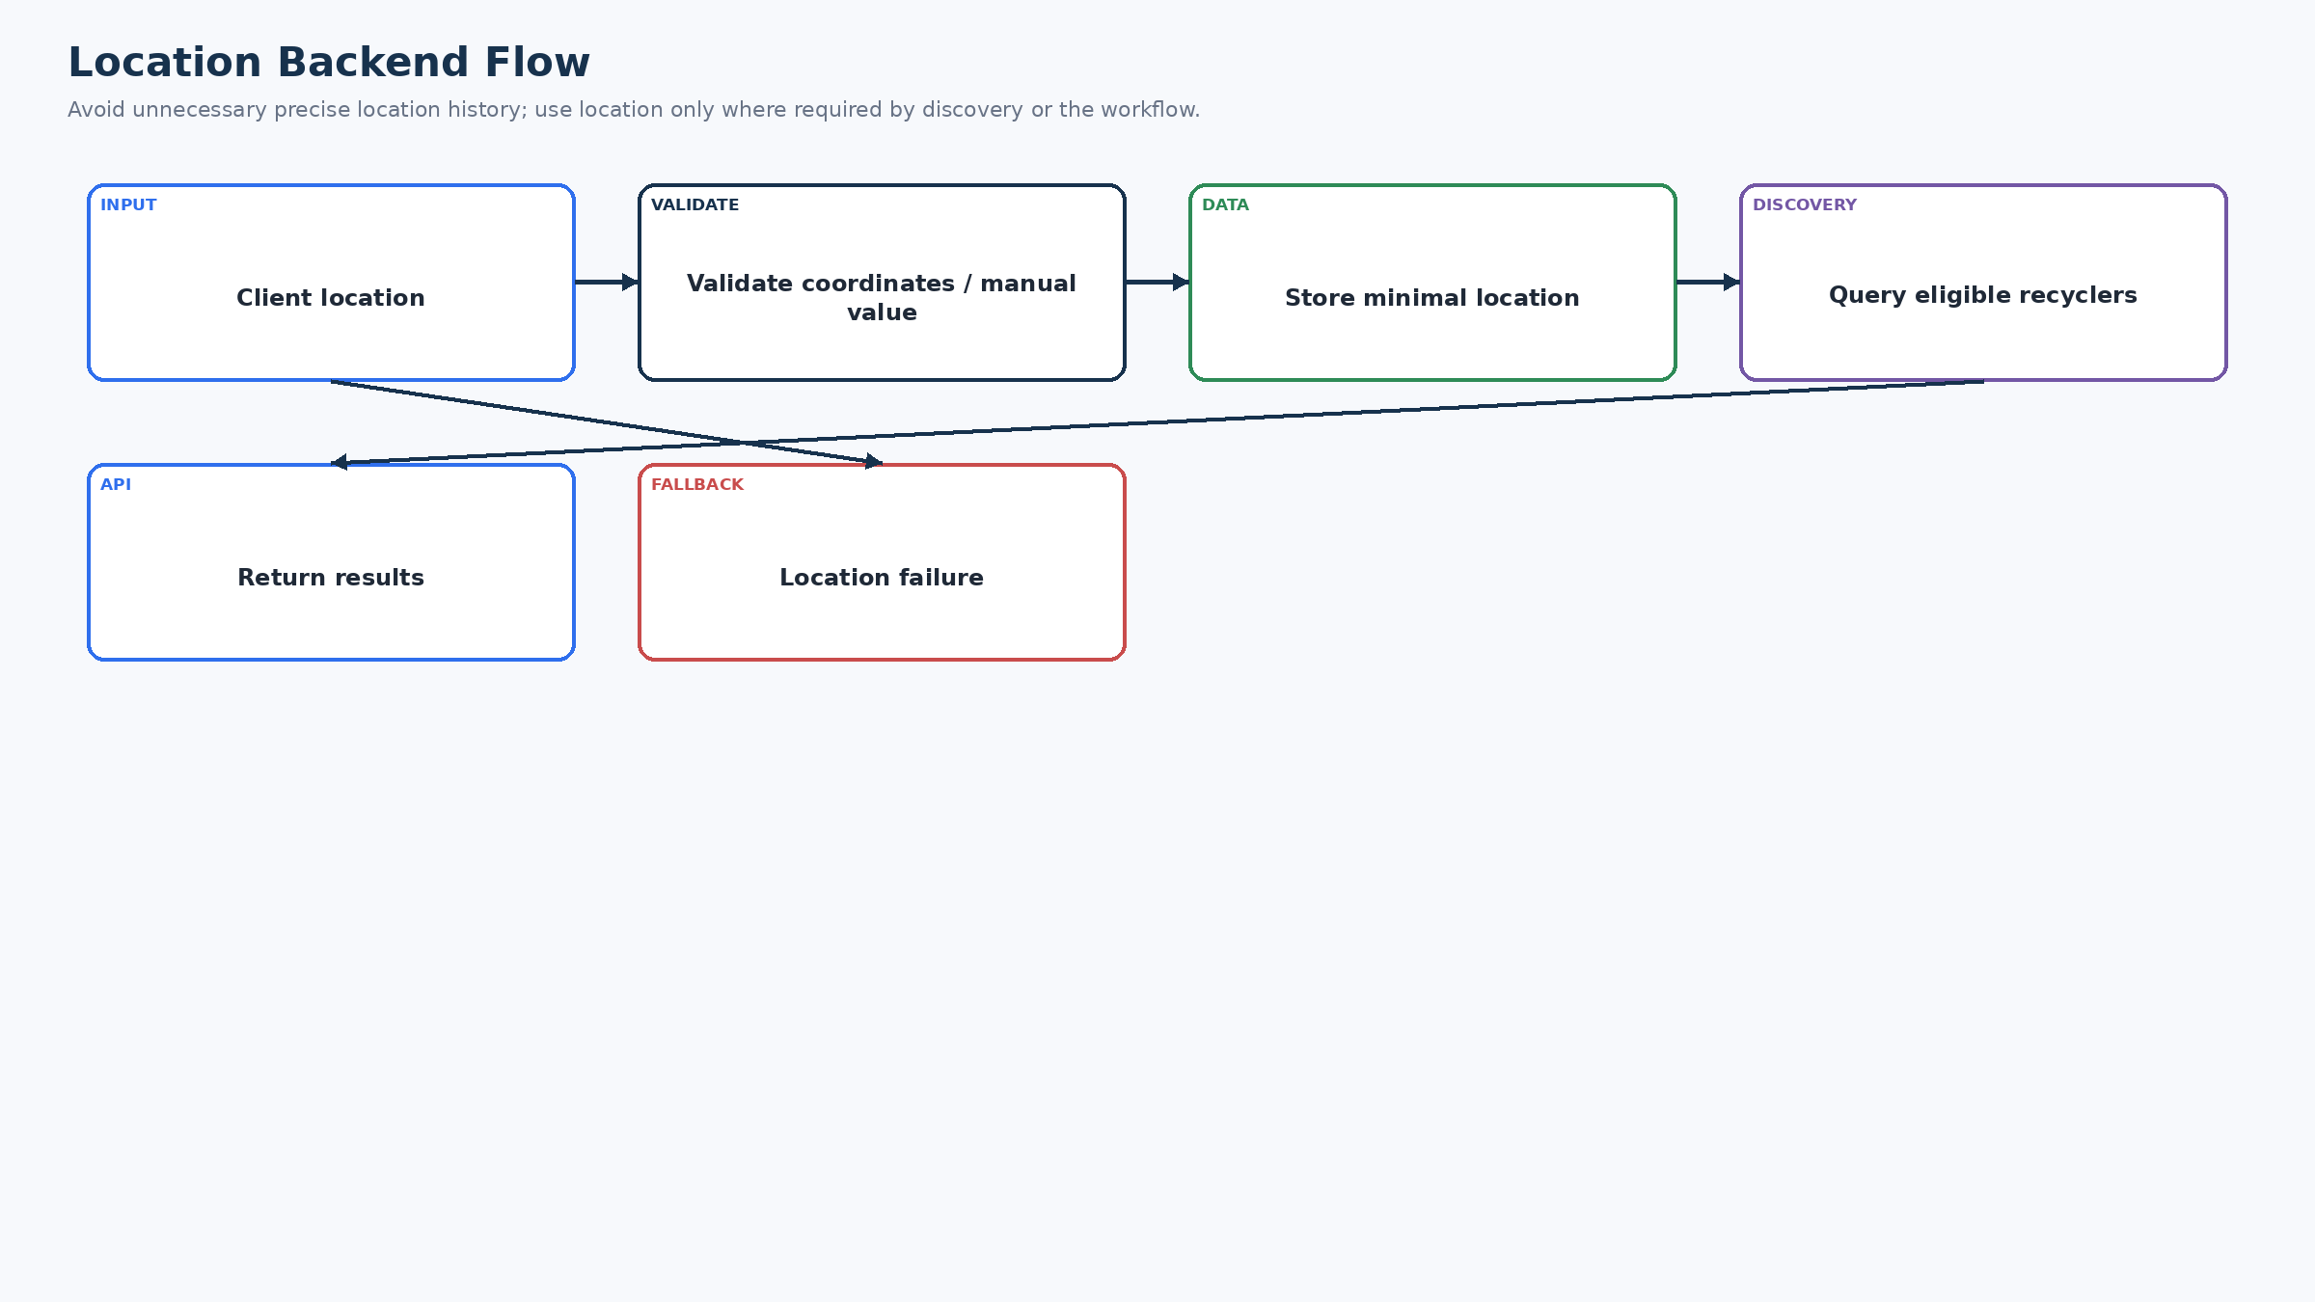
Figure 8. Location Backend Flow
Location handling accepts current or manual location, validates it, stores only what the workflow needs, and uses it for discovery when applicable.

24. AI Backend Integration
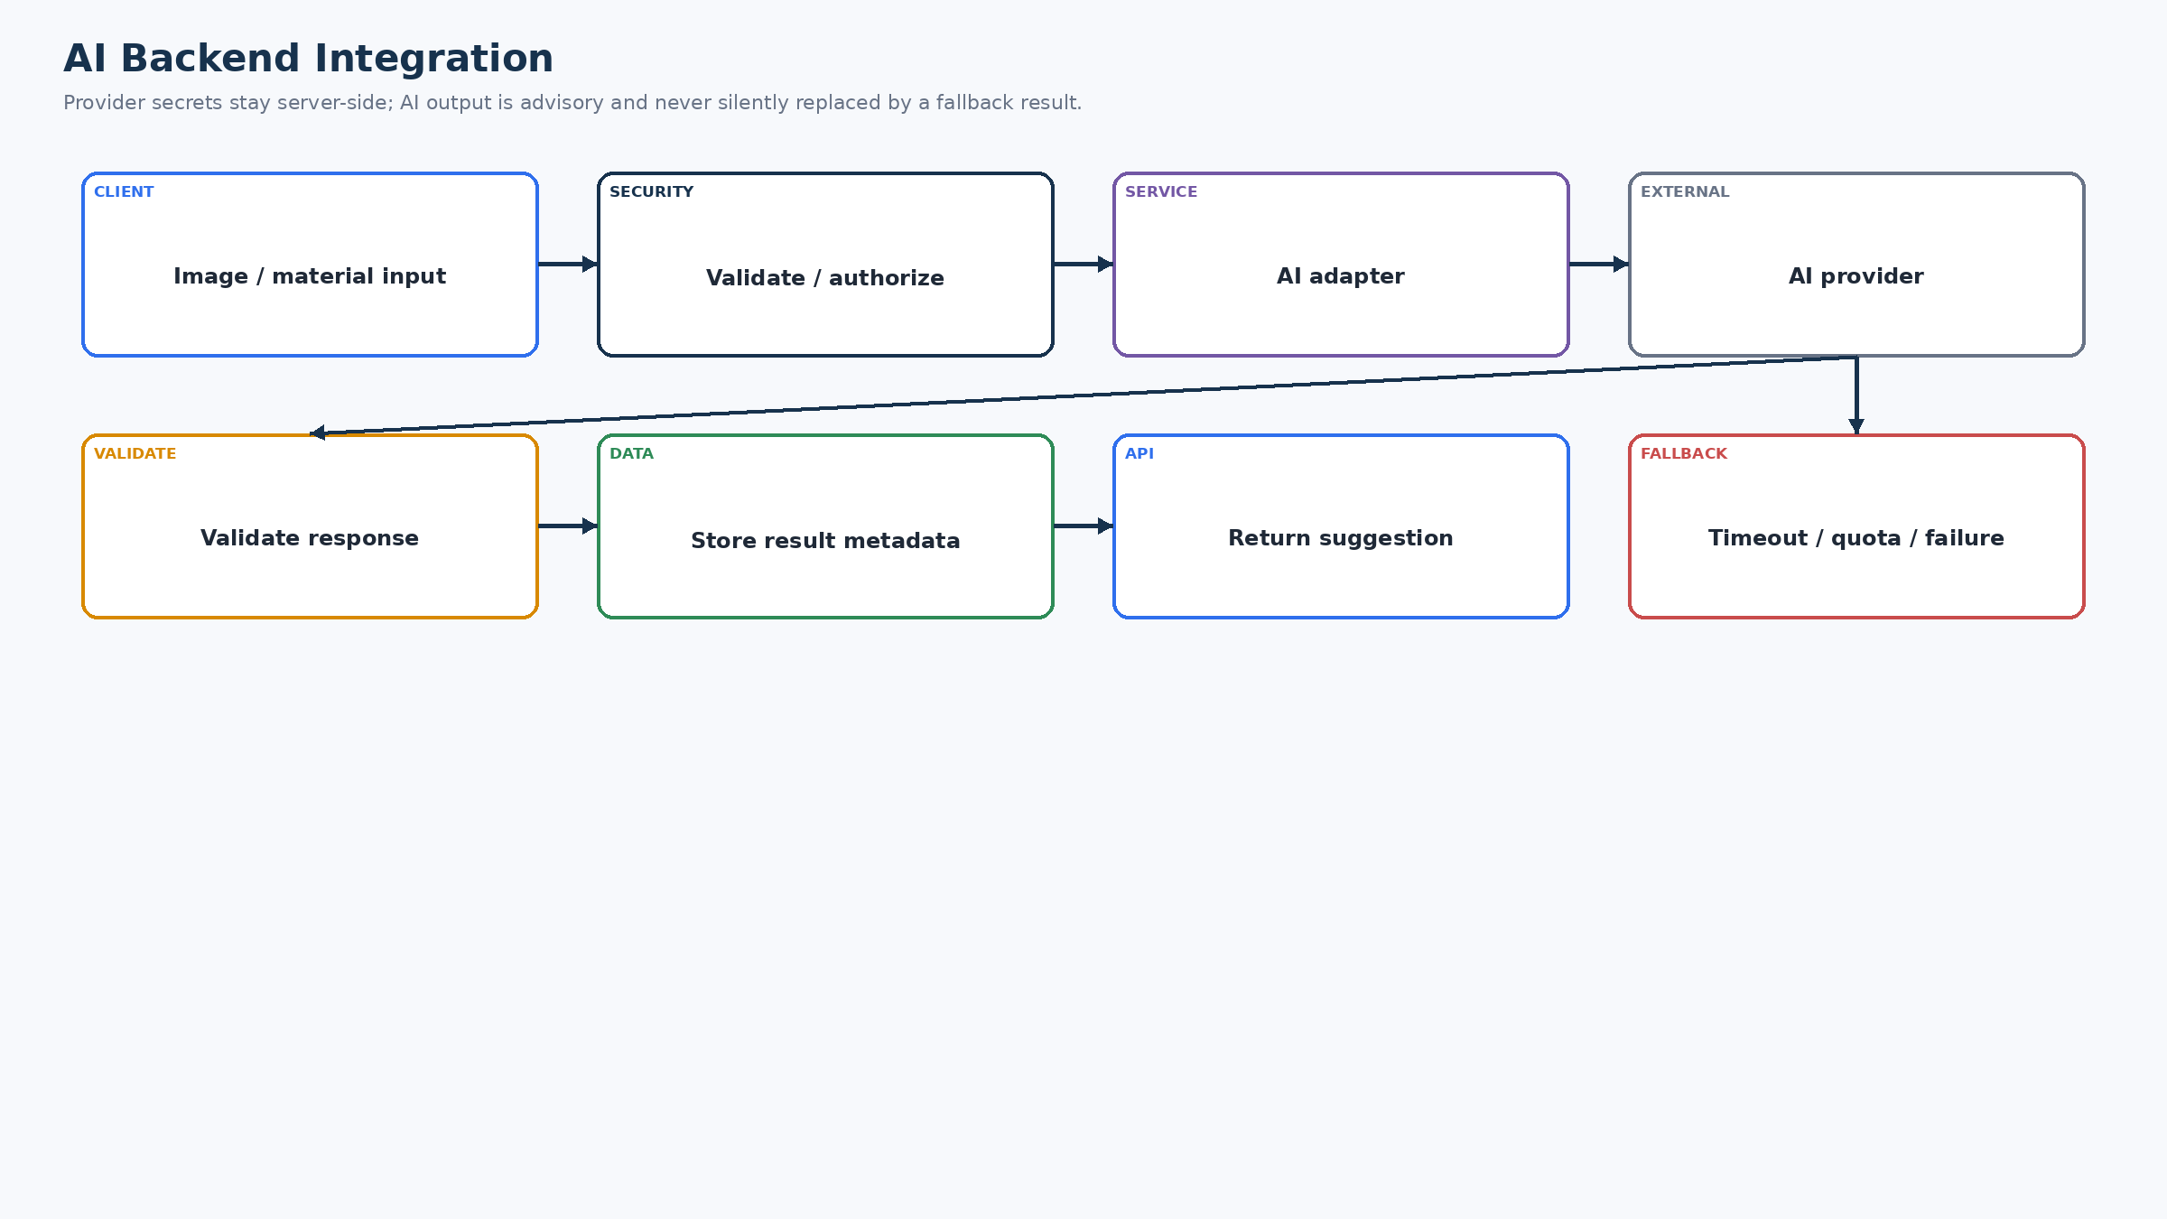
Figure 9. AI Backend Integration
The AI adapter receives validated input, calls the provider without exposing secrets to the client, validates the response and stores advisory metadata before returning a suggestion.
Concern | Backend rule
Input | Validate image reference/type/size and lot context before provider call.
Prompt/request | Construct provider request in the backend integration boundary.
Secret | Provider API key remains server-side; never return it to the client.
Timeout/quota | Bound the call; return controlled failure and allow manual classification.
Response validation | Require expected schema; reject malformed/unsupported output.
Confidence | Store/display only if provider returns a meaningful confidence value.
Logging | Do not log raw sensitive image content or secrets; log provider outcome/error class.
Retention | Retain only the data required by product/prototype; exact retention TBD.
Fallback | Manual classification is explicitly distinct from AI output.

25. AI Response Validation
Check | Action
Expected format | Reject malformed provider response.
Required fields | Treat missing classification/status as failure.
Supported classification | Map only to supported material categories.
Confidence | Validate range/meaning if supplied; do not invent confidence.
Missing values | Use controlled incomplete-result path.
Provider failure | Return retry/fallback status; never fabricate success.

26. Voice Backend Integration
Voice may be implemented entirely on the client for speech recognition/text-to-speech. Where the final prototype uses client-side voice, no backend dependency should be introduced merely to satisfy documentation. If a provider requires backend processing, the integration must follow the same adapter, secret protection, timeout and fallback rules as other external services. Exact backend involvement is TBD — Backend Decision Required.

27. Multilingual Backend Design
Data | Rule
User language | Store a stable language preference on profile/user settings.
Voice language | Store only if the application needs to persist a separate preference.
Static UI translation | Prefer client/resource localization rather than storing translated copies in the database.
Dynamic content | Store canonical data; localize presentation where possible.
Backend-generated content | Use stable message/event codes where clients can localize.
Fallback | Use the defined default language/resource when a translation is unavailable.

28. File / Image / Document Storage
Figure 9. AI Backend Integration
AI images use the same protected storage pattern as other sensitive uploads.
Storage flow: upload/capture → validate → store object → store metadata/reference → authorize retrieval → retrieve/delete according to policy. Binary content should not be stored directly in ordinary relational rows unless the selected design explicitly requires it.
Content | Metadata | Access
AI image | Object ref, type, size, owner, purpose, timestamps | Lot owner / authorized admin policy
Verification document | Object ref, verification ID, type, status, owner | Applicant/admin policy
Proof/user upload | Object ref, owner, purpose | Owner/authorized workflow
Transaction-related document | Object ref, transaction ID, type | Transaction participants/admin policy

29. Storage Access Control
- Sensitive files are not public by default.
- Authorization is checked before issuing a retrieval reference or serving protected content.
- File type and size are validated before persistence.
- Deletion must remove or revoke the object and its metadata reference according to the retention policy.
- The exact object-storage provider and signed-URL mechanism are TBD unless verified in the final prototype.

30. Verification Backend
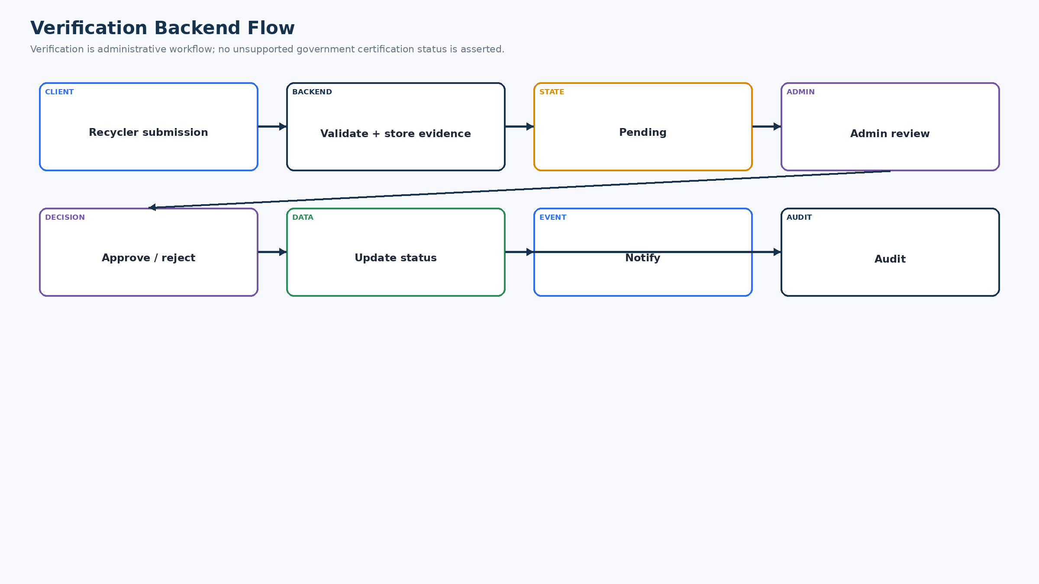
Figure 10. Verification Backend Flow
Recycler verification is a pending → admin review → approve/reject → status/notification/audit workflow.

31. Notification Backend
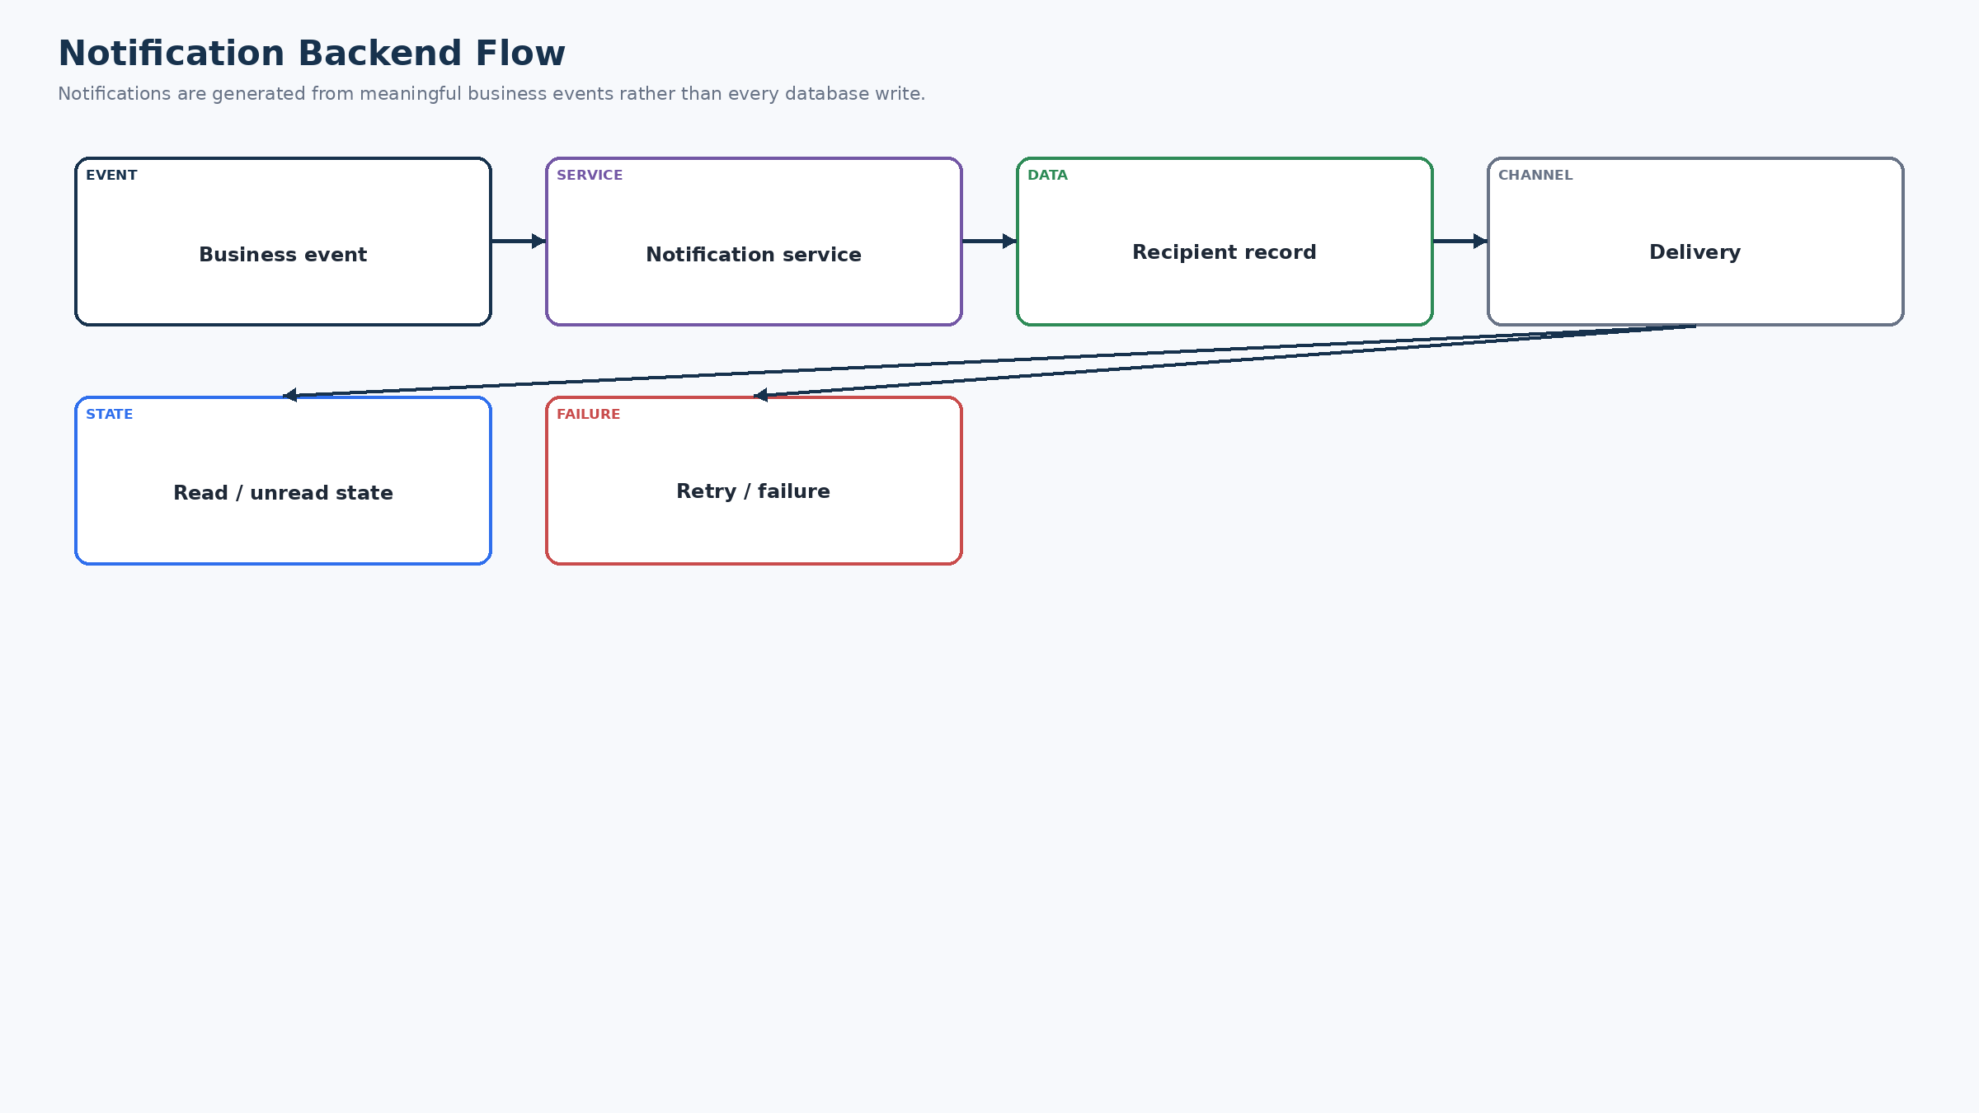
Figure 11. Notification Backend Flow
Business events generate recipient-scoped notification records. Delivery is a separate concern from the durable notification record.

32. Realtime Backend
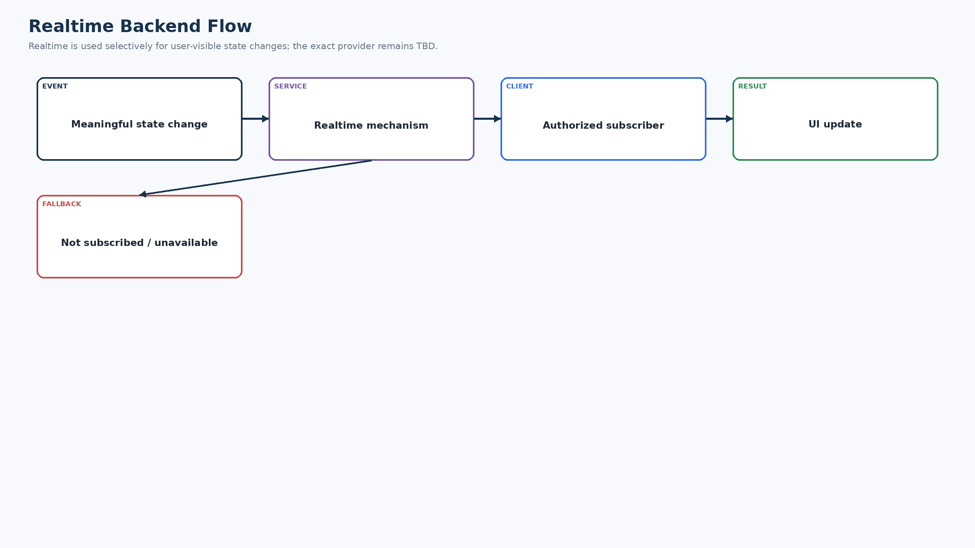
Figure 12. Realtime Backend Flow
Only meaningful user-facing state changes should trigger realtime updates; the exact mechanism is TBD. Polling/refresh remains a safe fallback.

33. Offline Sync Backend
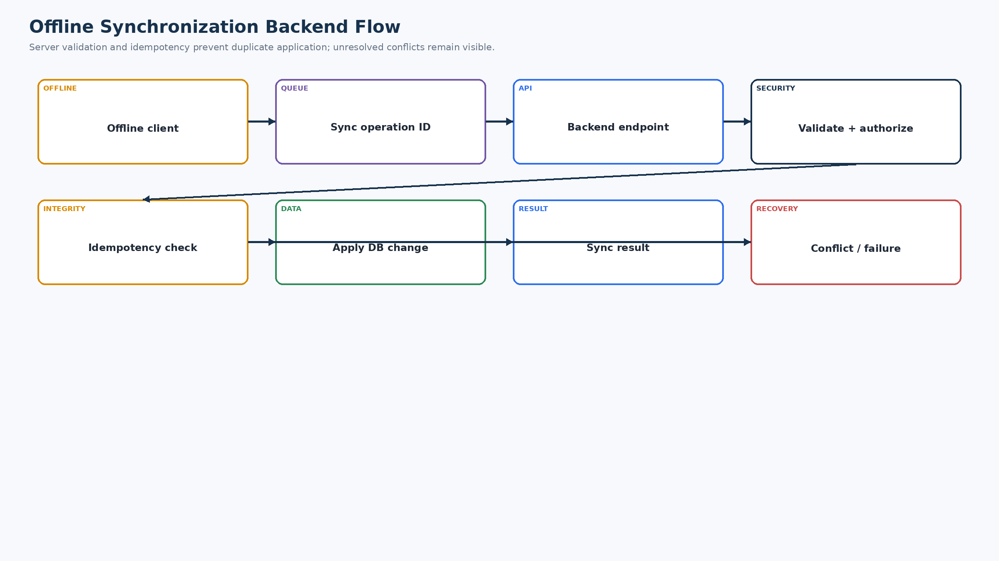
Figure 13. Offline Synchronization Backend Flow
The backend validates each queued operation, checks idempotency, applies it once and returns a durable result or a conflict/failure reason.

34. Sync Operation Model
Field | Purpose | Required? | Notes
operation_id | Idempotency key | Yes | Unique per client operation
user_id | Operation owner | Yes | Authenticated principal
entity | Target resource | Yes | Allow-listed entity name
action | Create/update/command | Yes | Allow-listed action
timestamp | Client operation time | Yes | Used for audit/conflict checks
client_version | Compatibility context | Optional | Useful when schema changes
payload reference | Data/command reference | Yes | Validated server-side
status | Pending/applied/conflict/failed | Yes | Server-controlled
retry_count | Operational retry tracking | Optional | Do not let client dictate final state

35. Idempotency
- Every offline/retry-sensitive command carries a unique operation identifier.
- The backend persists the identifier before/with the state-changing result so a repeated request can return the previous result instead of creating a duplicate.
- Business-level uniqueness constraints should be added where the domain has a natural unique combination.
- Idempotency does not mean blindly accepting stale commands; state and ownership validation still apply.

36. Conflict Resolution
Conflict | Detection | Resolution | User effect | Audit
Same request changed by two users | Version/state mismatch | Reject stale command; return current state | User sees actionable conflict | Record conflict
Offline transaction state stale | Allowed transition fails | Do not overwrite newer state | Show current status | Record sync conflict
Record no longer available | Missing/changed record | Mark operation failed/conflicted | Retry/review | Audit
Old client version | Compatibility/version check | Reject or migrate supported command | Prompt update/retry | Log version

Exact conflict-resolution UX and merge rules are TBD — Backend Decision Required where the product does not define a mergeable field set.

37. API Error Design
Category | Code example | HTTP | Meaning | User treatment | Retryable
Validation | VALIDATION_ERROR | 400/422 | Input invalid | Correct input | No until corrected
Authentication | AUTH_REQUIRED | 401 | Session missing/invalid | Sign in again | After auth
Authorization | FORBIDDEN | 403 | Role/ownership denied | Safe error/redirect | No
Not found | NOT_FOUND | 404 | Resource unavailable | Refresh/back | Usually no
Conflict | STATE_CONFLICT | 409 | Stale/invalid transition | Show current state | After resolution
Rate limit | RATE_LIMITED | 429 | Too many/costly requests | Wait/retry | Yes after backoff
External | EXTERNAL_SERVICE_ERROR | 502/503 | Provider failed | Retry/fallback | Usually yes
AI | AI_UNAVAILABLE | 502/504 | AI failed | Manual fallback | Yes
Storage | STORAGE_ERROR | 502/503 | Upload/retrieval failed | Retry | Yes
Sync | SYNC_CONFLICT / SYNC_FAILED | 409/422/503 | Offline op not applied | Show retry/conflict | Depends
Server | INTERNAL_ERROR | 500 | Unexpected backend failure | Safe error | Maybe

38. API Rate Limiting
Operation | Reason | Exact limit
OTP / login | Brute-force prevention | TBD — Benchmark/Threat Model Required
AI requests | Cost/quota/abuse | TBD — Benchmark/Threat Model Required
File uploads | Storage/abuse protection | TBD — Benchmark/Threat Model Required
Notifications | Abuse prevention | TBD — Benchmark/Threat Model Required
Sync operations | Protect backend from reconnect storms | TBD — Benchmark/Threat Model Required

39. Caching
No mandatory backend cache is required for the current prototype. Add caching only for a measured bottleneck such as recycler discovery or read-heavy reference data. If introduced, document TTL, invalidation, privacy impact and stale-data behavior. Distributed caching is not part of the current baseline architecture.

40. Background Jobs
No background worker is required for the current prototype unless the actual implementation introduces asynchronous delivery or long-running processing. Notifications, AI and synchronization may be handled synchronously or through provider mechanisms at prototype scale. Production/Future may add a job system when measured workload requires it.

41. Audit Logging
Event | Data captured | Purpose | Access | Retention
Login/security event | Actor, event type, timestamp, outcome | Security investigation | Restricted/admin | TBD
Verification decision | Actor, verification ID, decision, timestamp | Traceability | Admin/restricted | TBD
Request state change | Actor, request ID, from/to state, timestamp | Transaction trace | Restricted/admin | TBD
Transaction state change | Actor, transaction ID, from/to state | Integrity | Restricted/admin | TBD
Admin action | Actor, action, target | Accountability | Restricted/admin | TBD
Sync conflict | User, operation ID, target, reason | Offline support | Restricted | TBD

Secrets, authentication tokens, raw credentials and unnecessary sensitive payloads must never be logged.

42. Security Architecture
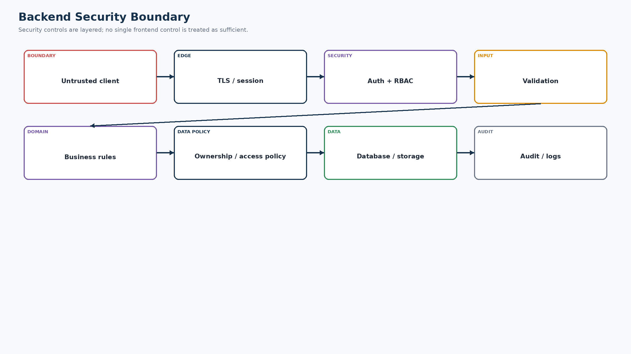
Figure 14. Backend Security Boundary
Security is layered from the untrusted client boundary through authentication, RBAC, validation, business rules, ownership/data policy, protected persistence and audit.
Control | Requirement
Authentication | All protected APIs require a valid authenticated principal.
RBAC | Role is resolved server-side and checked per operation.
Ownership | Resource ownership/participant checks prevent IDOR-style access.
Validation | Input and output structures are validated.
Secrets | Keys/credentials remain server-side and outside source control.
Encryption | TLS for transport; encryption-at-rest depends on selected managed services.
Files | Protected object access; type/size validation.
Rate limiting | Sensitive/high-cost endpoints are protected.
Audit | Sensitive changes are attributable.
Session | Expired/invalid sessions cannot access protected resources.

43. Secret Management
- Never hard-code secrets in frontend or backend source.
- Never commit secrets to Git.
- Use environment/project secret storage in deployment.
- Rotate compromised keys and restrict service-role credentials.
- Do not expose AI, database or storage service credentials to the browser.
- Exact secret manager is TBD — Backend Decision Required.

44. Data Privacy
Data | Collection | Storage | Access | Retention / deletion
Phone/auth identity | Only for authentication | Auth provider + user reference | Auth/self policy | Provider/product policy TBD
Profile | Required profile fields | DB | Owner/admin policy | TBD
Location | Only where workflow needs it | Minimal DB reference | Need-to-use | Avoid unnecessary history
Verification docs | When verification requires evidence | Protected object storage | Applicant/admin | TBD
Images | For AI/material evidence where needed | Protected storage + metadata | Owner/authorized | TBD
Transactions | Core traceability | DB | Participants/admin policy | TBD
AI inputs/results | Only required for assistive feature | Protected storage/DB metadata | Owner/admin policy | TBD

No regulatory compliance claim is made here because the supplied project material does not establish a verified compliance certification.

45. Logging & Monitoring
- Structured application logs: request outcome, error class, latency, correlation identifier where available.
- Authentication logs: failure/success class, not credentials/tokens.
- Database logs: errors and slow-query signals without sensitive payloads.
- AI logs: provider outcome, latency and error class, not secrets/raw sensitive content.
- Sync logs: operation ID, result/conflict class and retry count.
- Security events: authorization denials and suspicious repeated failures.
- Production monitoring is a future hardening requirement; exact vendor is TBD.

46. Database Migration Strategy
Area | Strategy
Initial schema | Versioned migration creates core entities/constraints/indexes.
Seed data | Minimal role/reference seed data; no fabricated production users.
Development reset | Allowed in development only; never as a production operation.
Production migration | Back up/verify before destructive or incompatible changes.
Rollback | Prefer forward-compatible migrations; rollback strategy depends on migration tool and data mutation.
Schema version | Application/deployment records migration version.

47. Backup & Recovery
Capability | Prototype | Production/Future
Database backup | Use managed/provider defaults where available; verify before demo | Scheduled backups + restore testing
File backup | Provider durability; verify | Defined object-storage backup/retention
Restore | Manual recovery if needed | Documented recovery runbook
Backup verification | Basic availability check | Periodic restore test
RPO/RTO | TBD | TBD — Business/Operations Decision Required

48. Performance Requirements
The SRS/TRD require measurable performance targets to be established before final deployment but do not establish a single backend benchmark here. Therefore this document does not invent numeric limits.
Area | Expectation | Target
API | Responsive for ordinary CRUD/state operations | TBD — Benchmark Required
DB queries | Indexed access for dashboard/history/discovery | TBD — Benchmark Required
Search/discovery | Return results or explicit failure; no indefinite loading | TBD — Benchmark Required
AI | Progress/timeout/fallback | Provider-dependent
File | Bound size/type and fail explicitly | TBD — Verify implementation
Sync | Do not unnecessarily block UI; retry safely | TBD — Benchmark Required

49. Scalability
Stage | Backend evolution
SIH prototype | Modular monolith, relational DB, object storage, replaceable integrations.
Pilot | Harden auth, monitoring, backups, rate limits, query/index review.
City | Scale API instances/DB/storage as measured; optimize discovery queries.
District/State | Introduce targeted async processing, read optimization or partitioning only when justified.
National | Evaluate service decomposition only after measured domain/scale boundaries justify it.

Microservices, message brokers and distributed caches are not baseline requirements for the current prototype.

50. Backend Failure Handling
Failure | Detection | Response | Fallback | Retry | User impact | Log
Database unavailable | DB error/timeout | Controlled 503 | Preserve supported local state | Yes when safe | Operation not falsely completed | Error class
Authentication unavailable | Provider/API error | Controlled auth error | No bypass | Provider-dependent | Cannot authenticate | Auth event
AI unavailable | Timeout/5xx/quota | AI unavailable result | Manual classification | Yes | Workflow continues | Provider error class
Storage unavailable | Upload error | Controlled failure | Retry/reupload | Yes | No false upload success | Storage error
Maps/location provider | Timeout/error | Explicit failure | Manual location | Yes | Discovery can continue where possible | Provider error
Voice service | Recognition/TTS error | Controlled client error | Text/touch | Yes | Voice not blocking | Error class
Network | Client/server connectivity failure | Offline/controlled error | Local queue where supported | Yes | User sees sync state | Client/server logs
External API | Non-success response | Controlled integration error | Fallback/manual | Depends | Task may continue or pause | Integration error

51. Backend Testing Strategy
Test layer | Focus
Unit | Services, validators, state transition rules, idempotency helpers
Integration | Database, storage, auth boundary, external adapters
API | Request/response contracts, validation, errors, pagination
Database | Constraints, ownership queries, migrations
Authorization | Role matrix, ownership/IDOR, admin isolation
Security | Input abuse, secrets, session, rate limits, file access
Performance | Measured response/search/sync targets before production
AI | Malformed output, timeout, quota, fallback
Storage | Type/size/access/retry
Realtime | Authorized subscription and state update where enabled
Offline sync | Duplicate operations, stale state, conflict and retry

52. API Test Cases
Test ID | API | Scenario | Input | Expected result | Expected error | Authorization | Status
BE-T-001 | API-004 | Create material lot | Valid collector + lot | 201/created | — | Collector owner | Required
BE-T-002 | API-004 | Create lot unauthorized | Recycler token | 403 | FORBIDDEN | Recycler | Required
BE-T-003 | API-005 | AI timeout | Valid image + provider timeout | Controlled fallback | AI_UNAVAILABLE | Collector | Required
BE-T-004 | API-007 | Duplicate request | Same operation ID twice | One request/result reused | Conflict/previous result | Collector | Required
BE-T-005 | API-009 | Recycler responds to foreign request | Valid recycler, non-eligible request | 403/409 | FORBIDDEN/STATE_CONFLICT | Recycler | Required
BE-T-006 | API-012 | Invalid confirmation transition | Wrong state | 409 | STATE_CONFLICT | Participant | Required
BE-T-007 | API-016 | Non-admin verification decision | Collector token | 403 | FORBIDDEN | Collector | Required
BE-T-008 | API-018 | Offline retry | Same operation ID twice | Applied once | Same result | Owner | Required
BE-T-009 | API-017 | Oversized file | Invalid size | 413/400 | FILE_INVALID | Authenticated | Required
BE-T-010 | API-021 | Audit access by collector | Collector token | 403 | FORBIDDEN | Collector | Required

53. Security Test Cases
- Unauthorized API access → must fail before business operation.
- Cross-role access → Collector cannot invoke Recycler/Admin-only operations.
- IDOR/resource ownership → changing a resource ID must not expose another user's record.
- Invalid/expired session → protected API returns authentication failure.
- Malicious input → validation rejects unsafe/unexpected structures.
- File upload abuse → type/size/access checks prevent unrestricted content.
- Rate limit → repeated sensitive requests are throttled according to configured policy.
- Secret exposure → frontend bundle/logs/API responses contain no provider/database secrets.
- RLS bypass attempt → if RLS is used, direct data access is tested against policies and service-role boundaries.

54. Data Consistency Testing
- Duplicate transactions are prevented by state rules and idempotency.
- Duplicate requests are prevented for repeated commands where applicable.
- Invalid state transitions are rejected.
- Concurrent updates produce a conflict rather than silent last-write corruption.
- Sync retries do not duplicate records.
- Partial external failures do not falsely mark a transaction complete.

55. Backend Deployment
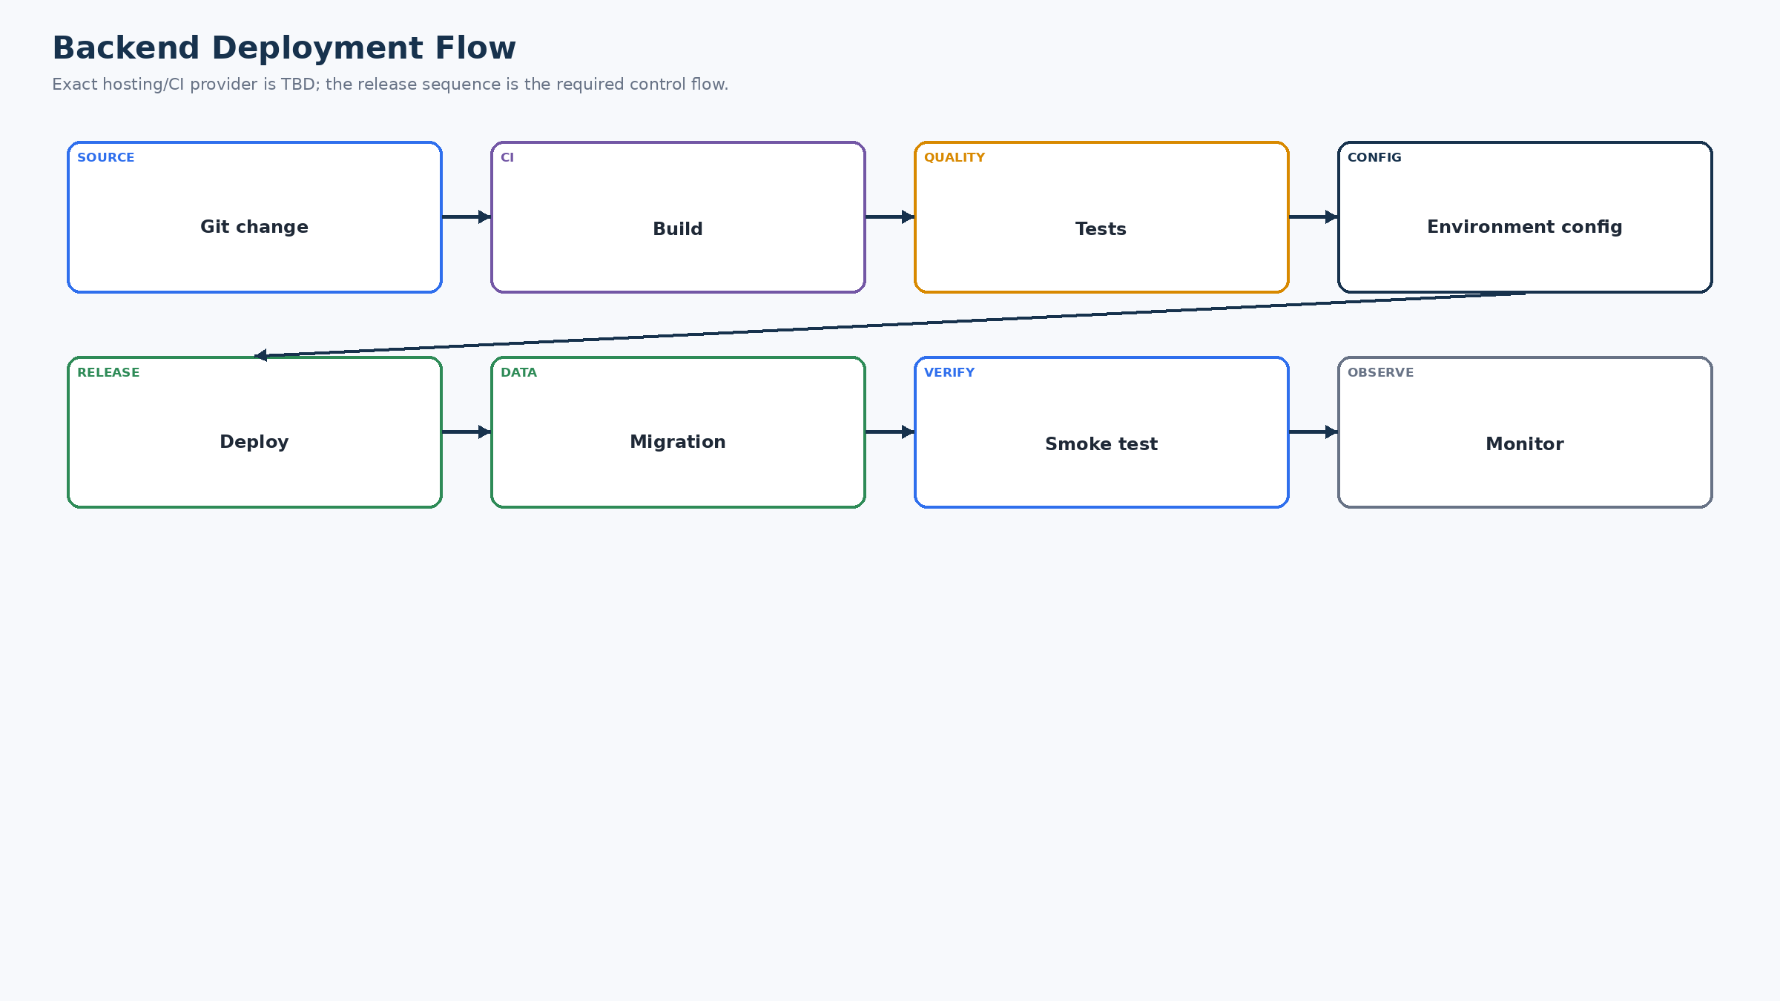
Figure 15. Backend Deployment Flow
Provider-specific deployment tooling is TBD, but the control sequence is source → build → tests → environment → deploy → migration → smoke test → monitor.

56. Development Environment
- Local backend should use a development database or isolated development instance.
- Environment variables provide connection/configuration values; secrets remain outside source control.
- External services may be mocked/stubbed only when clearly labeled as development behavior.
- Database reset/seed tools are development-only.

57. Production Environment
Component | Current design | Status
Backend hosting | Managed/reproducible deployment | TBD provider
Database | Managed relational system of record | TBD engine/provider
Storage | Protected object storage | TBD provider
Authentication | Managed identity boundary | TBD provider
External APIs | AI/location/voice/notifications through adapters | TBD providers
Secrets | Environment/project secret storage | Required
Monitoring | Structured logs + error/performance monitoring | Production/Future

58. API Versioning
A single stable API surface is sufficient for the screening prototype. Explicit versioning should be introduced when deployed clients and backend need independent compatibility. Do not add versioning complexity without a compatibility requirement.

59. Backward Compatibility
- Prefer additive API changes.
- Keep old response fields temporarily when clients depend on them.
- Use client version information only when needed for migration/sync compatibility.
- Do not silently change transaction state semantics between deployed client versions.

60. Backend Source Structure
Recommended modular-monolith structure (adapt to the actual framework):
Folder | Purpose | Allowed contents | Dependencies
routes/ | HTTP/API surface | Route declarations, thin handlers | controllers/services
controllers/ | Request orchestration | Parse/return HTTP concerns | services/validators
services/ | Domain logic | Business rules, workflows | repositories/integrations
repositories/ | Data access | Queries/persistence | DB
models/ | Data/domain shapes | Schemas/entities | DB/domain
middleware/ | Cross-cutting request controls | Auth, error, rate-limit | Services/config
validators/ | Input/output validation | Schemas/rules | Domain types
integrations/ | External adapters | AI/maps/voice/notifications | Provider SDKs
auth/ | Identity boundary | Token/session adapter | Auth provider
sync/ | Offline commands | Idempotency/conflict logic | services/repositories
tests/ | Automated tests | Unit/integration/API/security | All tested layers

61. Service / Controller / Data Access Responsibility
The required separation is: Controller/API → Validation → Service/business logic → Repository/data access → Database. Critical business rules such as ownership, eligibility and transaction state transitions must not be scattered across route handlers or implemented only in the frontend.

62. Backend Configuration
Category | Examples | Exposure
Public configuration | API base URL, feature availability flags | Client-safe only
Private configuration | Provider keys, service credentials | Server only
Database configuration | Connection reference/credentials | Server only
External API configuration | Provider endpoint/model IDs | Server; public only if explicitly safe
Feature flags | Prototype feature toggles | Only necessary flags

63. Feature Flags
Feature | Purpose | Environment | Default | Owner | Status
AI classification | Enable/disable assistive AI integration | Prototype/Production | Enabled only when configured | Backend/Product | Proposed
Realtime updates | Enable selective realtime | Prototype/Production | TBD | Backend | TBD
Voice backend processing | Only if required by implementation | Prototype/Production | Disabled unless required | Backend | TBD

Avoid introducing a dedicated feature-flag platform for simple prototype toggles.

64. Backend Technical Diagram Set
Figure | Diagram | Purpose | Status
Fig 1 | Backend Architecture | System-level backend structure | Embedded
Fig 2 | Backend Module Map | Modules and data boundaries | Embedded
Fig 3 | Request Lifecycle | Server processing sequence | Embedded
Fig 4 | Authentication | Identity/session boundary | Embedded
Fig 5 | Authorization | Role/ownership enforcement | Embedded
Fig 6 | Database ERD | Logical entities/relationships | Embedded
Fig 7 | Transaction Lifecycle | State machine | Embedded
Fig 8 | Location Backend Flow | Location/discovery data | Embedded
Fig 9 | AI Backend Integration | AI adapter and validation | Embedded
Fig 10 | Verification Backend Flow | Verification workflow | Embedded
Fig 11 | Notification Flow | Event-to-recipient flow | Embedded
Fig 12 | Realtime Flow | Selective state updates | Embedded
Fig 13 | Offline Sync | Server synchronization | Embedded
Fig 14 | Backend Security Boundary | Security layers | Embedded
Fig 15 | Backend Deployment | Release control flow | Embedded
Fig 16 | Failure / Recovery | Common backend failure pattern | Embedded
Fig 17 | SIH Prototype Backend Overview | Presentation-friendly prototype view | Embedded

65. SIH Prototype Backend
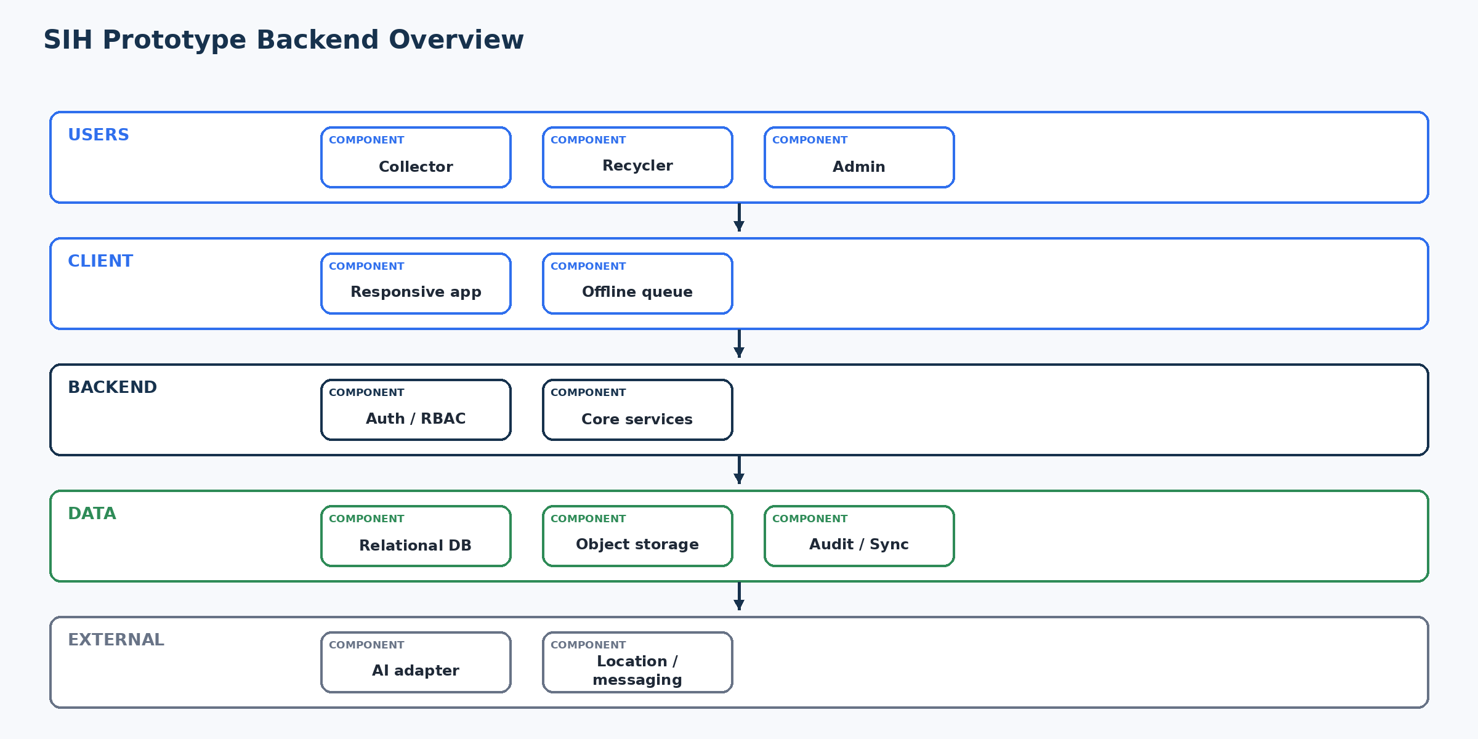
Figure 17. SIH Prototype Backend Overview
The screening prototype remains intentionally simple: users → frontend → auth/backend → relational DB/storage, with replaceable AI/location/external boundaries.

66. Backend Production Evolution
Area | SIH Prototype | Pilot/Production Evolution
Authentication | Managed auth boundary | Hardened provider configuration, recovery, monitoring
Database | Relational system of record | Scaling/index/query optimization, backup/restore
API | Modular monolith | Horizontal scaling, measured optimization
Storage | Object storage | Retention, backup, lifecycle policies
AI | Replaceable adapter | Quota management, async processing if needed, model evaluation
Realtime | Selective/TBD | Provider SLA/scale validation
Sync | Idempotent operation model | Conflict UX, compatibility/versioning
Monitoring | Structured logs | Metrics, traces, alerting, incident runbooks
Security | Layered auth/RBAC/validation | Pen testing, stronger abuse controls, secrets rotation
Backup | Basic/provider capability | Verified scheduled backup + restore tests

67. Backend Traceability
SRS | TRD/Feature | Backend Module | API | Entity | Security Control | Test | Status
AI-001..009 | AI integration/validation | BE-09 | API-005 | ai_results/material_lots | Secrets + response validation | BE-T-003 | Covered
OFF-001..008 | Offline operation | BE-13 | API-018 | sync_operations + target | Auth/idempotency | BE-T-008 | Covered
SYNC-001..007 | Synchronization | BE-13 | API-018 | sync_operations | Idempotency/conflict | BE-T-008 | Covered
SEC-001..010 | Security | BE-01/03/14 | Protected APIs | users/audit | Auth/RBAC/ownership | BE-T-002/006/007/010 | Covered
BR-001..012 | Business rules | BE-04/05/07/08 | API-007..016 | requests/transactions/verification | State/ownership | BE-T-005/006 | Covered
NFR-P-001..005 | Performance/fallback | BE-07/09/13 | Core APIs | Core entities | Timeout/retry | Performance suite | Target TBD

68. API-to-Database Matrix
API | Entities Read | Entities Written | Authorization | External | Transactionality | Test
API-004 | material_lots | material_lots | Collector owns lot | Optional storage/AI | Atomic create | BE-T-001
API-005 | material_lots, ai_results | ai_results | Lot owner | AI | Result + metadata | BE-T-003
API-006 | recyclers, locations | — | Discovery policy | Maps optional | Read | Discovery tests
API-007 | material_lots, users/recyclers | requests | Collector owns lot | — | Atomic create | BE-T-004
API-009 | requests | requests | Eligible recycler | Notification | Atomic state change | BE-T-005
API-010 | requests | requests/transactions | Collector owns request | Notification | Atomic transition | Workflow tests
API-012 | transactions | transactions | Participant + state | Notification/audit | Atomic transition | BE-T-006
API-015 | recyclers, verification_requests | verification_requests/docs | Applicant | Storage | Atomic metadata | Verification tests
API-016 | verification_requests | verification_requests | Admin only | Notification/audit | Atomic decision | BE-T-007
API-018 | sync_operations + target | target entity | Operation owner + state | — | Idempotent | BE-T-008

69. Role-to-API Matrix
Role | API | Purpose | Access
Collector | API-004 | Material lot | Allowed (scoped)
Collector | API-006 | Recycler discovery | Allowed (scoped)
Collector | API-007 | Create request | Allowed (scoped)
Collector | API-009 | Quote/response | —
Collector | API-010 | Accept quote | Allowed (scoped)
Collector | API-011 | Schedule | Allowed (scoped)
Collector | API-012 | Confirm | Allowed (scoped)
Collector | API-015 | Verification submit | —
Collector | API-016 | Verification decision | —
Collector | API-021 | Audit | —
Recycler | API-004 | Material lot | —
Recycler | API-006 | Recycler discovery | —
Recycler | API-007 | Create request | —
Recycler | API-009 | Quote/response | Allowed (scoped)
Recycler | API-010 | Accept quote | —
Recycler | API-011 | Schedule | Allowed (scoped)
Recycler | API-012 | Confirm | Allowed (scoped)
Recycler | API-015 | Verification submit | Allowed (scoped)
Recycler | API-016 | Verification decision | —
Recycler | API-021 | Audit | —
Admin | API-004 | Material lot | —
Admin | API-006 | Recycler discovery | —
Admin | API-007 | Create request | —
Admin | API-009 | Quote/response | —
Admin | API-010 | Accept quote | —
Admin | API-011 | Schedule | Allowed (admin policy)
Admin | API-012 | Confirm | Allowed (admin policy)
Admin | API-015 | Verification submit | —
Admin | API-016 | Verification decision | Allowed (admin policy)
Admin | API-021 | Audit | Allowed (admin policy)

70. Data-Access Matrix
Entity | Collector | Recycler | Admin
users/profiles | Owner | Owner/eligible | Admin
material_lots | Owner | — | Admin scoped
requests | Participant | Participant | Admin scoped
transactions | Participant | Participant | Admin scoped
verification_requests | — | Own | Admin
verification_documents | — | Own/restricted | Admin restricted
notifications | Recipient | Recipient | Admin policy
audit_logs | — | — | Admin
sync_operations | Own | Own | Service/admin policy

71. Backend Risk Register
Risk | Impact | Probability | Mitigation | Contingency | Status
R-01 | Incorrect authorization/RLS | High | High | Server-side role+ownership tests; DB policy tests if RLS | Disable risky operation; audit

71. Backend Risk Register — Continued
Risk | Impact | Probability | Mitigation | Contingency | Status | Control
R-01 | Incorrect authorization/RLS | High | High | Server-side role+ownership tests; DB policy tests if RLS | Disable risky operation; audit | Open until tested
Risk | Impact | Probability | Mitigation | Contingency | Status | Control
R-01 | Incorrect authorization/RLS | High | High | Server-side role+ownership tests; DB policy tests if RLS | Disable risky operation; audit | Open until tested
R-02 | Duplicate transactions | High | Medium | Operation IDs + unique constraints + state machine | Return prior result/conflict | Design covered
R-03 | Sync conflict | High | Medium | Version/state validation + visible conflict | Do not overwrite newer state | Design covered
R-04 | AI quota/outage | Medium | High | Adapter timeout, quota handling, manual fallback | Manual classification | Design covered
R-05 | Auth outage | High | Medium | Managed provider + controlled errors | No bypass; preserve local supported work | TBD provider
R-06 | Storage failure | High | Medium | Validation/retry/no false success | Retry/reupload | Design covered
R-07 | Data leakage | High | Medium | Least privilege, protected files, logs without secrets | Revoke access/rotate keys | Open testing
R-08 | Poor discovery query performance | Medium | Medium | Measured indexes/query review | Fallback filters/pagination | Benchmark required

72. Backend Open Decisions
ID | Question | Options | Impact | Required Information | Status
DEC-01 | Backend runtime/framework? | Verify prototype codebase | Routes/testing/deployment | Prototype source | TBD
DEC-02 | Database engine/provider? | Relational options | Schema/RLS/index syntax | Prototype deployment | TBD
DEC-03 | Authentication provider? | Managed provider options | OTP/session/recovery | Prototype auth config | TBD
DEC-04 | Object storage provider? | Managed object store | Upload/signed access | Prototype deployment | TBD
DEC-05 | AI provider/model? | Replaceable provider | Adapter/request format | AI integration config | TBD
DEC-06 | Realtime mechanism? | Provider/polling | Subscriptions | Prototype need | TBD
DEC-07 | Voice backend involvement? | Client-only vs backend | Dependency surface | Final prototype behavior | TBD
DEC-08 | API response/versioning convention? | Single API vs versioned | Compatibility | Frontend codebase | TBD
DEC-09 | RLS implementation? | DB policy model | Direct data access | Selected DB | TBD
DEC-10 | Conflict merge rules? | Reject/retry vs merge | Sync UX | Final workflow | TBD
DEC-11 | Production RPO/RTO? | Operational targets | Backup design | Pilot requirements | TBD

73. Final Backend Review
Review Question | Assessment
Unauthorized restricted API access? | Auth + RBAC + ownership controls are defined; execute security tests.
Collector data leakage to Recycler? | Participant-scoped queries and ownership policies must prevent it.
Recycler data leakage to Collector? | Recycler-specific records/documents are scoped; verify by API/RLS tests.
Normal users accessing Admin? | Admin-only service policies prevent access.
Frontend-only bypass? | Frontend is explicitly untrusted.
Duplicate transactions? | Idempotency + state constraints address the design risk.
Offline retries duplicating? | Operation IDs + sync records address the design risk.
Stale data overwriting newer state? | State/version validation rejects stale transitions.
AI failure crashing workflow? | Manual fallback is explicit.
AI/API keys leaking? | Keys remain server-side.
Verification documents protected? | Protected storage + scoped retrieval required.
Location protected? | Minimal location storage and need-to-use access.
IDOR by changing an ID? | Ownership checks are required in scoped services.
Business rules server-side? | Yes; service layer is authoritative.
Invalid state transitions prevented? | Yes; transaction state machine.
Database constraints sufficient? | Core constraints defined; final schema review required.
External failures handled? | Controlled error/fallback matrix included.
Prototype reliability? | Design is suitable; provider/code verification remains.
Scale later? | Modular monolith supports measured scaling.
Cross-document consistency? | Aligned to supplied source framing; final code/prototype must be re-verified.

74. Final Backend Readiness
READY WITH CORRECTIONS
The blueprint is ready for implementation/review, but it is not a claim that the deployed prototype is production-ready. Exact backend framework, database/auth/storage providers, realtime mechanism, numeric performance thresholds and several operational policies remain unverified and are explicitly marked TBD rather than invented.

75. Final Backend Summary
Area | Design Summary
Backend technology | Modular-monolith API; exact runtime/framework TBD
Architecture style | API → services → repositories → relational DB/storage + external adapters
Major modules | Auth, User/Profile, Role/Permission, Collector, Recycler, Admin, Request/Transaction, Verification, AI, Location, Notification, Storage, Sync, Audit
APIs | Identity/profile, lots, discovery, requests, transactions, verification, files, sync, notifications and audit
Database | Relational system of record; engine TBD
Authentication | Managed identity/session boundary; provider TBD
Authorization | Server-side RBAC + ownership/eligibility + data-access policy
RLS/access control | Use database row-level controls where supported/selected; existing policy set not claimed as verified
Storage | Protected object storage with metadata/access policy
AI integration | Server-side replaceable adapter; advisory output + response validation + manual fallback
Voice integration | Prefer client-side processing when sufficient; backend only if required
Location | Minimal validated location + manual fallback + discovery boundary
Notifications | Event-triggered recipient-scoped records + delivery boundary
Realtime | Selective meaningful state changes; mechanism TBD
Offline sync | Operation IDs, server validation, idempotency, conflict/failure states
Logging | Structured logs without secrets/sensitive payloads
Monitoring | Production/Future metrics, error monitoring and alerting
Security | Auth, RBAC, ownership, validation, protected files, rate limits, secrets and audit
Prototype limitations | Provider/codebase details and numeric thresholds require final verification
Production evolution | Backups, monitoring, scale testing, stronger abuse controls, targeted async processing
Major dependencies | Auth provider, relational DB, object storage, AI and optional location/voice/realtime/notification providers
Major risks | Authorization errors, duplicate operations, sync conflicts, external outages, data leakage, query performance
Open decisions | Framework, DB/auth/storage providers, AI/realtime/voice involvement, RLS, conflict policy, RPO/RTO

Appendix A — Backend Readiness Checklist
- ☐ Backend modules mapped
- ☐ Core APIs inventoried
- ☐ Authentication boundary defined
- ☐ RBAC matrix defined
- ☐ Ownership checks defined
- ☐ Logical entities defined
- ☐ ERD embedded
- ☐ Transaction lifecycle defined
- ☐ AI adapter/fallback defined
- ☐ Location handling defined
- ☐ Storage access defined
- ☐ Verification workflow defined
- ☐ Notification workflow defined
- ☐ Realtime boundary defined
- ☐ Offline sync/idempotency defined
- ☐ Conflict handling defined
- ☐ Error model defined
- ☐ Rate limiting marked where thresholds are unknown
- ☐ No unnecessary cache/worker/microservice dependency
- ☐ Audit logging defined
- ☐ Security boundary diagram embedded
- ☐ Secret handling defined
- ☐ Privacy treatment defined
- ☐ Migration strategy defined
- ☐ Backup/recovery separated from prototype
- ☐ Performance targets not invented
- ☐ Scalability path defined
- ☐ Failure matrix defined
- ☐ Testing strategy defined
- ☐ Deployment diagram embedded
- ☐ Traceability matrix included
- ☐ Risk register included
- ☐ Open decisions included
- ☐ Final review performed
- ☐ Final readiness qualified

Appendix B — File / Image / Document Storage Diagram
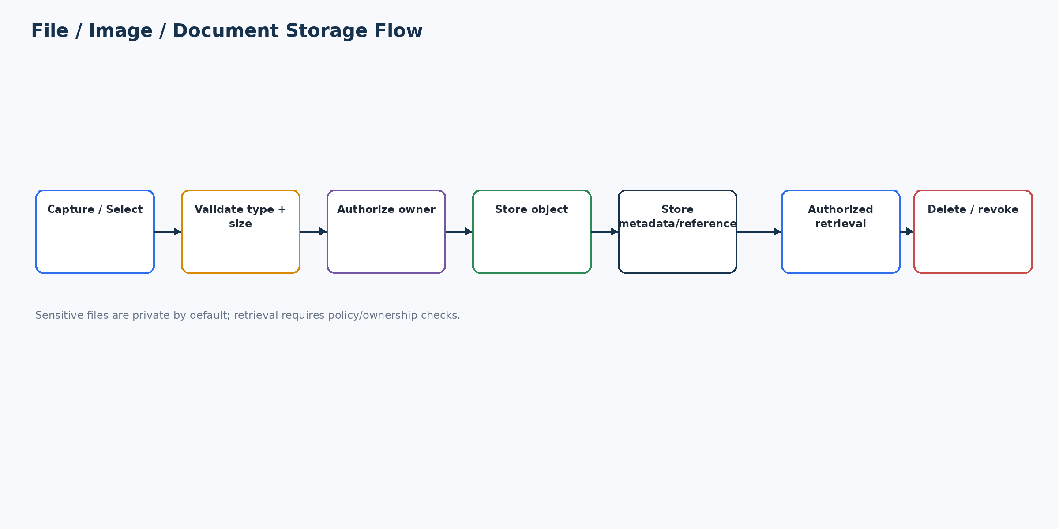
Figure 18. File / Image / Document Storage Flow — capture/select → validation → authorization → protected object storage → metadata/reference → authorized retrieval → deletion/revocation.

Appendix C — Source Consistency Principle
This backend document is downstream of product requirements and upstream of implementation code. Where the supplied source material establishes behavior, this design operationalizes it. Where it does not establish a provider, benchmark or implementation-specific mechanism, the design preserves that uncertainty as TBD — Backend Decision Required rather than silently inventing a technical fact.

