KABADIWALA CONNECT
System Architecture Document (SAD)
Smart India Hackathon 2026 • Problem Statement ID 26229
Kabadiwala Connect – Bringing the Informal Collector into the Formal Recycling Chain

Document Control | Value
Project | Smart India Hackathon 2026
Product | Kabadiwala Connect
Document | System Architecture Document
Version | 2.0 — Visual Architecture Edition
Date | 20 September 2026
Status | Architecture Blueprint — SIH Prototype / Production Evolution
Prepared By | TBD
Reviewed By | TBD
Approved By | TBD
SIH PS ID | 26229
Organization | Ministry of Mines (MoM)
Department | JNARDDC
Category / Theme | Software / Clean & Green Technology

1. Document Control
Version | Date | Change | Author | Status
1.0 | 20 Sep 2026 | Initial architecture baseline. | TBD | Superseded
2.0 | 20 Sep 2026 | Reworked into professional SAD with embedded visual architecture diagrams; no ASCII/Mermaid/text pseudo-diagrams. | TBD | Current

2. Architecture Purpose
This document defines how the complete Kabadiwala Connect software system is structured, how its components communicate, how data flows through the system, how users interact with role-specific experiences, how external services are isolated, and how the SIH prototype can evolve toward production.
It is deliberately an architecture document rather than another PRD or SRS. The supplied architecture specification explicitly distinguishes PRD, SRS and architecture concerns and requires a buildable, traceable architecture rather than architecture added for appearance. fileciteturn4file0L14-L34
Technology vendors and deployed integrations that were not established by the supplied project material are marked TBD or Proposed. No government integration, proprietary local AI model, performance benchmark, legal compliance claim, or existing CI/CD setup is presented as confirmed without source support.

3. Architecture Classification
Status | Meaning
Confirmed | Supported by the project requirements already established.
Proposed | Recommended design choice for implementation planning.
Prototype | Scope intended for the SIH screening/demo implementation.
Production | Hardening/scaling evolution, not a claim of current implementation.
Future Scope | Potential later capability outside the prototype boundary.
TBD | Requires explicit technical/product decision.

4. Architecture Principles
Principle | Architectural consequence
Simplicity | Use a modular monolith for the SIH prototype.
Modularity | Separate identity, collector, recycler, transaction, verification, AI, sync and supporting concerns.
Security by design | Backend authorization is authoritative; frontend visibility is not security.
Mobile-first | Collector workflow is optimized for small screens and low digital literacy.
Offline-first | Explicitly offline-capable operations use local persistence and a sync queue.
API-first | Role experiences consume controlled application interfaces.
Least privilege | Role and resource ownership restrict data and actions.
Privacy by design | Minimize identity, location, document and transaction exposure.
Replaceable integrations | AI, maps, voice, notifications and storage are accessed through boundaries/adapters.
Observability | Make authentication, transaction state, sync and external-service failures observable.
The source architecture specification also explicitly requires avoiding unnecessary microservices, message brokers, Kubernetes, event buses and distributed caches when they are not justified by actual requirements. fileciteturn4file0L1338-L1368

5. System Context
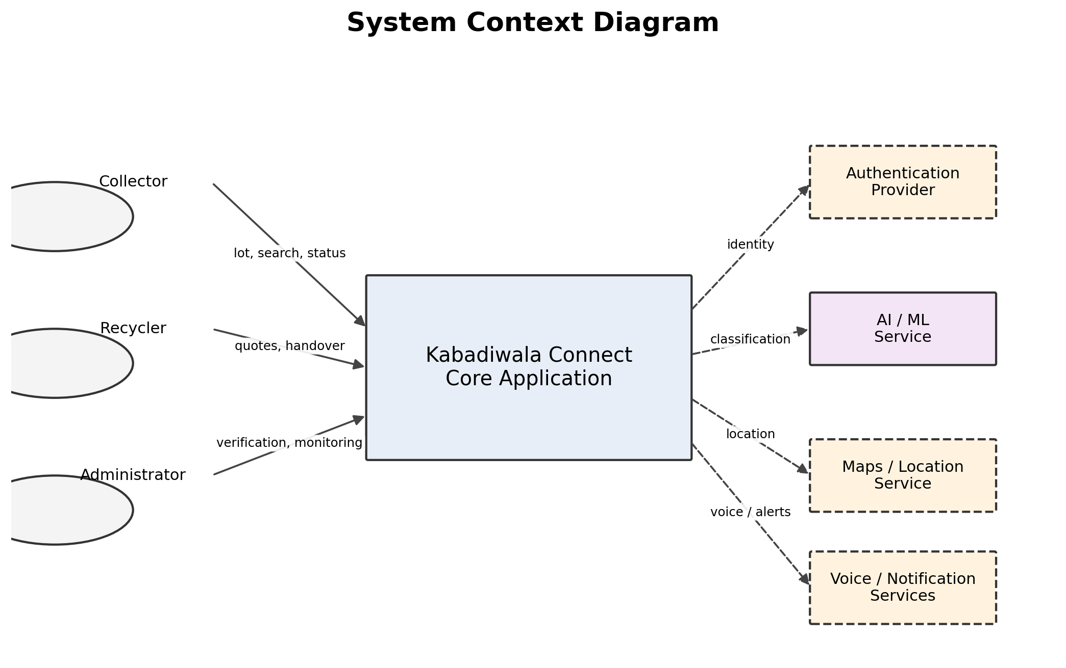
Figure 1. System Context Diagram
The system boundary contains the Kabadiwala Connect application and its role-specific experiences. Collectors, recyclers and administrators are the principal actors. Authentication, AI/ML, location, voice/notification and storage capabilities are external dependencies unless and until a concrete implementation makes one an internal component.
Actor / Dependency | Purpose | Status
Collector | Create lots, classify material, view price information, discover recyclers, manage quotes, handover and earnings. | Confirmed
Recycler / Aggregator | Receive eligible lots, provide quotes, participate in handover and payment recording. | Confirmed
Administrator | Verification, reference data, monitoring, audit and administrative controls. | Confirmed
Authentication provider | Identity and session establishment. | TBD provider
AI / ML | Assistive material classification/anomaly support where implemented. | Proposed / provider TBD
Maps / location | Location acquisition and recycler discovery/matching support. | Proposed / provider TBD
Voice | Speech interaction for supported languages. | Proposed / provider TBD
Notifications | Workflow updates and read status. | Proposed; exact channels TBD

6. High-Level Architecture
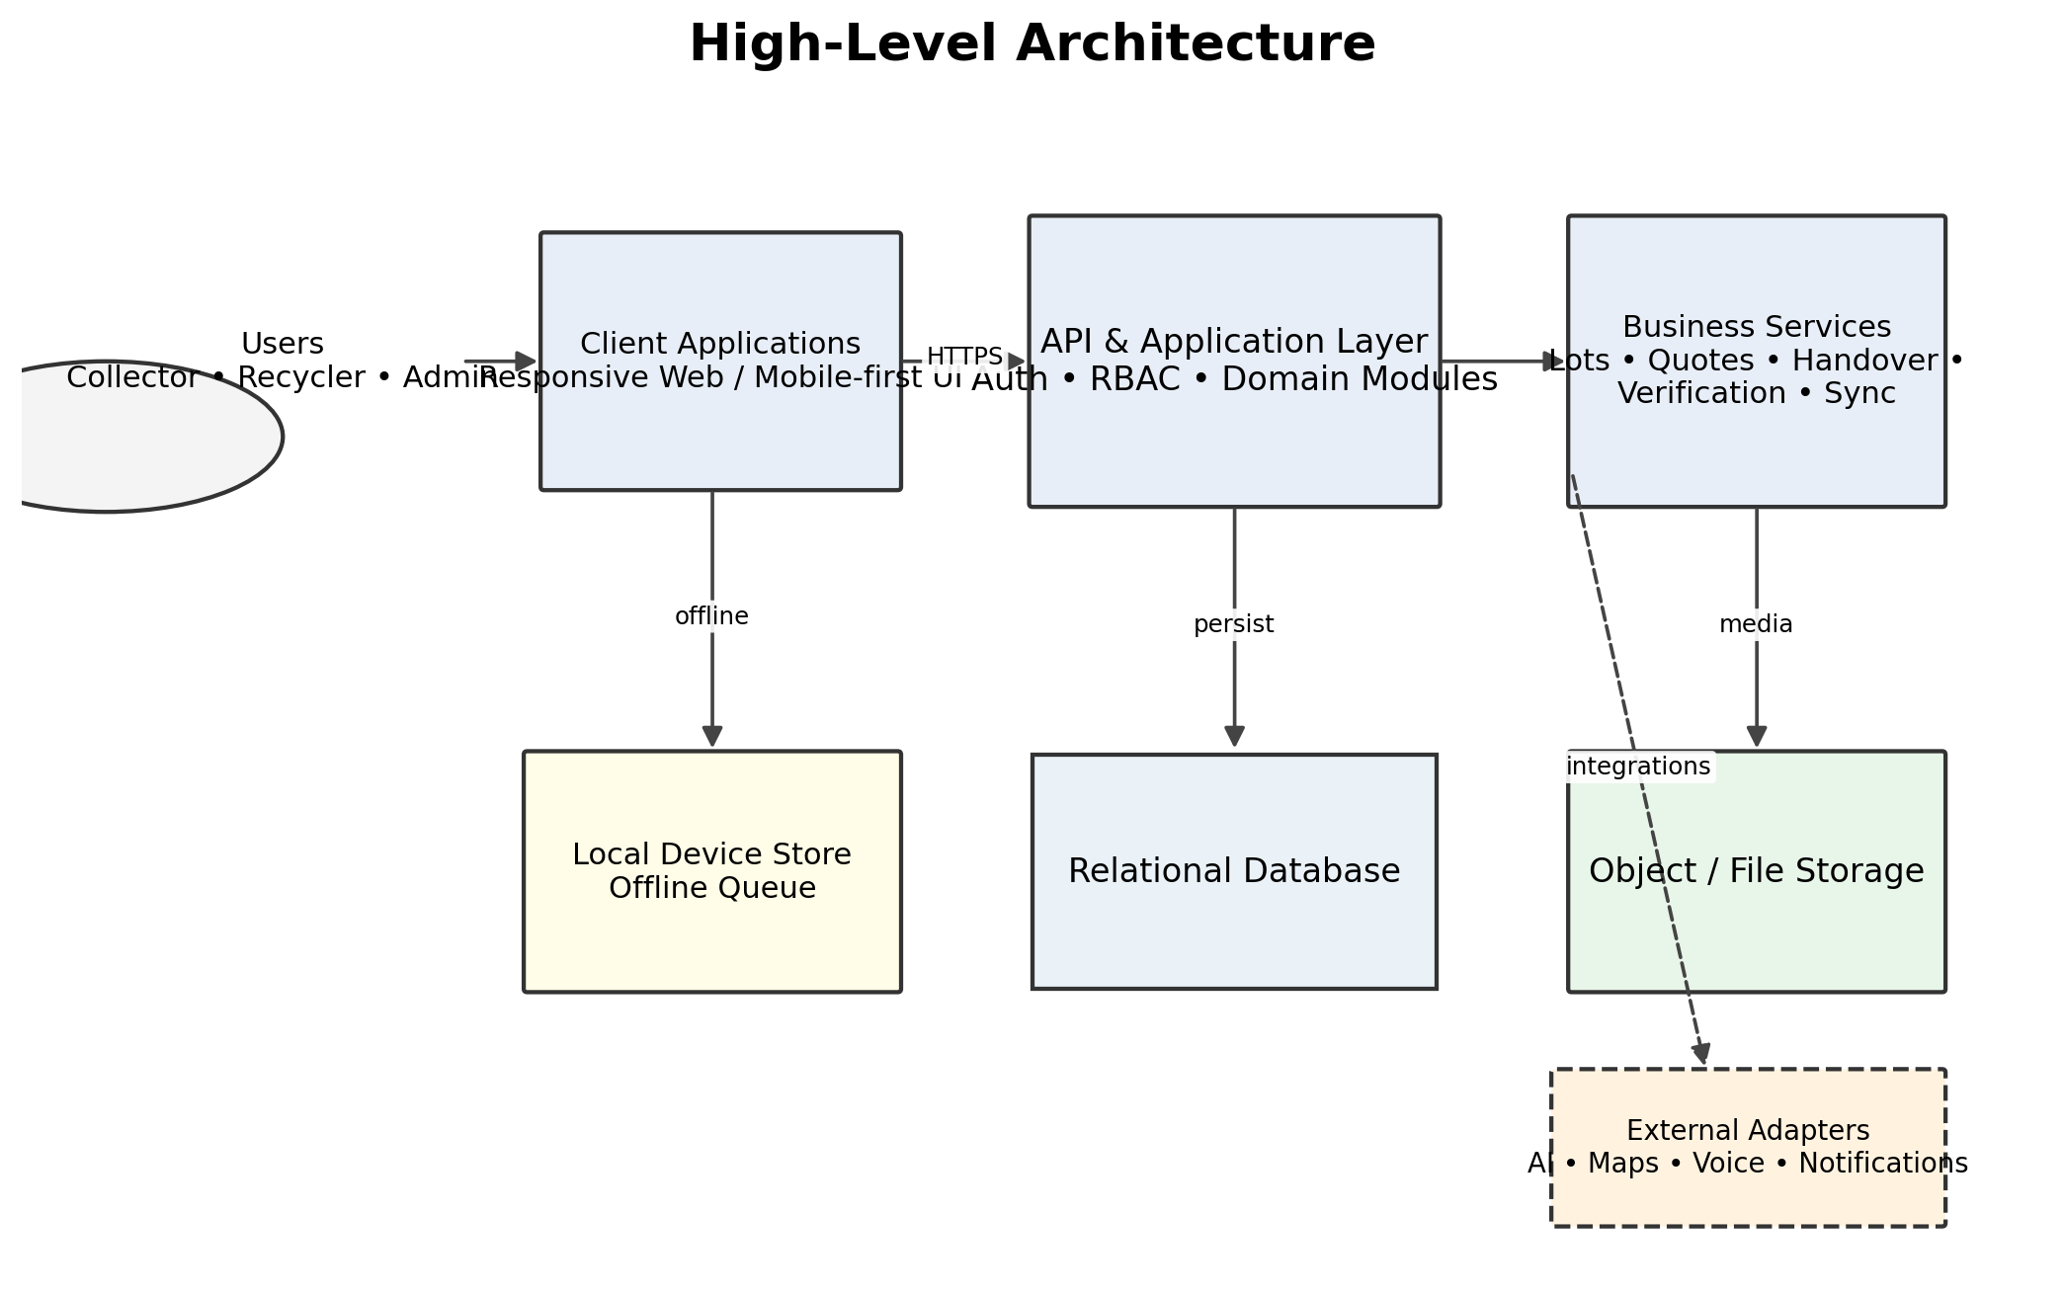
Figure 2. High-Level Architecture
The recommended SIH architecture is a layered client-server system with a modular backend. The relational database is the system of record, object storage handles large files, and external capabilities are isolated behind adapters.

7. Architectural Style
Decision | Selection | Status
Primary style | Layered client-server + modular monolith | Proposed
Prototype deployment | One deployable backend/API with internal domain modules | Prototype Target
Why | The product has a strongly connected transactional workflow and does not require independently deployed services for SIH. | Proposed
Alternatives considered | Microservices, event-driven distributed services, serverless-per-feature | Considered
Production path | Extract only modules that demonstrate an actual need for independent scale, isolation or ownership. | Production Evolution

8. Logical Architecture
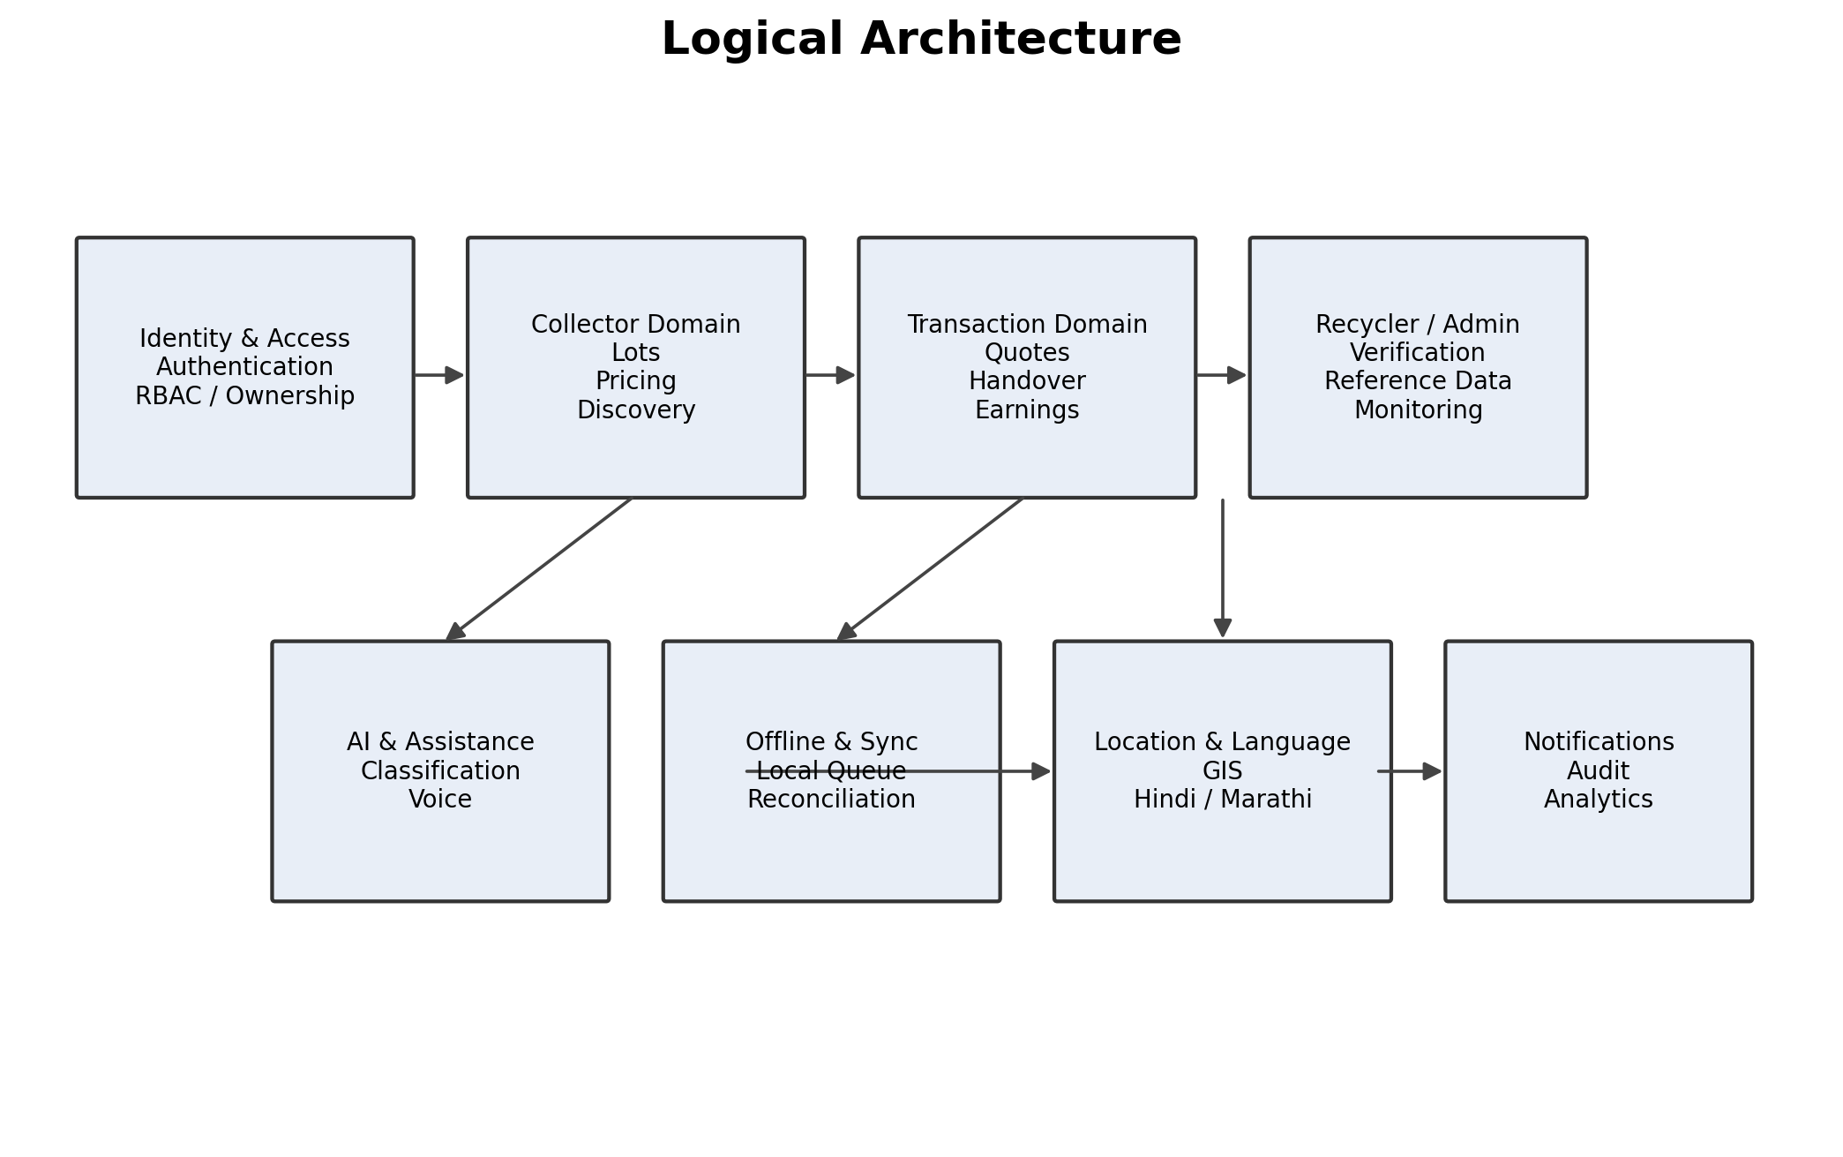
Figure 3. Logical Architecture
The logical model groups business responsibilities without implying separate deployment units. This keeps the prototype simple while preserving clean module boundaries for future evolution.
Module ID | Module | Core responsibility | Status
M-01 | Authentication & Session | Identity, login/logout, session lifecycle. | Confirmed requirement / provider TBD
M-02 | RBAC & Authorization | Role, permission and resource ownership checks. | Confirmed
M-03 | User & Profile | Role-specific profile and preferences. | Confirmed
M-04 | Collector Lot | Lot creation, material details, photos, weight and state. | Confirmed
M-05 | Material Classification | AI-assisted classification with manual correction/fallback. | Confirmed requirement; implementation TBD
M-06 | Price & Estimation | Reference prices and approximate value estimation. | Confirmed
M-07 | Recycler Discovery & Matching | Discover suitable formal recycling partners. | Confirmed
M-08 | Quote & Transaction | Quote lifecycle and transaction state transitions. | Confirmed
M-09 | Handover & Earnings | Digital handover, payment record and earnings history. | Confirmed
M-10 | Verification | Recycler verification/evidence review. | Confirmed
M-11 | Offline & Synchronization | Local queue, retries, reconciliation and sync status. | Confirmed
M-12 | Location / GIS | Device/manual location and matching support. | Confirmed
M-13 | Voice & Language | Hindi/Marathi localization and voice abstraction. | Confirmed
M-14 | Notifications | Workflow notifications and read status. | Confirmed requirement; channel TBD
M-15 | Admin & Analytics | Reference data, monitoring, audit and aggregate reporting. | Confirmed

9. Deployment Architecture
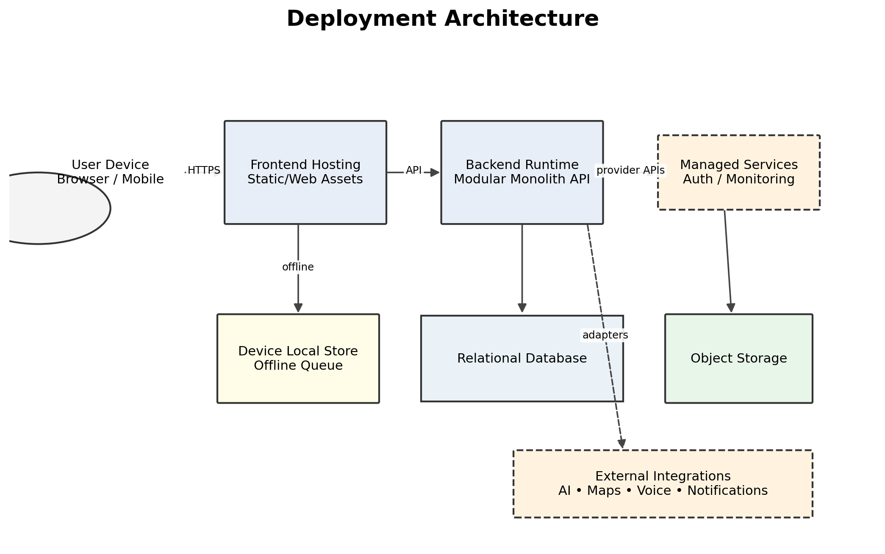
Figure 4. Deployment Architecture
This is the target SIH deployment shape. Exact frontend hosting, backend hosting, database vendor, authentication provider and storage provider remain technology decisions unless independently confirmed by the implementation team.

10. Component Architecture
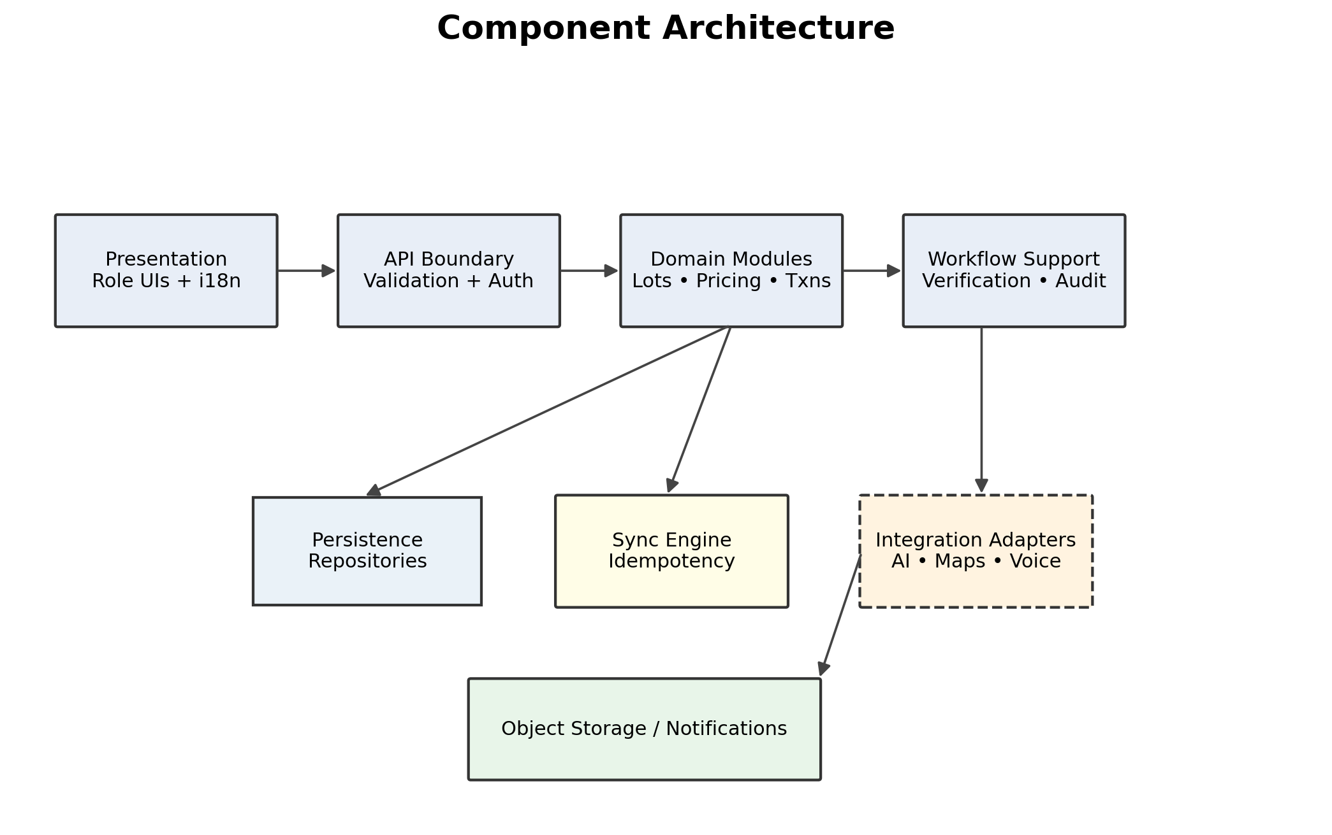
Figure 5. Component Architecture
Major components are bounded by responsibility. The API boundary handles authentication, authorization and validation before business modules access persistence or external adapters.

11. Frontend Architecture
- Role-aware application shell with protected route groups for Collector, Recycler and Administrator.
- Shared UI components for navigation, forms, image capture/upload, language selection, status indicators and error/loading states.
- API client layer centralizes authenticated calls and standardized errors.
- Offline layer owns local drafts and pending operations for explicitly supported workflows.
- Localization resources are separated from business logic.
- Voice interaction sits above existing application actions; it does not duplicate domain logic.
- Exact frontend framework/version is TBD unless an implementation source confirms it.

12. Role-Based Application Architecture
Role | Primary capabilities | Authorization boundary
Collector | Own lots, discover recyclers, receive/accept quotes, confirm handover, view earnings. | Authenticated collector + resource ownership.
Recycler | Manage recycler profile, access eligible/shared lots, submit quotes, confirm handover/payment records. | Authenticated recycler + verification/state constraints.
Administrator | Verification, reference data, monitoring, audit and administrative controls. | Explicit privileged permissions + audit.
Changing a URL, browser state or frontend role selector must never grant access. Backend authorization must independently validate identity, role, permission and resource ownership.

13. Backend Architecture
Concern | Architecture
API entry | Authenticated HTTPS requests.
Authentication | Managed provider boundary; exact provider TBD.
Authorization | RBAC + permission + resource ownership.
Validation | Schema and domain validation before state changes.
Business logic | Domain modules enforce state transitions and business rules.
Persistence | Relational database and object storage through controlled adapters.
External services | AI/maps/voice/notifications behind integration boundaries.
Errors | Structured, safe errors; no secrets or sensitive internals exposed.
Background work | Introduce only where necessary for heavy/asynchronous operations; not required as a distributed architecture for SIH.

14. API Architecture
Concern | Design
API style | HTTPS JSON API; exact framework TBD.
Authentication | Protected requests require authenticated session/token.
Authorization | Server-side role/permission/ownership enforcement.
Validation | Request schema validation + domain validation.
Errors | Stable machine-readable code + safe user-facing message.
Pagination | Required for growing lists/history.
Filtering | Server-side for status/material/location and other documented filters.
Rate limiting | Production control; thresholds TBD.
Versioning | Introduce explicit versioning for breaking public API changes.
Idempotency | Required for sync/retry-sensitive writes.
Detailed endpoint specifications should be maintained in a separate API document; this SAD defines the architectural boundary rather than inventing endpoints not required by the SRS.

15. Database Architecture
Entity | Purpose | Access principle
Users / Profiles / Roles | Identity and role-specific data. | User-scoped; privileged fields restricted.
Material Lots | Material, photo references, weight, category, location and status. | Collector-owned until workflow sharing.
Price Data | Reference price information and effective dates. | Admin-managed; broadly readable as allowed.
Recycler Records | Recycler profile, location and verification status. | Recycler-managed; admin verified.
Quotes / Transactions | Commercial workflow and state. | Participant-scoped; audited.
Handover / Payment | Final handover evidence and payment record. | Participant-scoped; audited.
Verification | Evidence, review decision and status. | Admin/reviewer scoped.
Notifications | Recipient delivery/read state. | Recipient scoped.
AI Results | Classification suggestions/confidence. | Lot scoped.
Audit Events | Security, administrative and domain audit trail. | Privileged append/read access.
A relational database is proposed as the system of record because the domain has strong relationships and stateful transactions. Exact engine/provider is TBD. Large binary files should be stored in object storage rather than relational rows.

16. Data Flow Architecture
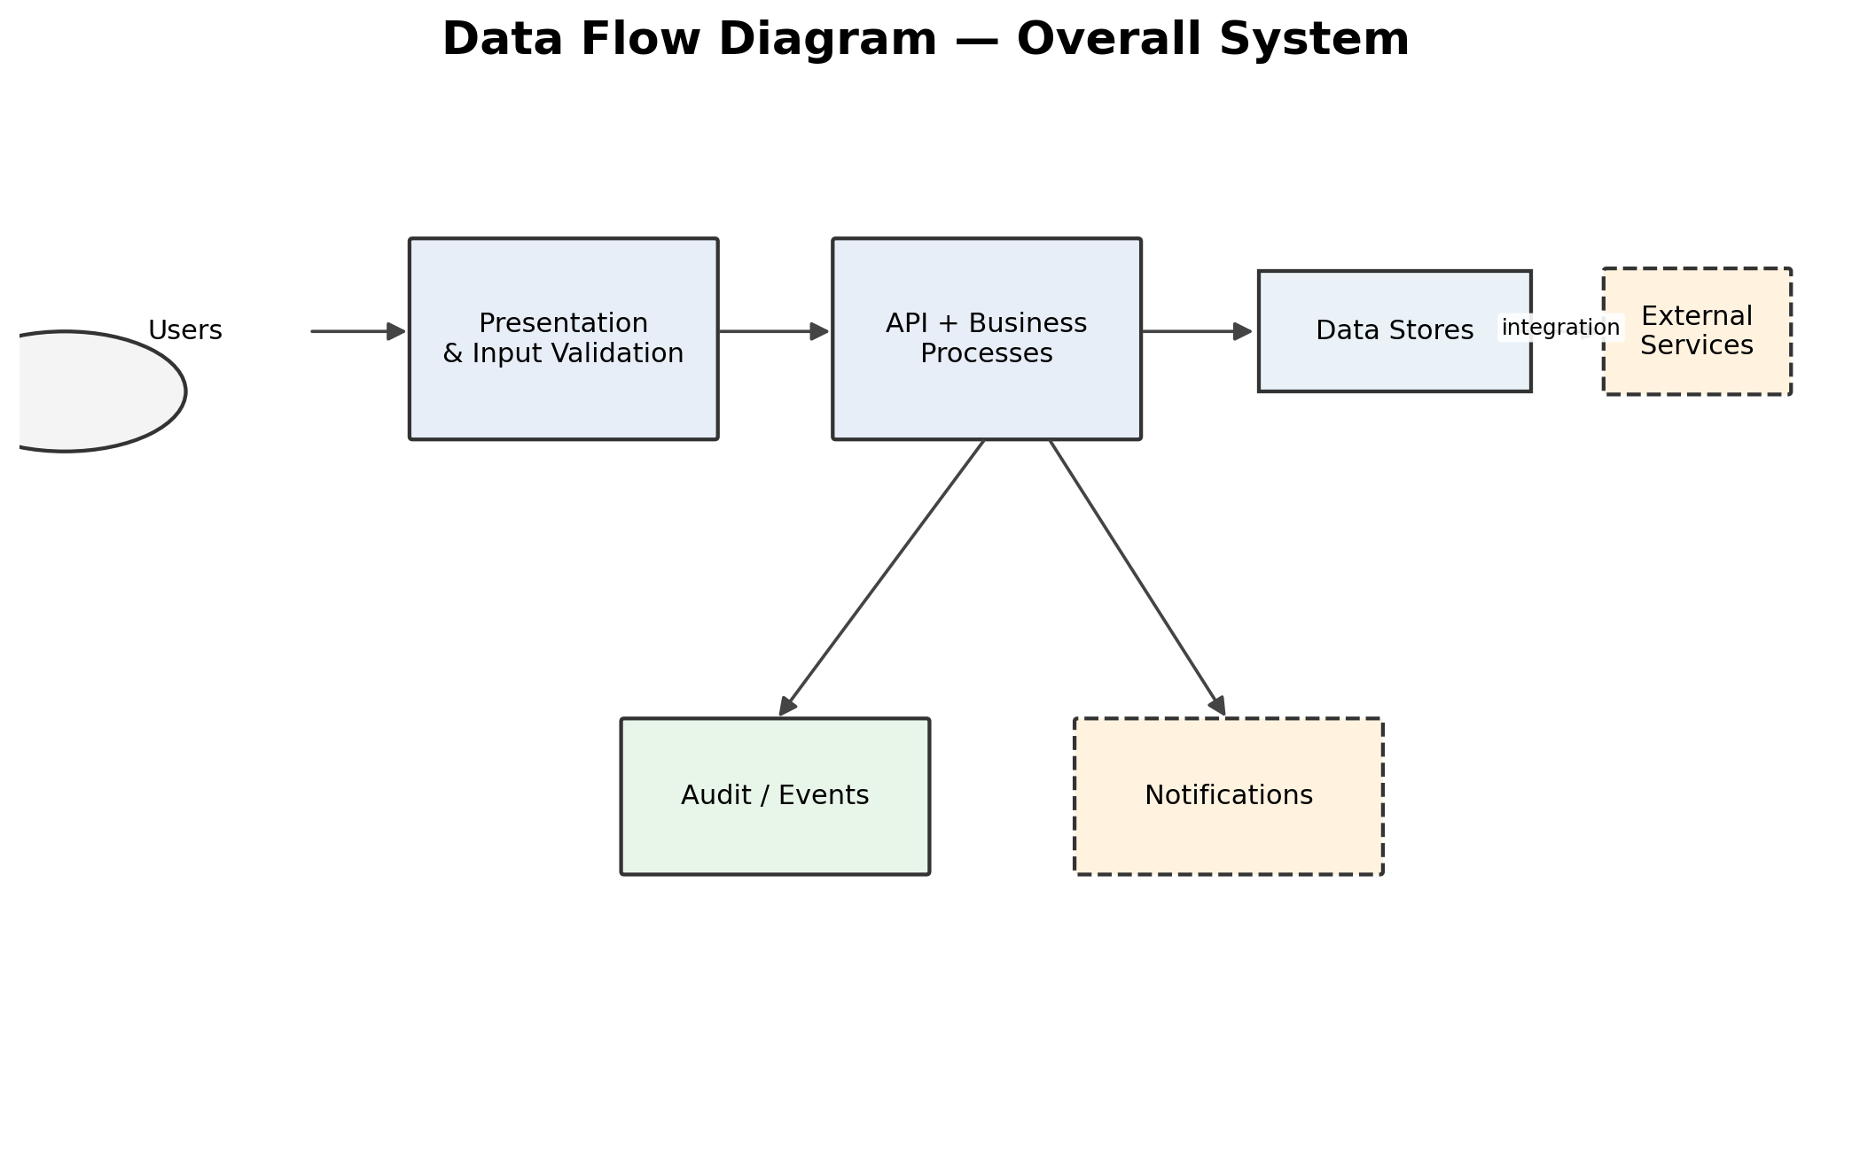
Figure 6. Data Flow Diagram — Overall System
The overall data flow separates presentation, business processing, persistence, audit and external service interactions. Server-side business logic remains authoritative.
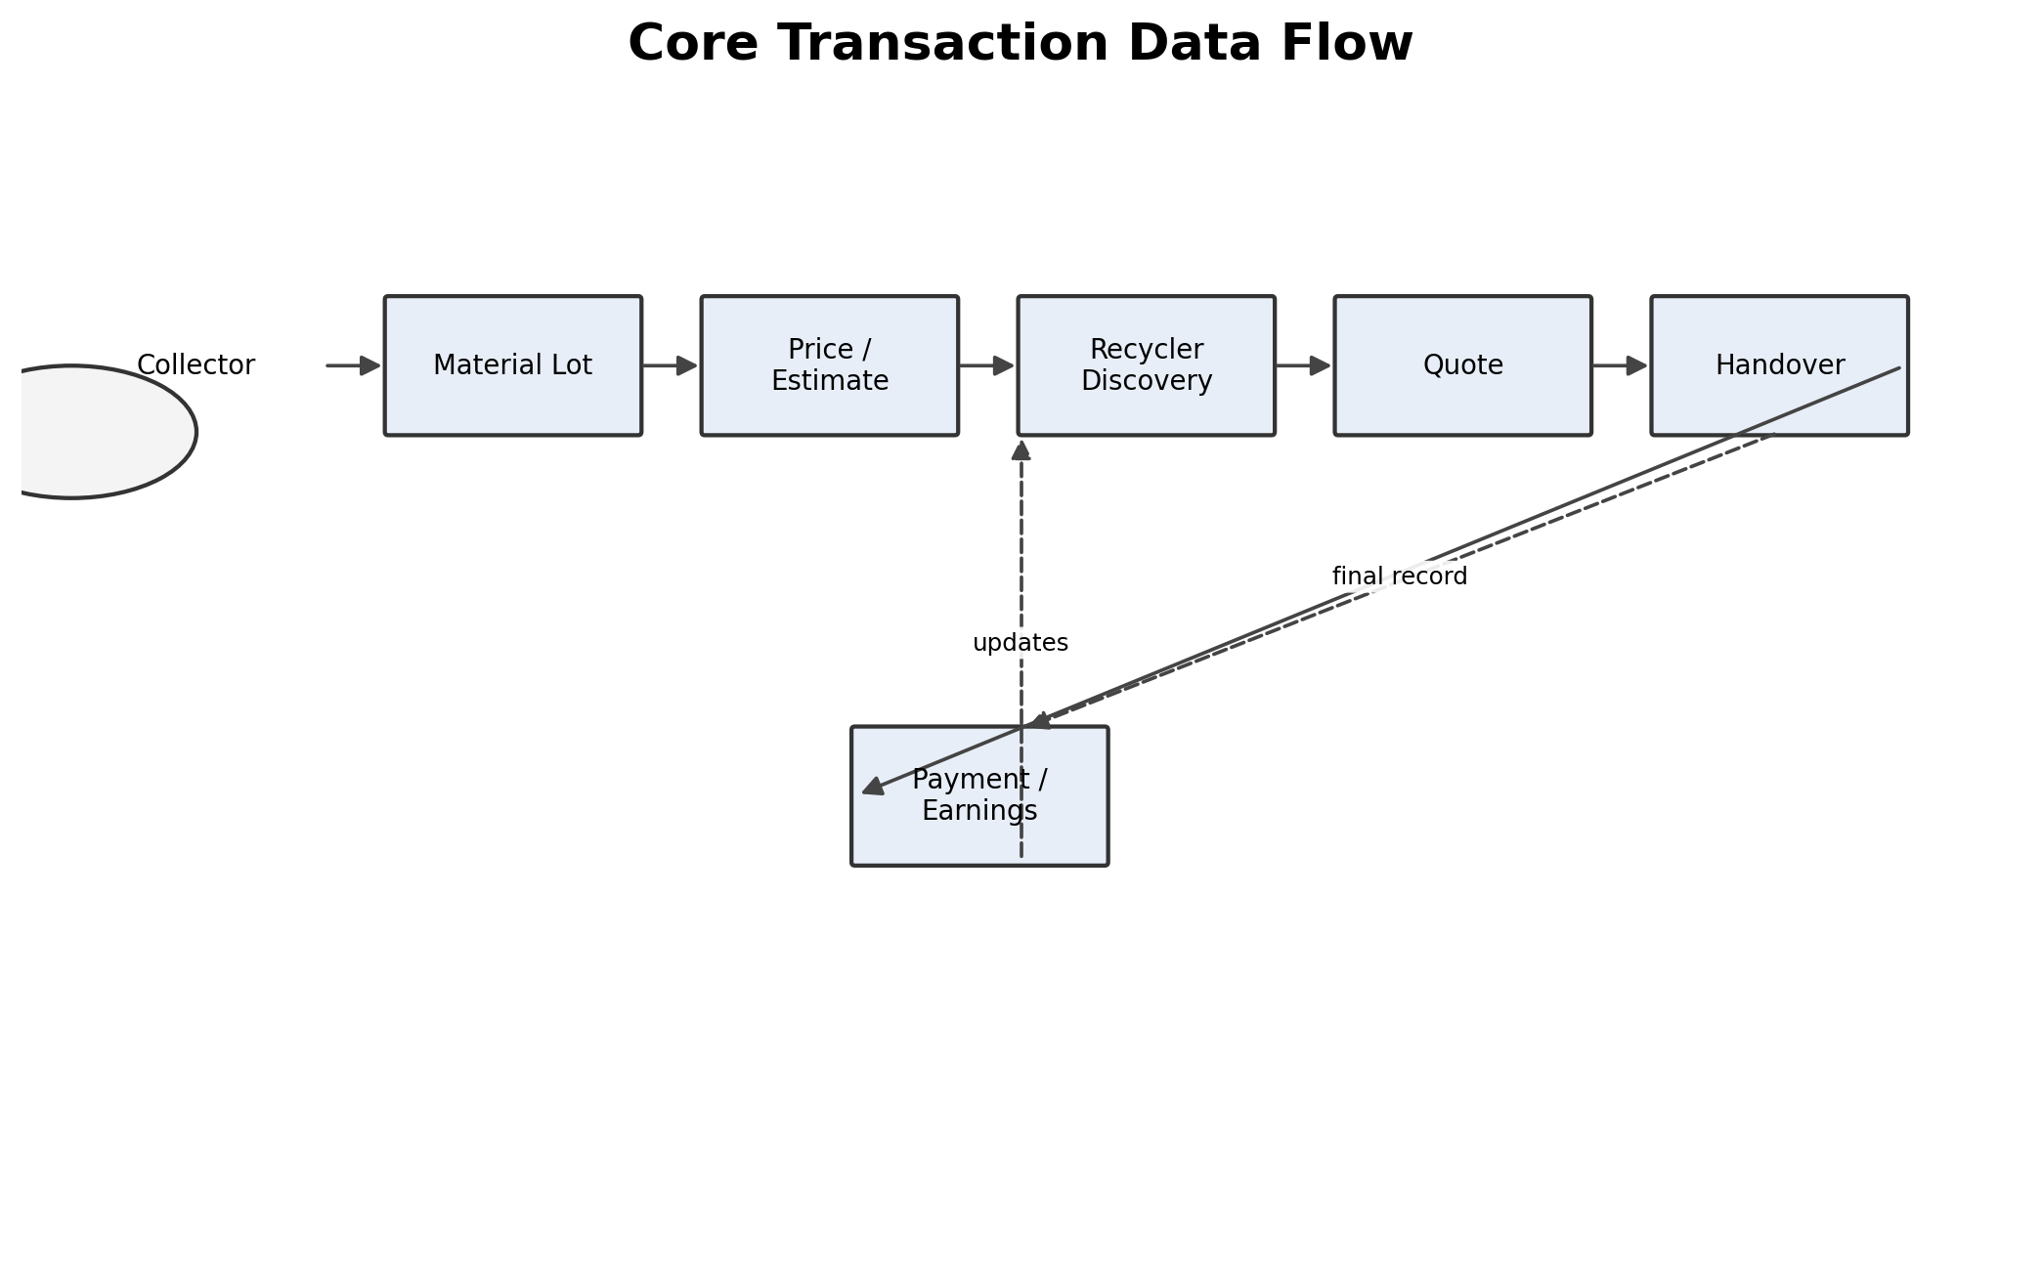
Figure 7. Core Transaction Data Flow
The core workflow begins with collector lot creation and ends in traceable handover/payment records and earnings history. The state machine defined in the SRS remains the authoritative transaction lifecycle.

17. Authentication Architecture
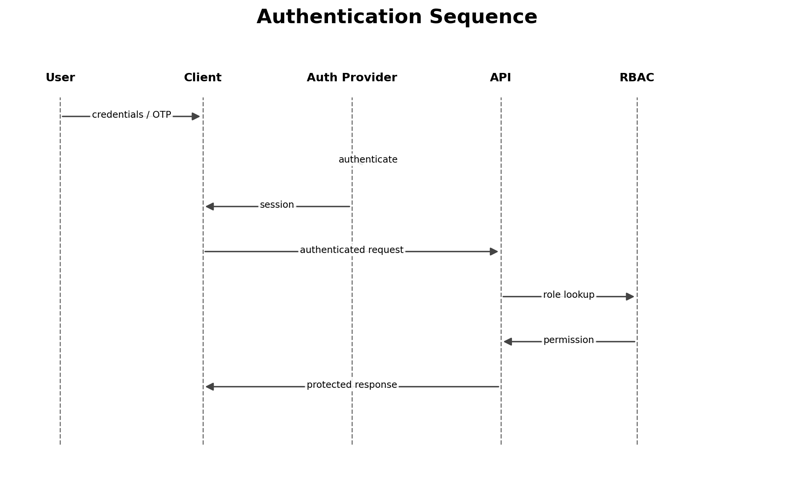
Figure 8. Authentication Sequence
Authentication establishes identity and a protected session. Role resolution and authorization occur after authentication and before protected resources are accessed. The provider is not treated as confirmed until the implementation team records the final technology decision.

18. Authorization Architecture
- Frontend route guards improve usability but are not security controls.
- Backend checks authenticated identity, role, permission and resource ownership.
- Sensitive administrative actions are audited.
- Database queries are scoped to authorized resources; additional row-level controls may be used where supported by the selected database.
- Unauthorized requests fail closed.

19. AI / ML Architecture
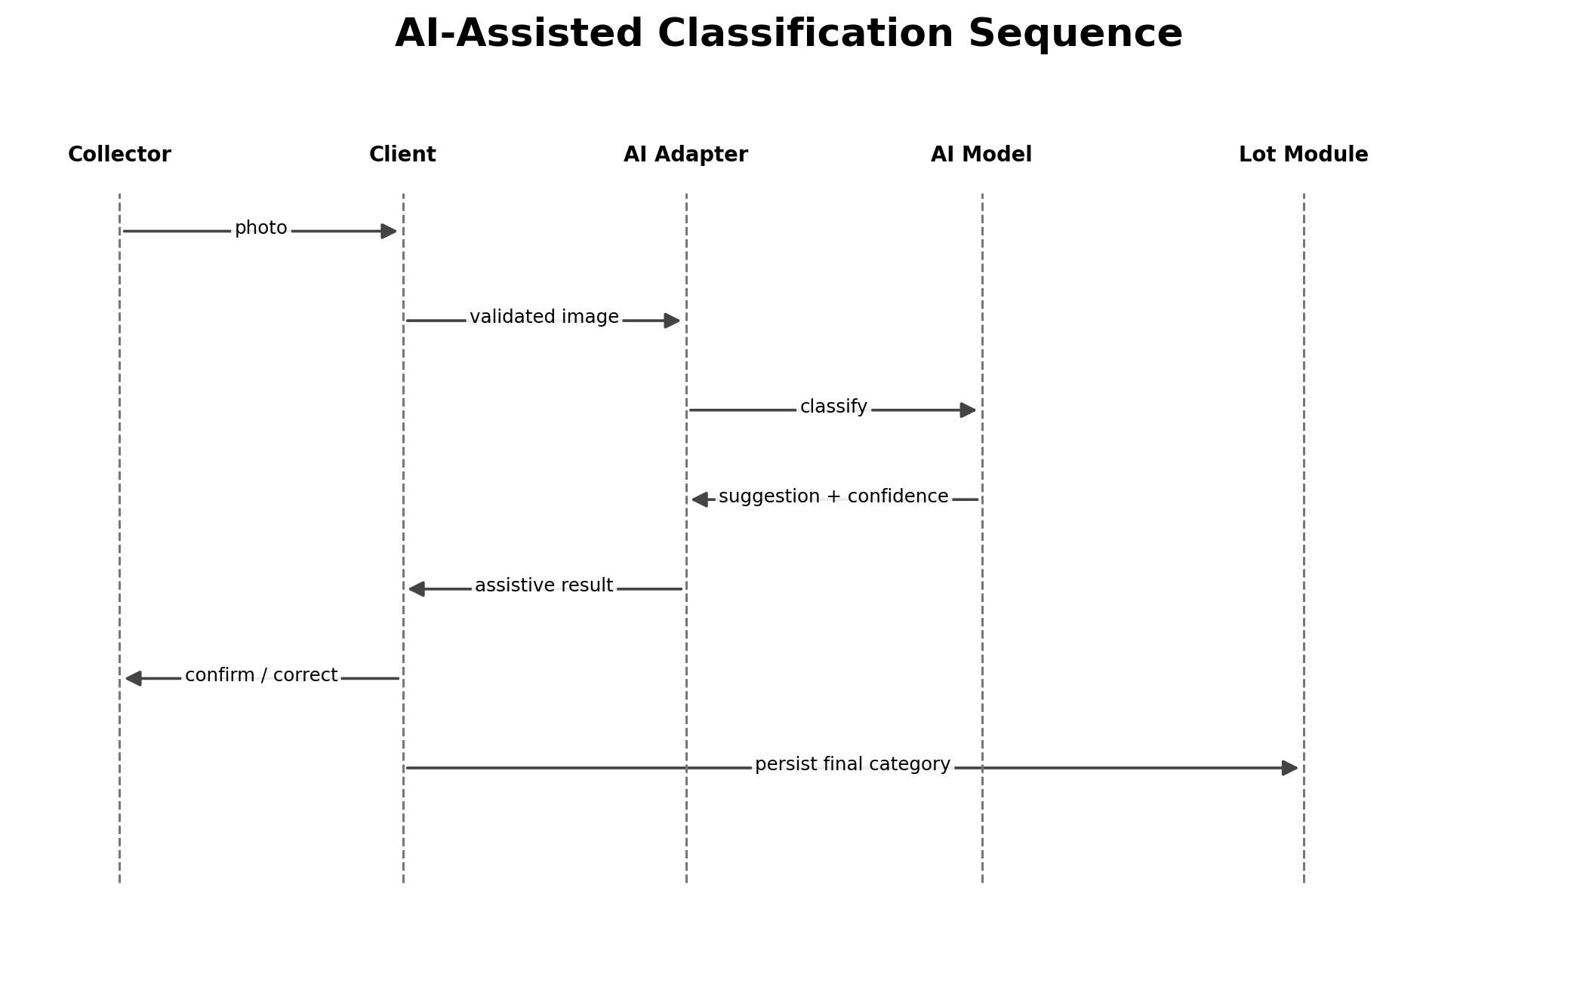
Figure 10. AI-Assisted Classification Sequence
AI is assistive. The user remains able to correct the classification, and a low-confidence, timed-out or unavailable model falls back to manual classification. No proprietary local model is claimed.
AI concern | Architecture
Input | Validated material image/user input.
Preprocessing | Size/type validation and any required image normalization.
Inference | External/hosted model through an adapter; exact model TBD.
Output | Suggested category + confidence/uncertainty.
Authority | User-confirmed category is authoritative for the lot.
Timeout/failure | Manual classification fallback.
Privacy | Minimize data sent to the AI provider; review provider retention before production.
Cost | Bound requests and evaluate whether AI adds sufficient value.

20. Voice Architecture
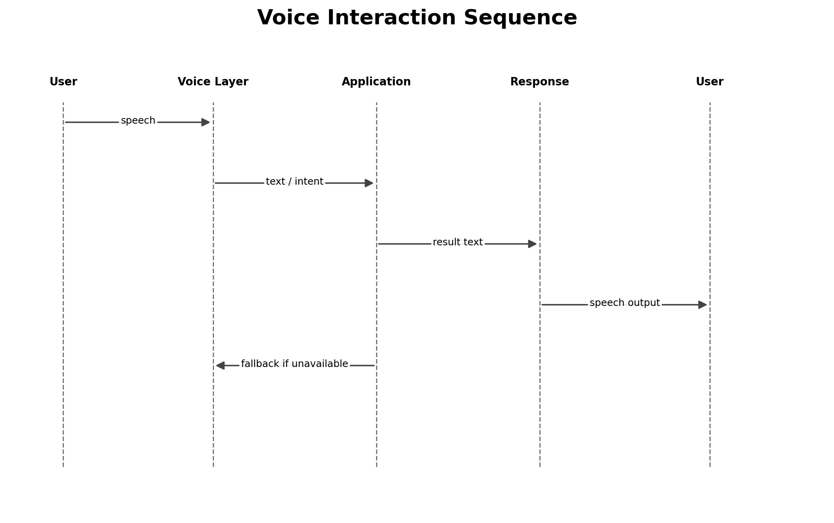
Figure 11. Voice Interaction Sequence
Voice is an accessibility layer over the same application logic. Hindi and Marathi are the documented target languages. Exact browser/device capability or external provider is TBD. Core workflows must remain usable without voice.

21. Regional Language Architecture
- UI strings are maintained in language resource bundles.
- Language selection is persisted for the user/device.
- Hindi and Marathi are P0 target languages.
- Dynamic domain content uses stable identifiers and localized labels.
- Missing translations fall back to the configured fallback language and are logged for correction.
- New Indian languages should be addable through resource/voice mapping changes rather than business-logic rewrites.

22. Location / GIS Architecture
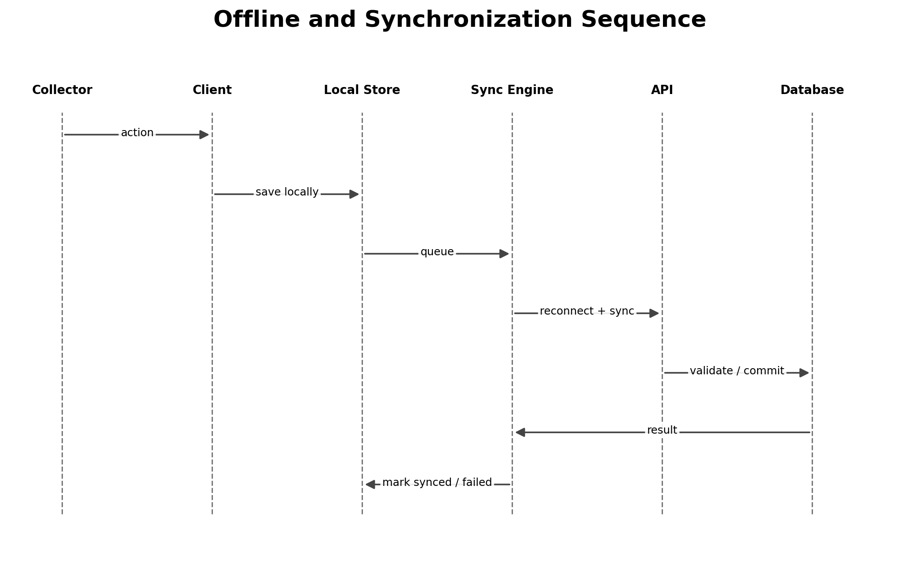
Figure 13. Offline and Synchronization Sequence
Location may originate from device GPS or a user-defined location. Permission, accuracy and normalization occur before location is used for recycler discovery, matching or traceability. Manual fallback prevents location failure from blocking the entire product.

23. Offline-First Architecture
Capability | Offline behavior
Create/edit lot draft | Supported locally.
Capture photo | Supported locally when device permits.
Category/weight entry | Supported locally.
Cached reference data | Available only for data already cached.
AI classification | May be unavailable; manual fallback.
Live recycler discovery | Normally requires connectivity.
Quote retrieval | Requires connectivity.
Handover/payment sync | Can queue supported writes for later synchronization.
The architecture does not claim that every feature is fully offline. The offline boundary is intentionally limited to the capabilities that can be safely represented and synchronized later.

24. Synchronization Architecture
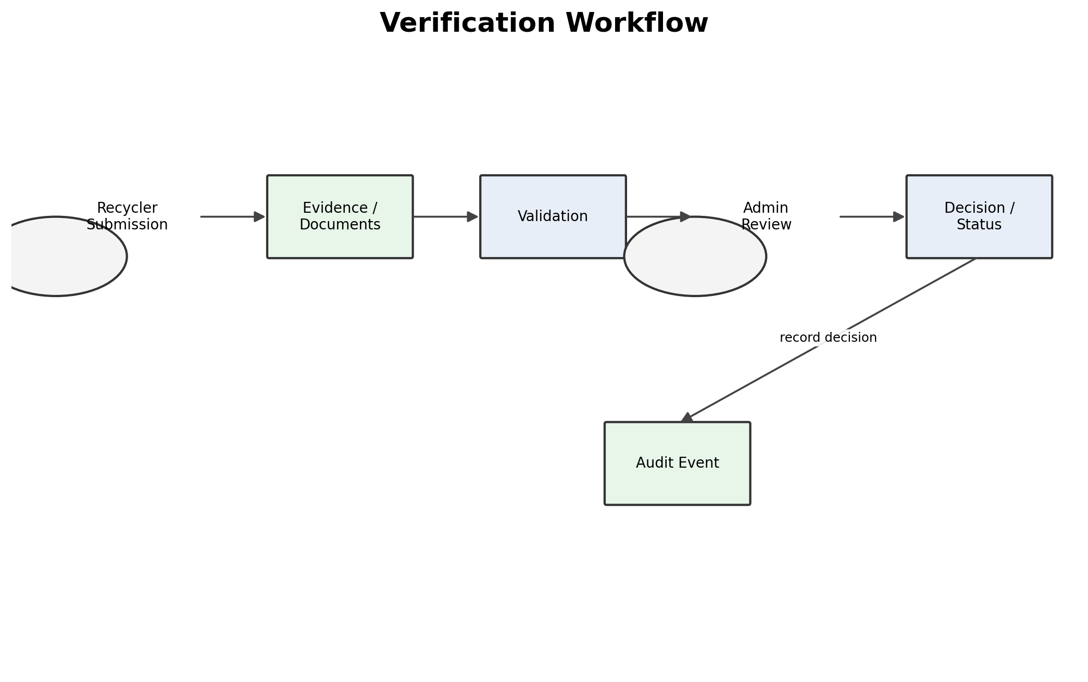
Figure 14. Verification Workflow
Local operations are queued while offline. On reconnection, the sync engine submits idempotent operations to the server, where validation and business rules remain authoritative.
Sync concern | Design
Queue record | Operation ID, entity ID, operation type, payload, timestamp, retry count and status.
Ordering | Preserve dependencies between related operations.
Idempotency | Stable operation IDs/idempotency keys prevent duplicate application.
Conflict | Server state and transaction rules are authoritative.
Retry | Transient failures are retried; exact backoff is TBD.
Partial failure | Each operation receives its own success/failure status.
Recovery | Failed operations remain available for controlled retry/reconciliation.

25. Verification Architecture

25. Verification Architecture
Figure 14. Verification Workflow
Verification follows submission, evidence capture, validation, administrative review, decision/status and audit. It does not imply government verification unless an actual government integration exists.

26. Notification Architecture
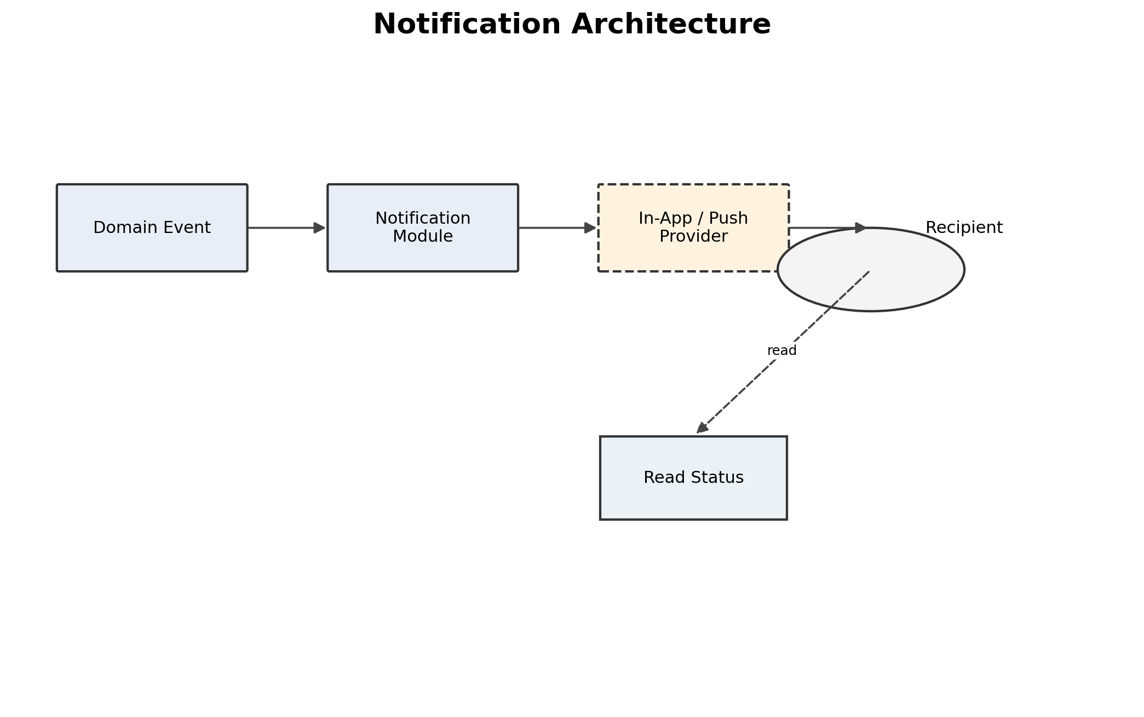
Figure 15. Notification Architecture
Workflow events feed the notification module. Delivery may be in-app or through a configured push channel. Notification failure must not invalidate a completed domain transaction.

27. Security Architecture
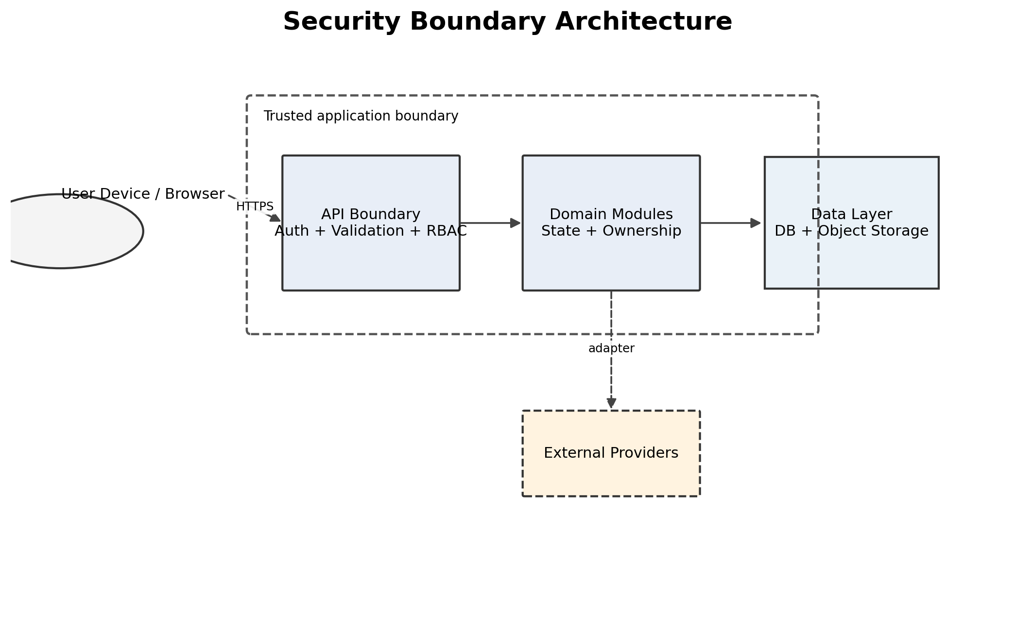
Figure 16. Security Boundary Architecture
The principal trust boundary is the application API. User devices and external providers are treated as untrusted or externally controlled. Authorization, validation and safe data access occur inside the application boundary.

28. Privacy Architecture
Data category | Architectural treatment
Personal identity / phone | Collect only required fields; role-scoped access.
Documents | Protected object storage with resource-scoped retrieval.
Location | Collect only when workflow requires it; avoid unnecessary precision.
Transaction history | Participant-scoped access; administrative access audited.
AI inputs | Transmit only necessary inputs; provider retention must be reviewed.
Logs | Never log passwords, session secrets or unnecessary personal data.
The architecture does not claim legal compliance. Retention, deletion, consent and regulatory controls require final legal/product review before production.

29. Failure-Tolerance Architecture
Failure | System response | Fallback
Authentication unavailable | Return controlled error; do not bypass authentication. | Preserve local drafts where possible.
Database unavailable | Reject remote write/read with controlled error. | Retain local offline state where supported.
AI unavailable | Timeout/error/low confidence. | Manual classification.
Voice unavailable | Permission/provider failure. | Visual/touch workflow.
Maps unavailable | Location/search degraded. | Manual location or non-map discovery.
Network unavailable | Detect offline state. | Local queue + later synchronization.
Storage unavailable | Upload not finalized. | Retry/re-upload; do not create false completion state.

30. External Service Architecture
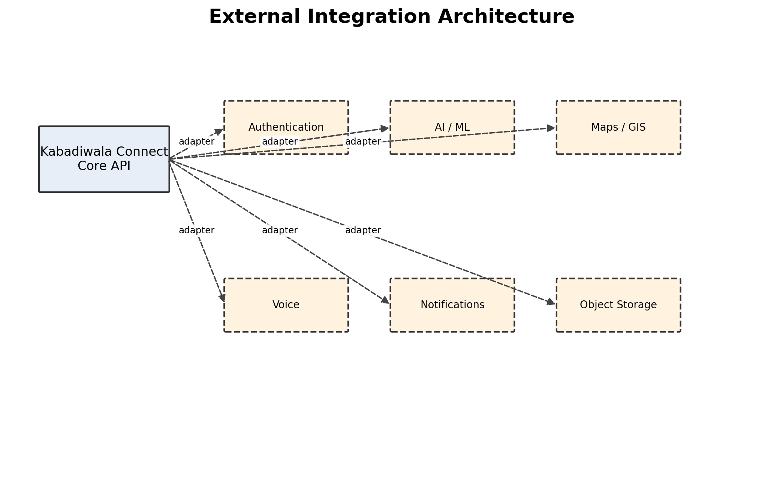
Figure 17. External Integration Architecture
External capabilities are isolated behind adapters. This limits vendor coupling and makes provider failures visible and replaceable. Exact vendors are TBD unless separately confirmed.
Service | Purpose | Dependency | Fallback | Status
Authentication | Identity/session | Critical | No bypass; retry/re-authenticate | TBD
AI/ML | Material assistance | Important | Manual classification | TBD
Maps/GIS | Location/search | Important | Manual location | TBD
Voice | Speech interaction | Important | Visual/touch UI | TBD
Notifications | Alerts | Important | In-app state | TBD
Object storage | Photos/documents | Critical | Retry upload | TBD

31. Observability Architecture
- Structured application and error logs with correlation/request identifiers.
- Authentication failure and privileged-action monitoring.
- Transaction state and handover monitoring.
- Offline queue and synchronization success/failure monitoring.
- AI timeout/fallback monitoring.
- External-service failure monitoring.
- Prototype dashboards should expose enough state to demonstrate a real connected workflow; production adds centralized logs, metrics, traces and alerting.

32. Caching Architecture
Cache | Use | Constraint
Price reference cache | Support offline viewing of recent reference information. | Timestamped; not presented as guaranteed live price.
Recycler directory cache | Reduce repeated lookups where useful. | Must not override current verification/status.
Static assets | Improve application loading. | Versioned assets.
Sensitive transaction state | Avoid broad client caching. | Prefer authoritative server state.

33. File / Image Storage Architecture
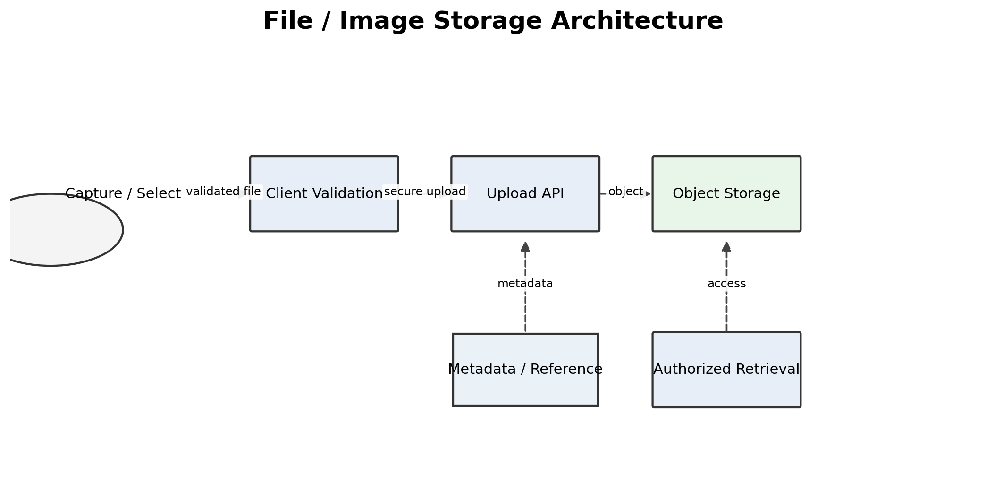
Figure 18. File / Image Storage Architecture
Material images and verification documents are stored as objects, while the relational database retains secure metadata and references. Access is authorized against the associated resource.

34. Performance Architecture
- Paginate growing histories and directories.
- Compress/resize material images before upload where acceptable.
- Index common lookup fields such as owner, status, category, verification state and timestamps.
- Do not block basic lot creation on a slow AI provider; use bounded timeouts and manual fallback.
- Keep offline caches scoped and bounded.
- Use measurable SRS targets once the finalized SRS defines them; this SAD does not fabricate benchmarks.

35. Scalability Architecture
Stage | Architecture evolution
SIH prototype | Single modular backend, managed DB/storage, bounded integrations.
Pilot / City | Indexing review, connection pooling, stronger monitoring, background jobs where useful.
District / State | Horizontal API scaling, CDN, asynchronous workers for heavy tasks, storage lifecycle controls.
National | Selective service extraction, regionalization/partitioning and advanced HA only when measured requirements justify them.
The system should evolve based on observed bottlenecks rather than adopting distributed infrastructure preemptively.

36. High Availability / Disaster Recovery
Prototype: use managed backup/redeploy capabilities available from the chosen platform and keep deployment reproducible. Production: define backup frequency, point-in-time recovery, object-storage versioning, restore testing, redundancy and recovery objectives after operational requirements are known. RPO/RTO values remain TBD.

37. Technology Stack and Decision Status
Layer | Current architecture position | Status
Frontend | Responsive role-based web/mobile-first client; framework/version not established in the supplied material. | TBD
Backend | Modular monolith API. | Proposed
Database | Relational system of record. | Proposed; engine TBD
Authentication | Managed authentication provider boundary. | TBD
Object storage | Separate object/file storage. | Proposed; provider TBD
AI | Replaceable assistive model/service adapter. | Proposed; provider/model TBD
Voice | Device/provider abstraction. | Proposed; provider TBD
Maps | Location/GIS provider abstraction. | Proposed; provider TBD
Hosting | Reproducible managed deployment. | TBD
Monitoring | Structured logging + error monitoring; production observability later. | Proposed

38. Architecture Decision Records

ADR-001 — Modular Monolith
Field | Content
Context | SIH needs a complete connected workflow without unnecessary operational complexity.
Decision | Use one backend deployment with clear domain modules.
Alternatives | Microservices / event-driven distributed architecture.
Trade-off | Simpler deployment; selective future extraction remains possible.
Status | Proposed unless implementation evidence changes it.

ADR-002 — Relational System of Record
Field | Content
Context | Lots, quotes, transactions, handovers and verification have strong relationships and state transitions.
Decision | Use a relational database.
Alternatives | Document database.
Trade-off | Schema management is required, but transactional integrity is strong.
Status | Proposed unless implementation evidence changes it.

ADR-003 — AI Adapter + Manual Fallback
Field | Content
Context | AI is assistive, not authoritative.
Decision | Isolate model/provider behind an adapter and retain manual correction.
Alternatives | Hard-coded AI dependency.
Trade-off | Adds a boundary but improves resilience and replaceability.
Status | Proposed unless implementation evidence changes it.

ADR-004 — Offline Queue
Field | Content
Context | Collector connectivity may be intermittent.
Decision | Persist supported local operations and synchronize later with idempotency.
Alternatives | Online-only workflow.
Trade-off | Adds synchronization complexity but supports the documented collector context.
Status | Proposed unless implementation evidence changes it.

ADR-005 — Backend RBAC + Ownership
Field | Content
Context | Multiple roles access sensitive resources.
Decision | Enforce authorization server-side.
Alternatives | Frontend-only route guards.
Trade-off | More backend checks; substantially stronger security boundary.
Status | Proposed unless implementation evidence changes it.

ADR-006 — Object Storage for Media
Field | Content
Context | Photos/documents are large binaries.
Decision | Store objects separately and keep metadata/reference in DB.
Alternatives | Binary DB columns.
Trade-off | Adds storage dependency but is operationally appropriate.
Status | Proposed unless implementation evidence changes it.

39. Environment Architecture
Environment | Purpose | Status
Development | Local implementation and feature development. | Required
Testing | Automated/manual testing configuration. | Required where configured
Staging | Production-like pre-release environment. | TBD — do not assume it exists
Production | Pilot/real deployment. | Future / TBD

40. Deployment and CI/CD Architecture
The intended deployment lifecycle is source control → build → validation/tests → deployment → smoke/health checks → release. The project material does not establish a current repository, hosting platform or configured CI/CD pipeline, so those are not represented as existing facts. A reproducible deployment should be established before final SIH submission.

41. Network Architecture
- Client-to-API communication uses HTTPS.
- External integrations use secure provider APIs/device interfaces.
- The API is the primary authorization and validation trust boundary.
- Offline state is a client condition, not proof of server acceptance.
- Reconnection initiates synchronization with server-side validation.

42. Sequence Diagrams
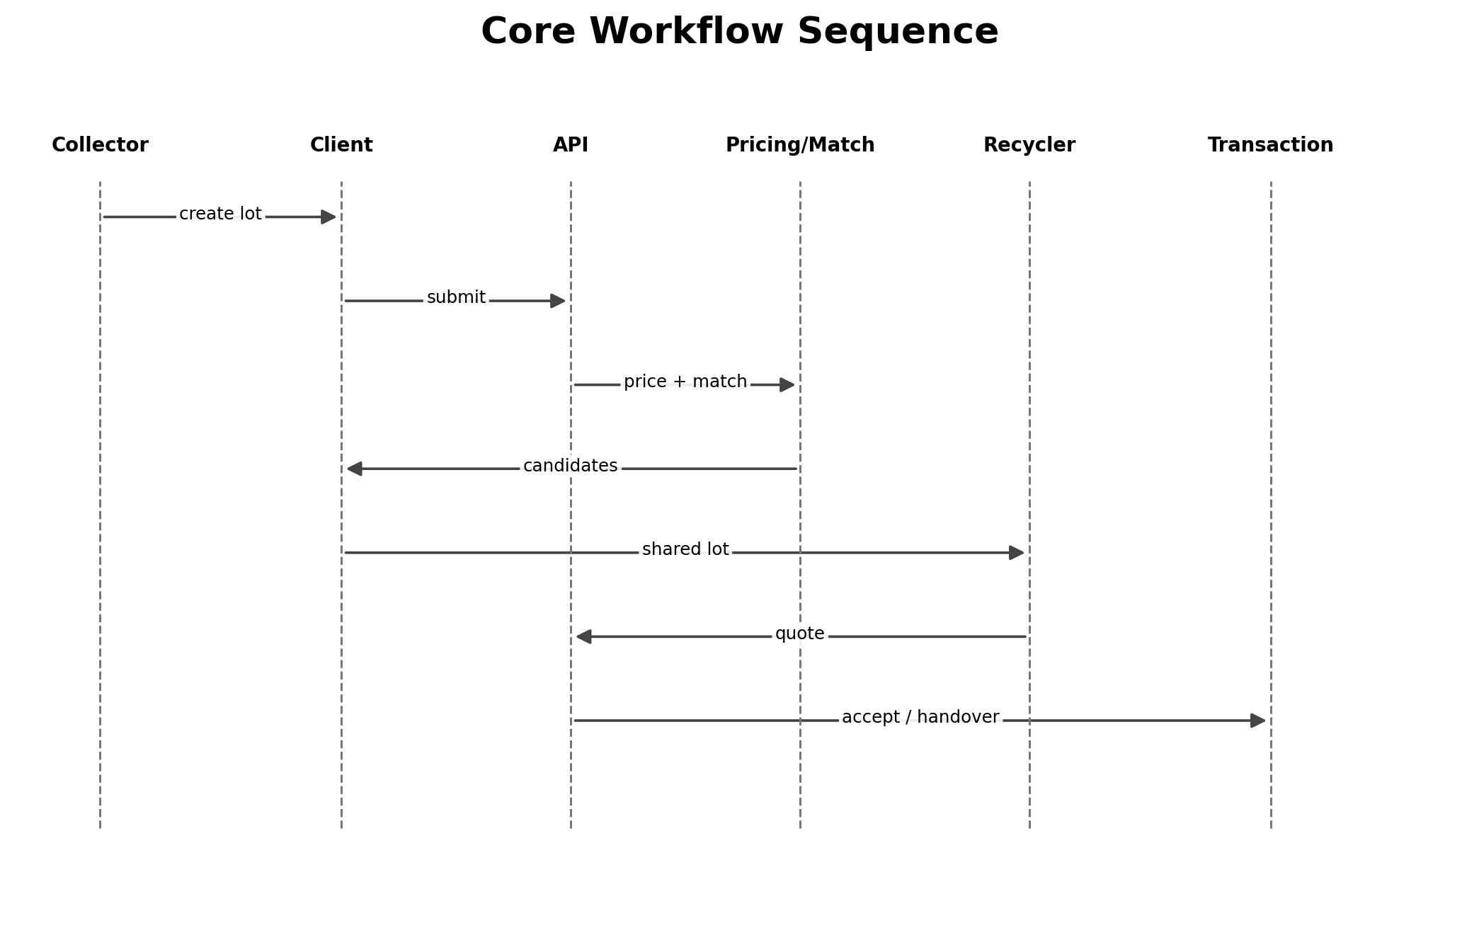
Figure 19. Core Workflow Sequence
The sequence shows the connected path from collector lot creation through pricing/matching, recycler interaction and transaction progression.
Figure 20. Authentication Sequence
Authentication establishes a session before protected API access and role/permission resolution.
Figure 21. AI Interaction Sequence
AI returns an assistive suggestion and confidence; the final category is confirmed or corrected by the user.
Figure 22. Voice Interaction Sequence
Voice translates speech into application input and returns a response while preserving a non-voice fallback.
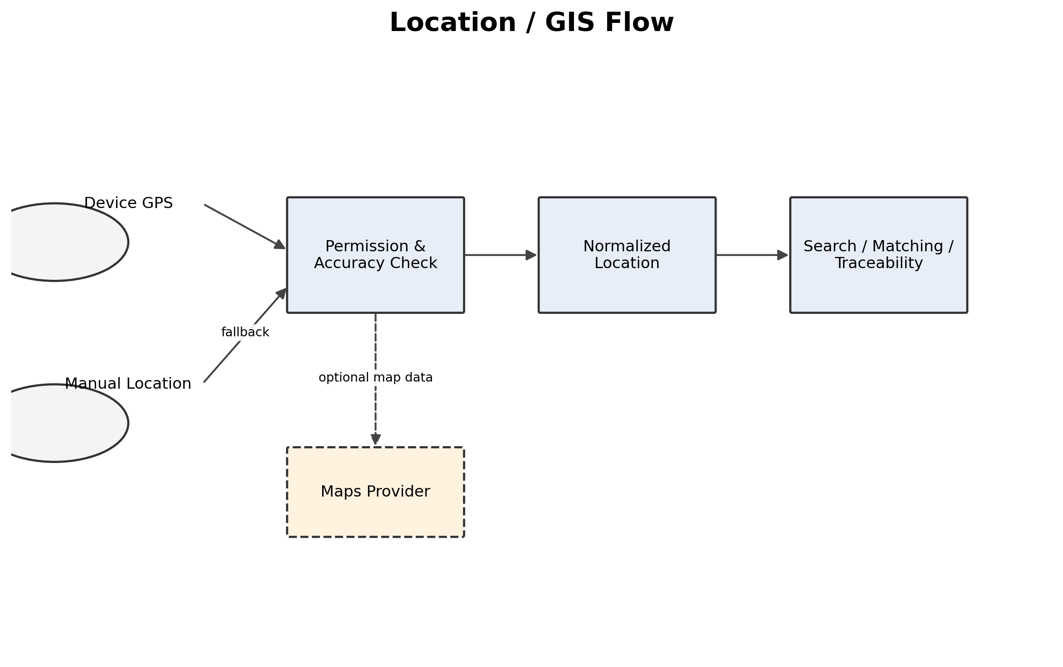
Figure 23. Location Sequence
Location can be acquired from GPS or manual input, then validated and normalized before use.
Figure 24. Offline / Synchronization Sequence
Offline actions are queued locally and reconciled with the server when connectivity returns.
Figure 25. Verification Sequence
Recycler evidence moves through validation and admin review to a decision and audit event.
Figure 26. Notification Sequence
Domain events generate recipient notifications and read-state updates.

43. Data Flow Diagrams
Figure 27. Overall Data Flow Diagram
The DFD shows users, processing, data stores and external systems at a system level.
Figure 28. Core Transaction Data Flow
The transaction data flow connects material lot data, pricing, recycler discovery, quotes, handover and earnings.
Figure 29. Verification Data Flow
Verification evidence is stored, reviewed and audited before status affects recycler discovery.
Figure 30. AI Data Flow
Material images are validated, classified and returned as assistive suggestions before user confirmation.
Figure 31. Offline Synchronization Data Flow
Local queued operations are submitted to the authoritative server and receive explicit sync results.
Figure 32. Admin / Component Data Flow Context
Administrative operations interact with verification, reference data, audit and transaction components through the same protected API boundary.

44. Threat Analysis
Threat | Affected area | Mitigation
Spoofing | Authentication | Managed authentication, secure sessions and protected transport.
Tampering | API / transactions | Server validation, state transitions and authorization.
Repudiation | Handover / payment | Actor identity, timestamps, confirmations and audit events.
Information disclosure | DB/files/location | Least privilege, scoped retrieval and protected object access.
Denial of service | API/external adapters | Rate limiting, bounded uploads, timeouts and monitoring.
Elevation of privilege | RBAC/admin | Backend permissions, ownership checks and audit.

45. Single Points of Failure
Component | Impact | Prototype mitigation | Production mitigation
Authentication provider | New sessions unavailable. | Retry; no bypass. | Provider contingency/redundancy where justified.
Database | Remote workflow unavailable. | Managed backup and controlled errors. | HA DB, replicas/backups, restore drills.
Object storage | Media unavailable. | Retry uploads. | Replication/versioning.
AI provider | AI assistance unavailable. | Manual classification. | Provider/model fallback if justified.
Maps provider | Location/search degraded. | Manual location. | Alternative/cached geographic strategy where justified.
Network | Remote actions delayed. | Offline queue. | Operational network/retry strategy.

46. External Dependency Risk
Dependency | Risk | Fallback
AI quota/outage | Classification assistance unavailable. | Manual classification.
Authentication outage | Users cannot establish sessions. | Do not bypass; retain local drafts.
Maps outage | Map/search degraded. | Manual location.
Voice outage | Voice unavailable. | Touch/text workflow.
Hosting outage | Application unavailable. | Reproducible redeploy; production redundancy later.
Network instability | Sync delayed. | Queue, retry and visible status.

47. Cost Architecture
Driver | Prototype approach | Production consideration
Hosting | Small managed deployment. | Scale based on measured load.
Database | Managed relational instance. | HA, sizing, backups and scaling.
Storage | Object storage for images/docs. | Lifecycle and retention management.
AI | Bounded assistive use. | Quota, model choice and cost controls.
Maps | Minimize calls. | Quota and provider economics.
Voice | Prefer device/browser capabilities where sufficient. | Provider costs/language coverage.
Notifications | In-app state where possible. | Add paid channels only when required.

48. Architecture Trade-Offs
Decision | Benefit | Cost / risk
Modular monolith | Simple, coherent prototype. | Requires discipline to preserve module boundaries.
Relational DB | Integrity and transactional consistency. | Schema evolution and later scaling work.
Offline queue | Resilience to intermittent connectivity. | Conflict/idempotency complexity.
AI adapter | Provider independence and fallback. | Additional abstraction.
Object storage | Efficient large-file handling. | Additional managed dependency.

49. Prototype vs Production Architecture
Area | SIH Prototype | Production Evolution
Hosting | Small reproducible deployment. | HA/CDN/load balancing as needed.
Database | Single managed relational DB. | HA, scaling, backup/restore and partitioning only if justified.
Authentication | Managed provider boundary. | Advanced policies/MFA/enterprise integrations if required.
AI | Single adapter + manual fallback. | Model routing, evaluation and cost governance.
Storage | Managed object storage. | Lifecycle, replication and scanning.
Scaling | Small deployment. | Horizontal scaling and selective service extraction.
Monitoring | Essential error/sync/audit visibility. | Centralized observability and alerting.
Security | RBAC, validation, secrets, audit. | Hardening, security testing and formal operational controls.
Availability | Prototype-level availability. | Multi-zone/region only when required.
Backup | Managed backup/redeploy. | Defined RPO/RTO and restore drills.
CI/CD | Manual/basic if configured. | Automated build/test/security/deploy/rollback.

50. Architecture Traceability
Requirement area | Feature / capability | Module | Architecture home | Data / interface | Test category
Authentication | Login/session | M-01 | Auth boundary | User/session | Security/integration
RBAC | Role access | M-02 | Authorization layer | Roles/permissions | Authorization
Lot creation | Material lot | M-04 | Collector domain | Lots/media | Functional/E2E
AI | Classification assist | M-05 | AI adapter | AI result | AI/fallback
Price | Price discovery/estimate | M-06 | Pricing module | Price data | Functional/data
Recycler matching | Discovery | M-07 | Matching module | Recycler/location | Functional
Quotes | Quote lifecycle | M-08 | Transaction module | Quotes | State/E2E
Handover/payment | Traceability/earnings | M-09 | Handover module | Handover/payment | E2E/audit
Verification | Recycler verification | M-10 | Verification module | Evidence/status | Workflow/security
Offline | Local operation | M-11 | Local store/sync | Queue | Offline/recovery
Language/voice | Hindi/Marathi + voice | M-13 | Localization/voice | Preferences/resources | Accessibility
Location | GPS/manual location | M-12 | Location adapter | Locations | Permission/fallback
Notifications | Workflow updates | M-14 | Notification module | Notifications | Integration
Admin | Monitoring/audit | M-15 | Admin module | Audit/reference | Security/E2E

51. Architecture Decision Summary
Decision | Selected approach | Status
Architecture style | Modular monolith | Proposed
Database | Relational system of record | Proposed
Authentication | Managed provider boundary | TBD provider
AI | Adapter + manual fallback | Proposed
Offline | Local store + sync queue | Confirmed requirement / Proposed implementation
Authorization | Backend RBAC + ownership | Confirmed architectural requirement
Media | Object storage | Proposed
External integrations | Provider adapters | Proposed

52. Architecture Risk Register
Risk ID | Risk | Probability | Impact | Mitigation | Status
AR-01 | Technology providers not finalized | High | High | Lock ADRs before implementation freeze. | Open
AR-02 | Offline conflicts/duplicates | Medium | High | Idempotency, ordering and server authority. | Open
AR-03 | AI quality insufficient | Medium | Medium | Confidence/fallback/manual correction. | Open
AR-04 | Role boundary bypass | Low/Medium | High | Backend authorization + negative tests. | Open
AR-05 | Media upload/storage failure | Medium | High | Validation, retries and controlled state. | Open
AR-06 | Insufficient price/recycler data | Medium | High | Controlled datasets and explicit reference-data labeling. | Open
AR-07 | Scope expansion | High | Medium | Freeze MVP and defer future modules. | Open

53. Future Evolution
- Scale recycler and collector coverage from city to district/state/national levels.
- Add additional Indian languages through resource bundles and voice mappings.
- Support multiple AI models through the same adapter contract.
- Add institution/government integrations only after actual API contracts and authorization exist.
- Introduce analytical storage when operational queries are no longer sufficient.
- Add native mobile applications later if the current client remains web-based.
- Extract individual modules into services only when scale, isolation, team ownership or reliability evidence justifies it.

54. Complete Visual Diagram Set
This document intentionally uses embedded visual images for architecture diagrams. It does not use ASCII architecture, Mermaid code, text-only pseudo-diagrams or arrow-based textual representations. Diagram terminology is kept consistent across the document.
Embedded visual diagram
System Context Diagram
High-Level Architecture
Logical Architecture
Deployment Architecture
Component Architecture
Data Flow Diagram — Overall System
Core Transaction Data Flow
Authentication Sequence
Core Workflow Sequence
AI-Assisted Classification Sequence
Voice Interaction Sequence
Location / GIS Flow
Offline and Synchronization Sequence
Verification Workflow
Notification Architecture
Security Boundary Architecture
External Integration Architecture
SIH Demo Architecture
File / Image Storage Architecture

55. SIH Demo Architecture
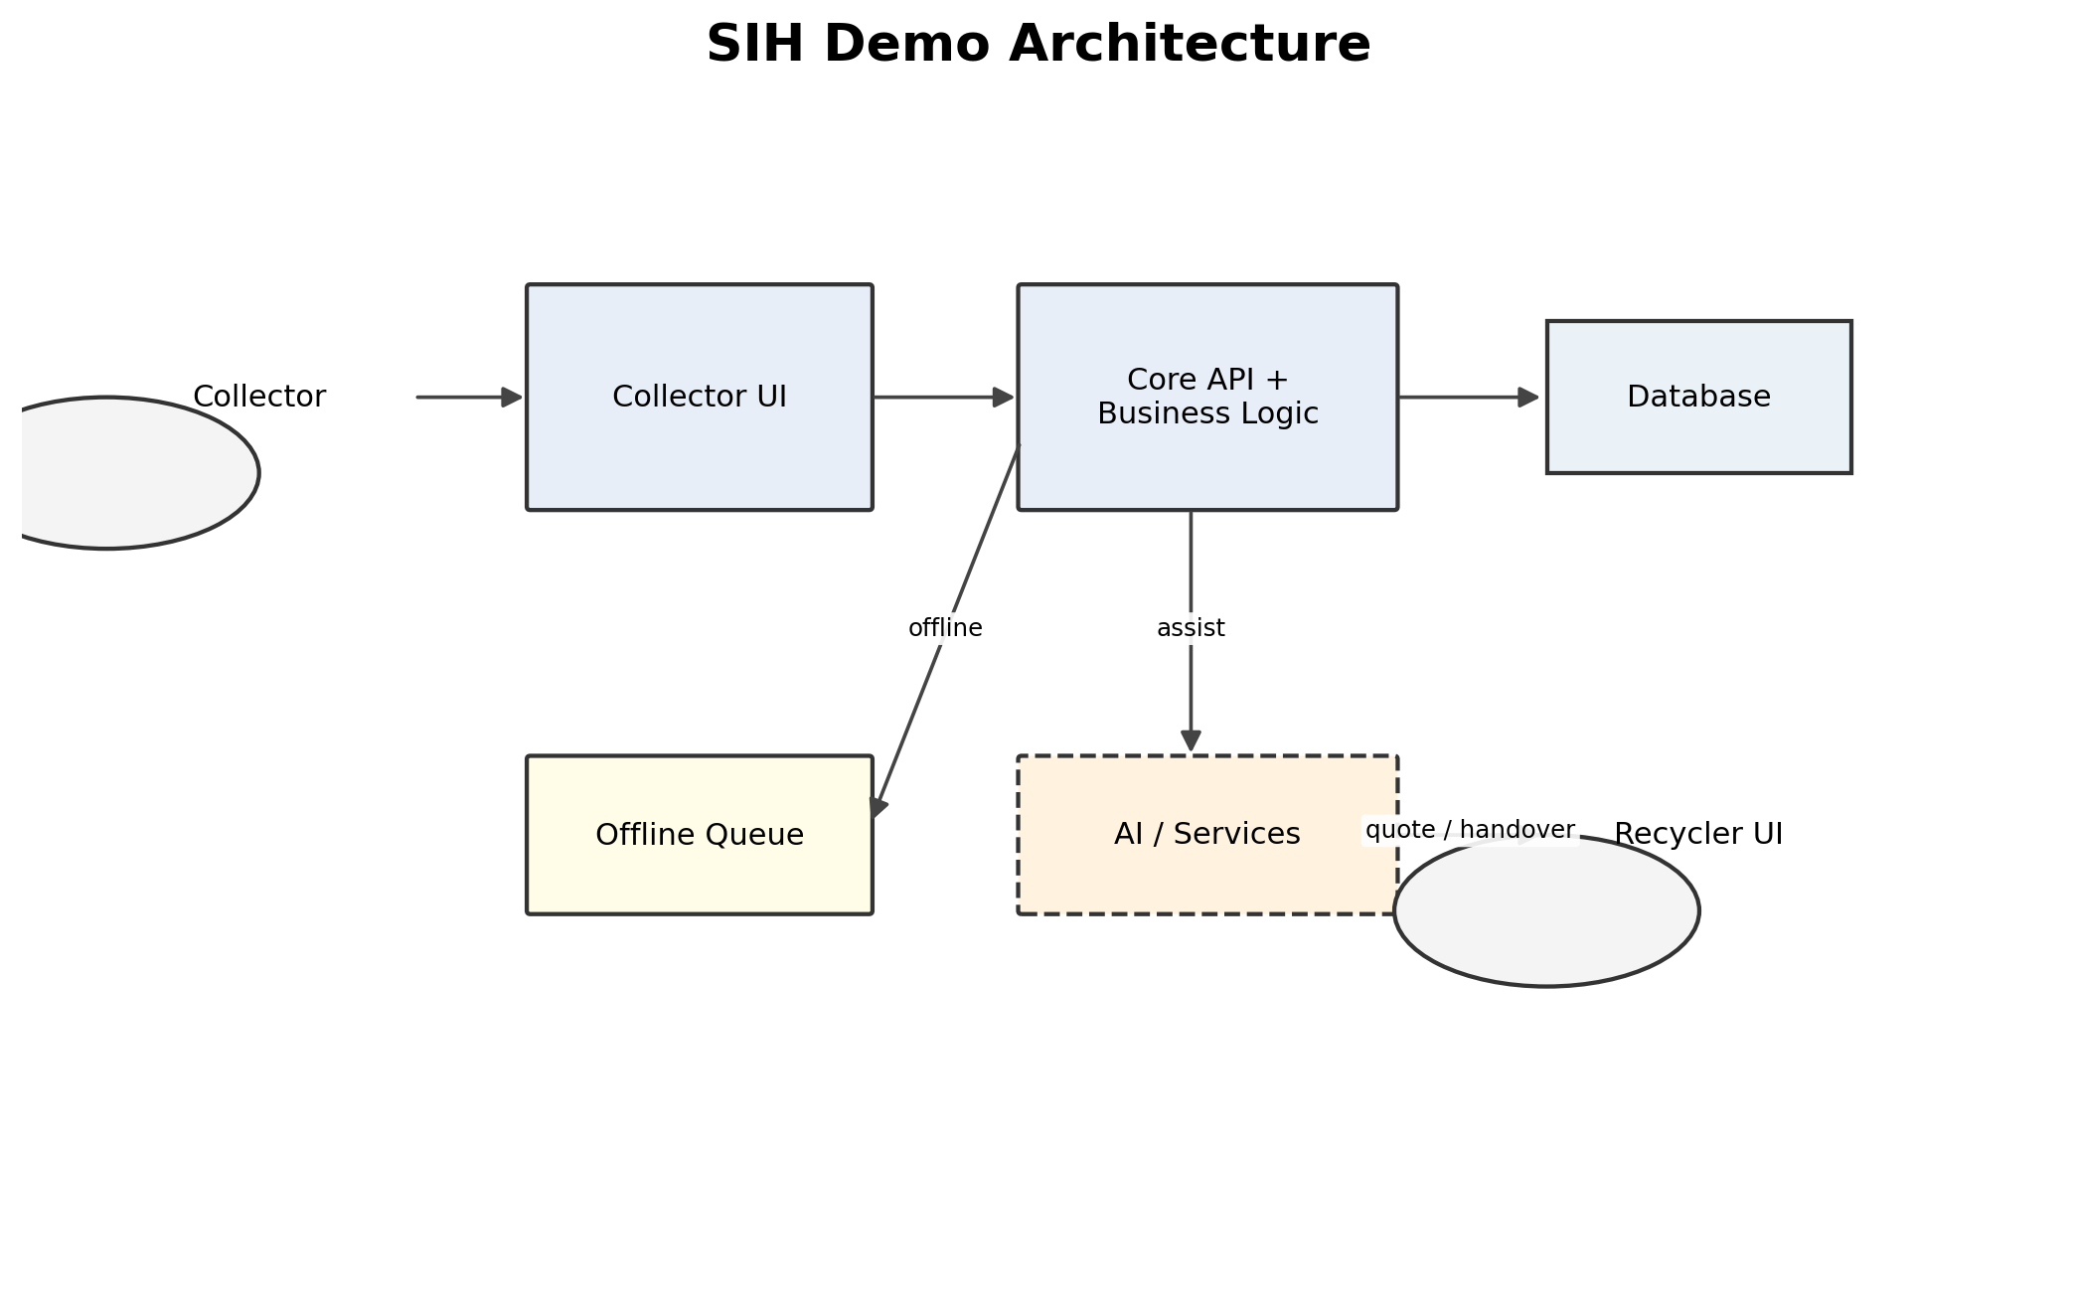
Figure 33. SIH Demo Architecture
The SIH presentation view emphasizes one complete connected journey: collector input, application/API, persistent data, bounded AI/services, recycler interaction, and offline/sync behavior.

56. Implementation Readiness Check
Check | Assessment
Every major SRS module has an architecture component | Yes — mapped in Sections 8 and 50.
Major interfaces are defined | Yes at architecture level; endpoint details remain separate.
Data flows are defined | Yes, with visual DFDs and workflow diagrams.
Authentication flow is defined | Yes.
Authorization boundaries are defined | Yes.
External integrations are defined | Yes; vendors are TBD unless confirmed.
AI architecture is defined | Yes.
Voice architecture is defined | Yes.
Language architecture is defined | Yes.
Location architecture is defined | Yes.
Offline architecture is defined | Yes.
Sync architecture is defined | Yes.
Security boundaries are defined | Yes.
Deployment architecture is defined | Yes.
Failure handling is defined | Yes.
Prototype scope is realistic | Yes, if kept modular and focused.
Production evolution is separated | Yes.
Technology decisions documented | Partially; final providers/frameworks remain open decisions.
Architecture traceability | Yes at module/requirement level.

57. Critical Architecture Review
Review question | Finding | Action
Unnecessarily complex? | No; modular monolith is appropriate. | Avoid premature distributed infrastructure.
Simpler solution available? | Yes: keep one backend deployment. | Use module boundaries without service deployment.
Hidden dependencies? | AI, auth, maps, voice, notifications and storage. | Maintain explicit adapters/fallbacks.
Authentication secure? | Architecture supports secure provider-managed auth; provider/config not final. | Lock provider and test lifecycle.
Authorization bypass? | Preventable only with backend enforcement. | Add negative permission/ownership tests.
Offline real? | Targeted offline capability is architecturally defined. | Implement and test queue/reconnect paths.
Sync failure? | Explicit per-operation state/retry is defined. | Test duplicates, partial failure and conflicts.
External APIs as SPOFs? | Yes for some important features. | Use fallbacks; avoid blocking core workflows.
Production evolution? | Yes. | Scale based on measured bottlenecks.
Architecture/SRS consistency? | High-level mapping is consistent. | Update traceability when requirements change.

58. Final Architecture Summary
Area | Summary
Style | Layered client-server modular monolith for SIH.
Major components | Auth, RBAC, profiles, lots, pricing, classification, matching, quotes/transactions, handover/earnings, verification, sync, location, language/voice, notifications, admin/analytics.
Database | Relational system of record; exact provider TBD.
Authentication | Managed provider boundary; exact provider TBD.
AI | Assistive, replaceable model/service with manual fallback.
Voice | Accessibility layer for Hindi/Marathi; provider/device TBD.
Language | Resource-based localization, extensible to additional Indian languages.
Location | GPS + manual fallback with privacy-scoped use.
Offline | Local store + pending operation queue for supported features.
Synchronization | Server-authoritative validation with idempotency and retry.
Security | HTTPS, managed auth, backend RBAC, ownership, validation, protected files and audit.
External dependencies | Auth, AI, maps, voice, notifications, object storage.
Deployment | Reproducible SIH deployment; production adds HA/DR/observability.
Prototype limitations | Exact technology providers, hosting and several operational policies remain TBD.
Production path | Scale selectively; extract services only when justified.
Major risks | Provider dependency, sync conflicts, AI quality, data availability, authorization, media storage, scope.
Open decisions | Frontend/backend providers, DB/auth/storage, AI/maps/voice/notifications, hosting, CI/CD and retention policies.

59. Source and Quality Basis
The supplied SAD specification requires the architecture to be technically realistic, internally consistent, traceable to the SRS, implementable, testable at the architectural level, secure by design, appropriately scalable, simple enough for an SIH prototype, and clear to both developers and technical judges. fileciteturn4file0L1338-L1359
It also requires a complete visual diagram set and consistent component names across diagrams. fileciteturn4file0L1218-L1237
Where the source material does not establish a concrete vendor, deployed integration, performance benchmark, legal compliance status or current CI/CD configuration, this document deliberately marks the item as TBD/proposed rather than fabricating a current-state implementation.

