KABADIWALA CONNECT
UI/UX DESIGN DOCUMENT
Collector-first digital experience for the formal recycling chain

Document Control | Value
Project | Smart India Hackathon — Kabadiwala Connect
Problem Statement ID | 26229
Problem Statement | Kabadiwala Connect – Bringing the Informal Collector into the Formal Recycling Chain
Organization / Department | Ministry of Mines / JNARDDC
Category / Theme | Software / Clean & Green Technology
Version | 1.0
Status | Design blueprint — implementation-ready direction
Prepared By | Project UX/Product Team
Reviewed By | TBD
Approved By | TBD
Date | 20 September 2026

Source basis: This blueprint follows the supplied UI/UX specification and the established Kabadiwala Connect product context. Design choices that are not fixed by the source material are explicitly marked Proposed, TBD, Prototype, Production, or Future.

Table of Contents
- 1. Document Control & Scope
- 2. UX Objective
- 3. UX Design Principles
- 4. Target Users
- 5. UX Personas
- 6. User Experience Journeys
- 7. Information Architecture
- 8. Navigation Architecture
- 9. Role-Specific UX
- 10. User Flow Diagrams
- 11. Screen Inventory
- 12. Screen-by-Screen Specification
- 13. Design System
- 14. Color System
- 15. Typography
- 16. Iconography
- 17. UI Component Library
- 18. Component States
- 19. Forms & Input Design
- 20. Authentication UX
- 21. Dashboard UX
- 22. Core Workflow UX
- 23. AI UX
- 24. Voice UX
- 25. Regional Language UX
- 26. Location UX
- 27. Offline UX
- 28. Synchronization UX
- 29. Verification UX
- 30. Notification UX
- 31. Search / Filter UX
- 32. Map UX
- 33. Admin UX
- 34. Empty States
- 35. Loading States
- 36. Error States
- 37. Success States
- 38. Mobile-First UX
- 39. Tablet & Desktop UX
- 40. Responsive Design System
- 41. Accessibility
- 42. Low-Literacy UX
- 43. Localization & Cultural UX
- 44. Trust & Transparency UX
- 45. Privacy UX
- 46. Microinteractions & Motion
- 47. UX Content / Microcopy
- 48. Design Tokens
- 49. Figma / Design Handoff
- 50. Design Handoff Requirements
- 51. Prototype / Production / Future Scope
- 52. Complete Screen Map
- 53. UX Traceability Matrix
- 54. UX Test Plan
- 55. UX Heuristic Review
- 56. UX Edge-Case Review
- 57. Visual Quality Audit
- 58. SIH Judge Experience
- 59. Demo Flow UX
- 60. Final Design System Summary
- 61. Visual Diagram Index
- 62. References & Appendix
- 63. Final Quality-Control Checklist

1. Document Control & Scope
This document is the visual and interaction blueprint for Kabadiwala Connect. It translates the product problem and supported workflows into user journeys, information architecture, navigation, screens, components, states, accessibility rules, responsive behavior, and handoff requirements.
Scope label | Meaning in this document
Required | Must exist for the supported core experience or explicit UX requirement.
Proposed | A design recommendation selected to make the supported workflow usable; validate during Figma/prototype review.
Prototype | Needed for the SIH demonstration path; not necessarily production-complete.
Production | Expected for a deployable product but outside the minimum demo path.
Future Scope | Useful extension that should not expand the SIH prototype unnecessarily.
TBD | A dependency that requires product/architecture/provider confirmation before final UI is locked.

Revision History
Version | Date | Change | Status
0.1 | 20 Sep 2026 | Initial UX structure derived from supplied specification and project context | Draft
1.0 | 20 Sep 2026 | Complete UX blueprint with visual diagrams, screen inventory, states, handoff and testing | Baseline

2. UX Objective
Primary UX objective: enable a collector with limited digital familiarity to create and track a material lot, discover a formal recycler, understand a quote, complete a documented handover, and see the resulting payment/traceability with minimal cognitive load — while giving recyclers and administrators role-specific controls for the same transaction lifecycle.
- Make the next action obvious at every step.
- Expose transaction status in plain language rather than internal terminology.
- Keep the collector experience mobile-first, touch-friendly and usable under intermittent connectivity.
- Use Hindi/Marathi and voice assistance as first-class interaction layers, not decorative add-ons.
- Use AI only as assistive input; preserve manual correction and never imply certainty.
- Communicate what is saved locally versus confirmed by the server.
- Make verification, payment, location and document states transparent without overstating trust.

3. UX Design Principles
Principle | Interface behavior
Simplicity | One primary action per screen; secondary actions remain visible but subordinate.
Clarity | Use plain language, strong hierarchy, status labels and contextual confirmation.
Accessibility | Readable type, contrast, focus states, semantic labels, large touch targets and non-color status cues.
Mobile-first | Design the collector journey at phone width first; expand rather than stretch on larger screens.
Low cognitive load | Use short forms, progressive disclosure, familiar patterns and step-by-step guidance.
Minimal steps | Do not ask for data already available from an earlier step; preserve drafts where possible.
Clear feedback | Every meaningful action produces a visible state: saved, syncing, accepted, failed, etc.
Consistency | Same action names, status vocabulary, components and navigation patterns across roles.
Error prevention/recovery | Validate early, explain failures, offer a direct recovery action or fallback.
Offline awareness | Show availability and sync state without making the interface feel broken.
Multilingual | Persist language choice and design for Hindi/Marathi text expansion.
Voice accessibility | Voice follows the same task model as touch and always offers a text fallback.
Trust & transparency | Distinguish verified, pending, user-entered, AI-suggested and server-confirmed information.
Privacy by design | Request camera, microphone, location and identity access only when needed and explain why.

4. Target Users
Role | Context | Goals / tasks | Digital literacy | Device | Connectivity | Language | UX needs
Collector | Informal e-waste/material collector | Create lots, classify material, discover recyclers, accept quotes, complete handover, view earnings/history | Low–medium digital literacy | Android phone; often mobile-only | Intermittent/slow; offline support important | Hindi/Marathi; voice useful | Outdoor/noisy environments; large controls; simple confirmation
Recycler / Aggregator | Formal recycler or aggregator participant | Review available lots, quote, coordinate/confirm handover, maintain transaction history | Medium digital literacy | Android phone and/or laptop | Usually connected, but mobile states still required | English/Hindi/Marathi depending deployment | Operational context; efficient lists, filters, status clarity
Administrator | Platform operator | Review verification, monitor users/lots/transactions, maintain operational oversight | Medium–high digital literacy | Laptop/desktop; tablet optional | Stable network expected | English plus localized UI where required | High information density but controlled; auditability and confirmation

5. UX Personas

Ramesh — Collector
Role | Background | Goals | Pain points | Device | Connectivity | Language / accessibility | Main tasks | UX needs
Informal collector | Works across local neighborhoods and collects mixed e-waste/material. Needs quick entry while standing or moving. | Get a fair, understandable quote; avoid repeated data entry; know whether a handover is confirmed. | Manual entry feels burdensome; uncertain network; unfamiliar technical terms. | Android phone; mobile-first | Intermittent | Hindi/Marathi; Large touch targets; voice/text fallback; strong confirmation. | Create lot; photo; weight; discover recycler; accept quote; confirm handover; view earnings. | Step-by-step workflow, offline save, clear status and simple language.

Asha — Recycler Operator
Role | Background | Goals | Pain points | Device | Connectivity | Language / accessibility | Main tasks | UX needs
Recycler / aggregator | Reviews incoming material lots and responds to viable collection opportunities. | Quickly inspect material details and submit a quote without losing context. | Many requests; needs concise comparison and clear status. | Android phone + laptop | Mostly connected | Hindi/English or Marathi depending deployment; Readable lists; filters; keyboard-friendly desktop views. | Review lot; quote; confirm handover; update transaction. | Dense but scannable request list; clear status and confirmation.

Platform Admin
Role | Background | Goals | Pain points | Device | Connectivity | Language / accessibility | Main tasks | UX needs
Administrator | Operates the platform and reviews verification/operational queues. | Make evidence-based status decisions and understand current transaction state. | High queue volume; risk of ambiguous status. | Laptop/desktop | Stable | English + configured regional support; Tables with filters, detail panels, confirmation dialogs. | Review verification; monitor users/lots/transactions. | Consistent statuses, audit context, low-error admin actions.

6. User Experience Journeys
The source specification requires current and proposed journeys plus visual diagrams. The following journeys describe the product behavior without inventing unsupported marketplace or logistics capabilities.

6.1 Collector — Current-state problem framing
Trigger | Current action | Pain point | Consequence
Has collected material | Contacts buyers/recyclers through informal channels | Limited price transparency and fragmented communication | Time spent searching; unclear value
Needs a buyer | Uses calls/messages/local contacts | No single transaction trail | Hard to prove what was handed over
Completes a sale | Relies on informal confirmation/payment records | Weak traceability | Difficult history/earnings view

6.2 Collector — Proposed journey
Stage | Interface | User action | System response | Decision | Outcome
Trigger | Dashboard | Tap Create Lot | Opens guided lot flow | Continue? | Draft lot
Capture | Photo / classification | Take photo; confirm material | AI suggestion + manual correction | Accept/edit? | Confirmed material
Measure | Weight | Enter/confirm weight | Validates input; shows estimate context | Continue? | Lot details ready
Discover | Recycler list/map | Search/filter and select recycler | Shows relevant details/status | Select? | Recycler context
Quote | Quote detail | Review and accept/reject | Updates lifecycle and notifies relevant role | Accept? | Accepted or back to discovery
Handover | Handover screen | Confirm handover details | Creates documented event | Confirm? | Handover recorded
Outcome | Payment/history | Record/view payment and history | Updates earnings/traceability | Done? | Completed transaction

Figure 1. Collector-to-formal-chain journey
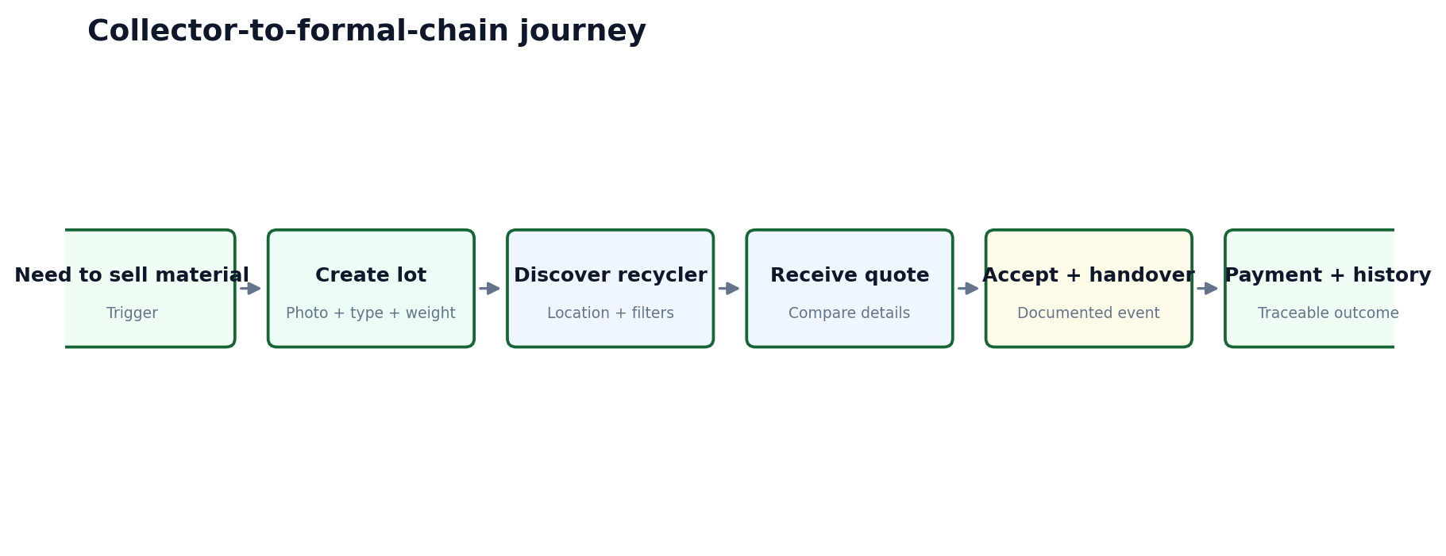

6.3 Recycler journey
Stage | UX intent | Required behavior
Incoming lot | Understand material quickly | Show photo, material, weight, location context and relevant status.
Quote | Make a clear offer | Keep quote amount and any supported terms explicit; no hidden commitment.
Waiting | Avoid uncertainty | Show quote status and actionable notification when accepted/rejected.
Handover | Confirm event | Provide confirmation controls for the actual handover event.
History | Maintain traceability | Show completed transactions with status/timestamps.

6.4 Admin journey
Admin UX is queue-first rather than dashboard-card-first: surface verification and operational exceptions, allow detail review, require confirmation for consequential decisions, and retain clear status/timestamps.

7. Information Architecture
The application uses a shared shell plus role-specific workspaces. Shared capabilities are intentionally small: authentication, language, help and session handling. Transaction features are organized around the lot/request lifecycle.
Figure 2. Information architecture / sitemap
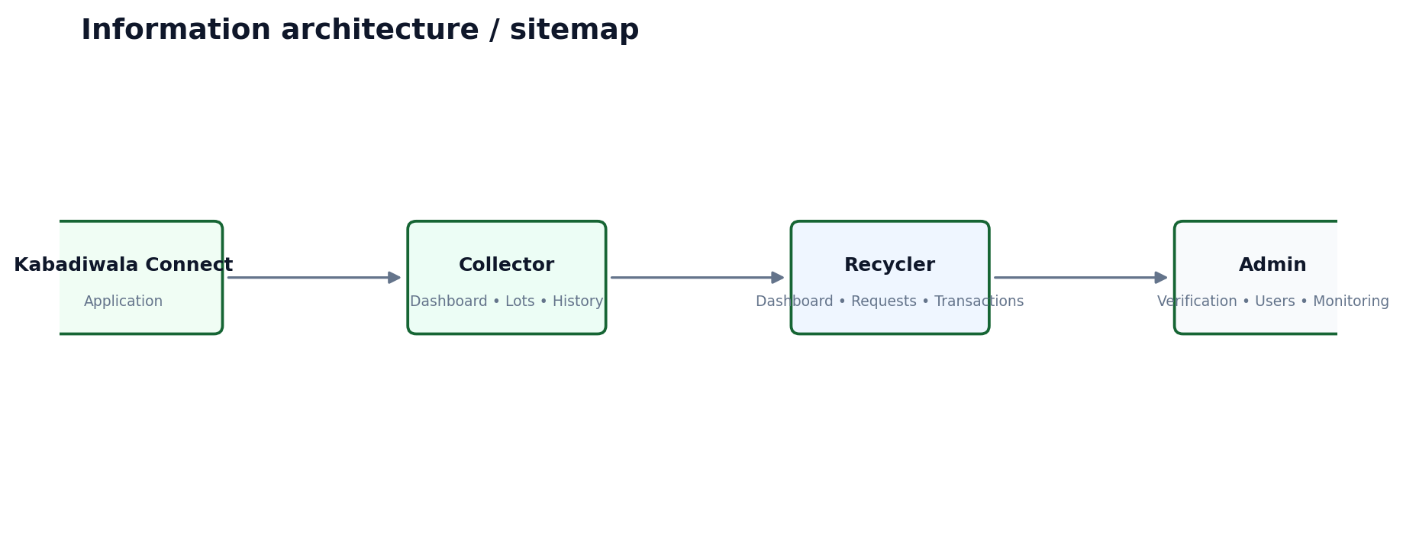
Area | Collector | Recycler | Admin
Home / dashboard | Create lot; active status; recent activity | Incoming lots; quote activity; transactions | Verification queue; operational monitoring
Lots / requests | My lots; requests/quotes | Available/shared lots; requests | Monitoring / detail views
Transactions / history | Completed handovers; earnings | Completed transactions | Transaction monitoring
Notifications | Quote/status/sync alerts | Lot/quote/status alerts | Verification/system alerts
Profile / settings | Language; profile; help | Profile; verification status; help | Account/settings
Verification | View own status where applicable | Submit/view verification | Review and decision

8. Navigation Architecture
Collector and recycler navigation is optimized for mobile. Admin uses a desktop-oriented sidebar because queue review and monitoring benefit from persistent context.
Figure 3. Role-aware navigation architecture
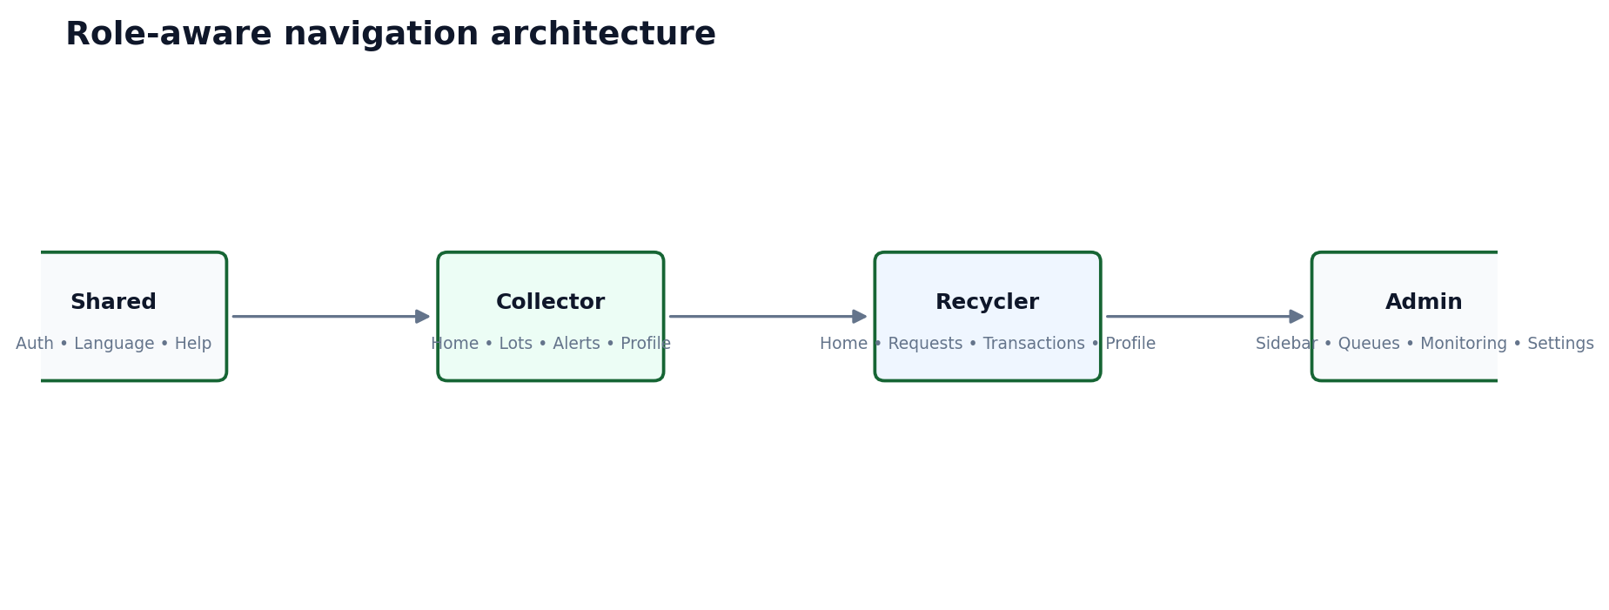
Role | Primary navigation | Secondary / contextual | Header behavior
Collector | Home • Lots/History • Notifications • Profile | Create Lot is the primary Home CTA; back navigation inside flows | Language, connectivity/sync state, help
Recycler | Home • Requests • Transactions • Profile | Quote/handover actions inside detail screens | Language, verification/status, help
Admin | Sidebar: Dashboard • Verification • Users • Transactions • Monitoring/Reference Data as supported | Filters, search, detail panels | Global status, profile, logout

9. Role-Specific UX
Role | Dashboard purpose | Primary action | Important info | Role actions | Restricted actions | Notifications | History | Profile/help
Collector | Turn collected material into a traceable lot. | Create Lot | Current lots, quote status, sync state, recent earnings/history. | Create lot; edit draft; discover; review quote; confirm handover. | Administrative verification decisions. | Actionable quote/status alerts. | Transaction and earnings history. | Language, profile, permissions, help.
Recycler | Turn viable lots into actionable quotes and confirmed handovers. | Review available lots / requests | Material details, request status, verification status where applicable. | Review; quote; confirm handover; view transactions. | Collector-side identity/verification decisions. | New lot/quote/handover alerts. | Transaction history. | Profile, verification, help.
Admin | Operate trust and transaction controls. | Review queue | Verification and operational status. | Review; approve/reject where supported; monitor. | Collector/recycler transactional controls unless explicitly authorized. | Operational alerts. | Monitoring/history. | Admin account/settings/help.

10. User Flow Diagrams
Figure 4. Authentication UX flow
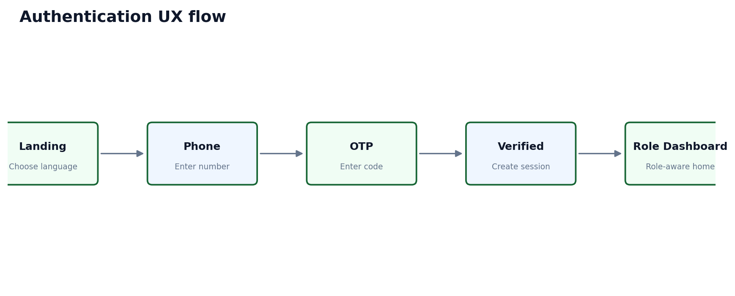
Figure 5. Collector core workflow
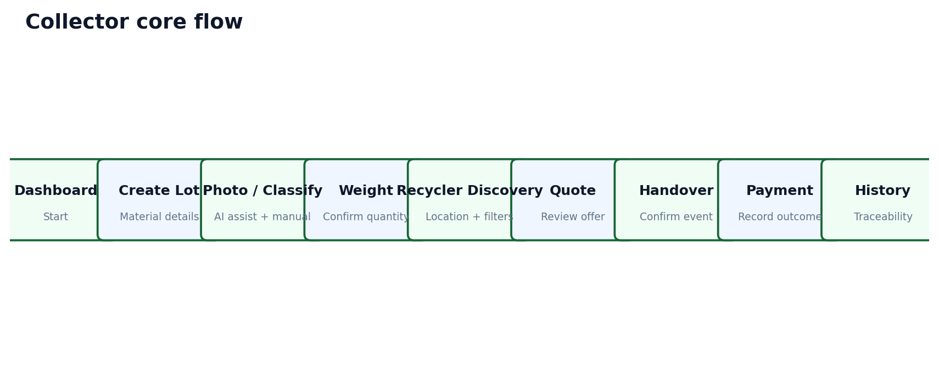
Figure 6. Recycler core workflow
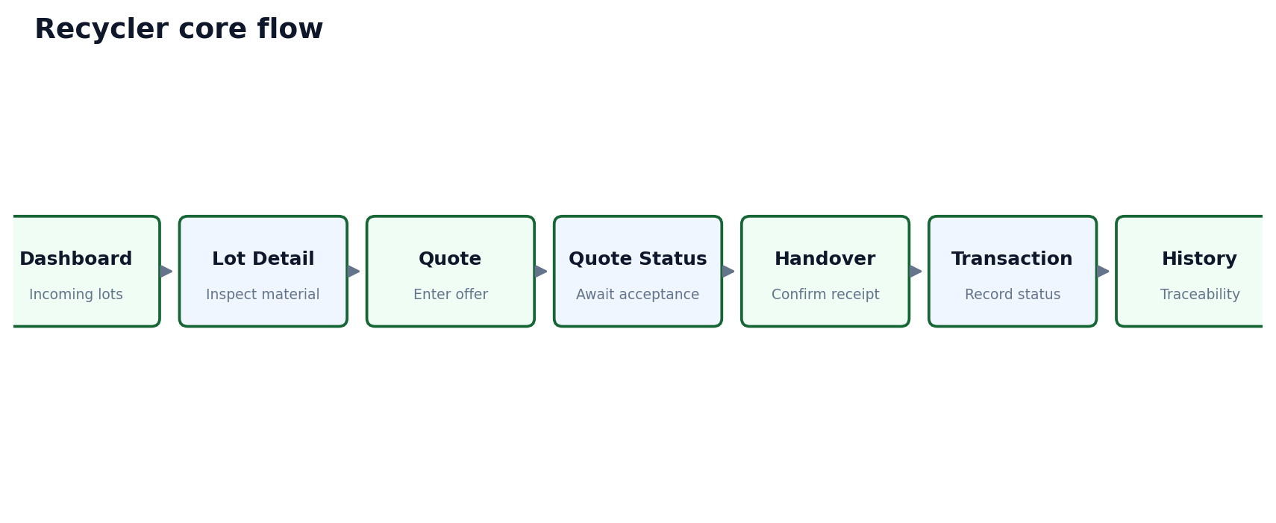
Figure 7. Admin workflow
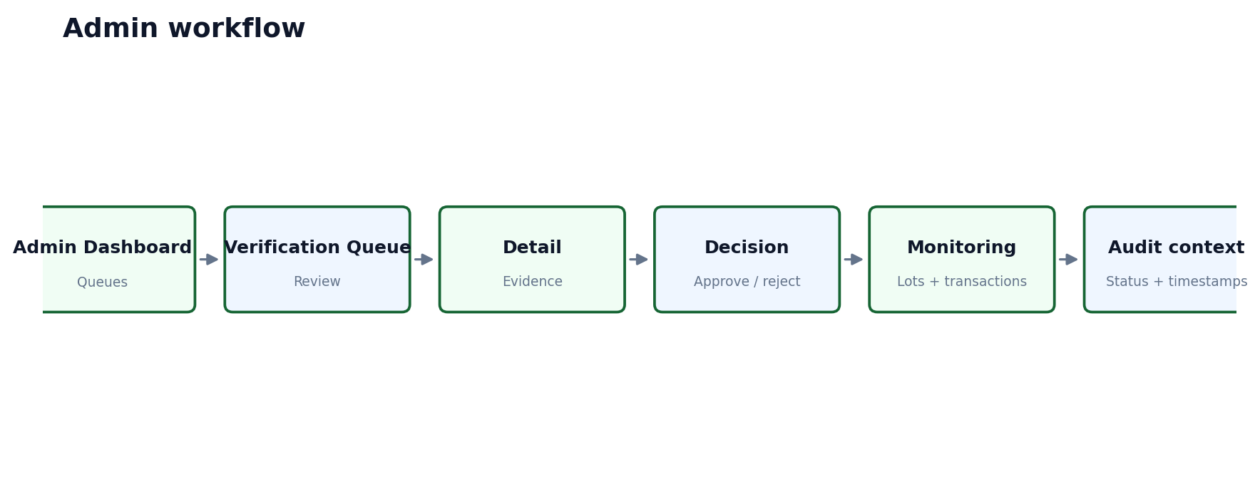
Figure 8. Core transaction/request flow
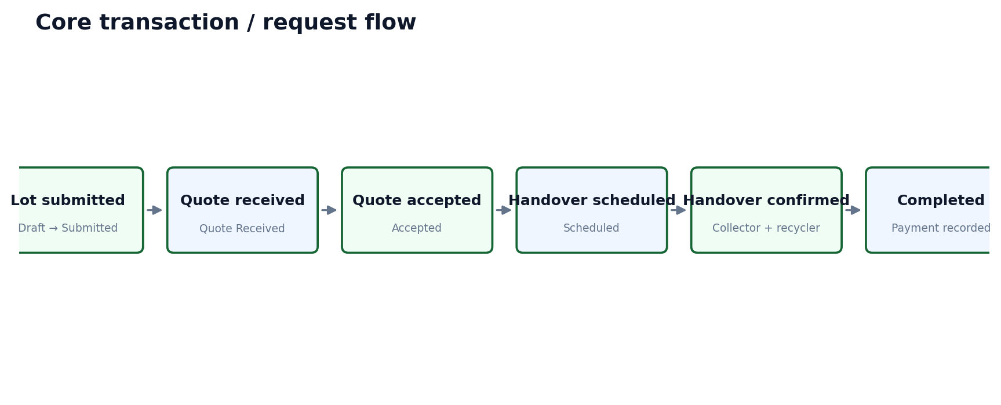
Figure 9. Verification UX flow
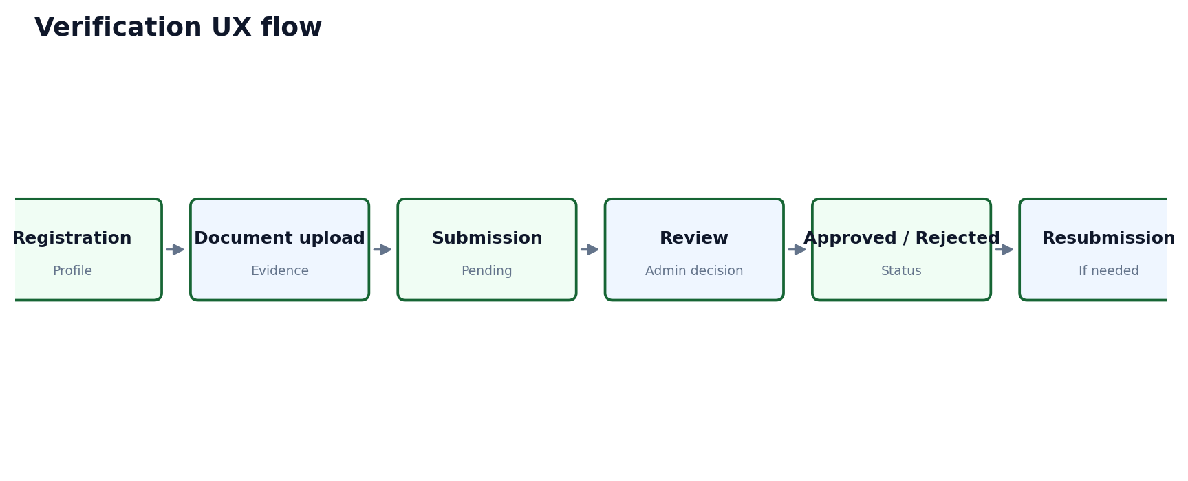
Design rule: Use accurate status labels such as Pending, Approved or Rejected; do not imply government certification unless actually provided.

Figure 10. AI-assisted material UX flow
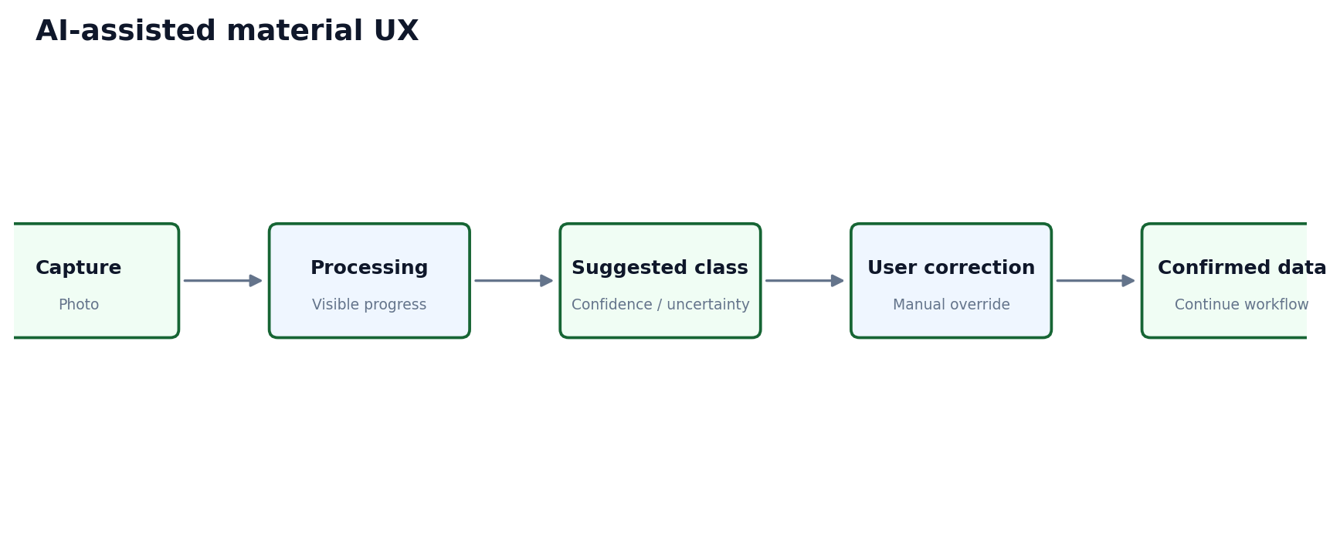
Design rule: AI output is assistive and editable; confidence/uncertainty must be visible when available.

Figure 11. Voice assistance UX flow
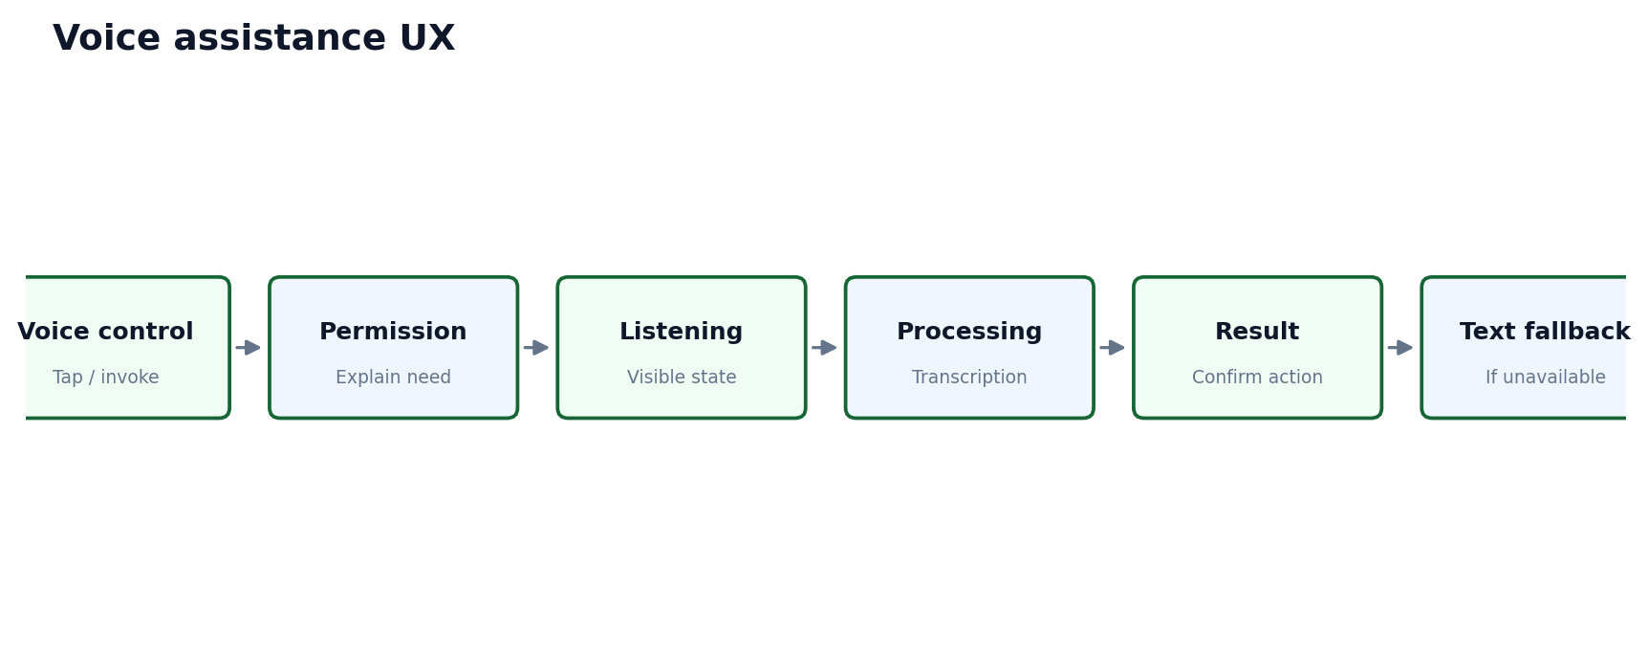
Design rule: Voice mirrors the same task model as touch and always offers text fallback.

Figure 12. Location UX flow
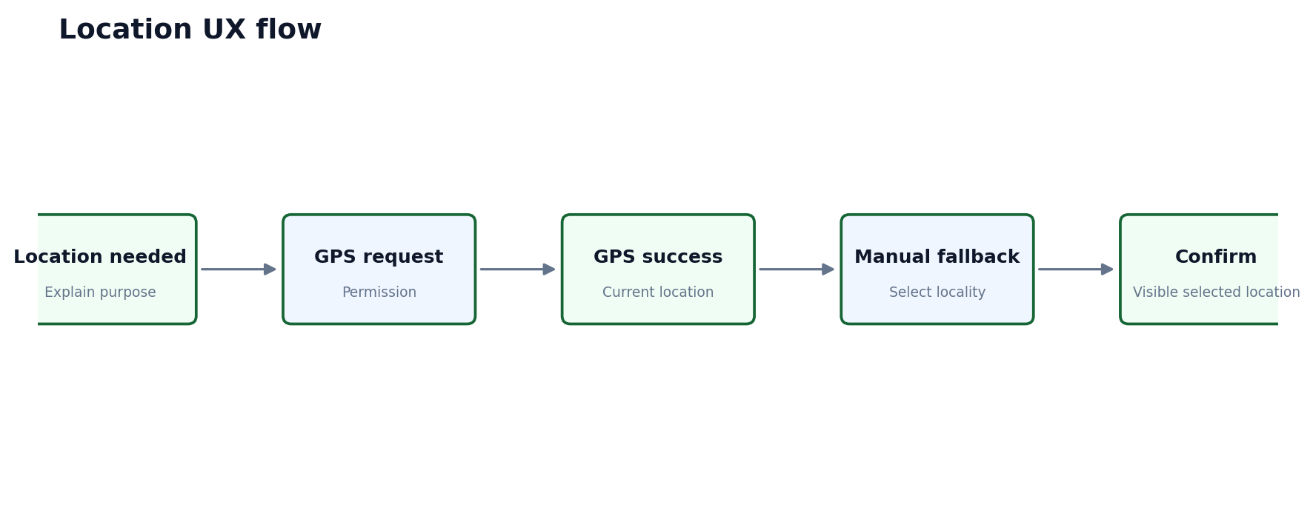
Figure 13. Offline UX flow
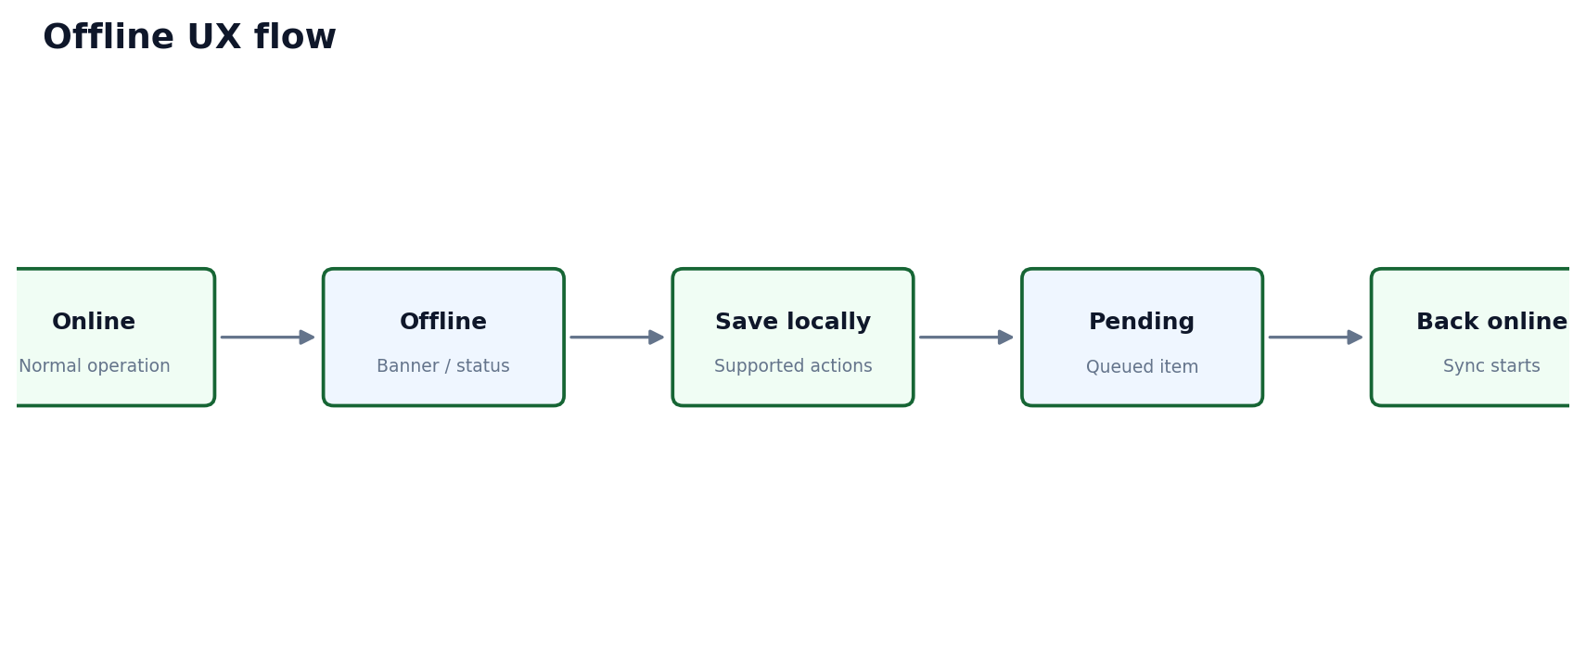
Design rule: Only explicitly supported operations are available offline; unsynced data is visibly marked.

Figure 14. Synchronization UX flow
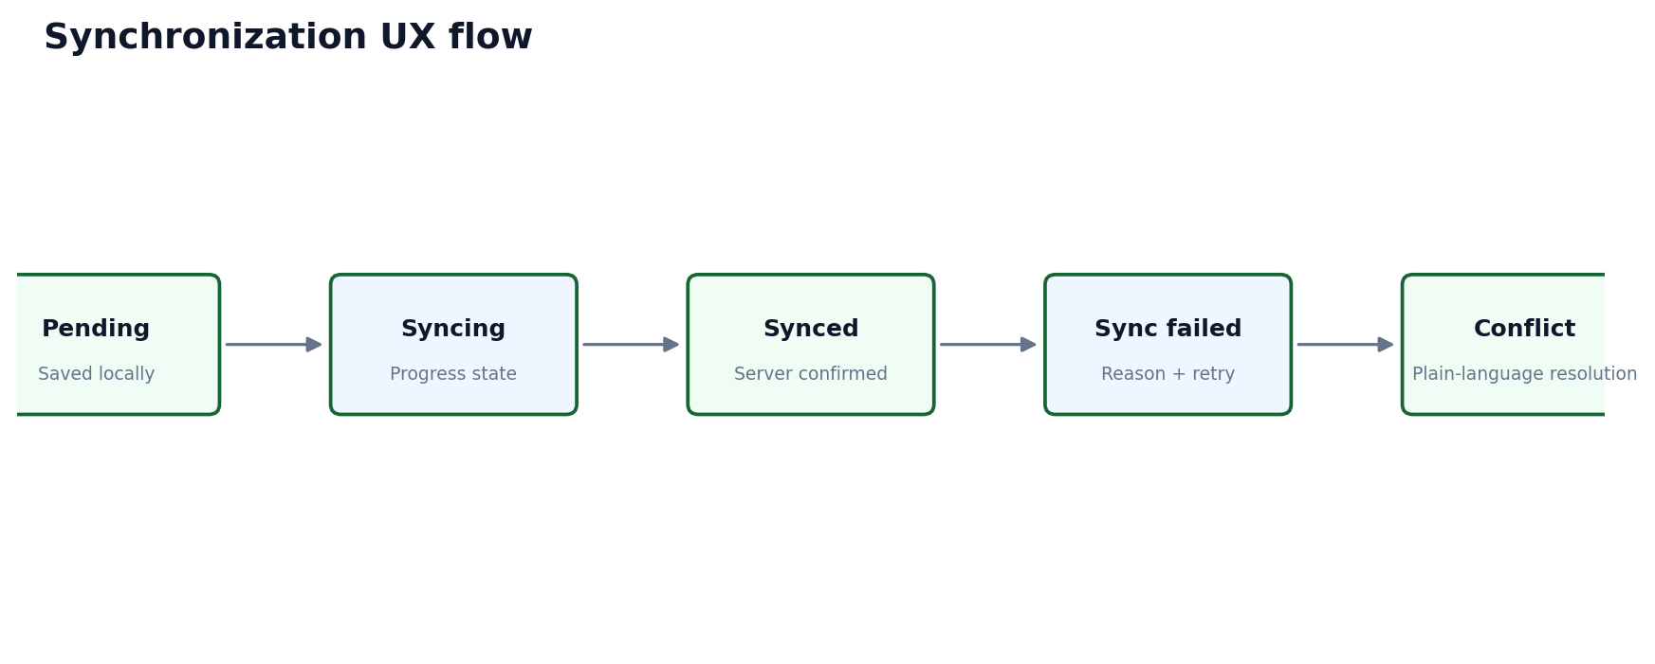
Design rule: Server confirmation is distinct from local save; failures have a direct retry/recovery action.

Figure 15. Notification interaction flow
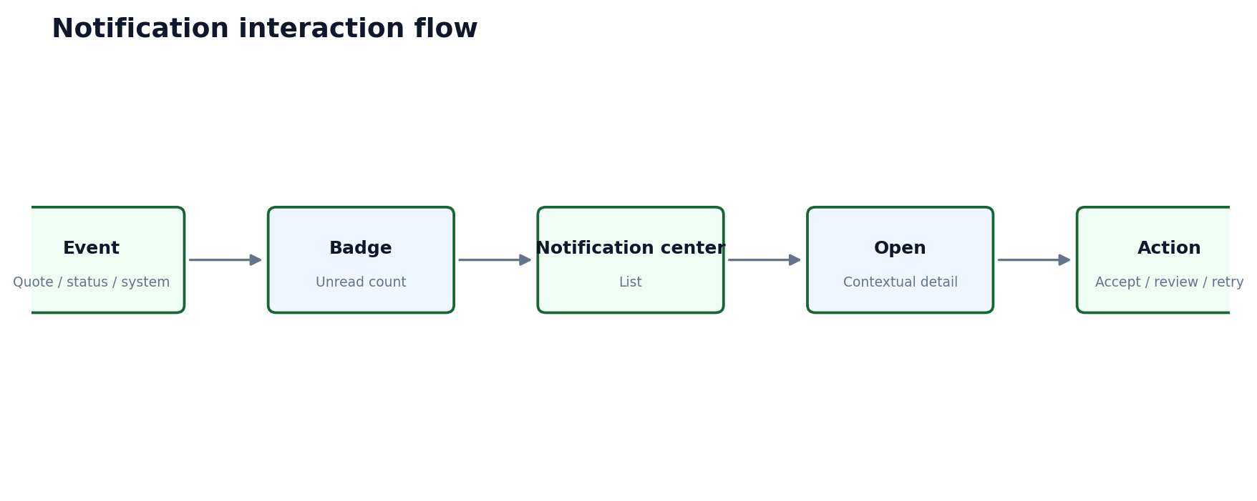
Figure 16. Error recovery flow
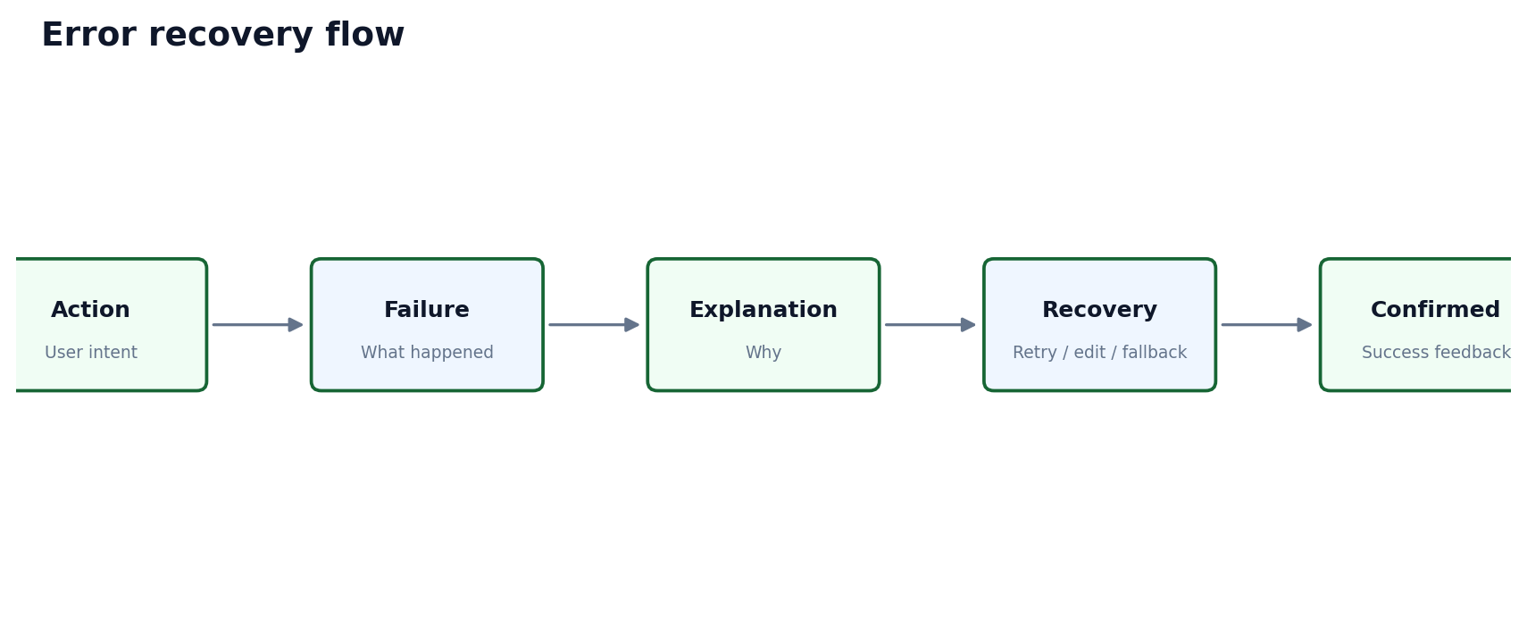
Figure 17. SIH demo journey
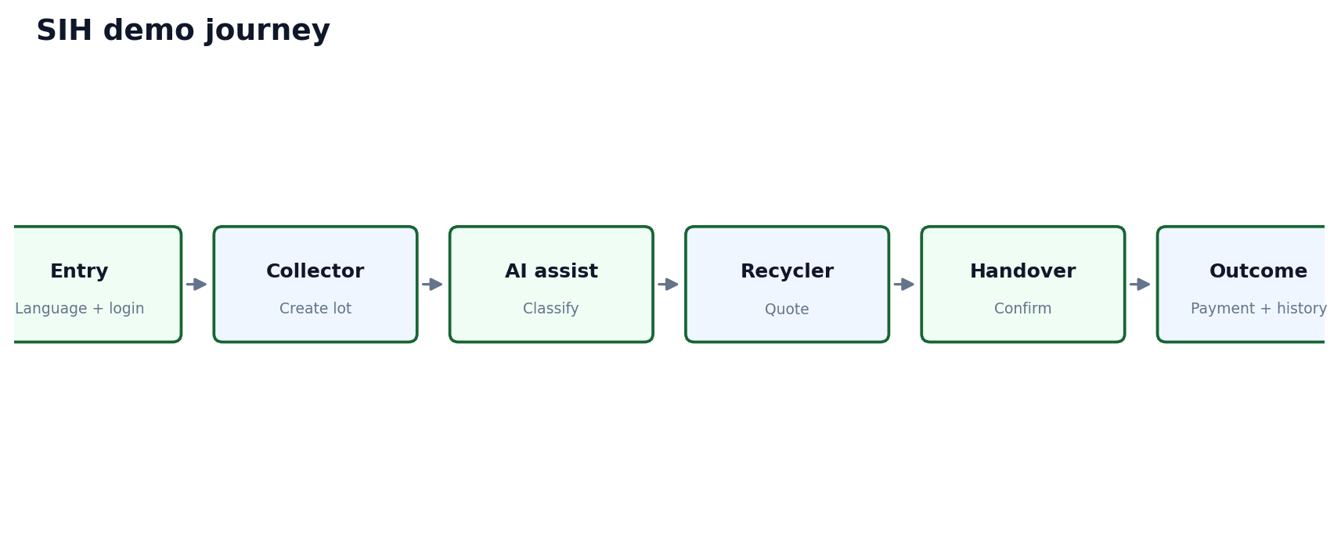

11. Screen Inventory
ID | Screen | Role | Purpose | Entry | Exit | Main actions | Information | Components | Data/API | Loading | Empty | Error | Success | Offline | Accessibility | Responsive | Priority | Status
SH-01 | Landing | Shared | Explain product and provide entry point | App open | Login / Help | Choose language; login | Product purpose; supported roles | Language selector; CTA; help | Auth/config | Initial | N/A | Auth error | Continue | Online; basic shell | Readable; focus | Mobile-first | P0 | Prototype
SH-02 | Login / Phone | Shared | Start authentication | Landing | OTP | Enter phone; continue | Phone field; consent/context | Input; CTA; error text | Auth API | Loading | Invalid input | Network/auth error | OTP sent | May show retry | Large input; labels | Responsive | P0 | Prototype
SH-03 | OTP Verification | Shared | Verify phone | Login | Role dashboard | Enter OTP; resend | OTP timer/status | OTP input; resend | Auth API | Verifying | — | Invalid/expired/network | Verified | Online required unless auth provider supports otherwise | Accessible OTP | Responsive | P0 | Prototype
SH-04 | Language | Shared | Select/persist language | Landing/settings | Previous/context | Select English/Hindi/Marathi where configured | Language names | Language list | Profile/settings | Saving | — | Save failure | Saved | Local preference | Native script labels | Responsive | P0 | Prototype
SH-05 | Help | Shared | Explain key tasks | Any screen | Back/context | Open guidance | Short task guidance | FAQ/help blocks | Content | Loading | No help content | Load error | Viewed | Available cached if designed | Plain language | Responsive | P1 | Prototype
CO-01 | Collector Dashboard | Collector | Start/track core work | Auth | Create Lot / detail | Create lot; open active item | Status; recent activity; sync state | CTA; cards; nav | Lot/notification data | Skeleton | No active lots | Load error | Action opens | Offline indicator | Large CTA | Mobile/tablet/desktop | P0 | Prototype
CO-02 | Create Lot | Collector | Capture lot basics | Dashboard | Photo/classification | Enter material; continue | Progress + validation | Stepper; fields | Lot API/local store | Saving | Draft state | Validation/network | Draft saved | Supported offline | Labels; voice | Mobile-first | P0 | Prototype
CO-03 | Material Photo | Collector | Capture/upload image | Create Lot | Classification | Take/select photo | Preview + processing state | Camera/upload; preview | Media/AI | Processing | No image | Permission/upload/AI error | Image attached | Local save if supported | Camera labels | Mobile-first | P0 | Prototype
CO-04 | Material Classification | Collector | Confirm material type | Photo | Weight | Review AI suggestion; edit | Confidence/uncertainty + manual option | Result card; select/edit | AI/service | Processing | No suggestion | AI failure | Confirmed | Cached/manual fallback | Non-color confidence | Responsive | P0 | Prototype
CO-05 | Weight Entry | Collector | Confirm quantity | Classification | Price estimate | Enter weight | Unit + validation | Numeric input | Lot data | Saving | — | Invalid/network | Accepted | Offline if draft | Numeric keyboard | Responsive | P0 | Prototype
CO-06 | Price Estimate / Price Board | Collector | Understand indicative value | Weight | Recycler discovery | Review estimate/context | Clearly labeled estimate, not guaranteed quote | Value card; explanation | Price/reference data | Loading | Unavailable data | Data error | Viewed | Show last-known only if explicitly supported | Clear currency/units | Responsive | P0 | Prototype
CO-07 | Recycler Discovery | Collector | Find formal recycler/aggregator | Price estimate | Recycler detail | Search/filter/select | List/map and status | Search; filters; cards; map | Recycler/location data | Loading | No matches | Location/API error | Selected | Manual location fallback | List first on mobile | Responsive | P0 | Prototype
CO-08 | Recycler Detail | Collector | Inspect selected recycler | Discovery | Quote/request | Review relevant details | Verification/status language is accurate | Detail card; CTA | Recycler data | Loading | Missing detail | Load error | Continue | Cached basic detail if supported | Readable labels | Responsive | P0 | Prototype
CO-09 | Quote Detail | Collector | Understand offer | Notification/history | Accept/reject/back | Review quote | Amount, status, timestamps, terms supported by product | Quote card; actions | Quote API | Loading | No quote | API error | Accepted/rejected | Pending sync visible | Clear primary action | Responsive | P0 | Prototype
CO-10 | Handover Confirmation | Collector | Document actual handover | Quote | History/payment | Review and confirm | Checklist/context; explicit confirmation | Summary; confirm CTA | Transaction API | Saving | — | Validation/network | Recorded | Can queue if explicitly supported | Confirmation text | Responsive | P0 | Prototype
CO-11 | Payment / Outcome | Collector | Record/view payment outcome | Handover | History | Enter/view payment record | No mandatory digital payment claim | Outcome fields; status | Transaction API | Saving | No record | Validation/network | Recorded | Pending sync visible | Numeric/text labels | Responsive | P0 | Prototype
CO-12 | Collector History / Earnings | Collector | Review traceability | Dashboard/nav | Detail | Open transaction | Status, amount, date, counterpart context | List/cards | History API | Loading | No history | Load error | Viewed | Show sync state if local items | Accessible list | Responsive | P1 | Prototype
RE-01 | Recycler Dashboard | Recycler | Review incoming work | Auth | Requests/detail | Open lot; quote | Request/quote status | Cards; lists | Lot/quote data | Skeleton | No requests | Load error | Opened | Offline banner | Status labels | Responsive | P0 | Prototype
RE-02 | Available Lots / Requests | Recycler | Discover viable lots | Dashboard | Lot detail | Search/filter/open | Material + status | Search/filter/list | Lot API | Loading | No results | Error | Opened | Cached only if supported | Keyboard/filter labels | Responsive | P0 | Prototype
RE-03 | Lot Detail | Recycler | Inspect lot | Requests | Create quote | Review evidence/details | Clear data hierarchy | Photo; facts; CTA | Lot API | Loading | Missing lot | Load error | Quote form | Read-only offline | Image alt | Responsive | P0 | Prototype
RE-04 | Create Quote | Recycler | Submit offer | Lot detail | Quote status | Enter quote | Validation and confirmation | Form; amount; submit | Quote API | Submitting | — | Invalid/network | Quote submitted | Queue only if explicitly supported | Numeric input | Responsive | P0 | Prototype
RE-05 | Handover Confirmation (Recycler) | Recycler | Confirm receipt | Accepted request | Transaction | Review + confirm | Both sides' confirmation state | Summary; CTA | Transaction API | Saving | — | Conflict/network | Confirmed | Sync state | Confirmation semantics | Responsive | P0 | Prototype
RE-06 | Recycler Transactions | Recycler | Track completed work | Dashboard/nav | Detail | Open history | Status and timestamps | Table/list | Transaction API | Loading | No transactions | Load error | Viewed | Pending items marked | Responsive | P1 | Prototype
AD-01 | Admin Dashboard | Admin | Prioritize queues | Auth | Verification/detail | Open queue | Counts only when actionable | Queue cards; nav | Admin data | Loading | No queue | Load error | Opened | Stable network | Keyboard | Desktop | P0 | Prototype
AD-02 | Verification Queue | Admin | Review submissions | Dashboard | Detail | Filter/search/open | Pending status and evidence count | Table; filters | Verification API | Loading | No requests | Load error | Opened | Not offline-critical | Keyboard/screen reader | Desktop | P0 | Prototype
AD-03 | Verification Detail | Admin | Make decision | Queue | Queue | Review evidence; approve/reject | Decision explanation + confirmation | Evidence; status; dialogs | Verification API | Saving | Missing evidence | Authorization/API | Updated | Not offline-critical | Confirmation | Desktop | P0 | Prototype
AD-04 | Users / Participants | Admin | Inspect platform participants | Dashboard | Detail | Search/filter/open | Role + status + relevant verification state | Table; filters | User API | Loading | No users | Load error | Viewed | Not offline-critical | Keyboard | Desktop | P1 | Prototype
AD-05 | Transaction Monitoring | Admin | Monitor lifecycle | Dashboard | Transaction detail | Filter/open | Lifecycle state + timestamps | Table; filters; detail | Transaction API | Loading | No data | Load error | Viewed | Not offline-critical | Keyboard | Desktop | P0 | Prototype
AD-06 | Admin Settings / Reference Data | Admin | Manage supported configuration where actually implemented | Sidebar | Context | Open supported setting | Only show capabilities confirmed by product scope | Forms/tables | TBD | Loading | No data | Error | Saved | Online | Keyboard | Desktop | P1 | Production

12. Screen-by-Screen Specification

CO-01 Collector Dashboard
Specification | Requirement
Objective | Collector's operational home. The screen must answer: what can I do now, what is waiting, and is anything unsynced?
Layout / hierarchy | Top: greeting/context + connectivity/sync indicator. Middle: single dominant Create Lot CTA. Below: active lot/quote/handover status and recent activity. Bottom: role navigation.
Primary / secondary actions | Primary: Create Lot. Secondary: open active item, notifications, profile.
Validation / feedback | No dashboard chart unless it directly supports a decision. Status must be plain language.
Offline / edge behavior | Offline: banner/status chip; never imply server confirmation for local-only data.

CO-02 Create Lot
Specification | Requirement
Objective | Capture the minimum information needed to create a material lot.
Layout / hierarchy | Use a short stepper: material → photo/classification → weight → review. Preserve entered data between steps.
Primary / secondary actions | Primary: Continue/Save. Secondary: Back/Edit.
Validation / feedback | Inline validation; no technical field names. Required fields visibly marked.
Offline / edge behavior | If offline-supported, save draft locally and show Pending Sync; otherwise explain unavailable action.

CO-03 Material Classification
Specification | Requirement
Objective | Turn a photo into an assistive material suggestion while preserving user control.
Layout / hierarchy | Photo preview at top; suggested class card with confidence/uncertainty; Edit/Choose manually action; continue CTA.
Primary / secondary actions | AI result must be visually labeled as suggestion. Manual correction must be equally accessible.
Validation / feedback | AI failure: keep photo and show manual classification option; never present fallback as AI output.
Offline / edge behavior

CO-06 Price Estimate / Price Board
Specification | Requirement
Objective | Provide contextual value information before recycler discovery.
Layout / hierarchy | Show material, weight, reference/estimate range where supported, timestamp/source context when available, and disclaimer that a recycler quote may differ.
Primary / secondary actions | Primary: Find Recycler. Secondary: edit weight/material.
Validation / feedback | Do not imply guaranteed market price. If reference data is unavailable, explain and allow workflow continuation only if supported.
Offline / edge behavior | Offline behavior depends on data availability; stale data must be labeled rather than silently presented as current.

CO-07 Recycler Discovery
Specification | Requirement
Objective | Help collector find a suitable formal recycler/aggregator without overwhelming them.
Layout / hierarchy | Mobile: searchable list first, optional map view. Cards show name, location context, supported material context, accurate verification/status label.
Primary / secondary actions | Primary: Select. Secondary: filter, map, change location.
Validation / feedback | No-result state suggests changing location/material filters.
Offline / edge behavior | If GPS fails, offer manual location selection. Do not display a fake fixed location.

CO-09 Quote Detail
Specification | Requirement
Objective | Make the offer and its status understandable before acceptance.
Layout / hierarchy | Header: quote status. Main card: amount and relevant terms. Supporting context: lot/material/weight, recycler identity/status, timestamps. Bottom: Accept / Decline.
Primary / secondary actions | Accept is the only dominant action when valid. Decline requires clear confirmation.
Validation / feedback | Network error must preserve context and offer retry; duplicate submission must be prevented.
Offline / edge behavior

CO-10 Handover Confirmation
Specification | Requirement
Objective | Create a deliberate confirmation point for the physical handover.
Layout / hierarchy | Summary of lot, parties, status, date/time and supported evidence; explicit confirm action.
Primary / secondary actions | Primary: Confirm Handover. Secondary: back/cancel before submission.
Validation / feedback | Confirmation should explain what recording means and what happens next.
Offline / edge behavior | If offline queueing is supported, show local-save vs server-confirmed state.

RE-03 Lot Detail
Specification | Requirement
Objective | Let recycler inspect a lot before quoting.
Layout / hierarchy | Photo/evidence, material, weight, location context, status, collector-facing details allowed by privacy rules, quote CTA.
Primary / secondary actions | Primary: Create Quote. Secondary: back/save where supported.
Validation / feedback | Keep privacy boundaries explicit; do not expose unnecessary personal data.
Offline / edge behavior

RE-04 Create Quote
Specification | Requirement
Objective | Submit a clear quote with validation.
Layout / hierarchy | Short form, amount field, review state, submit confirmation.
Primary / secondary actions | Primary: Submit Quote. Secondary: cancel/back.
Validation / feedback | Prevent accidental double submit; show submitted status immediately when server confirms.
Offline / edge behavior

AD-02 Verification Queue
Specification | Requirement
Objective | Enable efficient review without excessive density.
Layout / hierarchy | Desktop table with filters/search/status badge; click opens detail.
Primary / secondary actions | Primary: Open Review. Secondary: filter/sort/search.
Validation / feedback | Status labels: Pending / Approved / Rejected / Resubmission Required only when those states exist.
Offline / edge behavior

AD-03 Verification Detail
Specification | Requirement
Objective | Make a consequential decision with enough evidence and an explicit confirmation.
Layout / hierarchy | Evidence area, participant details, current status, decision controls, reason field where needed, confirmation dialog.
Primary / secondary actions | Primary: decision action. Secondary: back to queue.
Validation / feedback | Do not call status 'Government Verified' unless the actual mechanism supports that claim.
Offline / edge behavior

SH-03 OTP Verification
Specification | Requirement
Objective | Complete authentication with low friction.
Layout / hierarchy | One OTP field or segmented accessible field; resend state; clear expiry text; network status.
Primary / secondary actions | Primary: Verify. Secondary: Resend / Change number.
Validation / feedback | Errors are inline and actionable; focus moves to the relevant field without trapping the user.
Offline / edge behavior

13. Design System
The following visual system is Proposed unless explicitly fixed elsewhere. It is intended to communicate clean recycling, trust and operational clarity without making the interface look like a government portal or a generic marketplace.
Token family | Proposed rule | Rationale
Color | Green/teal primary; blue for neutral information; restrained semantic colors | Associates product with recycling while preserving status clarity.
Spacing | 4px base; common increments 8/12/16/24/32 | Predictable rhythm and easy Figma tokenization.
Grid | Mobile 4-column logical grid; tablet 8; desktop 12 | Supports responsive information hierarchy.
Radius | 8px controls; 12px cards; 16px large surfaces | Friendly without becoming overly decorative.
Elevation | Use low elevation only for surfaces requiring separation | Avoids visual clutter and excessive card stacking.
Motion | 150–250ms for feedback; avoid decorative loops | Fast enough for field use and compatible with reduced-motion.
Status | Color + icon + text | Never rely on color alone.
Imagery | Real material photos where they improve recognition; avoid stock imagery in task-critical cards | Grounds AI/classification and trust in actual workflow.

14. Color System
Name | Purpose | HEX | Contrast consideration | Usage restrictions
Primary Green | Primary action, selected state | #166534 | Use with white text; verify contrast for every text size. | Do not use for warnings/errors.
Secondary Teal | Secondary actions, links/interactive context | #0F766E | Use for supporting emphasis; verify contrast. | Do not use as a universal status color.
Background | Application background | #F8FAFC | Provides neutral canvas. | Do not place small low-contrast text directly on busy imagery.
Surface | Cards/forms/modals | #FFFFFF | Primary content surface. | Use borders when elevation is insufficient.
Text | Primary text | #0F172A | High-contrast body/headings. | Do not use pure gray for primary text.
Muted | Secondary text | #64748B | Supporting metadata only. | Not for essential instructions or disabled actions.
Success | Completed/synced/approved | #15803D | Pair with check icon and text. | Never communicate success by green alone.
Warning | Attention/pending/uncertain | #B45309 | Pair with warning icon and text. | Avoid overuse.
Error | Failure/invalid/rejected | #B91C1C | Pair with error icon and recovery text. | Do not use as decorative accent.
Info | Neutral information | #0369A1 | Pair with info icon/context. | Not a trust certification.
Disabled | Disabled controls/borders | #CBD5E1 | Visual reduction only. | Disabled text must remain readable; do not rely on color alone.

15. Typography
Token | Latin | Hindi/Marathi | Weight | Use
Display | Inter | Noto Sans Devanagari | 700 | Short page titles only
H1 | Inter | Noto Sans Devanagari | 700 | 24–28px mobile / 28–32 desktop
H2 | Inter | Noto Sans Devanagari | 700 | 20–24px
H3 | Inter | Noto Sans Devanagari | 600 | 18–20px
Body | Inter | Noto Sans Devanagari | 400 | 16px mobile; 15–16 desktop
Label | Inter | Noto Sans Devanagari | 600 | 14px
Caption | Inter | Noto Sans Devanagari | 400 | 12–13px; non-critical metadata
Button | Inter | Noto Sans Devanagari | 600 | 15–16px
Numeric | Inter | Noto Sans Devanagari | 700 | 16–24px for amounts/weight

Typography rule: Hindi and Marathi must be tested in actual Figma/device layouts; never assume English string length or baseline behavior will remain unchanged.

16. Iconography
- Use one consistent outline/filled icon family; proposed default is a common 24px interface icon set.
- Interactive icons require an accessible name; icon-only actions should be rare and contextually obvious.
- Use icons beside status text rather than replacing text with symbols.
- Do not duplicate one action through multiple icons.
- Camera, microphone, location, sync, verification and notification icons must have distinct semantics.
- Touch target: at least 44×44 CSS px; preferred 48×48 for primary mobile actions.

17. UI Component Library
ID | Name | Purpose | Anatomy | States | Variants | Interaction | Accessibility | Responsive | Usage
C-BTN | Button | Primary action | Label + optional icon | Default/Hover/Focus/Active/Disabled/Loading/Success/Error | Solid/Outline/Text | Tap/click | Accessible name; focus ring | Full-width on narrow mobile where appropriate | One primary CTA per context.
C-INP | Input | Capture data | Label + field + helper/error | Default/Focus/Invalid/Disabled/Read-only/Loading | Text/Numeric/Phone | Typing/voice where supported | Label tied to input | Stacked on mobile | Never rely on placeholder as label.
C-SEL | Select | Choose from bounded list | Label + value + affordance | Default/Open/Selected/Disabled/Error | Single/multi where needed | Open/select | Keyboard and screen-reader semantics | Bottom sheet or native pattern on mobile | Keep option lists short.
C-CARD | Card | Group related information | Header/body/action | Default/Selected/Disabled/Loading | Info/lot/quote/status | Tap/open | Semantic grouping | Single column mobile | Avoid card-in-card nesting.
C-STATUS | Status | Communicate lifecycle | Icon + text + optional timestamp | Active/Pending/Success/Error/Offline/Syncing | Semantic variants | Read-only | Never color-only | Inline or full-width | Use approved vocabulary.
C-NAV | Navigation | Move between major areas | Icon + label | Active/Inactive/Disabled | Bottom/Sidebar | Tap/click | Current location announced | Bottom mobile; sidebar desktop | No duplicate destinations.
C-UPLOAD | Photo upload | Attach material evidence | Camera + gallery + preview | Idle/Permission/Uploading/Success/Error | Camera/Gallery | Tap/select | Permission explanation | Mobile optimized | Show preview and retry.
C-VOICE | Voice control | Invoke voice interaction | Mic + state + text | Idle/Listening/Processing/Speaking/Error/Disabled | Compact/Full | Tap/cancel | Live status + text alternative | Bottom sheet/inline | Never trap user in voice mode.
C-FILTER | Filter | Narrow discovery/queues | Chips/sheet | Default/Selected/Loading | Quick/Advanced | Tap/select | Labels and reset | Bottom sheet mobile | Show active filter count.
C-TABLE | Table | Admin monitoring | Header/rows/actions | Loading/Empty/Error/Selected | Compact/Comfortable | Sort/filter/open | Keyboard semantics | Horizontal scroll only when unavoidable | Prefer detail drawer over dense inline editing.
C-MAP | Map | Location/discovery | Map + markers + controls | Loading/Ready/Error/Permission | List+map | Pan/select | Text list alternative | Full-width mobile | Map never the only way to discover.
C-TOAST | Toast | Transient feedback | Icon + message + optional action | Success/Error/Info | Semantic | Auto-dismiss/close | Not sole feedback for critical state | Bottom/top safe area | No critical information only in toast.

18. Component States
State | Visual rule | Interaction rule | Accessibility rule
Default | Normal border/surface | Action available | Normal focus order
Hover | Subtle surface/border change | No layout shift | Must not be sole state cue
Focus | Visible high-contrast focus ring | Keyboard focus remains obvious | Required for keyboard navigation
Active | Pressed/selected visual | Immediate feedback | Announce selected where semantic
Disabled | Muted control with reason where useful | No action | Do not make disabled text unreadable
Loading | Spinner/skeleton/progress appropriate to scope | Prevent duplicate actions | Expose busy status
Success | Success color + icon + text | Return to stable state | Announce if important
Error | Error color + icon + text + recovery | Keep entered data where safe | Move focus to error context when appropriate
Offline | Offline badge/banner | Supported local actions remain usable | State is textual, not color-only
Syncing | Progress/label | Prevent conflicting edits where necessary | Announce sync status for relevant actions

19. Forms & Input Design
- Every field has a persistent label; placeholders are examples, not labels.
- Group fields by the user's mental model: material, photo, classification, weight, location, then review.
- Use numeric keyboards for weight/amount fields and constrain units explicitly.
- Validate on blur and on submit; keep error text beside the field and preserve valid entries.
- Camera and voice are optional input methods, not mandatory replacements for text.
- Permission requests appear at the point of need and explain why the permission is required.
- Forms should be one column on mobile and use two-column grouping only when it improves scanning on larger screens.

20. Authentication UX
Authentication follows the supported phone/OTP pattern: Landing → Login → Phone → OTP → verification → role dashboard. No evaluator-facing developer/demo login shortcut is specified.
State | User sees | Recovery
Invalid OTP | Plain-language error near OTP field | Retry; keep phone context; resend if available
Expired OTP | OTP expired message + resend action | Resend
Network error | Network explanation; no data loss | Retry
Authentication failure | Actionable generic failure | Retry or return to phone step
Session expiry | Explain session ended | Sign in again; preserve unsaved local work if supported
Logout | Confirmation only if unsaved work could be affected | Cancel / logout

21. Dashboard UX
Dashboards are action launchers, not analytics walls. Only metrics that support a next decision should be shown.
Role | Primary summary | Primary action | Recent activity | Empty state
Collector | Active lot/quote/handover + sync state | Create Lot | Recent transaction/status items | Explain there are no active lots and point to Create Lot
Recycler | Incoming requests + quote activity | Review Requests | Recent quote/handover items | Explain no requests and allow refresh/filter
Admin | Verification queue + operational exceptions | Open Queue | Recent review/monitoring items | Explain queue is empty; show last refresh if useful

22. Core Workflow UX
Step | User goal | Interface | System feedback | Next
1. Create lot | Goal: record material quickly. | Short form; save draft. | Saved / validation. | Photo/classification.
2. Classify | Goal: identify material. | AI suggestion + manual edit. | Suggestion status/confidence. | Weight.
3. Weight | Goal: record quantity. | Numeric input + unit. | Validated value. | Estimate.
4. Estimate | Goal: understand indicative value. | Reference/value context. | Timestamp/context where supported. | Recycler discovery.
5. Discover | Goal: select recycler. | List first; map optional. | Filters + selection. | Recycler detail.
6. Quote | Goal: understand offer. | Quote detail + accept. | Accepted/declined state. | Handover.
7. Handover | Goal: record physical event. | Review + confirm. | Confirmation state. | Payment/outcome.
8. Outcome | Goal: preserve traceability. | Payment record/history. | Completed + timestamps. | History/earnings.

23. AI UX
Stage | UI behavior | Trust rule | Fallback
Input | Camera/photo capture with preview | Explain why photo is needed | Manual upload/retake
Processing | Visible progress, no false certainty | Do not imply instant certainty | Retry/manual path
Result | Suggestion card + confidence/uncertainty when available | Label as AI suggestion | Manual correction
Correction | Same prominence as accepting suggestion | User remains authoritative | Choose manually
Failure | Explain AI unavailable | Never label fallback as AI | Manual classification

AI boundary: The UI must not create the impression that an AI suggestion is a verified classification or that a low-confidence output is certain.

24. Voice UX
State | Visual | User control | Fallback
Idle | Mic button + label | Start | Text/touch
Permission | Short explanation | Allow / deny | Continue with touch/text
Listening | Visible listening indicator + transcript if available | Stop/cancel | Text input
Processing | Processing label | Cancel where safe | Retry/text
Speaking | Response state | Stop | Text response
Recognition failure | Plain-language error | Retry | Text/touch
Unsupported language/network | Explain limitation | Dismiss/retry | Text/touch

25. Regional Language UX
- Support English, Hindi and Marathi where configured; exact translation coverage is a content dependency/TBD.
- Persist the selected language across sessions when supported.
- Use native-script labels and avoid English-only iconography.
- Allow language switching from shared settings and relevant first-run entry points.
- Test text expansion and line wrapping in Hindi/Marathi; never hard-code one-line labels.
- Keep AI/voice language relationship explicit: the voice language should follow the configured supported language where technically available.
- Missing translation fallback should be readable and transparent; do not show blank labels.

26. Location UX
State | UI treatment | User action
Before request | Explain why location is needed for discovery/context | Allow
GPS loading | Progress label | Wait/cancel if supported
GPS success | Show selected locality/location context | Confirm/edit
Permission denied | Explain impact without blocking unrelated actions | Use manual location
GPS failure | Retry + manual location | Choose manually
Manual selection | Search/select locality or map where supported | Confirm
Editing | Current value visible | Change and confirm

27. Offline UX
State | Indicator | User meaning | Allowed behavior
Online | No disruptive banner; subtle status | Server communication available | Normal supported actions
Offline | Persistent but compact banner/chip | Network unavailable | Only supported offline actions
Pending | Clock/queue icon + text | Saved locally; not server-confirmed | Edit/review if supported
Syncing | Progress/label | Data being sent | Avoid duplicate edits where needed
Synced | Check + text where useful | Server confirmation received | Normal
Sync failed | Error + retry | Server did not confirm | Retry; inspect issue

28. Synchronization UX
- Separate local save from server confirmation in language and visuals.
- Use a single consistent vocabulary: Saved Offline, Syncing, Synced, Sync Failed, Pending.
- On failure, explain what the user can do: Retry, edit, or continue safely if supported.
- Conflict handling must use plain language and show which record is affected; never expose database IDs as the primary explanation.
- Do not silently discard locally created data.

29. Verification UX
Status | Meaning | Collector/Recycler view | Admin view
Pending | Submitted and awaiting review | Show expected next step if known | Queue item
Approved | Review completed positively under the actual verification mechanism | Show accurate status | Decision + evidence
Rejected | Review did not approve | Show reason when appropriate + resubmission path if supported | Decision + reason
Resubmission Required | Additional/changed evidence needed | Explain what to change | Review state

Trust rule: Do not use unsupported wording such as 'Government Verified'. The interface should name the actual platform verification state.

30. Notification UX
Type | Priority | UI | Action
Quote received | High | Badge + in-app; push if supported | Open quote
Quote accepted/rejected | High | Badge + in-app | Open transaction
Handover status | High | In-app; push if supported | Open handover
Sync failed | Medium | Persistent sync indicator + notification if needed | Retry
Verification status | Medium/High | In-app; push if supported | Open verification
General information | Low | Notification center | Read

31. Search / Filter UX
- Search should accept common material/recycler terms where supported.
- Show active filters as removable chips and provide Reset.
- Use list-first discovery on mobile; map is supplementary.
- No results must say what was searched/filtered and suggest a useful change.
- Loading should preserve the query and filter state.
- Sorting options should be limited to meaningful operational choices.

32. Map UX
- Map is a secondary discovery representation, not the sole path.
- Show current/selected location distinctly and provide a text/list alternative.
- Markers open concise detail; do not force users to interpret dense maps.
- GPS errors always have a manual-location fallback.
- Directions are included only if supported by the actual product integration; otherwise label as TBD.

33. Table / Admin UX
- Desktop-first table with responsive collapse to cards/detail views where needed.
- Provide search, filter, sort and status badges; pagination only when data volume requires it.
- Open detail in a dedicated page or drawer rather than embedding complex forms in rows.
- Approve/reject actions require confirmation and preserve a reason field when the workflow needs one.
- Bulk actions are Future/TBD unless the product explicitly requires them.
- Avoid excessive density; prioritize status, identity, timestamps and action.

34. Empty States
Empty state | Message structure | Primary action
No active lots | No active lots yet + short explanation | Create Lot
No requests | No matching requests + filter/location suggestion | Adjust filters
No transactions | No completed transactions yet | Back to workflow
No notifications | You're up to date | Back
No verification requests | No items need review | Return to dashboard
No search results | Nothing matched + what to try next | Clear filters

35. Loading States
Context | Pattern | Rule
Page | Skeleton for structured content | Avoid layout jump.
Small action | Button spinner | Keep label when possible.
Search | Inline spinner + preserved query | Do not clear user input.
AI | Progress state + clear 'AI suggestion' context | No fake instant results.
Map | Map skeleton/loading label | Keep list alternative.
Upload | Progress indicator | Allow cancel where safe.
Sync | Persistent sync indicator | Never hide server confirmation state.

36. Error States
Error | Problem | Recovery | UX requirement
Login / OTP | Could not verify the code. | Check code / resend | Preserve phone context.
API / network | We couldn't connect right now. | Retry | Keep entered data.
AI | Material suggestion unavailable. | Try again / Choose manually | Do not block workflow if manual path is supported.
Voice | Voice input wasn't understood. | Try again / Type instead | Return to text/touch.
GPS | Location unavailable. | Retry / Choose manually | Never fake location.
Upload | Photo could not be uploaded. | Retry / Choose another photo | Keep preview if possible.
Sync | Changes haven't reached the server. | Retry sync | Clearly mark Pending.
Authorization | You don't have access to this action. | Go back | Do not expose sensitive details.
Invalid input | Value is not valid. | Fix field | Inline error and field focus.

37. Success States
- Login successful: transition to the correct role dashboard with a short confirmation only if useful.
- Lot created: show lot identifier/context and next action.
- Quote submitted: show Submitted and timestamp/context.
- Handover completed: show confirmation and next available action.
- Payment recorded: show recorded outcome; do not imply digital settlement if only a record was captured.
- Language changed: update UI immediately and confirm persistence where applicable.
- Location saved: show selected location clearly.
- Data synchronized: show Synced state and remove Pending indicator.

38. Mobile-First UX
- Preferred minimum touch target 44×44; 48×48 for key actions where practical.
- One-column forms and stacked cards.
- Bottom navigation for role-level destinations; in-flow back navigation for tasks.
- Camera opens full-screen or near full-screen with obvious capture/retake controls.
- Voice control should not cover critical form context.
- Dialogs use full-width or bottom-sheet patterns on narrow screens.
- Respect safe areas and keyboard avoidance.
- Do not require horizontal scrolling for core collector tasks.
- Support portrait-first; landscape may be supported but must not be assumed for the core flow.

39. Tablet & Desktop UX
- Tablet: retain mobile information hierarchy but use wider cards and two-column content where it improves scanning.
- Desktop collector/recycler: use a wider content container with persistent navigation only when useful; do not stretch cards to full screen.
- Admin desktop: persistent sidebar, filterable tables and detail panels.
- Desktop keyboard users must have complete navigation and visible focus.

40. Responsive Design System
Component | Mobile | Tablet | Desktop
Navigation | Bottom nav + compact header | Bottom nav or compact sidebar depending role | Sidebar for admin; compact header for other roles
Cards | 1 column | 2 columns where useful | 2–4 columns only when content remains readable
Forms | 1 column | 1–2 columns | 2 columns for related fields; never over-dense
Tables | Cards/detail view | Condensed table or cards | Full table with filters
Map | Full-width secondary view | Split list/map | Split view where operationally useful
Dialogs | Bottom sheet/full-width | Centered dialog | Centered dialog
Dashboard | Action-first | Action + recent activity | Role-appropriate workspace
Typography | 16px body baseline | 16px | 15–16px body baseline

41. Accessibility
- Use WCAG-aligned design considerations; do not claim certification until verified.
- Maintain sufficient contrast for normal and large text; test all semantic combinations.
- Every interactive element has a visible focus state.
- Use semantic headings, labels, landmarks and accessible names.
- Status is conveyed by icon + text + color, not color alone.
- Touch targets should meet the proposed minimums; avoid tightly packed controls.
- Support keyboard navigation for admin and desktop experiences.
- Voice is an additional modality, not a substitute for accessible text.
- Respect reduced-motion preferences.
- Error messages identify the field/problem and provide a recovery action.
- Support larger text settings without clipping or horizontal overflow.
- Test Hindi/Marathi with screen readers where those languages are supported.

42. Low-Literacy / Low-Digital-Skill UX
- Use familiar words such as Create Lot, Weight, Quote, Confirm, History rather than technical terms.
- Pair important icons with labels.
- Keep one primary task per screen.
- Use numbered/stepped workflows when a process has multiple stages.
- Use confirmation summaries before irreversible or consequential actions.
- Offer voice and visual guidance but always preserve touch/text fallback.
- Explain errors in terms of what the person can do next.

43. Localization & Cultural UX
- Use Indian date/time and currency presentation consistent with the deployment locale.
- Keep addresses structured for Indian locality patterns; exact address schema is a product/data dependency.
- Use local terminology only after validation with target users; avoid stereotypes.
- Support rural/urban usage differences through connectivity and location fallback rather than separate visual stereotypes.
- Test Hindi and Marathi string expansion in every high-priority flow.

44. Trust & Transparency UX
Area | Show | Do not imply
AI | AI suggestion, confidence/uncertainty where available, manual correction | Certainty or verification
Verification | Actual status and review mechanism | Government certification unless actually provided
Transaction | Lifecycle state, timestamps, confirmations | A completed transaction before both required confirmations exist
Location | Current selected location and permission purpose | A fixed/fake location
Payment | Recorded payment outcome and method only if actually captured | Mandatory digital payment
Identity | Relevant role/status information | Unnecessary personal data
Offline/sync | Local save vs server confirmation | Server success before sync

45. Privacy UX
- Camera permission: explain that it is needed to capture material evidence/classification input.
- Microphone permission: explain that it is needed for voice assistance.
- Location permission: explain that it helps discover/select nearby recyclers or record relevant location context.
- Identity/document data: explain why it is required for verification and who can access it where supported.
- Do not expose personal information in recycler/collector views beyond what the transaction needs.
- Permission denial should degrade gracefully whenever possible.

46. Microinteractions & Motion
Interaction | Motion | Purpose
Button press | Subtle 100–150ms state change | Immediate acknowledgement
Navigation | 150–250ms transition | Orient user without slowing task
Success | Small check/status transition | Confirm completion
Sync | Subtle progress indicator | Communicate ongoing work
Voice | Listening waveform/pulse only when useful | Make state visible
Modal | Fade/slide 150–250ms | Preserve context
Reduced motion | Remove nonessential animation | Accessibility

47. UX Content / Microcopy
Context | Preferred style | Example
Primary action | Verb-first | Create Lot / Find Recycler / Accept Quote
Error | Problem + action | We couldn't sync this lot. Try again.
Offline | State + implication | Saved offline. We'll sync when you're back online.
AI | Transparent | Suggested material: Copper. Review before continuing.
Verification | Exact status | Verification pending.
Empty | What + next | No active lots yet. Create your first lot.
Confirmation | Consequence | Confirm handover? This records the handover event.

Copy rule: Do not use technical error strings, vague 'Something went wrong' messages without a recovery action, or trust labels that the system cannot substantiate.

48. Design Tokens
Token | Value
color.primary | #166534
color.secondary | #0F766E
color.background | #F8FAFC
color.surface | #FFFFFF
color.text | #0F172A
color.muted | #64748B
color.success | #15803D
color.warning | #B45309
color.error | #B91C1C
color.info | #0369A1
space.1 | 4px
space.2 | 8px
space.3 | 12px
space.4 | 16px
space.5 | 24px
space.6 | 32px
radius.sm | 8px
radius.md | 12px
radius.lg | 16px
touch.min | 44px
touch.preferred | 48px
motion.fast | 150ms
motion.standard | 250ms
breakpoint.mobile | < 768px
breakpoint.tablet | 768–1199px
breakpoint.desktop | ≥ 1200px

49. Figma / Design Handoff Specification
- Page 00 — Cover / Design principles
- Page 01 — Foundations: color, typography, spacing, tokens
- Page 02 — Components: buttons, inputs, cards, status, navigation, uploads, voice, filters, tables, maps
- Page 03 — Shared flows: landing, auth, language, help
- Page 04 — Collector: dashboard through completed transaction
- Page 05 — Recycler: dashboard through quote/handover/history
- Page 06 — Admin: dashboard, verification, monitoring
- Page 07 — Responsive variants and states
- Page 08 — Prototype links and developer notes

Figma naming conventions
Object | Convention | Example
Frame | ROLE / ID / Name | CO / CO-07 / Recycler Discovery
Component | C-ID / Name | C-BTN / Primary
Variant | property=value | State=Loading
Token | category.semantic | color.primary
Prototype node | FLOW / step | FLOW / Collector / Quote

Handoff rule: Figma must map one-to-one with the screen IDs in this document. A developer should be able to locate the frame, component, states, data dependencies and responsive behavior from the screen ID.

50. Design Handoff Requirements
Required artifact | Must include
Screen frame | Screen ID, role, breakpoint, state
Components | Component IDs and variants
Interactions | Trigger, response, navigation destination
Assets | Photo/icon/illustration source and usage
Responsive | Mobile/tablet/desktop behavior
Accessibility | Labels, focus order, contrast notes
Data | Fields, read/write behavior, empty/error/loading
Developer notes | TBD dependencies, API/data assumptions, offline behavior

51. Prototype / Production / Future Scope
Scope | Included UX
SIH Screening Prototype | End-to-end collector journey; recycler quote interaction; handover confirmation; payment/outcome history; authentication; Hindi/Marathi UI sample; AI assist with manual fallback; location fallback; offline/sync states; verification sample; role dashboards; visual traceability.
Production UX | Full verification workflows; robust notifications; complete transaction/history coverage; tested offline/sync behavior; accessibility validation; localization coverage; operational admin monitoring; security/privacy review; real provider integrations where selected.
Future UX | Advanced analytics, broader marketplace/discovery capabilities, additional automation, expanded integrations, and other capabilities only after product validation.

52. Complete Screen Map
Role | Screen IDs / names | Priority
Shared | SH-01 Landing; SH-02 Login; SH-03 OTP; SH-04 Language; SH-05 Help | P0/P1
Collector | CO-01 Dashboard; CO-02 Create Lot; CO-03 Photo; CO-04 Classification; CO-05 Weight; CO-06 Estimate; CO-07 Discovery; CO-08 Recycler Detail; CO-09 Quote; CO-10 Handover; CO-11 Payment/Outcome; CO-12 History/Earnings | P0/P1
Recycler | RE-01 Dashboard; RE-02 Requests; RE-03 Lot Detail; RE-04 Create Quote; RE-05 Handover; RE-06 Transactions | P0/P1
Admin | AD-01 Dashboard; AD-02 Verification Queue; AD-03 Verification Detail; AD-04 Users; AD-05 Transaction Monitoring; AD-06 Settings/Reference Data (TBD/Production) | P0/P1

53. UX Traceability Matrix
Requirement / need | User need | Journey | Screen | Component | Interaction | Acceptance criteria | Test
Lot creation | Collector needs quick structured capture | Collector core | CO-02/03/04/05 | C-INP/C-UPLOAD/C-BTN | Save/Continue | Valid lot can be saved | T-01
AI assist | Reduce manual classification effort | AI flow | CO-03/04 | C-UPLOAD/C-STATUS | Suggest/edit | User can correct result | T-02
Recycler discovery | Find formal participant | Collector journey | CO-07/08 | C-FILTER/C-CARD/C-MAP | Search/select | Recycler selected without confusion | T-03
Quote | Understand and accept offer | Core transaction | CO-09 | C-CARD/C-BTN/C-STATUS | Accept/reject | Lifecycle updates correctly | T-04
Handover | Document actual handover | Core transaction | CO-10/RE-05 | C-STATUS/C-BTN | Confirm | Both role states are clear | T-05
Payment/history | Preserve traceability | Collector journey | CO-11/12 | C-CARD/C-STATUS | Record/view | Outcome visible | T-06
Verification | Trust workflow | Verification | AD-02/03 | C-TABLE/C-STATUS/C-BTN | Review/decision | Accurate status shown | T-07
Language | Reduce language friction | Shared/localization | SH-04 + all | C-NAV/C-SEL | Switch | UI updates without clipping | T-08
Voice | Support low-literacy interaction | Voice | All relevant screens | C-VOICE | Listen/speak/cancel | Text fallback works | T-09
Location | Support discovery/context | Location | CO-07 | C-MAP/C-FILTER | GPS/manual | Selected location is explicit | T-10
Offline | Continue supported tasks | Offline | CO-02 onward | C-STATUS | Save offline | No false server confirmation | T-11
Sync | Communicate server confirmation | Sync | All synced data | C-STATUS/C-TOAST | Retry | Synced state is explicit | T-12
Accessibility | Support diverse users | All | All P0 screens | All components | Keyboard/touch/reader | No critical blocker | T-13
Privacy | Limit unnecessary exposure | Trust/privacy | Discovery/profile/admin | C-CARD/C-STATUS | View only needed data | No excess personal data | T-14
Responsive | Work across devices | Responsive | All | All | Resize/rotate | No overflow | T-15

54. UX Test Plan
Test | Participant/context | Task | Success | Failure
T-01 | First-time collector | Create a lot from dashboard | Lot reaches saved/review state with clear next action | Confusion, missing data, duplicate action
T-02 | AI correction | Capture photo and review classification | User understands suggestion and can edit | AI output treated as fact
T-03 | Recycler discovery | Find a recycler using list and optional map | User can identify and select intended recycler | No-result/location confusion
T-04 | Quote | Review and accept quote | User can state what they are accepting | Ambiguous amount/status
T-05 | Handover | Confirm handover | User understands event is recorded | Premature/duplicate confirmation
T-06 | History | Find completed transaction and outcome | User can locate status/amount/date | Traceability missing
T-07 | Admin verification | Review and decide | Admin sees evidence/status and confirms action | Wrong status or accidental action
T-08 | Hindi/Marathi | Switch language and complete core path | No clipped/ambiguous critical text | English-only fallback
T-09 | Voice | Use voice to enter/assist | User can cancel/retry/use text fallback | Voice trap
T-10 | Location | Deny GPS and choose manually | Workflow remains understandable | Fake/fixed location
T-11 | Offline | Create supported draft offline | User knows data is local/pending | False synced state
T-12 | Sync failure | Return online with failed sync | User can retry and understand outcome | Silent data loss
T-13 | Accessibility | Keyboard + screen reader + larger text | No critical blocker | Focus/contrast/clipping failure
T-14 | Privacy | Inspect discovery/profile views | Only necessary data exposed | Sensitive data leakage
T-15 | Responsive | Phone/tablet/desktop | No core overflow or broken hierarchy | Stretched mobile UI

55. UX Heuristic Review
Heuristic | Observation | Priority | Required improvement
Visibility of system status | Show lifecycle, sync, loading and permission states. | High | Use C-STATUS consistently.
Match with real world | Use collector/recycler terminology and physical handover concepts. | High | Validate terminology with users.
User control | Allow back/edit/manual classification/cancel voice where safe. | High | Preserve entered data.
Consistency | Shared components and vocabulary across roles. | High | Tokenize in Figma.
Error prevention | Validation, confirmation, duplicate-action prevention. | High | Disable only when necessary; explain why.
Recognition over recall | Keep material/quote/lot context visible. | High | Avoid multi-screen memory burden.
Flexibility | Voice + touch + manual fallback; offline where supported. | Medium | Do not create parallel incompatible workflows.
Minimal design | Avoid decorative cards/charts. | High | Every dashboard item needs a decision purpose.
Recovery | Errors contain problem + explanation + action. | High | Audit all P0 errors.
Help | Contextual help and simple guidance. | Medium | Keep help close to task.

56. UX Edge-Case Review
Edge case | UX treatment | Acceptance check
No internet | Offline banner; supported local save; pending state | No false server confirmation
Slow internet | Progress and retry; avoid duplicate submit | Preserve context
GPS unavailable | Manual location | Never fake location
Permission denied | Explain impact + fallback | Core flow remains usable where possible
Voice unavailable | Text/touch fallback | Do not block
AI unavailable | Manual classification | Do not label fallback as AI
Empty database | Useful empty state | No blank screens
No matching recycler | Explain no results; change location/filter | Do not imply service failure without evidence
Language change mid-flow | Preserve data; re-render labels | No reset unless required
Very long translated text | Wrap/resize | No clipping
Very small screen | Single-column | No horizontal overflow
Large text | Flexible height; wrap labels | No clipping
Duplicate action | Disable while submitting / idempotent UX | No double quote/handover
Session expiry | Re-authenticate | Preserve local work if supported
Unauthorized access | Explain access issue without leaking data | Return safely
Failed synchronization | Persistent pending/error + retry | No silent loss

57. Visual Quality Audit
- Reduce excessive explanatory text on operational screens; keep help contextual.
- Keep headings proportional; avoid large decorative hero typography in the core workflow.
- Use one clear primary CTA per context.
- Use consistent 8/12/16/24/32 spacing tokens.
- Do not repeat the same action with multiple icons.
- Keep status vocabulary consistent across collector, recycler and admin.
- Limit semantic colors to actual status meaning.
- Test all P0 screens for contrast and touch-target size.
- Audit mobile layouts for keyboard, safe-area and long-language behavior.
- Keep dashboards focused on decisions, not vanity metrics.

58. SIH Judge Experience
- Understand the product from the landing/dashboard without a developer explanation.
- Recognize that the collector is the primary field user and the workflow is role-aware.
- See the core path in a small number of deliberate interactions.
- Observe AI assistance without being misled about certainty.
- Observe offline/sync states and why they matter.
- Switch to recycler role and see the quote/handover relationship.
- See admin verification/monitoring without entering unnecessary screens.
- Open history/traceability to connect the action to an outcome.

59. Demo Flow UX
The SIH recording should use a prepared, deterministic demonstration dataset and avoid exploratory navigation. The visible path should be the same path represented in Figure 17.
Demo step | Visible action | What judge should understand
1 | Language + login | The product is accessible and role-aware.
2 | Collector dashboard | The collector's next action is obvious.
3 | Create lot + photo | Material enters a structured digital workflow.
4 | AI suggestion + correction | AI assists but the user remains in control.
5 | Recycler discovery | The collector reaches formal ecosystem participants.
6 | Recycler quote | The other role participates in the same transaction.
7 | Handover confirmation | The physical exchange becomes a documented event.
8 | Payment/outcome + history | The result is traceable.
9 | Offline/sync state | The system communicates connectivity honestly.

Figure 17. SIH demo journey

60. Final Design System Summary
Dimension | Final direction
Principles | Clarity, accessibility, simplicity, workflow efficiency, consistency, trust, feasibility
Color | Green/teal primary; restrained semantic colors; color + icon + text
Typography | Inter + Noto Sans Devanagari; 16px mobile body baseline
Spacing | 4px base with 8/12/16/24/32 common steps
Components | Shared tokenized buttons, inputs, cards, status, nav, upload, voice, filters, tables, map, feedback
Navigation | Mobile bottom nav for collector/recycler; desktop sidebar for admin
Screen count | 30 mapped screens: 5 shared + 12 collector + 6 recycler + 6 admin + 1 production/TBD settings context
Roles | Collector, Recycler/Aggregator, Administrator
Responsive | Mobile-first; tablet adaptation; desktop workspace
Accessibility | WCAG-aligned considerations; verification required before claiming compliance
Language | English/Hindi/Marathi where configured; native-script testing
Voice | Integrated stateful control with text fallback
Location | GPS + manual fallback; explicit selected location
Offline | Online/offline/pending/syncing/synced/sync failed
Errors | Problem + explanation + recovery
Prototype | End-to-end core transaction and role interaction
Production | Complete operational, accessibility, localization, verification and sync hardening
Future | Advanced capabilities only after core validation

61. Visual Diagram Index
Figure | Description | Embedded asset
Figure 1 | Collector-to-formal-chain journey | 01_journey.png
Figure 2 | Information architecture / sitemap | 02_ia.png
Figure 3 | Role-aware navigation architecture | 03_navigation.png
Figure 4 | Authentication UX flow | 04_auth.png
Figure 5 | Collector core workflow | 05_collector.png
Figure 6 | Recycler core workflow | 06_recycler.png
Figure 7 | Admin workflow | 07_admin.png
Figure 8 | Core transaction/request flow | 08_core.png
Figure 9 | Verification UX flow | 09_verification.png
Figure 10 | AI-assisted material UX flow | 10_ai.png
Figure 11 | Voice assistance UX flow | 11_voice.png
Figure 12 | Location UX flow | 12_location.png
Figure 13 | Offline UX flow | 13_offline.png
Figure 14 | Synchronization UX flow | 14_sync.png
Figure 15 | Notification interaction flow | 15_notification.png
Figure 16 | Error recovery flow | 16_error.png
Figure 17 | SIH demo journey | 17_demo.png

62. References & Appendix
Primary source: supplied UI/UX Design Document specification (1,485 lines), which defines the required structure, visual-diagram requirement, interaction-state requirements, accessibility/localization/offline/AI/voice/location considerations, handoff expectations, testing, heuristic review, and final QC.
Project context used for product-specific mapping: Kabadiwala Connect — collector-first platform connecting informal e-waste/material collectors with formal/authorized recycling ecosystem participants; roles Collector, Recycler/Aggregator, Administrator; core lifecycle Draft → Submitted → Quote Received → Accepted → Scheduled → Handover Initiated → Collector Confirmed → Recycler Confirmed → Completed → Payment Recorded.
Important boundary: exact technology providers, API contracts, verification authority, map provider, voice/AI provider, payment integration and production hosting remain TBD unless already confirmed by the project team. The UX deliberately avoids inventing those implementation details.

Appendix A — Status vocabulary
Status | User-facing meaning
Draft | Started but not yet submitted.
Submitted | Sent into the transaction/request workflow.
Quote Received | A recycler has provided an offer.
Accepted | The collector accepted the quote.
Scheduled | A handover has been scheduled where scheduling is supported.
Handover Initiated | Handover process is underway.
Collector Confirmed | Collector confirmed their side of the handover.
Recycler Confirmed | Recycler confirmed their side.
Completed | Transaction lifecycle completed.
Payment Recorded | Payment outcome has been recorded.
Pending Sync | Saved locally but not yet server-confirmed.
Syncing | The app is attempting synchronization.
Synced | Server confirmation received.
Sync Failed | Synchronization did not complete; retry/recovery is available.

Appendix B — Design decision boundaries
- Do not turn the product into a nationwide marketplace in the SIH prototype.
- Do not use blockchain solely for traceability.
- Do not claim government certification unless the verification mechanism actually provides it.
- Do not make digital payment mandatory when the supported workflow is only payment recording.
- Do not collect unnecessary personal data.
- Do not make AI mandatory when manual classification is a valid fallback.
- Do not make the map the only discovery mechanism.
- Do not make offline status synonymous with server success.

63. Final Quality-Control Checklist
- ☐ Every major role has a defined UX.
- ☐ Every major workflow has a user flow.
- ☐ Information architecture and role navigation are defined.
- ☐ All important screens are inventoried.
- ☐ Loading, empty, error and success states are specified.
- ☐ Components and interaction states are defined.
- ☐ Design tokens and visual system are defined.
- ☐ Responsive behavior is defined.
- ☐ Mobile UX is defined.
- ☐ Accessibility considerations are defined without unsupported certification claims.
- ☐ Regional language behavior is defined.
- ☐ Voice, location, offline and synchronization UX are defined.
- ☐ AI is presented as assistive and uncertain where appropriate.
- ☐ Verification wording is accurate and does not overclaim.
- ☐ Privacy and trust UX are defined.
- ☐ No decorative screens without a user purpose are included.
- ☐ Prototype, production and future scope are separated.
- ☐ UX traceability maps requirements to screens/components/tests.
- ☐ Visual diagrams are embedded.
- ☐ No ASCII or Mermaid diagrams are used as substitutes.
- ☐ Diagrams match the written UX.
- ☐ Design is realistic for implementation and Figma handoff.

