# Chapter 3 Assignment

# Chapter 3: Data Cleaning

Selected Dataset: countries_1.csv

## Data Summary

ID life_expectancy ... gni_per_capita ggei  
count 176.000000 170.000000 ... 170.000000 137.000000  
mean 88.500000 71.193725 ... 19623.400800 0.516973  
std 50.950957 7.676614 ... 20042.287799 0.110238  
min 1.000000 52.525400 ... 731.786709 0.262051  
25% 44.750000 65.672050 ... 4464.044662 0.435723  
50% 88.500000 71.806500 ... 12327.813500 0.495417  
75% 132.250000 76.461250 ... 30106.038932 0.580326  
max 176.000000 84.783900 ... 90918.644710 0.799382  
  
[8 rows x 11 columns]

Visualizing Column: ID

## Histogram

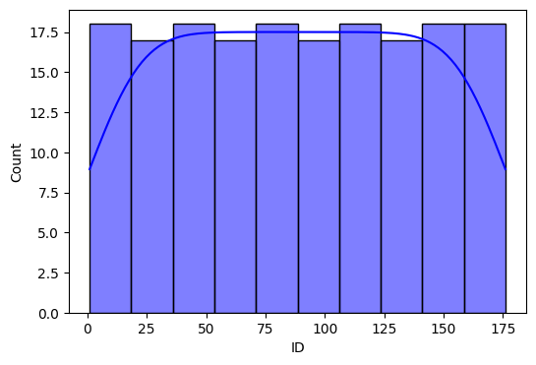

## Box Plot

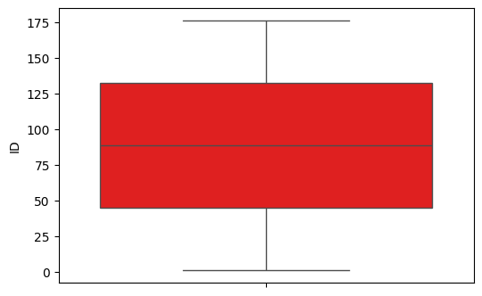

## Density Plot

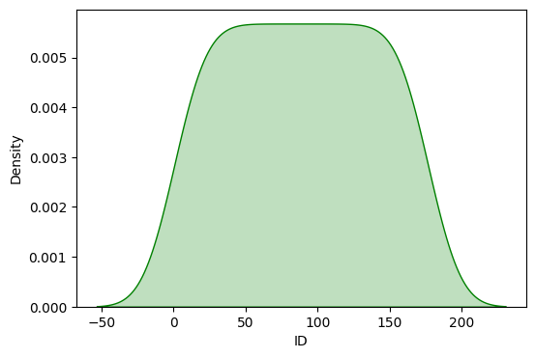

# Answer Key

This section contains the cleaned dataset after removing invalid/missing entries.

Number of rows before cleaning: 176

Number of rows after cleaning: 93

📂 Cleaned Dataset: static/csv/cleaned_countries_1.csv