## Final Cleaned Dataset with All Tasks Applied

Section 3  
The dataset shown above has the incorrect formats cleaned. Grade based on comparison between student dataset and dataset shown above.

Section 4  
The dataset shown above has the categorized values in italics. Grade based on comparison between student dataset and dataset shown above.

Section 5  
The dataset shown above has a new column representing a boolean variable. Grade based on comparison between student dataset and dataset shown above.

Number of times 'biscoe' appeared before cleaning: 163

Number of times other values appeared: 170

# GSB 521 Chapter 3 Answer Key

## Section 6: Plots

Histogram

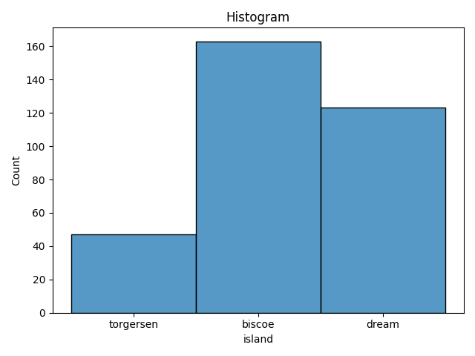

Box Plot with a Categorical Variable

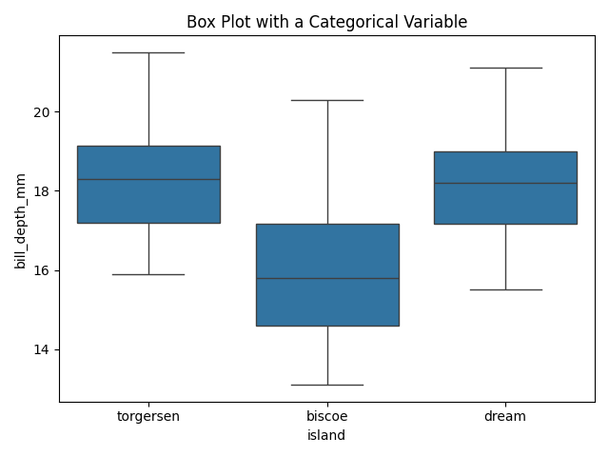

Scatterplot

