# Chapter 3 Assignment

# Chapter 3: Making Sense through Data Visualization

Selected Dataset: imdb_1.csv

## Data Summary

runtime ... gross  
count 831.000000 ... 831.000000  
mean 124.078219 ... 68.034751  
std 27.501455 ... 109.750043  
min 45.000000 ... 0.001305  
25% 104.000000 ... 3.253559  
50% 120.000000 ... 23.530892  
75% 138.000000 ... 80.750893  
max 242.000000 ... 936.662225  
  
[8 rows x 5 columns]

Visualizing Column: runtime

## Histogram

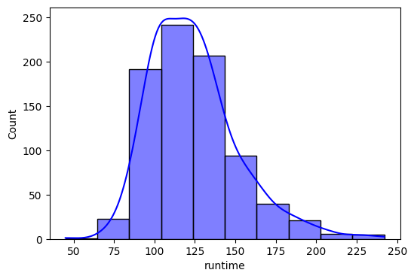

## Box Plot

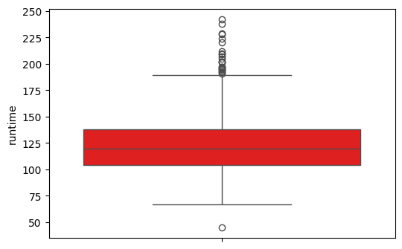

## Density Plot

