Selected Dataset: countries_1.csv

# GSB 521 Chapter 4 Answer Key

## Task 1: Summary Statistics After Outlier Handling

Mean: 27137347.89

Mode: N/A

Median: 17144743.00

90% Trimmed Mean: 23504088.51

Range: 213178216.00

Variance: 954157207633334.62

Standard Deviation: 30889435.21

## Task 2: Histogram Shape

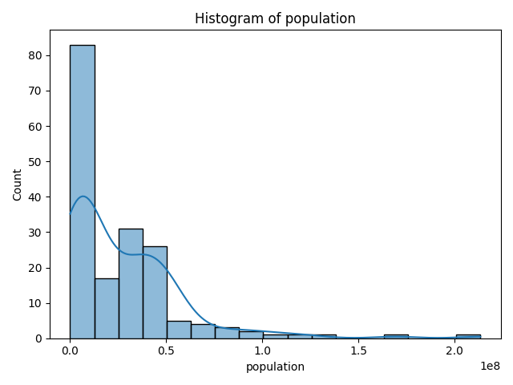

## Task 3: Scatterplot of Two Numeric Variables

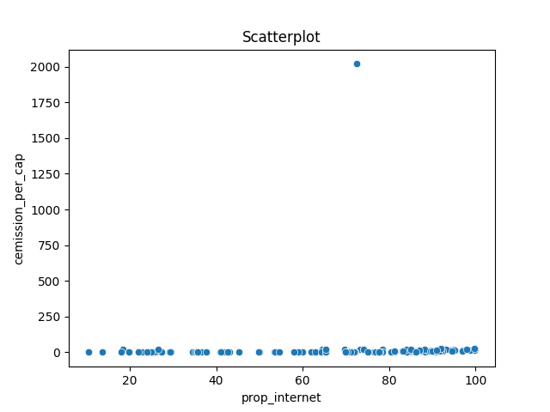

## Task 4: Column Chart from Two Text Variables

