Documentation of the course
Student Name - Sujata Shrestha
Email - t1shsu00@students.oamk.fi
Course - Html and CSS programming
URL of the website: https://sujata054.github.io/HTML-and-CSS/
URL of the UI mockup: https://www.figma.com/file/eVIhaZQXPQBvH0v2yc8OSy/Sujata-Portfolio?node-id=0%3A1

- Threshold resolution for responsiveness
Min-width: 1024px;
Resolution: 2048 * 2732 px and above

Mobile first design is implemented. So, the normal style is for mobile devices and the responsiveness is done to large devices which has min-width of 1024px.

- Colors for the page. Use color wheel for planning
Hex - #C593E3;
RGB - rgba(197, 147, 227, 1)

- Typography: what fonts, font colors and main font sizes you will use.
Font-family: Quicksand;
Font-size (default): 16px; (large devices)
Font-size (default): 15px; (small devices)
Font-size (on headings): 1.8rem;
Font color: rgba(249, 250, 251, 1) on dark background;
Font color: rgba(0, 0, 0, 1) on white background;

- Add images of the UI mockups in the document and link to Figma design.
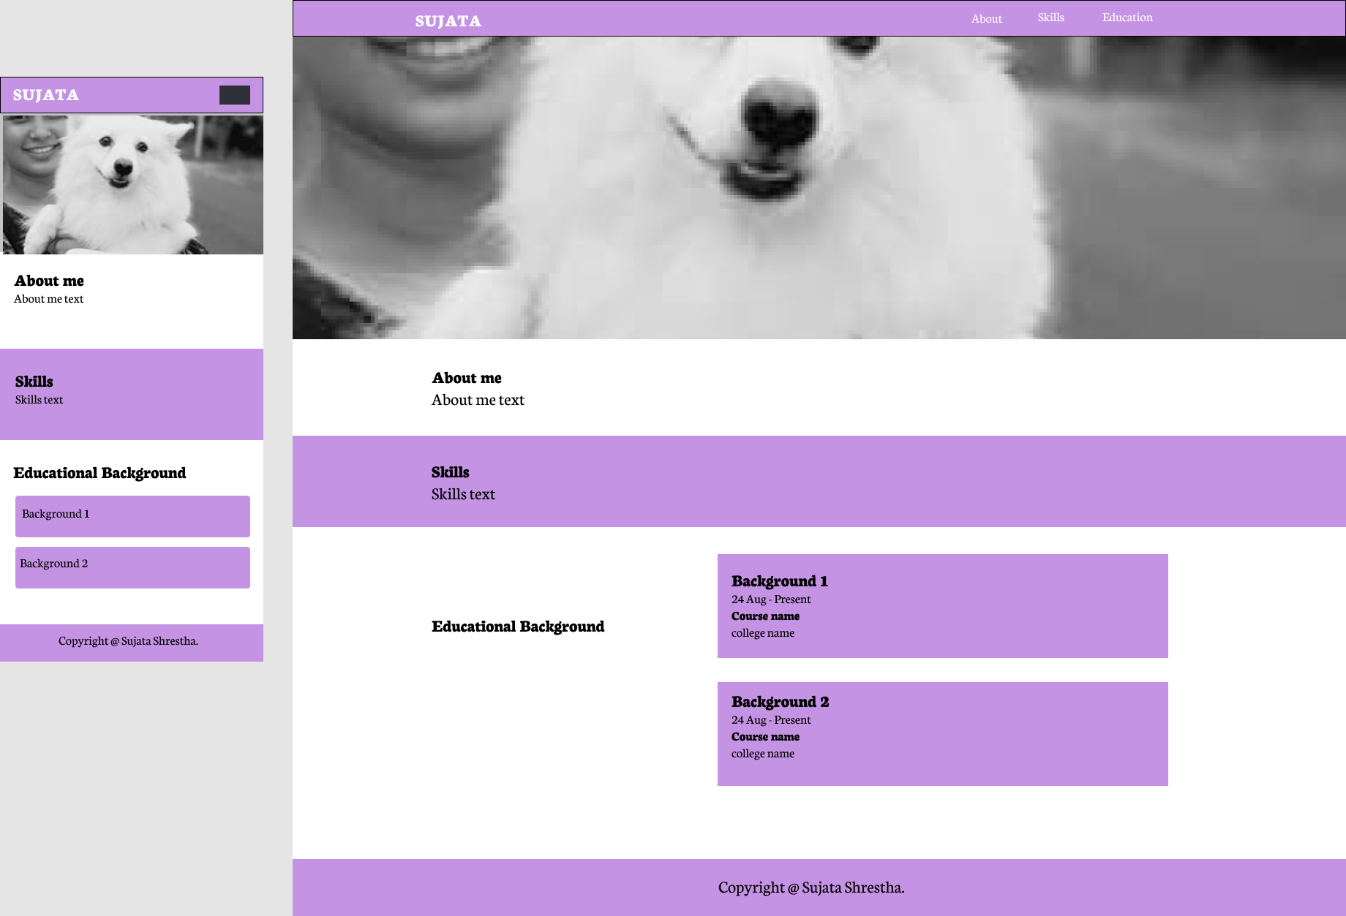

Above image is the UI mockup of the website. On the left in image is for mobiles devices and on the right is for large devices – desktop.

UI of the website

The website I created is about my portfolio. The main folder consists of 3 sub-folders, “images”, “scripts”, “styles” and 1 file, “index.html”. The folder ‘images’ contain all the images and logo used on the website. The folder ‘scripts’ contains “main.js” file which is used as an external JavaScript. The folder ‘styles’ contains “main.css” file which is used as an external CSS. The file “index.html” is the homepage of the website.

It is a single page website. The webpage consists total 4 menu named as about, skills, education and contact. There is a smooth scroll behavior on this website. The user can go to different sections of the page by clicking on the navigation link at the top of the page.
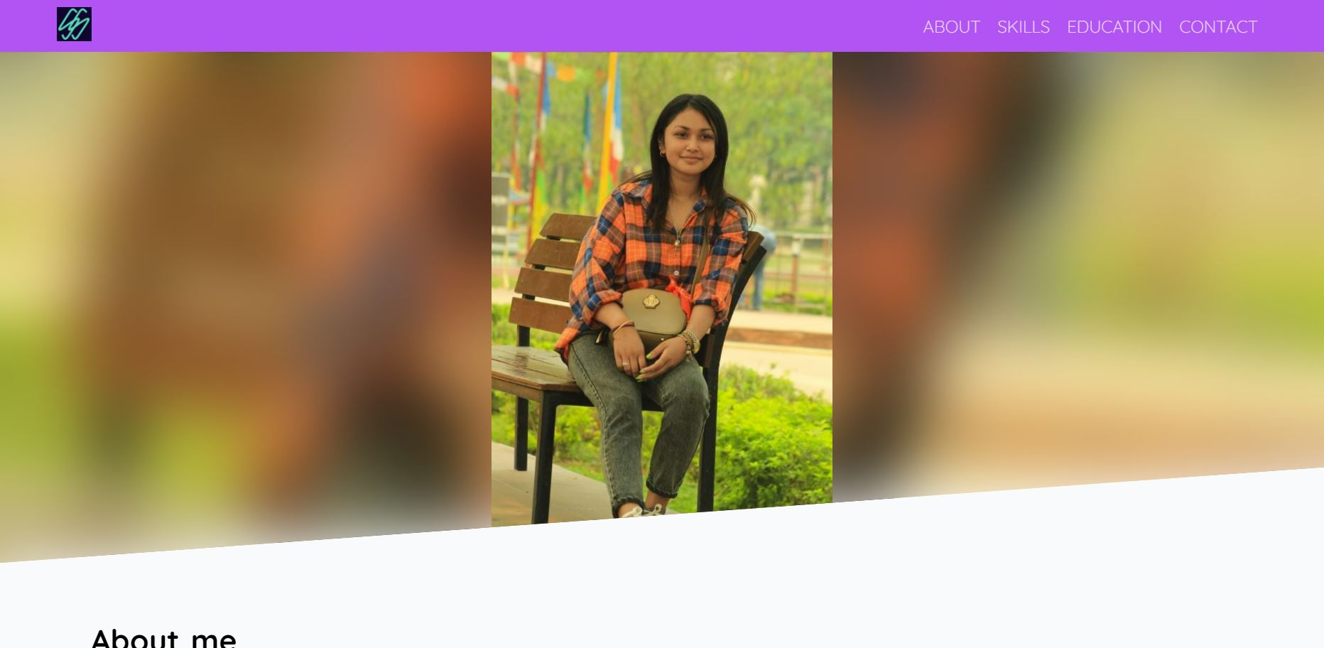
The above image is the image of first section of the page, and it contains my image as well as background image which is zoomed in and blurred in style.

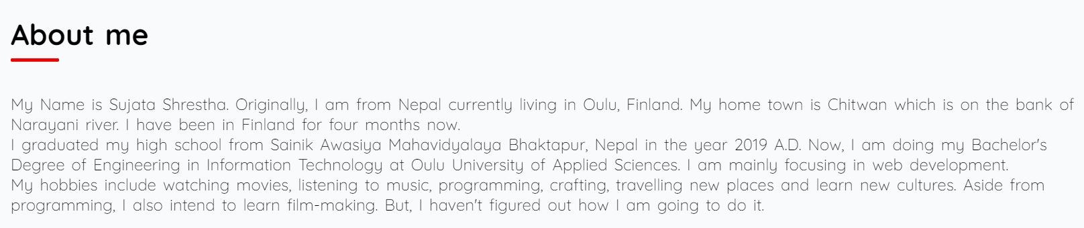
The above image is the image of second section of the page “about me” which contains my personal details, such as my name, hometown.

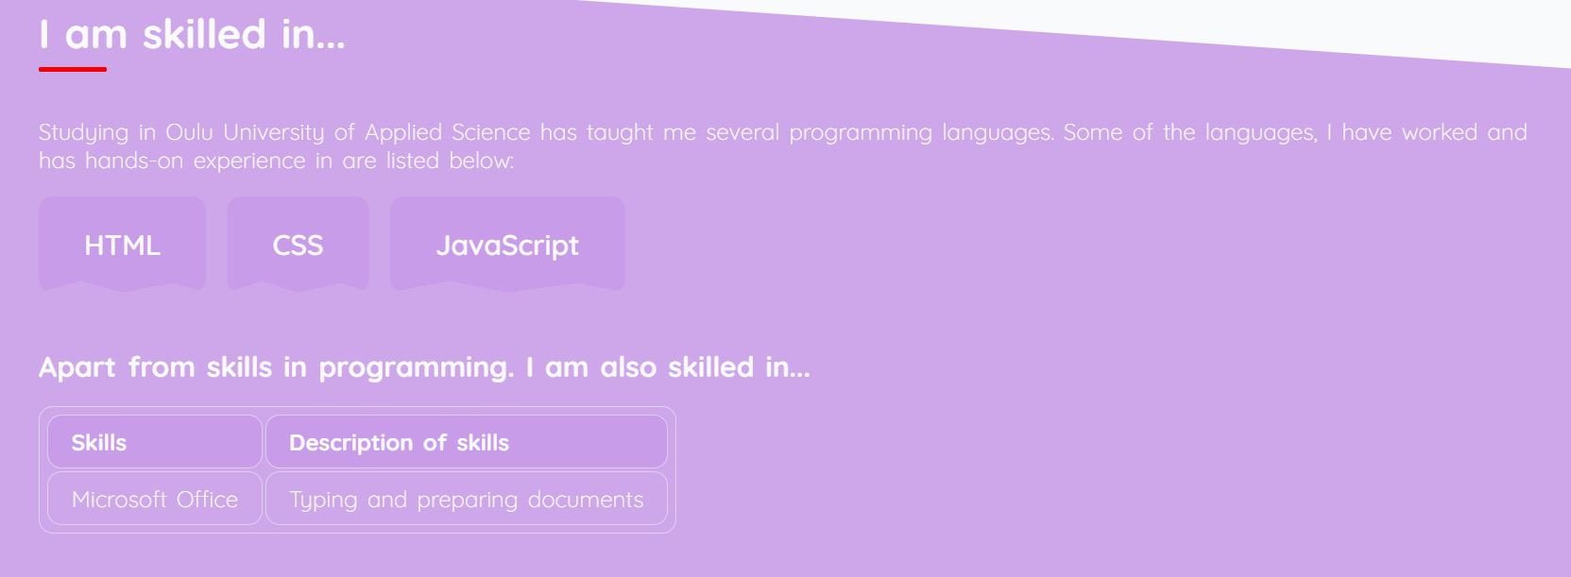
The above image is the image of third section of the page “skills” which contains my programming skills as well as other skills present in tables.


The above image is the image of fourth section of the page “education” which contains my educational background.

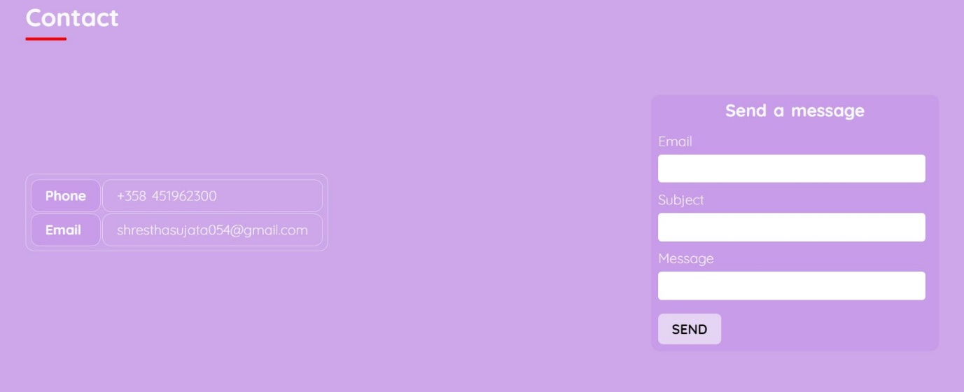
The above image is the image of fifth section of the page “contact” which contains my personal contact details like my phone no. and email address. It also has contact form which contains inputs for email, subject and message along with the send button. It shows alert message when the send button is clicked.


The above image is the footer of the webpage. The date “2022” shown in footer is a current year and is generated from the JavaScript. The footer also has social media links.

URL of the website: https://sujata054.github.io/HTML-and-CSS/
URL of the UI mockup: https://www.figma.com/file/eVIhaZQXPQBvH0v2yc8OSy/Sujata-Portfolio?node-id=0%3A1

