**Online Resume**

In this assignment, you will begin building your online resume with HTML and CSS. Of course, there always room for improvements in every project. For this reason, we are going to complete this assignment in multiple stages.

**Goal:**

The goal is to have a responsive online resume you can showcase to any employer you would like to work for.

**Desktop Version:**

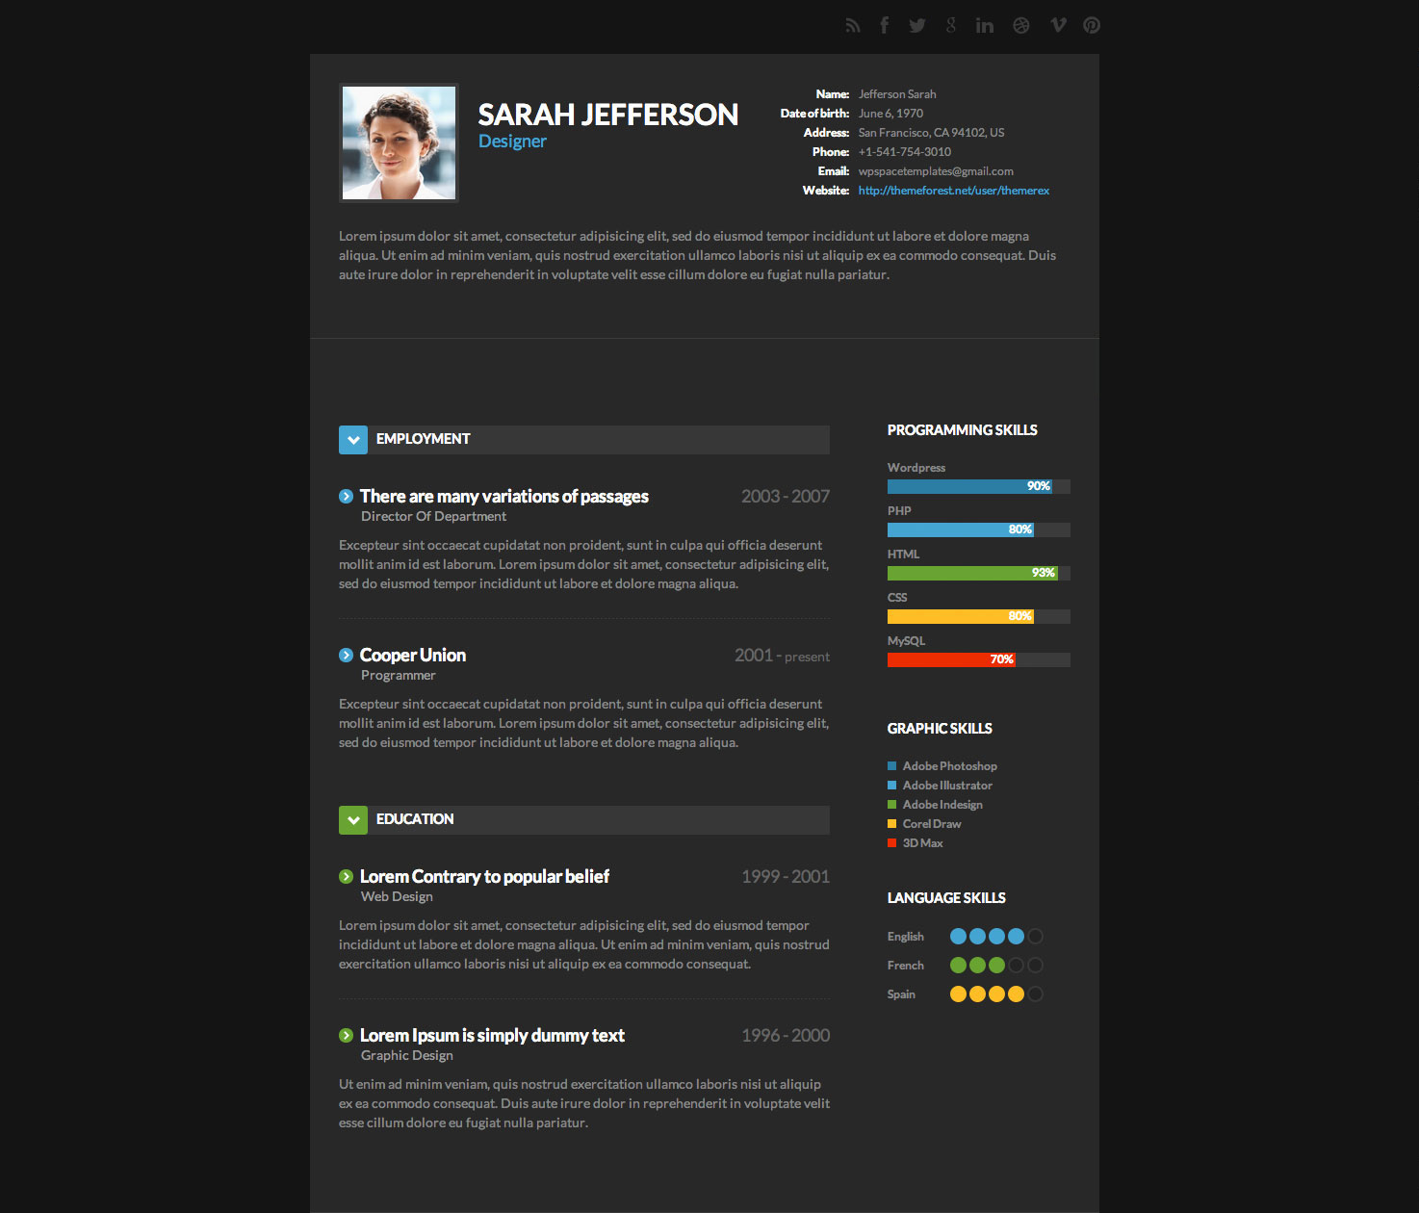

**Mobile Version:**

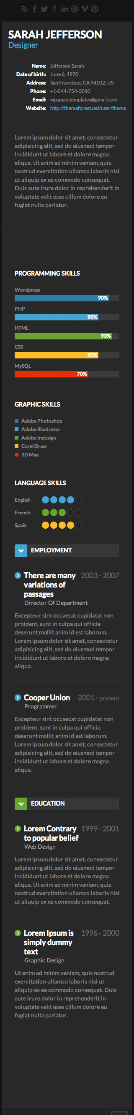

**Steps:**

1. This may seem overwhelming but don’t worry we will go in single steps. For this step you just need to layout the structure of the first session of the resume. This includes: an image, full name, title, general information, and a bio. You can always go back and re-structure the html. For now, let’s think of one possible structure for this session. Of course, you are welcome to follow your own creative structure.
   1. Think of the entire resume inside a big container, let’s call this container “main_container”.
   2. Inside the main-container, we can have a session where we can put all the information required for this step, call it: session1
   3. Now inside session1, the simplest way to see it, is by visualizing three boxes. 1) for the image, full name, title 2) for the general information 3) for the bio
   4. Go ahead and start implementing it. After, play around with the CSS. Although we have not learned about the “display” property of CSS, it is pretty easy to understand and we encourage you to research it.