MINI PROJECT REPORT ON

C -PROGRAMMIMG

**Module:** C-Programming

**Project title :** Simple-Calculator

**Submitted by**

Sujata Naikar

PS:99007669

AIM: To design a simple calculator using c programming.

OBJECTIVES

* To make a user interactive program , a simple calculator.
* Two numbers are accepted to run the operation for addition, substraction, multiplication and substraction, and only one number is asked as an input for the operations such as to find out squares and cubes.
* Exceptions have been specified in the code .

ABSTRACT

The project that I would be doing will mainly stress on performing simple mathematic calculations that are required while adding, substracting, dividing, multiplying any two numbers and gives squares and cubes of any particular number that you ask for. This project consists of a program which takes an arithmetic operator +, -, *, / and two operands from the user. Then, it performs the calculation on the two operands depending upon the operator entered by the user.

SOFTWARES REQUIRED

* Visual studio code, github, ubuntu-wsl.

There is a folder as milestone-1,which in short gives idea about what all is to be covered in carrying out the project.

## Milestone-1

* Folder structure.
* Idea
* Requirements
* Design
* Test plan
* ISSUE THAT WAS CREATED AT THE STARTING OF ANALYSING THE PROBLEM STATEMENT.

1.Capture a well processed idea.  
2.Requirements for the project.  
 -low level and high level  
3.Design(behavioural and structural)  
4.Test plan and Validation.

1. CERTIFICATES INCLUDE:
   1. Sololearn.

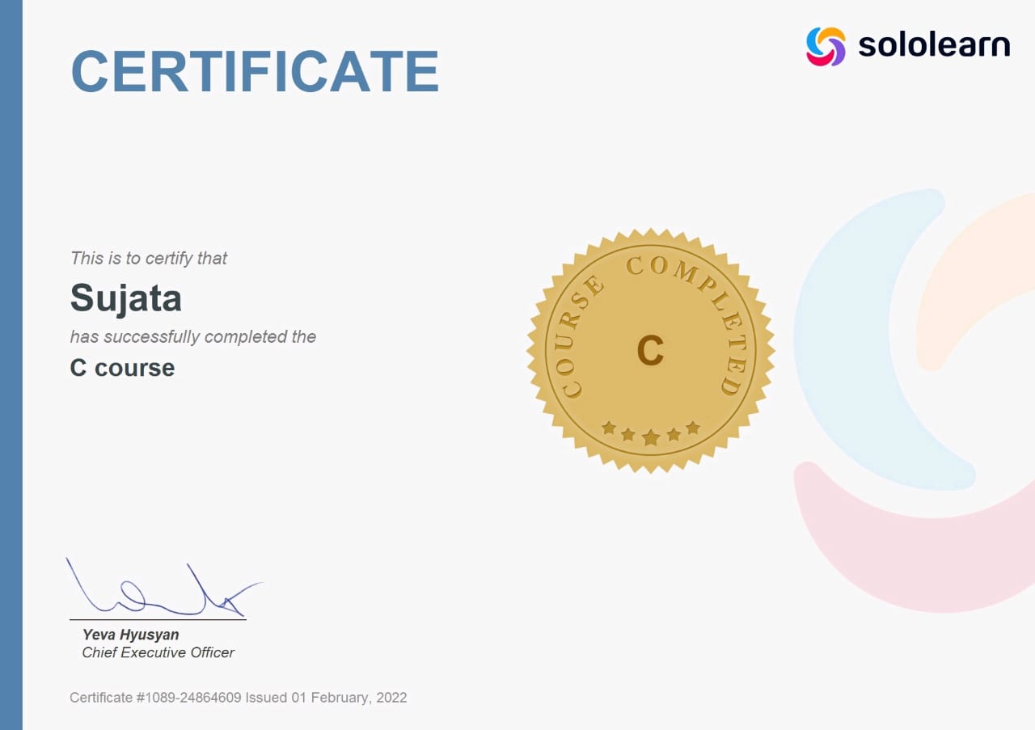

* 1. Cisco NDG Linux.



* 1. Screenshot of HackerEarth points.



* 1. Screenshot of Github learning.

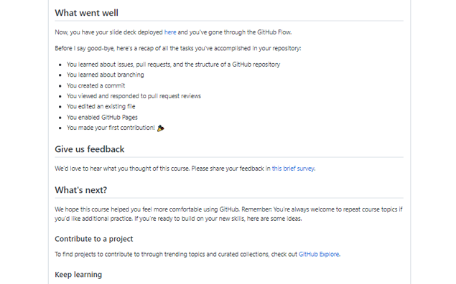

# 2.Requirements

## High level Requirements

* Able to perform operations such as,

1. Addition.
2. Substraction.
3. Multiplication.
4. Division.
5. Square.
6. Cube.

## Low level Requirements

1. Taking the two numbers to do any operation.
2. A code is written where different commands are used for different operations.
3. In case of squaring and cubing a number take only one number as an input.
4. The answer must be displayed on the screen.

## SWOT Analysis

1. Strength

* Capable of adding, substracting, dividing, multiplying any two numbers and gives squares and cubes of any particular number that you ask for.

1. Weakness

* As the main intension is to work with two numbers provided more will not be supported.

1. Opportunities

* In the basic step to make someone understand the simple operations of mathematics it is most useful one.

1. Threat

* Will not ask for more than two numbers.

3.Architecture.

## Design

## 3.1 Structural diagrams

3.2 Behavioural diagrams

* + Flowcharts

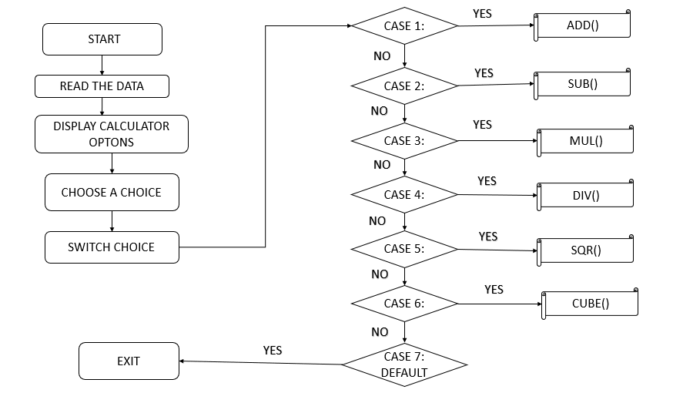

* + Use case diagrams

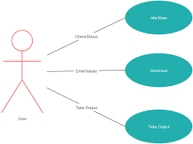

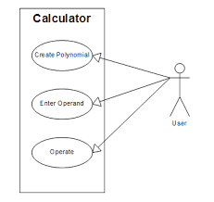

MODELS:

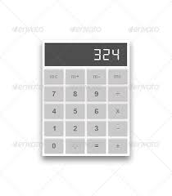 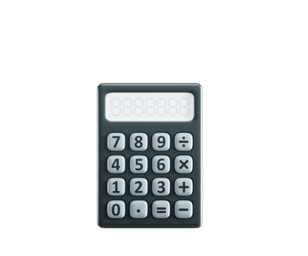

4.IMPLEMENTATION.

CODE FOR SIMPLE CALCULATOR

#include<stdio.h>

#include<stdlib.h>

#include<math.h>

//simple computer: add, sub, mul, div, sqr, cube

// progarm to obtain some basic operations used in simple calculators

int main()

{

int choose;

long no1, no2, m;

printf("Please choose your option from the below:"

"\n1 = Addition"

"\n2 = Subtraction"

"\n3 = Multiplication"

"\n4 = Division"

"\n5 = Squares"

"\n6 = Cubes"

"\n7 = exit"

"\n\nchoose: ");

scanf("%d", &choose);

//while loop check whether the choose option is in the given range

while(choose< 1 || choose > 7)

{

printf("\nPlease choose the above mentioned option."

"\nChoose: ");

scanf("%d", &choose);

}

switch (choose)

{

case 1:

printf ("Enter the two numbers to add: \n");

scanf("%ld %ld", &no1, &no2);

m = no1 + no2;

printf("Sum = %ld", m);

break;

case 2:

printf("Enter the two numbers substract: \n");

scanf("%ld %ld", &no1, &no2);

m = no1 - no2;

printf("Sub = %ld", m);

break;

case 3:

printf("Enter the two numbers to multiply: \n");

scanf("%ld %ld", &no1, &no2);

m = no1 * no2;

printf("Pdt= %ld", m);

break;

case 4:

printf("Enter the Dividend: ");

scanf("%ld", &no1);

printf("Enter the Divisor: ");

scanf("%ld", &no2);

//while loop checks for the divisor whether it is zero or not

while(no2 == 0)

{

printf("\nDivisor cannot be zero."

"\nEnter divisor once again to confirm: ");

scanf("%ld", &no2);

}

m = no1 / no2;

printf("\nQuotient = %ld", m);

break;

case 5:

printf("Enter any number of your choice: \n");

scanf("%ld", &no1);

m= no1 * no1;

printf("Sqr = %ld", m);

break;

case 6:

printf("Enter any number of your choice: \n");

scanf("%ld", &no1);

m = no1 * no1 * no1;

printf("Cube = %ld", m);

break;

case 7:

return 0;

default: printf("\nError");

}

}

OUTPUT(includes all the results of various operations)

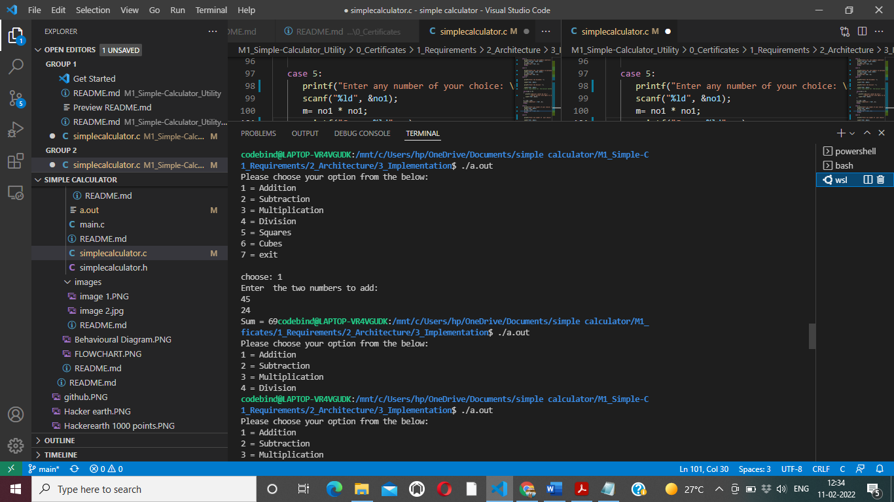

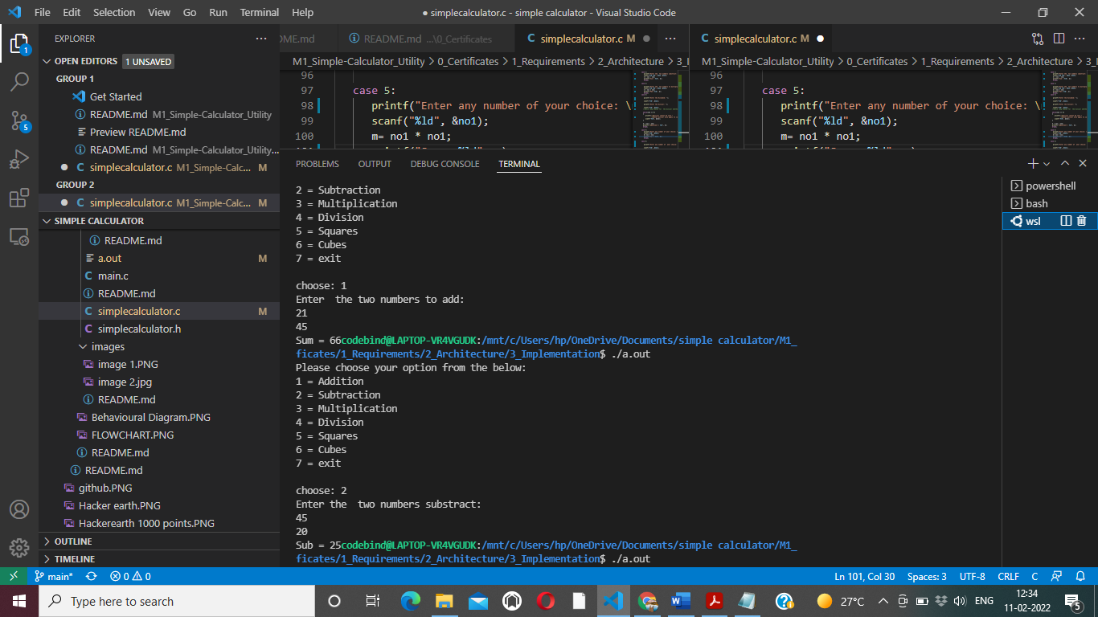

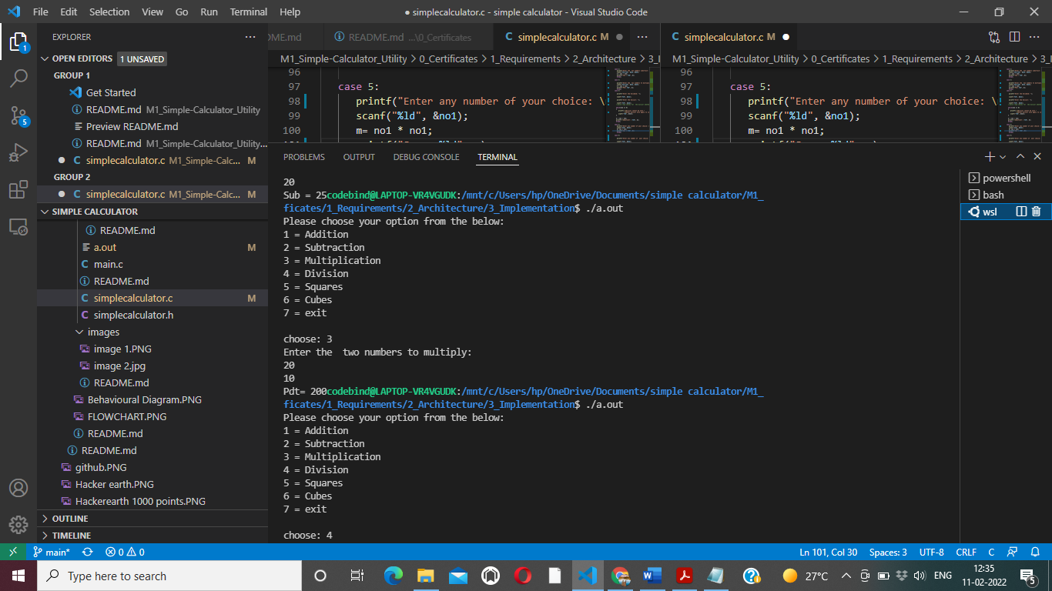

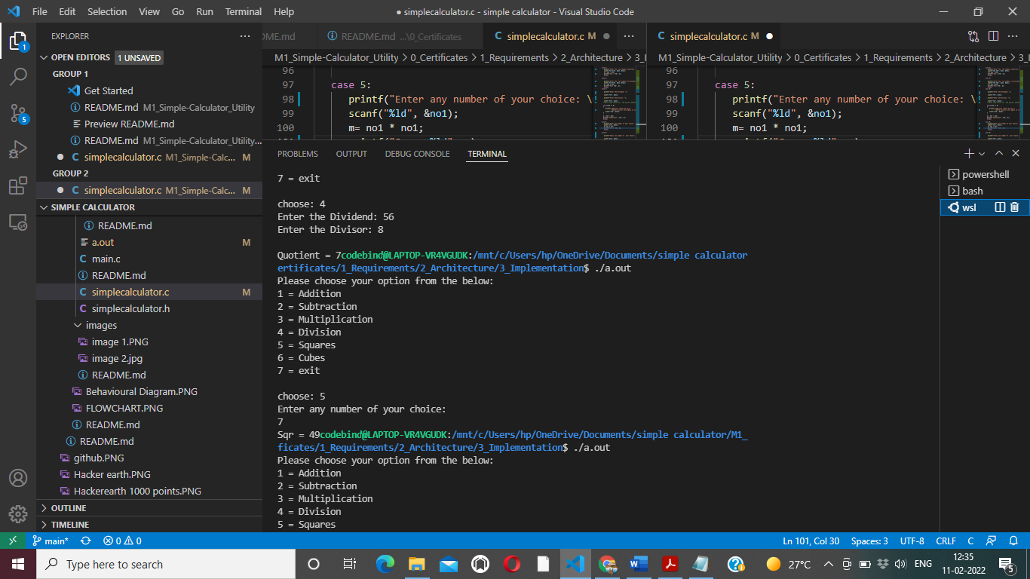

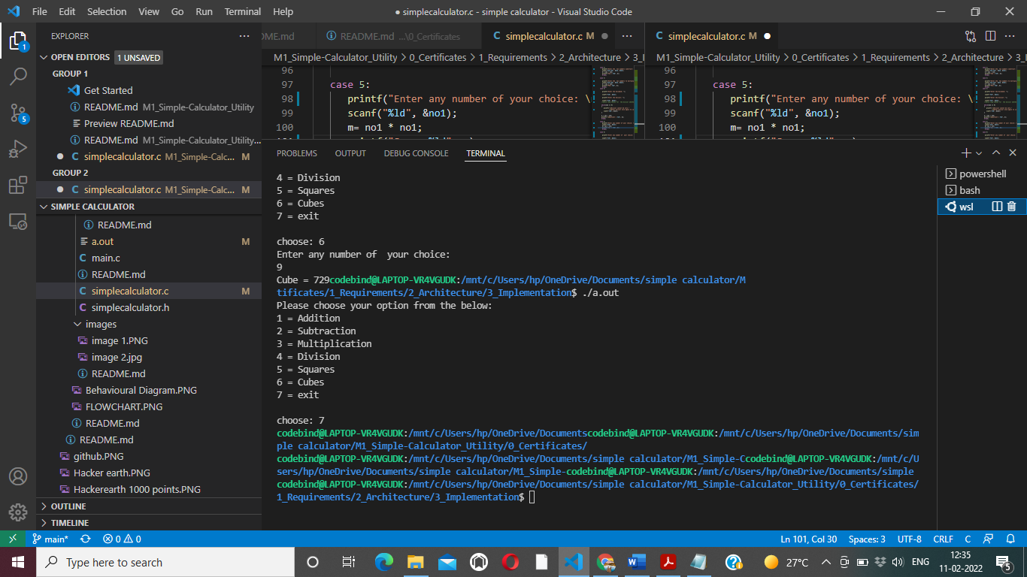

# 5.Test plan

1. For the Addition operation after taking two numbers we use '+' operand to do Addition .
2. For the Substraction operation after taking two numbers we use '-' operand to do Substraction.
3. For the Multiplication operation after taking two numbers we use '*' operand to do Multiplication.
4. For the Division operation after taking two numbers we use '/' operand to do Division .
5. For the Squaring operation after taking one number we use '*' operand to get the square of the particular number .
6. To Cube a particular number we use '*' opearnd twice in the operation.

6.REFERENCES:

* Refered some raw ideas from web platform and while analysing the code for the project.