**ORDERS,CUST,SALESPEOPLE**

1. Create the Salespeople as below screenshot.

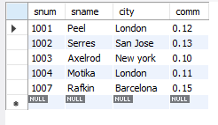

1. Create the Cust Table as below Screenshot 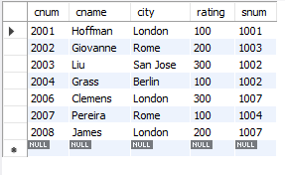
2. Create orders table as below screenshot.

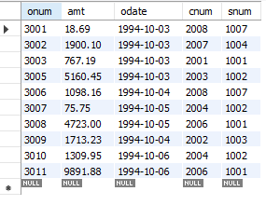

1. Write a query to match the salespeople to the customers according to the city they are living.
2. Write a query to select the names of customers and the salespersons who are providing service to them.
3. Write a query to find out all orders by customers not located in the same cities as that of their salespeople
4. Write a query that lists each order number followed by name of customer who made that order
5. Write a query that finds all pairs of customers having the same rating………………
6. Write a query to find out all pairs of customers served by a single salesperson………………..
7. Write a query that produces all pairs of salespeople who are living in same city………………..
8. Write a Query to find all orders credited to the same salesperson who services Customer 2008
9. Write a Query to find out all orders that are greater than the average for Oct 4th
10. Write a Query to find all orders attributed to salespeople in London.
11. Write a query to find all the customers whose cnum is 1000 above the snum of Serres.
12. Write a query to count customers with ratings above San Jose’s average rating.
13. Write a query to show each salesperson with multiple customers.