**Intelligent Search**

**Search Functionality:**

It can connect to different Data sources like RealTime (Salesforce, Dynamics etc) and Non-RealTime ( SQL, ElasticSearch, FlatFile) to get Data and will provide result by ignoring case, discrepancies in the request provided and return matching records .

|  |  |
| --- | --- |
| **Scenario** | **Example** |
| Spelling mistakes | Sujith Kumar vs Sujath Kumar  Sujatha vs Sujata |
| Words in different order | Mohapatra Amit K vs Amit K Mohapatra  Sujatha Anand P vs Sujatha P Anand |
| Middle initials or Suffix/Prefix exists/absent | Sujatha vs Sujatha Jr.  Amit K Mohapatra vs Amit Mohapatra |
| phonetic search | Amith vs Amit  Shiva vs Siva |

Search Offerings:

* Search functionality in UI ( user can enter input in the UI and can see the result in UI )
* Search functionality as backend service (REST API) [ user can send the request and get the result in response]

**Data Sources Types**: Currently we have configured below data sources types and it is open to extend to configure other Datasources Types also like Dynamics etc

* Salesforce
* ElasticSearch
* SQL Server
* FlatFile

**Algorithms applied:**

FuzzyWuzzy

Levenshtein (LongestCommonSubSequence)

**Technology Stack**:

.NetFramework

How to perform search:

Any application who registered or configured can directly access our application UI search page ( for now we provided login in future we can enable SSO) or REST API by configuring urls at their end.

1. Applications need to be Registered with us, while registering they an choose multiple data sources form where it requires data on which search to be performed[ we can see this info in configurations page attached screen shot below].
2. Search REST API: hit the REST Api Post method by passing request , it will return the Search results.

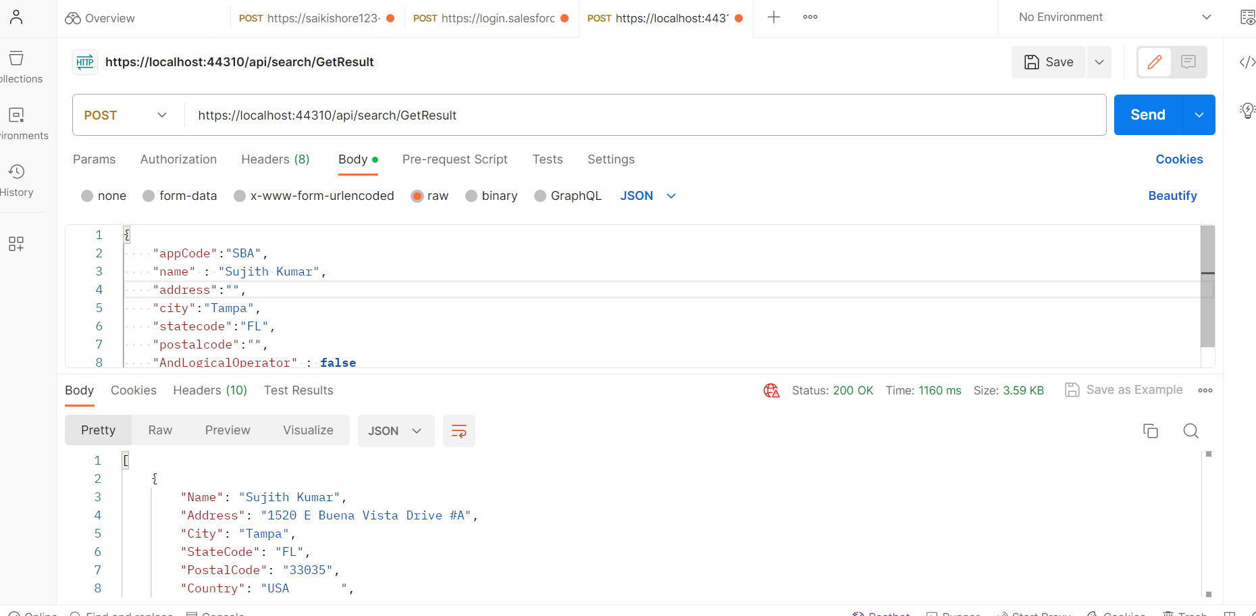

1. Search functionality from UI.

* Navigate to Login page and enter provided credentials ( this we remove later by enabling SSO) and click login.

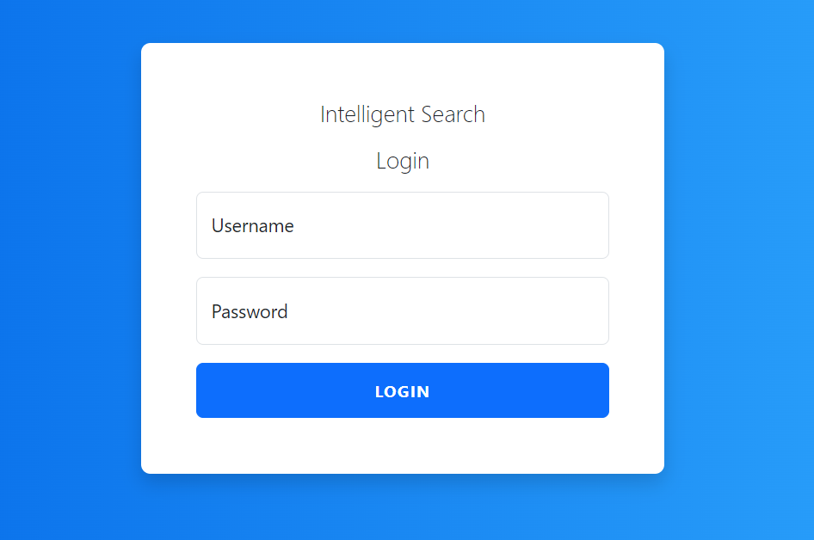

* After login Search Page will be displayed. Enter the details like name, street etc and click on search.

For now we enabled fuzzy search for Name, Street fields only. (remaining fields should match exactly) ([we can extend fuzzy for the rest of the fields also]

Values for Name or street need to be provided rest are optional.

After entering the details click on the button “Search”, Results will be displayed in the same page below to Searh window.

**Search Type [Logical Operator between Name, Address] :**

AND: will give the result where both Name and Street matches with the request provided.

OR: will give the result either Name or Streed matches with the request provided.

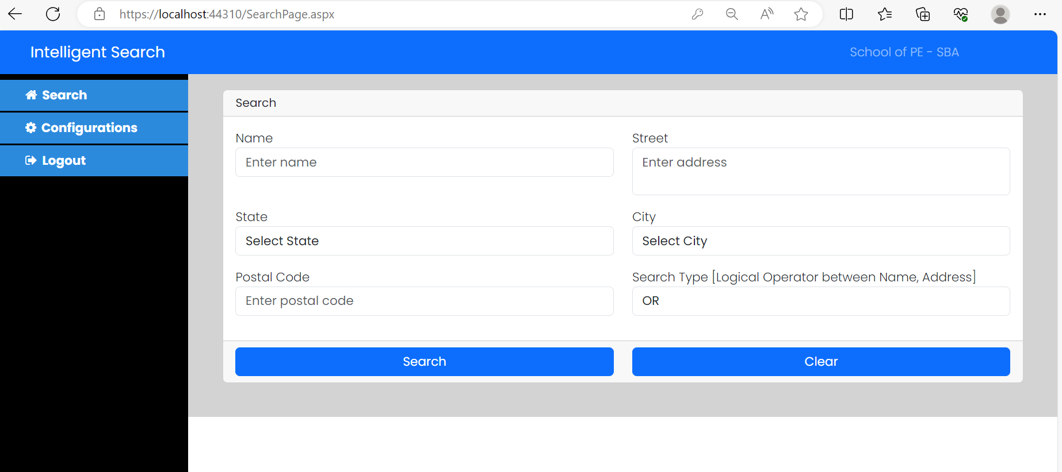

On Search result also we can perform search by entering the data in the text box, it will filter the data if word matches with any of the data in any of the column. For now search on result is not fuzzy we can extend this to fuzzy search in future.

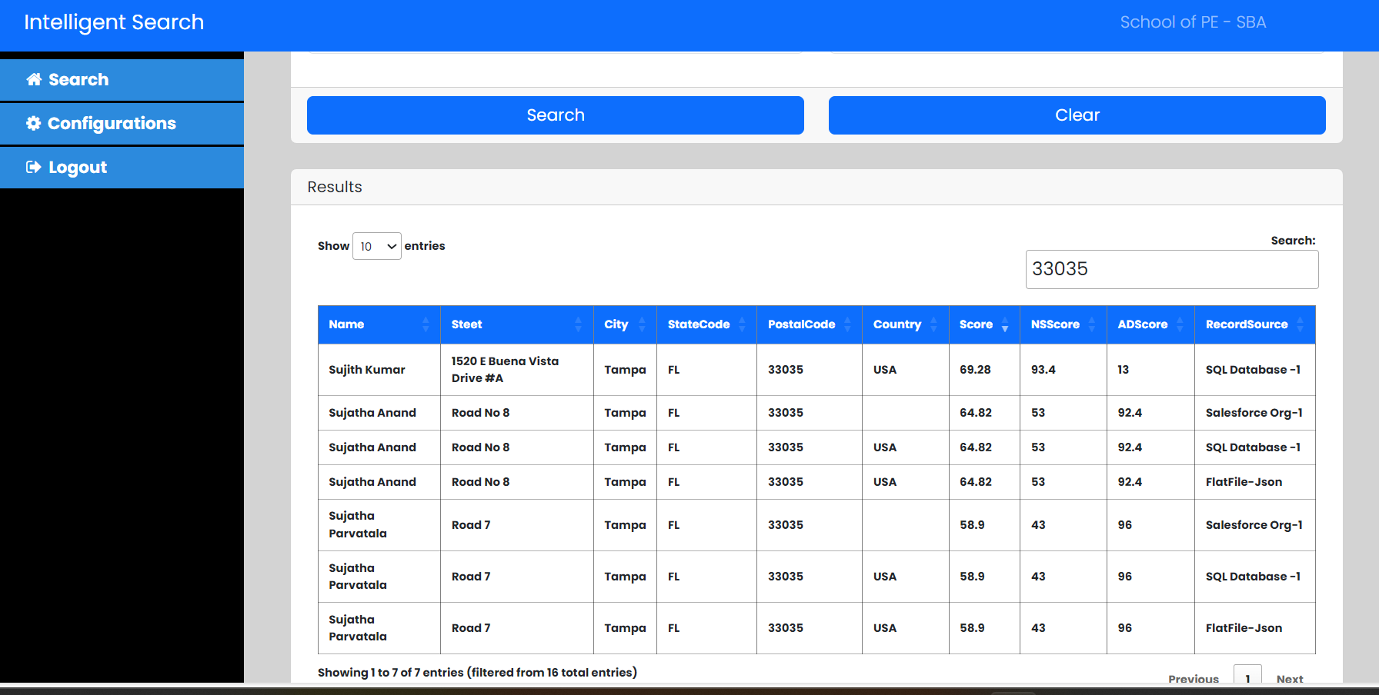



In the above grid use can see what is the data source

* In the configuration page users can see what are the data sources ( and Types) they have opted to get the data. They can change the data sources as and when required.

The below application/user configured 3 data sources which are Salesforce. SQL and Flatfile.

So when this user performs search, it will fetch data form these 3 data sources and will perform the serch operation.

