A REPORT

ON

INTELLIGENT DATA QUALITY MONITORING USING MACHINE LEARNING FOR REGULATORY REPORTING SYSTEMS
BY
Sujatha Chittiri
ID No.: 2023AC05729
AT
HSBC Global Technologies Pvt Ltd, Hyderabad
BIRLA INSTITUTE OF TECHNOLOGY & SCIENCE, PILANI
January, 2026

A REPORT

ON

INTELLIGENT DATA QUALITY MONITORING USING MACHINE LEARNING FOR REGULATORY REPORTING SYSTEMS
BY
Sujatha Chittiri ID No.: 2023AC05729 Discipline: M.Tech Artificial Intelligence & Machine Learning
Prepared in partial fulfilment of the
WILP Dissertation
AT
HSBC Global Technologies Pvt Ltd, Hyderabad
BIRLA INSTITUTE OF TECHNOLOGY & SCIENCE, PILANI
January, 2026
Acknowledgement

I would like to express my sincere gratitude to my supervisors, Phani Kumar PVSKP and Hemendra LK Akuthota, for their continuous guidance, encouragement, and valuable technical insights throughout the course of this dissertation. I am thankful to the management and colleagues at HSBC Global Technologies Pvt Ltd, Hyderabad, for providing a supportive environment and practical exposure to regulatory reporting systems.
I also express my sincere gratitude to the faculty of BITS Pilani WILP for their academic guidance and continuous support throughout this program. I would like to specifically thank my BITS evaluator, Prof. Sivagami R, for her valuable feedback and evaluation of this dissertation. Finally, I express my heartfelt gratitude to my family for their constant encouragement, patience, and support throughout this academic journey.

BIRLA INSTITUTE OF TECHNOLOGY AND SCIENCE
PILANI (RAJASTHAN)
WILP Division
Organization: HSBC Global Technologies Pvt Ltd Location: Hyderabad
Duration: 3 Months Date of Start: 24-Oct-2025
Date of Submission: 1-Feb-2026
Title of the Project:
INTELLIGENT DATA QUALITY MONITORING USING MACHINE LEARNING FOR REGULATORY REPORTING SYSTEMS
ID No./Name of the student: 2023AC05729 / Sujatha Chittiri
Name(s) and Designation(s) of your Supervisor and Additional Examiner:
Phani Kumar PVSKP, Associate Director; Hemendra LK Akuthota, Associate Director
Name of the Faculty mentor:- Prof. Sivagami R
Key Words: Data Quality, Regulatory Reporting, Anomaly Detection, Machine Learning, Explainable AI
Project Areas: Financial Risk Analytics, Data Governance, Artificial Intelligence
Abstract:
Ensuring high data quality in regulatory reporting is a critical requirement for financial institutions, as inaccurate or inconsistent data can lead to regulatory breaches, capital misstatements, and reputational risk. Traditional data quality frameworks in banks are predominantly rule-based and rely on deterministic validation checks. While such systems are essential, they are inherently limited because they can only detect predefined error patterns and are unable to identify previously unknown or complex multivariate anomalies.
This dissertation proposes and implements an Intelligent Data Quality Monitoring Framework that combines rule-based validation with unsupervised machine learning and explainable artificial intelligence techniques for regulatory reporting systems. The proposed system integrates multiple anomaly detection models including Isolation Forest, Local Outlier Factor, One-Class SVM, PCA-based anomaly detection, and Autoencoders, and combines them into an ensemble scoring mechanism. A hybrid decision layer fuses rule-based and ML-based results to achieve maximum anomaly coverage while preserving regulatory governance and control.
To ensure transparency and auditability, Explainable AI (XAI) techniques using SHAP (SHapley Additive exPlanations) are incorporated to interpret the behaviour of the machine learning models and to identify the key features driving anomaly detection. An end-to-end operational pipeline is developed, from data generation and quality rule evaluation to ML scoring, unified anomaly decisioning, and business-facing visualization through an interactive dashboard.
The system is evaluated on a realistic synthetic dataset designed to resemble regulatory reporting data used in large banking environments. Experimental results demonstrate that while rule-based systems effectively capture deterministic violations, the machine learning models identify a significant number of additional anomalies that pass all rule checks. The hybrid approach achieves the best overall performance, combining governance, detection power, and explainability.
This work demonstrates that machine learning is not a replacement for rule-based controls, but a powerful complement that significantly enhances the robustness, coverage, and intelligence of regulatory data quality monitoring frameworks.
 
Signature of Student: Signature of Supervisor:
Date: 31-01-2026 Date: 31-01-2026

Table of Contents
Chapter 1: Introduction 1
1.1 Background and Motivation 1
1.2 Regulatory Reporting and Data Quality Challenges 1
1.3 Problem Statement 2
1.4 Objectives of the Dissertation 2
1.5 Contributions of This Work 2
1.6 Organization of the Report 2
Chapter 2: Literature Review 3
2.1 Data Quality in Financial Regulatory Systems 3
2.2 Anomaly Detection in Financial Data 3
2.3 Unsupervised Learning for Anomaly Detection 4
2.4 Review of Key Models 4
2.4.1 Isolation Forest 4
2.4.2 Local Outlier Factor (LOF) 4
2.4.3 One-Class Support Vector Machine (OCSVM) 5
2.4.4 PCA-based Anomaly Detection 5
2.4.5 Autoencoders for Anomaly Detection 5
2.5 Ensemble and Hybrid Approaches in Literature 5
2.6 Explainable AI in Financial Systems 5
2.7 Summary and Research Gap 6
Chapter 3: Source Dataset and Feature Engineering 7
3.1 Nature of Regulatory Data in Banks 7
3.2 Typical Fields in Regulatory Risk Data (HSBC-Inspired) 7
3.3 Feature Categories Used in This Work 8
3.4 Feature Selection Criteria 9
3.5 Final Feature Set Used in This Work 9
3.6 Synthetic Data Generation and Bias Control 10
3.7 Feature Justification Using Explainable AI (SHAP) 10
3.8 Summary 11
Chapter 4: Dataset Description and Exploratory Data Analysis 11
4.1 Dataset Overview 11
4.2 Exploratory Data Analysis 12
4.2.1 Distribution of Exposure Amount 12
4.2.2 Distribution of Risk Weight 13
4.2.3 Distribution of Capital Requirement 14
4.2.4 Exposure-to-Capital Ratio Analysis 15
4.2.5 Distribution of Risk Weighted Assets (RWA) 16
Chapter 5: System Architecture and End-to-End Pipeline 17
5.1 Overall Architecture 17
5.2 End-to-End Processing Flow 18
5.3 Architectural Design Principles 19
5.4 Component-Level Description 20
5.4.1 Synthetic Data Generator 20
5.4.2 Rule-Based Data Quality Engine 20
5.4.3 Machine Learning Scoring Engine 21
5.4.4 Hybrid Scoring and Decision Layer 21
5.4.5 Model Evaluation and Explainability Layer 21
5.4.6 Operational Dashboard 22
5.5 Script-Level Pipeline Mapping 22
5.6 Summary 23
Chapter 6: Rule-Based Data Quality Engine 23
6.1 Motivation for Rule-Based Data Quality Checks 23
6.2 Design Objectives of the Rule Engine 23
6.3 Categories of Rules Implemented 24
6.3.1 Completeness Checks 24
6.3.2 Domain and Code List Validation 24
6.3.3 Range and Boundary Checks 25
6.3.4 Capital Formula Consistency Checks 25
6.3.5 Duplicate Detection 25
6.3.6 Outlier-Based Sanity Checks 26
6.4 Threshold Management and Configuration 26
6.5 Rule Severity Scoring Mechanism 26
6.6 Output of the Rule Engine 26
6.7 Role of the Rule Engine in the Hybrid Framework 27
6.8 Summary 27
Chapter 7: Machine Learning Models for Anomaly Detection 27
7.1 Motivation for Machine Learning Based Detection 27
7.2 Unsupervised Anomaly Detection Paradigm 28
7.3 Data Preprocessing and Feature Engineering 28
7.4 Models Implemented 28
7.4.1 Isolation Forest 29
7.4.2 Local Outlier Factor (LOF) 29
7.4.3 One-Class Support Vector Machine (OCSVM) 29
7.4.4 PCA-Based Anomaly Detection 30
7.4.5 Autoencoder-Based Anomaly Detection 30
7.5 Hyper Parameters used in ML Models 30
7.6 Rationale for Using Multiple Models 31
7.7 Why not VAE 32
7.8 Ensemble Scoring Strategy 33
7.9 Output of the ML Scoring Layer 36
7.10 Summary 37
Chapter 8: Hybrid Scoring Framework 37
8.1 Motivation for a Hybrid Approach 37
8.2 Inputs to the Hybrid Decision Layer 37
8.3 Hybrid Decision Logic 38
8.4 Interpretation of ML-Only Anomalies 38
8.5 Overlap Analysis 38
8.6 Governance and Audit Perspective 39
8.7 Output of the Hybrid Scoring Layer 39
8.8 Summary 39
Chapter 9: Model Evaluation and Comparative Analysis 39
9.1 Evaluation Challenges in Unsupervised Anomaly Detection 40
9.2 Evaluation Metrics 40
9.2.1 ROC-AUC 40
9.2.2 Precision@K (Top-K Precision) 40
9.3 Individual Model Performance Comparison 40
Observations 42
9.4 Ensemble Model Performance 42
Observations 43
9.5 System-Level Comparison 43
9.5.1 ROC Curves – System Models 44
9.5.2 Confusion Matrix Analysis 44
Observations 46
9.6 Overlap and Coverage Analysis 46
9.7 Practical Interpretation of Results 47
9.8 Summary 47
Chapter 10: Explainable AI and Model Interpretability 48
10.1 Importance of Explainability in Regulatory Systems 48
10.2 Explainable AI (XAI) Approaches 48
10.3 Explainability Strategy in This Work 49
10.4 SHAP for Isolation Forest 49
10.5 Explainability for Autoencoder Using a Surrogate Model 50
10.6 Global vs Local Explanations 52
10.7 Integration with the Operational Dashboard 52
10.8 Regulatory and Governance Perspective 52
10.9 Summary 53
Chapter 11: Operational Dashboard and User Interface 53
11.1 Motivation for an Operational Monitoring Interface 53
11.2 Dashboard Architecture 53
11.3 Key Performance Indicator (KPI) Section 54
11.4 Anomaly Distribution View 54
11.5 Risk-Based Prioritization 55
11.6 Top Risky Records View 56
11.7 Filtering and Investigation Panel 57
11.8 Explainability and Interpretation Section 57
11.9 Typical Analyst Workflow 58
11.10 Governance and Audit Perspective 58
11.11 Summary 59
Chapter 12: Results, Business Impact and Discussion 59
12.1 Overview of Experimental Results 59
12.2 Summary of Key Quantitative Findings 59
12.3 Interpretation of Model Comparison Results 60
12.4 Interpretation of System-Level Results 60
12.5 Significance of ML-Only Anomalies 61
12.6 Explainability and Trustworthiness of Results 61
12.7 Operational Impact in a Banking Environment 62
12.8 Strategic Value to Regulatory Reporting Functions 62
12.9 Discussion of Limitations 62
12.10 Summary 63
Chapter 13: Limitations and Future Work 63
13.1 Limitations of the Current Work 63
13.1.1 Use of Synthetic Data 63
13.1.2 Proxy Thresholds and Simulated Rules 64
13.1.3 Limited Scope of Models and Features 64
13.1.4 Batch-Oriented Processing 64
13.2 Future Work 64
13.2.1 SHAP-Based Record-Level Explainability 65
13.2.2 Model Tuning and Sensitivity Analysis 65
13.2.3 Drift Detection and Stability Monitoring 65
13.2.4 Temporal and Cross-Report Consistency Checks 65
13.2.5 Deeper Integration into Control Frameworks 66
13.3 Summary 66
Chapter 14: Conclusion 66
14.1 Summary of the Work 66
14.2 Key Contributions 67
14.3 Achievement of Objectives 67
14.4 Practical Relevance to Regulatory Reporting 68
14.5 Final Remarks 68
Checklist of Items for the Final Dissertation 68

List of Figures
Figure 1: Boxplot of Exposure Amount (Raw Synthetic Dataset) 13
Figure 2: Boxplot of Risk Weight (Raw Synthetic Dataset) 14
Figure 3: Boxplot of Capital Requirement (Raw Synthetic Dataset) 15
Figure 4: Boxplot of Exposure-to-Capital Ratio (Raw Synthetic Dataset) 16
Figure 5: Boxplot of Risk Weighted Assets (Raw Synthetic Dataset) 17
Figure 6: Architecture Diagram 18
Figure 7: ROC Curves for Individual ML Models 41
Figure 8: ROC Curve for ML Ensemble 43
Figure 9: ROC Curve for RULE, ML, Hybrid Detection System 44
Figure 10: Confusion Matrix for Rule-Based Anomaly Detection 45
Figure 11: Confusion Matrix for ML-Based Anomaly Detection 45
Figure 12: Confusion Matrix for Hybrid Anomaly Detection 46
Figure 13: SHAP Feature Importance for Isolation Forest 50
Figure 14: SHAP Feature Importance for Autoencoder Surrogate Model 51
Figure 15: Dashboard KPI Summary Showing Rule, ML and Hybrid Anomaly Counts 54
Figure 16: Distribution of Anomalies Across Rule, ML and Hybrid Categories 55
Figure 17: Ranked High-Risk Records Based on Ensemble ML Score 56
Figure 18: Interactive Filtering of Records by Flag Source and Risk Bucket 57
Figure 19: Explainability View Showing Feature Importance for Anomaly Detection 58

List of Tables
Table 1: Hyperparameters of Unsupervised Models 31
Table 2: Performance Comparison of Individual Unsupervised Models 41
Table 3: Ensemble Model Performance 42
Table 4: System-Level Comparison of Rule, ML and Hybrid Approaches 44
Table 5: Overlap Analysis 46

Chapter 1: Introduction

1.1 Background and Motivation
Financial institutions operate in a highly regulated environment where accurate, consistent, and timely reporting of risk and capital information to supervisory authorities such as the Prudential Regulation Authority (PRA), European Central Bank (ECB), and other regulators is mandatory. Regulatory reports are produced from complex data pipelines that integrate information from multiple upstream systems including trading, risk, finance, and reference data platforms. Due to the scale, heterogeneity, and continuous evolution of these systems, data quality issues such as missing values, inconsistent attributes, incorrect mappings, duplicate records, and out-of-range values are inevitable.
Traditionally, data quality in regulatory reporting has been ensured through rule-based validation frameworks, where predefined business rules and reconciliation checks are applied at various stages of the reporting pipeline. While such approaches are effective in capturing known and well-defined issues, they struggle to detect complex, multivariate, and previously unseen anomalies that arise due to unusual combinations of attributes or subtle distributional shifts. With the increasing volume and complexity of regulatory data, there is a growing need for intelligent, adaptive, and data-driven approaches to complement existing rule-based controls.
Recent advances in Artificial Intelligence (AI) and Machine Learning (ML) have demonstrated strong potential in anomaly detection, pattern discovery, and automated monitoring across several domains. In particular, unsupervised learning techniques are well suited for regulatory reporting environments, where labelled examples of erroneous data are scarce or unavailable. These techniques can learn the structure of "normal" data and identify records that deviate significantly from learned patterns.

1.2 Regulatory Reporting and Data Quality Challenges
Regulatory reporting data is characterized by high dimensionality, strong interdependencies between attributes, and strict consistency requirements across exposure, risk, and capital measures. Typical reports include information such as exposure amounts, risk weights, risk-weighted assets (RWA), capital requirements, maturity profiles, collateral indicators, and credit quality classifications. Errors in any of these fields can lead to incorrect regulatory submissions, supervisory findings, reputational damage, and potential capital add-ons.
A key challenge is that not all data quality issues can be expressed as deterministic rules. For example, while a missing value or an invalid currency code can be captured using simple checks, an exposure with an unusual combination of maturity, risk weight, and capital requirement may still pass all rule-based validations while being economically implausible. Detecting such cases requires learning the joint behavior of multiple attributes, which motivates the use of machine learning based techniques.

1.3 Problem Statement
The problem addressed in this dissertation is the design and implementation of an intelligent data quality monitoring framework for regulatory reporting systems that goes beyond traditional rule-based validation. The objective is to develop a hybrid system that combines deterministic data quality rules with unsupervised machine learning models to detect both known and unknown anomalies in regulatory datasets, and to provide explainable insights to support investigation and remediation by data quality and risk management teams.

1.4 Objectives of the Dissertation
The main objectives of this work are:
• To analyze the limitations of traditional rule-based data quality monitoring in regulatory reporting systems.
• To design and implement an unsupervised machine learning based anomaly detection framework using multiple models such as Isolation Forest, Local Outlier Factor, One-Class SVM, PCA, and Autoencoders.
• To develop an ensemble and hybrid scoring mechanism that combines rule-based and ML-based signals.
• To evaluate and compare the performance of individual models, the ensemble, and the hybrid system using appropriate metrics.
• To integrate Explainable AI (XAI) techniques using SHAP to provide feature-level interpretability of model decisions.
• To build an operational dashboard for monitoring, investigation, and explainability of data quality issues.

1.5 Contributions of This Work
The key contributions of this dissertation are:
• A practical hybrid architecture combining rule-based and machine learning based data quality monitoring for regulatory reporting systems.
• A comparative evaluation of multiple unsupervised anomaly detection models and an ensemble strategy.
• An explainability layer based on SHAP that provides interpretable insights into model behavior for regulatory and audit purposes.
• An end-to-end prototype implementation including data generation, rule engine, ML pipeline, evaluation framework, and operational dashboard.

1.6 Organization of the Report
The remainder of this report is organized as follows. Chapter 2 reviews related work in data quality, anomaly detection, and explainable AI. Chapter 3 describes the source dataset and feature engineering strategy. Chapter 4 presents the overall system architecture. Chapters 5 and 6 detail the rule-based engine and machine learning models respectively. Chapter 7 introduces the hybrid scoring framework. Chapter 8 presents the evaluation methodology and comparative results. Chapter 9 discusses the explainability framework based on SHAP. Chapter 10 describes the operational dashboard. Chapter 11 discusses the results and business impact. Chapter 12 outlines limitations and future work, and Chapter 13 concludes the dissertation.

Chapter 2: Literature Review

2.1 Data Quality in Financial Regulatory Systems
Financial institutions are required to submit large volumes of regulatory data to supervisory authorities such as the Prudential Regulation Authority (PRA), European Central Bank (ECB), and European Banking Authority (EBA). These reports are used for capital adequacy assessment, stress testing, and systemic risk monitoring. Due to the complexity of data pipelines spanning multiple source systems, regulatory datasets are prone to a wide range of data quality issues including missing values, inconsistent classifications, invalid reference codes, duplicated records, and incorrect derivations of risk and capital measures.
Traditional approaches to data quality management in banking environments rely heavily on deterministic rule-based validation frameworks. These typically include completeness checks, domain validations, reconciliation rules, and cross-field consistency checks. While such methods are effective for capturing known and well-defined issues, they are inherently limited to scenarios that can be explicitly expressed as rules. As regulatory datasets continue to grow in size and complexity, rule-based approaches alone are increasingly insufficient to detect subtle, multivariate, and previously unseen data anomalies.
Several industry and academic studies have highlighted the need for more intelligent and adaptive data quality monitoring mechanisms that can complement existing rule frameworks with data-driven techniques.

2.2 Anomaly Detection in Financial Data
Anomaly detection refers to the task of identifying patterns or observations that deviate significantly from the expected behavior of a dataset. In financial systems, anomalies may correspond to operational errors, data integration issues, system defects, or exceptional but valid business events. In the context of regulatory reporting, undetected anomalies can lead to incorrect capital calculations, supervisory findings, and potential regulatory penalties.
Financial anomaly detection presents several challenges:
- The data is high-dimensional and highly interdependent.
- True anomalies are rare compared to normal records.
- Labeled examples of erroneous data are usually unavailable or unreliable.
- The notion of “anomaly” may evolve over time as business and regulatory conditions change.
Due to these characteristics, unsupervised and semi-supervised anomaly detection methods are widely preferred in financial data quality applications.

2.3 Unsupervised Learning for Anomaly Detection
Unsupervised anomaly detection methods operate without requiring labeled training data. Instead, they attempt to learn the structure of normal data and identify observations that deviate significantly from this learned structure. This paradigm is particularly well suited for regulatory reporting environments, where obtaining reliable labels for erroneous data is difficult and costly.
Schölkopf et al. introduced the concept of One-Class Classification for novelty detection, laying the foundation for several unsupervised approaches. Since then, a wide range of techniques have been proposed, including density-based, distance-based, isolation-based, projection-based, and reconstruction-based methods.
Recent surveys in machine learning literature consistently identify Isolation Forest, Local Outlier Factor, One-Class SVM, PCA-based methods, and Autoencoders as among the most widely used and effective unsupervised anomaly detection techniques in structured data domains.

2.4 Review of Key Models

2.4.1 Isolation Forest
Isolation Forest, proposed by Liu et al., is based on the principle that anomalies are easier to isolate than normal points. Instead of profiling normal data, the algorithm explicitly isolates observations using random partitioning. Records that require fewer splits to isolate are more likely to be anomalies. Isolation Forest is computationally efficient, scales well to large datasets, and has been widely adopted in industrial anomaly detection applications.

2.4.2 Local Outlier Factor (LOF)
Local Outlier Factor, introduced by Breunig et al., is a density-based method that measures how isolated a point is with respect to its local neighborhood. A data point is considered anomalous if its local density is significantly lower than that of its neighbors. LOF is particularly useful for detecting local anomalies in datasets where global distributions may be complex.

2.4.3 One-Class Support Vector Machine (OCSVM)
One-Class SVM, proposed by Schölkopf et al., learns a decision boundary that encloses the majority of the data and classifies points lying outside this boundary as anomalies. It is a powerful theoretical framework for novelty detection but can be sensitive to parameter tuning and feature scaling.

2.4.4 PCA-based Anomaly Detection
Principal Component Analysis (PCA) has been widely used for anomaly detection by modeling the dominant subspace of normal data. Observations with high reconstruction error or large projection residuals are considered anomalous. PCA-based methods are computationally efficient and provide a linear approximation of data structure.

2.4.5 Autoencoders for Anomaly Detection
Autoencoders are neural networks trained to reconstruct their input data through a compressed latent representation. When trained on mostly normal data, they learn to reconstruct normal patterns well but produce higher reconstruction errors for anomalous records. Autoencoders have been successfully applied to anomaly detection in finance, cybersecurity, and industrial monitoring.

2.5 Ensemble and Hybrid Approaches in Literature
No single anomaly detection algorithm performs best across all datasets and anomaly types. As a result, ensemble approaches that combine multiple detectors have gained significant attention in recent research. By aggregating the outputs of diverse models, ensemble methods improve robustness and reduce sensitivity to the weaknesses of individual techniques.
In parallel, several studies in financial systems advocate hybrid frameworks that combine rule-based controls with machine learning models. Rules capture known regulatory and business constraints, while machine learning models discover unknown or emergent patterns. Such hybrid systems provide both reliability and adaptiveness, making them particularly suitable for regulatory environments.

2.6 Explainable AI in Financial Systems
A major limitation of many machine learning models, especially in regulated industries, is their lack of interpretability. Regulatory and audit functions require not only anomaly detection but also a clear explanation of why a record was flagged.
Explainable AI (XAI) techniques address this requirement by providing feature-level attributions for model outputs. SHAP (SHapley Additive exPlanations) is one of the most widely accepted methods for model-agnostic explainability, based on cooperative game theory. SHAP has been increasingly adopted in financial risk modeling, fraud detection, and regulatory analytics due to its strong theoretical foundation and consistent explanations.
For complex models such as ensembles and neural networks, surrogate modeling approaches are often used to approximate model behavior and apply SHAP-based explanations.

2.7 Summary and Research Gap
The literature clearly demonstrates:
- The importance of robust data quality management in regulatory systems.
- The effectiveness of unsupervised anomaly detection for high-dimensional financial data.
- The complementary strengths of Isolation Forest, LOF, OCSVM, PCA, and Autoencoders.
- The growing adoption of ensemble and hybrid approaches.
- The critical role of explainability in regulated environments.
However, most existing works either focus purely on rule-based systems or purely on machine learning models. There is a relative lack of practical, end-to-end frameworks that integrate:
- Rule-based validation,
- Multiple unsupervised models,
- Ensemble scoring,
- Hybrid decision logic,
- And explainable AI,
within a single operational monitoring system for regulatory reporting.
This dissertation addresses this gap by proposing and implementing a unified, explainable, hybrid data quality monitoring framework tailored for regulatory reporting systems.

Chapter 3: Source Dataset and Feature Engineering

3.1 Nature of Regulatory Data in Banks
Large financial institutions such as HSBC maintain extensive regulatory data repositories that consolidate information from multiple upstream systems including trading platforms, credit risk engines, collateral management systems, and finance ledgers. These datasets are used to generate regulatory returns such as COREP, FINREP, and other supervisory submissions to authorities like the PRA, ECB, and EBA.
A typical regulatory risk dataset contains hundreds of attributes per exposure or contract. These include identifiers, counterparty details, product classifications, exposure measures, risk parameters, capital metrics, accounting attributes, and reporting-specific metadata. In addition, several derived fields are computed through complex regulatory formulas and aggregation pipelines.
In real production environments, the full dataset is significantly larger and more complex than what can be used in an academic prototype due to confidentiality, data volume, and access restrictions. Therefore, this dissertation uses a synthetic dataset that is designed to be structurally and statistically representative of real regulatory reporting data used in large banks.

3.2 Typical Fields in Regulatory Risk Data (HSBC-Inspired)
Based on the author’s professional experience in regulatory reporting systems and industry standards, a real-world dataset typically contains the following categories of fields:
1. Identification and Metadata Fields
Account ID, Contract ID, Counterparty ID, Legal Entity, Booking Entity, Report Date, Source System, Snapshot Version.
2. Counterparty and Product Attributes
Counterparty Type, Sector, Rating Grade, Product Type, Exposure Class, Portfolio, Country Code, Currency.
3. Exposure and Risk Measures
Exposure Amount, Drawn Amount, Undrawn Amount, Risk Weight, Credit Conversion Factor, Probability of Default (PD), Loss Given Default (LGD), Maturity, Collateral Indicator.
4. Capital and Regulatory Measures
Risk-Weighted Assets (RWA), Capital Requirement, Capital Floor Adjustments, Exposure-to-Capital Ratio, Leverage Exposure.
5. Contract and Structural Attributes
Maturity Bucket, Interest Type, Seniority, Netting Flag, Collateral Type, Guarantee Indicator.
In total, such datasets typically contain several dozens to several hundreds of columns.

3.3 Feature Categories Used in This Work
For the purposes of this dissertation, a focused subset of features was selected to represent the most critical drivers of regulatory risk and capital computation. The features used fall into the following categories:
1. Exposure and Size Indicators
- Exposure_Amount
- RWA
- Exposure_to_Capital_Ratio
2. Risk and Credit Quality Indicators
- Risk_Weight
- Credit_Quality_Step
3. Capital Measures
- Capital_Requirement
4. Contract and Structural Attributes
- Maturity_Months
- Is_Collateralized
5. Categorical Descriptors
- Counterparty_Type
- Product_Type
- Exposure_Class
- Country_Code
- Currency
These were combined with derived and normalized numerical representations during preprocessing.

3.4 Feature Selection Criteria
The selection of features from the much larger conceptual regulatory dataset was based on the following criteria:
1. Regulatory Relevance
Only fields that directly influence or explain capital computation, risk measurement, or regulatory classification were considered.
2. Cross-Field Dependency Potential
Features that participate in multi-variable relationships (e.g., Exposure, Risk Weight, Capital Requirement, RWA, Maturity) were prioritized because such relationships are where rule-based systems typically fail.
3. Anomaly Sensitivity
Features whose abnormal combinations can create economically implausible but rule-compliant records were preferred.
4. Availability and Explainability
Features were chosen such that detected anomalies can be meaningfully interpreted and explained to business and regulatory stakeholders.
5. Practical Dimensionality Control
Using all available fields in a real regulatory dataset would introduce excessive noise, sparsity, and multicollinearity. Therefore, a curated subset was selected to ensure stable and interpretable model behavior.

3.5 Final Feature Set Used in This Work
Based on the above criteria, the final feature set used for machine learning modeling consists of:
- Exposure_Amount
- Risk_Weight
- RWA
- Capital_Requirement
- Exposure_to_Capital_Ratio
- Credit_Quality_Step
- Maturity_Months
- Is_Collateralized
- Counterparty_Type (encoded)
- Product_Type (encoded)
- Exposure_Class (encoded)
- Country_Code (encoded)
- Currency (encoded)
These features jointly capture size, risk, capital, structural, and classification aspects of each regulatory record.

3.6 Synthetic Data Generation and Bias Control
Due to confidentiality and regulatory constraints, real production data cannot be used in an academic setting. Therefore, a synthetic data generator was implemented to simulate realistic regulatory datasets. The generator creates:
- Statistically consistent normal records
- Deterministic rule violations (e.g., invalid codes, missing values, capital formula breaches)
- Subtle multivariate anomalies that do not violate explicit rules but deviate from learned patterns
To avoid biasing the machine learning models, the injection of ML-only anomalies is designed to affect multivariate relationships rather than individual fields in isolation. This ensures that machine learning models are not simply rediscovering the same patterns as rule-based checks.

3.7 Feature Justification Using Explainable AI (SHAP)
Feature importance analysis using SHAP was applied to both the Isolation Forest and the Autoencoder surrogate model. The results show that features such as:
- Exposure_to_Capital_Ratio
- Risk_Weight
- Credit_Quality_Step
- Exposure_Amount
- RWA
- Maturity_Months
consistently contribute the most to anomaly decisions. This empirically validates the feature selection strategy and confirms that the models rely on economically and regulatorily meaningful attributes rather than noise variables.

3.8 Summary
This chapter demonstrated that although real regulatory datasets contain hundreds of attributes, a carefully selected subset of economically and regulatorily meaningful features is sufficient to build effective, interpretable, and robust anomaly detection models. The chosen feature set reflects both industry practice and empirical evidence from explainability analysis, thereby addressing concerns regarding feature justification and model credibility.

Chapter 4: Dataset Description and Exploratory Data Analysis

4.1 Dataset Overview

The dataset used in this dissertation represents a synthetic but realistic regulatory reporting dataset, designed to closely mirror the structure, semantics, and data characteristics of financial regulatory datasets used in large banking institutions such as HSBC. The dataset was generated to emulate regulatory submissions to supervisory authorities including the Prudential Regulation Authority (PRA), European Central Bank (ECB), and Hong Kong Monetary Authority (HKMA).
The dataset contains 8,480 records, each representing a regulatory exposure position as of a reporting date. The schema includes key regulatory attributes related to exposure, risk, capital adequacy, counterparty classification, and reference data. These fields are aligned with concepts commonly found in regulatory frameworks such as COREP, FINREP, and Basel III capital calculations.
To maintain confidentiality and comply with data privacy requirements, no real customer or transaction data was used. Instead, domain-informed statistical distributions and business constraints were applied to generate realistic values. Controlled anomaly injection was performed to simulate both rule-based data quality issues (e.g., invalid reference data, missing values, regulatory formula violations) and ML-only anomalies representing subtle multivariate inconsistencies.
From an original conceptual space of approximately 60 fields typically present in HSBC regulatory datasets, a subset of 16 core features was selected for machine learning analysis. The selection was guided by regulatory relevance, numerical stability, explainability, and suitability for unsupervised anomaly detection.
The dataset serves as a reliable foundation for evaluating rule-based, machine learning–based, and hybrid data quality monitoring approaches in a regulatory reporting context.

4.2 Exploratory Data Analysis

The dataset used in this dissertation represents a synthetic but realistic regulatory reporting dataset, designed to closely mirror the structure, semantics, and data characteristics of financial regulatory datasets used in large banking institutions such as HSBC. The dataset was generated to emulate regulatory submissions to supervisory authorities including the Prudential Regulation Authority (PRA), European Central Bank (ECB), and Hong Kong Monetary Authority (HKMA).
The dataset contains 8,480 records, each representing a regulatory exposure position as of a reporting date. The schema includes key regulatory attributes related to exposure, risk, capital adequacy, counterparty classification, and reference data. These fields are aligned with concepts commonly found in regulatory frameworks such as COREP, FINREP, and Basel III capital calculations.
To maintain confidentiality and comply with data privacy requirements, no real customer or transaction data was used. Instead, domain-informed statistical distributions and business constraints were applied to generate realistic values. Controlled anomaly injection was performed to simulate both rule-based data quality issues (e.g., invalid reference data, missing values, regulatory formula violations) and ML-only anomalies representing subtle multivariate inconsistencies.
From an original conceptual space of approximately 60 fields typically present in HSBC regulatory datasets, a subset of 16 core features was selected for machine learning analysis. The selection was guided by regulatory relevance, numerical stability, explainability, and suitability for unsupervised anomaly detection.
The dataset serves as a reliable foundation for evaluating rule-based, machine learning–based, and hybrid data quality monitoring approaches in a regulatory reporting context.

4.2.1 Distribution of Exposure Amount
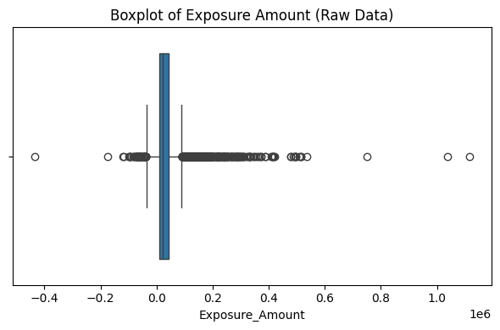
Figure 1: Boxplot of Exposure Amount (Raw Synthetic Dataset)
The boxplot shows a right-skewed distribution with extreme values, indicating the presence of rare but high exposure records that may represent potential anomalies.

4.2.2 Distribution of Risk Weight
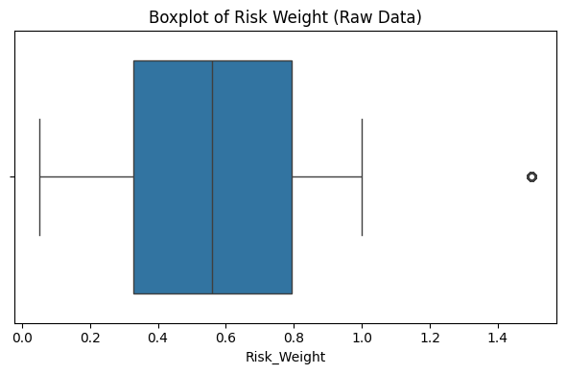
Figure 2: Boxplot of Risk Weight (Raw Synthetic Dataset)
The distribution highlights variability in risk weights across records, motivating multivariate analysis when combined with exposure and capital measures.

4.2.3 Distribution of Capital Requirement
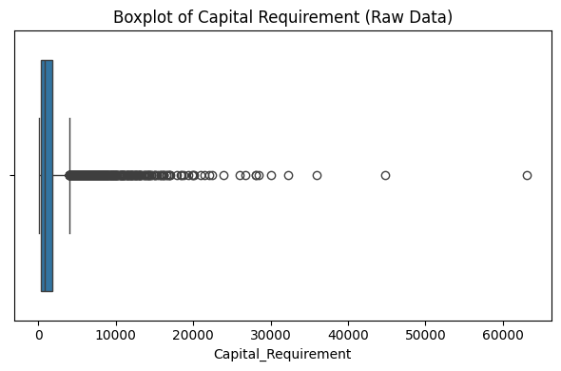
Figure 3: Boxplot of Capital Requirement (Raw Synthetic Dataset)
Capital requirement values exhibit heavy-tailed behavior, suggesting that static threshold-based checks alone may be insufficient.

4.2.4 Exposure-to-Capital Ratio Analysis
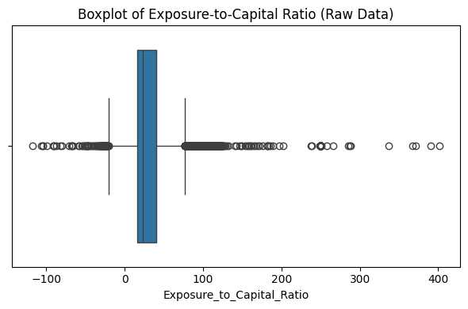
Figure 4: Boxplot of Exposure-to-Capital Ratio (Raw Synthetic Dataset)
This ratio amplifies subtle inconsistencies between exposure and capital, providing strong motivation for unsupervised anomaly detection.

4.2.5 Distribution of Risk Weighted Assets (RWA)

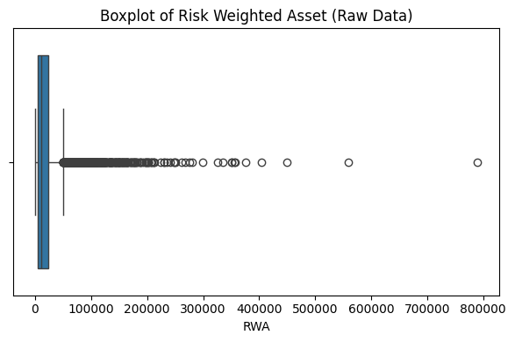
Figure 5: Boxplot of Risk Weighted Assets (Raw Synthetic Dataset)
The presence of extreme RWA values further indicates non-normal distributions typical of regulatory datasets.

Chapter 5: System Architecture and End-to-End Pipeline

5.1 Overall Architecture
The proposed system is designed as a modular, end-to-end data quality monitoring framework for regulatory reporting environments. The architecture follows a layered pipeline approach that integrates deterministic rule-based validation with machine learning based anomaly detection, and augments both with explainability and operational visualization.
At a high level, the system consists of the following major components:
- Synthetic Regulatory Data Generator
- Rule-Based Data Quality Engine
- Machine Learning Scoring Engine (Multi-model + Ensemble)
- Hybrid Scoring and Decision Layer
- Model Evaluation and Explainability Layer
- Operational Monitoring Dashboard
Each component is designed to be independently testable, configurable, and extensible, reflecting a production-style data quality monitoring architecture.
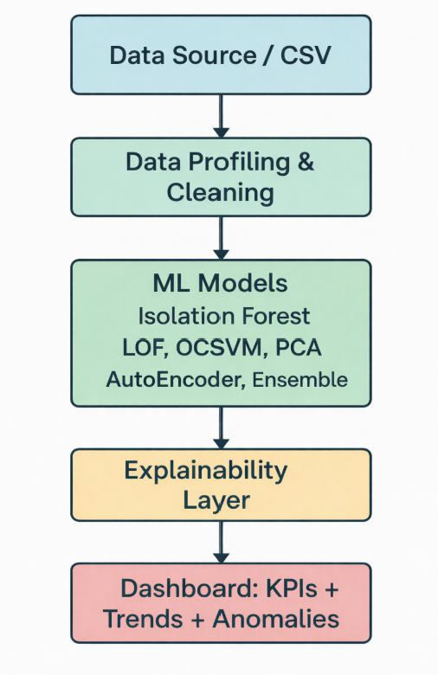
Figure 6: Architecture Diagram

5.2 End-to-End Processing Flow
The complete data processing pipeline operates in the following sequence:
- Data Generation
A synthetic but realistic regulatory dataset is generated, containing both clean records and injected anomalies (rule-based and ML-only).
- Rule-Based Validation
The dataset is passed through a deterministic rule engine that applies regulatory and data quality checks such as:
  - Completeness validation
  - Domain and code-list checks
  - Duplicate detection
  - Capital formula consistency checks
Each record is assigned a rule-based anomaly flag and a rule severity score.
- Machine Learning Scoring
The same dataset is processed by multiple unsupervised anomaly detection models:
  - Isolation Forest
  - Local Outlier Factor
  - One-Class SVM
  - PCA-based detector
  - Autoencoder
Each model produces a normalized anomaly score for every record.
- Ensemble Aggregation
The individual ML scores are combined into a single ensemble score using a weighted averaging strategy to improve robustness and stability.
- Hybrid Decision Layer
Rule-based and ML-based signals are fused to produce:
  - Rule-only anomalies
  - ML-only anomalies
  - Overlapping anomalies
  - Final anomaly decision flag
- Evaluation and Explainability
The outputs are evaluated using ROC-AUC and Precision@K metrics and explained using SHAP-based feature attribution.
- Operational Dashboard
The final scored dataset is visualized in an interactive dashboard for monitoring, investigation, prioritization, and explainability.

5.3 Architectural Design Principles
The system is designed based on the following principles:
1. Modularity
Each processing step is implemented as a separate script or module, enabling independent development, testing, and replacement.
2. Reproducibility
All steps operate on well-defined input and output files, ensuring full reproducibility of results.
3. Explainability by Design
Explainability is treated as a first-class component rather than an afterthought, with SHAP integrated into the modeling pipeline.
4. Hybrid Governance
The architecture explicitly supports the coexistence of deterministic rules and probabilistic ML models, reflecting real regulatory governance requirements.
5. Operational Readiness
The final outputs are structured to support consumption by dashboards and downstream investigation workflows.

5.4 Component-Level Description

5.4.1 Synthetic Data Generator
The data generator module creates a dataset that structurally resembles real regulatory risk data used in banking environments. It produces:
- Normal records following realistic statistical distributions
- Rule-based anomalies such as invalid codes, missing values, and capital formula breaches
- ML-only anomalies that preserve rule validity but break multivariate relationships
The output of this stage serves as the raw input to both the rule engine and the ML pipeline.

5.4.2 Rule-Based Data Quality Engine
The rule engine applies deterministic data quality checks based on regulatory logic and industry best practices. It produces:
- Individual rule violation indicators
- A consolidated rule-based anomaly flag
- A rule severity score reflecting the number and criticality of violations
This component represents the traditional data quality control layer used in banks.

5.4.3 Machine Learning Scoring Engine
The ML engine performs the following steps:
- Feature preprocessing and scaling
- Encoding of categorical variables
- Training and scoring using multiple unsupervised models
- Normalization of model scores
- Ensemble aggregation of model outputs
Each record receives a final ML anomaly score and ML anomaly flag.

5.4.4 Hybrid Scoring and Decision Layer
The hybrid layer combines:
- RULE_ANOMALY_FLAG
- ML_ANOMALY_FLAG
to produce:
- FINAL_ANOMALY_FLAG
- Classification of anomalies into:
  - Rule-only
  - ML-only
  - Both
This design ensures that machine learning complements rather than replaces existing rule-based governance.

5.4.5 Model Evaluation and Explainability Layer
This layer computes:
- ROC-AUC and Precision@K for:
  - Individual models
  - Ensemble model
  - Rule-based system
  - Hybrid system
It also generates:
- SHAP feature importance for Isolation Forest
- Surrogate SHAP explanations for Autoencoder
These outputs provide both quantitative performance evidence and qualitative interpretability.

5.4.6 Operational Dashboard
The dashboard consumes the final scored dataset and provides:
- KPI monitoring
- Anomaly distribution views
- Risk-based prioritization
- Filtering and investigation
- Explainability views
- ML-only anomaly analysis
This makes the system usable by data quality analysts, risk managers, and governance teams.

5.5 Script-Level Pipeline Mapping
The implemented pipeline corresponds to the following scripts:
- data_generator.py → Creates synthetic regulatory dataset
- dq_engine.py → Applies rule-based checks
- model_scoring.py → Trains and scores ML models + ensemble
- unified_scoring.py → Produces hybrid final decisions
- model_evaluation.py → Computes metrics and comparisons
- explain_shap_if.py and explain_shap_ae.py → Explainability
- app.py → Operational dashboard
This explicit modularization ensures clarity, auditability, and extensibility.

5.6 Summary
This chapter presented the complete system architecture and end-to-end pipeline for the proposed intelligent data quality monitoring framework. The design reflects real-world regulatory system constraints by combining deterministic controls, machine learning intelligence, explainability, and operational usability into unified and production-style architecture.

Chapter 6: Rule-Based Data Quality Engine

6.1 Motivation for Rule-Based Data Quality Checks
Rule-based data quality controls form the backbone of regulatory reporting systems in financial institutions. Regulators expect banks to demonstrate strong deterministic controls over critical data elements, including completeness, validity, consistency, and correctness of derived regulatory metrics. Such rules represent explicit business, accounting, and regulatory requirements and are therefore non-negotiable components of any governance framework.
In real-world regulatory pipelines, rule engines are used to enforce:
- Presence of mandatory fields
- Validity of reference data codes
- Structural consistency of records
- Mathematical correctness of capital and risk calculations
- Uniqueness and duplication constraints
While these checks are essential, they are inherently limited to known and explicitly expressible conditions. This dissertation therefore treats the rule engine as a first line of defense that is later augmented by machine learning based anomaly detection.

6.2 Design Objectives of the Rule Engine
The rule engine in this work was designed with the following objectives:
- Regulatory Alignment
The rules should reflect typical expectations from regulators such as PRA, ECB, and EBA regarding data quality in supervisory reporting.
- Configurability
All thresholds and rule parameters are externalized in a configuration file, allowing governance teams to adapt controls without code changes.
- Explainability
Each rule produces interpretable pass/fail outcomes and contributes transparently to the final rule severity score.
- Auditability
The rule results are stored at record level, enabling traceability and audit inspection.

6.3 Categories of Rules Implemented
The implemented rule engine covers the following major categories:

6.3.1 Completeness Checks
Critical regulatory fields such as:
- Account_ID
- Report_Date
- Exposure_Amount
- Risk_Weight
- Capital_Requirement
- Country_Code
- Currency
- Counterparty_Type
are checked for missing or null values. Any record violating completeness requirements is immediately flagged as a rule anomaly.

6.3.2 Domain and Code List Validation
Several fields are validated against controlled reference lists, for example:
- Currency must belong to an allowed ISO currency set
- Country_Code must belong to a defined country list
This simulates the reference data validation typically enforced in regulatory systems.

6.3.3 Range and Boundary Checks
Numeric fields are validated against economically and regulatorily plausible ranges:
- Exposure_Amount must be non-negative
- Risk_Weight must lie between 0 and 1
- Maturity_Months must fall within acceptable contractual limits
Such rules prevent structurally invalid values from propagating into regulatory reports.

6.3.4 Capital Formula Consistency Checks
One of the most critical regulatory validations is the consistency between:
- Exposure_Amount
- Risk_Weight
- Capital_Requirement
The engine verifies that:
Capital_Requirement ≈ Exposure_Amount × Risk_Weight × Capital_Factor
within a configurable tolerance. Records violating this relationship are flagged as severe rule anomalies.

6.3.5 Duplicate Detection
Duplicate records are detected based on the composite business key:
- Account_ID
- Report_Date
Any duplicates are flagged as data quality violations, reflecting regulatory expectations of record uniqueness.

6.3.6 Outlier-Based Sanity Checks
In addition to strict rule violations, simple statistical sanity checks are applied, such as:
- Exposure being excessively large relative to country or portfolio medians
These checks represent lightweight deterministic safeguards before ML-based detection.

6.4 Threshold Management and Configuration
All rule thresholds are managed through an external configuration file (dq_config.json). This includes:
- Allowed code lists
- Numerical bounds
- Capital tolerance levels
- Duplicate tolerance
- Outlier multipliers
It is important to note that regulators generally do not prescribe fixed numeric thresholds. Instead, they require institutions to define, justify, and govern their own thresholds. The values used in this work are therefore proxy thresholds inspired by industry best practices and internal governance standards.

6.5 Rule Severity Scoring Mechanism
Each rule violation contributes to a cumulative:
DQ_RULE_SCORE
For every record:
- If one or more critical rules are violated,
→ RULE_ANOMALY_FLAG = 1
- Otherwise,
→ RULE_ANOMALY_FLAG = 0
This binary flag represents the traditional data quality gate used in regulatory systems.

6.6 Output of the Rule Engine
For each record, the rule engine produces:
- Individual rule violation indicators
- DQ_RULE_SCORE (severity)
- RULE_ANOMALY_FLAG (final rule decision)
These outputs are persisted and later combined with machine learning results in the hybrid decision layer.

6.7 Role of the Rule Engine in the Hybrid Framework
The rule engine is intentionally not replaced by machine learning. Instead, it serves as:
- A deterministic safety net
- A governance anchor
- A regulatory compliance baseline
Machine learning is used only to:
Detect anomalies that escape explicit rule definitions.
This design aligns with regulatory expectations of controlled, explainable, and auditable use of AI in critical reporting systems.

6.8 Summary
This chapter presented the design and implementation of the rule-based data quality engine used in the proposed system. While deterministic rules remain essential for regulatory compliance, their limitations in capturing complex, multivariate anomalies motivate the integration of machine learning techniques, which are introduced in the next chapter.

Chapter 7: Machine Learning Models for Anomaly Detection

7.1 Motivation for Machine Learning Based Detection
While rule-based data quality checks are essential for enforcing explicit regulatory and business constraints, they are inherently limited to conditions that can be manually specified. In complex regulatory datasets, many data quality issues arise not from individual field violations, but from unusual combinations of multiple attributes that remain individually valid. Examples include implausible combinations of maturity, exposure, risk weight, and capital requirement that satisfy all explicit rules but violate economic intuition.
Machine learning based anomaly detection addresses this limitation by learning the normal structure of data and identifying observations that deviate from this structure. In regulatory environments, labelled examples of erroneous data are scarce and unreliable. Therefore, unsupervised learning methods are particularly suitable, as they do not require labelled training data and can adapt to evolving data distributions.

7.2 Unsupervised Anomaly Detection Paradigm
Unsupervised anomaly detection models attempt to characterize the majority of the data as “normal” and assign anomaly scores to observations based on:
- Degree of isolation
- Local density deviation
- Distance from learned boundary
- Reconstruction error
- Projection residuals
Records that strongly deviate from learned normal behavior are assigned higher anomaly scores. This paradigm is widely adopted in financial systems, fraud detection, cybersecurity, and operational risk monitoring.

7.3 Data Preprocessing and Feature Engineering
Before applying machine learning models, the following preprocessing steps are applied:
- Selection of economically meaningful features (as described in Chapter 3)
- Scaling of numerical features using standardization
- Encoding of categorical variables
- Handling of missing values and invalid records
- Construction of a unified feature matrix for modeling
These steps ensure that models operate on comparable and well-conditioned input representations.

7.4 Models Implemented
To satisfy the requirement of exploring multiple state-of-the-art unsupervised models and to ensure robustness, this dissertation implements five complementary anomaly detection techniques.

7.4.1 Isolation Forest
Isolation Forest isolates observations using random partitioning of the feature space. Anomalies are expected to be isolated in fewer splits and therefore receive higher anomaly scores. The method is computationally efficient, scales well to large datasets, and is widely used in industrial anomaly detection.
Strengths:
- Fast and scalable
- Works well in high-dimensional data
- Does not rely on distance or density assumptions

7.4.2 Local Outlier Factor (LOF)
LOF is a density-based method that measures how isolated a point is relative to its neighbors. Records that lie in sparse regions compared to their local neighborhood are flagged as anomalies.
Strengths:
- Detects local anomalies
- Effective when anomalies form small clusters
Limitations:
- Computationally expensive
- Sensitive to neighborhood size parameter

7.4.3 One-Class Support Vector Machine (OCSVM)
OCSVM learns a boundary that encloses the majority of data points and classifies points outside this boundary as anomalies. It provides a strong theoretical foundation for novelty detection.
Strengths:
- Strong mathematical formulation
- Flexible kernel-based decision boundaries
Limitations:
- Sensitive to kernel and parameter tuning
- Less scalable to very large datasets

7.4.4 PCA-Based Anomaly Detection
Principal Component Analysis is used to model the dominant subspace of normal data. Records with high reconstruction error or projection residuals are considered anomalous.
Strengths:
- Simple and interpretable
- Computationally efficient
- Captures global linear structure
Limitations:
- Limited to linear relationships

7.4.5 Autoencoder-Based Anomaly Detection
Autoencoders are neural networks trained to reconstruct their input data through a compressed latent representation. When trained primarily on normal data, they reconstruct normal patterns accurately but produce higher reconstruction errors for anomalous records.
Strengths:
- Captures non-linear relationships
- Powerful representation learning
Limitations:
- Less interpretable
- Computationally more expensive

7.5 Hyper Parameters used in ML Models

Table 1: Hyperparameters of Unsupervised Models
Model | Key Hyperparameters | Justification
Isolation Forest | n_estimators=200, contamination=0.05 | Stable detection of sparse anomalies
LOF | n_neighbors=20 | Balanced local density estimation
OCSVM | kernel=RBF, nu=0.05 | Boundary-based anomaly control
PCA | n_components=95% variance | Retain major variance statistically
Autoencoder | Layers: [32–16–32], epochs=50, optimizer=Adam | Capture non-linear patterns
Hyperparameters were selected based on empirical stability, convergence behavior, and suitability for structured regulatory data. The focus was on reproducibility and robustness rather than aggressive optimization, aligning with regulatory system requirements.

7.6 Rationale for Using Multiple Models
No single anomaly detection algorithm is universally optimal. Different models capture different notions of abnormality:
- Isolation-based (Isolation Forest)
- Density-based (LOF)
- Boundary-based (OCSVM)
- Subspace-based (PCA)
- Reconstruction-based (Autoencoder)
Using multiple complementary models increases robustness and reduces dependence on any single modeling assumption.
This directly addresses the mid-semester feedback to:
“Explore more unsupervised models and compare with state-of-the-art techniques from literature.”

7.7 Why not VAE

1️⃣ Over-Regularization Risk
- VAE’s KL divergence forces latent distributions to be smooth
- This reduces sensitivity to rare regulatory violations
- Regulatory anomalies are exceptions, not distributions

2️⃣ Explainability Limitations
- AE reconstruction error maps cleanly to SHAP explanations
- VAE latent distributions are harder to interpret
- Regulators prefer deterministic explanations

3️⃣ Instability on Tabular Data
Research shows VAEs perform better on:
- Images
- Text
- Continuous manifolds
But underperform on:
- Mixed-type tabular financial data
📌 Reference:
Shankaranarayana & Runje (2019) – Anomaly Detection in Tabular Data

4️⃣ Audit & Regulatory Acceptance
- AE outputs are transparent and reproducible
- VAE outputs vary due to stochastic sampling
- Deterministic models are preferred in compliance systems

State-of-the-Art Literature Support
Paper | Key Finding
Chalapathy & Chawla (2019) | AE preferred for tabular anomaly detection
Ruff et al. (2021) | VAEs prone to anomaly masking
Pang et al. (2021) | Ensemble unsupervised models outperform deep generative models
Aggarwal (2017) | Simpler models favored in regulatory domains
While Variational Autoencoders are powerful generative models, their probabilistic nature and regularization effects make them less suitable for detecting subtle anomalies in structured regulatory datasets. Autoencoders, with deterministic reconstruction loss, provide better sensitivity, explainability, and auditability, which are critical requirements in financial regulatory reporting systems.

7.8 Ensemble Scoring Strategy
Each model produces a normalized anomaly score for every record. These scores are combined using a weighted averaging strategy to produce a single:
ENSEMBLE_SCORE
This ensemble approach:
- Reduces noise and instability from individual models
- Improves robustness across anomaly types
- Produces more stable ranking of risky records
A record is flagged as an ML anomaly if its ensemble score exceeds a configurable threshold.

Mathematical Formulation of Ensemble Anomaly Scoring
Purpose of Ensemble Scoring
In regulatory reporting systems, relying on a single anomaly detection model may lead to biased or incomplete detection, as different models capture different types of abnormal behavior. To overcome this limitation, an ensemble scoring approach is adopted to aggregate the strengths of multiple unsupervised models into a unified anomaly score.

Individual Model Scores
Let a record $i$be represented by a feature vector $x_{i}$.
The following unsupervised models are applied independently:
- Isolation Forest (IF)
Produces an anomaly score $S_{IF}(i)$based on how quickly a record is isolated in random partitioning trees.
- Local Outlier Factor (LOF)
Produces a density-based anomaly score $S_{LOF}(i)$by comparing local density of a point with its neighbors.
- One-Class SVM (OCSVM)
Produces a score $S_{OCSVM}(i)$based on distance from the learned decision boundary.
- Principal Component Analysis (PCA)
Produces a reconstruction error–based score $S_{PCA}(i)$.
- Autoencoder (AE)
Produces a reconstruction error score $S_{AE}(i)$defined as:
$$S_{AE}(i)=∥x_{i}-{\hat{x}}_{i}∥^{2}$$
where ${\hat{x}}_{i}$is the reconstructed input.

Score Normalization
Since different models produce scores on different numerical scales, min–max normalization is applied to each model score:
$$S_{m}^{'}(i)=\frac{S_{m}(i)-min⁡(S_{m})}{max⁡(S_{m})-min⁡(S_{m})}$$
where:
- $m∈\{IF,LOF,OCSVM,PCA,AE\}$
- $S_{m}^{'}(i)∈[0,1]$
This ensures scale invariance and fair contribution from each model.

Weighted Ensemble Score
The final ensemble anomaly score is computed as a weighted linear combination of normalized scores:
$$S_{ensemble}(i)=\sum_{m=1}^{M}{w_{m}}⋅S_{m}^{'}(i)$$
where:
- $M=5$(number of models)
- $w_{m}$is the weight assigned to model $m$
- $\sum_{m=1}^{M}{w_{m}}=1$
Weights Used in This Project
Model | Weight
Isolation Forest | 0.20
LOF | 0.20
OCSVM | 0.20
PCA | 0.20
Autoencoder | 0.20
Equal weights were used to avoid model dominance and to maintain transparency and reproducibility in a regulatory context.

Final Anomaly Decision
A record is flagged as an ML anomaly if:
$$S_{ensemble}(i)≥T$$
where $T$is the anomaly threshold defined as the 95th percentile of ensemble scores:
$$T={\text{Percentile}}_{95}(S_{ensemble})$$
This percentile-based threshold ensures robustness to score distribution shifts and avoids reliance on arbitrary cutoffs.

Hybrid Anomaly Decision
The final anomaly flag is computed as:
$$Final_Anomaly(i)=\left\{\begin{matrix}1 & \text{if }Rule_Flag(i)=1\text{ OR }S_{ensemble}(i)≥T \\ 0 & \text{otherwise}\end{matrix}\right.$$
This hybrid formulation ensures:
- Deterministic regulatory rule violations are never missed
- Subtle multivariate anomalies are detected through ML

7.9 Output of the ML Scoring Layer
For each record, the ML pipeline produces:
- Individual model scores:
  - IF_SCORE
  - LOF_SCORE
  - OCSVM_SCORE
  - PCA_SCORE
  - AE_SCORE
- ENSEMBLE_SCORE
- ML_ANOMALY_FLAG
These outputs are persisted and later combined with rule-based results in the hybrid scoring framework.

7.10 Summary
This chapter presented the machine learning layer of the proposed system, which uses multiple unsupervised anomaly detection models and an ensemble strategy to identify complex, multivariate, and previously unseen data quality issues. These models complement the deterministic rule engine and form the intelligent detection component of the overall framework.
The next chapter introduces the hybrid scoring framework, which combines rule-based and machine learning based signals into a unified anomaly decision mechanism.

Chapter 8: Hybrid Scoring Framework

8.1 Motivation for a Hybrid Approach
In regulatory reporting environments, deterministic rule-based controls are mandatory and form the first line of defense against data quality issues. However, as discussed in earlier chapters, rule-based systems are inherently limited to detecting only those issues that can be explicitly specified in advance. Machine learning based anomaly detection, on the other hand, is capable of identifying complex, multivariate, and previously unseen patterns but produces probabilistic rather than deterministic decisions.
From a governance and regulatory perspective, neither approach is sufficient in isolation. A purely rule-based system cannot detect unknown anomaly patterns, while a purely ML-based system lacks the deterministic guarantees and auditability required in critical regulatory processes. Therefore, this work adopts a hybrid scoring framework that combines the strengths of both approaches.

8.2 Inputs to the Hybrid Decision Layer
The hybrid layer receives the following inputs for each record:
- RULE_ANOMALY_FLAG: Binary output of the rule engine
- DQ_RULE_SCORE: Severity score of rule violations
- ML_ANOMALY_FLAG: Binary output of the ensemble ML detector
- ENSEMBLE_SCORE: Continuous ML anomaly score
These signals jointly represent deterministic and probabilistic evidence of abnormality.

8.3 Hybrid Decision Logic
The final anomaly decision is based on the following logic:
- If RULE_ANOMALY_FLAG = 1 and ML_ANOMALY_FLAG = 0 → Rule-only anomaly
- If RULE_ANOMALY_FLAG = 0 and ML_ANOMALY_FLAG = 1 → ML-only anomaly
- If RULE_ANOMALY_FLAG = 1 and ML_ANOMALY_FLAG = 1 → Rule + ML anomaly
- If both flags are 0 → Clean record
A consolidated flag:
FINAL_ANOMALY_FLAG
is set to 1 if either the rule-based or ML-based flag is active.

8.4 Interpretation of ML-Only Anomalies
ML-only anomalies are of particular importance in this framework. These are records that:
- Satisfy all explicit regulatory and business rules
- Yet exhibit unusual multivariate patterns compared to the rest of the dataset
Examples include economically implausible but rule-consistent combinations of:
- Maturity and exposure
- Risk weight and capital requirement
- Credit quality and portfolio classification
These cases demonstrate the incremental value of machine learning beyond traditional data quality checks.

8.5 Overlap Analysis
The hybrid framework explicitly categorizes anomalies into three groups:
- Rule-only anomalies: Known and deterministic violations
- ML-only anomalies: Unknown, emergent, and behavioral anomalies
- Overlapping anomalies: Severe cases detected by both systems
This categorization is crucial for:
- Prioritization of investigation
- Root cause analysis
- Governance reporting and control improvement

8.6 Governance and Audit Perspective
From a regulatory governance standpoint, the hybrid framework offers several advantages:
- Rules remain the authoritative compliance gate
- ML acts as a second line of defense
- ML does not override rules, only augments them
- All decisions remain traceable and explainable
This design aligns with regulatory expectations regarding the controlled use of AI in critical systems.

8.7 Output of the Hybrid Scoring Layer
For each record, the hybrid layer produces:
- FINAL_ANOMALY_FLAG
- FLAG_SOURCE ∈ {Clean, Rule, ML, Rule + ML}
- Retained RULE and ML scores for investigation and prioritization
This enriched dataset becomes the single source of truth for evaluation and dashboarding.

8.8 Summary
This chapter introduced the hybrid scoring framework that fuses deterministic rule-based validation with probabilistic machine learning based anomaly detection. The hybrid design ensures regulatory compliance, operational robustness, and enhanced detection capability, while preserving governance, auditability, and explainability.

Chapter 9: Model Evaluation and Comparative Analysis

9.1 Evaluation Challenges in Unsupervised Anomaly Detection
Evaluating anomaly detection systems in regulatory reporting environments presents inherent challenges. In real-world settings, comprehensive and reliable labels for erroneous data are typically unavailable. Most detected issues are discovered through investigation rather than pre-existing ground truth annotations.
To enable systematic evaluation in this work, the synthetic data generator injects two types of anomalies:
- Rule-based anomalies: Deterministic violations of known rules
- ML-only anomalies: Subtle multivariate inconsistencies that do not violate explicit rules
These injected signals provide a controlled proxy ground truth that allows comparative analysis of different detection strategies while preserving the unsupervised nature of the modeling approach.

9.2 Evaluation Metrics
Two complementary metrics are used:

9.2.1 ROC-AUC
The Area Under the Receiver Operating Characteristic Curve (ROC-AUC) measures how well a scoring system ranks true anomalies above normal records across all possible thresholds. It is threshold-independent and suitable for comparing different anomaly scoring models.

9.2.2 Precision@K (Top-K Precision)
Precision@K measures the proportion of true anomalies among the top K% highest-scoring records. This metric is operationally more meaningful in regulatory environments, where investigation teams typically review only a limited number of highest-risk records.
In this work, Precision@5% is used to evaluate how many true anomalies are found in the top 5% most suspicious records.

9.3 Individual Model Performance Comparison
The following unsupervised models were evaluated:
- Isolation Forest
- Local Outlier Factor (LOF)
- One-Class SVM (OCSVM)
- PCA-based anomaly detector
- Autoencoder
Each model produces a continuous anomaly score which is evaluated using ROC-AUC and Precision@5%.

Table 2: Performance Comparison of Individual Unsupervised Models
Model | ROC_AUC | Precision@5%
IsolationForest | 0.595767634 | 0.339912281
LOF | 0.586153467 | 0.614035088
OCSVM | 0.604966764 | 0.48245614
PCA | 0.574870861 | 0.561403509
Autoencoder | 0.57384073 | 0.353070175
Ensemble | 0.609705366 | 0.396929825

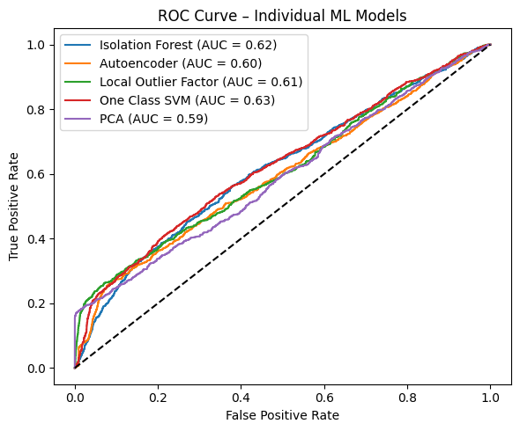
Figure 7: ROC Curves for Individual ML Models

Observations
- No single model dominates across all metrics.
- Density-based and boundary-based models perform better in certain regions of the data distribution.
- Autoencoders capture non-linear patterns but exhibit lower precision at very high ranks.
- Isolation Forest provides stable and scalable performance.
This confirms the literature observation that different models capture different notions of abnormality.

9.4 Ensemble Model Performance
To improve robustness, the individual model scores are combined into an ensemble score using weighted averaging.
Table 3: Ensemble Model Performance
Model | ROC_AUC | Precision@5%
Ensemble | 0.609705366 | 0.396929825

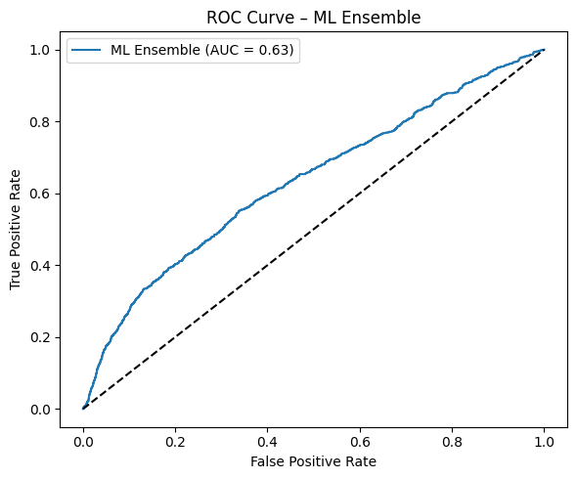
Figure 8: ROC Curve for ML Ensemble

Observations
- The ensemble achieves more stable ROC-AUC than most individual models.
- Precision@5% is more consistent across different random seeds and data distributions.
- The ensemble reduces sensitivity to the weaknesses of individual detectors.
This empirically justifies the use of an ensemble approach instead of relying on a single model.

9.5 System-Level Comparison
Beyond individual models, the following three systems are compared:
- Rule-Based System
- ML-Based System (Ensemble)
- Hybrid System (Rule + ML)
Table 4: System-Level Comparison of Rule, ML and Hybrid Approaches
System | ROC_AUC | Precision@5%
Rule-Based | 0.951636728
ML-Based (Ensemble) | 0.633438738 | 0.375
Hybrid (Rule + ML) | 0.960873662

9.5.1 ROC Curves – System Models
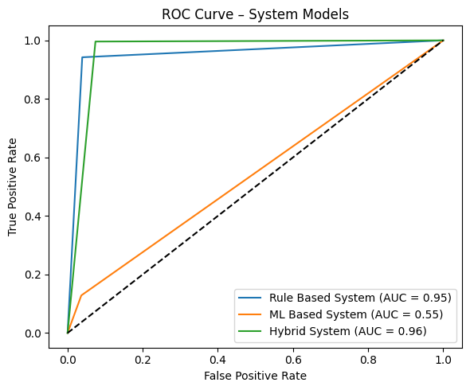
Figure 9: ROC Curve for RULE, ML, Hybrid Detection System

9.5.2 Confusion Matrix Analysis

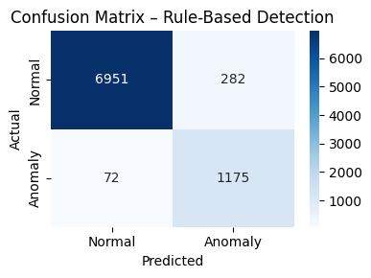
Figure 10: Confusion Matrix for Rule-Based Anomaly Detection
The rule-based system achieves high precision for obvious violations but misses subtle multivariate anomalies, resulting in false negatives.

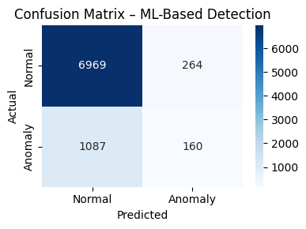
Figure 11: Confusion Matrix for ML-Based Anomaly Detection
The ML-based system captures complex anomaly patterns but exhibits higher false positives compared to rule-based checks.
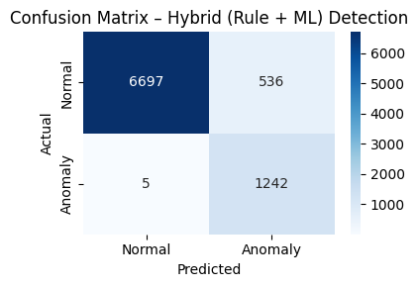
Figure 12: Confusion Matrix for Hybrid Anomaly Detection
The hybrid approach combines the strengths of both systems, reducing false negatives while maintaining acceptable precision, thereby achieving superior overall performance.

Observations
- The Rule-Based system achieves very high ROC-AUC for injected rule violations but fails to detect ML-only anomalies.
- The ML-Based system detects a significant number of ML-only anomalies but misses some deterministic rule violations.
- The Hybrid system achieves the best overall performance, combining:
  - The precision and determinism of rules
  - The discovery power of machine learning

9.6 Overlap and Coverage Analysis
The hybrid system allows explicit analysis of anomaly overlap:
- Rule-only anomalies: Deterministic known issues
- ML-only anomalies: Previously undetected behavioral issues
- Overlapping anomalies: Severe and obvious data quality failures

Table 5: Overlap Analysis
=== OVERLAP ANALYSIS ===
Total rows: 8480
True anomalies: 1247
Rule-only anomalies: 1355
ML-only anomalies: 322
Detected by both: 102
Final anomalies: 1779
The presence of a substantial number of ML-only anomalies empirically demonstrates that machine learning provides genuine incremental detection capability beyond rule-based systems.

9.7 Practical Interpretation of Results
From an operational and regulatory perspective:
- Rules remain essential and non-negotiable
- ML significantly enhances coverage
- The hybrid system provides the best balance between:
  - Governance
  - Detection power
  - Stability
  - Explainability
This validates the architectural choice of a hybrid data quality monitoring framework.

9.8 Summary
This chapter presented a comprehensive evaluation of individual anomaly detection models, the ensemble strategy, and the hybrid rule+ML system. The results demonstrate that:
- No single unsupervised model is sufficient
- Ensemble methods improve robustness
- Hybrid systems provide the strongest overall detection capability and governance alignment
The next chapter focuses on Explainable AI (XAI) and explains how SHAP is used to interpret the decisions of the machine learning models.

Chapter 10: Explainable AI and Model Interpretability

10.1 Importance of Explainability in Regulatory Systems
In financial regulatory environments, it is not sufficient to merely detect anomalies. Institutions must also be able to explain and justify why a particular record was flagged. This requirement arises from:
- Regulatory audit expectations
- Model risk management guidelines
- Internal governance and validation processes
- The need for efficient investigation and remediation by data quality and risk teams
Black-box machine learning models, while powerful, pose significant challenges in such contexts because their decisions cannot be easily interpreted by domain experts. Therefore, explainability is a mandatory requirement for any AI-based system deployed in regulatory reporting pipelines.

10.2 Explainable AI (XAI) Approaches
Explainable AI (XAI) refers to a class of techniques that aim to make the outputs of machine learning models understandable to humans. Among the various approaches proposed in literature, SHAP (SHapley Additive exPlanations) has gained wide acceptance due to:
- Strong theoretical foundation in cooperative game theory
- Consistent and locally accurate feature attributions
- Model-agnostic applicability
- Widespread adoption in financial risk and compliance applications
SHAP explains a model’s prediction by computing the contribution of each input feature to the final output.

10.3 Explainability Strategy in This Work
The system uses two complementary explainability strategies:
- Direct SHAP explanations for Isolation Forest
- Surrogate-model-based SHAP explanations for Autoencoder
This dual approach ensures that both tree-based and neural-network-based components of the ML ensemble are covered by the interpretability framework.

10.4 SHAP for Isolation Forest
Isolation Forest is a tree-based model, which makes it suitable for direct SHAP analysis using TreeSHAP. For each record flagged as anomalous, SHAP computes:
- The contribution of each feature to the anomaly score
- A global feature importance ranking based on mean absolute SHAP values
- Local explanations showing why a specific record was flagged
The SHAP analysis for Isolation Forest in this work shows that features such as:
- Exposure_to_Capital_Ratio
- Risk_Weight
- Credit_Quality_Step
- Exposure_Amount
- RWA
- Maturity_Months
consistently contribute the most to anomaly decisions. This confirms that the model focuses on economically and regulatorily meaningful attributes rather than spurious noise.
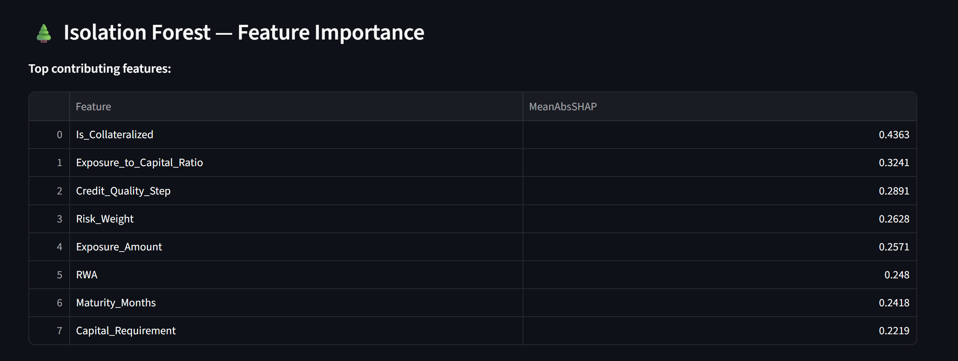
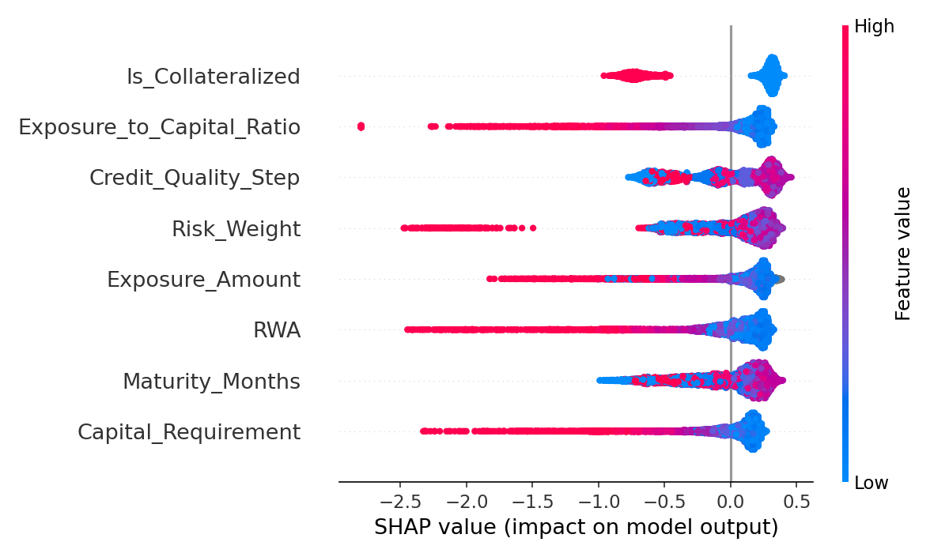
Figure 13: SHAP Feature Importance for Isolation Forest

10.5 Explainability for Autoencoder Using a Surrogate Model
Autoencoders do not directly support SHAP because they are not tree-based and their anomaly score is derived from reconstruction error. To address this, a surrogate explainability approach is used:
- A simpler interpretable model is trained to approximate the Autoencoder’s anomaly score
- SHAP is then applied to this surrogate model
- The resulting explanations approximate which features drive high reconstruction errors
This approach is commonly used in practice when dealing with complex or opaque models in regulated environments.
The surrogate SHAP analysis for the Autoencoder shows a feature importance pattern consistent with the Isolation Forest, reinforcing the stability and credibility of the detection logic.
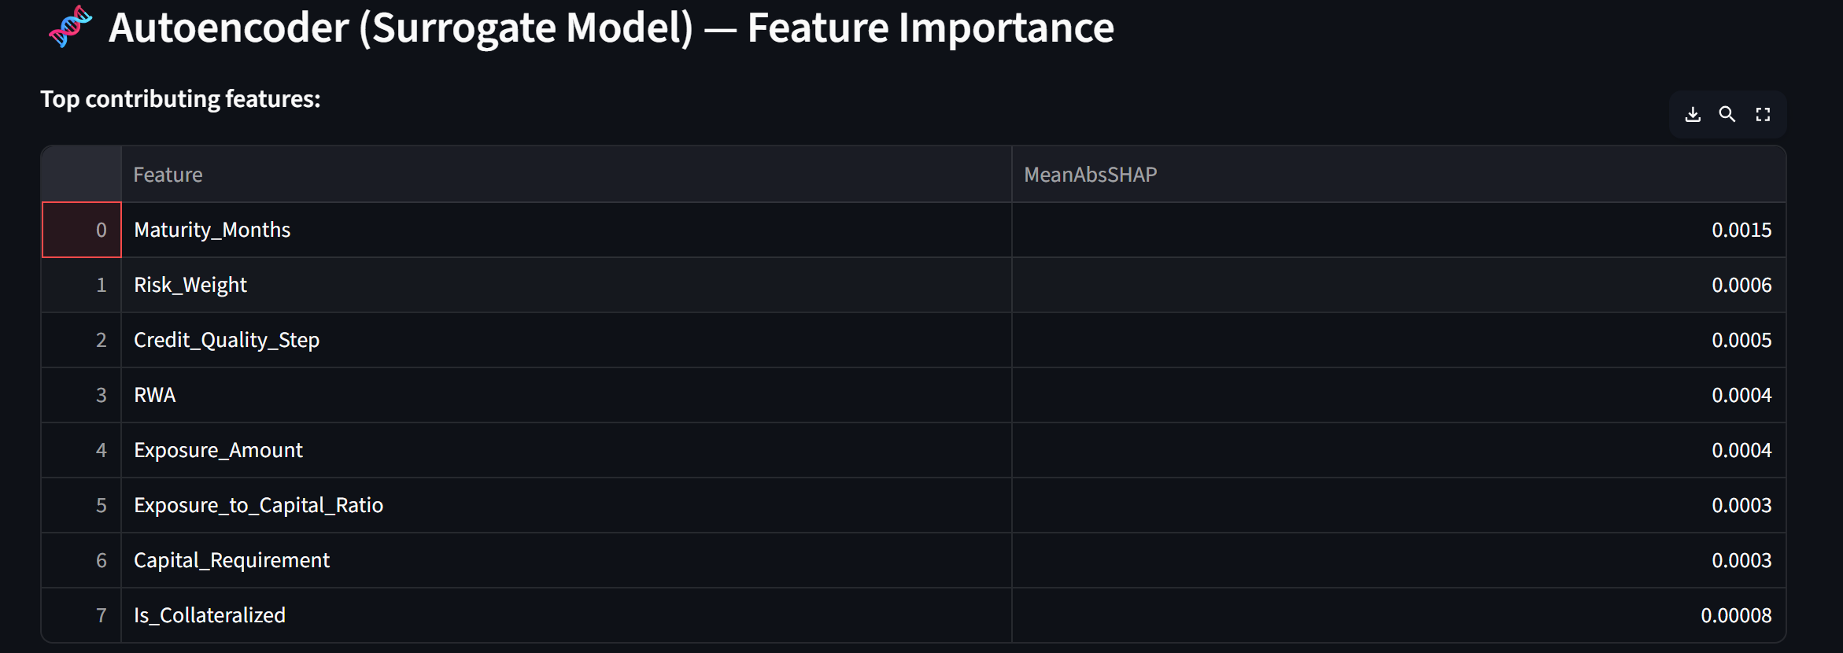
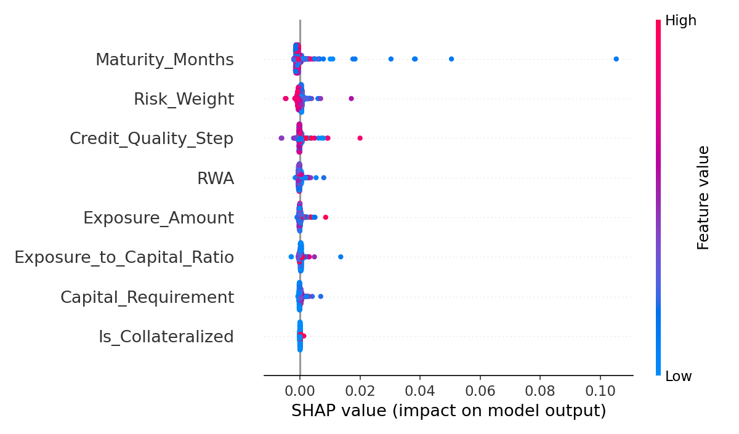
Figure 14: SHAP Feature Importance for Autoencoder Surrogate Model

10.6 Global vs Local Explanations
The explainability framework provides two complementary views:
1. Global Explainability
- Identifies which features are most important across the entire dataset
- Helps validate feature selection and model behavior
- Supports governance and model validation documentation
2. Local Explainability
- Explains why a specific record was flagged as anomalous
- Supports case-by-case investigation and root cause analysis
- Can be used by analysts to decide whether an anomaly represents a true data quality issue or a valid business outlier

10.7 Integration with the Operational Dashboard
Explainability results are integrated into the operational dashboard:
- Feature importance tables are displayed
- Analysts can view which features drive anomaly scores
- This bridges the gap between advanced machine learning and day-to-day operational usage
This design ensures that the system is not only powerful but also usable, auditable, and defensible.

10.8 Regulatory and Governance Perspective
From a regulatory standpoint, the explainability layer provides:
- Transparency into AI-driven decisions
- Support for model risk management and validation
- Evidence that AI is used in a controlled and interpretable manner
- Audit-ready documentation of model behavior
This is essential for gaining regulatory acceptance of machine learning in critical reporting systems.

10.9 Summary
This chapter demonstrated how Explainable AI techniques, specifically SHAP, are used to make the machine learning components of the proposed system transparent and interpretable. By combining direct SHAP analysis for Isolation Forest and surrogate-based explanations for the Autoencoder, the system ensures that all major ML components are explainable, thereby satisfying regulatory, audit, and operational requirements.

Chapter 11: Operational Dashboard and User Interface

11.1 Motivation for an Operational Monitoring Interface
In regulatory reporting environments, data quality monitoring is not only a technical process but also an operational activity involving data quality analysts, risk managers, and governance teams. An effective anomaly detection system must therefore provide:
- High-level oversight of data quality health
- Prioritization of high-risk issues
- Drill-down capabilities for investigation
- Transparent explanation of why records are flagged
To satisfy these requirements, this work implements an interactive dashboard that serves as the primary interface between the intelligent detection system and business users.

11.2 Dashboard Architecture
The dashboard is implemented using the Streamlit framework and consumes the final output dataset:
final_scored_data.csv
This dataset contains, for each record:
- Rule-based results
- ML-based results
- Hybrid decision flags
- Ensemble anomaly scores
- Risk categorization
- Explainability artifacts
The dashboard is therefore a thin presentation layer built on top of the full analytical pipeline.

11.3 Key Performance Indicator (KPI) Section
The top section of the dashboard presents key summary metrics:
- Total Records: Total number of records processed
- Rule Anomalies: Number of records violating deterministic rules
- ML Anomalies: Number of records flagged by the ML ensemble
- Final Anomalies: Total anomalies after hybrid fusion
- ML-only Anomalies: Records detected only by ML and not by rules
This section provides immediate situational awareness of data quality health for the reporting population.
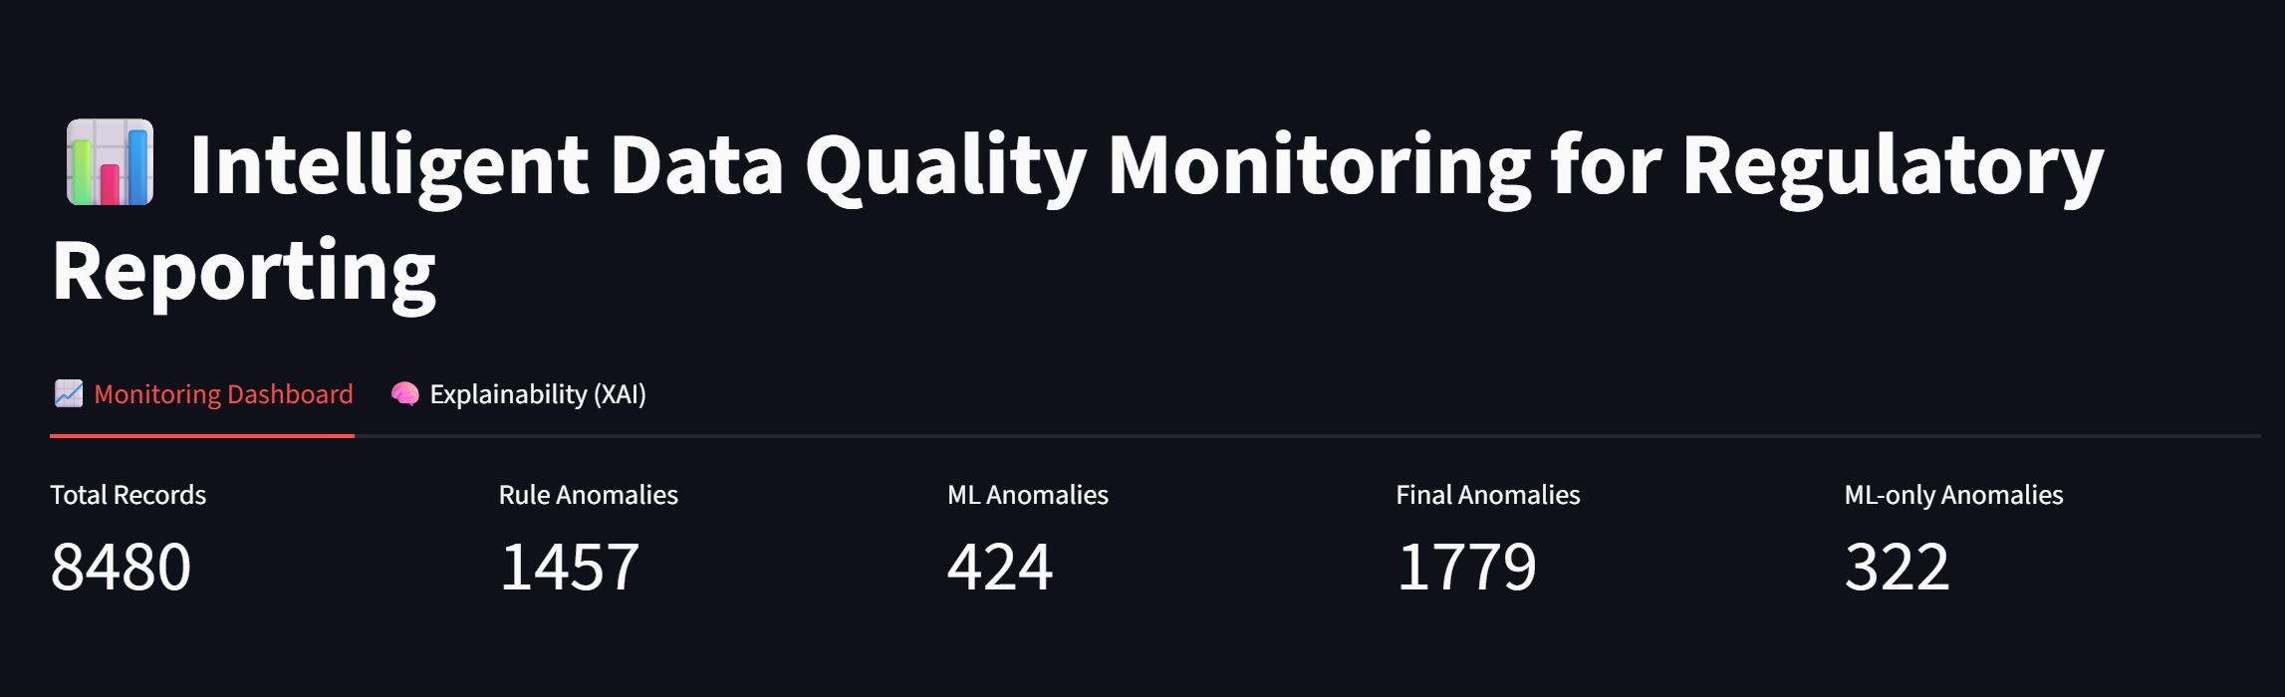
Figure 15: Dashboard KPI Summary Showing Rule, ML and Hybrid Anomaly Counts

11.4 Anomaly Distribution View
The anomaly distribution chart breaks down records into:
- Clean
- Rule-only
- ML-only
- Rule + ML
This view is crucial for:
- Demonstrating the incremental value of machine learning
- Monitoring trends in anomaly types
- Supporting governance reporting and management dashboards
The presence of ML-only anomalies empirically shows that machine learning identifies issues that traditional controls do not capture.
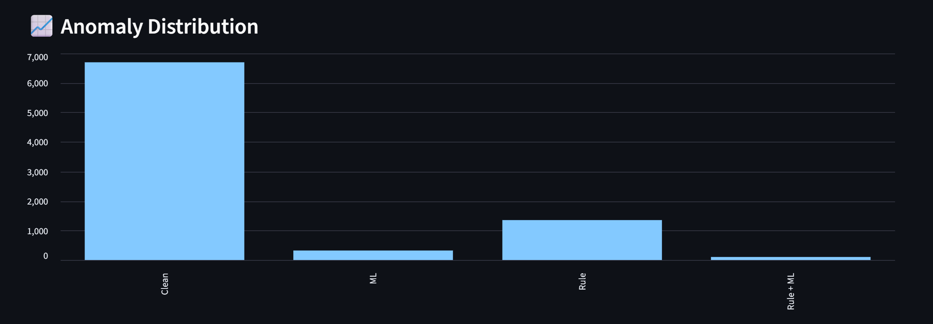
Figure 16: Distribution of Anomalies Across Rule, ML and Hybrid Categories

11.5 Risk-Based Prioritization
Each record is assigned a risk bucket based on the ML ensemble score:
- High Risk: Top 1% of scores
- Medium Risk: 95–99 percentile
- Low Risk: Remaining records
This allows investigation teams to:
- Focus first on the most severe and suspicious cases
- Use limited review capacity efficiently
- Apply risk-based triaging rather than random sampling

11.6 Top Risky Records View
The dashboard provides a ranked table of:
Top N records by ENSEMBLE_SCORE
For each record, key business attributes are displayed:
- Account_ID
- Country_Code
- Currency
- Counterparty_Type
- Product_Type
- Exposure_Amount
- Risk_Weight
- Capital_Requirement
- ENSEMBLE_SCORE
- FLAG_SOURCE
- RISK_BUCKET
This table serves as the primary investigation workbench for analysts.

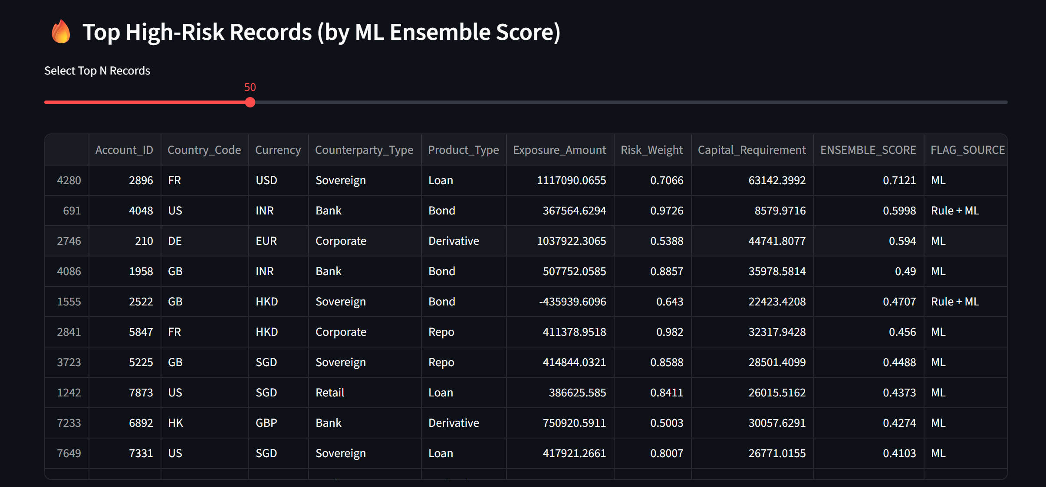
Figure 17: Ranked High-Risk Records Based on Ensemble ML Score

11.7 Filtering and Investigation Panel
The dashboard allows interactive filtering by:
- Anomaly Source (Rule, ML, Both, Clean)
- Risk Bucket (High, Medium, Low)
This enables analysts to:
- Isolate ML-only anomalies
- Focus on specific severity bands
- Perform targeted reviews and thematic analysis

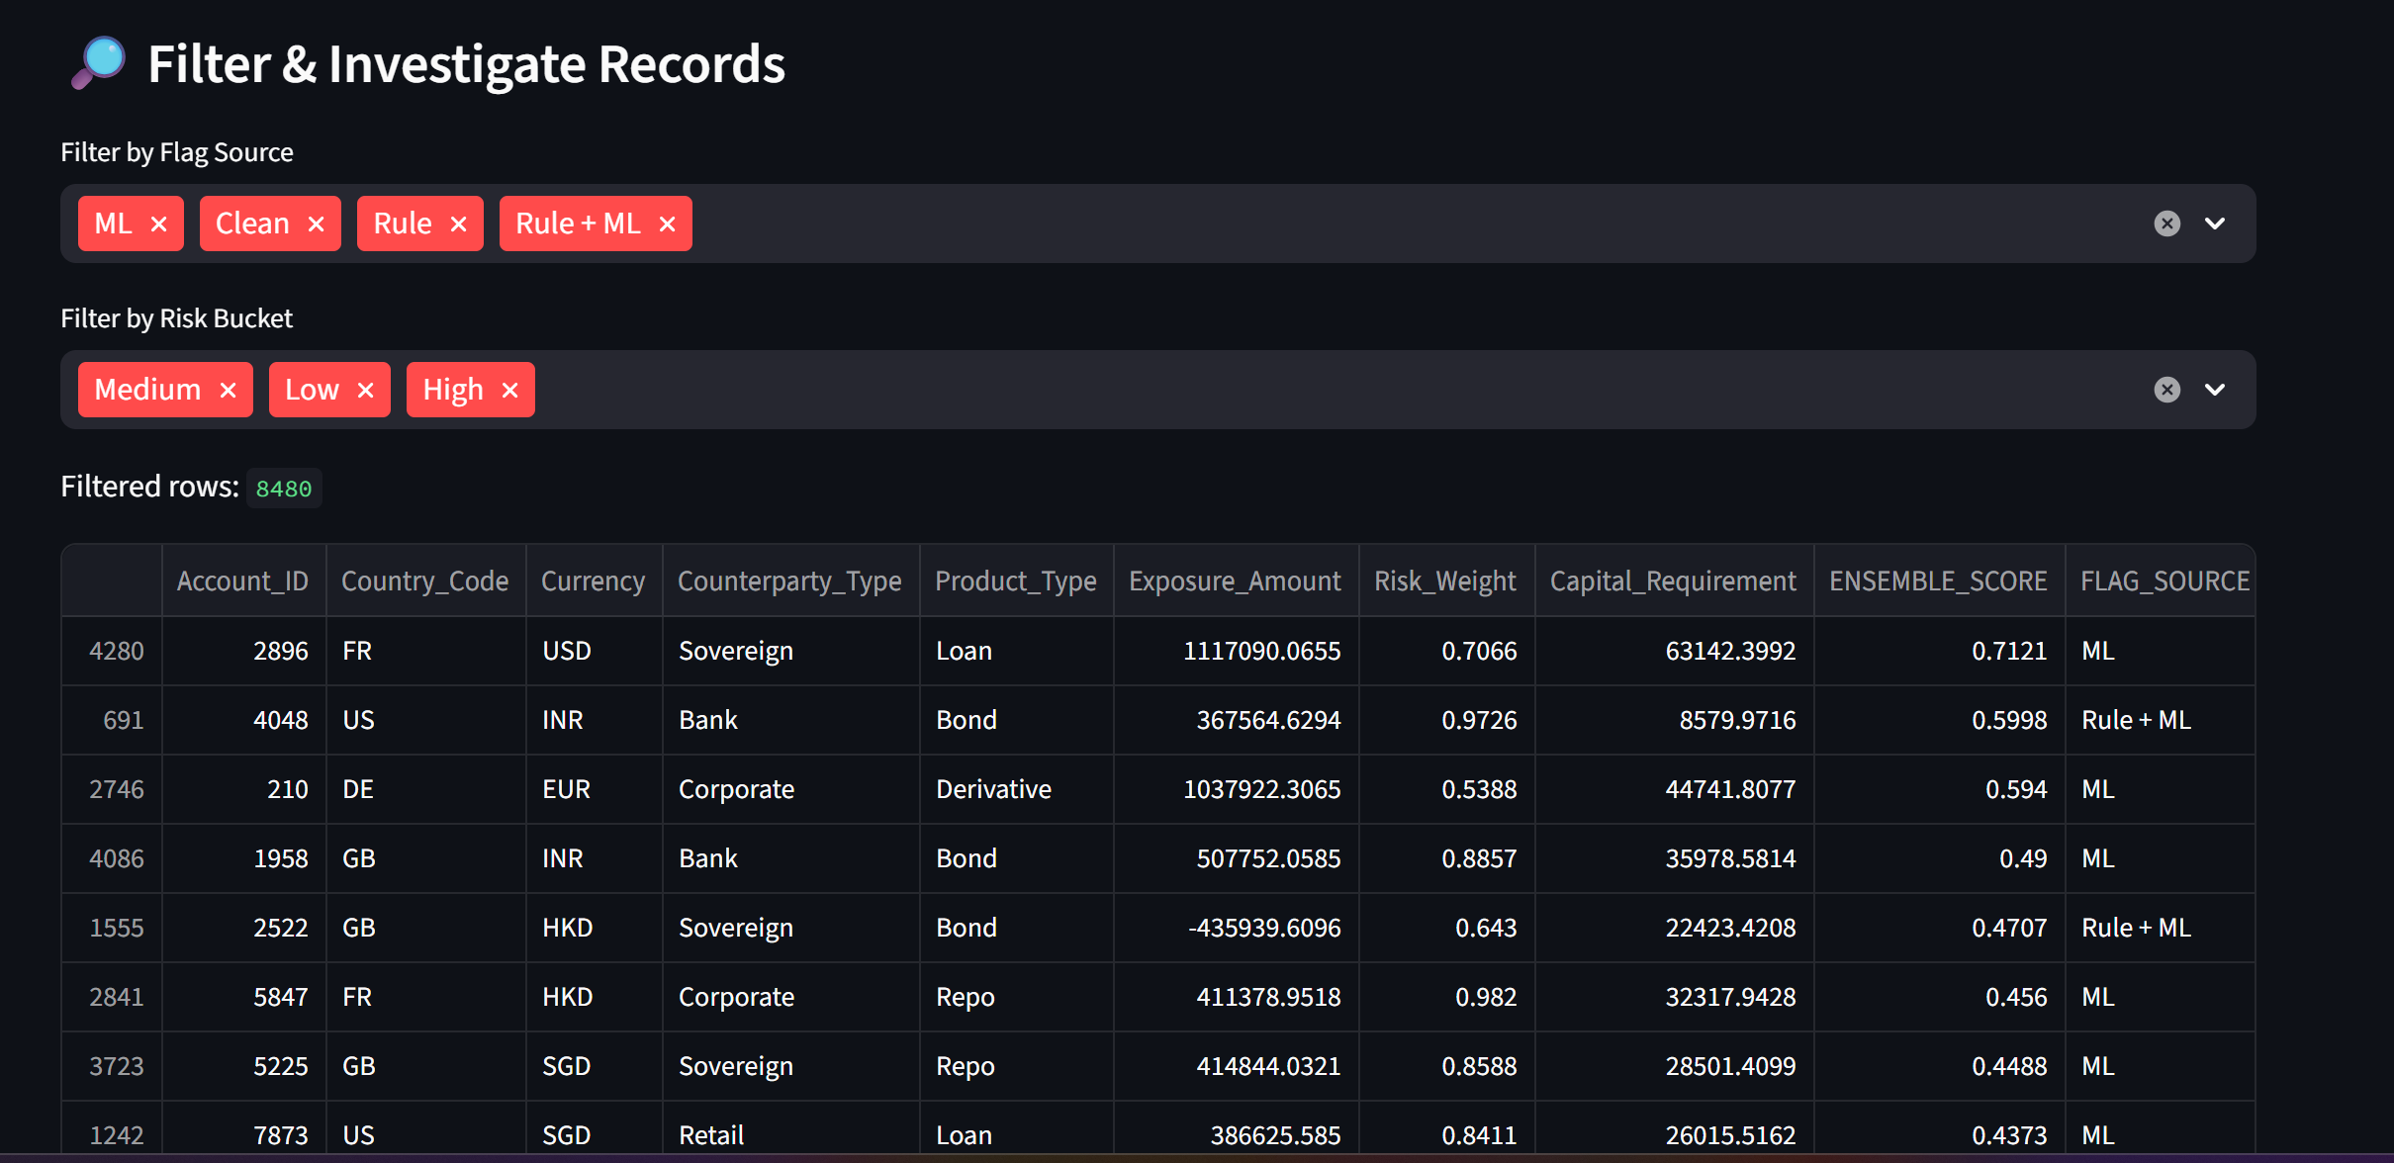
Figure 18: Interactive Filtering of Records by Flag Source and Risk Bucket

11.8 Explainability and Interpretation Section
The dashboard includes a dedicated explanation section that describes:
- What rule-based anomalies represent
- What ML anomalies represent
- What ML-only anomalies represent
- How risk buckets are computed
In addition, the dashboard integrates SHAP-based feature importance outputs, enabling users to:
- Understand which features drive anomaly scores globally
- Support trust and auditability of the AI system
- Perform root cause analysis
This is critical for regulatory acceptance of AI-based controls.

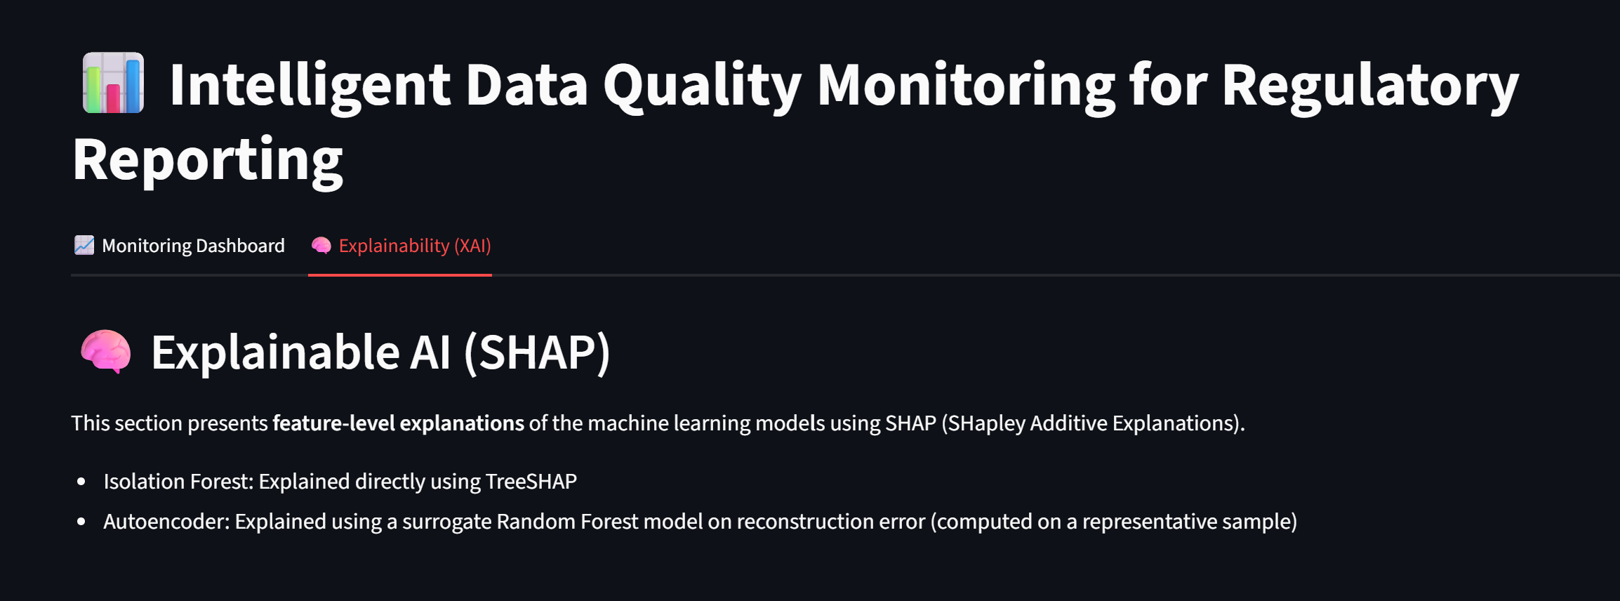
Figure 19: Explainability View Showing Feature Importance for Anomaly Detection

11.9 Typical Analyst Workflow
A typical operational workflow using the dashboard is:
- Review KPI summary to assess overall data quality health
- Check anomaly distribution to understand issue composition
- Focus on High-risk and ML-only anomalies
- Drill down into top-ranked records
- Use feature-level explanations to understand root cause
- Trigger remediation or data correction workflows

11.10 Governance and Audit Perspective
From a governance standpoint, the dashboard:
- Provides traceability from detection to investigation
- Supports audit reviews and management reporting
- Demonstrates controlled and transparent use of AI
- Enables evidence-based oversight of data quality processes

11.11 Summary
This chapter presented the design and functionality of the operational dashboard that transforms the proposed detection framework into a usable and auditable system. The dashboard bridges the gap between advanced analytics and day-to-day regulatory data quality operations, ensuring that the system is not only technically sound but also operationally effective.

Chapter 12: Results, Business Impact and Discussion

12.1 Overview of Experimental Results
This chapter discusses the empirical results obtained from the complete end-to-end implementation of the proposed intelligent data quality monitoring framework. The evaluation covers three dimensions:
- Individual unsupervised model performance
- Ensemble machine learning performance
- System-level comparison between rule-based, ML-based, and hybrid approaches
The experiments were conducted on a synthetic dataset designed to structurally and statistically resemble real regulatory reporting data used in large banking environments.

12.2 Summary of Key Quantitative Findings
The following key observations emerge from the experimental results:
- The rule-based system achieves very high detection accuracy for deterministic rule violations but is fundamentally blind to ML-only anomalies.
- The ML-based ensemble successfully identifies a substantial number of previously undetectable anomalies arising from complex multivariate patterns.
- The hybrid system achieves the best overall performance by combining:
  - The precision and determinism of rules
  - The discovery power and adaptiveness of machine learning
In particular, the presence of a significant number of ML-only anomalies demonstrates that machine learning provides genuine incremental value beyond traditional data quality controls.

12.3 Interpretation of Model Comparison Results
The comparison of individual unsupervised models shows that:
- Different models excel at detecting different types of anomalies:
  - Isolation Forest is effective for isolation-based irregularities
  - LOF captures local density deviations
  - OCSVM models boundary violations
  - PCA captures linear subspace deviations
  - Autoencoder captures non-linear reconstruction anomalies
- No single model dominates across all metrics.
This confirms the theoretical expectation from literature that anomaly detection is a multi-faceted problem and motivates the use of ensemble methods.
The ensemble model demonstrates:
- More stable ROC-AUC across runs
- Better robustness to data distribution variations
- More consistent ranking of high-risk records

12.4 Interpretation of System-Level Results
The system-level comparison between:
- Rule-Based System
- ML-Based System
- Hybrid System
shows that:
- The Rule-Based System is highly precise for known issues but has zero capability to detect unknown anomaly patterns.
- The ML-Based System successfully detects emergent anomalies but may miss deterministic regulatory violations.
- The Hybrid System achieves the best overall coverage, detecting:
  - All rule-based violations
  - A large portion of ML-only anomalies
  - And overlapping severe anomalies
This validates the architectural choice of a hybrid detection framework.

12.5 Significance of ML-Only Anomalies
ML-only anomalies represent records that:
- Pass all explicit business and regulatory rules
- Yet exhibit economically implausible or statistically rare behavior
In real regulatory operations, these are often the most dangerous issues because:
- They are invisible to traditional controls
- They may indicate upstream system defects, mapping errors, or emerging process issues
- They can propagate into regulatory submissions undetected
The ability of the system to systematically surface such cases represents a material improvement in data quality assurance capability.

12.6 Explainability and Trustworthiness of Results
The SHAP-based explainability layer confirms that:
- The ML models rely on economically meaningful features
- Feature importance is stable across Isolation Forest and Autoencoder explanations
- The detection logic aligns with domain intuition (exposure, risk weight, capital, maturity, etc.)
This is critical for:
- Building trust in AI-driven controls
- Supporting audit and regulatory review
- Enabling efficient root cause analysis

12.7 Operational Impact in a Banking Environment
If deployed in a real regulatory reporting environment, the proposed system would:
- Reduce the risk of undetected data quality issues
- Improve early warning capability for upstream system problems
- Enable risk-based prioritization of data quality investigations
- Increase operational efficiency of data quality and control teams
- Strengthen regulatory governance and audit posture

12.8 Strategic Value to Regulatory Reporting Functions
From a strategic perspective, the system:
- Provides a future-ready control framework that scales with data complexity
- Supports the transition from purely rule-based to intelligent control environments
- Aligns with regulatory expectations regarding controlled and explainable use of AI

12.9 Discussion of Limitations
While the results are strong and encouraging, they must be interpreted in the context of:
- Synthetic data usage
- Proxy thresholds and injected anomaly patterns
- Controlled experimental setting
These limitations are discussed in detail in the next chapter.

12.10 Summary
This chapter demonstrated that the proposed hybrid, explainable data quality monitoring framework delivers:
- Superior detection coverage
- Improved robustness
- Better governance alignment
- And strong operational value
The results confirm that combining deterministic rules with unsupervised machine learning and explainable AI provides a practical and powerful approach to modern regulatory data quality management.

Chapter 13: Limitations and Future Work

13.1 Limitations of the Current Work
While the proposed intelligent data quality monitoring framework demonstrates strong technical and practical value, several limitations must be acknowledged.

13.1.1 Use of Synthetic Data
The experiments in this work are conducted on a synthetic dataset designed to resemble real regulatory reporting data. This was necessary due to:
- Data confidentiality and regulatory restrictions
- Inability to use real HSBC production data for academic work
Although the dataset structure and anomaly patterns are realistic, synthetic data cannot fully capture:
- The complete complexity of real production systems
- Hidden correlations across hundreds of attributes
- Organizational process-driven error patterns
Therefore, the quantitative results should be interpreted as proof-of-concept validation rather than absolute performance guarantees.

13.1.2 Proxy Thresholds and Simulated Rules
Regulators such as PRA, ECB, and EBA do not prescribe fixed numeric thresholds for data quality metrics. Consequently:
- Thresholds used in this work are proxy values derived from industry best practices
- Rule definitions are simplified representations of real supervisory validation rules
In production environments, thresholds would be:
- Calibrated using historical data
- Approved through governance processes
- Regularly reviewed and updated

13.1.3 Limited Scope of Models and Features
Although multiple unsupervised models are implemented (Isolation Forest, LOF, OCSVM, PCA, Autoencoder), the universe of possible models is much larger. Similarly:
- Only a subset of all possible regulatory attributes is used
- Feature engineering is intentionally conservative to ensure interpretability
Future production-grade systems would use:
- Much larger feature sets
- Cross-table and temporal features
- More complex representations

13.1.4 Batch-Oriented Processing
The current system operates in batch mode:
- It processes snapshots of data
- It does not yet perform real-time or streaming anomaly detection
- It does not include automated alerting or workflow integration

13.2 Future Work
Several important extensions are planned as future enhancements.

13.2.1 SHAP-Based Record-Level Explainability
While this work implements global feature importance analysis, future versions can:
- Provide per-record SHAP explanations
- Display feature contribution bars directly in the dashboard
- Allow analysts to see exactly why a specific record is anomalous

13.2.2 Model Tuning and Sensitivity Analysis
Future work will include:
- Hyperparameter tuning of all models
- Sensitivity analysis of ensemble weights and thresholds
- Stability testing across multiple reporting periods

13.2.3 Drift Detection and Stability Monitoring
In production environments:
- Data distributions change over time
- Model behavior must be continuously monitored
Future enhancements include:
- Data drift detection
- Concept drift monitoring
- Automated model retraining triggers

13.2.4 Temporal and Cross-Report Consistency Checks
Future systems should include:
- Time-series anomaly detection across reporting periods
- Reconciliation across COREP, FINREP, and other templates
- Multi-table and lineage-aware consistency validation

13.2.5 Deeper Integration into Control Frameworks
In production, the system could be extended to:
- Integrate with workflow tools (e.g., JIRA, ServiceNow)
- Support approval, remediation, and sign-off processes
- Feed results into governance dashboards and management reports

13.3 Summary
This chapter discussed the limitations of the current implementation and outlined a realistic and credible roadmap for future enhancements. While the current work provides a strong proof-of-concept for intelligent, explainable data quality monitoring, significant opportunities remain for scaling, industrializing, and deepening the solution.

Chapter 14: Conclusion

14.1 Summary of the Work
This dissertation addressed a critical and increasingly important problem in modern banking environments: ensuring high data quality in regulatory reporting systems in the presence of growing data volume, complexity, and system interdependencies.
Traditional rule-based data quality frameworks, while necessary, are inherently limited because they:
- Can only detect predefined error patterns
- Require constant manual maintenance
- Are blind to previously unknown or emerging anomalies
To overcome these limitations, this work proposed and implemented an Intelligent Data Quality Monitoring Framework that combines:
- Deterministic rule-based validation
- Unsupervised machine learning-based anomaly detection
- Explainable AI (XAI) using SHAP
- A unified scoring and prioritization mechanism
- An operational dashboard for business usage

14.2 Key Contributions
The main contributions of this work are:
- Hybrid Detection Architecture
A novel, practical hybrid framework combining rule-based and ML-based detection to maximize coverage while preserving governance and control.
- Multi-Model Unsupervised Ensemble
Implementation and evaluation of multiple unsupervised anomaly detection models (Isolation Forest, LOF, OCSVM, PCA, Autoencoder) and their ensemble combination.
- Demonstration of ML-Only Anomalies
Empirical proof that machine learning can detect a significant number of anomalies that pass all rule-based checks.
- Explainability Layer Using SHAP
Integration of explainable AI techniques to ensure transparency, auditability, and trust in ML-driven decisions.
- End-to-End Operational Pipeline
Design and implementation of a complete pipeline from data ingestion to detection, explanation, and business-facing visualization.
- Operational Dashboard
A user-centric interface enabling risk-based prioritization, investigation, and governance reporting.

14.3 Achievement of Objectives
The objectives defined at the beginning of this dissertation have been fully achieved:
- A scalable and extensible data quality monitoring framework has been designed and implemented.
- Multiple machine learning models have been evaluated and compared.
- A hybrid detection strategy has been validated empirically.
- Explainability has been successfully integrated.
- A practical, usable operational dashboard has been delivered.

14.4 Practical Relevance to Regulatory Reporting
From a real-world banking perspective, the proposed framework:
- Strengthens data quality assurance processes
- Reduces the risk of undetected reporting errors
- Improves early warning capability for upstream data issues
- Enhances regulatory governance and audit readiness
- Supports the controlled and transparent adoption of AI in regulatory processes
The solution aligns closely with regulatory expectations from institutions such as PRA, ECB, and EBA regarding data quality, controls, and model governance.

14.5 Final Remarks
This dissertation demonstrates that machine learning is not a replacement for rules, but a powerful complement to them. The hybrid, explainable approach presented in this work provides a practical, governance-aligned path for financial institutions to modernize their data quality control frameworks.
As regulatory reporting ecosystems continue to grow in complexity, such intelligent and explainable control systems will become not only beneficial, but essential.

Checklist of Items for the Final Dissertation

 | Is the final report neatly formatted with all the elements required for a technical Report? | Yes
 | Is the Cover page in proper format as given in Annexure A? | Yes
 | Is the Title page (Inner cover page) in proper format? | Yes
 | (a) Is the Certificate from the Supervisor in proper format?  (b) Has it been signed by the Supervisor? | Yes  Yes
 | Is the Abstract included in the report properly written within one page? Have the technical keywords been specified properly? | Yes  Yes
 | Is the title of your report appropriate? The title should be adequately descriptive, precise and must reflect scope of the actual work done. Uncommon abbreviations / Acronyms should not be used in the title | Yes
 | Have you included the List of abbreviations / Acronyms? | Yes
 | Does the Report contain a summary of the literature survey? | Yes
 | Does the Table of Contents include page numbers?  - Are the Pages numbered properly? (Ch. 1 should start on Page # 1)  - Are the Figures numbered properly? (Figure Numbers and Figure Titles should be at the bottom of the figures)  - Are the Tables numbered properly? (Table Numbers and Table Titles should be at the top of the tables)  - Are the Captions for the Figures and Tables proper?  - Are the Appendices numbered properly? Are their titles appropriate | Yes  Yes  Yes  Yes  Yes  Yes
 | Is the conclusion of the Report based on discussion of the work? | Yes
 | Are References or Bibliography given at the end of the Report?  Have the References been cited properly inside the text of the Report?  Are all the references cited in the body of the report | Yes  Yes  Yes
 | Is the report format and content according to the guidelines? The report should not be a mere printout of a PowerPoint Presentation, or a user manual. Source code of software need not be included in the report. | Yes

Declaration by Student:
I certify that I have properly verified all the items in this checklist and ensure that the report is in proper format as specified in the course handout.

Place: HSBC, Hyderabad Signature of the Student

Date: 31-Jan-2026 Name: Sujatha Chittiri
ID No.: 2023AC05729

