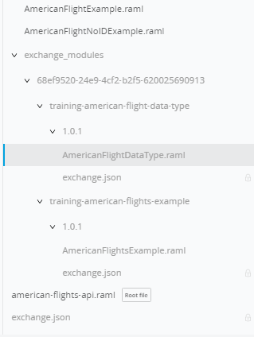

**american-flights-api.raml**

#%RAML 1.0

title: American Flights API

version: 1.0.0

baseUri: http://http://training4-american-api-sujatha.us-e2.cloudhub.io/

traits:

  client-id-required:

    headers:

      client_id:

        type: string

      client_secret:

        type: string

    responses:

      401:

        description: Unauthorized, The client_id or client_secret are not valid or the client does not have access.

      429:

        description: The client used all of it's request quota for the current period.

      500:

        description: An error ocurred, see the specific message (Only if it is a WSDL enpoint).

      503:

        description: Contracts Information Unreachable.

types:

  AmericanFlight: !include /exchange_modules/68ef9520-24e9-4cf2-b2f5-620025690913/training-american-flight-data-type/1.0.1/AmericanFlightDataType.raml

/flights:

  is: [client-id-required]

  description: flight records from the database

  get:

    description: retrieves records from the database

    queryParameters:

      destination:

        required: false

        enum:

          - LAX

          - SFO

          - CLE

    responses:

      200:

        body:

          application/json:

            type: AmericanFlight[]

            examples:

              output: !include /exchange_modules/68ef9520-24e9-4cf2-b2f5-620025690913/training-american-flights-example/1.0.1/AmericanFlightsExample.raml

  post:

    description: add a recordto the database

    body:

      application/json:

        type: AmericanFlight

        examples:

          input: !include examples/AmericanFlightNoIDExample.raml

    responses:

      201:

        body:

          application/json:

            example:

              responsemessage: Flight record added, nothng really happened

  /{ID}:

    is: [client-id-required]

    description: a specific record from the database

    get:

      description: retrieve the record matching ID

      responses:

        200:

          body:

            application/json:

              type: AmericanFlight

              examples:

                output: !include examples/AmericanFlightExample.raml

    delete:

        responses:

          200:

            body:

              application/json:

                example:

                  message: Flight deleted (but not really)

    put:

      responses:

        200:

          body:

            application/json:

              example:

                message: Flight updated (but not really)

in examples folder

1. AmericanFlightExample.raml
2. AmericanFlightNoIDExample.raml

**AmericanFlightExample.raml**

#%RAML 1.0 NamedExample

value:

    ID: 1

    code: ER38sd

    price: 800

    departureDate: 2017/07/26

    origin: CLE

    destination: SFO

    emptySeats: 0

    plane:

      type: Boeing 737

      totalSeats: 150

**AmericanFlightNoIDExample.raml**

#%RAML 1.0 NamedExample

value:

    code: ER38sd

    price: 800

    departureDate: 2017/07/26

    origin: CLE

    destination: SFO

    emptySeats: 0

    plane:

      type: Boeing 737

      totalSeats: 150

**AmericanFlightDatatype.raml**

#%RAML 1.0 DataType

type: object

properties:

  ID?: integer

  code: string

  price: number

  departureDate: string

  origin: string

  destination: string

  emptySeats: integer

  plane:

    type: object

    required: false

    properties:

      type: string

      totalSeats: integer

**AmericanFlightsExample.raml**

#%RAML 1.0 NamedExample

value:

  -

    ID: 1

    code: ER38sd

    price: 400

    departureDate: 2017/07/26

    origin: CLE

    destination: SFO

    emptySeats: 0

    plane:

      type: Boeing 737

      totalSeats: 150

  -

    ID: 2

    code: ER45if

    price: 540.99

    departureDate: 2017/07/27

    origin: SFO

    destination: ORD

    emptySeats: 54

    plane:

      type: Boeing 777

      totalSeats: 300