AI StudyBuddy
AI-Powered Learning Assistance Backend
PROJECT DOCUMENTATION
Node.js • Express.js • MongoDB Atlas • Google Gemini • JWT • Postman
Backend-only REST API Project

1. Introduction
AI StudyBuddy is an AI-powered learning assistance backend developed to help students organize and improve their study process. The system provides secure REST APIs for user registration and login, study material storage, AI-generated summaries, flashcards, quizzes, and personalized study plans. The backend is designed as a standalone API and can be tested using Postman or integrated with a future web or mobile client.
The application uses Node.js and Express.js for server-side development, MongoDB Atlas with Mongoose for data management, JWT and bcryptjs for authentication and password security, and Google Gemini for generating educational content. Its modular structure separates routes, controllers, models, middleware, and utility services.

2. Abstract
AI StudyBuddy automates common study tasks by converting user-provided study material into concise summaries, revision flashcards, multiple-choice quizzes, and personalized study plans. The project demonstrates secure authentication, database integration, REST API design, and Generative AI integration in a backend-only application.

3. Problem Statement
Students often spend significant time reading lengthy notes, preparing revision questions, creating flashcards, and planning study schedules manually. These repetitive activities can reduce the time available for understanding concepts. AI StudyBuddy addresses this problem by automating these learning-support tasks through REST APIs.

4. Objectives
- Implement secure student registration and login using JWT and bcryptjs.
- Store study materials in MongoDB Atlas.
- Generate concise AI summaries from study content.
- Generate flashcards for active recall.
- Generate multiple-choice quizzes for self-assessment.
- Generate personalized study plans from learning goals and available study time.
- Maintain a modular and testable backend architecture.

5. Scope
The current project is backend-only. It exposes REST APIs for authentication, material management, and AI learning features. Postman is used as the API client for demonstration. A frontend can be added later without changing the core backend services.

6. Key Features
Feature | Description
Authentication | JWT-based login and bcryptjs password hashing.
Study Material | Stores title, subject, and learning content.
AI Summary | Generates a concise summary from a material.
AI Flashcards | Generates question-and-answer revision cards.
AI Quiz | Generates multiple-choice questions.
AI Study Plan | Generates a day-wise plan from goal, days, and hours per day.
Database | MongoDB Atlas with Mongoose.

7. System Architecture
The AI StudyBuddy backend follows a modular REST API architecture. Requests from Postman are received by Express.js, routed to the appropriate API route, processed by controllers, and secured using JWT authentication middleware where required. Mongoose communicates with MongoDB Atlas for persistent data, while the Gemini utility communicates with Google Gemini to generate AI learning resources.
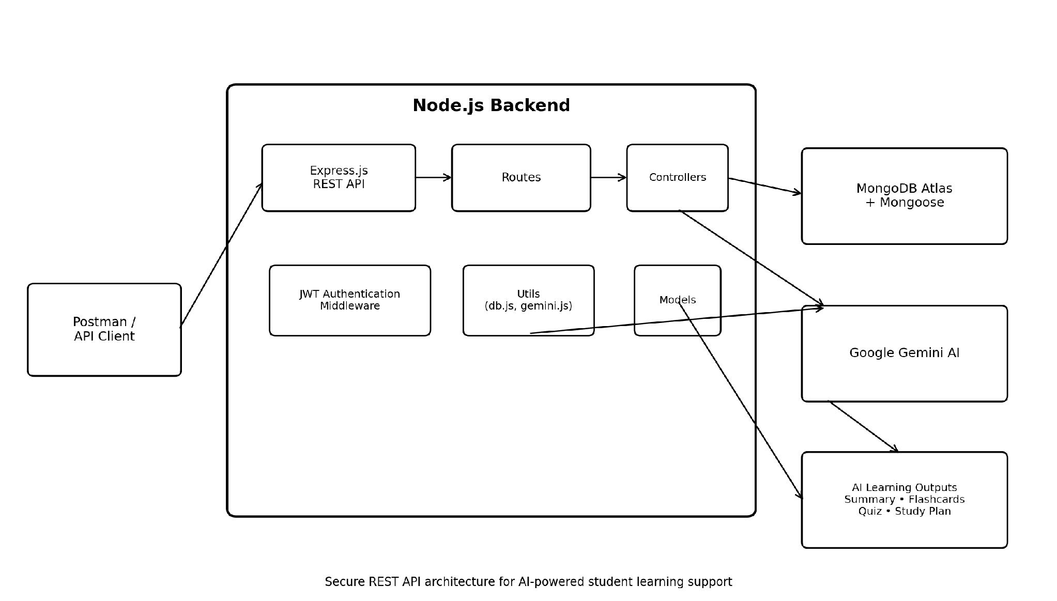
Figure 1. AI StudyBuddy System Architecture

8. Project Structure
backend/
├── index.js
├── package.json
├── .env
├── .gitignore
└── src/
├── controllers/
├── models/
├── routes/
├── middleware/
│ └── auth.js
└── utils/
├── db.js
└── gemini.js
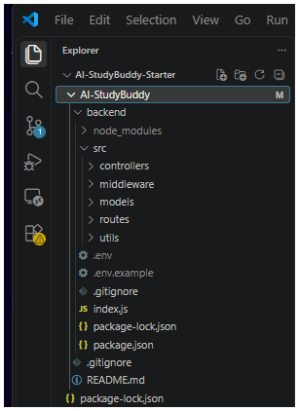

9. Technologies Used
Technology | Purpose
Node.js | JavaScript runtime.
Express.js | REST API framework and routing.
MongoDB Atlas | Cloud NoSQL database.
Mongoose | ODM for MongoDB.
JWT | Authentication tokens.
bcryptjs | Password hashing.
Google Gemini | Generative AI service.
Postman | API testing.
Visual Studio Code | Development environment.

10. Database Design
The main data entities used by the backend are:
- User – authentication and profile information.
- Material – uploaded study content.
- Summary – AI-generated summary.
- Flashcard – generated question-and-answer cards.
- Quiz – generated multiple-choice questions.
- StudyPlan – personalized learning plan.
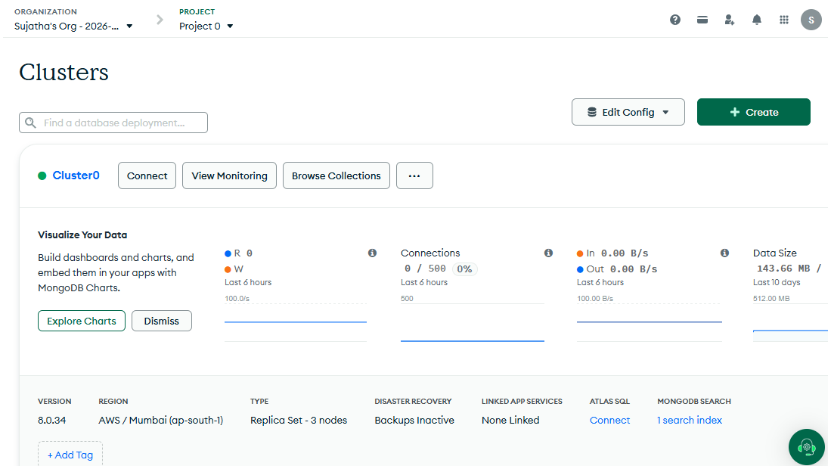

11. API Endpoints
Method | Endpoint | Purpose
GET | / | Server health check
POST | /api/auth/register | Register a user
POST | /api/auth/login | Login and generate JWT
POST | /api/material/upload | Upload/store study material
POST | /api/ai/summary/:id | Generate AI summary
POST | /api/ai/flashcards | Generate AI flashcards
POST | /api/ai/quiz | Generate AI quiz
POST | /api/ai/study-plan | Generate personalized study plan

12. Implementation

12.1 Application Entry Point
index.js loads environment variables, configures Express, connects to MongoDB, registers routes, and starts the server on port 5000.

12.2 Authentication
Registration securely hashes passwords using bcryptjs. Login verifies credentials and returns a JWT token used to access protected APIs.

12.3 AI Integration
The Gemini utility sends prompts to Google Gemini and returns generated educational content for summaries, flashcards, quizzes, and study plans.

12.4 Database
Mongoose models define the application data structure and provide database operations against MongoDB Atlas.

13. Project Execution
- Open the backend folder in Visual Studio Code.
- Run npm install to install dependencies.
- Configure the required environment variables in .env.
- Run npm run dev to start the development server.
- Verify that the terminal shows “MongoDB connected” and “Server running on port 5000”.
- Use Postman Desktop Agent to test the REST APIs.
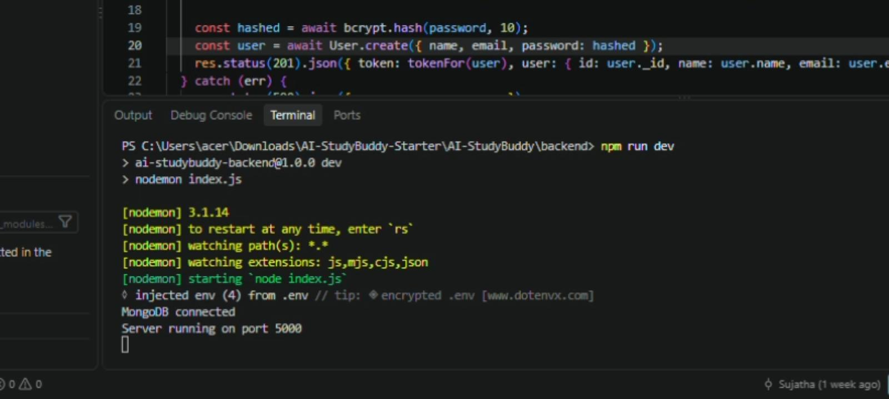

14. API Testing Using Postman
The main APIs were tested successfully in Postman. The testing sequence starts with the server health check, followed by registration, login, material upload, and AI feature generation.
- GET / – server health check
- POST /api/auth/register – registration
- POST /api/auth/login – login and JWT generation
- POST /api/material/upload – study material upload
- POST /api/ai/summary/:id – AI summary
- POST /api/ai/flashcards – AI flashcards
- POST /api/ai/quiz – AI quiz
- POST /api/ai/study-plan – AI study plan
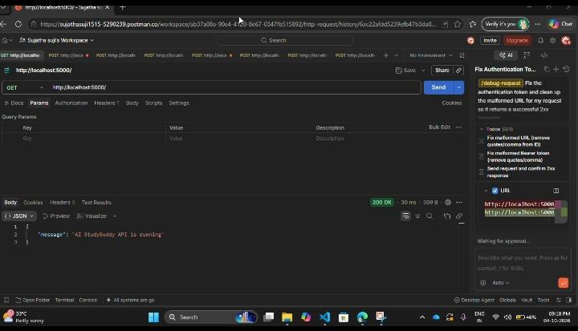
SERVER HEALTH CHECK

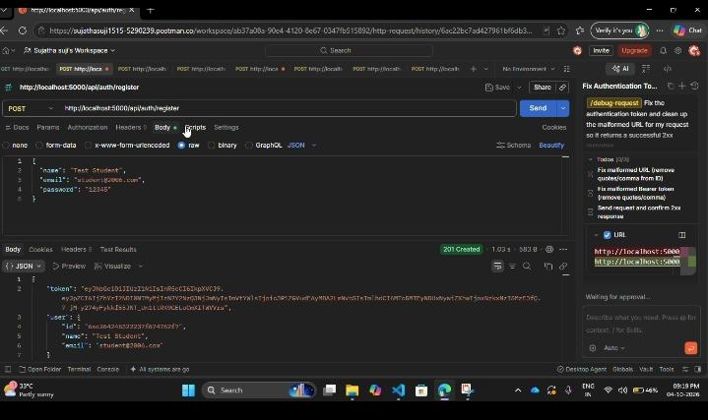
REGISTER
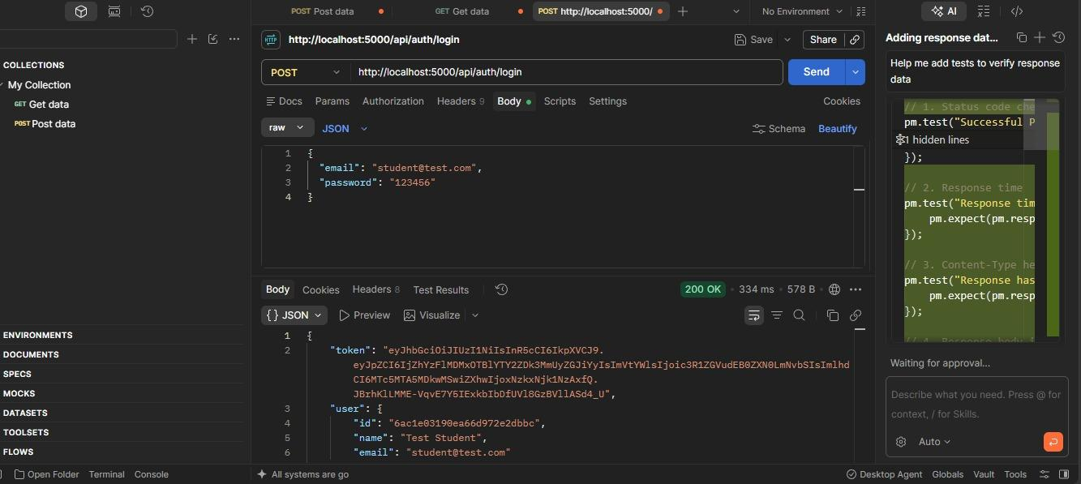
LOGIN

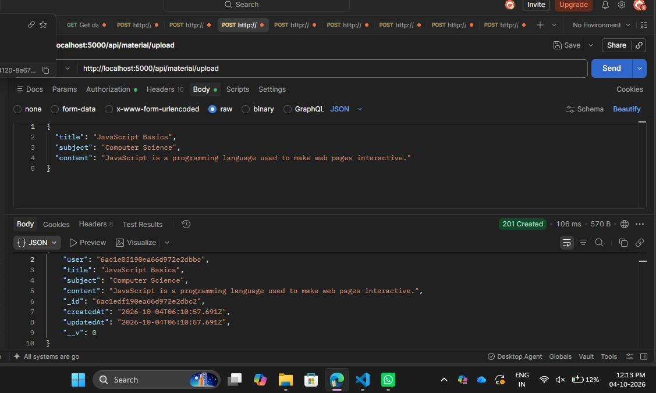
UPLOAD
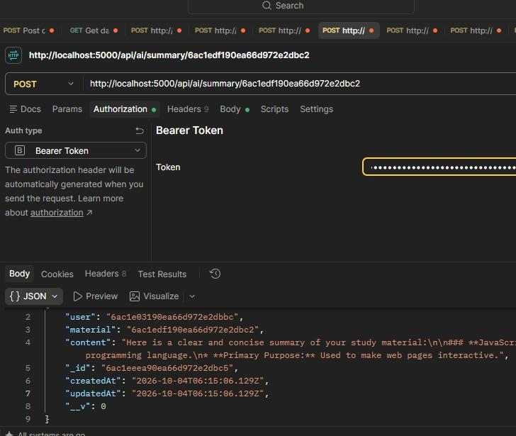
SUMMARY
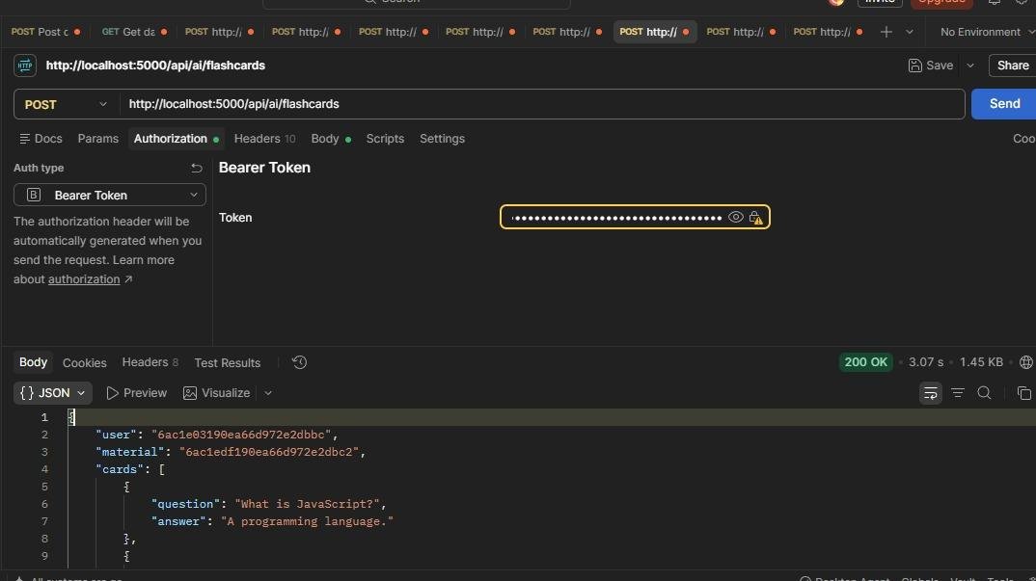
FLASHCARDS

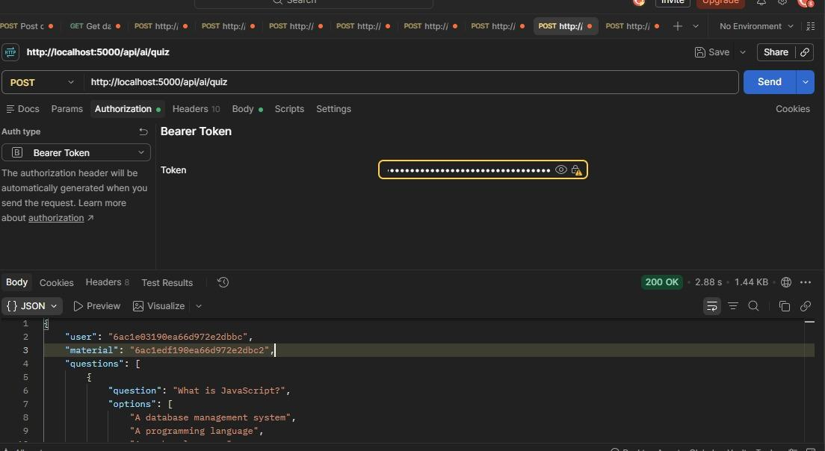
QUIZ
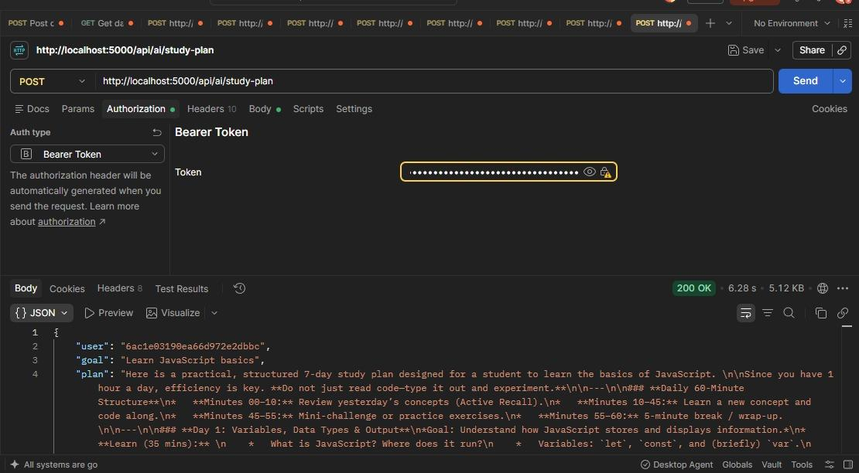
STUDYPLAN

15. Testing Result
The implemented APIs were successfully executed through Postman. Registration and login worked with JWT authentication, study material was stored successfully, and the AI endpoints generated summary, flashcard, quiz, and study-plan responses.

16. Demonstration Links
API Testing Video:
https://drive.google.com/file/d/1Y9qf7nAccKHsT__91sUR60BaUDFOcasT/view?usp=drive_link
Project Demo Video:
https://drive.google.com/file/d/1Izc_VkioAHmjbahIcLs9DUtnCm1Gz2-x/view?usp=drive_link
Source Code / Project Drive:
https://drive.google.com/drive/folders/1n7XuXiJz2ibMXed4huL_s5qGmTDQpv46?usp=drive_link

17. Conclusion
AI StudyBuddy demonstrates the integration of Generative AI with a secure and modular backend to support student learning. The project combines REST API development, MongoDB data management, JWT authentication, password security, and Google Gemini AI to automate common study tasks.

