Algorithmic Fairness:
Baseline Discrimination Analysis of the UCI Adult Dataset
SUJAY PARI
GH1037955
MSc Data Science, AI & Digital Business
GISMA University of Applied Sciences

Abstract
This report evaluates baseline discrimination in a Random Forest classifier trained on the UCI Adult income dataset to predict whether an individual earns more than $50,000 annually. Predictions were analysed across two protected attributes — sex and race — using four fairness-related error metrics: False Positive Rate (FPR), False Negative Rate (FNR), False Discovery Rate (FDR), and False Omission Rate (FOR). The results reveal substantial subgroup disparities, particularly in False Negative Rate. Females exhibited an FNR of 0.4595 compared to 0.2714 for males, while Black individuals showed a higher FNR (0.4064) than White individuals (0.2979). These findings indicate that the model disproportionately fails to identify high-income individuals within certain protected groups. No bias mitigation techniques were applied, allowing the analysis to capture the model’s baseline discriminatory behaviour. The study demonstrates how standard machine learning systems can reproduce structural inequalities embedded in historical data.

1. Introduction
Machine learning systems trained on historical data may reproduce discriminatory patterns across protected groups. This report evaluates baseline discrimination in a Random Forest classifier trained on the UCI Adult dataset to predict whether an individual earns more than $50K annually. The analysis focuses on two sensitive attributes — sex and race — and evaluates subgroup disparities using four fairness-related error metrics: False Positive Rate (FPR), False Negative Rate (FNR), False Discovery Rate (FDR), and False Omission Rate (FOR). No bias mitigation was applied, allowing the study to measure the raw discriminatory behaviour of the model.2. Methodology

2.1 Dataset and Preprocessing
The UCI Adult dataset (OpenML ID: 1590) was loaded using fetch_openml. Missing-value rows containing “?” were removed, categorical variables were label encoded, and the income target was binarised (>50K = 1, <=50K = 0). The dataset was split using an 80/20 stratified train-test split. Raw copies of the protected attributes (sex, race) were retained for subgroup evaluation.

2.2 Model Training

A Random Forest classifier (n_estimators=100, random_state=42) was trained as a baseline model without fairness constraints. Protected attributes remained in the feature set to intentionally measure existing discrimination patterns rather than mitigate them.

2.3 Fairness Metrics
For each subgroup, a confusion matrix was generated and four error-rate metrics computed from its components (TP = True Positive, TN = True Negative, FP = False Positive, FN = False Negative):

Metric | Formula | Interpretation
FPR | FP / (FP + TN) | Rate of false alarms among true negatives
FNR | FN / (FN + TP) | Rate of missed positives among true positives
FDR | FP / (FP + TP) | Fraction of positive predictions that are wrong
FOR | FN / (FN + TN) | Fraction of negative predictions that are wrong
Table 1. Fairness metric definitions.
FPR and FDR capture the error burden on individuals falsely labelled as high-earners (>50K). FNR and FOR capture the error burden on individuals falsely labelled as low-earners (<=50K). In the income-prediction context, FNR is particularly consequential: a high FNR for a protected group means the model systematically fails to recognise high-earning members of that group, potentially denying them access to credit or opportunities

3. Results

3.1 Overall Model Performance
The Random Forest classifier achieved an overall test-set accuracy of 78.76% (macro F1 = 0.77). Precision was 0.81 for the <=50K class and 0.75 for the >50K class; recall was 0.85 and 0.69 respectively. The slight imbalance in recall (the model is better at identifying low earners) already hints at systematic difficulties in detecting high earners — a pattern that will be shown to affect protected groups disproportionately.

3.2 Full Fairness Metrics Table
Table 2 presents all four fairness metrics for every subgroup in the test set.

Subgroup | N | FPR | FNR | FDR | FOR | Accuracy
Sex = Male | 6,399 | 0.1957 | 0.2714 | 0.2367 | 0.2262 | 0.7692
Sex = Female | 3,077 | 0.0818 | 0.4595 | 0.3183 | 0.1395 | 0.8258
Race = White | 8,129 | 0.1589 | 0.2979 | 0.2492 | 0.1946 | 0.7847
Race = Black | 890 | 0.1038 | 0.4064 | 0.2727 | 0.1745 | 0.8000
Race = Asian-PI | 277 | 0.0957 | 0.3708 | 0.2432 | 0.1626 | 0.8159
Race = AI-Eskimo | 84 | 0.0702 | 0.4444 | 0.2105 | 0.1846 | 0.8095
Race = Other | 96 | 0.1176 | 0.3571 | 0.3077 | 0.1429 | 0.8125
Table 2. Full fairness metrics per subgroup (test set, n = 9,476).

3.3 Error Rate Disparity Comparison
Figure 3 visualises the disparity across all four metrics for the two primary comparisons: Male vs. Female and White vs. Black.
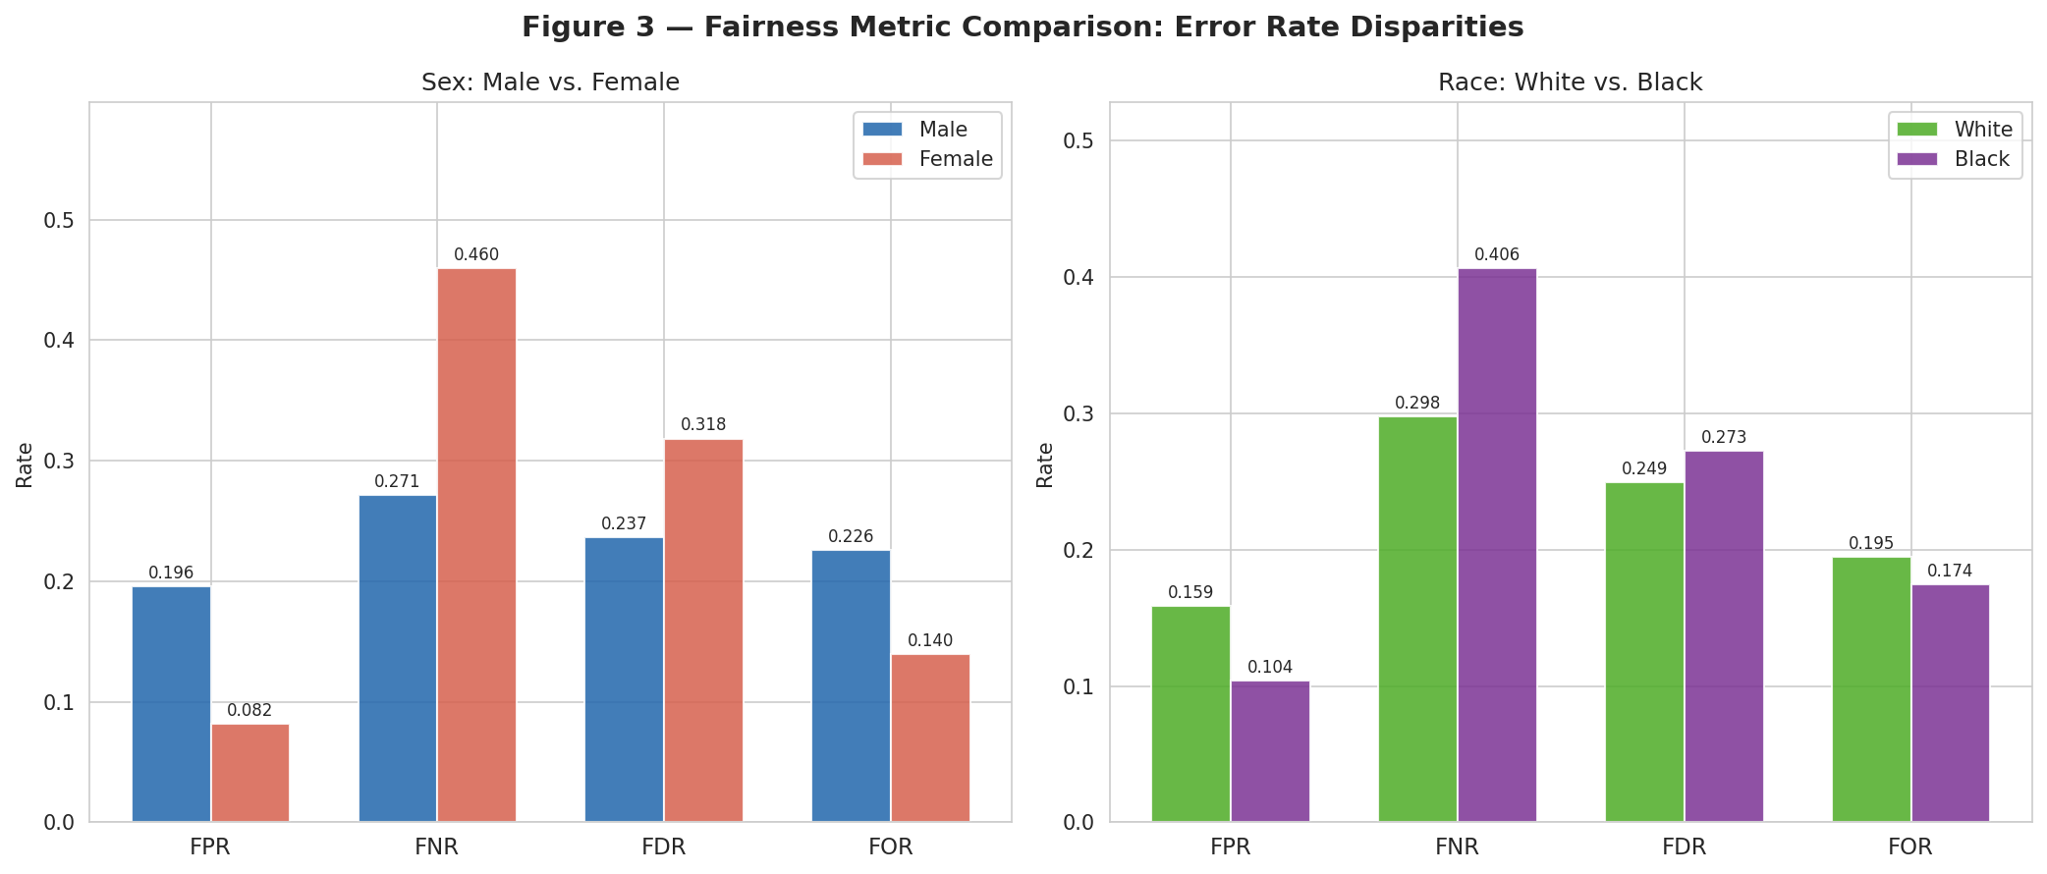
Figure 3. Grouped bar chart comparing FPR, FNR, FDR, and FOR across sex (left) and race (right) subgroups.
Table 3 summarises the absolute disparities (Δ) for each metric.

Metric | Male | Female | Δ (M−F) | White | Black | Δ (W−B)
FPR | 0.1957 | 0.0818 | +0.1139 | 0.1589 | 0.1038 | +0.0551
FNR | 0.2714 | 0.4595 | +0.1881 | 0.2979 | 0.4064 | +0.1085
FDR | 0.2367 | 0.3183 | +0.0816 | 0.2492 | 0.2727 | +0.0235
FOR | 0.2262 | 0.1395 | -0.0867 | 0.1946 | 0.1745 | -0.0201
Table 3. Absolute disparities (Δ) between primary subgroup pairs. Red values indicate the largest disparities.

4. Discussion

4.1 FNR Disparity — The Most Consequential Gap
The most significant disparity occurs in the False Negative Rate (FNR). Females show an FNR of 0.4595 compared to 0.2714 for males, indicating that high-earning women are substantially more likely to be misclassified as low earners. Similarly, Black individuals experience a higher FNR (0.4064) than White individuals (0.2979). These disparities indicate unequal model sensitivity across protected groups and are consistent with prior fairness research on the Adult dataset.

4.2 Additional Fairness Disparities
Beyond FNR disparities, additional differences appear across FPR, FDR, and FOR metrics. Males and White individuals exhibit higher False Positive Rates, whereas females and Black individuals show higher False Discovery Rates, indicating reduced reliability of positive predictions for those groups. These opposing disparities demonstrate that different groups experience different forms of predictive error simultaneously. The results also reflect known trade-offs between fairness criteria, where reducing one disparity may worsen another.

4.3 Feature Importance and Structural Sources of Bias
Figure 4 presents the top-15 feature importances from the trained Random Forest, offering insight into the structural sources of the observed disparities.
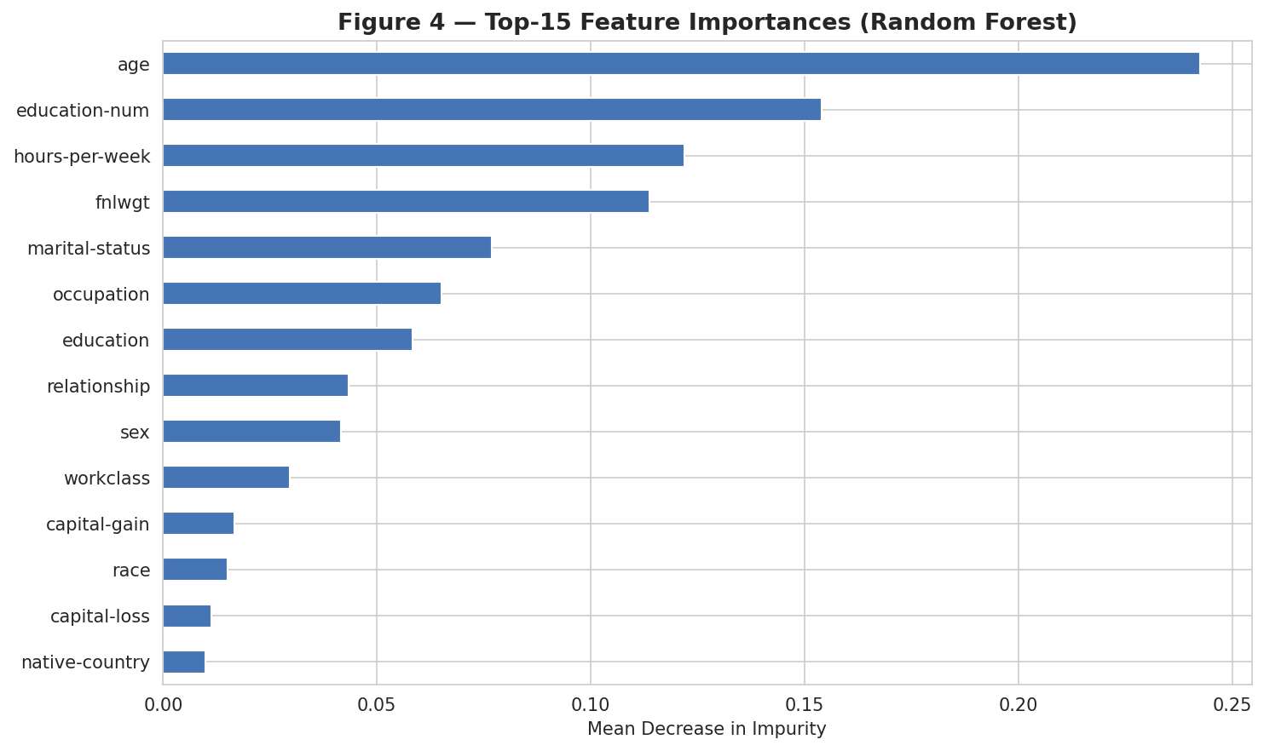
Figure 4. Top-15 feature importances by mean decrease in impurity.
Feature importance analysis showed that variables such as capital gain, relationship status, marital status, and hours-per-week contributed strongly to predictions. Several of these variables are correlated with protected attributes, enabling proxy discrimination even when fairness constraints are absent. This demonstrates how structurally biased socioeconomic patterns embedded in training data can propagate into model outcomes.

5. Conclusions
This study evaluated baseline discrimination in a Random Forest classifier trained on the UCI Adult dataset. Although the model achieved strong overall accuracy, substantial subgroup disparities were identified across fairness metrics. The largest disparities occurred in False Negative Rate, where females and Black individuals were significantly more likely to have high income incorrectly predicted as low income. The findings demonstrate how standard machine learning models can reproduce structural inequalities present in historical data, even without explicit fairness interventions.

Code Availability
The complete source code for this project is available

