**Assignment 1 – DropBox**

**Course No: CSE6331- Cloud Computing**

**Student Name: Amrish Khanna Chandrasekaran**

**Student ID: 1001112651**

**Reference:**

1. <https://www.dropbox.com/developers/core/start/python>
2. <http://eli.thegreenplace.net/2010/06/25/aes-encryption-of-files-in-python-with-pycrypto>

**Procedure:**

1. Install dropbox python package.
2. Install pycrypto python package.
3. Use pip install or python setup.py install command to install those packages.
4. Install watchdog package to monitor the files that is droped in syncing folder.
5. Write the python code for secure upload and download files.
6. Pycrypto is used for encrypting and decrypting the files that is uploaded and downloaded.
7. Drop the file to be encrypted and uploaded in Sync folder being monitored.
8. Once dropped it prompts authentication.
9. Go to the URL link generated and copy the hash code and paste in terminal to authenticate
10. Once done the file is encrypted and uploaded.
11. Then the file is downloaded after decryption.

**Screenshot:**

Dropping File to Sync Folder:

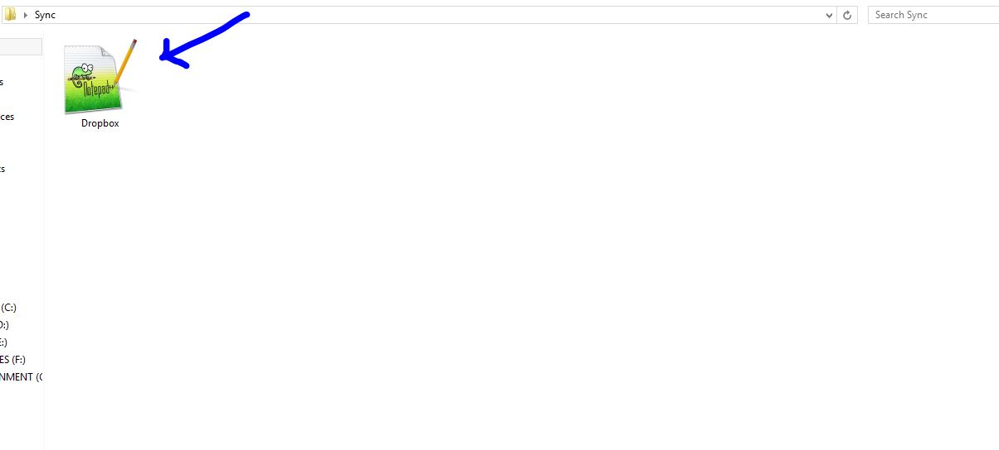

Authentication:

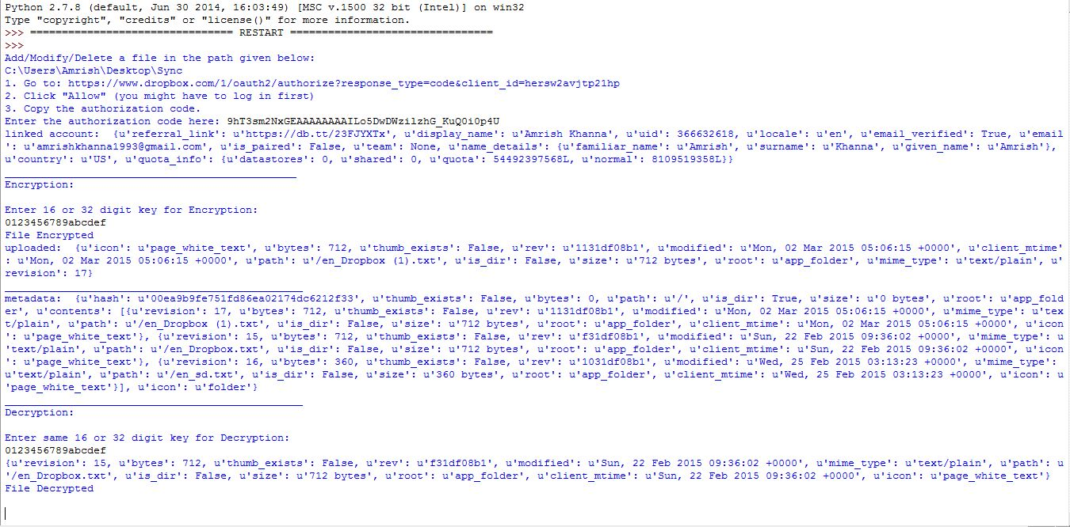

Encrypted:

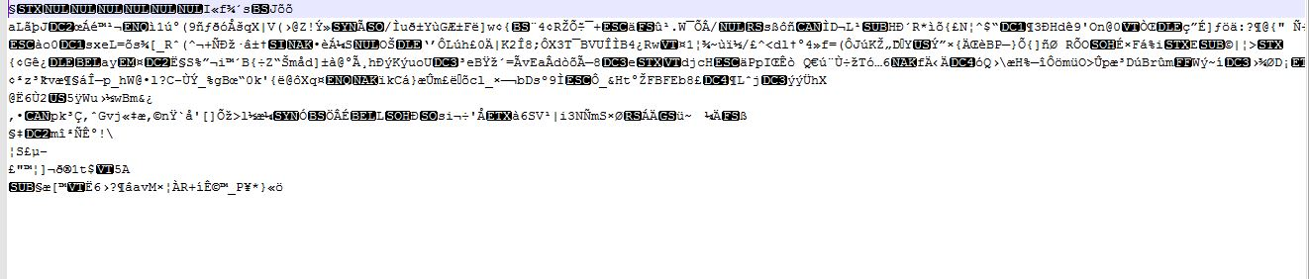

Uploaded in Dropbox after Encryption:

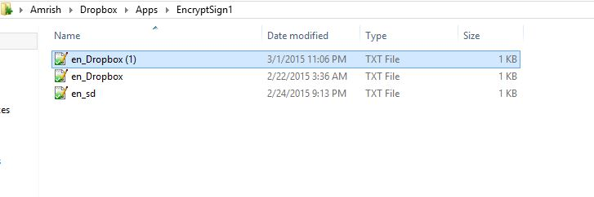

Decrypted:

