# Controller

After planning the path of the robot Virat, a sliding mode controller can be proposed for robust tracking trajectory. In this strategy, two positions are needed to be known  ,the desired /reference position , pr =(xr , yr , alphar) and current position p=(x, y, alpha) and error in position pe be the difference between the reference position  and the current position .

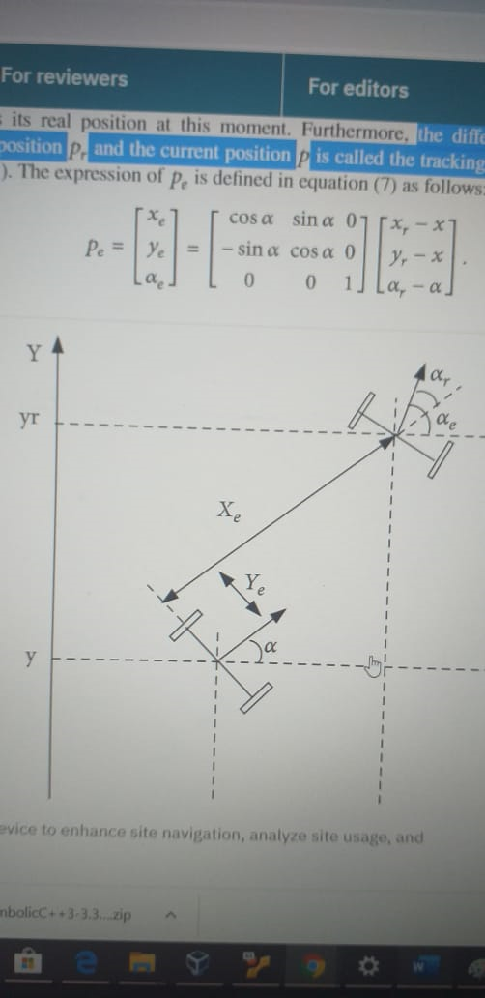

Tracking trajectory can be introduced as finding the adequate control vector (vel, ang. vel)

 (vel is the linear velocity of the wheeled mobile robot and ang vel is its angular velocity). So that the error position  converges asymptotically to zero.

OR

To ensure that our Virat is on the right track, we take real time data of parameters such as its wheel velocity, the angle rotated, position, etc., and compare them with the desired or ideal states of the parameter at that particular instance. In case we find that those values differ, we raise an alarm or high priority signal which tells Virat which parameter values it should change and mend its way .

If I am the controller expert of the team, my top priority would be-

1.Virat take valid path and does not crosses the boundary.

2.It does not crash into any obstacle and maintain a minimum safe distance from any barrier.

3.Virat takes the shortest route, so to ensure minimum time.( the path is required to be optimal)

Point 1 would be ensured using efficient use of image detection and certain programmable features like locking of motion in direction when the cutoff distance to boundary is reached , conditional reactions based on fuzzy logic.

Regarding point 2 and point 3, there is a path planning method which I find intelligent and very practical which is based on free segments and a turning point strategy.

A **free segment** is considered as the distance between two endpoints of two different obstacles. It searches the endpoint of a safe segment where the mobile robot turns around this point without hitting obstacles.

When there are no obstacles, the path planning problem does not arise. In fact, the robot moves from an initial position to goal position in a straight line which will be considered as the shortest path.

However, when the mobile robot encounters with obstacles, the robot should be turning without collision with obstacles. So, the major problem is how to determinate a suitable path from a starting point to a target point in a static environment.

To solve this problem our developed algorithm is proposed to search for a turning point of a safe free segment which gives the shortest path and allows the robot to avoid obstacles. Once the turning point is located, a dangerous circle with radius Rmin is fixed in this point.

In this case, our proposed strategy aims to search for the turning point of the safe free segment around which the robot turns safely. For ensuring safety, we select only the segments whose distance is larger than the width of Virat so the Virat can pass through obstacle . It will also consider the boundary as an obstacle.

The free segment which are smaller than width of Virat is a Danger segment and are not considered for shortest path.

With the shortest path in mind, we fix minimum radius(depends on steering capability of Virat) at the corner of obstacle and that’s where we will turn and moves towards the tangential direction to this circle. Even when there is a danger problem, our proposed algorithm will be reactive to allow the robot to avoid obstacles and reach the goal. In this case, the robot reserves the determined turning point and searches for a new turning point to avoid collision with obstacles.

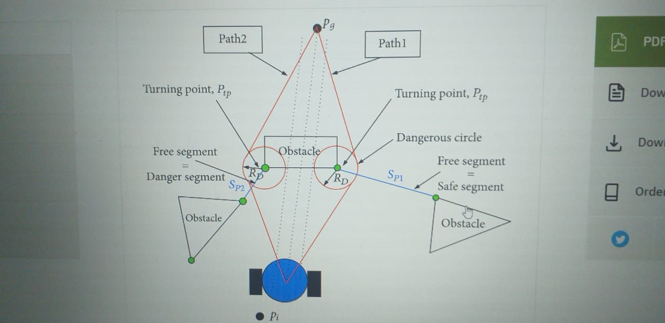

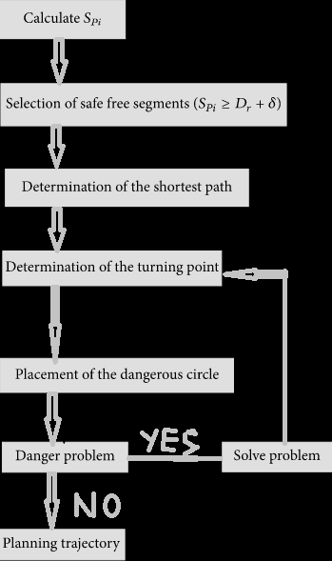

Resource links:

<https://www.hindawi.com/journals/mpe/2018/2163278/>

<https://www.hindawi.com/journals/cin/2016/9548482/>