**DAILY ONLINE ACTIVITIES SUMMARY**

|  |  |  |  |  |  |  |  |  |
| --- | --- | --- | --- | --- | --- | --- | --- | --- |
| **Date:** | **18/05/2020** | | | | | **Name:** | **SUJAYA** | |
| **Sem & Sec** | **IV SEM & B Section** | | | | | **USN:** | **4ALCS90** | |
| **Online Test Summary** | | | | | | | | |
| **Subject** | | **COMPLEX ANALYSIS, PROBABILITYAND STATISTICAL METHODS** | | | | | | |
| **Max. Marks** | | **30** | | **Score** | | | **-** | |
| **Certification Course Summary** | | | | | | | | |
| **Course** | **PYTHON FOR MACHINE LEARNING** | | | | | | | |
| **Certificate Provider** | | | **Greatlearning academy** | | **Duration** | | | **5hours** |
| **Coding Challenges** | | | | | | | | |
| **Problem Statement 1: Given array of distinct integers. The task is to count all the triplets such that the sum of two elements equals to the third element.**  **Problem Statement 2: Write a C program to check whether the two strings are anagram or not** | | | | | | | | |
| **Status:Executed** | | | | | | | | |
| **Uploaded the report in Github** | | | | | **Yes** | | | |
| **If yes Repository name** | | | | | **Online coding** | | | |
| **Uploaded the report in slack** | | | | | **Yes** | | | |

Online Test Details: (Attach the snapshot and briefly write the report for the same)

Engineering Maths(18MAT41)test was conducted from 9.30 am to 10 am. Portion for IA was 4th module.Time allotted was 30 minutes with a total of 30 questions. Questions were of mcq type.

Certification Course Details: (Attach the snapshot and briefly write the report for the same)

I have opted online certification course in Greatlearning academy the course which I have opted is Python for machine learning. The course contains assessments and practice assessments the faculty is Dan Mitchell-Industrial and System Engineering. Today I have gone through python introduction. Python is easy is learn, powerful programming language. We can also use Python when our data analysis task needs to be incorporated into a production data base. It’s a great tool to implement algorithms for production use.

In this video I came to know what exactly is python programming language and what is the difference between two well-known languages Python and R. Python is an open source and there are tons of packages freely available and there are many Python IDE’s like pycharm, jupyter, notebooks etc. In the Upcoming sessions I am going to learn about jupyter notebooks and Anaconda installation. 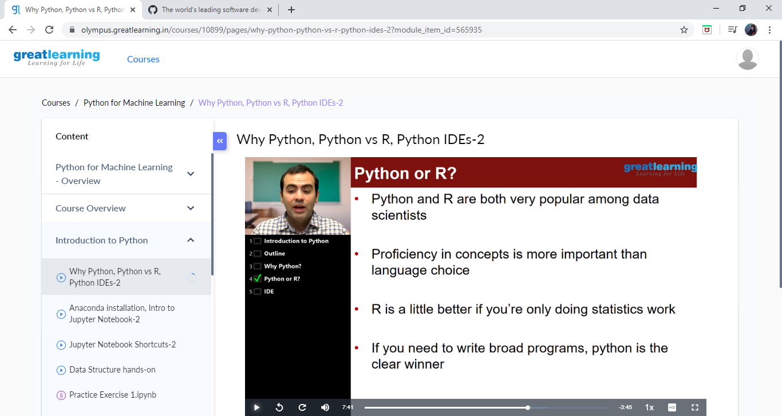Coding Challenges Details: (Attach the snapshot and briefly write the report for the same)

Problem statement 1: Given array of distinct integers. The task is to count all the triplets such that the sum of two elements equals to the third element.

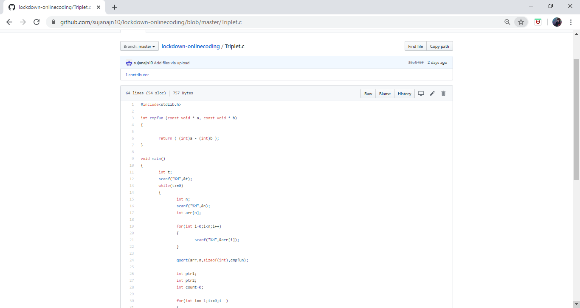

Problem Statement 2: Write a C program to check whether the two strings are angarman or not