**Module-1 SQL Server**

**1.Create the table as per normalization and Insert the Data.**

Created 3 tables. They are:

* **DFA_HEALTHCARE_HOSPITAL**
* **DFA_HEALTHCARE_DOCTOR**
* **DFA_HEALTHCARE_PATIENT**

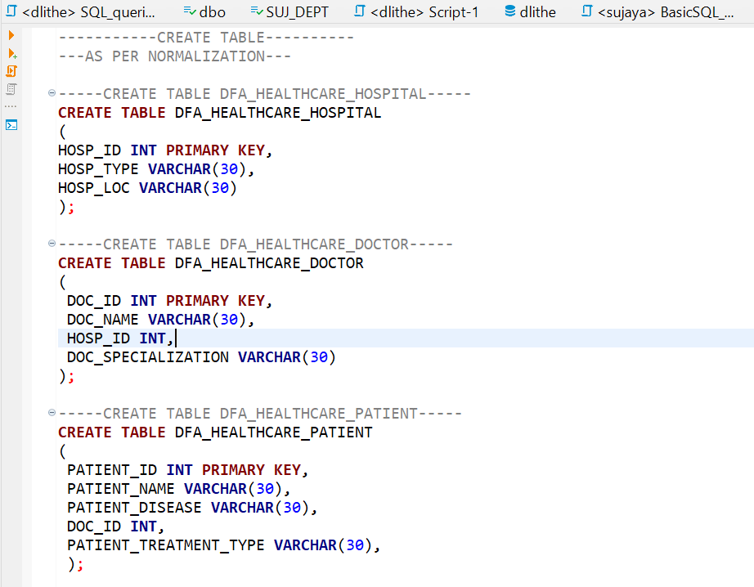

Adding Foreign Key Constraints to table Doctor and Patient.

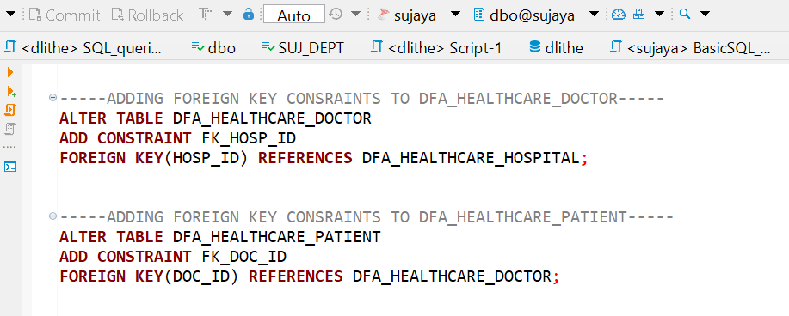

**1b).Inserting the values to three tables.**

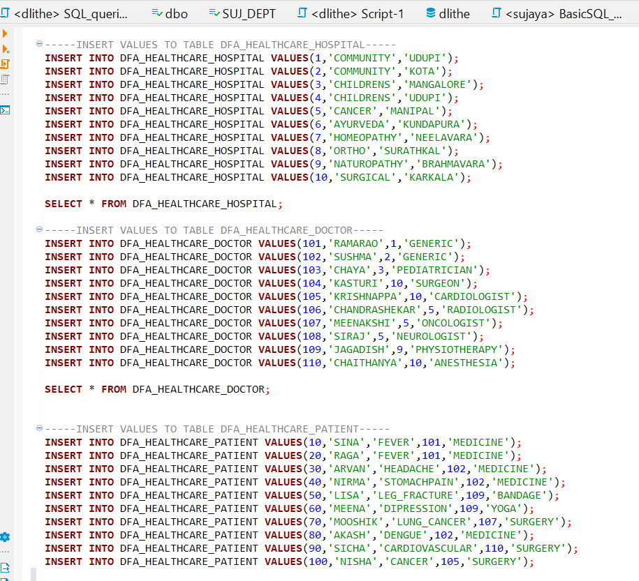

**1c).Perform Joins**

**Inner Join**

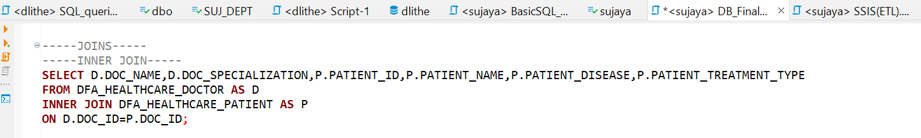

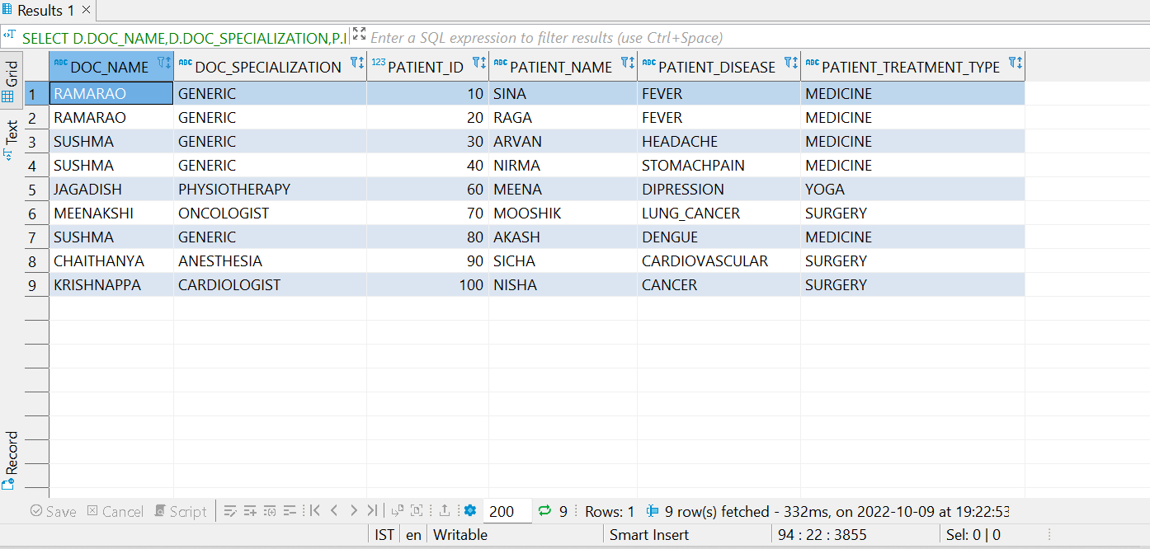

**Left Join**

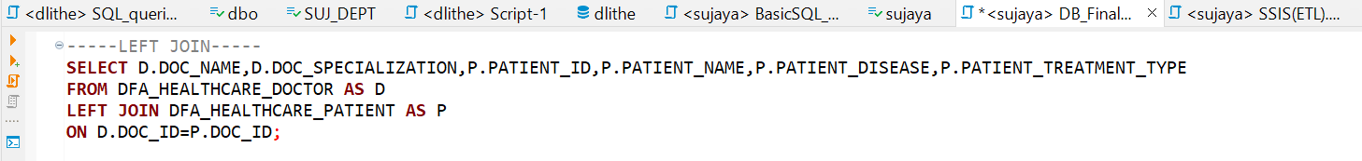

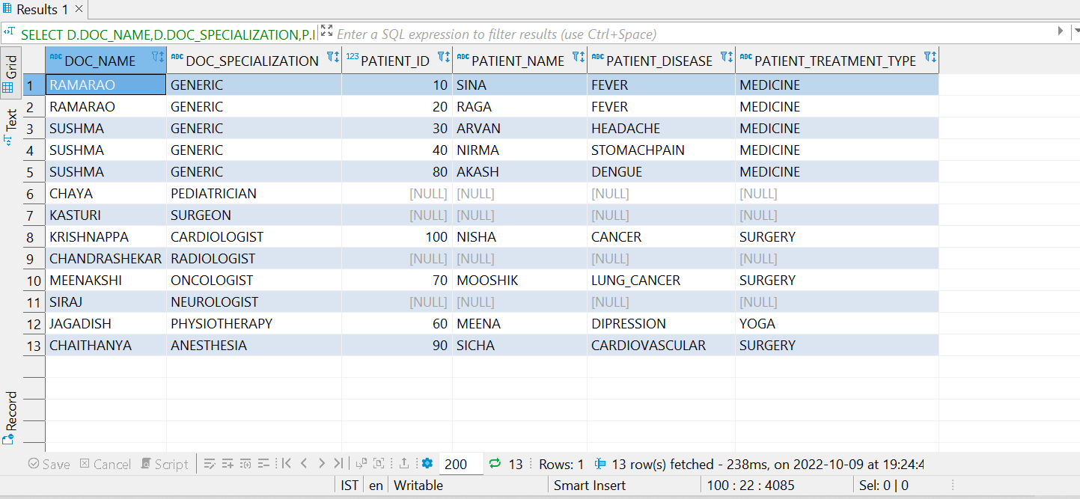

**Right Join**

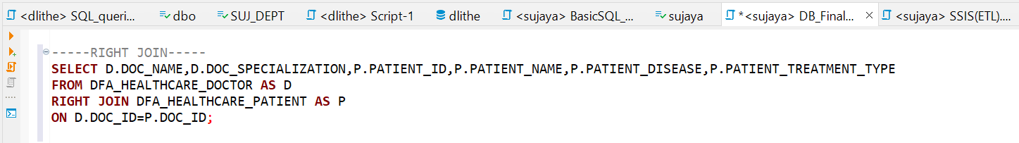

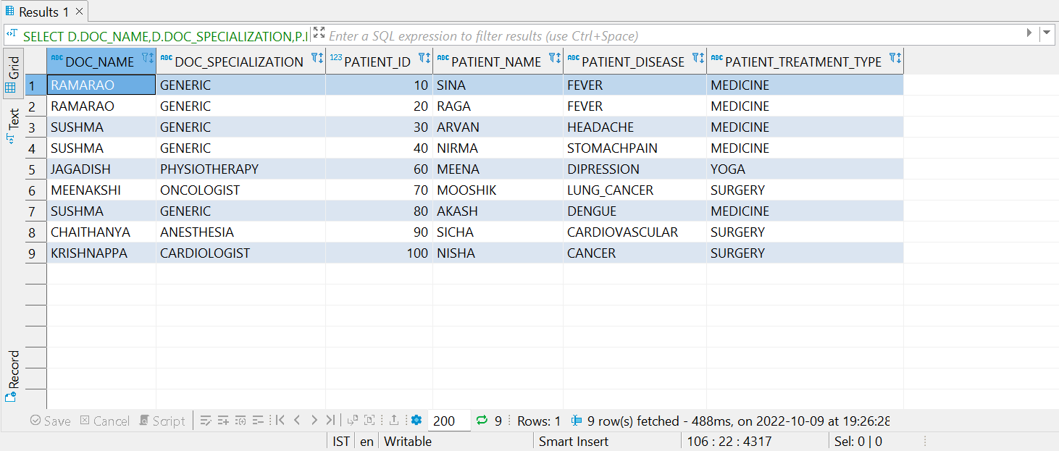

**Full Join**

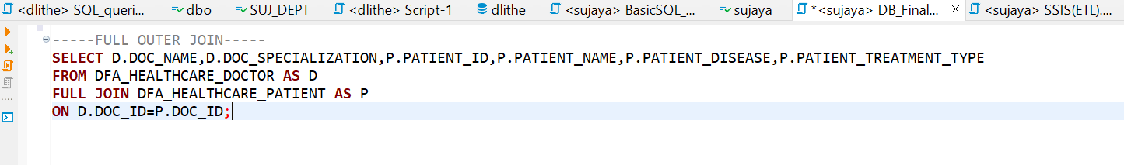

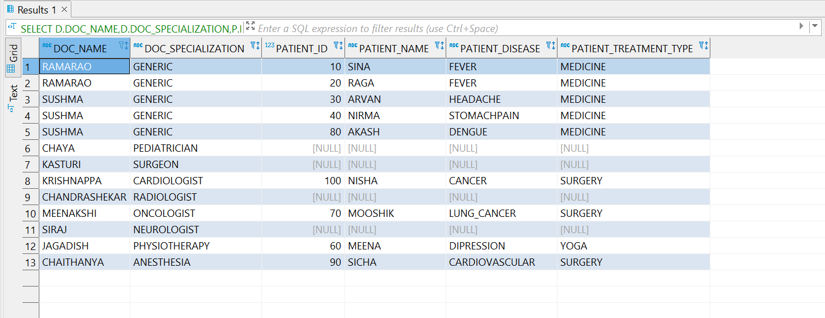

**1d).Views**

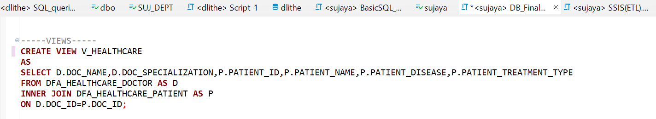

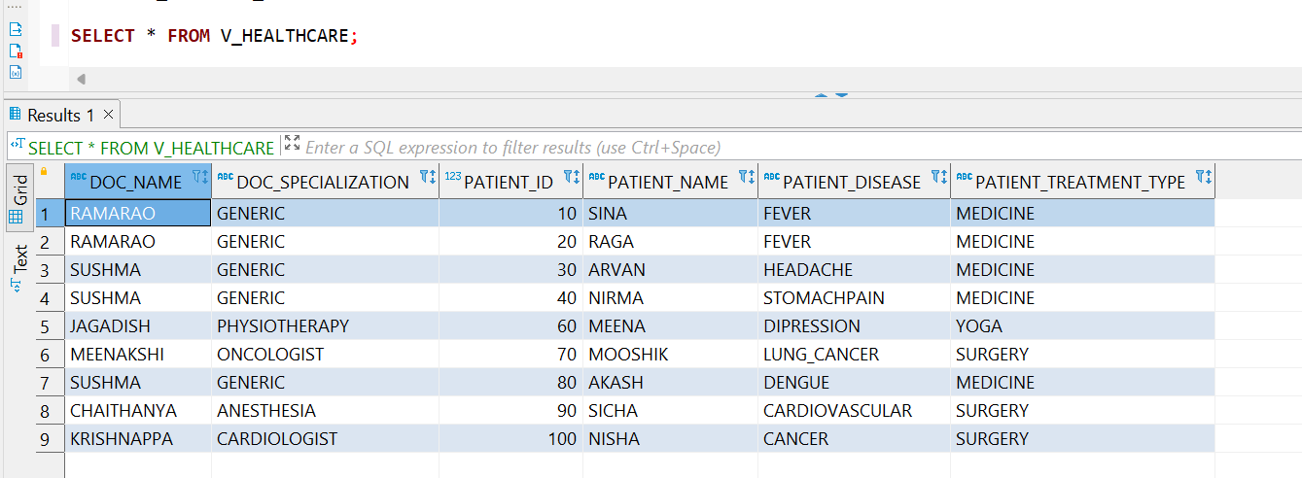

**2.** **2. Using transaction table perform various operations ( DDL,DML) .**

Created the table named **DFA_CINEMA_TICKET** and Inserted the values to the table.

Used the ***CinemaTicket_Ref_Entertainment*** Datasource.

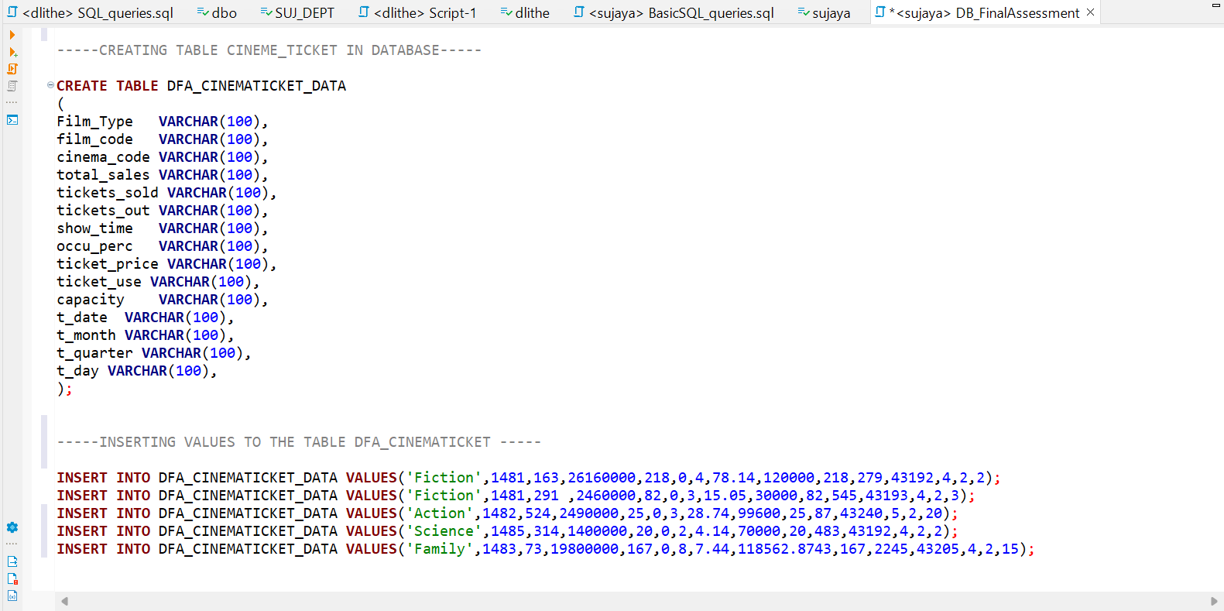

Displaying the table values.

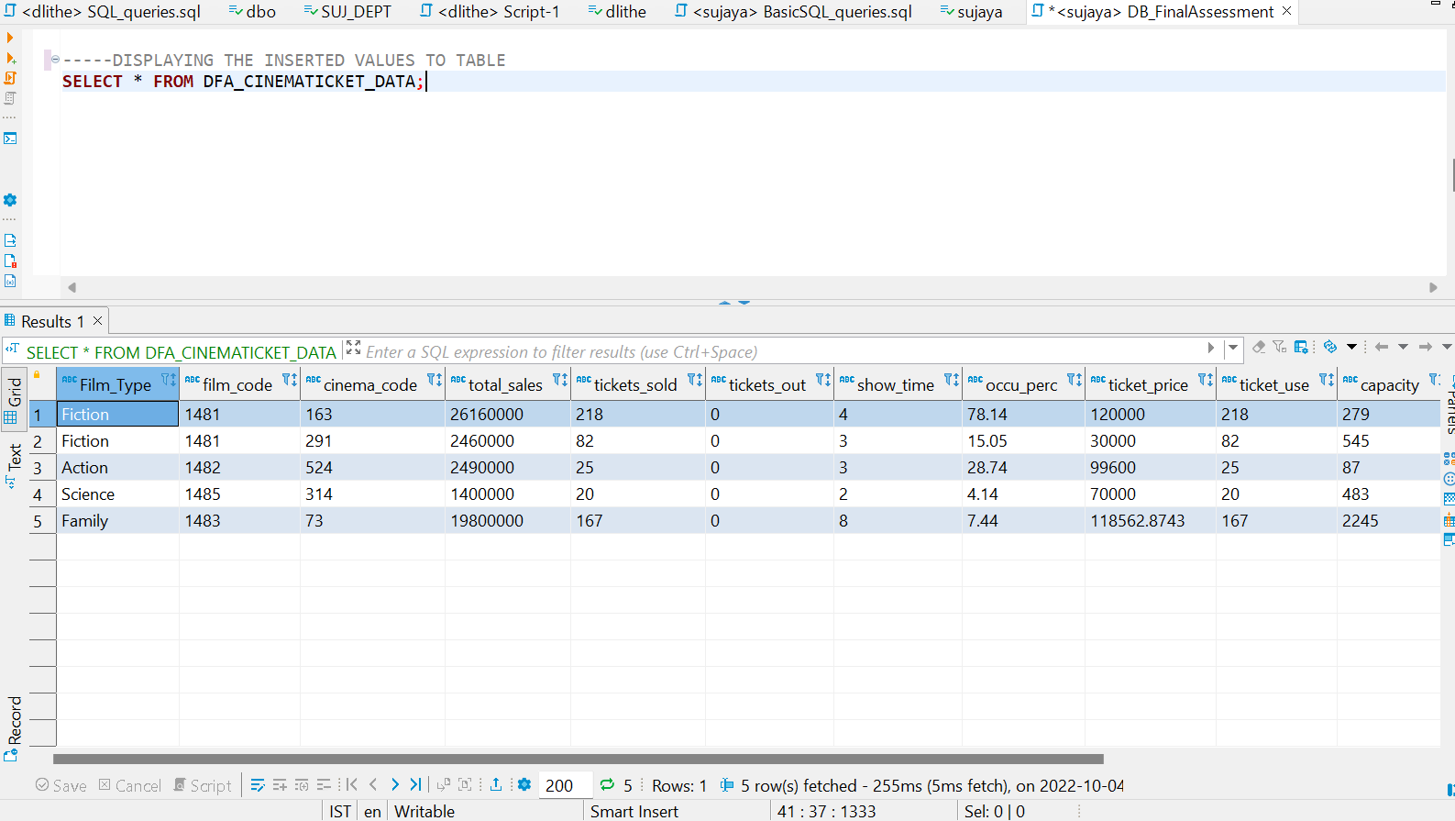

**DDL Performed :**

**a)CREATE**

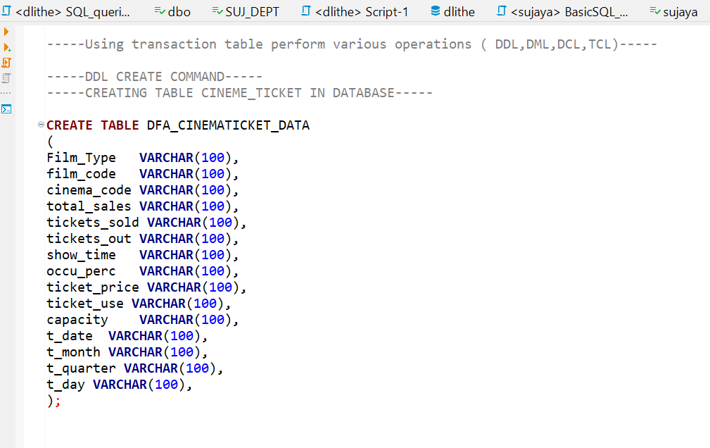

**b)ALTER**

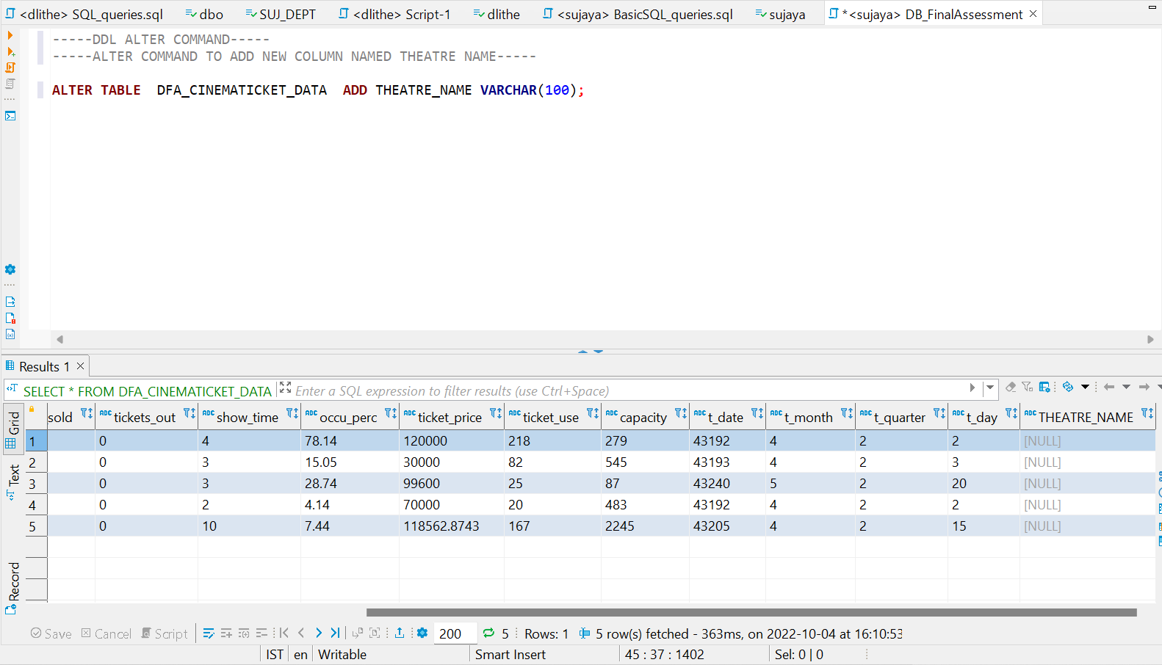

**c)TRUNCATE**

**d)DROP**

**DML**

**a)INSERT**

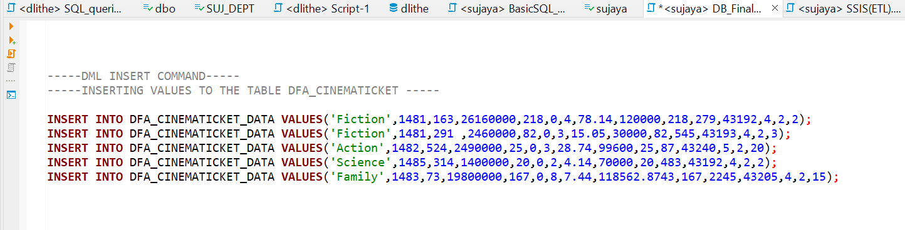

**b)SELECT**



**b)UPDATE**

**c)DELETE**

