**Module-1 SQL Server**

**1.Create the table as per normalization and Insert the Data.**

Created 3 tables. They are:

* **DFA_HEALTHCARE_HOSPITAL**
* **DFA_HEALTHCARE_DOCTOR**
* **DFA_HEALTHCARE_PATIENT**

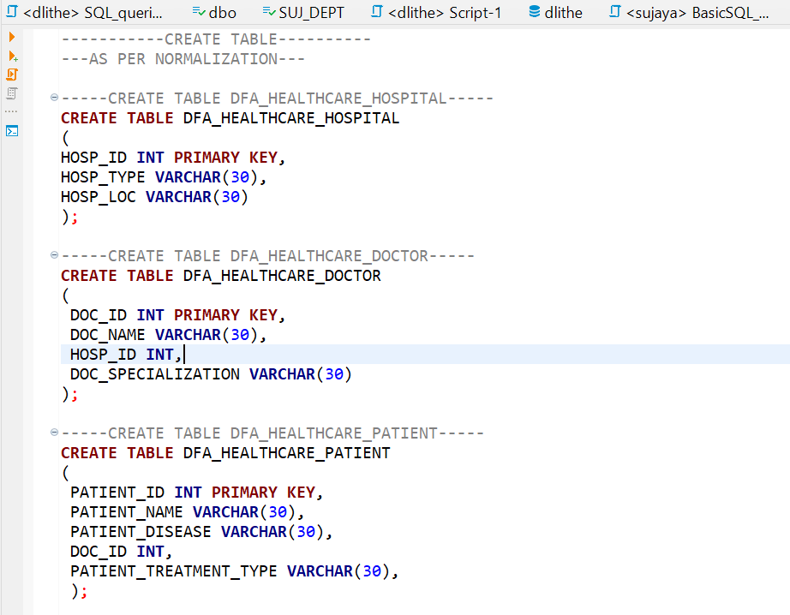

Adding Foreign Key Constraints to table Doctor and Patient.

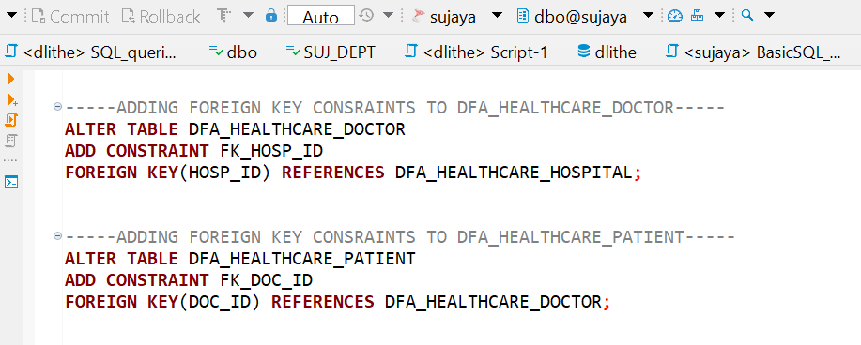

**1b).Inserting the values to three tables.**

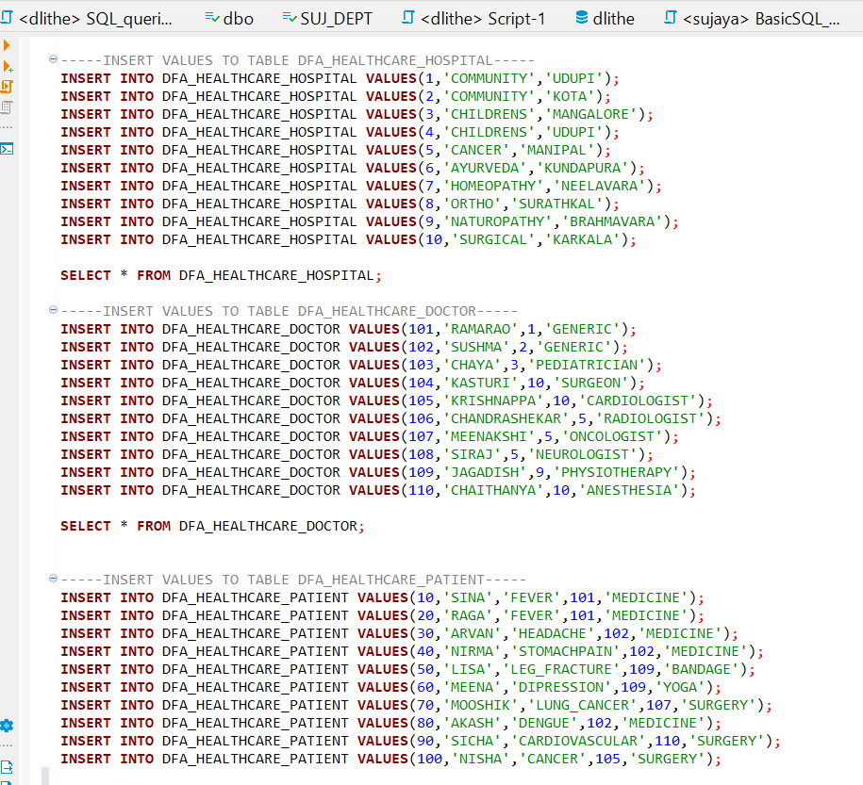

**1c).Perform Joins**

**Inner Join**

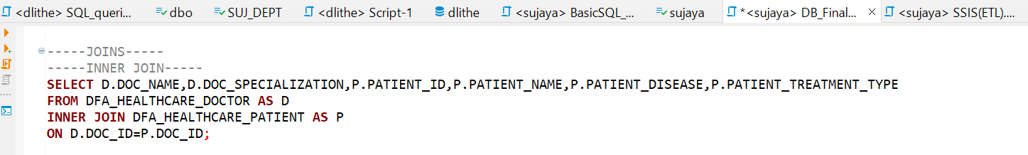

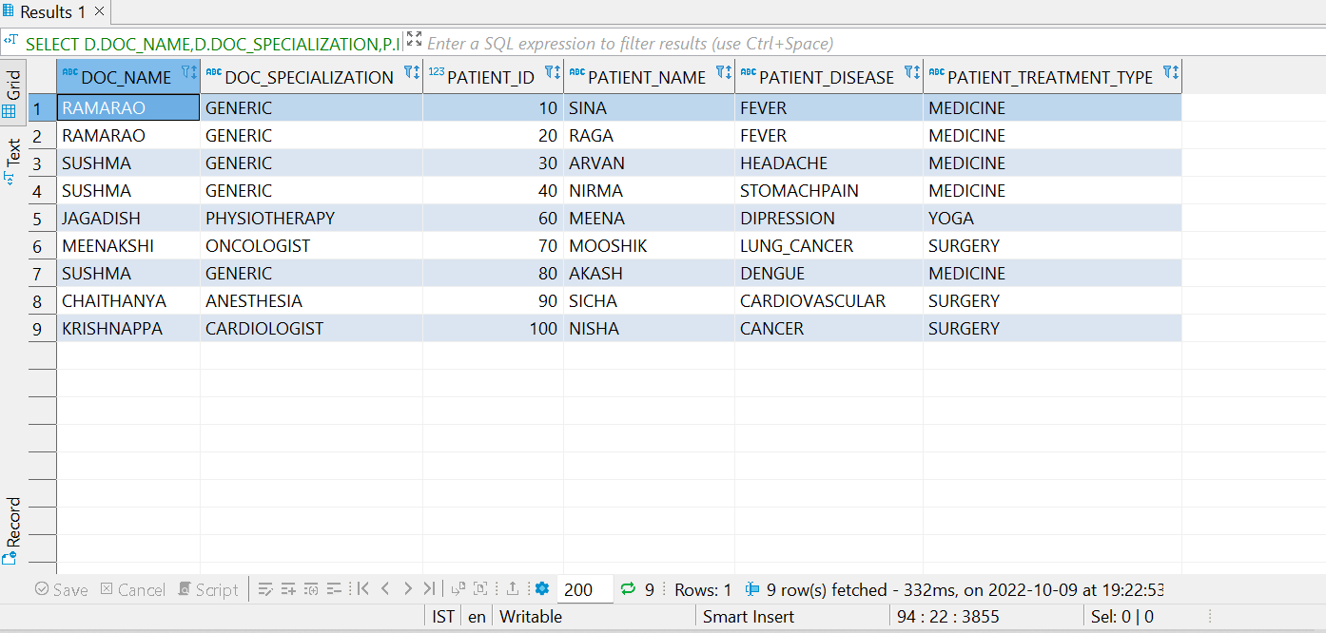

**Left Join**

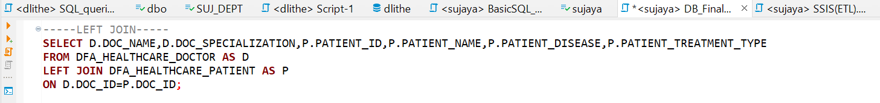

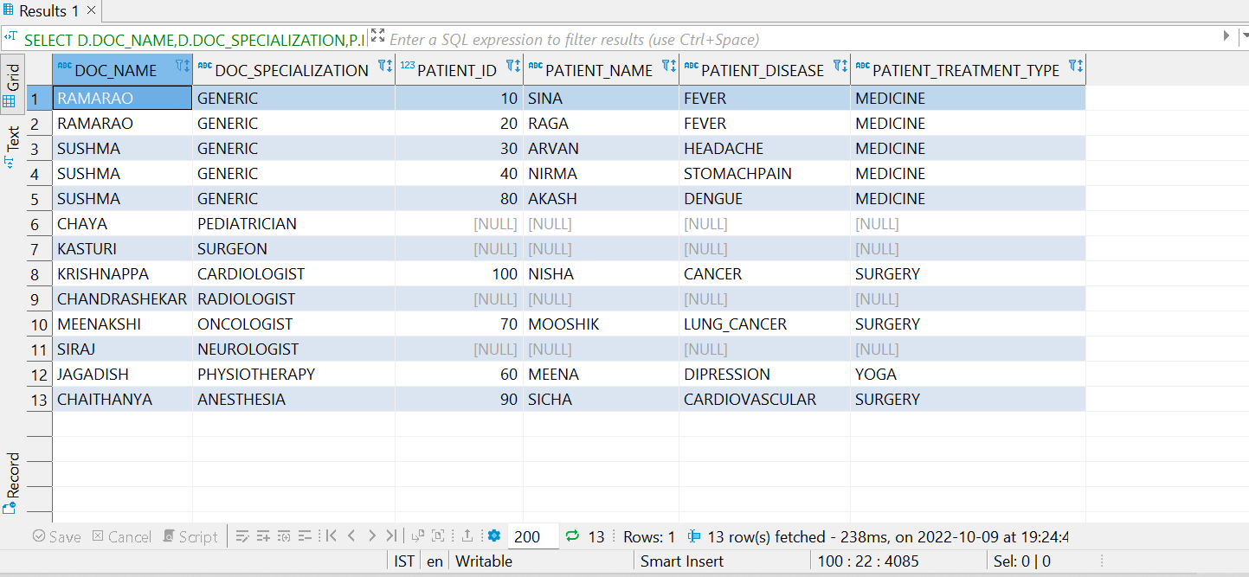

**Right Join**

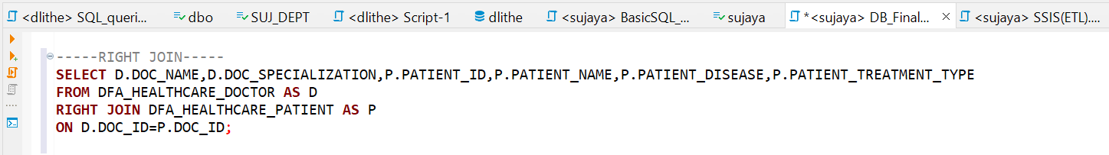

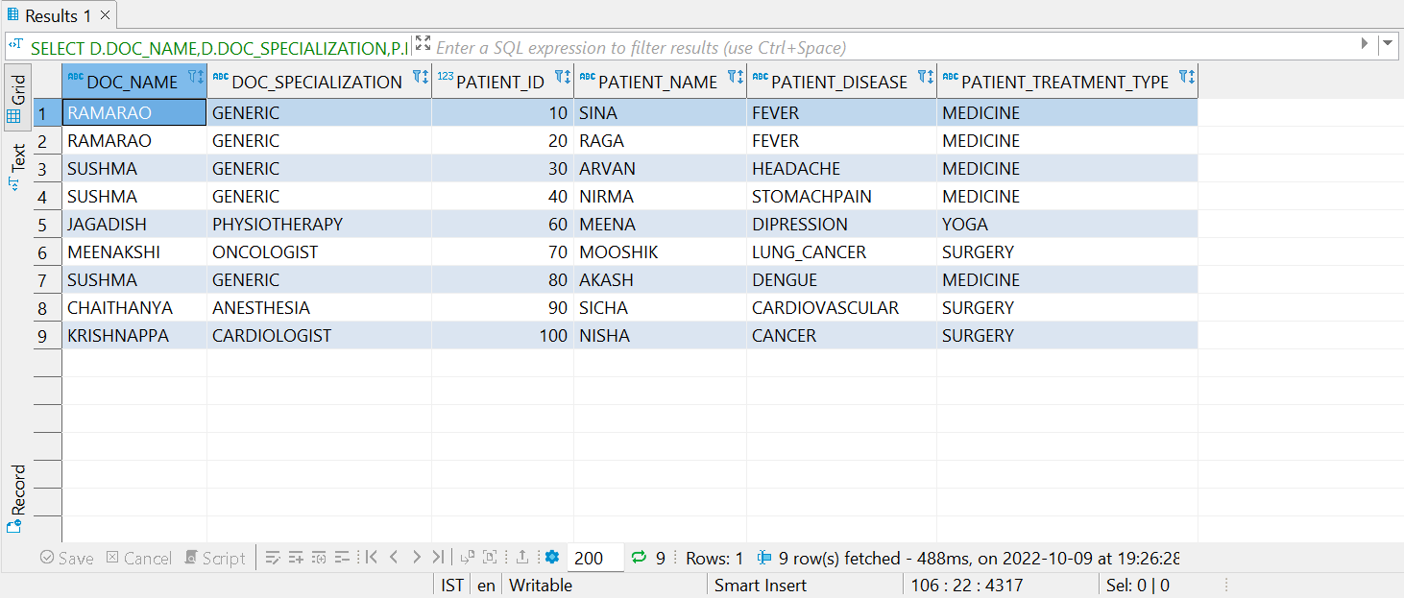

**Full Join**

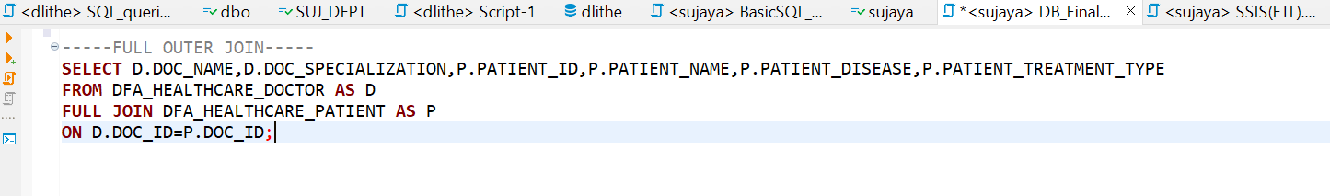

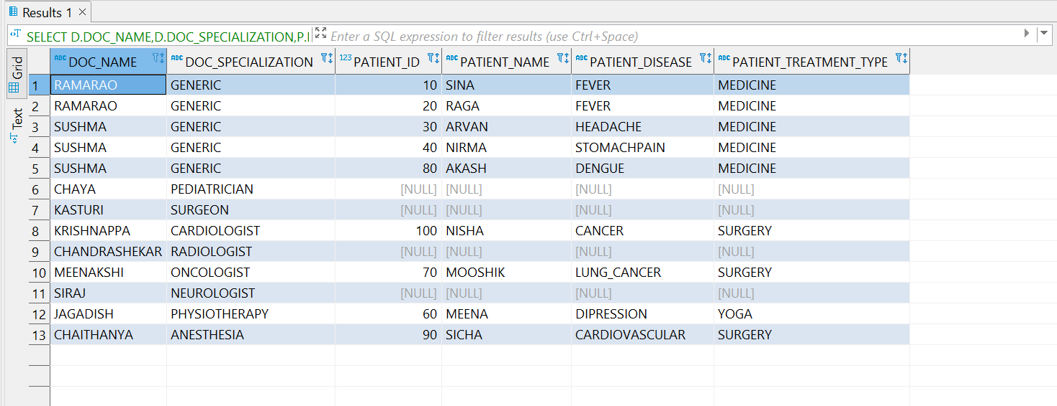

**1d).Views**



