COVID HEALTH CARE REPORT

  Drug and Provider Details
  Report By:
  CORPINDIA\EI13112
  Drill down Report about details about drug and provider details
  Execution Time :
  10/13/2022 12:45:39 PM
DRG ID | DRG Definition | Provider Name | Provider City
101 | SEIZURES W/O MCC | UNIVERSITY MEDICAL CENTER | LEBANON
149 | DYSEQUILIBRIUM | BAPTIST MEDICAL CENTER SOUTH | MONTGOMERY
178 | RESPIRATORY INFECTIONS & INFLAMMATIONS W CC | SAINT JOSEPH HOSPITAL | LEXINGTON
192 | CHRONIC OBSTRUCTIVE PULMONARY DISEASE W/O CC/MCC | BRATTLEBORO MEMORIAL HOSPITAL | BRATTLEBORO
195 | SIMPLE PNEUMONIA & PLEURISY W/O CC/MCC | KINGSBROOK JEWISH MEDICAL CENTER | BROOKLYN
292 | HEART FAILURE & SHOCK W CC | SCOTT & WHITE MEMORIAL HOSPITAL | TEMPLE
39 | EXTRACRANIAL PROCEDURES W/O CC/MCC | SOUTHEAST ALABAMA MEDICAL CENTER | DOTHAN
64 | INTRACRANIAL HEMORRHAGE OR CEREBRAL INFARCTION W MCC | FORT WALTON BEACH MEDICAL CENTER | FORT WALTON BEA
69 | TRANSIENT ISCHEMIA | JOHNS HOPKINS BAYVIEW MEDICAL CENTER | BALTIMORE

 | 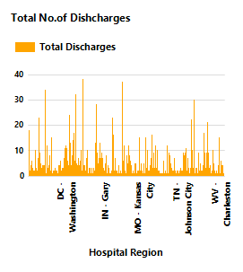
 |  |  |  | 