**PYTHON ASSIGNMENT**

Sujaya

4AL18CS090

#for updating

import openpyxl

wb = openpyxl.load_workbook('produceSales.xlsx')

sheet = wb.get_sheet_by_name('Sheet')

# The produce types and their updated prices

PRICE_UPDATES = {'Mango': 3.07,

'Apple': 1.19,

'Orange': 1.27}

#for chaning font style

import openpyxl

from openpyxl.styles import Font

wb = openpyxl.Workbook()

sheet = wb.get_sheet_by_name('Sheet')

italic24Font = Font(size=24, italic=True)

sheet['A1'].font = italic24Font

sheet['A1'] = 'Hello world!'

wb.save('styled.xlsx')

#Font object

import openpyxl

from openpyxl.styles import Font

wb = openpyxl.Workbook()

sheet = wb.get_sheet_by_name('Sheet')

fontObj1 = Font(name='Times New Roman', bold=True)

sheet['A1'].font = fontObj1

sheet['A1'] = 'Bold Times New Roman'

fontObj2 = Font(size=24, italic=True)

sheet['B3'].font = fontObj2

sheet['B3'] = '24 pt Italic'

wb.save('styles.xlsx')

#formula

import openpyxl

wb = openpyxl.Workbook()

sheet = wb.active

sheet['A1'] = 200

sheet['A2'] = 300

sheet['A3'] = '=SUM(A1:A2)'

wb.save('writeFormula.xlsx')

#Adjusting Rows and Columns

import openpyxl

wb = openpyxl.Workbook()

sheet = wb.active

sheet['A1'] = 'Tall row'

sheet['B2'] = 'Wide column'

sheet.row_dimensions[1].height = 70

sheet.column_dimensions['B'].width = 20

wb.save('dimensions.xlsx')

#for charts

import openpyxl

wb = openpyxl.Workbook()

sheet = wb.active

for i in range(1, 11):

sheet['A' + str(i)] = i

refObj = openpyxl.chart.Reference(sheet, min_col=1, min_row=1, max_col=1, max_row=10)

seriesObj = openpyxl.chart.Series(refObj, title='First series')

chartObj = openpyxl.chart.BarChart()

chartObj.title = 'My Chart'

chartObj.append(seriesObj)

sheet.add_chart(chartObj, 'C5')

wb.save('sampleChart.xlsx')

Changing the font style

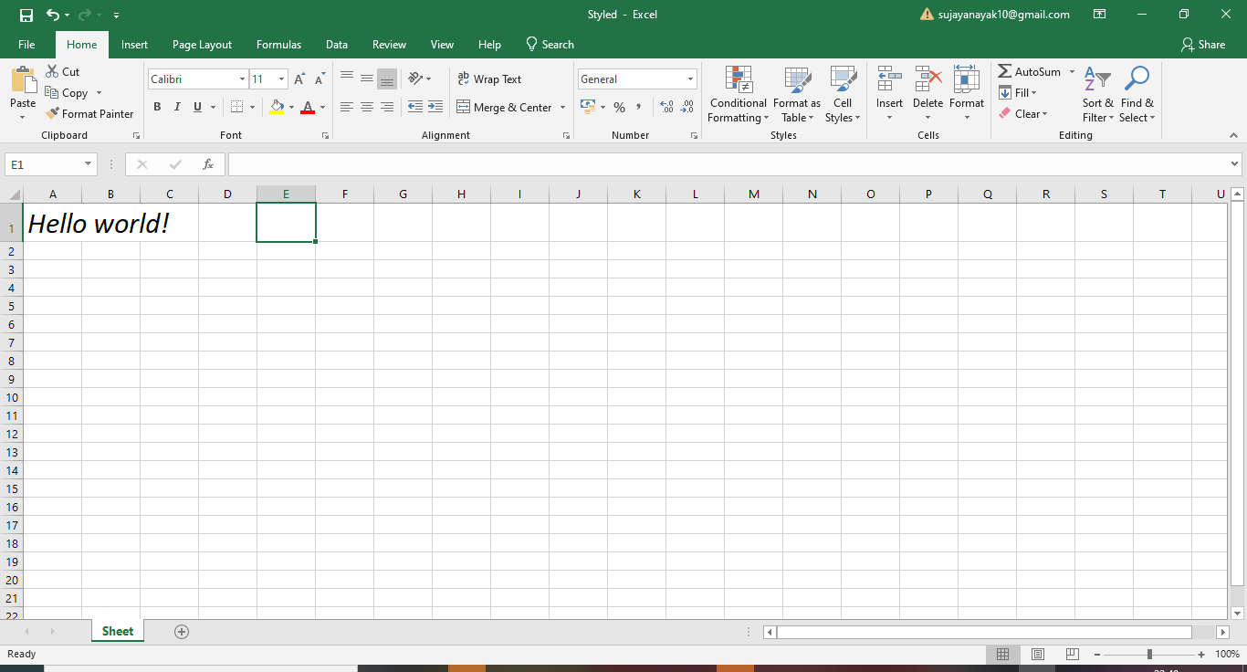

Formulas

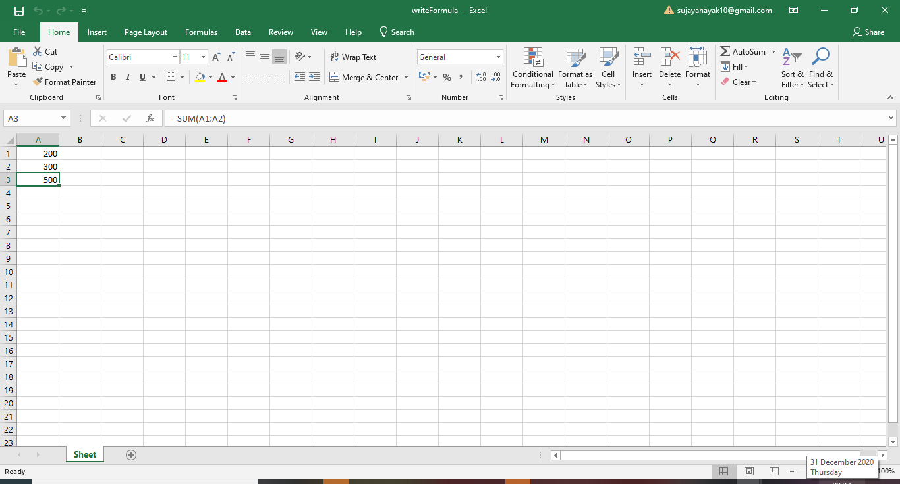

Adjusting Rows and Columns

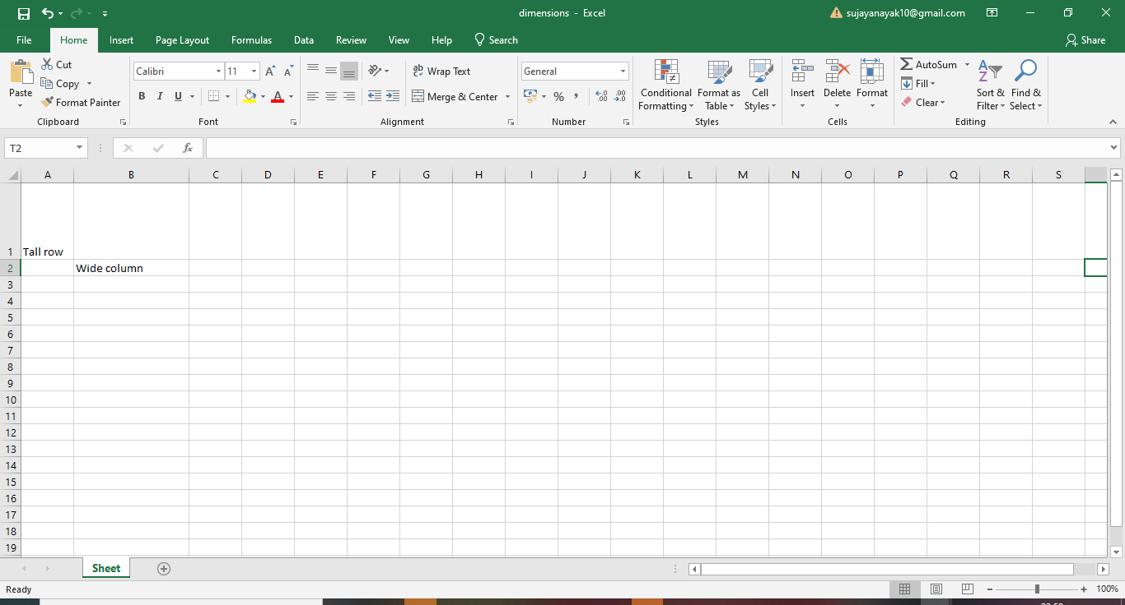

Charts:

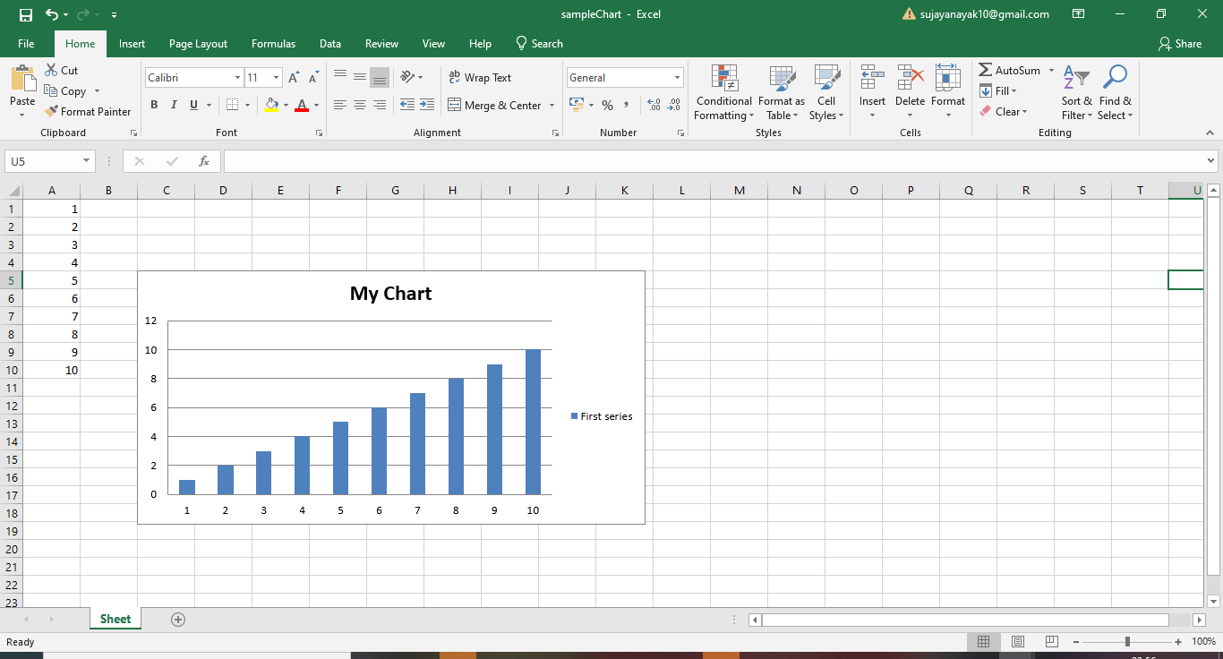

Font Object:

