

<body>

<h1 align="center">RESUME</h1>

<b> Abc Pqr</b><br>

55,SDF ll,<br>

SEEPZ,Andheri(E),<br>

Mumbai-400096<br>

Mobile: 8237510544<br>

<b>email_Id:</b>

abc@gmail.com<br>

<br>

<hr>

<h2>Educational Qualification</h2>

<table HEIGHT="100" WIDTH="600">

<tr align="LEFT">

<th> Qualification</th>

<th> Institute</th>

<th> University/Board</th>

<th> Marks(%)</th>

<th> Year of passing</th>

</tr>

</tr align="LEFT">

<td>BE(CS)</td>

<td>VJTI</td>

<td>Mumbai University</td>

<td>89%</td>

<td>2003</td>

</tr>

<tr>

<td>HSC</td>

<td>Cambridge</td>

<td>ICSC</td>

<td>97%</td>

<td>1999</td>

</tr>

<tr>

<td>HSC</td>

<td>Cambridge</td>

<td>ICSC</td>

<td>97%</td>

<td>1999</td>

</tr>

<tr>

<td>HSC</td>

<td>Cambridge</td>

<td>ICSC</td>

<td>97%</td>

<td>1999</td>

</tr>

</table>

<br>

<h2>Skill set:</h2><br>

<table>

<tr>

<th align="left"><b> Operating System:</b></th>

<td align="left">Windows 9'x,DOS</td>

</tr>

<tr>

<th align="left"><b> Language:</b></th>

<td align="left">C/C++</td>

</tr>

<tr>

<th align="left"><b> Front End:</b></th>

<td align="left">VB 6.0</td>

</tr>

<tr>

<th align="left"><b> DBMS:</b></th>

<td align="left">Oracle 9i</td>

</tr>

</table>

</body>





<html>

<head>

<body>

<ol>

<li>language</li>

<ol type ="i">

<li>English</li>

<ol type"A">

<li>Prose</li>

<li>Poetry</li>

</ol>

<li>Hindi</li>

<ol type"A">

<li>Prose</li>

<li>Poetry</li>

</ol>

<li>Marathi</li>

<ol type"A">

<li>Prose</li>

<li>Poetry</li>

</ol>

</ol>

<li>Social Study</li>

<ol type "i">

<li>History</li>

<li>Geography</li>

</ol>

<li>Science</li>

<ol type "i">

<li>Physics</li>

<ol type "A">

<li>Part1</li>

<li>Part2</li>

</ol>

<li>Chemistry</li>

<ol type "A">

<li>Organic</li>

<li>Inorganic</li>

</ol>

<li>Biology</li>

<ol type "A">

<li>Botany</li>

<li>Zoology/li>

</ol>

</ol>

<li>Maths

<ol type "i">

<li>Algebra</li>

<li>Geometry</li>

</ol>

</li>

</ol>

</body>

</head>

</html>

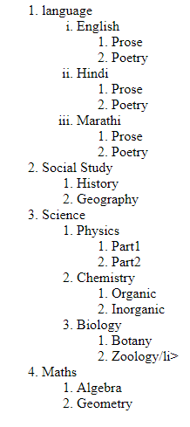

<html>

<body>

<h1>List of Java Books</h1>

<table border="Z" height="50px" width="400px">

<tr align="center">

<th>Book Title</th>

<th>Author</th>

<th>Book Price</th>

</tr>

<tr align="left">

<td><a href="https://www.amazon.in/Core-Java-I-Fundamentals-Cay-Horstmann/dp/0135166306"><u>Core Java</u></a></td>

<td>Cay Horsman</td>

<td>400</td>

</tr>

<tr align="left">

<td><a href="https://www.amazon.in/Ivor-Horton%E2%80%B2s-Beginning-Java-Programmer/dp/0470404140"><u>Beginning Java</u></a></td>

<td>Ivar Hortan</td>

<td>600</td>

</tr>

<tr align="left">

<td><a href="#"><u>Learning Java</u></a></td>

<td>Kishori Shahane</td>

<td>400</td>

</tr>

<tr align="left">

<td><a href="#"><u>Java Cookbook</u></a></td>

<td>John Keller</td>

<td>800</td>

</tr>

</table>

</body>

</html>

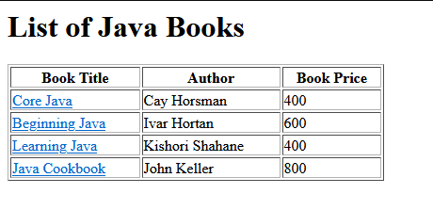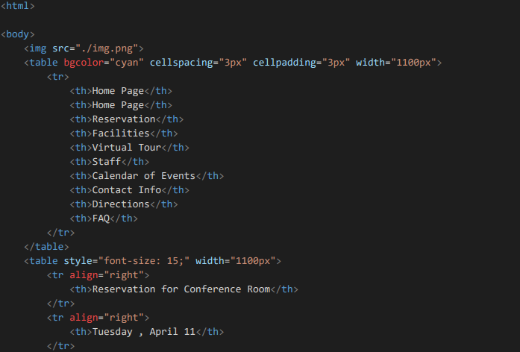

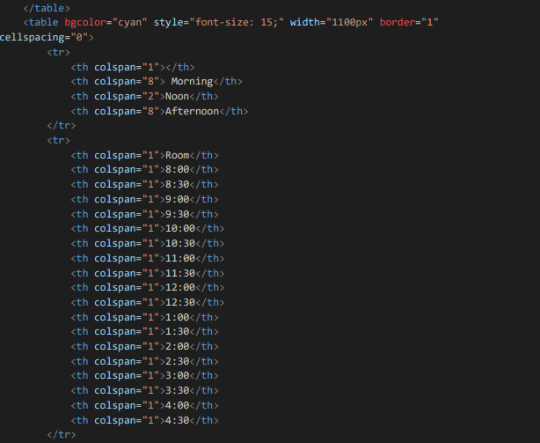

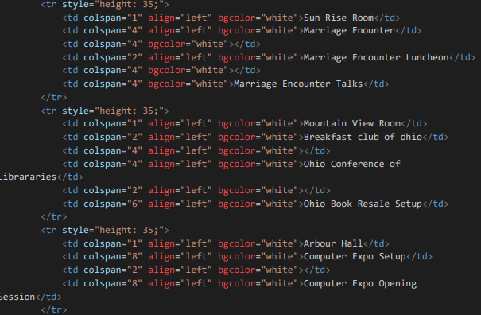

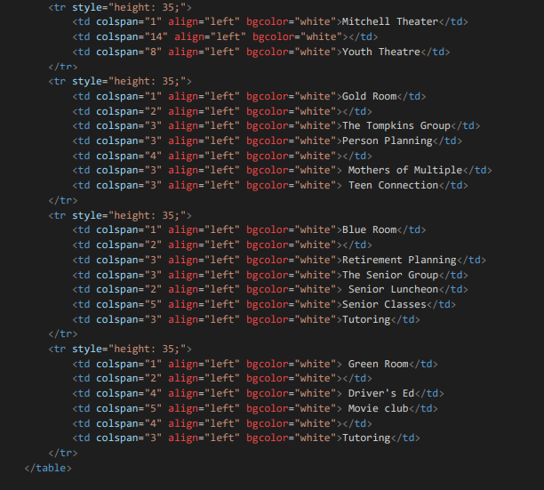

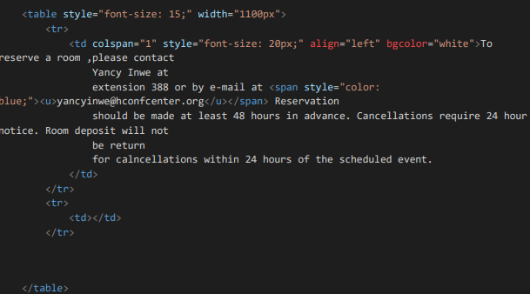

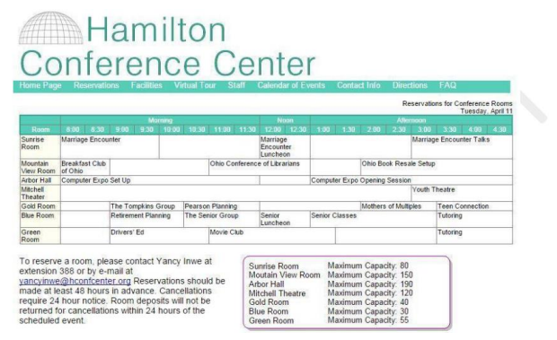



<html>

<body style="border-color:black; border:3px solid;">

<h1>Stratovolcanoes</h1>

<p>A stratovolcano, also known as a composite volcano, is a conical volcano built up by

many layers (strata) of hardened lava and tephra.[1] Unlike shield volcanoes,

stratovolcanoes are characterized by a steep profile with a summit crater and

periodic intervals of explosive eruptions and effusive eruptions, although some

have collapsed summit craters called calderas. </p>

<img src="./800px-Mayon_0052.jpg" width="300" height="150" style="float:left;border-color:red;" border="2px"

hspace="15px" vspace="10px">

<p>lava flowing from stratovolcanoes typically cools and hardens before spreading far,

due to high viscosity.The magma forming this lava is often felsic,

having high-to-intermediate levels of silica (as in rhyolite, dacite, or andesite),

with lesser amounts of less-viscous mafic magma.

[2] Extensive felsic lava flows are uncommon,

but have travelled as far as 15 km (9 mi).[3]</p>

<img src="Rainier20200906.jpg" width="300" height="150" style="float:right;border-color:red;" border="2px"

hspace="10px" vspace="0px">

<p>Stratovolcanoes are sometimes called composite volcanoes because of their composite

stratified structure, built up from sequential outpourings of erupted materials.

They are among the most common types of volcanoes, in contrast to the less common

shield volcanoes.[4] Two famous examples of stratovolcanoes are Krakatoa in Indonesia,

known for its catastrophic eruption in 1883, and Vesuvius in Italy, whose catastrophic

eruption in AD 79 buried the Roman cities of Pompeii and Herculaneum.

Both eruptions claimed thousands of lives. In modern times, Mount St.

Helens in Washington State, USA and Mount Pinatubo in the Philippines have

erupted catastrophically, but with fewer deaths.

</p>

<p> These internal triggers may be modified by external triggers such as sector collapse,

earthquakes, or interactions with groundwater.These internal triggers may be modified

by external triggers such as sector collapse, earthquakes, or interactions with

groundwater. Some of these triggers operate only under limited conditions.

For example, sector collapse (where part of the flank of a volcano collapses in

a massive landslide) can trigger eruption only of a very shallow magma chamber.

Magma differentiation and thermal expansion also are ineffective as triggers

for eruptions from deep magma chambers.[14]

</p>

<p>

Whatever the precise mechanism, the pressure in the magma chamber increases

to a critical point where the roof of the magma chamber fractures, and the

contents of the magma chamber are provided with a path to the surface

through which to erupt.[citation needed]

</p>

<p>In recorded history, explosive eruptions at subduction zone (convergent-boundary)

volcanoes have posed the greatest hazard to civilizations.[15] Subduction-zone

stratovolcanoes, such as Mount St. Helens, Mount Etna and Mount Pinatubo, typicall

y erupt with explosive force: the magma is too stiff to allow easy escape of v

olcanic gases. As a consequence, the tremendous internal pressures of the

trapped volcanic gases remain and intermingle in the pasty magma.

Following the breaching of the vent and the opening of the crater,

the magma degasses explosively. The magma and gases blast out

with high speed and full force.[15]

Since 1600 CE, nearly 300,000 people have been killed by volcanic eruptions.

[15] Most deaths were caused by pyroclastic flows and lahars, deadly hazards

that often accompany explosive eruptions of subduction-zone stratovolcanoes.

Pyroclastic flows are swift, avalanche-like, ground-sweeping, incandescent

mixtures of hot volcanic debris, fine ash, fragmented lava, and superheated

gases that can travel at speeds over 160 km/h (100 mph). Around 30,000 people

were killed by pyroclastic flows during the 1902 eruption of Mount Pelée

on the island of Martinique in the Caribbean.[15] In March to April 1982,

three explosive eruptions of El Chichón in the State of Chiapas in

southeastern Mexico, caused

the worst volcanic disaster in that country's history. Villages within 8 km

(5 mi) of the volcano were destroyed by pyroclastic flows, killing more than

2,000 people.[15]</p>

</body>

</html>

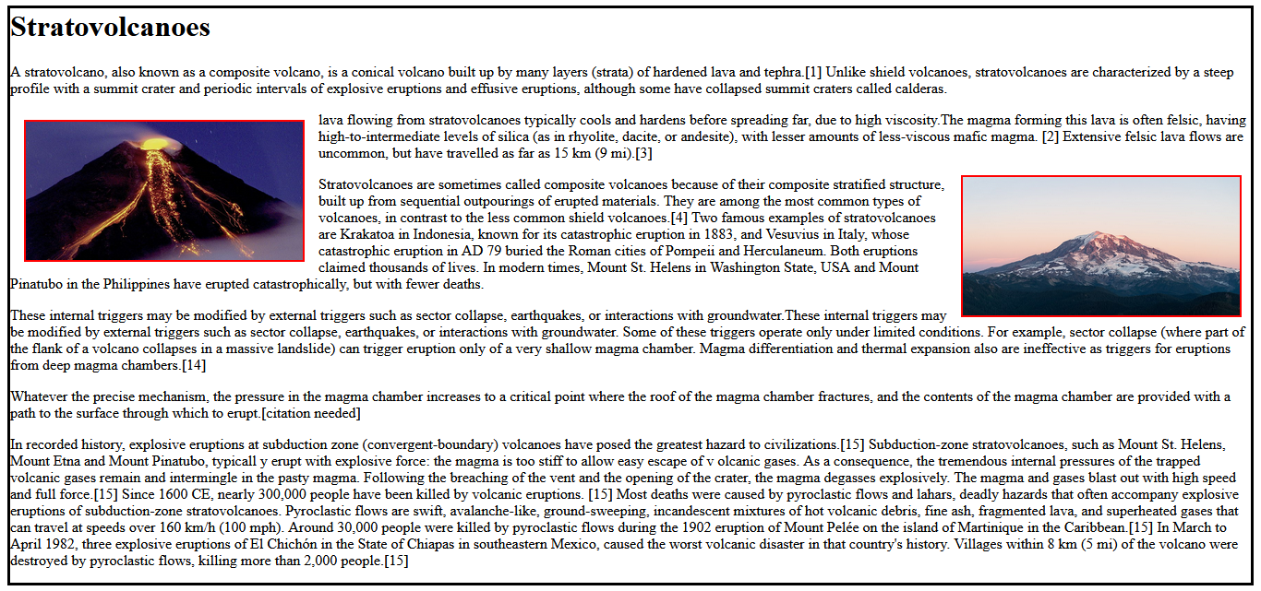

<html>

<table border="z" height="50px" width="00px" bgcolor="pink">

<form method="get">

<tr>

<th align="left" width="300px">Name</th>

<td><input type="text" name="uname" id="uname"</td>

</tr>

<tr>

<th align="left">Employee code</th>

<td><input type="text" name="empcode" id="empcode"</td>

</tr>

<tr>

<th align="left">Department</th>

<td>

<input type="radio" name="department" id="admin" checked>Admin<br>

<input type="radio" name="department" id="hr" checked>HR<br>

<input type="radio" name="department" id="TECHNICAL" checked>TECHNICAL<br>

<input type="radio" name="department" id="ACCOUNTS" checked>ACCOUNTS<br>

</td>

</tr>

<tr>

<th align="left">Date of joining</th>

<td><input type="date" name="dt" id="dt"></td>

</tr>

<tr>

<th align="left">Address</th>

<td>

<textarea rows="5" cols="40" name="addr" id="addr"></textarea>

</td>

</tr>

<tr>

<th align="left">Training programs Attended</th>

<td>

<input type="checkbox" name="training" id="html">HTML/DHTML <br>

<input type="checkbox" name="training" id="Java">JAVA <br>

<input type="checkbox" name="training" id="html">CLIENT/SERVER <br>

<input type="checkbox" name="training" id="html">.NET <br>

</td>

</tr>

<tr>

<th align="left">Training programmes need to attend</th>

<td>

<select id="prog" name="prog" size="2">

<option>--Select One--</option>

<option value="JAVASCRIPT">JAVASCRIPT</option>

<option value="JSTRUTS">JSTRUTS</option>

</select>

</td>

</tr>

<tr>

<th align="left">Send the information</th>

<td><span style="color: blue;"><u>abc@gmail.com</u></span>

</td>

</tr>

</form>

</table>

</html>

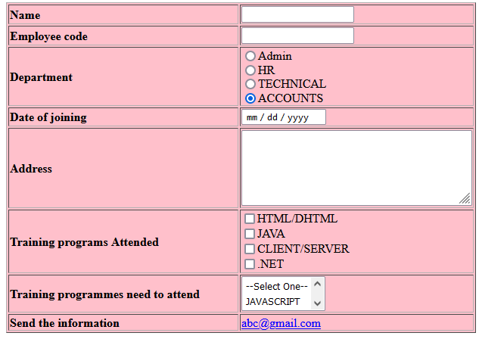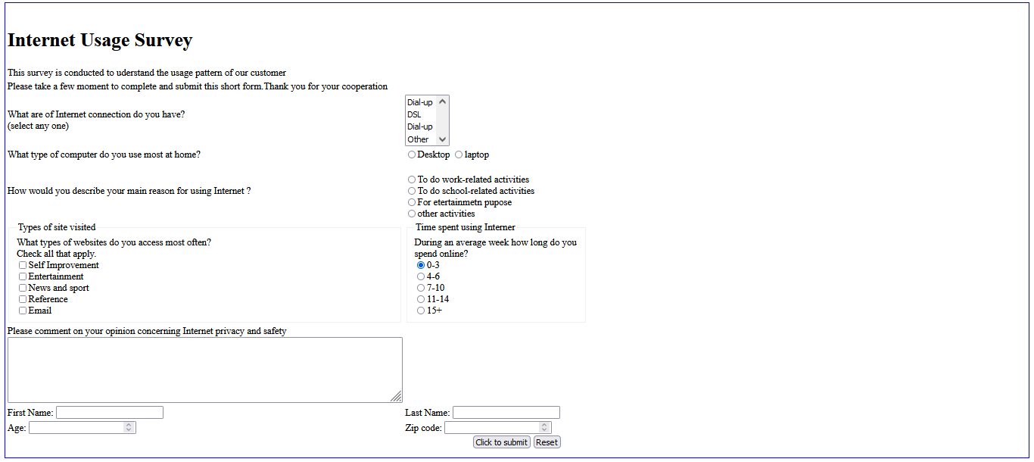<html>

<body style="border-color:blue;border: 2px solid;border-color: blue;">

<form style="border: 1cm;">

<table>

<tr><td><h1>Internet Usage Survey</h1></td></tr>

<tr><td colspan="2">This survey is conducted to uderstand the usage pattern of our customer</td></tr>

<tr><td colspan="2">Please take a few moment to complete and submit this short form.Thank you for your cooperation</td></tr>

<tr>

<td align="left" width="450">What are of Internet connection do you have?<br>(select any one)</td>

<td width="300">

<select id="conne" name="conne" size="4">

<option value="Dial-up">Dial-up</option>

<option value="DSL">DSL</option>

<option value="High speed Cable">Dial-up</option>

<option value="Other">Other</option>

</select>

</td>

</tr>

<tr>

<td>What type of computer do you use most at home?</td>

<td>

<input type="radio" name="deks" id="desk">Desktop

<input type="radio" name="deks" id="lapt">laptop<br>

</td>

</tr>

<tr>

<td>How would you describe your main reason for using Internet

?</td>

<td><br>

<input type="radio" name="work" id="work">To do work-related activities<br>

<input type="radio" name="work" id="school">To do school-related activities<br>

<input type="radio" name="work" id="entertainment">For etertainmetn pupose<br>

<input type="radio" name="work" id="other">other activities<br>

</td>

</tr>

<tr>

<td style="height: 150;">

<fieldset>

<legend>Types of site visited</legend>

What types of websites do you access most often?<br>

Check all that apply.<br>

<input type="checkbox" name="self" id="self">Self Improvement<br>

<input type="checkbox" name="enter" id="enter">Entertainment<br>

<input type="checkbox" name="enter" id="enter">News and sport<br>

<input type="checkbox" name="enter" id="enter">Reference<br>

<input type="checkbox" name="enter" id="enter">Email<br>

</fieldset>

</td>

<td style="height: 150;">

<fieldset>

<legend>Time spent using Interner</legend>

During an average week how long do you spend online?<br>

<input type="radio" name="option" id="0-3" checked>0-3<br>

<input type="radio" name="option" id="4-6">4-6<br>

<input type="radio" name="option" id="7-10">7-10<br>

<input type="radio" name="option" id="11-14">11-14<br>

<input type="radio" name="option" id="15+">15+<br>

</fieldset>

</td>

</tr>

<tr>

<td>Please comment on your opinion concerning Internet privacy and safety <br>

<textarea rows="5" cols="100" name="opinion" id="opinion"></textarea>

</td>

</tr>

<tr>

<br>

<td>

First Name:

<input type="text" name="name" id="name">

</td>

<td>

Last Name:

<input type="text" name="lname" id="name">

</td>

</tr>

<tr>

<br>

<td>

Age:

<input type="number" name="age" id="age">

</td>

<td>

Zip code:

<input type="number" name="zip" id="zip">

</td>

</tr>

</table>

<div align="center">

<td>

<button type="button" name="submit" id="sub">Click to submit</button>

<button type="reset" name="reset" id="res">Reset</button>

</td>

</div>

</form>

</body>

</html>

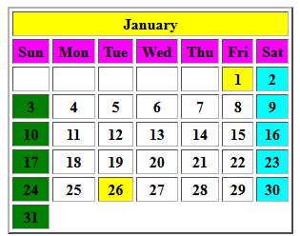

<html>

<table border="2" height: "300"; width="300" cellspacing=3px cellpadding="3px">

<tr>

<th colspan="7" bgcolor="yellow"><b>January</b></th>

</tr>

<tr bgcolor="magenta">

<th >Sun</th>

<th>Mon</th>

<th>Tue</th>

<th>Wed</th>

<th>Thu</th>

<th>Fri</th>

<th>Sat</th>

</tr>

<tr>

<th ></th>

<th></th>

<th></th>

<th></th>

<th></th>

<th bgcolor="yellow">1</th>

<th bgcolor="cyan">2</th>

</tr>

<tr>

<th bgcolor="green">3</th>

<th>4</th>

<th>5</th>

<th>6</th>

<th>7</th>

<th>8</th>

<th bgcolor="cyan">9</th>

</tr>

<tr>

<th bgcolor="green">10</th>

<th>11</th>

<th>12</th>

<th>13</th>

<th>14</th>

<th>15</th>

<th bgcolor="cyan">16</th>

</tr>

<tr>

<th bgcolor="green">17</th>

<th>18</th>

<th>19</th>

<th>20</th>

<th>21</th>

<th>22</th>

<th bgcolor="cyan">23</th>

</tr>

<tr>

<th bgcolor="green">24</th>

<th>25</th>

<th bgcolor="yellow">26</th>

<th>27</th>

<th>28</th>

<th>29</th>

<th bgcolor="cyan">30</th>

</tr>

<tr>

<th bgcolor="green">31</th>

</tr>

</table>

</html>

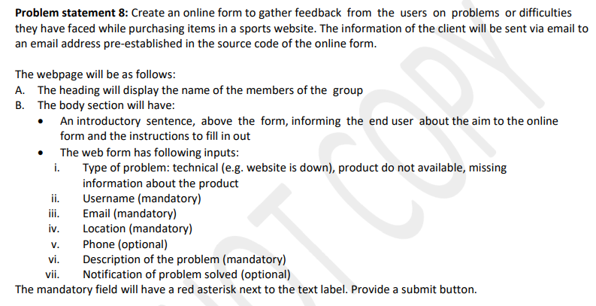

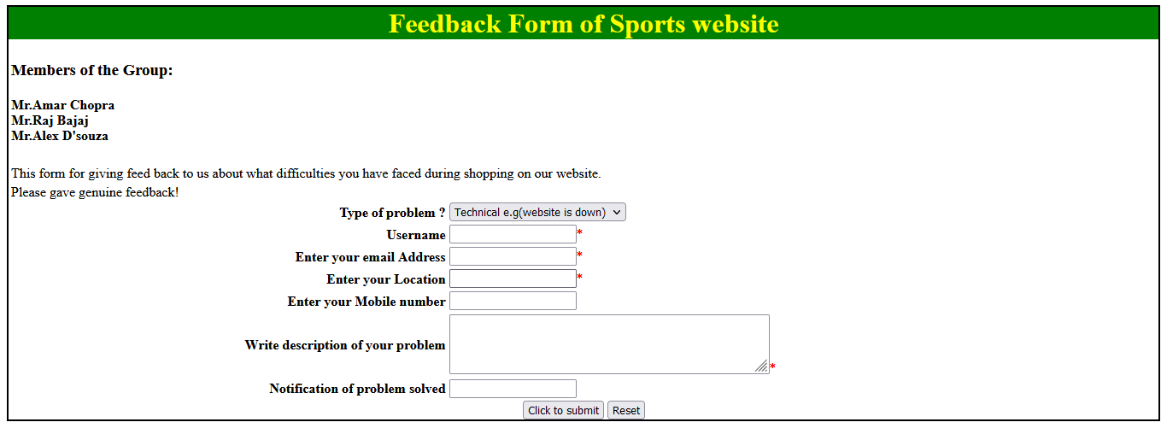

<html>

<body>

<head>

<h1 style="color: yellow; background-color: green; text-align: center;">Feedback Form of Sports website</h1>

</head>

<body style="border-color: brown;border:2px solid;">

<table width="100%">

<form>

<tr>

<td>

<h3 colspan="2">Members of the Group:</h3>

<h4>Mr.Amar Chopra<br>

Mr.Raj Bajaj<br>

Mr.Alex D'souza<br></h4>

</td>

</tr>

<tr>

<td colspan="2">This form for giving feed back to us about what difficulties you have faced during

shopping on our website.</td>

</tr>

<tr>

<td colspan="2">Please gave genuine feedback! </td>

</tr>

<tr>

<th align="right">Type of problem ?</th>

<td align="left">

<select id="prob" name="prob">

<option value="Tech">Technical e.g(website is down)</option>

<option value="Prod">Product not available</option>

<option value="info">Missing information of product</option>

</select>

</td>

</tr>

<tr>

<th align="right">Username </th>

<td>

<input type="text" name="username" id="uname" required><span style="color: red;">*</span>

</td>

</tr>

<tr>

<th align="right">Enter your email Address</th>

<td>

<input type="text" name="email" id="id"><span style="color: red;">*</span>

</td>

</tr>

<tr>

<th align="right">Enter your Location</th>

<td>

<input type="text" nasme="Location" id="Location"><span style="color: red;">*</span>

</td>

</tr>

<tr>

<th align="right">Enter your Mobile number</th>

<td>

<input type="text" name="Mobile" id="Mobile" maxlength="10">

</td>

</tr>

<tr>

<th align="right">Write description of your problem</th>

<td>

<textarea name="desc" id="desc" rows="3" cols="50"> </textarea><span

style="color: red;">*</span>

</td>

</tr>

<tr>

<th align="right">Notification of problem solved</th>

<td>

<input type="text" name="not" id="not">

</td>

</tr>

</form>

</table>

<div>

<div align="center">

<td>

<button type="submit" name="submit" id="sub">Click to submit</button>

<button type="reset" name="reset" id="res">Reset</button>

</td>

</div>

</body>

</html>

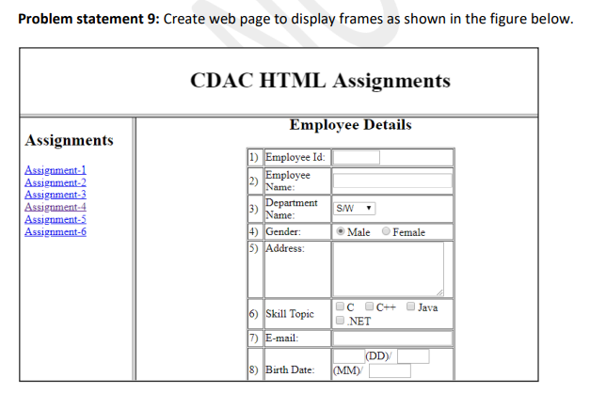<!DOCTYPE html>

<html lang="en">

<head>

<meta charset="UTF-8">

<meta http-equiv="X-UA-Compatible" content="IE=edge">

<meta name="viewport" content="width=device-width, initial-scale=1.0">

<title>Document</title>

</head>

<body>

<iframe src="q9_frm1.html" frameborder="10" width="100%" height="30%"></iframe>

<iframe src="q9_frm2.html" frameborder="10" width="25%" height="620px"></iframe>

<iframe src="" name="right_box" frameborder="10" width="73%" height="620px">Employee Details</iframe>

</body>

</html>

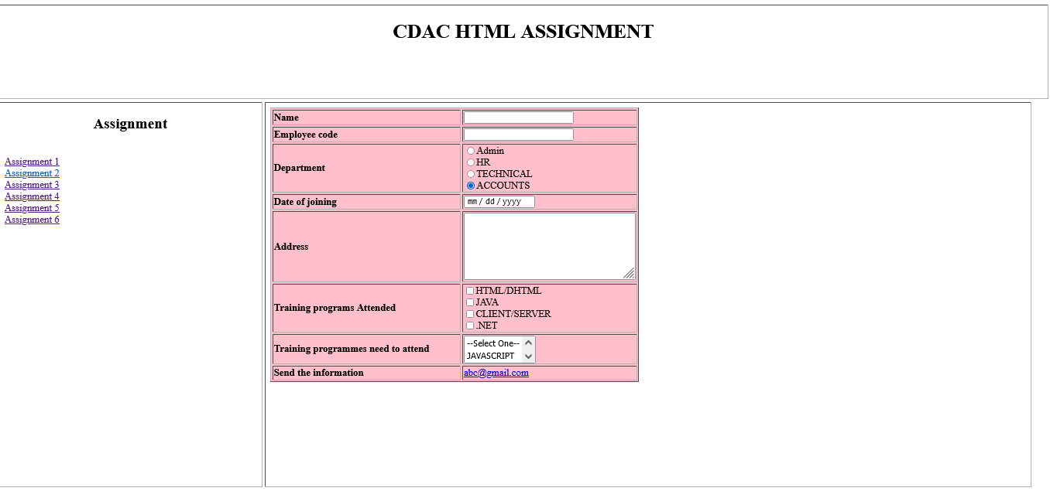

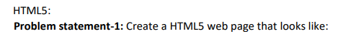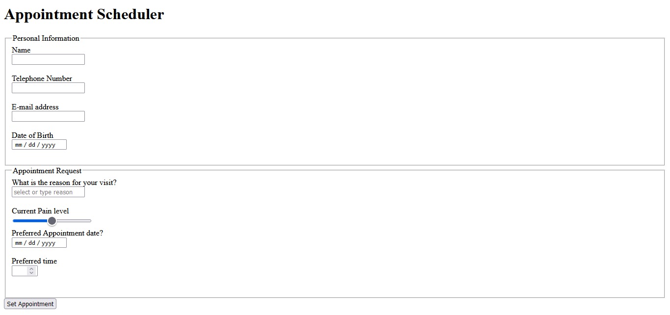<!DOCTYPE html>

<html lang="en">

<head>

<meta charset="UTF-8">

<meta http-equiv="X-UA-Compatible" content="IE=edge">

<meta name="viewport" content="width=device-width, initial-scale=1.0">

<title>Document</title>

</head>

<body>

<h1>Appointment Scheduler</h1>

<fieldset style="width: 500; height: 250px;">

<legend>Personal Information</legend>

<table>

<tr>

<label for="name">Name</label><br>

<input type="text" name="name" id="name"><br><br>

<label for="tele">Telephone Number</label><br>

<input type="text" name="tele" id="tele" maxlength="10"><br><br>

<label for="email">E-mail address</label><br>

<input type="email" name="email" id="email"><br><br>

<label for="birth">Date of Birth</label><br>

<input type="date" name="birth" id="birth">

</tr>

</table>

</fieldset>

<fieldset style="width: 500; height: 250px;">

<legend>Appointment Request</legend>

<tr>

<label for="reason">What is the reason for your visit?</label><br>

<input type="text" name="reason" id="reason" placeholder="select or type reason"><br><br>

Current Pain level<br>

<input type="range"><br>

<label for="apdt">Preferred Appointment date?</label><br>

<input type="date" name="apdt" id="apdt"><br><br>

<label for="apt">Preferred time</label><br>

<input type="number" max="24" size="4">

</tr>

</fieldset>

<button type="submit" name="submit" id="submit">Set Appointment</button>

</body>

</html>



<html>

<!DOCTYPE html>

<html lang="en">

<head>

<meta charset="UTF-8">

<meta http-equiv="X-UA-Compatible" content="IE=edge">

<meta name="viewport" content="width=device-width, initial-scale=1.0">

<title>Document</title>

<style>

.b1 {

text-align: right;

}

.b {

float: left;

}

body {

background-color: rgb(14, 119, 168);

}

fieldset {

border: 2px solid white;

background-color: rgb(14, 119, 168);

}

</style>

</head>

<body>

<fieldset style="width: 500px; height: 280px;">

<legend>Registration Details</legend>

<table align="center">

<tr>

<td class="b1">

<label for="name">University: </label>

</td>

<td class="b">

<input type="text" name="name" id="name">

</td>

</tr>

<tr style="height: 10;"></tr>

<tr>

<td class="b1">

<label for="name">Institute: </label>

</td>

<td class="b">

<input type="text" name="name" id="name">

</td>

</tr>

<tr style="height: 10;"></tr>

<tr>

<td class="b1">

<label for="name">Branch: </label>

</td>

<td class="b"><select name="branch" id="branch">

<option value="select">select</option>

<option value="Mech">Mechanical</option>

<option value="Civil">Civil</option>

<option value="IT">IT</option>

<option value="Electrical">Electrical</option>

<option value="ET">ET</option>

</select><br>

</td>

</tr>

<tr style="height: 10;"></tr>

<tr>

<td class="b1">

<label for="degree">Degree: </label>

</td>

<td class="b">

<select name="degree" id="degree">

<option value="grad">Graduation</option>

<option value="PG">Post-Graduation</option>

<option value="Diploma">Diploma</option>

<option value="Phd">PHD</option>

</select>

<input type="radio" name="option" id="degree">

<label for="degree1">Persuing</label>

<input type="radio" name="option" id="Degree2">

<label for="Degree2">Comleted</label>

</td>

</tr>

<tr style="height: 10;"></tr>

<tr>

<td class="b1">

<label for="cgpi">Average CGPI: </label>

</td>

<td class="b">

<input type="number" name="cgpi" id="cgpi" size="5" min="5" max="10">

<label for="sem">Upto</label>

<input type="number" name="sem" id="sem" size="5" min="1" max="8"> Th semester

</td>

</tr>

<tr style="height: 10;"></tr>

<tr>

<td class="b1">

<label for="exp">Experence: </label>

</td>

<td class="b">

<select name="exp" id="exp">

<option value=""></option>

<option value="0">0</option>

<option value="1">1</option>

<option value="2">2</option>

<option value="3">3</option>

</select>

</td>

</tr>

<tr style="height: 10;"></tr>

<tr>

<td class="b1">

<label for="web">Your Website or Blog: </label>

</td>

<td class="b">

<input type="text" name="web" id="web">

</td>

</tr>

</table>

</fieldset>

<div>

<button class="btn">

<a href="./first.html">

<svg xmlns="http://www.w3.org/2000/svg" width="16" height="16" fill="currentColor"

class="bi bi-arrow-left-circle-fill" viewBox="0 0 16 16">

<path

d="M8 0a8 8 0 1 0 0 16A8 8 0 0 0 8 0zm3.5 7.5a.5.5 0 0 1 0 1H5.707l2.147 2.146a.5.5 0 0 1-.708.708l-3-3a.5.5 0 0 1 0-.708l3-3a.5.5 0 1 1 .708.708L5.707 7.5H11.5z" />

</svg></a>

</button>

<button class="btn">

<a href="./nine.html">

<svg xmlns="http://www.w3.org/2000/svg" width="16" height="16" fill="currentColor"

class="bi bi-arrow-right-circle-fill" viewBox="0 0 16 16">

<path

d="M8 0a8 8 0 1 1 0 16A8 8 0 0 1 8 0zM4.5 7.5a.5.5 0 0 0 0 1h5.793l-2.147 2.146a.5.5 0 0 0 .708.708l3-3a.5.5 0 0 0 0-.708l-3-3a.5.5 0 1 0-.708.708L10.293 7.5H4.5z" />

</svg></a>

</button>

</div>

</body>

</html>

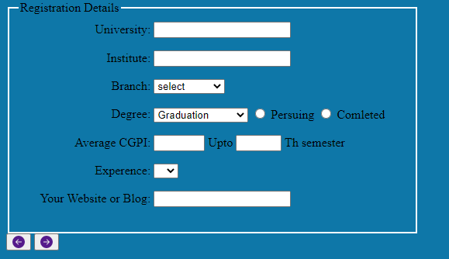

<!DOCTYPE html>

<html lang="en">

<head>

<meta charset="UTF-8">

<meta http-equiv="X-UA-Compatible" content="IE=edge">

<meta name="viewport" content="width=device-width, initial-scale=1.0">

<title>Document</title>

<style>

input{

color: white;

}

</style>

</head>

<body bgcolor ="black">

<fieldset style="width: 500px; height: 300px ; border-radius: 30px; border-width: 2mm; border-color: blue;">

<legend style="background-color: blue; color: antiquewhite; border-radius: 4px;">Name and address</legend>

<table>

<tr style="color:antiquewhite;">

<th align="right" style="width: 50%;"><label for="ssn">SSN: </label></th>

<td><input type="text" id="ssn" style="background-color: black;"></td>

</tr>

<tr style="color:antiquewhite;">

<th align="right" style="width: 50%;"><label for="fll">Full Name: </label></th>

<td><input type="text" id="fll" style="background-color: black;"></td>

</tr>

<tr style="color:antiquewhite;">

<th align="right" style="width: 50%;"><label for="sn">Street and Number: </label></th>

<td><input type="text" id="sn" style="background-color: black;"></td>

</tr>

<tr style="color:antiquewhite;">

<th align="right" style="width: 50%;"><label for="postal">Postal Code: </label></th>

<td><input type="text" id="postal" style="background-color: black;"></td>

</tr>

<tr style="color:antiquewhite;">

<th align="right" style="width: 50%;"><label for="city">City: </label></th>

<td><input type="text" id="city" style="background-color: black;"></td>

</tr>

</table>

</fieldset><br>

<fieldset style="width: 200px; height: 100px ; border-radius: 30px; border-width: 2mm; border-color: blue;">

<legend style="background-color: blue; color: antiquewhite; border-radius: 4px;">Username and Password</legend>

<table>

<tr style="color:antiquewhite;">

<th align="right" style="width: 50%;"><label for="username">Username: </label></th>

<td><input type="text" id="username" style="background-color: black;"></td>

</tr>

<tr style="color:antiquewhite;">

<th align="right" style="width: 50%;"><label for="Password">Password: </label></th>

<td><input type="text" id="Password" value="mypwd" style="background-color: black;"></td>

</tr>

<tr>

</tr>

</table>

</fieldset>

</body>

</html>

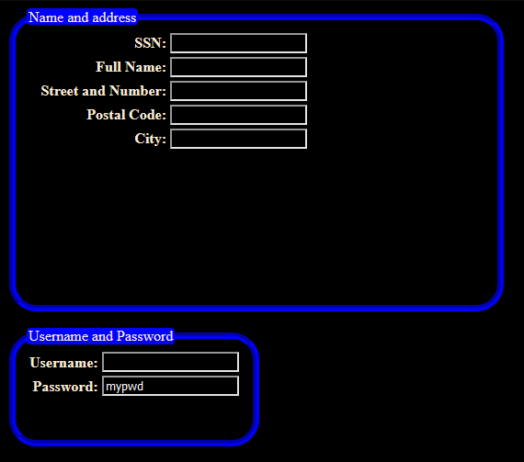



<!DOCTYPE html>

<html lang="en">

<head>

<meta charset="UTF-8">

<meta http-equiv="X-UA-Compatible" content="IE=edge">

<meta name="viewport" content="width=device-width, initial-scale=1.0">

<title>Document</title>

</head>

<body>

<script>

function maxnum() {

var num1=parseInt(prompt("Enter the first number: "));

var num2=parseInt(prompt("Enter the second num2"));

var num3=parseInt(prompt("Enter the third number"));

var max;

if((num1>= num2) && (num1>=num3)){

max=num1;

}else if ((num2>= num1) && (num2>=num3)){

max=num2;

}

else max=num3;

alert("maximum number is "+ max);

}

</script>

<button type="button" name="btn" id="btn" onclick="maxnum()">Find maximum number</button>

</body>

</html>

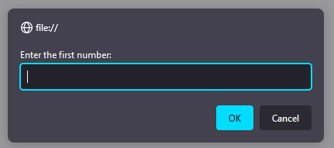

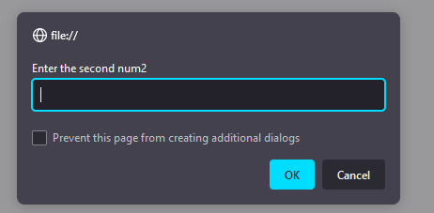

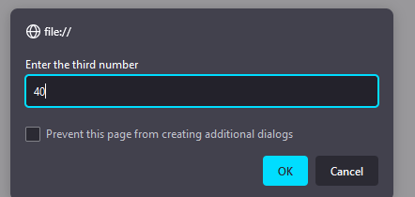

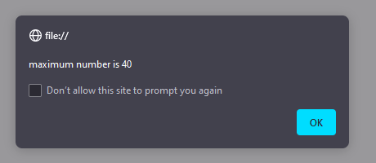



<!DOCTYPE html>

<html lang="en">

<head>

<meta charset="UTF-8">

<meta http-equiv="X-UA-Compatible" content="IE=edge">

<meta name="viewport" content="width=device-width, initial-scale=1.0">

<title>Document</title>

<script>

function print() {

var n = parseInt(document.getElementById("num").value);

var m = document.getElementById("msg").value;

for (let index = 0; index < n; index++) {

document.getElementById("mydiv").innerHTML += m + "<br>";

}

}

</script>

</head>

<body>

<label for="msg">Enter the Messege to print</label>

<input type="text" name="msg" id="msg" required><br><br>

<label for="num">Enter the how many times you want to print</label>

<input type="number" name="num" id="num" required><br>

<button type="submit" name="sbmt" id="sbmt" onclick="print()">

<h3>Print</h3>

</button>

</body>

<div id="mydiv"></div>

</html>

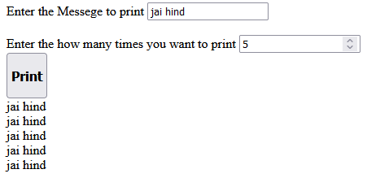



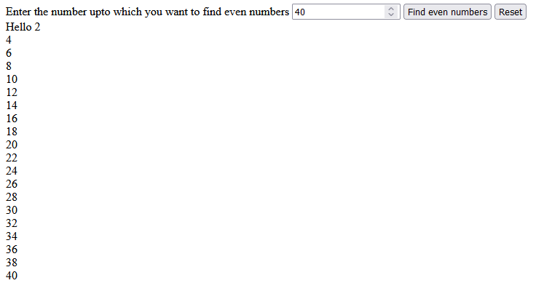

<!DOCTYPE html>

<html lang="en">

<head>

<meta charset="UTF-8">

<meta http-equiv="X-UA-Compatible" content="IE=edge">

<meta name="viewport" content="width=device-width, initial-scale=1.0">

<title>Document</title>

<script>

function evenno() {

var n = parseInt(document.getElementById("num").value);

for (let index = 1; index <= n; index++) {

if (index % 2 == 0) {

document.getElementById("mydiv").innerHTML += index + "<br>"

}

}

}

function res(){

document.getElementById("mydiv").innerHTML =" ";

}

</script>

</head>

<body>

<FORM >

<label for="num">Enter the number upto which you want to find even numbers</label>

<input type="number" id="num" name="num">

<!-- <input type="submit" value="Submit" onclick="evenno()"/> -->

<button type="button" name="btn" id="btn" onclick="evenno()">Find even numbers</button>

<!-- button type="submit sends data to server and reset all components

type="button" dont reset

" -->

<button type="reset" name="rst" id="rst" value="cancel" onclick="res()">Reset</button>

<div id="mydiv">Hello </div>

</FORM>

</body>

</html>

**Q4 - Write a function that accepts two numbers and a operator like (+,-,*, /) from user and performs the appropriate operation indicated by the operator.**

<!DOCTYPE html>

<html lang="en">

<head>

<meta charset="UTF-8">

<meta http-equiv="X-UA-Compatible" content="IE=edge">

<meta name="viewport" content="width=device-width, initial-scale=1.0">

<title>Document</title>

<script>

function operation() {

n1 = parseInt(document.getElementById("n1").value);

n2 = parseInt(document.getElementById("n2").value);

o1 = document.getElementById("op1").value;

switch (o1) {

case '+':

document.getElementById("d").innerHTML = "Sum of number is : " + (n1 + n2);

break;

case '-':

document.getElementById("d").innerHTML = "Subtraction of number is : " + (n1 - n2);

break;

case '*':

document.getElementById("d").innerHTML = "Multiplication of number is : " + (n1 * n2);

break;

case '/':

document.getElementById("d").innerHTML = "Division of number is : " + (n1 / n2);

break;

}

}

</script>

</head>

<body>

<p>Q4. Write a function that accepts two numbers and a operator like (+,-,*, /) from user and performs the

appropriate operation indicated by the operator</p>

<label for="n1">Enter number1 : </label>

<input type="number" name="n1" id="n1"><br><br>

<label for="n2">Enter number2 : </label>

<input type="number" name="n2" id="n2"><br><br>

<label for="op1">Enter operation: </label>

<input type="text" name="op1" id="op1"><br><br>

<button type="button" name="btn" id="btn" onclick="operation()"> Click to show Result</button>

<div id="d"></div>

</body>

</html>

**Q5 - Write a program to print the multiplication table of a given number up to 10 multiples. Eg for number 2, output should be like.**

<!DOCTYPE html>

<html lang="en">

<head>

<meta charset="UTF-8">

<meta http-equiv="X-UA-Compatible" content="IE=edge">

<meta name="viewport" content="width=device-width, initial-scale=1.0">

<title>Document</title>

<script>

function table() {

var n = parseInt(document.getElementById("num").value);

for (var i = 1; i <= 10; i++) {

sol = n * i;

document.getElementById("div").innerHTML += n + " * " + i + " = " + sol + "<br>";

}

}

</script>

</head>

<body>

<p>Q5. Write a program to print the multiplication table of a given number up to 10 multiples. Eg for number 2,

output should be like</p>

<label for="num">Enter number</label>

<input type="number" name="num" id="num">

<button type="button" name="btn" id="btn" onclick="table()">Print Table</button>

<div id="div"></div>

</body>

</html>

**Q6 - Write a program to find sum of digits of given five-digit number.**

<!DOCTYPE html>

<html lang="en">

<head>

<meta charset="UTF-8">

<meta http-equiv="X-UA-Compatible" content="IE=edge">

<meta name="viewport" content="width=device-width, initial-scale=1.0">

<title>Document</title>

<script>

function digitsum() {

var n = parseInt(document.getElementById("num").value);

var sum = 0;

while (n != 0) {

var r = parseInt(n % 10);

sum = sum + r;

n = parseInt(n / 10);

}

document.getElementById("digit").innerHTML = "Sum of Digit is : " + sum;

}

</script>

</head>

<body>

<p>Q6. Write a program to find sum of digits of given five-digit number.</p>

<label for="num">Enter number</label>

<input type="number" name="num" id="num">

<button type="button" name="btn" id="btn" onclick=digitsum()>Print sum</button><br><br>

<div id="digit"></div>

</body>

</html>

**Q7 - Write a program min() that takes any number of arguments and returns minimum number in the set of arguments. Do not use the Math predefined objet.**

<!DOCTYPE html>

<html lang="en">

<head>

<meta charset="UTF-8">

<meta http-equiv="X-UA-Compatible" content="IE=edge">

<meta name="viewport" content="width=device-width, initial-scale=1.0">

<title>Document</title>

<script>

function min(x, y, ...arr) {

var m = arguments[0];

for (var i = 0; i < arguments.length; i++) {

if (m > arguments[i]) {

m = arguments[i];

}

}

document.getElementById("minval").innerHTML = "Minimum :" + m;

}

</script>

</head>

<body>

<p>Q8. Write a program min() that takes any number of arguments and returns minimum number in the set of

arguments. Do not use the Math predefined objet</p>

<button type="button" name="btn" id="min" onclick=min(5,40,9,12)>find min</button>

<div id="minval"></div>

</body>

</html>

**Q8 - Write a function pow(x,y) that calculates xy . Do not use the Math predefined objet.**

<!DOCTYPE html>

<html lang="en">

<head>

<meta charset="UTF-8">

<meta http-equiv="X-UA-Compatible" content="IE=edge">

<meta name="viewport" content="width=device-width, initial-scale=1.0">

<title>Document</title>

<script>

function pow() {

var x = parseInt(document.getElementById("x").value);

var y = parseInt(document.getElementById("y").value);

var sum = 1;

for (var i = 0; i < y; i++) {

sum = sum * x;

}

document.getElementById("div").innerHTML = sum;

}

</script>

</head>

<body>

<p>Q8. Write a function pow(x,y) that calculates x^y. Do not use the Math predefined objet</p>

<label for="x">Enter base number : </label>

<input type="number" id="x"><br><br>

<label for="y">Enter power number :</label>

<input type="number" id="y"><br>

<button type="button" name="btn" id="pow" onclick=pow()>Cal power</button>

<div id="div"></div>

</body>

</html>

**Q9 Create a web page to calculate the Compound Interest using the formula given below: Compound Interest = Where: p = Principal, r = Rate of Interest, n = period in years The values used in the example in the following figure are as follows: P = 1000, n = 1, r = 10**

<!DOCTYPE html>

<html lang="en">

<head>

<meta charset="UTF-8">

<meta http-equiv="X-UA-Compatible" content="IE=edge">

<meta name="viewport" content="width=device-width, initial-scale=1.0">

<title>Document</title>

<script>

function ci() {

var p = parseInt(document.getElementById("p").value);

var r = parseInt(document.getElementById("r").value);

var n = parseInt(document.getElementById("n").value);

var ci = parseInt((Math.pow((1 + r / 100), n) * p) - p);

document.getElementById("div").innerHTML = "Calculate Compound Interest :" + ci;

}

</script>

</head>

<body>

<p>Q9. Create a web page to calculate the Compound Interest using the formula given below: </p>

<label for="p">Enter Principle amount</label>

<input type="number" name="p" id="p"><br><br>

<label for="r">Rate of Interest</label>

<input type="number" name="r" id="r"><br><br>

<label for="n">Number of Years</label>

<input type="number" name="n" id="n">

<button type="button" name="btn" id="cal" onclick="ci()">CI</button><br><br>

<div id="div"></div>

</body>

</html>

**Day-1 : JS objects (DO Not Use UI for any of these assignments)**

**Q10 - Create a web page that displays the current date in the format specified as in example below. Also as per current time, suitable greeting should be printed.**

<!DOCTYPE html>

<html lang="en">

<head>

<meta charset="UTF-8">

<meta http-equiv="X-UA-Compatible" content="IE=edge">

<meta name="viewport" content="width=device-width, initial-scale=1.0">

<title>Document</title>

<script>

function date() {

var date = new Date();

var d = date.getDate();

var day = date.toLocaleString('default', { weekday: 'long' });

var m = date.toLocaleString('default', { month: 'long' });

var y = date.getFullYear();

var last = new Date("2022/12/31");

var diffDays = parseInt((last - date) / (1000 * 60 * 60 * 24), 10);

document.getElementById("div").innerHTML = "Today is " + day + ", " + d + " " + m + " " + y + ", " + "Welcome, and Good Aternoon to you. "

document.getElementById("div2").innerHTML = "Number of Days left till end of year :" + diffDays;

}

</script>

</head>

<body>

<button type="button" name="date" id="date" onclick="date()">show date</button>

<b>

<div id="div" style="color: red"></div>

<div id="div2" style="color: red"></div>

</b>

</body>

</html>

**Q11 Write a function getWeekDay(date) to show the weekday in short format: ‘Mon’, ‘Tue’, ‘Wed’, ‘Thurs’, ‘Fri’, ‘Sat’, ‘Sun’. Eg : let date = new Date(2012, 0, 3); // 3 Jan 2012**

<!DOCTYPE html>

<html lang="en">

<head>

<meta charset="UTF-8">

<meta http-equiv="X-UA-Compatible" content="IE=edge">

<meta name="viewport" content="width=device-width, initial-scale=1.0">

<title>Document</title>

<script>

function weekDay() {

var dt = new Date(document.getElementById("dte").value);

var day = dt.toLocaleString('default', { weekday: 'long' });

alert(day.substr(0,3));

document.getElementById("mydiv").innerHTML = "<br><b>Todays date is " + dt + " And WeekDay is " + (day.substr(0, 3))+"<b>";

}

</script>

</head>

<body>

<label for="dte"><b>Enter the date to see the week day in format of yyyy/mm/dd </b></label>

<input type="text" name="dte" id="dte">

<button type="submit" onclick="weekDay()">Submit to see weekDay</button>

<div id="mydiv">

</div>

</body>

</html>

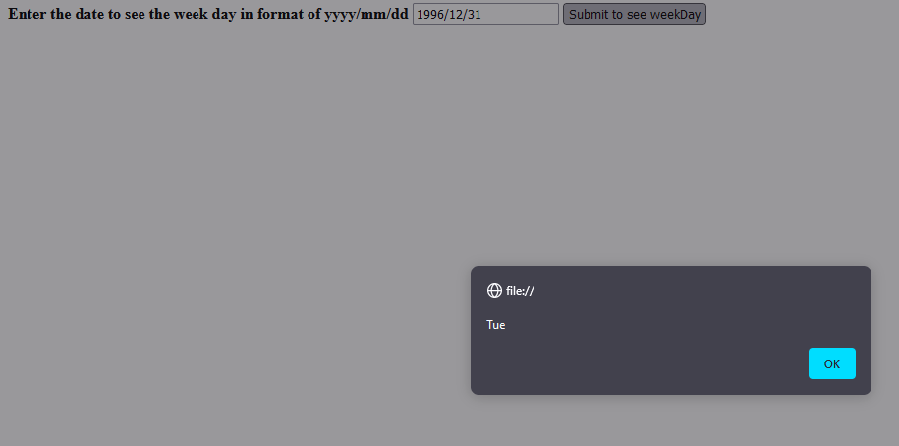

<!DOCTYPE html>

<html lang="en">

<head>

<meta charset="UTF-8">

<meta http-equiv="X-UA-Compatible" content="IE=edge">

<meta name="viewport" content="width=device-width, initial-scale=1.0">

<title>Document</title>

<script>

function ArrSorted() {

var a = prompt("Enter Name: ");

var b = prompt("Enter Name: ");

var c = prompt("Enter Name: ");

var d = prompt("Enter Name: ");

var e = prompt("Enter Name: ");

var f = prompt("Enter Name: ");

var arr = [a, b, c, d, e, f];

arr.sort();

document.getElementById("mydiv").innerHTML += arr;

}

</script>

</head>

<body>

<button type="submit" onclick="ArrSorted()">Click to Enter Names and sort them</button>

<div id="mydiv"></div>

</body>

</html>

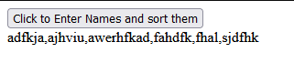



<!DOCTYPE html>

<html lang="en">

<head>

<meta charset="UTF-8">

<meta http-equiv="X-UA-Compatible" content="IE=edge">

<meta name="viewport" content="width=device-width, initial-scale=1.0">

<title>Document</title>

<script>

class employee{

constructor(empid,empname,salary){

this.empid=empid;

this.empname=empname;

this.salary=salary;

}

}

var arr=[];

var a={empid:10, empname:"sujay@1, salary:25000"};

var b={empid:10, empname:"sujay@2, salary:35000"};

var c={empid:10, empname:"sujay@3, salary:45000"};

var d={empid:10, empname:"sujay@4, salary:55000"};

arr.push(a);

arr.push(b);

arr.push(c);

arr.push(d);

function display(){

var str = "<table border='2'><tr><th>Emp id</th><th>Emp name</th><th>Salary</th></tr>";

for(var ob of arr){

str+= `<tr><td>${ob.empid}</td><td>${ob.empname}</td><td>${ob.salary}</td>

onclick="deleteproduct(${ob.empid})">delete</button></td></tr>`

}

str+="</table>";

document.getElementById("mydiv").innerHTML=str;

}

</script>

</head>

<body>

<button type="submit" name="sbmit" id="sbmit" onclick="display()">Display Employee</button>

<div id="mydiv"></div>

</body>

</html>

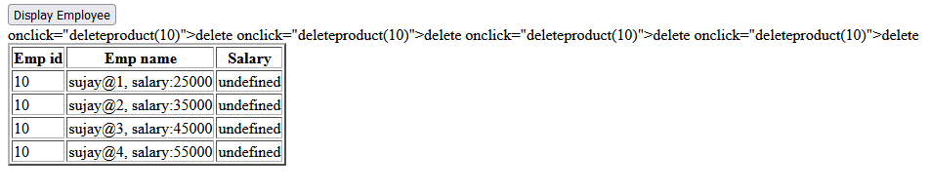

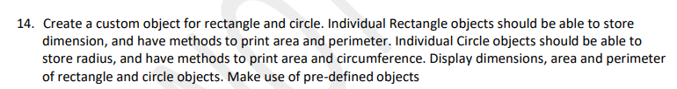

<!DOCTYPE html>

<html lang="en">

<head>

<meta charset="UTF-8">

<meta http-equiv="X-UA-Compatible" content="IE=edge">

<meta name="viewport" content="width=device-width, initial-scale=1.0">

<title>Document</title>

<script src="q14_class.js"></script>

<script>

function rect(){

var l=parseInt(prompt("Enter the lenght"));

var b=parseInt(prompt("Enter the width "));

var myrec=new Rectangle(l,b);

document.getElementById("mydiv").innerHTML="Area of rectangle is: " + myrec.rectangleArea() + " Perimeter of the rectangle: "+ myrec.rectanglePerimeter();

}

function cir(){

var r=parseInt(prompt("Enter the radius"));

var mycir=new Circle(r);

document.getElementById("mydiv").innerHTML="Area of circle is: "+ mycir.circleArea()+"<br>Perimeter of circle: "+ mycir.circlePerimeter();

}

</script>

</head>

<body>

<button type="submit" name="rect" id="rect" onclick="rect()">Rectangle</button>

<button type="submit" name="circle" id="circle" onclick="cir()">Circle</button>

<div id="mydiv"></div>

</body>

</html>

<!DOCTYPE html>

<html lang="en">

<head>

<meta charset="UTF-8">

<meta http-equiv="X-UA-Compatible" content="IE=edge">

<meta name="viewport" content="width=device-width, initial-scale=1.0">

<title>Document</title>

<script>

var arr=["stadia",'azure',"metaverse","gatespace"];

var temp=[];

function reverse() {

for (let i = 0; i < arr.length; i++) {

let s=arr[i].split("");

let r=s.reverse();

let j=r.join("");

temp[i]=j;

}

temp.sort();

var str="";

document.getElementById("mydiv").innerHTML +=temp;

}

</script>

</head>

<body>

<button type="submit" onclick="reverse()">Reverse the array</button>

<div id="mydiv"></div>

</body>

</html>

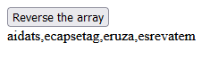

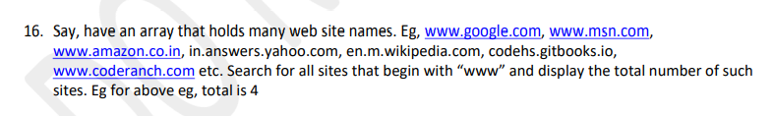

<!DOCTYPE html>

<html lang="en">

<head>

<meta charset="UTF-8">

<meta http-equiv="X-UA-Compatible" content="IE=edge">

<meta name="viewport" content="width=device-width, initial-scale=1.0">

<title>Document</title>

<script>

var arr=["www.msn.com","www.google.com/","www.amazon.in","in.answer.yahoo.com","en.m.wikipedia.com","codehs.gitbooks.com","www.coderanch.com"];

function www(){

var count=0;

for (let i = 0; i < arr.length; i++) {

if (arr[i].startsWith("www")) {

count++;

}

document.getElementById("mydiv").innerHTML=count +" <= Total number of sites starts with www";

}

}

</script>

</head>

<body>

<button type="submit" onclick="www()">click to see www(nos)</button>

<div id="mydiv"></div>

</body>

</html>

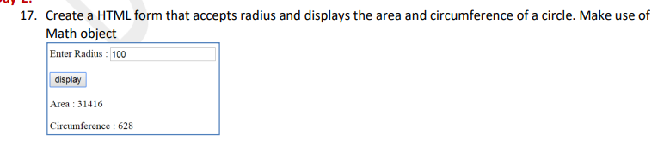

<!DOCTYPE html>

<html lang="en">

<head>

<meta charset="UTF-8">

<meta http-equiv="X-UA-Compatible" content="IE=edge">

<meta name="viewport" content="width=device-width, initial-scale=1.0">

<title>Document</title>

<script>

function circle() {

var r=parseInt(document.getElementById("radius").value);

document.getElementById("are").innerHTML=3.14*r*r;

document.getElementById("peri").innerHTML=Math.round(3.14*2*r);

}

</script>

</head>

<body>

<table border="1px">

<tr>

<th><label for="radius">Enter the radius</label></th>

<td><input type="text" name="radius" id="radius"></td>

</tr>

<tr>

<td></td>

<th><button type="submit" name="sbmt" id="sbmt" onclick="circle()"><b>Submit</b></button></th>

</tr>

<tr>

<td>Area of circle</td>

<td><b><textarea cols="23" id="are" ></textarea></b></td>

</tr>

<tr>

<td>Circumference of circle</td>

<td><textarea cols="23" id="peri" ></textarea></td>

</tr>

</table>

</body>

</html>

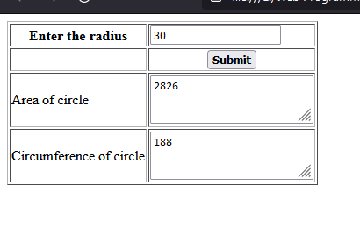

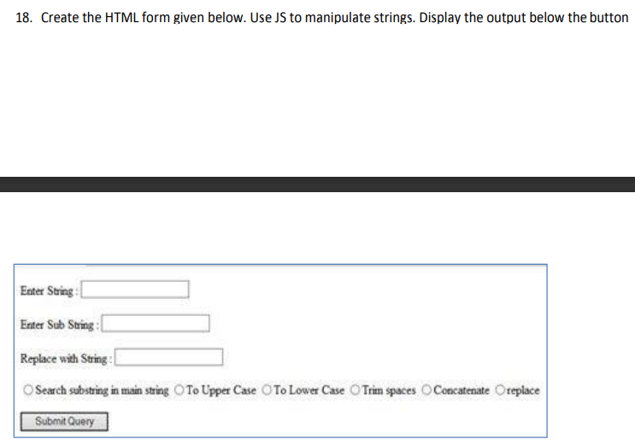

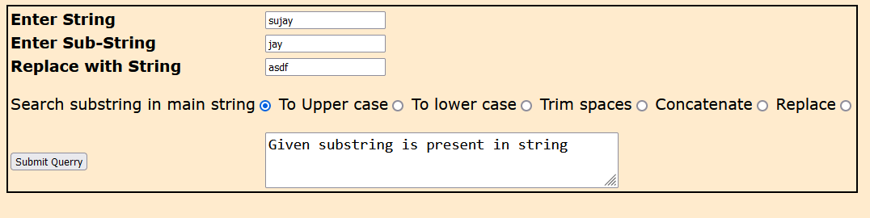

<!DOCTYPE html>

<html lang="en">

<head>

<meta charset="UTF-8">

<meta http-equiv="X-UA-Compatible" content="IE=edge">

<meta name="viewport" content="width=device-width, initial-scale=1.0">

<title>Document</title>

<style>

table {

border: 2px solid black;

font-size: larger;

font-family: Verdana, Geneva, Tahoma, sans-serif;

}

body {

background-color: blanchedalmond;

}

</style>

<script>

function myfuction() {

var str = document.getElementById("strng").value;

var sub = document.getElementById("substrng").value;

var rep = document.getElementById("replcstrng").value;

var op = document.getElementsByName("menu");

for (var i = 0; i < op.length; i++) {

if (op[i].checked) {

switch (op[i].id) {

case 'search':

if ((str.includes(sub))) {

document.getElementById("result").innerHTML = "Given substring is present in string";

} else {

document.getElementById("result").innerHTML = "Given substring is not present in string";

}

break;

case 'upper':

document.getElementById("result").innerHTML = str.toUpperCase();

break;

case 'lower':

document.getElementById("result").innerHTML = str.toLowerCase();

break;

case 'Trim':

document.getElementById("result").innerHTML = str.trim();

break;

case 'Concatenate':

document.getElementById("result").innerHTML = str.concat(sub);

break;

case 'replace':

document.getElementById("result").innerHTML = str.replace(sub,rep); //not working

break;

default:

break;

}

}

}

}

</script>

</head>

<body>

<table id="mytable">

<tr>

<th align="left" width="30%">Enter String</th>

<td><input type="text" name="strng" id="strng"></td>

</tr>

<tr>

<th align="left">Enter Sub-String</th>

<td><input type="text" name="substrng" id="substrng"></td>

</tr>

<tr>

<th align="left">Replace with String</th>

<td><input type="text" name="replcstrng" id="replcstrng"></td>

</tr>

<tr>

<td colspan="2">

<p>

<label for="search">Search substring in main string</label><input type="radio" name="menu"

id="search">

<label for="upper">To Upper case</label><input type="radio" name="menu" id="upper">

<label for="lower">To lower case</label><input type="radio" name="menu" id="lower">

<label for="Trim">Trim spaces</label><input type="radio" name="menu" id="Trim">

<label for="Concatenate">Concatenate</label><input type="radio" name="menu" id="Concatenate">

<label for="replace">Replace</label><input type="radio" name="menu" id="replace">

</p>

</td>

</tr>

<tr>

<td><button type="submit" name="sbmit" id="sbmit" onclick="myfuction()">Submit Querry</button></td>

<td><textarea id="result" placeholder="Answer" cols="40" style="font-size: larger;"></textarea></td>

</tr>

</table>

</body>

</html>

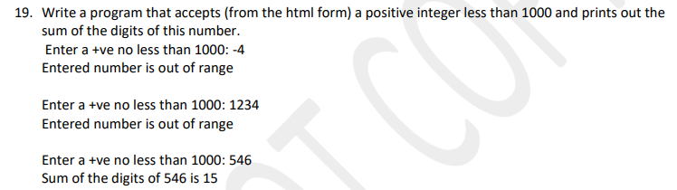

<!DOCTYPE html>

<html lang="en">

<head>

<meta charset="UTF-8">

<meta http-equiv="X-UA-Compatible" content="IE=edge">

<meta name="viewport" content="width=device-width, initial-scale=1.0">

<title>Document</title>

<script>

function sum(){

var n=parseInt(document.getElementById("num").value);

if(n<1000 && n>0){

var sum1=0;

while (n>0) {

var rem=parseInt(n%10);

sum1=parseInt(sum1+rem);

n=parseInt(n/10);

}

document.getElementById("mydiv").innerHTML="Sum of digits is: "+sum1;

}else{

alert("Entered number is not valid");

}

}

</script>

</head>

<body>

<label for="num">Enter the digit</label>

<input type="text" name="num" id="num" placeholder="Enter number lessThan 1000">

<button type="submit" name="submit" id="submit" onclick="sum()">Submit</button>

<div id="mydiv"></div>

</body>

</html>

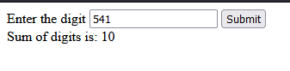

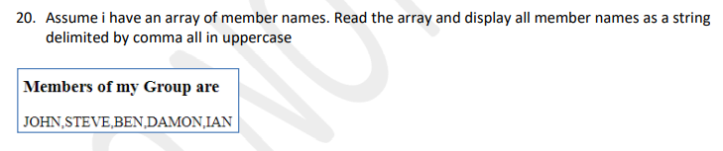

<!DOCTYPE html>

<html lang="en">

<head>

<meta charset="UTF-8">

<meta http-equiv="X-UA-Compatible" content="IE=edge">

<meta name="viewport" content="width=device-width, initial-scale=1.0">

<title>Document</title>

<style>

#myform{ border: 2px solid black;

font-size: medium;

font-family: Verdana, Geneva, Tahoma, sans-serif;

height: 200px;

}

body{

background-color:beige;

}

</style>

<script>

function names(){

document.getElementById("mydiv").innerHTML="";

var arr=["akshay","radhe","arjun","bheem","rajkamel"];

var str="";

for(var i=0;i<arr.length-1;i++){

str += arr[i].toUpperCase()+",";

}

str+=arr[arr.length -1].toUpperCase();

document.getElementById("mydiv").innerHTML=str;

}

</script>

</head>

<body>

<form id="myform">

<h3>Members of my Group are</h3>

<button type="button" id="submit" onclick="names()">Click to show</button><br><br><br>

<div id="mydiv"></div>

</form>

</body>

</html>

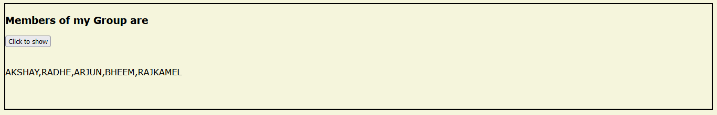

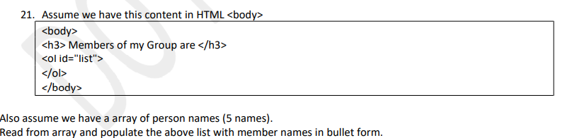

<!DOCTYPE html>

<html lang="en">

<head>

<meta charset="UTF-8">

<meta http-equiv="X-UA-Compatible" content="IE=edge">

<meta name="viewport" content="width=device-width, initial-scale=1.0">

<title>Document</title>

<script>

function shownames() {

document.getElementById("list").innerHTML += "";

var arr = ["John", "Steve", "Ben", "Damon", "Ian"];

var str = "";

for (var i = 0; i < arr.length; i++) {

str = arr[i];

document.getElementById("list").innerHTML += "<li>" + str + "</li>";

}

}

</script>

</head>

<body>

<h3>Members of my Group are</h3>

<button type="button" name="button" id="button" onclick="shownames()">ShowAllNames</button>

<ol id="list">

</ol>

</body>

</html>

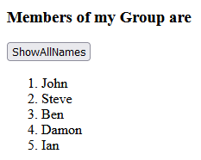

<!DOCTYPE html>

<html lang="en">

<head>

<meta charset="UTF-8">

<meta http-equiv="X-UA-Compatible" content="IE=edge">

<meta name="viewport" content="width=device-width, initial-scale=1.0">

<title>Document</title>

<style>

div {

border: 2px solid black;

width: 300px;

height: 30PX;

text-align: center;

vertical-align: middle;

margin: 10px;

}

</style>

<script src="jq/jquery.js"></script>

<script>

$(document).ready(function(){

$('#btn').click(function(){

$("div:contains('Training')").css("color","red")

});

});

</script>

</head>

<body>

<button type="button" name="btn" id="btn">Search</button>

<div>how are you</div>

<div>im going home</div>

<div>He loves swimming</div>

<div>he is Training Hard</div>

</body>

</html>

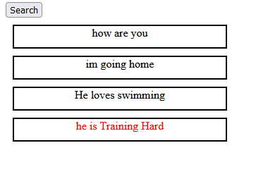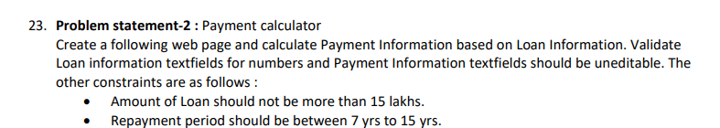

<!DOCTYPE html>

<html lang="en">

<head>

<meta charset="UTF-8">

<meta http-equiv="X-UA-Compatible" content="IE=edge">

<meta name="viewport" content="width=device-width, initial-scale=1.0">

<title>Document</title>

<style>

table{

border: 2px solid blue;

height: 300px;

width: 500px;

}

</style>

<script>

function loanCalculator(){

var loan=parseInt(document.getElementById("amt").value);

if (loan>1500000) {

alert("Invalid amount")

}

var intrest=parseInt(document.getElementById("int").value);

var years=parseInt(document.getElementById("yrs").value);

if (years<7 && years>15) {

alert("Enter years in between 7 to 15");

}

var monthly=parseInt(((loan+(loan*intrest/100))/(years*12)));

// alert(monthly);

document.getElementById("month").value=monthly;

var totPay=parseInt(loan+(loan*intrest/100));

document.getElementById("tot").value=totPay;

var totInt=parseInt(loan*intrest/100);

document.getElementById("totint").value=totInt;

}

</script>

</head>

<body>

<table>

<tr>

<td colspan="2"><h3>Enter Loan Information</h3></td>

<td></td>

</tr>

<tr>

<td><label for="amt">1)Amount of the loan(any currency)</label></td>

<td><input type="text" name="amt" id="amt" placeholder="must be < 15Lakhs"></td>

</tr>

<tr>

<td><label for="int">2)Annual percentage rate of intrest</label></td>

<td><input type="text" name="int" id="int"></td>

</tr>

<tr>

<td><label for="yrs">3)Repayment period in years</label></td>

<td><input type="text" name="yrs" id="yrs" placeholder="Must be between 7 to 15"></td>

</tr>

<tr>

<td></td>

<td><button type="button" id="compute" onclick="loanCalculator()">Compute</button></td>

</tr>

<tr>

<td><h3>Payment Information:</h3></td>

<td></td>

</tr>

<tr>

<td> <label for="month">4)Your monthly payment will be</label></td>

<td><input type="text" name="month" id="month"></td>

</tr>

<tr>

<td> <label for="tot">5)Your total payment will be</label></td>

<td><input type="text" name="tot" id="tot"></td>

</tr>

<tr>

<td> <label for="totint">6)Your total intrest payments will be</label></td>

<td><input type="text" name="totint" id="totint"></td>

</tr>

</table>

</body>

</tot

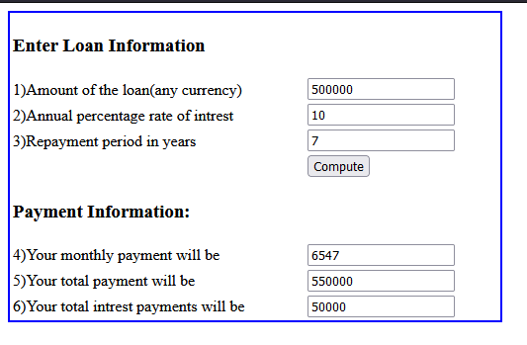

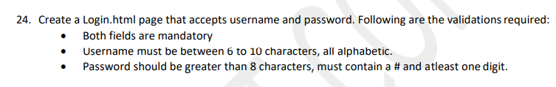<!DOCTYPE html>

<html lang="en">

<head>

<meta charset="UTF-8">

<meta http-equiv="X-UA-Compatible" content="IE=edge">

<meta name="viewport" content="width=device-width, initial-scale=1.0">

<title>Document</title>

<style>

#my {

border: 2px solid black;

width: 300px;

height: 150px;

padding: 10px;

margin: 10px;

background-color: rgb(210, 210, 210);

}

</style>

<script>

function show() {

var p = document.getElementById("pass");

if (p.type == 'password') {

p.type = 'text';

} else

p.type = 'password';

}

</script>

</head>

<body>

<form id="my">

<b><u>Enter login details</u></b><br><br>

<label for="user">Username</label>

<input type="text" id="user" name="user" required pattern="[A-Za-z] {6,10}"><br><br>

<label for="pass">Password</label>

<input type="password" id="pass" name="pass" pattern="[a-zA-Z0-9#] {8,}"><br><br>

<button type="button">LogIn</button>

<label for="shw">Show Password</label><input type="checkbox" name="shw" id="shw" onclick="show()">

</form>

</body>

</html>

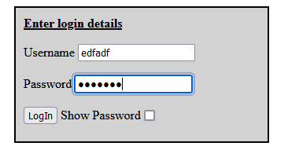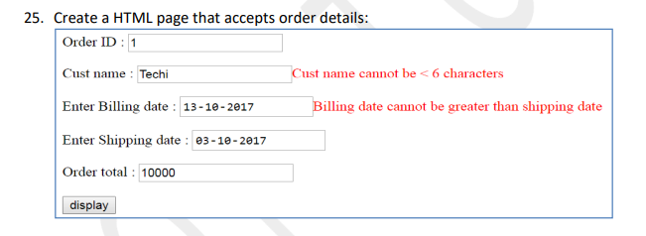

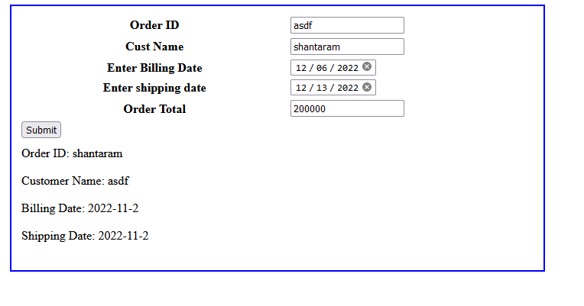

<!DOCTYPE html>

<html lang="en">

<head>

<meta charset="UTF-8">

<meta http-equiv="X-UA-Compatible" content="IE=edge">

<meta name="viewport" content="width=device-width, initial-scale=1.0">

<title>Document</title>

<style>

#mytable {

border: 2px solid blue;

padding: 10px;

margin: 10px;

width: 700px;

height: 350px;

}

</style>

<script>

function custval() {

var c = document.getElementById("cust").value

if (c.length > 6) {

document.getElementById("custtd").innerHTML = " ";

return true;

} else {

document.getElementById("custtd").innerHTML = "Length must be >5";

return false;

}

}

function billdate() {

var b = new Date(document.getElementById("bill").value);

var s = new Date(document.getElementById("ship").value);

if (b.getTime() > s.getTime()) {

document.getElementById("billtd").innerHTML = "Bill date must be before than shipping date";

return false;

} else {

return true;

}

}

function object() {

if (custval() && billdate()) {

var oid = document.getElementById("cust").value

var cu = document.getElementById("ord").value

var bd = new Date(document.getElementById("bill").value);

var sd = new Date(document.getElementById("ship").value);

var total=parseInt(document.getElementById("ord").value);

var bdd=bd.getFullYear() + "-" + bd.getMonth() + "-" + bd.getDay();

var sdd=sd.getFullYear() + "-" + sd.getMonth() + "-" + sd.getDay();

document.getElementById("1d").innerHTML="Order ID: "+ oid;

document.getElementById("2d").innerHTML="Customer Name: "+ cu;

document.getElementById("3d").innerHTML="Billing Date: "+ bdd;

document.getElementById("4d").innerHTML="Shipping Date: "+ sdd;

} else {

alert("Date or customer name is not valid")

}

}

</script>

</head>

<body>

<table id="mytable">

<tr>

<th> <label for="ord">Order ID </label></th>

<td><input type="text" name="ord" id="ord"></td>

<td id="ordtd"></td>

</tr>

<tr>

<th><label for="cust">Cust Name</label></th>

<td><input type="text" id="cust" pattern="{6,}"></td>

<td id="custtd" style="color: red;"> </td>

</tr>

<tr>

<th><label for="bill">Enter Billing Date</label></th>

<td><input type="date" id="bill"></td>

<td id="billtd" style="color: red;"></td>

</tr>

<tr>

<th><label for="ship">Enter shipping date</label></th>

<td><input type="date" id="ship" name="ship"></td>

<td id="shiptd"></td>

</tr>

<tr>

<th><label for="tot">Order Total</label></th>

<td><input type="text" id="tot" name="tot"></td>

<td></td>

</tr>

<tr>

<td><button type="submit" id="sbmt" name="sbmt" onclick="object()">Submit</button></td>

</tr>

<tr>

<td>

<div id="1d"></div><br>

<div id="2d"></div><br>

<div id="3d"></div><br>

<div id="4d"></div><br>

</td>

</tr>

</table>

</body>

</html>

**Q26 Create a HTML page that will display the following form and on clicking the button, the details will be listed as shown. Also create an object with all details from form, show them in new window thru the newly created object. Replace with HTML5 elements wherever possible.**

<!DOCTYPE html>

<html lang="en">

<head>

<meta charset="UTF-8">

<meta http-equiv="X-UA-Compatible" content="IE=edge">

<meta name="viewport" content="width=device-width, initial-scale=1.0">

<title>Document</title>

<style>

#me {

border: 2px solid blue;

width: 500px;

height: 350px;

padding: 10px;

margin: 10px;

}

</style>

<script>

function validateEmail() {

var e = document.getElementById("mail").value;

if (e.includes("@company.com")) {

document.getElementById("errorMail").innerHTML = "";

return true;

}

else {

document.getElementById("errorMail").innerHTML = "(Use format name@company.com)";

return false;

}

}

function validateNumber() {

var n = document.getElementById("num").value;

if (n > 1 && n < 100) {

document.getElementById("errorNum").innerHTML = "";

return true;

}

else {

document.getElementById("errorNum").innerHTML = "(A number between 1 and 100)";

return false;

}

}

function sendData() {

var nm = document.getElementById("name").value;

var gen = document.getElementsByName("gen");

for (var i = 0; i < gen.length; i++) {

if (gen[i].checked) {

g = gen[i].value;

}

}

var d = new Date(document.getElementById("dob").value);

var dob = d.getFullYear() + "-" + d.getMonth() + "-" + d.getDay();

var foodarr = document.getElementsByName("food");

for (var i = 0; i < foodarr.length; i++) {

if (foodarr[i].checked) {

f = foodarr[i].value;

}

}

var n = document.getElementById("num").value;

var e = document.getElementById("mail").value;

if (validateEmail() && validateNumber()) {

document.getElementById("d1").innerHTML = nm;

document.getElementById("d2").innerHTML = dob;

document.getElementById("d3").innerHTML = e;

document.getElementById("d4").innerHTML = g;

document.getElementById("d5").innerHTML = n;

document.getElementById("d6").innerHTML = f;

}

}

</script>

</head>

<body>

<p>Q26. Create a HTML page that will display the following form and on clicking the button, the details will be

listed as shown. Also create an object with all details from form, show them in new window thru the

newly created object</p>

<form id="me">

<table>

<tr>

<td><label for="name">Name:</label></td>

<td><input type="text" name="name" id="name" required maxlength="10" pattern="[a-zA-Z]"></td>

</tr>

<tr>

<td><label for="dob">Birth Date:</label></td>

<td><input type="date" name="dob" id="dob" required></td>

</tr>

<tr>

<td><label for="mail">Email Address:</label></td>

<td><input type="text" name="mail" id="mail" required></td>

<td>

<div id="errorMail"></div>

</td>

</tr>

<tr>

<td><label for="gender">Gender</label></td>

<td><input type="radio" name="gen" id="male" value="male">Male<br>

<input type="radio" name="gen" id="female" value="female">Female

</td>

</tr>

<tr>

<td><label for="num">Lucky number:</label></td>

<td><input type="number" name="num" id="num" required minlength="4" maxlength="4"></td>

<td>

<div id="errorNum"></div>

</td>

</tr>

<tr>

<td><label for="foods">Favorite Foods:</label></td>

<td><input type="radio" name="food" id="pizza" value="pizza">Pizza <br>

<input type="radio" name="food" id="pasta" value="pasta">Pasta <br>

<input type="radio" name="food" id="chinese" value="chinese"> Chinese

</td>

</tr>

<tr>

<td><button type="button" name="btn" id="btn" onclick="sendData()">Send Data</button></td>

</tr>

</table>

<div id="d1"></div>

<div id="d2"></div>

<div id="d3"></div>

<div id="d4"></div>

<div id="d5"></div>

<div id="d6"></div>

</form>

</body>

</html>

