**Question 2:** For this question you’ll need to use SQL. [Follow this link](https://www.w3schools.com/SQL/TRYSQL.ASP?FILENAME=TRYSQL_SELECT_ALL) to access the data set required for the challenge. Please use queries to answer the following questions. Paste your queries along with your final numerical answers below.

1. How many orders were shipped by Speedy Express in total?

**Query:**

SELECT Count(OrderID) AS 'Total Orders'

FROM Orders o

JOIN Shippers s

on o.ShipperID = s.ShipperID

Where ShipperName = 'Speedy Express'

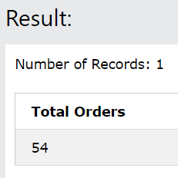 **Output**:

1. What is the last name of the employee with the most orders?

**Query:**

SELECT o.EmployeeID, Count(OrderID) AS 'Total Orders', Lastname FROM Orders o

JOIN Employees e

on o.employeeID = e.employeeID

GROUP BY o.EmployeeID

ORDER BY Count(OrderID) DESC

LIMIT 1

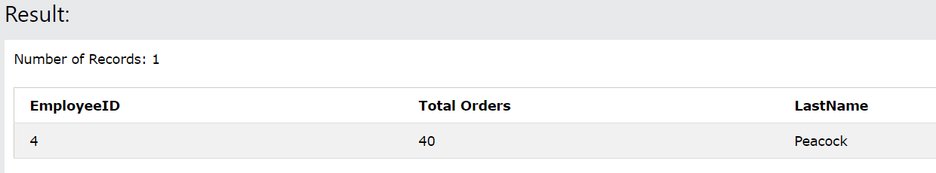 **Output**:

1. What product was ordered the most by customers in Germany?

**Query**:

SELECT [Products].ProductName,

SUM([OrderDetails].Quantity) AS "TotalOrdered"

FROM [Orders]

JOIN [Customers] ON [Customers].CustomerID = [Orders].CustomerID

JOIN [OrderDetails] ON [OrderDetails].OrderID = [Orders].OrderID

JOIN [Products] ON [Products].ProductID = [OrderDetails].ProductID

WHERE [Customers].Country = 'Germany'

GROUP BY [OrderDetails].ProductID

ORDER BY TotalOrdered DESC

LIMIT 1

**Output**:

