**UCS 1211 Mini Project Report**

|  |  |
| --- | --- |
| Ex No : 8  Date: 22.04.2019 | **MINI PROJECT** |
| Title | **Car Dealership System** |
| Team Lead | **185001200 Vishnu Krishna kumar** |
| Team Members | **185001174 Sujay Sathya**  **185001205 Srinath Srinivasan**  **185001185 Utkarsh Uniyal** |

Abstract

The car dealership System is an efficient application to handle data s. With large number of consumers wanting to buy cars these days, the goal of the mini project was to develop a simple software which handles all the different aspects of purchasing a car and everything that comes with it . It also lays emphasis on the needs of an end user by providing various options to buy from while keeping the interface user-friendly.

The car dealership system involves data entry, input validation and record cross referencing. The project was developed using C making it easily portable over modern platforms like Windows, Ubuntu etc. while keeping the size of the application relatively small. These features improve the overall efficiency and portability of the software.

Project Description:

This Mini Project uses C compiled using GCC to create a simple system to handle the car database and the customer database. It allows the user to enter data such as , but not limited to Name,Address Aadhaar number and address and initially stores them in structures and using files, store this data for later reference and updates. The 4 team members each took a specific approach to this project (i.e: Visual side, Internal computation, File handling)

Using header files, all the 3 parts of code were compiled using same helper functions and validity of inputs were checked. The final code was able to efficiently handle files, create new ones, modify the car database in the admin mode and much more.

Salient Features:

* + Buy the most suitable car based on your likes and dislikes.
  + System recommends various cars to you based on your previously purchased car from our dealership and recommends a list of similar cars for you to buy from.
  + Provides an option to apply for insurance on the purchase of the cars.
  + Allows the admin to display/modify the car and customer database
  + Allows for service based on day of purchase done using date difference calculation.
  + Functionality to generate a group of cars to either buy or rent based on their respective emp number
  + Has a function named emp which takes in consideration features of a car like transmission , number of airbags , number of seats and etc and returns cars with very similar features after cross referencing from a file.

Outline

* Begin
* Read user’s choice whether buy, sell, rent or service a car (or to exit). Also asking if ADMIN wants to login to access customer or car database.
* If the user chooses to buy a new car:

1. Ask if user has bought a car here before

* If they have then ask them for their information, use the emp() value of their previous car

1. If the emp value is 0 then they haven’t bought a car before
2. Else cars with emp value +- 5 is displayed
3. The serial number of their preferred car is taken
4. They are asked if they want insurance and their credit rating is noted

* If they want insurance then thensurance money is calculated

1. The customer info is noted and purchase sate is noted, these details are noted in the customer database.

* Else ask them for their preferences and calculate the rating of car

1. Check for card with +- of rating

a) The serial number of their preferred car is taken

b) They are asked if they want insurance and their credit rating is noted

* If they want insurance then the insurance money is calculated

1. The customer info is noted and purchase sate is noted, these details are noted in the customer database.

* If the user chooses to rent a car:

1. Get preferred car details and calculate the rating. Display similar cars to user and get the car to be rented
2. Show them rent per month and ask if they want insurance:

a) if yes then calculate insurance money

1. Get customer details and then store in customer database

* If they choose to service the car:

1. Get customer and car details

2. Check if car is eligible for free service

a) If the car has been bought before a year the service is free

b) Else set the service costs standard as per car details

* If ADMIN wants to login to check customer database, get password:

1. If password is correct then get details of car and display insurance details

2. Else deny access

* If ADMIN wants to login to check car database, get password:

1. If password is correct then display details of car and ask if new car to be added

a) If yes then get details of car and store in car database

2. Else deny access.

* If user wants to exit, then exit program
* End

Output Snapshots:

Main Menu**:**

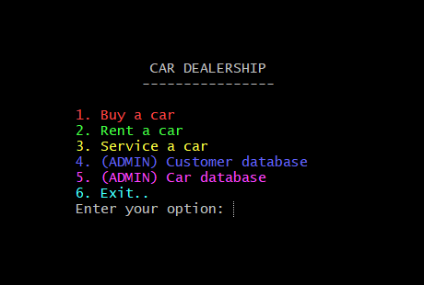

Buying : Having bought a car before

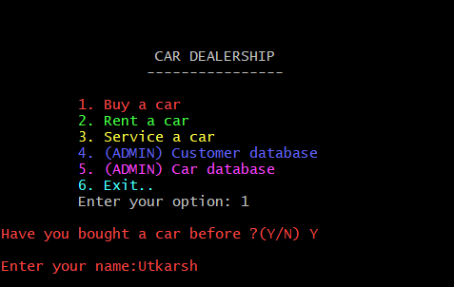

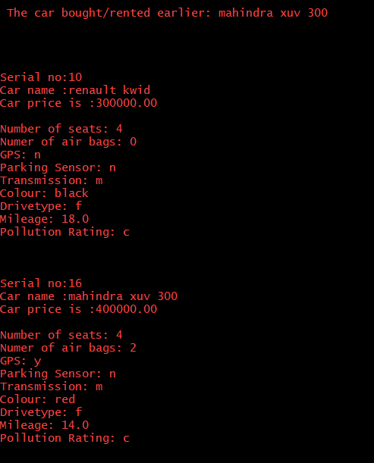

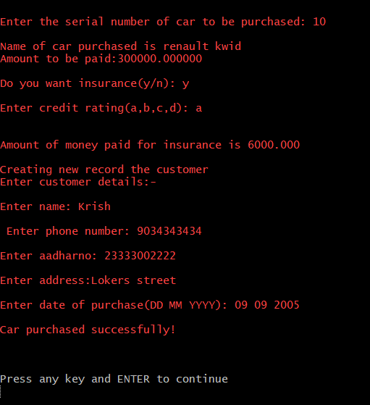

Buying: As a fresh customer

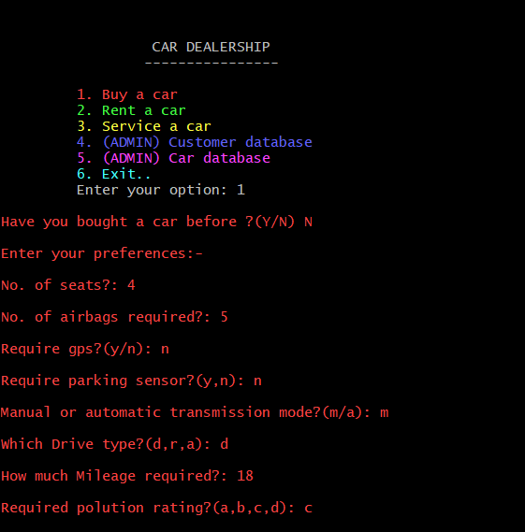

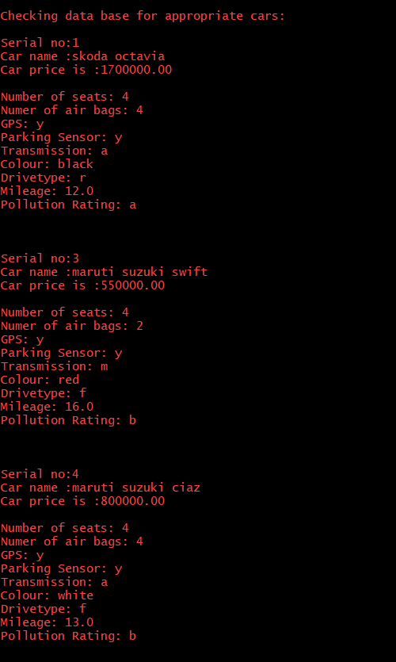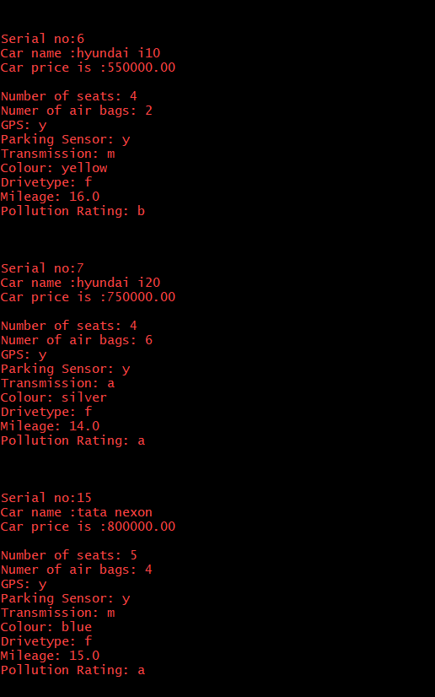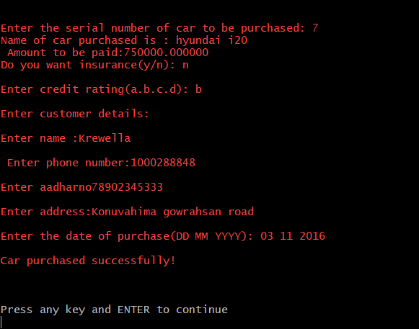

Car Database: Displaying and Adding records

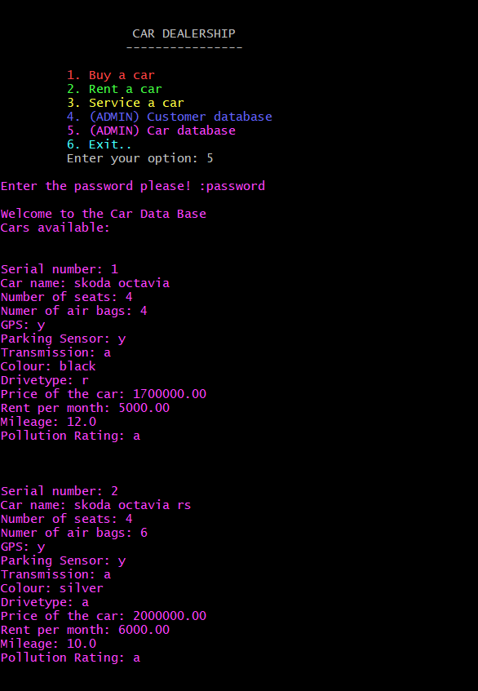

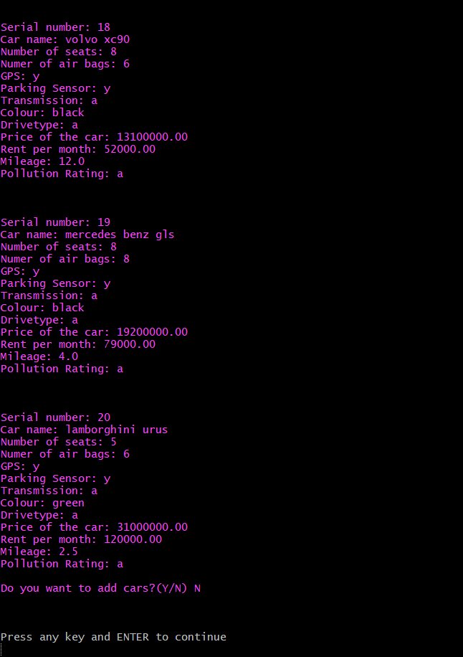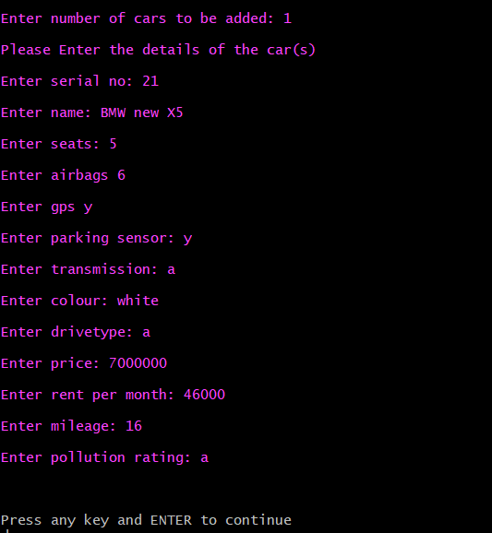

Customer Database: Displaying purchase history and customer details

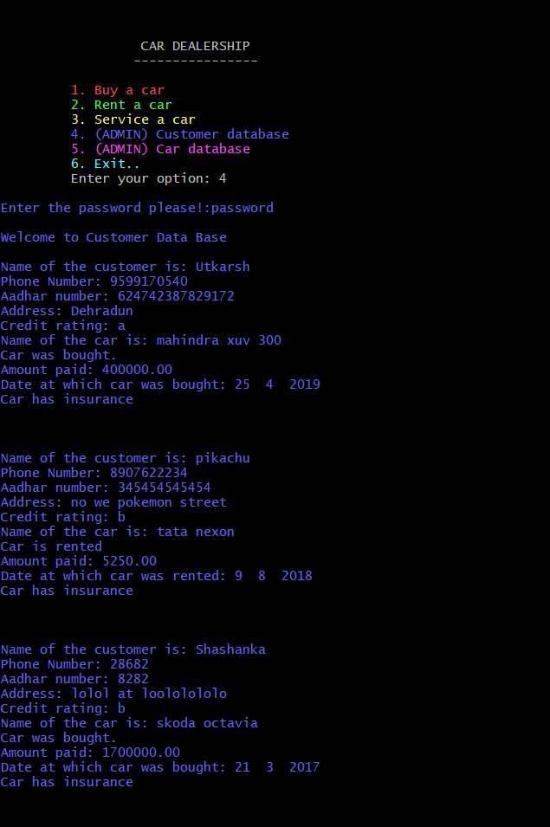

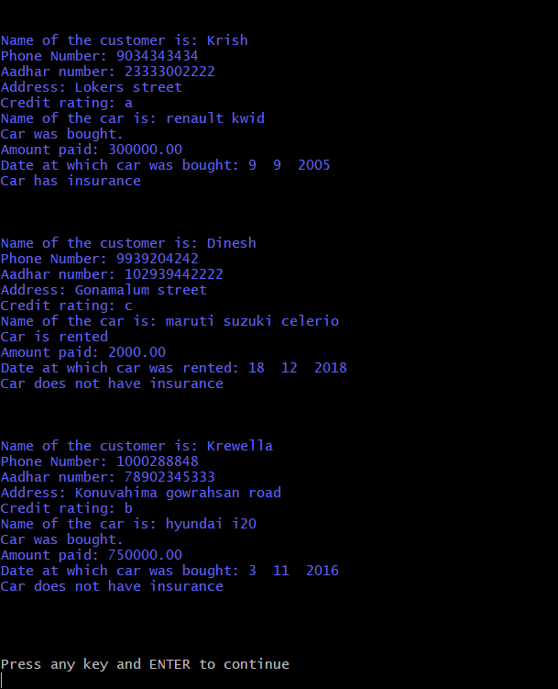

Renting:

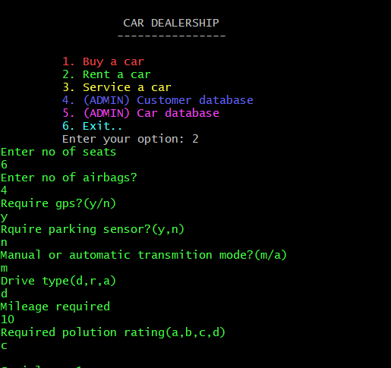

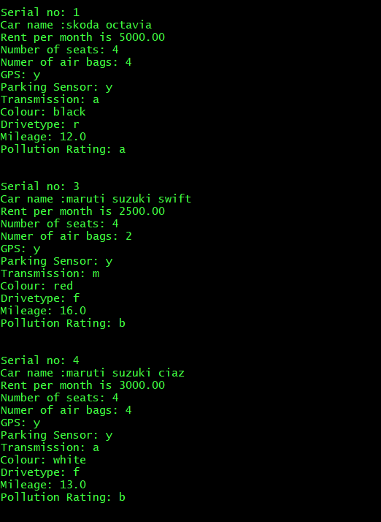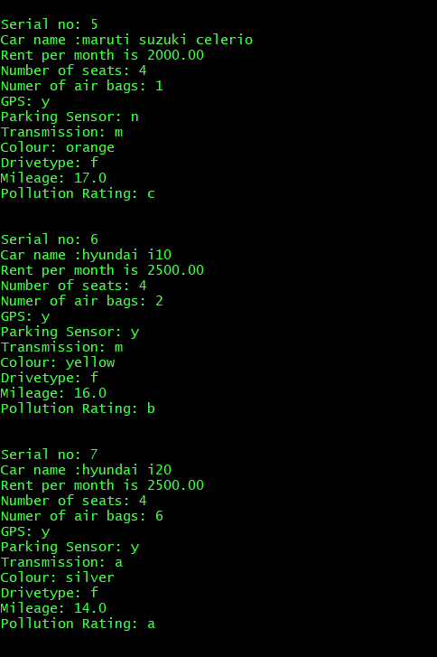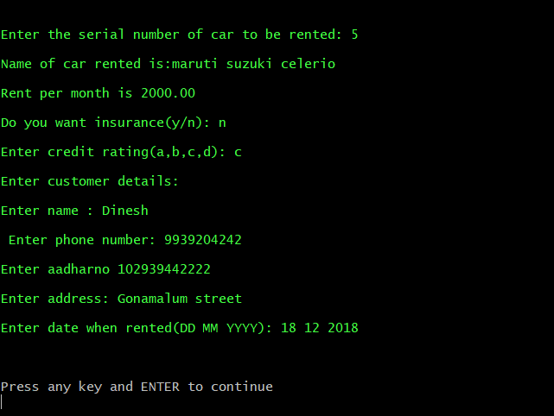

Servicing:

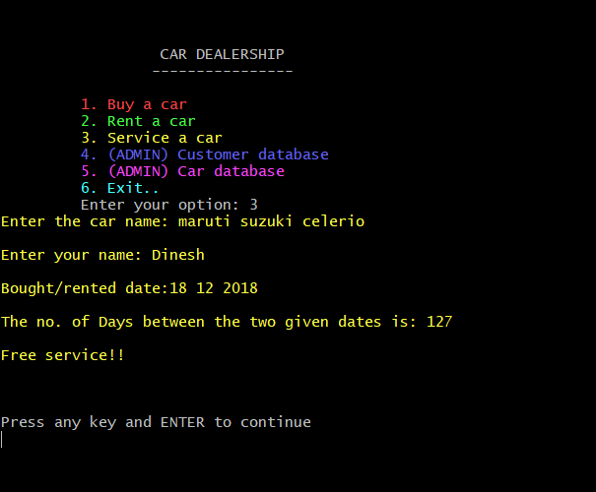

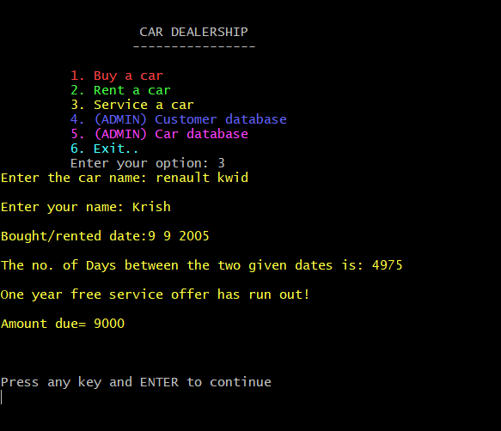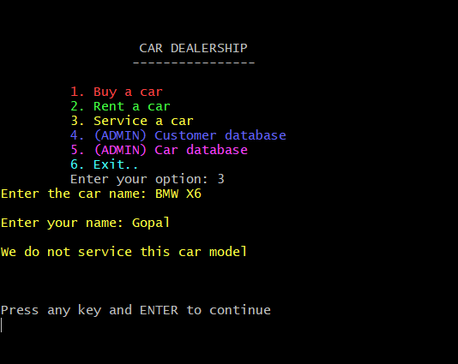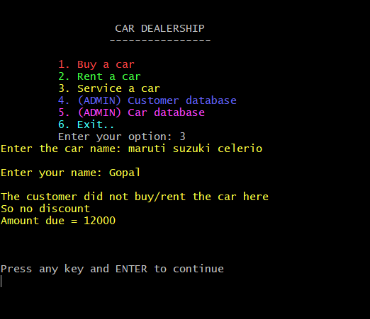

Learning Experience:

* This mini project involved the usage of a combination of all the concepts applied in the previous assignments and also involved concepts out of syllabus.
* Applying the concept of files to store and retrieve data safely was the first challenge I faced as there were inconsistencies in certain file modes

.

* Use of various function and different lines of code to make the program look better was an eye opener.
* The use of various algorithms to efficiently compare various parameters significant to the project helped me think differently and out of the box..
* Writing code incrementally helped as this was a relatively large program with a large number of functions to be properly linked and executed.
* The buy and rent function were relatively difficult as it involved getting various inputs from user and various comparisons that were quite difficult to get right the first time.
* Overall, this mini project has strengthened my coding skills (especially with files) and helped me develop my teamwork and leadership skills needed to solve real-world problems.