项目简介
本项目是一个基于 OpenGL 3.0 的 C++ 动画演示程序，实现了日地月三体系统的动态模拟与可视化。主要功能如下：
- 太阳、地球、月亮三球体的实时运动与渲染。
- 地球绕太阳椭圆轨道运动，月亮绕地球椭圆轨道且轨道有倾角，运动关系和速度比例合理。
- 轨道以线条方式动态显示，便于观察运动路径和空间关系。
- 支持通过方向键和 W/S 键实时调整摄像机视角，体验不同观察角度。
- 可切换线框/填充模式，开启/关闭背面剔除，便于学习和调试 OpenGL 渲染特性。
- 控制说明会在程序启动时自动输出。

运行截图
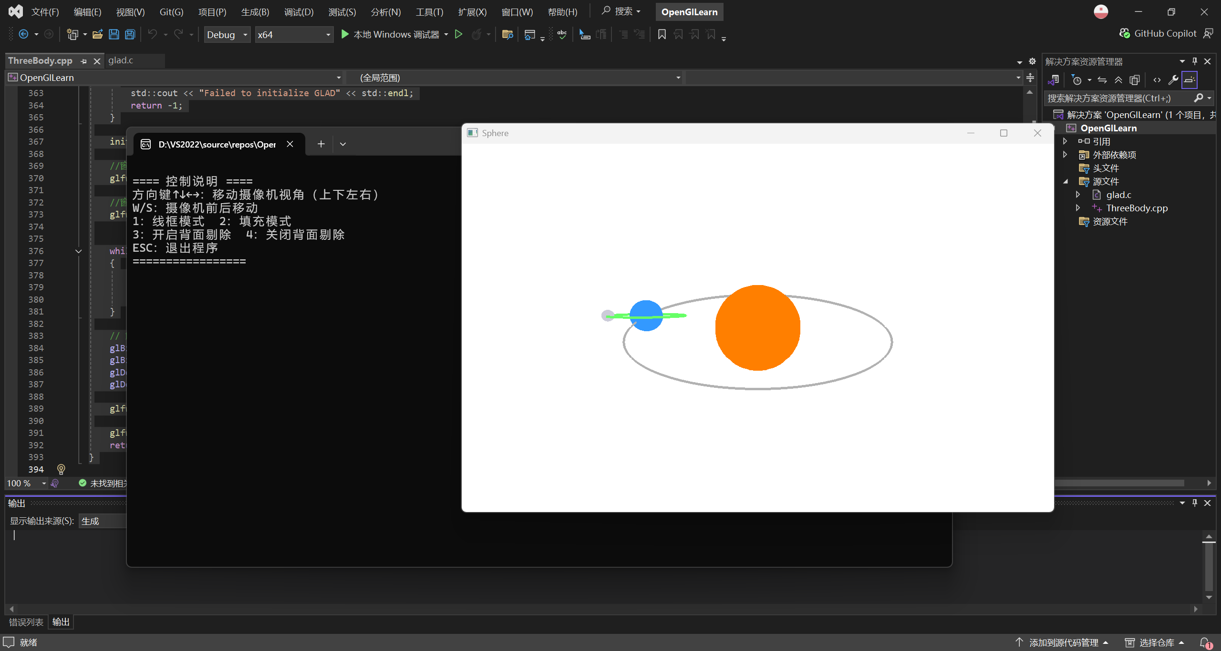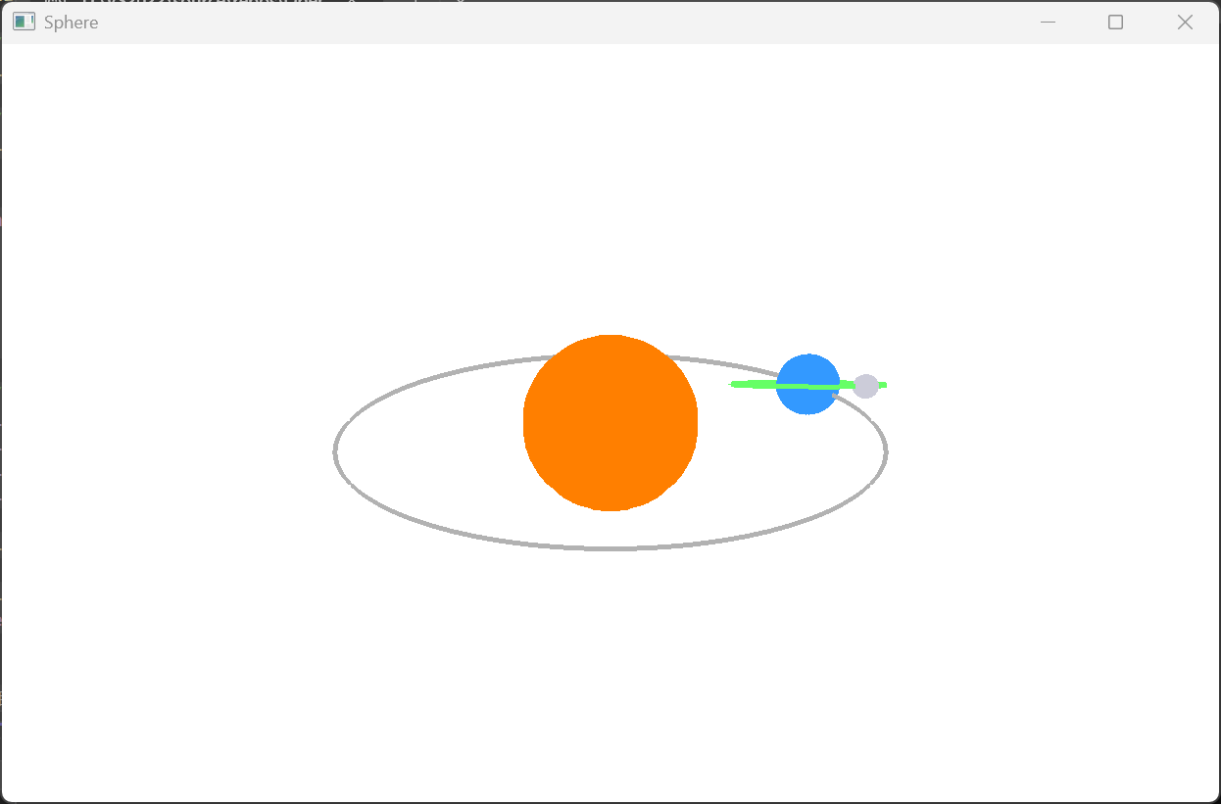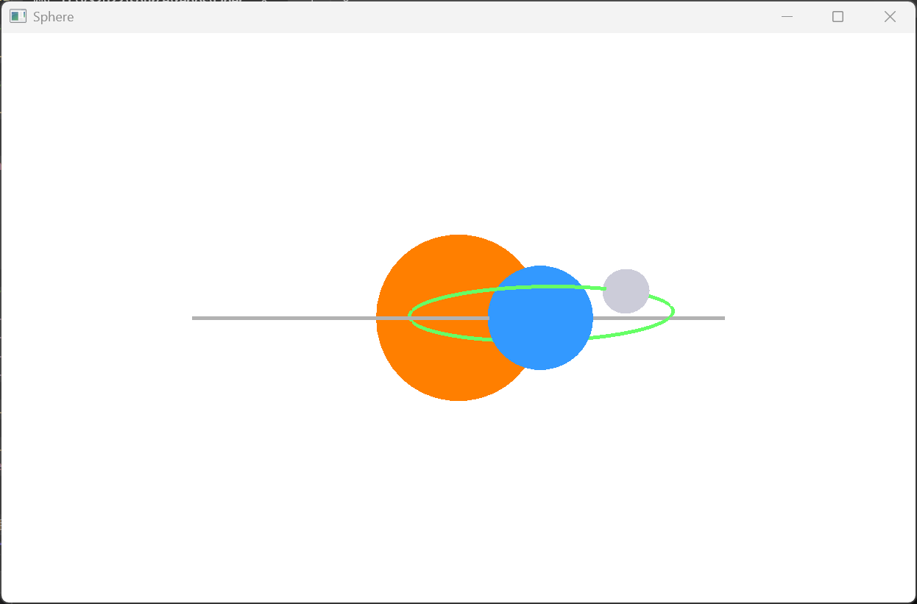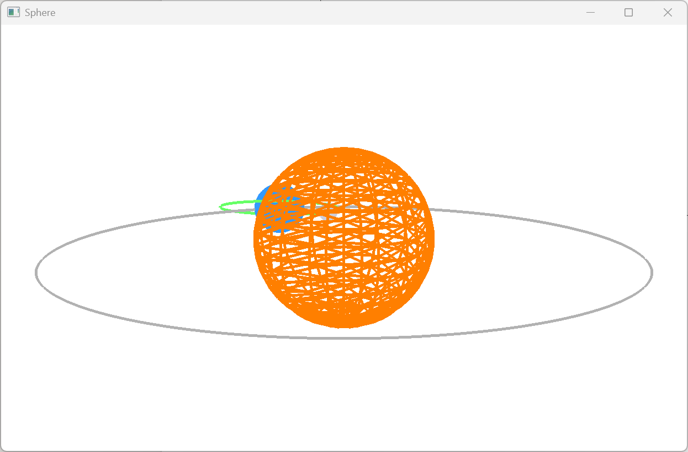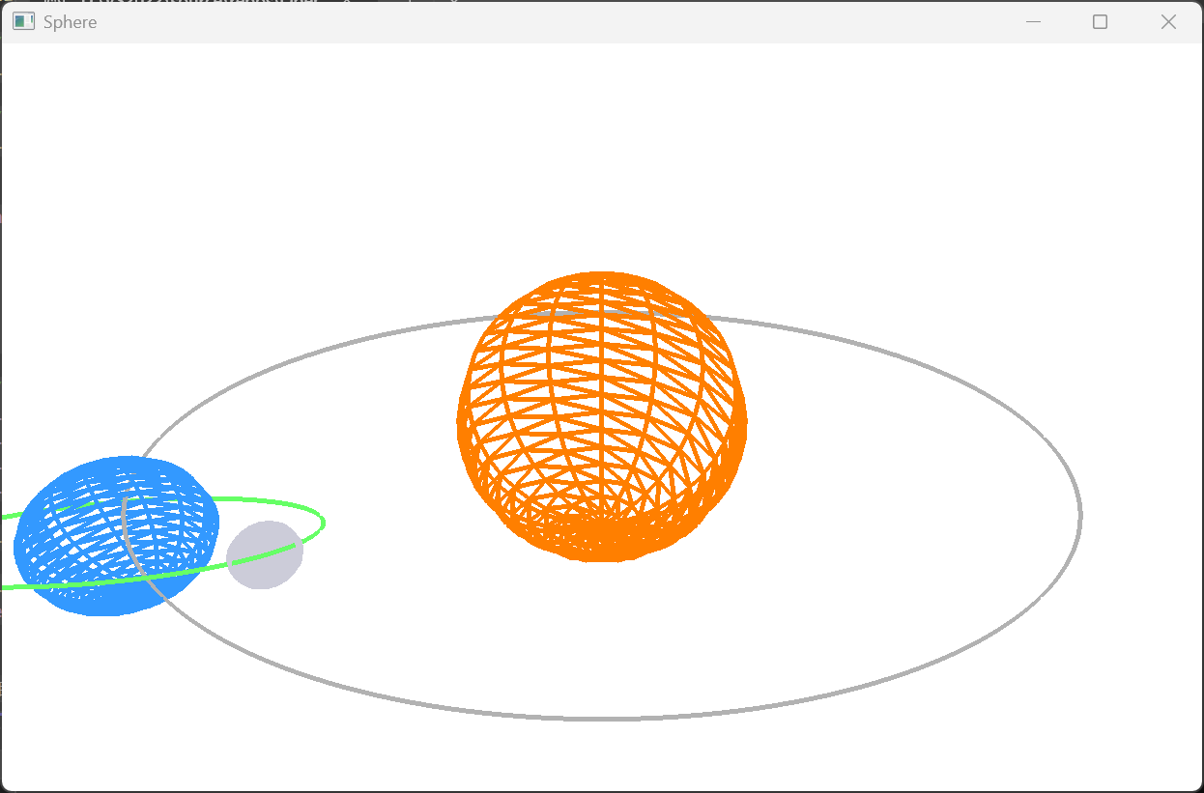

源代码
//////////////////////////////////////////////////////////////////////////////
// ThreeBody.cpp
// 日地月运动模型动画
// - 球体绘制（太阳、地球、月亮）
// - 椭圆轨道绘制（地球轨道XZ平面，月亮轨道有倾角）
// - 方向键/W/S控制摄像机视角
//////////////////////////////////////////////////////////////////////////////
#include <glad/glad.h>
#include <GLFW/glfw3.h>
#include <iostream>
#include <vmath.h>
#include <vector>

//窗口大小参数
const unsigned int SCR_WIDTH = 800;
const unsigned int SCR_HEIGHT = 600;
float aspact = (float)4.0 / (float)3.0;

// 摄像机参数
float camX = 0.0f, camY = 6.0f, camZ = 12.0f;

//球体和轨道数据参数
std::vector<float> sphereVertices;
std::vector<int> sphereIndices;
std::vector<float> earthOrbitVertices;
std::vector<float> moonOrbitVertices;
GLuint vertex_array_object, vertex_buffer_object, element_buffer_object;
GLuint earthOrbitVAO = 0, earthOrbitVBO = 0;
GLuint moonOrbitVAO = 0, moonOrbitVBO = 0;
int shader_program;
const int Y_SEGMENTS = 20;
const int X_SEGMENTS = 20;
const int ORBIT_SEGMENTS = 256;
const float Radio = 3.0;
const GLfloat PI = 3.14159265358979323846f;

void print_controls() {
std::cout << "\n==== 控制说明 ====" << std::endl;
std::cout << "方向键↑↓←→：移动摄像机视角（上下左右）" << std::endl;
std::cout << "W/S：摄像机前后移动" << std::endl;
std::cout << "1：线框模式 2：填充模式" << std::endl;
std::cout << "3：开启背面剔除 4：关闭背面剔除" << std::endl;
std::cout << "ESC：退出程序" << std::endl;
std::cout << "=================\n" << std::endl;
}

void initial(void)
{
// 球体顶点生成
for (int y = 0; y <= Y_SEGMENTS; y++)
for (int x = 0; x <= X_SEGMENTS; x++) {
float xSegment = (float)x / (float)X_SEGMENTS;
float ySegment = (float)y / (float)Y_SEGMENTS;
float xPos = std::cos(xSegment * Radio * PI) * std::sin(ySegment * PI);
float yPos = std::cos(ySegment * PI);
float zPos = std::sin(xSegment * Radio * PI) * std::sin(ySegment * PI);
sphereVertices.push_back(xPos);
sphereVertices.push_back(yPos);
sphereVertices.push_back(zPos);
}
for (int i = 0; i < Y_SEGMENTS; i++)
for (int j = 0; j < X_SEGMENTS; j++) {
sphereIndices.push_back(i * (X_SEGMENTS + 1) + j);
sphereIndices.push_back((i + 1) * (X_SEGMENTS + 1) + j);
sphereIndices.push_back((i + 1) * (X_SEGMENTS + 1) + j + 1);
sphereIndices.push_back(i * (X_SEGMENTS + 1) + j);
sphereIndices.push_back((i + 1) * (X_SEGMENTS + 1) + j + 1);
sphereIndices.push_back(i * (X_SEGMENTS + 1) + j + 1);
}
glGenVertexArrays(1, &vertex_array_object);
glGenBuffers(1, &vertex_buffer_object);
glBindVertexArray(vertex_array_object);
glBindBuffer(GL_ARRAY_BUFFER, vertex_buffer_object);
glBufferData(GL_ARRAY_BUFFER, sphereVertices.size() * sizeof(float), &sphereVertices[0], GL_STATIC_DRAW);
glGenBuffers(1, &element_buffer_object);
glBindBuffer(GL_ELEMENT_ARRAY_BUFFER, element_buffer_object);
glBufferData(GL_ELEMENT_ARRAY_BUFFER, sphereIndices.size() * sizeof(int), &sphereIndices[0], GL_STATIC_DRAW);
glVertexAttribPointer(0, 3, GL_FLOAT, GL_FALSE, 3 * sizeof(float), (void*)0);
glEnableVertexAttribArray(0);
glBindBuffer(GL_ARRAY_BUFFER, 0);
glBindVertexArray(0);

// 轨道顶点生成
const float earthA = 6.0f, earthB = 4.5f;
for (int i = 0; i < ORBIT_SEGMENTS; ++i) {
float theta = (float)i / ORBIT_SEGMENTS * 2.0f * PI;
float x = earthA * std::cos(theta);
float z = earthB * std::sin(theta);
earthOrbitVertices.push_back(x);
earthOrbitVertices.push_back(0.0f);
earthOrbitVertices.push_back(z);
}
glGenVertexArrays(1, &earthOrbitVAO);
glGenBuffers(1, &earthOrbitVBO);
glBindVertexArray(earthOrbitVAO);
glBindBuffer(GL_ARRAY_BUFFER, earthOrbitVBO);
glBufferData(GL_ARRAY_BUFFER, earthOrbitVertices.size() * sizeof(float), &earthOrbitVertices[0], GL_STATIC_DRAW);
glVertexAttribPointer(0, 3, GL_FLOAT, GL_FALSE, 3 * sizeof(float), (void*)0);
glEnableVertexAttribArray(0);
glBindVertexArray(0);
const float moonA = 2.0f, moonB = 1.2f, moonTiltDeg = 20.0f;
float tiltRad = moonTiltDeg * PI / 180.0f;
for (int i = 0; i < ORBIT_SEGMENTS; ++i) {
float theta = (float)i / ORBIT_SEGMENTS * 2.0f * PI;
float x = moonA * std::cos(theta);
float z = moonB * std::sin(theta);
float y = z * std::sin(tiltRad);
float z_tilted = z * std::cos(tiltRad);
moonOrbitVertices.push_back(x);
moonOrbitVertices.push_back(y);
moonOrbitVertices.push_back(z_tilted);
}
glGenVertexArrays(1, &moonOrbitVAO);
glGenBuffers(1, &moonOrbitVBO);
glBindVertexArray(moonOrbitVAO);
glBindBuffer(GL_ARRAY_BUFFER, moonOrbitVBO);
glBufferData(GL_ARRAY_BUFFER, moonOrbitVertices.size() * sizeof(float), &moonOrbitVertices[0], GL_STATIC_DRAW);
glVertexAttribPointer(0, 3, GL_FLOAT, GL_FALSE, 3 * sizeof(float), (void*)0);
glEnableVertexAttribArray(0);
glBindVertexArray(0);

// 顶点着色器和片段着色器源码
const char *vertex_shader_source =
"#version 330 core\n"
"layout (location = 0) in vec3 vPos;\n" // 位置变量的属性位置值为0
"out vec4 vColor;\n" // 位置变量的属性位置值为0
"uniform mat4 transform;\n"
"uniform vec4 color;\n"
"void main()\n"
"{\n"
" gl_Position = transform*vec4(vPos, 1.0);\n"
" vColor = color;\n"
"}\n\0";
const char *fragment_shader_source =
"#version 330 core\n"
"in vec4 vColor;\n" // 输出的颜色向量
"out vec4 FragColor;\n" // 输出的颜色向量
"void main()\n"
"{\n"
" FragColor = vColor;\n"
"}\n\0";

// 生成并编译着色器
// 顶点着色器
int success;
char info_log[512];
int vertex_shader = glCreateShader(GL_VERTEX_SHADER);
glShaderSource(vertex_shader, 1, &vertex_shader_source, NULL);
glCompileShader(vertex_shader);
// 检查着色器是否成功编译，如果编译失败，打印错误信息
glGetShaderiv(vertex_shader, GL_COMPILE_STATUS, &success);
if (!success)
{
glGetShaderInfoLog(vertex_shader, 512, NULL, info_log);
std::cout << "ERROR::SHADER::VERTEX::COMPILATION_FAILED\n" << info_log << std::endl;
}
// 片段着色器
int fragment_shader = glCreateShader(GL_FRAGMENT_SHADER);
glShaderSource(fragment_shader, 1, &fragment_shader_source, NULL);
glCompileShader(fragment_shader);
// 检查着色器是否成功编译，如果编译失败，打印错误信息
glGetShaderiv(fragment_shader, GL_COMPILE_STATUS, &success);
if (!success)
{
glGetShaderInfoLog(fragment_shader, 512, NULL, info_log);
std::cout << "ERROR::SHADER::FRAGMENT::COMPILATION_FAILED\n" << info_log << std::endl;
}
// 链接顶点和片段着色器至一个着色器程序
shader_program = glCreateProgram();
glAttachShader(shader_program, vertex_shader);
glAttachShader(shader_program, fragment_shader);
glLinkProgram(shader_program);
// 检查着色器是否成功链接，如果链接失败，打印错误信息
glGetProgramiv(shader_program, GL_LINK_STATUS, &success);
if (!success) {
glGetProgramInfoLog(shader_program, 512, NULL, info_log);
std::cout << "ERROR::SHADER::PROGRAM::LINKING_FAILED\n" << info_log << std::endl;
}

// 删除着色器
glDeleteShader(vertex_shader);
glDeleteShader(fragment_shader);

glUseProgram(shader_program);

//设定点线面的属性
glPointSize(15);//设置点的大小
glLineWidth(5);//设置线宽

//启动剔除操作
glEnable(GL_CULL_FACE);
glCullFace(GL_BACK);

//开启深度测试
glEnable(GL_DEPTH_TEST);
}

void key_callback(GLFWwindow* window, int key, int scancode, int action, int mods)
{
if (action == GLFW_PRESS || action == GLFW_REPEAT) {
switch (key)
{
case GLFW_KEY_ESCAPE:
glfwSetWindowShouldClose(window, GL_TRUE);
break;
case GLFW_KEY_UP:
camY += 1.0f;
break;
case GLFW_KEY_DOWN:
camY -= 1.0f;
break;
case GLFW_KEY_LEFT:
camX -= 1.0f;
break;
case GLFW_KEY_RIGHT:
camX += 1.0f;
break;
case GLFW_KEY_W:
camZ -= 1.0f;
break;
case GLFW_KEY_S:
camZ += 1.0f;
break;
case GLFW_KEY_1:
glPolygonMode(GL_FRONT_AND_BACK, GL_LINE);
break;
case GLFW_KEY_2:
glPolygonMode(GL_FRONT_AND_BACK, GL_FILL);
break;
case GLFW_KEY_3:
glEnable(GL_CULL_FACE);
glCullFace(GL_BACK);
break;
case GLFW_KEY_4:
glDisable(GL_CULL_FACE);
break;
default:
break;
}
}
}

void Draw(void)
{
// 清空颜色缓冲和深度缓冲区
glClearColor(1.0f, 1.0f, 1.0f, 1.0f);
glClear(GL_COLOR_BUFFER_BIT | GL_DEPTH_BUFFER_BIT);

// 动态相机矩阵
vmath::mat4 view = vmath::lookat(
vmath::vec3(camX, camY, camZ),
vmath::vec3(0.0f, 0.0f, 0.0f),
vmath::vec3(0.0f, 1.0f, 0.0f));
vmath::mat4 proj = vmath::perspective(60, aspact, 1.0f, 500.0f);

unsigned int transformLoc = glGetUniformLocation(shader_program, "transform");
unsigned int colorLoc = glGetUniformLocation(shader_program, "color");

float t = (float)glfwGetTime();
// 轨道参数
const float earthA = 6.0f, earthB = 4.5f;
const float moonA = 2.0f, moonB = 1.2f, moonTiltDeg = 20.0f;
const float earthPeriod = 20.0f;
const float moonPeriod = 2.0f;
float tiltRad = moonTiltDeg * PI / 180.0f;

// 太阳（原点）
// 太阳大小由 scale(1.5f) 控制，调节此参数可改变太阳半径
vmath::mat4 sunTrans = proj * view * vmath::scale(2.0f); // <--- 太阳缩放因子
glUniformMatrix4fv(transformLoc, 1, GL_FALSE, sunTrans);
GLfloat sunColor[4] = { 1.0f, 0.5f, 0.0f, 1.0f }; // 太阳颜色
glUniform4fv(colorLoc, 1, sunColor);
glBindVertexArray(vertex_array_object);
glDrawElements(GL_TRIANGLES, X_SEGMENTS * Y_SEGMENTS * 6, GL_UNSIGNED_INT, 0);

// 地球轨道（灰色线条）
vmath::mat4 orbitTrans = proj * view;
glUniformMatrix4fv(transformLoc, 1, GL_FALSE, orbitTrans);
GLfloat orbitColor[4] = { 0.7f, 0.7f, 0.7f, 1.0f };
glUniform4fv(colorLoc, 1, orbitColor);
glBindVertexArray(earthOrbitVAO);
glDrawArrays(GL_LINE_LOOP, 0, ORBIT_SEGMENTS);

// 地球
float angEarth = -t * (2.0f * PI / earthPeriod);
float earthX = earthA * std::cos(angEarth);
float earthZ = earthB * std::sin(angEarth);
// 地球大小由 scale(0.7f) 控制，调节此参数可改变地球半径
vmath::mat4 earthTrans = proj * view * vmath::translate(earthX, 0.0f, earthZ) * vmath::scale(0.8f); // <--- 地球缩放因子
glUniformMatrix4fv(transformLoc, 1, GL_FALSE, earthTrans);
GLfloat earthColor[4] = { 0.2f, 0.6f, 1.0f, 1.0f }; // 地球颜色
glUniform4fv(colorLoc, 1, earthColor);
glBindVertexArray(vertex_array_object);
glDrawElements(GL_TRIANGLES, X_SEGMENTS * Y_SEGMENTS * 6, GL_UNSIGNED_INT, 0);

// 月亮轨道（绿色线条，绕地球）
vmath::mat4 moonOrbitTrans = proj * view * vmath::translate(earthX, 0.0f, earthZ);
glUniformMatrix4fv(transformLoc, 1, GL_FALSE, moonOrbitTrans);
GLfloat moonOrbitColor[4] = { 0.4f, 1.0f, 0.4f, 1.0f };
glUniform4fv(colorLoc, 1, moonOrbitColor);
glBindVertexArray(moonOrbitVAO);
glDrawArrays(GL_LINE_LOOP, 0, ORBIT_SEGMENTS);

// 月亮
float angMoon = -t * (2.0f * PI / moonPeriod);
float moonX = moonA * std::cos(angMoon);
float moonZ = moonB * std::sin(angMoon);
float moonY = moonZ * std::sin(tiltRad);
float moonZ_tilted = moonZ * std::cos(tiltRad);
// 月亮大小由 scale(0.3f) 控制，调节此参数可改变月亮半径
vmath::mat4 moonTrans = proj * view * vmath::translate(earthX, 0.0f, earthZ) * vmath::translate(moonX, moonY, moonZ_tilted) * vmath::scale(0.3f); // <--- 月亮缩放因子
glUniformMatrix4fv(transformLoc, 1, GL_FALSE, moonTrans);
GLfloat moonColor[4] = { 0.8f, 0.8f, 0.85f, 1.0f }; // 月亮颜色
glUniform4fv(colorLoc, 1, moonColor);
glBindVertexArray(vertex_array_object);
glDrawElements(GL_TRIANGLES, X_SEGMENTS * Y_SEGMENTS * 6, GL_UNSIGNED_INT, 0);

glBindVertexArray(0);
}

void reshaper(GLFWwindow* window, int width, int height)
{
glViewport(0, 0, width, height);
if (height == 0)
{
aspact = (float)width;
}
else
{
aspact = (float)width / (float)height;
}

}

int main()
{
print_controls(); // 启动时显示控制说明
glfwInit(); // 初始化GLFW

// OpenGL版本为4.4，主次版本号均设为4
glfwWindowHint(GLFW_CONTEXT_VERSION_MAJOR, 4);
glfwWindowHint(GLFW_CONTEXT_VERSION_MINOR, 4);

// 使用核心模式(无需向后兼容性)
glfwWindowHint(GLFW_OPENGL_PROFILE, GLFW_OPENGL_CORE_PROFILE);

// 创建窗口(宽、高、窗口名称)
GLFWwindow* window = glfwCreateWindow(SCR_WIDTH, SCR_HEIGHT, "Sphere", NULL, NULL);

if (window == NULL)
{
std::cout << "Failed to Create OpenGL Context" << std::endl;
glfwTerminate();
return -1;
}

// 将窗口的上下文设置为当前线程的主上下文
glfwMakeContextCurrent(window);

// 初始化GLAD，加载OpenGL函数指针地址的函数
if (!gladLoadGLLoader((GLADloadproc)glfwGetProcAddress))
{
std::cout << "Failed to initialize GLAD" << std::endl;
return -1;
}

initial();//初始化

//窗口大小改变时调用reshaper函数
glfwSetFramebufferSizeCallback(window, reshaper);

//窗口中有键盘操作时调用key_callback函数
glfwSetKeyCallback(window, key_callback);

while (!glfwWindowShouldClose(window))
{
Draw();
glfwSwapBuffers(window);
glfwPollEvents();
}

// 解绑和删除VAO和VBO
glBindVertexArray(0);
glBindBuffer(GL_ARRAY_BUFFER, 0);
glDeleteVertexArrays(1, &vertex_array_object);
glDeleteBuffers(1, &vertex_buffer_object);

glfwDestroyWindow(window);

glfwTerminate();
return 0;
}

