Day 27 Architecture
PromptOps, CI/CD & Continuous Evaluation
Comparing Architecture A vs Architecture B
Based on the Day 27 bootcamp plan and its stated objective: prevent AI regressions.

1. Executive Summary
Day 27 introduces a critical production-AI concept: a prompt, model, retriever, or other AI-system change should not be deployed simply because it looks better in one manual test. The change should first pass a repeatable evaluation suite and a quality threshold. The supplied Day 27 plan expresses this as “Prompt Versioning → Prompt Review → Prompt Testing → Prompt Deployment → Prompt Rollback” and as “git push → GitHub Action → Run Evaluation → Run RAGAS → Metrics → Pass? → Deploy.”
The architectural question is where the prompt is owned. Two useful designs are compared below:
- Architecture A — Git versions the complete n8n workflow/prompt artifact; production receives a promoted workflow version.
- Architecture B — Git versions a standalone prompt file; n8n retrieves that prompt at runtime and injects it into the agent.

2. Day 27 Context
By Day 27, the bootcamp assumes the learner already has n8n, LiteLLM, LangFuse, Ollama/OpenAI, Qdrant, a RAG pipeline, RAGAS evaluation, LangFuse traces, and model routing. The supplied plan therefore uses continuous evaluation as the quality gate across prompt, model, retriever, embedding model, chunk size, top-K, temperature, and routing-rule changes.
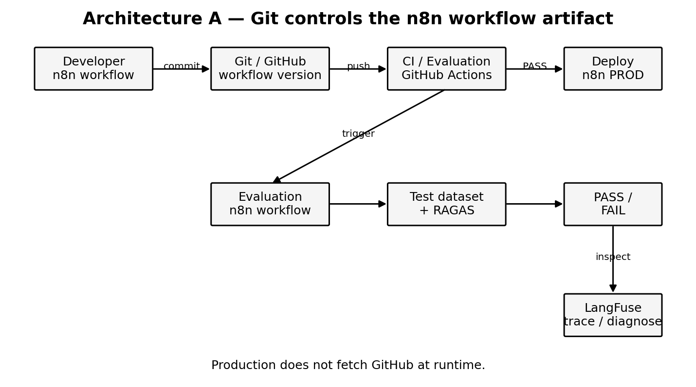

3. Architecture A — Git Versions the n8n Workflow
In Architecture A, the prompt remains part of the n8n workflow. GitHub is the source-control and promotion mechanism for the workflow artifact rather than a runtime prompt server.

3.1 Flow
- Developer changes the n8n workflow/prompt.
- The workflow artifact is versioned in Git/GitHub.
- A commit/push starts the CI pipeline.
- GitHub Actions starts the separate n8n evaluation workflow.
- The evaluation workflow runs the fixed regression dataset through the candidate agent.
- RAGAS produces evaluation metrics and the pipeline compares them with thresholds and/or the previous version.
- If the quality gate passes, the candidate workflow can be promoted/deployed; otherwise deployment is rejected or rolled back.
- LangFuse remains the diagnostic layer: when a metric falls, inspect the traces to understand why.

3.2 Key property
The production agent does not need to contact GitHub merely to obtain its prompt for every user request. Git is used for version control and deployment, not as the production request-time configuration server.

4. Architecture B — Prompt as an External Git Artifact
In Architecture B, the prompt is deliberately separated from the n8n workflow. A file such as prompts/hr_agent_v3.txt or a structured prompt configuration is stored in GitHub. The n8n workflow retrieves the selected prompt and injects it into the agent.
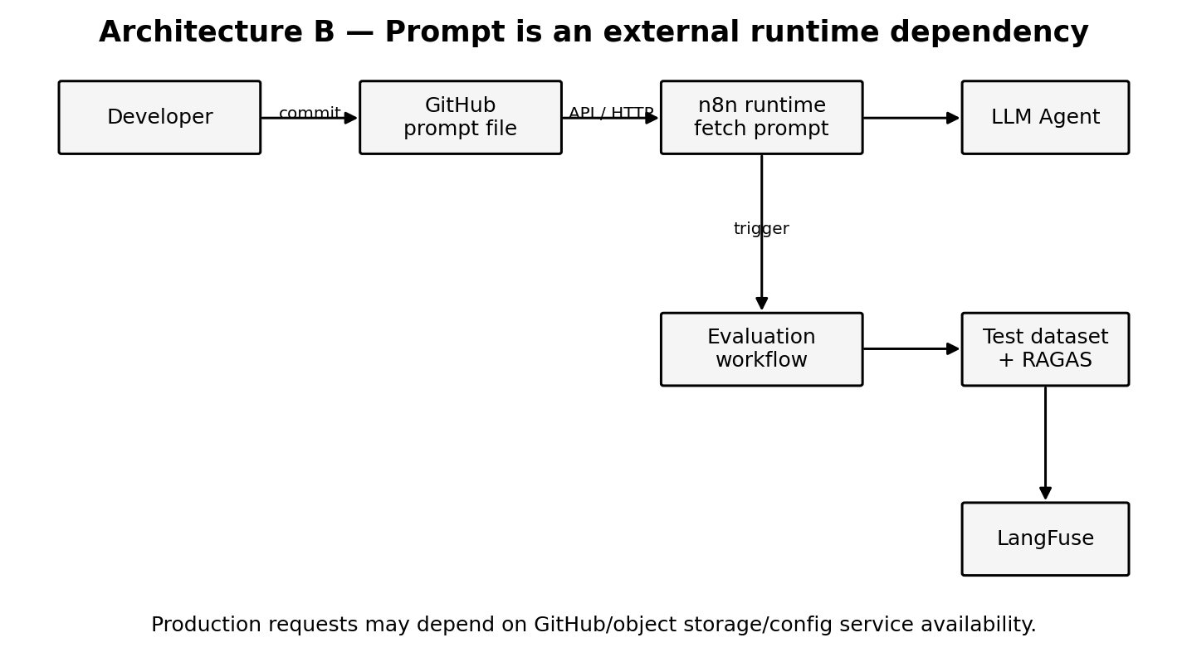

4.1 Flow
- Developer edits the external prompt file.
- GitHub versions the prompt independently of the n8n workflow.
- CI can run the same evaluation suite against the changed prompt.
- At runtime, n8n obtains the selected prompt through an API/HTTP/configuration mechanism.
- The agent executes using that prompt.

4.2 Key property
The prompt becomes an external runtime dependency. That can be useful when many applications consume the same prompt, when prompt management is intentionally centralized, or when prompts need to be deployed independently of workflow changes. It also introduces operational concerns that Architecture A avoids.

5. Architecture Comparison
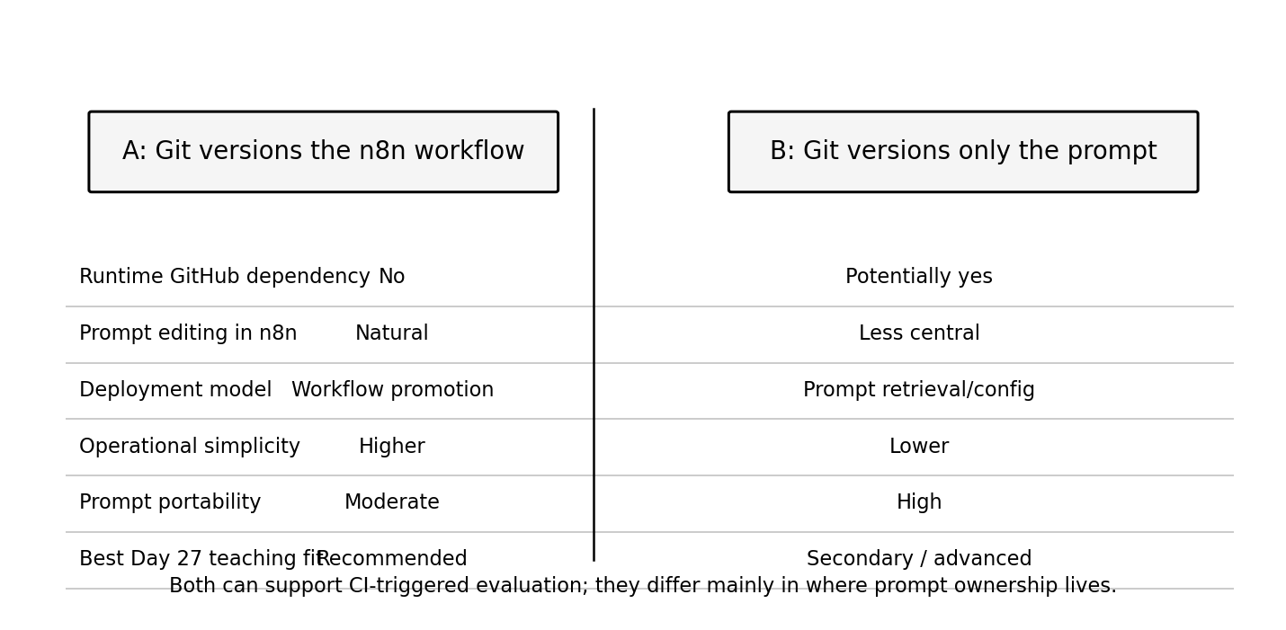
Dimension | Architecture A | Architecture B
Source of truth | Versioned n8n workflow | Versioned prompt artifact
Runtime dependency on GitHub | No, after deployment | Potentially yes, if fetched per request
Deployment unit | n8n workflow/version | Prompt/configuration
Prompt reuse across apps | Moderate | Strong
Operational simplicity | Higher | Lower
Failure mode | Deployment/version mismatch | Prompt retrieval/config outage or stale cache
Day 27 teaching fit | Primary | Advanced comparison

6. What Both Architectures Should Share
Regardless of where the prompt is stored, the CI/CD evaluation path should remain separate from the production user path.
Production path: Real user → Production n8n webhook → Agent → Answer.
Evaluation path: CI trigger → Evaluation n8n workflow → Test dataset → Agent → RAGAS/evaluator → Metrics → Quality gate.
The evaluation workflow should not pretend to be a real user request. The test dataset supplies the controlled questions and, where applicable, expected answers/reference information needed for evaluation.

7. Recommended Day 27 Architecture
For this bootcamp, Architecture A should be the primary architecture. It maps cleanly to the existing n8n-first implementation and makes the PromptOps lifecycle easy to demonstrate. Architecture B should be shown as a contrast/advanced pattern rather than the main hands-on path.
- Keep Production and Evaluation as two separate n8n workflows.
- Use Git/GitHub for version control and promotion of the n8n workflow/prompt artifact.
- Use GitHub Actions to orchestrate CI and invoke the evaluation workflow.
- Use a fixed regression dataset rather than production user traffic.
- Use RAGAS (or the selected evaluator) to produce repeatable metrics.
- Use thresholds as a release gate.
- Use LangFuse to inspect traces when the evaluation detects a regression.
- Demonstrate rollback by returning to the previously passing workflow/prompt version.

8. Recommended Teaching Sequence
A. Baseline: Run Prompt V2 against the test dataset and record the metrics.
B. Change: Make a deliberate Prompt V3 change.
C. Evaluate: Run the same dataset against V3.
D. Compare: Show V2 versus V3 metrics.
E. Diagnose: If a metric falls, open the corresponding LangFuse traces.
F. Gate: Make the CI decision PASS or FAIL using a threshold.
G. Promote/Rollback: Deploy the passing version or reject/rollback the failing version.
H. Contrast: Explain that Architecture B would externalize only the prompt and make prompt retrieval a runtime concern.

9. Important Architectural Distinction
GitHub Actions should not call the production HR webhook simply to run an evaluation. That would mix the production inference interface with test semantics. Instead, CI should invoke an evaluation-specific interface that knows it is processing a regression dataset. Both paths may ultimately exercise the same agent logic, but they have different entry points and different responsibilities.

10. Bottom Line
Architecture A is the better default for Day 27: it demonstrates PromptOps and CI/CD without making GitHub a runtime dependency. Architecture B is valuable when prompts are treated as independently managed configuration or shared assets across multiple applications. The central Day 27 lesson is unchanged in either design:
CHANGE → EVALUATE → COMPARE → QUALITY GATE → DEPLOY / ROLLBACK

Source basis: The attached 28-day bootcamp plan and Day 27 Continuous Evaluation plan. The source explicitly positions Day 27 around continuous evaluation, CI/CD, PromptOps, RAGAS, LangFuse, and regression testing.

