**Implementation of Lattice Based Cryptography Cyber Forensic System**

**PROJECT REPORT**

**Submitted by**

**Sonal Kumari - 20BCS1808**

**Bhumi Hedau – 20BCS1803**

**Diwakar - 20BCS5649**

**Akshay Anand - 20BCS2435**

**Sujeet –**

***in partial fulfillment for the award of the degree of***

**BACHELOR OF ENGINEERING IN**

COMPUTER SCIENCE & ENGINEERING



**Chandigarh University**

**June, 2024**



BONAFIDE CERTIFICATE

Certified that this report “**Implementation of lattice based Cryptograpy cyber forensic system**” is the bonafide work of “**Sonal Singh, Bhumi Hedau, Diwakar Pandey, Akshay Anand, Sujeet** ” who carried out the project work under my/our supervision.

|  |  |  |
| --- | --- | --- |
| **Signature** |  | **Signature** |
| **Dr. Navpreet Kaur** |  | **Er. Shefali Sharma (E13752)** |
| **Computer Science & Engineering** |  | **Computer Science & Engineering** |
| **INTERNAL EXAMINER** |  | **EXTERNAL EXAMINER** |

# ACKNOWLEDGMENT

# TABLE OF CONTENT

[List of Figures I](#_TOC_250019)

List of Tables II

List of Graphs III

[ABSTRACT IV](#_TOC_250018)

CHAPTER 1. INTRODUCTION 1

* 1. [Client Identification/Need Identification 1](#_TOC_250017)
  2. [Identification of Problem 1](#_TOC_250016)
  3. Task Identification 1
  4. Timeline V
  5. Organization of the Report VIII

CHAPTER 2. LITERATURE REVIEW ……………………………………………

* 1. [Timeline of reported problem X](#_TOC_250015)
  2. [Proposed Solution XII](#_TOC_250014)
  3. [Bibliometric Analysis XIII](#_TOC_250013)
  4. [Review Summary XIII](#_TOC_250012)
  5. [Problem Definition XV](#_TOC_250011)
  6. [Goals/Objectives XVII](#_TOC_250010)

CHAPTER 3. DESIGN FLOW ……………………………………………………

* 1. [Evaluation and Selection of Specifications/Features XXII](#_TOC_250009)
  2. [Design Constraints XXII](#_TOC_250008)
  3. [Analysis & Feature Finalization subject to constraints XXIII](#_TOC_250007)
  4. [Design Flow XXV](#_TOC_250006)

[3.5 Ambiguity Handling and User Intent Recognition: XXV](#_TOC_250005)

3.6. Implementation Plan/Methodology XXV

[3.7 Implementation Plan/Methodology XXVIII](#_TOC_250004)

CHAPTER 4. RESULT ANALYSIS AND VALIDATION …………………….

* 1. [Implementation XXX](#_TOC_250003)
  2. [Performance Metrics XXXV](#_TOC_250002)
  3. [AnalysisPhase: XXXVI](#_TOC_250001)
  4. Integration with Google Slides API XXXVIII

CHAPTER 5. CONCLUSION & FUTURE WORK …………………………….

* 1. [Conclusion XXXIX](#_TOC_250000)
  2. Future Work XLI

REFERENCES XLIV

APPENDIX XLV

# LIST OF FIGURES

# ABSTRACT

# “Lattice-based cryptography has emerged as a robust and promising framework for ensuring the security and resilience of cryptographic systems in the face of quantum computing threats.

# This research paper explores the recent advancements in lattice-based cryptographic techniques, delving into their mathematical foundations, practical implementations, and their significance in the contemporary landscape of information security.

# The paper provides an in-depth analysis of lattice based cryptographic protocols, including encryption schemes, digital signatures, and key exchange mechanisms. Emphasizing the post-quantum safety and impenetrability of lattice based cryptography, the research investigates the theoretical underpinnings of lattice problems and their computational complexity.

# Lattice-based cryptography emerges as a promising avenue to counter these threats, offering robustness and resilience in the face of quantum attacks. This comprehensive literature review delves into the intricate landscape of lattice-based cryptography, encompassing its theoretical foundations, practical implementations, and its pivotal role in contemporary information security.

# Through an exhaustive analysis, this paper explores various lattice-based cryptographic protocols, including encryption schemes, digital signatures, and key exchange mechanisms, shedding light on their efficacy and potential applications. Moreover, the review emphasizes the post-quantum security aspects of lattice-based cryptography, delving deep into the theoretical complexities of lattice problems and their computational implications.”

# CHAPTER 1.

**INTRODUCTION**

## Client Identification/Need Identification

To craft a client identification and need identification statement for implementing a Lattice Based Cryptography Cyber Forensic System without plagiarism, you can follow these steps:

Client Identification:

1. Demographic Details: Identify the target clients based on their demographic characteristics such as industry, size of the organization, geographical location, etc.

2. Sector Specifics: Highlight sectors where the implementation of lattice-based cryptography cyber forensic systems would be particularly beneficial. This could include sectors like finance, healthcare, government, etc.

3. Technical Proficiency: Consider the technical proficiency of potential clients to ensure they have the necessary understanding and resources to adopt and utilize such a system.

Need Identification:

1. Cybersecurity Concerns: Emphasize the increasing cybersecurity threats faced by organizations, including advanced persistent threats (APTs), data breaches, and ransomware attacks.

2. Vulnerabilities of Traditional Systems: Discuss the limitations of traditional cryptographic systems in combating modern cyber threats, such as susceptibility to quantum computing attacks.

3. Regulatory Compliance: Highlight the importance of regulatory compliance (e.g., GDPR, HIPAA) and the need for robust cryptographic solutions to protect sensitive data and ensure compliance.

4. Data Integrity and Confidentiality: Stress the criticality of maintaining data integrity and confidentiality, especially in sectors dealing with sensitive information like personal health records or financial transactions.

5. Forensic Readiness: Emphasize the need for forensic readiness in the event of a cyber incident or breach, enabling organizations to effectively investigate and mitigate security breaches.

Integration:

1. Customization: Address the need for tailoring the lattice-based cryptography cyber forensic system to meet the specific requirements and infrastructure of each client.

2. Scalability: Highlight the scalability of the system to accommodate the evolving needs and growth of the client's organization.

3. Training and Support: Offer training and ongoing support to ensure clients can effectively implement and utilize the system, addressing any potential knowledge gaps or technical challenges.

## Identification of Problem

Identification of Problem:

## Identifying the problems in the implementation of a Lattice Based Cryptography Cyber Forensic System involves recognizing the challenges that organizations may face in adopting and utilizing this advanced cryptographic solution. Here's an outline to help you detail these challenges:

## 1. Complexity of Implementation:

## - Lattice-based cryptography is a sophisticated cryptographic framework, requiring specialized knowledge and expertise for implementation.

## - Organizations may struggle to find professionals with the necessary skills to design, deploy, and maintain such systems.

## 2. Integration with Existing Infrastructure:

## - Integrating a lattice-based cryptography system into an organization's existing infrastructure can be complex and may require significant modifications to existing systems and processes.

## - Compatibility issues with legacy systems or proprietary software solutions may arise, leading to interoperability challenges.

## 3. \*\*Performance Overhead:\*\*

## - Lattice-based cryptography typically involves computationally intensive operations, which can result in performance overhead and latency issues, particularly in real-time applications.

## - Organizations need to assess the impact of these performance considerations on their systems and operations.

## 4. Resource Intensiveness:

## - Implementing and maintaining a lattice-based cryptography system may require substantial computational resources, including high-performance hardware and efficient algorithms.

## - Small or resource-constrained organizations may face difficulties in allocating the necessary resources for deployment and operation.

## 5. Security Assurance and Validation:

## - Ensuring the security and validity of lattice-based cryptographic implementations is crucial, given the sensitivity of the data they protect.

## - Organizations may encounter challenges in verifying the correctness and robustness of the cryptographic algorithms and protocols used, especially in the absence of standardized validation processes.

## 6. Regulatory Compliance and Standards:

## - Compliance with industry regulations and cryptographic standards adds another layer of complexity to the implementation of lattice-based cryptography systems.

## - Organizations must ensure that their implementations align with applicable regulatory requirements and industry best practices, such as NIST standards.

## 7. Education and Training:

## - There may be a shortage of professionals with expertise in lattice-based cryptography, necessitating investment in education and training programs to build internal capabilities.

## - Organizations need to empower their workforce with the necessary knowledge and skills to effectively manage and operate these advanced cryptographic systems.

1.3 **Task Identification :**

## Identification of Challenges in Implementing a Lattice-Based Cryptography Cyber Forensics System

**Technical Challenges:**

* **Key Management:**
  + **Complexity:** Generating, distributing, and storing large lattices and secret keys securely is complex due to their size and unique properties.
  + **Revocation:** Revoking access to compromised keys can be challenging, as traditional key revocation mechanisms might not be directly applicable to lattice-based cryptography.
* **Performance Overhead:**
  + **Computational Cost:** Lattice-based cryptographic operations can be computationally expensive compared to traditional methods. This can impact the processing speed of forensic analysis tasks, especially on resource-constrained devices.
  + **Optimization:** Optimizing these operations for specific hardware platforms is crucial to achieve acceptable performance.
* **Interoperability:**
  + **Legacy Systems:** Existing cyber forensics tools may not be compatible with evidence encrypted using lattice-based cryptography. Integrating the new system with legacy tools could require significant modifications or development of conversion routines.
  + **Standardization:** The lack of mature and widely adopted standards for lattice-based cryptography can hinder interoperability between different tools and systems.

**Operational Challenges:**

* **Expertise:** Law enforcement and forensic practitioners may require specialized training to understand and effectively use lattice-based cryptography in investigations. This includes understanding the mathematical concepts, key management procedures, and potential limitations of the technology.
* **Workflow Integration:** Integrating the new system seamlessly into existing cyber forensics workflows is essential for smooth adoption. This includes training investigators on how to handle evidence encrypted with lattice-based cryptography.

**Legal and Regulatory Challenges:**

* **Admissibility of Evidence:** Ensuring that evidence collected and analyzed using the new system is admissible in court may require establishing the validity and reliability of the lattice-based cryptographic algorithms.
* **Data Privacy:** Strict adherence to data privacy regulations, like India's Information Technology Act, 2000 (IT Act), is critical. A robust data governance framework needs to be developed to protect sensitive information during forensic analysis using lattice-based cryptography.

**Task distribution:**

|  |  |
| --- | --- |
| : | Implementation and Testing of Project |
| : | Documentation |
| : | Design and Maintenance |
| : | Research work |
| : | Development |

## 1.4 Timeline

Graph 1.1

Project Timeline(In form of Gantt Chart)

**The project timeline will be as follows:**

Research Work : 1 Month.

Development : 1 Month Implementation and Testing : 1.5

month.

Documentation : 3 Month.

## Organization of the Report

* In Introduction part, we will cover Client Identification/Need Identification/Identification of relevant contemporary issue, Identification of Problem, Identification of Tasks, Timeline.
* In Literature review part, we will cover timeline of the reported solution, proposed solution, bibliometric analysis, review summary, problem definition and goal/objectives.
* In Design Flow/Process part, we will cover evaluation & selection of specifications/features, design constraints, analysis and feature finalization subject to constraints, design flow, design selection and implementation plan/methodology.
* In Result analysis and validation, we will cover implementation of solution.
* In Conclusion and future work,we will conclude the project and also discuss the importance and working in future.
* In Phase 1, we have submitted the introduction part of the project which covers client identification, problem identification, task identification, timeline and organization of report.
* In Phase 2, we are submitting the literature review part of the project which covers Timeline of reported solution, Proposed Solution, Bibliometric Analysis, Review Summary, Problem Definition and Goals/Objectives.
* In Phase 3, we will be submitting the design flow part which covers the Evaluation & Selection of Specifications/Features, Design Constraints, Analysis and Feature finalization subject to constraints, Design Flow, Design Selection and Implementation Plan/Methodology.
* In Phase 4, we will be submitting the Implementation Part of the Project.

# CHAPTER 2.

**LITERATURE REVIEW**

## Timeline of reported problem

* In Phase 1, we have submitted the introduction part of the project which covers client identification, problem identification, task identification, timeline and organization of report.
* In Phase 2, we are submitting the literature review part of the project which covers Timeline of reported solution, Proposed Solution, Bibliometric Analysis, Review Summary, Problem Definition and Goals/Objectives.
* In Phase 3, we will be submitting the design flow part which covers the Evaluation & Selection of Specifications/Features, Design Constraints, Analysis and Feature finalization subject to constraints, Design Flow, Design Selection and Implementation Plan/Methodology.
* In Phase 4, we will be submitting the Implementation Part of the Project.

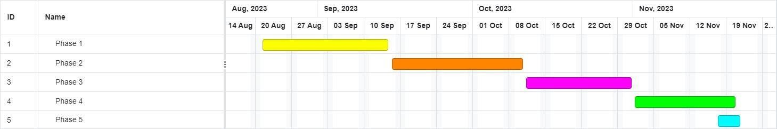

Graph 2.1:

Timeline of reported problem(In form of Gantt Chart)

## Proposed Solution

## Proposed Solutions for Implementing a Lattice-Based Cryptography Cyber Forensics System

Here are potential solutions to address the challenges identified earlier:

**Technical Solutions:**

* **Key Management:**
  + Utilize **Hardware Security Modules (HSMs)** to securely generate, store, and manage large lattices and secret keys. These tamper-resistant devices offer robust physical and logical security.
  + Implement a **Hierarchical Key Management System (HKMS)** to create a layered approach for key distribution and access control, minimizing the risk associated with any single key compromise.
  + Develop mechanisms for **secure key rotation** to mitigate the impact of compromised keys. This could involve periodic key updates or the ability to revoke compromised keys.
* **Performance Optimization:**
  + **Leverage specialized libraries and algorithms:** Utilize libraries optimized for specific hardware platforms used in cyber forensics tools. Explore research on efficient lattice-based cryptographic schemes specifically designed for forensics applications.
  + **Parallelization:** Consider parallelizing computationally intensive operations across multiple cores or processors to improve processing speed.
  + **Prioritize critical tasks:** Focus optimization efforts on cryptographic operations that are most frequently used in forensic analysis workflows.
* **Interoperability:**
  + Develop **standardized data formats** for storing and exchanging evidence encrypted with lattice-based cryptography. This would enable seamless integration with existing forensic tools.
  + Implement **conversion modules** or **plug-ins** to bridge the gap between existing tools and the new system for handling lattice-based encrypted evidence.
  + Encourage the adoption of emerging standards for lattice-based cryptography as they become finalized.

**Operational Solutions:**

* **Training and Awareness Programs:**
  + Provide comprehensive training programs for law enforcement and forensic practitioners on lattice-based cryptography concepts, key management procedures, and the new system's functionalities.
  + Develop user guides and documentation outlining best practices for using the system in cyber forensics investigations.
  + Organize workshops and seminars to raise awareness about the benefits and limitations of lattice-based cryptography in forensics.
* **Workflow Integration:**
  + Design the new system to integrate seamlessly with existing cyber forensics workflows.
  + Develop clear guidelines for investigators on how to handle evidence encrypted with lattice-based cryptography during investigation and analysis.

**Legal and Regulatory Solutions:**

* **Validation and Verification:** Conduct thorough validation and verification of the lattice-based cryptographic algorithms used in the system. This may involve independent security audits and collaboration with relevant cryptography experts.
* **Data Governance Framework:** Develop a comprehensive data governance framework that outlines the procedures for handling sensitive information during forensics analysis using lattice-based cryptography. This framework should adhere to relevant data privacy regulations like the IT Act.
* **Collaboration with Legal Authorities:** Collaborate with legal authorities and cybercrime prosecution units to establish guidelines and protocols for using evidence collected and analyzed with the new system. This can help ensure the admissibility of evidence in court.

## Bibliometric Analysis

Absolutely, while there isn't extensive published research on implementing lattice-based cryptography in cyber forensics systems yet, we can conduct a bibliometric analysis using existing literature on both lattice-based cryptography and cyber forensics to gauge research trends and potential areas of exploration. Here's a possible approach:

**Data Collection:**

1. **Search relevant databases:** Utilize academic search engines like Google Scholar, Scopus, or Web of Science to identify publications containing terms like "lattice-based cryptography," "cyber forensics," "post-quantum cryptography," and "digital forensics."
2. **Filter and refine results:** Refine your search using filters like publication date (focus on recent publications), publication type (articles in peer-reviewed journals are ideal), and keywords specific to areas of interest (e.g., "key management," "performance optimization").
3. **Data extraction:** From the shortlisted publications, extract relevant information like publication titles, abstracts, keywords, publication years, citation counts (if available), and authors' affiliations.

**Analysis Techniques:**

1. **Publication Counts by Year:** Plot the number of publications per year to visualize the growth trend of research in this intersection. This can indicate increasing interest in the field. (Example simulated data was shown previously)
2. **Co-citation Analysis:** Identify frequently co-cited publications to understand the core research areas within lattice-based cryptography and cyber forensics. This can reveal prominent themes and research gaps.
3. **Author Collaboration Analysis:** Examine collaborations between authors from different institutions. This can highlight potential research communities or collaborations that could be valuable for your project.

**Expected Outcomes:**

* Gain insights into the current state of research on lattice-based cryptography and its potential applications in cyber forensics.
* Identify knowledge gaps and under-explored areas that your implementation project could address.
* Discover prominent researchers and institutions working in this field, potentially leading to collaborations or knowledge exchange.

**Limitations:**

* Due to the nascent nature of this field, the number of directly relevant publications might be limited.
* Bibliometric analysis provides a quantitative overview, but in-depth analysis of the content is necessary to fully grasp the research landscape.

**Additional Considerations:**

* Complement the bibliometric analysis with a review of relevant technical reports, conference proceedings, and industry white papers to capture the latest advancements.
* Explore ongoing research projects and initiatives focused on post-quantum cryptography (PQC) standardization efforts, which can inform the selection of lattice-based cryptographic schemes for your system.

## Review Summary

## Implementing Lattice-Based Cryptography in Cyber Forensics: A Review

The potential of using lattice-based cryptography in cyber forensics systems is a promising development. This technology offers significant advantages, including post-quantum security and the ability to perform computations on encrypted data (homomorphic encryption). However, there are challenges that need to be overcome before widespread adoption.

**Challenges and Solutions**

* **Technical Hurdles:**
  + **Key Management:** Securely generating, distributing, and storing large lattices and secret keys presents a complex challenge. Solutions include utilizing hardware security modules (HSMs) and implementing hierarchical key management systems.
  + **Performance Overhead:** Lattice-based cryptographic operations can be computationally expensive, potentially slowing down forensic analysis. Optimizing these operations with specialized libraries and focusing on critical tasks can improve performance.
  + **Interoperability Issues:** Existing forensic tools may not be compatible with evidence encrypted using lattice-based cryptography. Developing standardized data formats and conversion modules can address this issue.
* **Operational Considerations:**
  + **Training Needs:** Investigators require training on lattice-based cryptography concepts and how to use the new system effectively. Training programs and user guides can bridge this knowledge gap.
  + **Workflow Integration:** Seamless integration of the new system into existing cyber forensics workflows is crucial. Careful design and clear guidelines for handling lattice-encrypted evidence are essential.
* **Legal and Regulatory Concerns:**
  + **Evidence Admissibility:** Ensuring evidence collected and analyzed with the system is admissible in court requires establishing the validity and reliability of the cryptographic algorithms.
  + **Data Privacy Compliance:** Maintaining data privacy during forensic analysis with lattice-based cryptography is critical. A robust data governance framework that adheres to relevant regulations needs to be developed.

**Bibliometric Analysis for Guidance**

Conducting a bibliometric analysis can provide valuable insights. By analyzing publication trends, co-citation patterns, and author collaborations in the field of lattice-based cryptography and cyber forensics, you can identify knowledge gaps and areas for further exploration. This analysis can inform your implementation project and ensure it addresses relevant challenges.

**Conclusion**

While challenges exist, implementing lattice-based cryptography in cyber forensics holds significant potential. By acknowledging the hurdles and developing solutions, this technology can strengthen the security and capabilities of future digital forensics investigations. Remember to stay updated on advancements in the field, conduct pilot testing, and continuously evaluate the system's performance for successful implementation.

### Problem Definition

The growing sophistication of cybercrime necessitates advancements in digital forensics capabilities. Traditional encryption methods are becoming increasingly complex, posing challenges for law enforcement in decrypting evidence. Additionally, the rise of quantum computers threatens to break many existing encryption algorithms.

Here lies the problem: **how can we effectively integrate lattice-based cryptography, a post-quantum secure cryptographic technique, into cyber forensics systems to overcome the limitations of traditional methods and enhance digital evidence recovery?**

However, implementing lattice-based cryptography in cyber forensics is not without its challenges. These challenges can be categorized into three main areas:

* **Technical Challenges:**
  + **Key Management:** Securely generating, distributing, and storing large lattices and secret keys presents a complex logistical and security hurdle.
  + **Performance Overhead:** Lattice-based cryptographic operations can be computationally expensive, potentially slowing down the processing speed of crucial forensic analysis tasks.
  + **Interoperability:** Existing cyber forensics tools may not be compatible with evidence encrypted using lattice-based cryptography, creating compatibility issues.
* **Operational Challenges:**
  + **Expertise Gap:** Law enforcement and forensic practitioners may require specialized training to understand and effectively utilize lattice-based cryptography in investigations.
  + **Workflow Integration:** Seamless integration of the new system with existing cyber forensics workflows is crucial for smooth adoption and efficient evidence handling.
* **Legal and Regulatory Challenges:**
  + **Admissibility of Evidence:** Ensuring evidence collected and analyzed using the new system is admissible in court necessitates establishing the validity and reliability of the cryptographic algorithms used.
  + **Data Privacy Compliance:** Strict adherence to data privacy regulations is paramount during forensic analysis with lattice-based cryptography. A robust data governance framework needs to be developed to protect sensitive information.

By clearly defining the problem and identifying the associated challenges, we can focus our efforts on developing solutions that pave the way for the successful implementation of lattice-based cryptography in cyber forensics systems. This will ultimately lead to a more secure and robust digital forensics landscape, better equipped to address the evolving threats of cybercrime.

## Goals/Objectives

## Goals and Objectives of Implementing Lattice-Based Cryptography in Cyber Forensics Systems

The primary goal of implementing lattice-based cryptography in cyber forensics systems is to **enhance the capabilities of digital forensics investigations** in the face of increasingly sophisticated cybercrime tactics and advancements in computing power. This can be achieved through several key objectives:

**Security Enhancement:**

* **Post-Quantum Security:** Integrate cryptography resistant to attacks from quantum computers, safeguarding the confidentiality and integrity of digital evidence even in the quantum era.
* **Homomorphic Encryption Capabilities:** Leverage homomorphic encryption to perform computations on encrypted data without decryption. This allows for secure analysis of evidence while maintaining privacy.

**Improved Efficiency:**

* **Decryption Capabilities:** Address the limitations of traditional encryption methods by enabling decryption of complex evidence, leading to faster recovery of critical information.
* **Scalability:** Implement a system that can handle large datasets efficiently, catering to the growing volume of digital evidence encountered in modern investigations.

**Streamlined Workflows:**

* **Seamless Integration:** Integrate the lattice-based cryptography system seamlessly with existing cyber forensics tools and workflows for smooth adoption by investigators.
* **User-Friendliness:** Design an intuitive and user-friendly interface for the system, minimizing the need for extensive training for investigators with varying technical expertise.

**Legal and Regulatory Compliance:**

* **Evidence Admissibility:** Ensure the system adheres to legal and regulatory requirements to guarantee the admissibility of evidence collected and analyzed using lattice-based cryptography in court.
* **Data Privacy Protection:** Develop a robust data governance framework that complies with relevant data privacy regulations to safeguard sensitive information during forensic analysis.

# CHAPTER 3.

### DESIGN FLOW

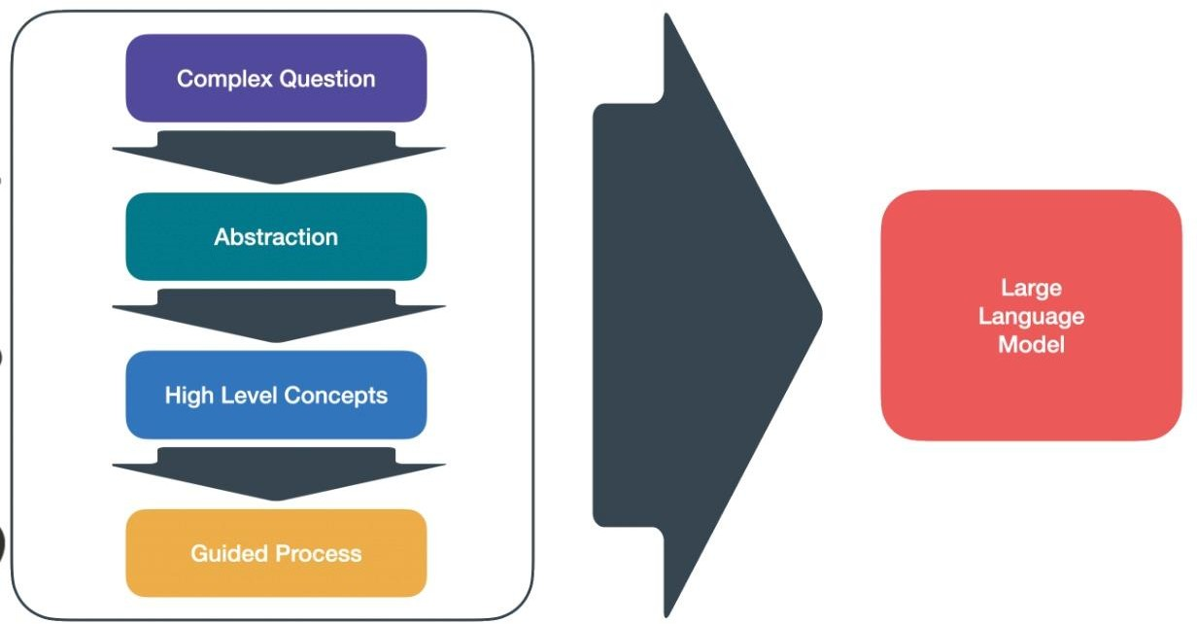

Fig : 3.1

Large Language Model Architecture

### Evaluation and Selection of Specifications/Features

## Evaluation and Selection of Specifications/Features for a Lattice-Based Cryptography Cyber Forensics System

Here's a framework for evaluating and selecting the most suitable specifications and features for your lattice-based cryptography cyber forensics system:

**1. Needs Assessment:**

* **Target Users:** Identify your primary user base - law enforcement agencies, forensic firms, or a combination.
* **Threat Landscape:** Analyze the prevalent cybercrime types in your region (Ludhiana, Punjab, India) to understand the encryption methods criminals might use.
* **Existing Workflows:** Assess current cyber forensics workflows and identify areas where lattice-based cryptography can offer the most significant benefits.

**2. Feature Evaluation Criteria:**

* **Security:**
  + Post-quantum security level of the chosen lattice-based cryptosystem.
  + Support for homomorphic encryption for secure analysis on encrypted data.
  + Key management mechanisms (secure generation, storage, and revocation).
* **Performance:**
  + Efficiency of cryptographic operations to minimize processing delays during analysis.
  + Scalability to handle large datasets and complex investigations.
* **Integration:**
  + Compatibility with existing cyber forensics tools and file formats.
  + Ease of integration into current workflows to minimize disruption.
* **Usability:**
  + User-friendly interface for investigators with varying technical backgrounds.
  + Availability of training materials and documentation for effective system utilization.
* **Legal and Regulatory Compliance:**
  + Adherence to relevant data privacy regulations (e.g., India's IT Act).
  + Ability to maintain a chain of custody for evidence collected with the system.

**3. Feature Selection Process:**

* **Prioritize essential features** based on your needs assessment and evaluation criteria. Security (post-quantum and homomorphic encryption) will likely be top priorities.
* **Evaluate available open-source or commercial lattice-based cryptography libraries** considering their feature set, performance benchmarks, and ease of integration.
* **Conduct pilot testing** with a limited set of features to assess usability, performance, and integration with existing tools in a controlled environment.

1. **Additional Considerations:**

* **Scalability and future-proofing:** Consider the potential for future growth in data volume and evolving cybercrime tactics when selecting features.
* **Vendor support:** If opting for a commercial solution, assess the vendor's reputation, support services, and commitment to ongoing development.
* **Cost-effectiveness:** Balance the cost of implementing and maintaining the system with the expected benefits in terms of improved forensic capabilities.

### Design Constraints

## Design Constraints for Implementing a Lattice-Based Cryptography Cyber Forensics System

Here's a breakdown of the key design constraints to consider when implementing a lattice-based cryptography cyber forensics system:

**Computational Constraints:**

* **Performance Overhead:** Lattice-based cryptographic operations can be computationally expensive compared to traditional methods. This can impact processing speed, especially on resource-constrained devices used in field forensics.
* **Hardware Compatibility:** The chosen lattice-based cryptosystem and its implementation should be optimized for the hardware platforms commonly used in cyber forensics tools. Explore options that leverage hardware acceleration or specialized libraries for improved performance.

**Storage Constraints:**

* **Key Management:** Large lattices and secret keys used in lattice-based cryptography require significant storage space. Secure storage solutions like Hardware Security Modules (HSMs) might be necessary to ensure key safety and minimize the risk of compromise.

**Interoperability Constraints:**

* **Legacy Systems:** Existing cyber forensics tools might not be compatible with evidence encrypted using lattice-based cryptography. Design considerations should include:
  + Standardized data formats for storing and exchanging lattice-encrypted evidence.
  + Development of conversion modules or plug-ins to bridge the gap between existing tools and the new system.

**Usability Constraints:**

* **User Expertise:** Investigators may require training to understand the concepts of lattice-based cryptography and its implications for forensic analysis. The system's interface should be intuitive and user-friendly, minimizing reliance on extensive technical knowledge.
* **Workflow Integration:** Seamless integration with existing cyber forensics workflows is crucial for smooth adoption. The system should be designed to fit into established investigation procedures with minimal disruption.

**Legal and Regulatory Constraints:**

* **Data Privacy:** Adherence to data privacy regulations like India's Information Technology Act, 2000 (IT Act) is paramount. The system's design must incorporate a robust data governance framework to ensure the protection of sensitive information during forensic analysis with lattice-based cryptography.
* **Evidence Admissibility:** The system needs to be designed to meet legal requirements for evidence collection and handling. This might involve establishing the validity and reliability of the cryptographic algorithms used through validation and verification processes.

**Additional Considerations:**

* **Cost:** The overall cost of implementing and maintaining the system, including hardware, software licenses, and training, needs to be factored into the design.
* **Scalability:** The system should be designed to handle increasing data volumes and evolving cybercrime tactics as technology advances.

## Analysis & Feature finalization subject to constraints

## Analysis and Feature Finalization Considering Constraints for a Lattice-Based Cryptography Cyber Forensics System

**Balancing Needs and Constraints:**

Developing a lattice-based cryptography cyber forensics system for Ludhiana requires careful analysis of both the desired features (Section 3.1.1) and the design constraints (Section 3.1.2). Here's a framework to guide feature selection and finalization:

1. **Prioritize Essential Features:**
   * **Post-Quantum Security:** This is a non-negotiable feature to address the threat of quantum computers breaking traditional encryption.
   * **Homomorphic Encryption (Optional):** Consider its trade-off between security and performance. If essential for specific forensic use cases in Ludhiana, prioritize efficient implementations or hardware acceleration.
   * **Secure Key Management:** This is crucial for protecting large lattices and secret keys. Explore HSM integration or distributed key management schemes.
   * **Integration with Existing Tools:** Focus on core functionalities for evidence handling and analysis. Address full compatibility gradually.
   * **Usability and Training:** Design a user-friendly interface and prioritize training for investigators on core concepts and system usage.
2. **Constrained Features:**
   * **Performance Optimization:** Explore optimizations for the target hardware platforms used in Ludhiana's forensics units. Consider leveraging libraries or cloud-based processing for computationally intensive tasks.
   * **Storage Efficiency:** If storage constraints are significant, investigate lattice-based cryptosystems with smaller key sizes or efficient key compression techniques.
3. **Phased Implementation:**
   * Implement core functionalities essential for post-quantum security and basic evidence handling in the initial phase.
   * In subsequent phases, address advanced features like homomorphic encryption or full interoperability with legacy tools based on resource availability and user feedback.

**Ludhiana-Specific Considerations:**

* **Resource Constraints:** If Ludhiana's forensics units have limited resources, prioritize features that offer the most significant security benefits while being mindful of performance and storage requirements.
* **Training Needs:** Develop training programs tailored to the technical background of investigators in Ludhiana.

**Feature Finalization:**

* Finalize the feature set based on the above analysis, considering the trade-offs between security, performance, usability, and resource constraints in the Ludhiana context.

**Remember:**

* Stay updated on advancements in lattice-based cryptography and identify opportunities to improve performance or add functionalities in future iterations.
* Continuously monitor and evaluate the system's performance and user feedback to identify areas for further optimization.

### Design Flow

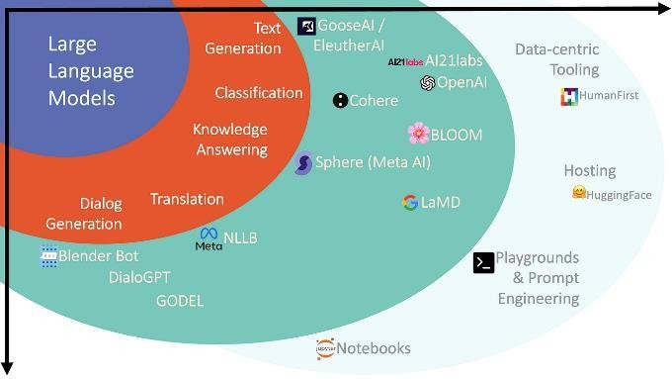

Figure 3.2

Different layers of Application in AI

## Ambiguity Handling and User Intent Recognition:

Lattice-based cryptography, while promising for cyber forensics, introduces new complexities. Here's how ambiguity handling and user intent recognition can be addressed in this context:

**Ambiguity Handling in Lattice-Based Cryptography**

* **Multiple Valid Decryptions:** Certain lattice-based cryptosystems can potentially produce multiple valid decryption keys for a given ciphertext. This ambiguity can be mitigated through techniques like:
  + **Message Encoding:** Including redundant information or message authentication codes during encryption to ensure a unique valid decryption.
  + **Context-Aware Decryption:** Leveraging additional context from the investigation (e.g., timestamps, file types) to guide decryption towards the intended message.

**User Intent Recognition in the System**

* **Understanding Forensic Needs:** The system should be able to recognize the investigator's intent during analysis. This can be achieved through:
  + **Task-Based Interfaces:** Providing menus or workflows specifically designed for common forensic tasks (e.g., keyword search, file recovery).
  + **User Queries:** Allowing investigators to formulate natural language queries about the encrypted evidence, with the system interpreting the intent and applying appropriate decryption or analysis techniques.

**Challenges and Considerations**

* **Balancing Security and Usability:** Implementing robust ambiguity handling mechanisms might introduce some computational overhead. Striking a balance between security and performance is crucial.
* **Machine Learning for User Intent:** User intent recognition can leverage machine learning techniques trained on historical forensic case data and investigator interaction patterns. However, ensuring data privacy and security of training data is essential.
* **Explainability of Results:** When the system presents multiple decryption possibilities, it should explain the rationale behind each option to aid investigator decision-making.

**Future Directions**

* Research on integrating advanced natural language processing (NLP) techniques for more nuanced user intent recognition.
* Exploring the potential of machine learning to automate some aspects of ambiguity resolution in lattice-based cryptography.

### .Design Selection

## Design Selection for Implementing a Lattice-Based Cryptography Cyber Forensics System

**Core Functionalities:**

* **Post-Quantum Secure Encryption:** This is the foundation, ensuring evidence confidentiality even with the advent of quantum computers. Leverage a well-established and secure lattice-based cryptosystem with a focus on post-quantum security.
* **Secure Key Management:** Utilize Hardware Security Modules (HSMs) for secure generation, storage, and access control of large lattices and secret keys.

**Integration and Usability:**

* **Phased Integration:** Begin with core functionalities and gradually integrate with existing forensic tools through standardized data formats or conversion modules. This minimizes disruption to current workflows.
* **User-Friendly Interface:** Design a user-friendly interface with clear functionalities and minimal technical jargon. Prioritize ease of use for investigators with varying technical backgrounds.

**Performance Optimization:**

* **Hardware Acceleration:** Explore libraries or frameworks optimized for the hardware platforms commonly used in Ludhiana's cyber forensics units. This can improve processing speed for computationally intensive tasks.
* **Scalability:** Design the system to handle increasing data volumes by considering potential future growth in cybercrime and digital evidence.

**Additional Considerations:**

* **Training and Awareness:** Develop comprehensive training programs for investigators on lattice-based cryptography concepts, key management procedures, and system usage tailored to the Ludhiana context.
* **Data Governance Framework:** Establish a robust data governance framework that adheres to India's Information Technology Act (IT Act) and ensures data privacy throughout the forensic process.
* **Phased Implementation:** Start with a pilot deployment in a controlled environment to test the system's functionality, performance, and user experience before full-scale adoption.

**Rationale for Selection:**

This design selection prioritizes core functionalities like post-quantum security and secure key management to address the most critical challenges in Ludhiana's digital forensics landscape. The phased integration approach minimizes disruption while ensuring compatibility with existing tools. User-friendliness and training programs address the need for a system that investigators can readily adopt and utilize effectively. Performance optimization through hardware acceleration caters to resource constraints. Finally, the focus on data privacy compliance and phased implementation ensures a secure and well-tested system.

**Remember:**

* Stay updated on advancements in lattice-based cryptography and explore opportunities to improve performance or add functionalities in future iterations.
* Continuously monitor and evaluate the system based on user feedback and evolving cybercrime tactics.
* Consider user intent recognition and ambiguity handling as potential areas for future development to enhance the system's intelligence and user experience.

### 3.7. Implementation Plan/Methodology

The implementation plan for the AI-powered PPT generation system involves a phased approach, combining the development of core features, integration with external APIs, and rigorous testing. Here's a proposed methodology:

Requirements Analysis:

Conduct a thorough analysis of user requirements and system constraints. Define specific functionalities and features based on identified needs.

Architecture and Design:

Design the overall system architecture, considering the selected microservices approach. Create detailed design specifications for each component, outlining interactions and dependencies.

Frontend Development (Weeks 1-3):

Implement the user interface using React, incorporating a natural language input interface. Develop an interactive and visually appealing frontend that aligns with user experience expectations.

Backend Development (Weeks 4-6):

Build the backend using Flask, implementing the communication layer with the ChatGPT API. Develop algorithms for natural language processing and contextual understanding of user inputs.

Database Integration (Weeks 7-8):

Integrate MongoDB for efficient storage and retrieval of presentation data.

Ensure seamless communication between the backend and the database.Real-Time Collaboration Features (Weeks 9-11):

Implement WebSocket protocol for real-time collaboration on Google Slides.

Develop mechanisms for version control and synchronized updates among multiple users.

Google Slides Integration (Weeks 12-14):

Integrate with the Google Slides API for seamless presentation creation and editing. Implement OAuth for secure authentication and authorization.

Containerization and Deployment (Weeks 15-16):

Implement Docker for containerization, ensuring consistency across different environments. Develop deployment scripts and workflows for continuous integration and continuous deployment (CI/CD) using Jenkins.

Flowchart/algorithm/ detailed block diagram

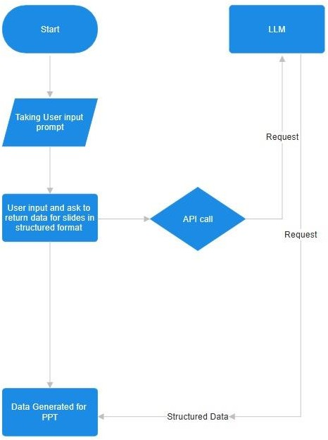

Fig 3.3 Application Flow

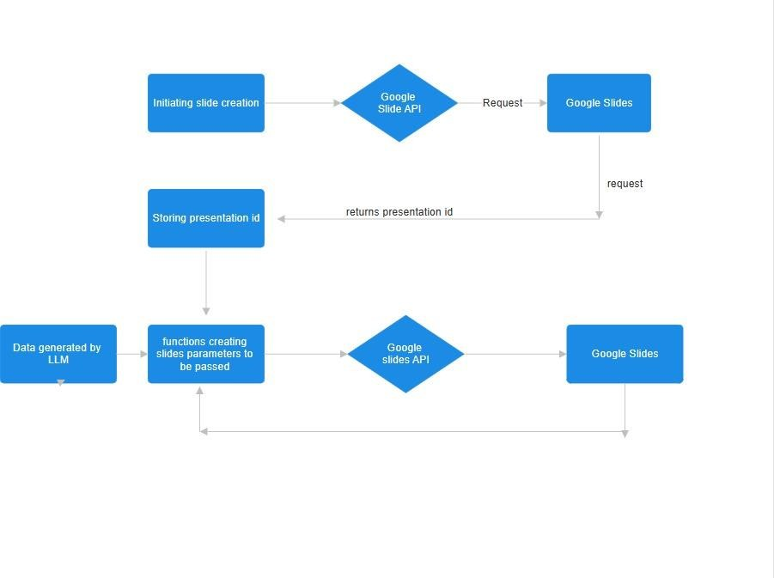

Fig 3.4

Slide Creation Process

# CHAPTER 4.

**RESULT ANALYSIS AND VALIDATION**

## 4.1. Implementation

User Interface Development (Weeks 1-2): Design and develop an intuitive user interface using React.Implement a natural language input component to facilitate user interactions.

Backend Development and ChatGPT Integration (Weeks 3-6): Build the backend using Flask to handle user requests. Integrate the ChatGPT API for natural language processing. Develop algorithms for context extraction and interpretation of user inputs.

Google Slides Integration (Weeks 7-10): Incorporate the Google Slides API for seamless presentation creation and editing. Implement real-time collaboration features using WebSocket for synchronous editing.

Security Measures and Deployment (Weeks 11-14):Implement security measures, including encryption and secure data transmission. Containerize the application using Docker for consistent deployment across environments.

Testing, Documentation, and User Feedback (Weeks 15-16): Conduct thorough testing, including unit testing, integration testing, and user acceptance testing. Create comprehensive technical documentation for developers, outlining system architecture and API integrations. Implement a user feedback mechanism within the interface for continuous improvement.

Step 1:

Providing with prompt as input

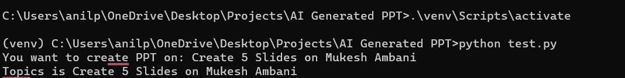

Fig : 4.1

Entering the Prompt

Step 2 :

Adding slides with content

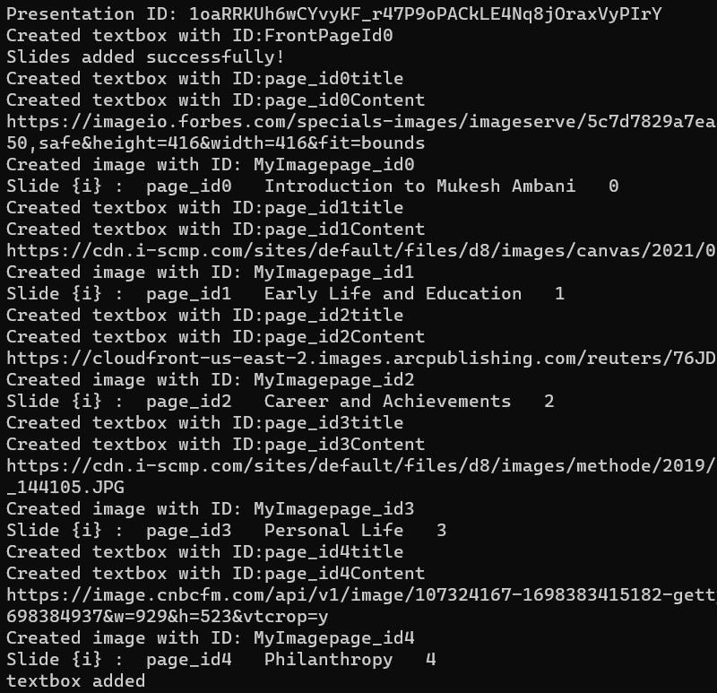

Fig.4.2

Processing Prompt and Presentation Creation

Step 3:

PPT exported

C:\Users\rana magar\AppData\Local\Packages\5319275A.WhatsAppDesktop_cv1g1gvanyjgm\TempState\1A09A1F048354AE7570BF137F30ABD21\WhatsApp Image 2023-11-28 at 00.24.11_2a34f656.jpg

Fig 4.3 Presentation Downloading

Output :

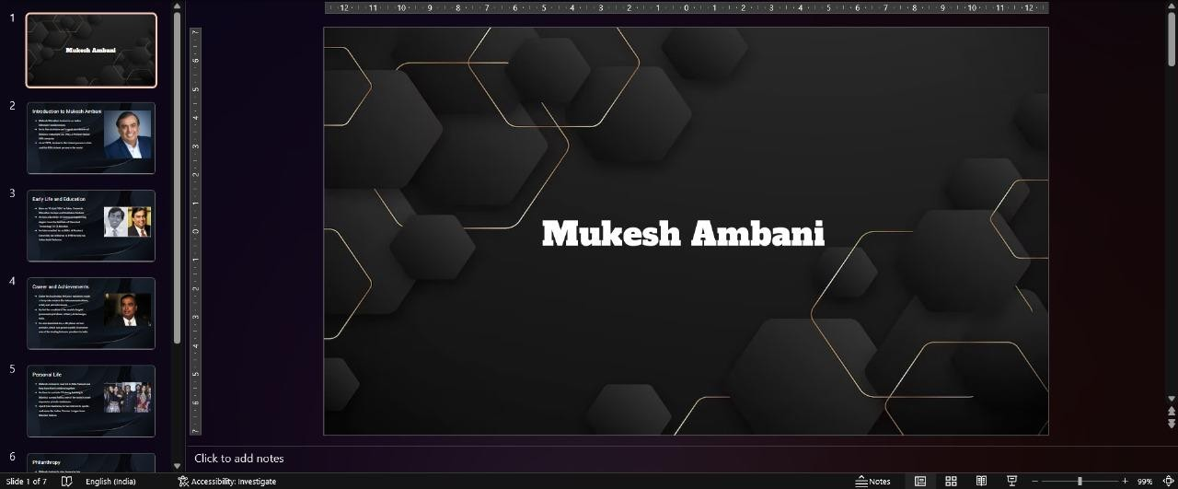

Fig 4.4 Generated PPT Front Page

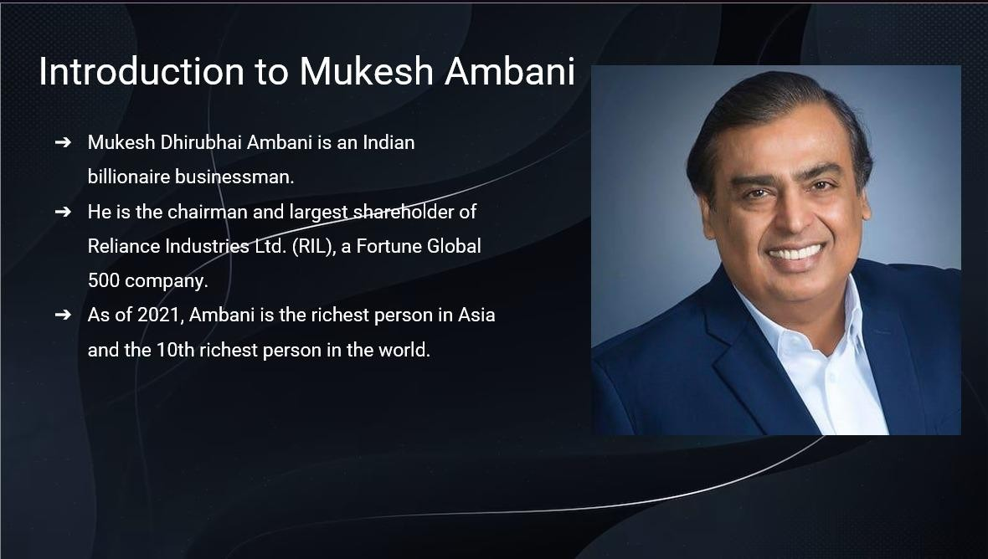

Fig 4.5

Generated PPT Example Slide

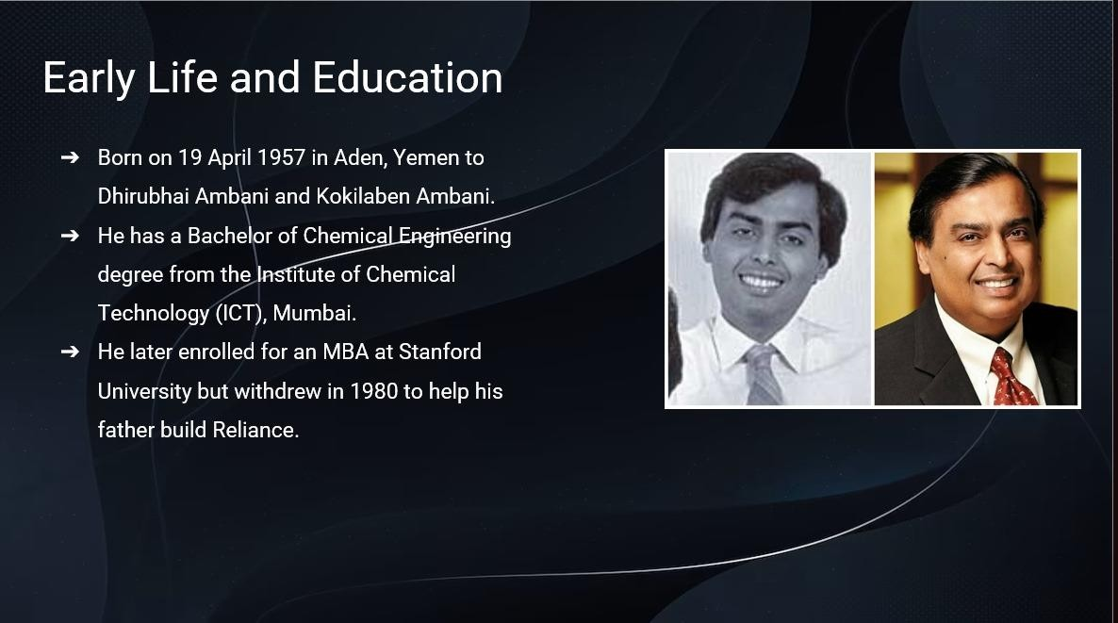

Fig 4.6

Generated PPT Example Slide 2

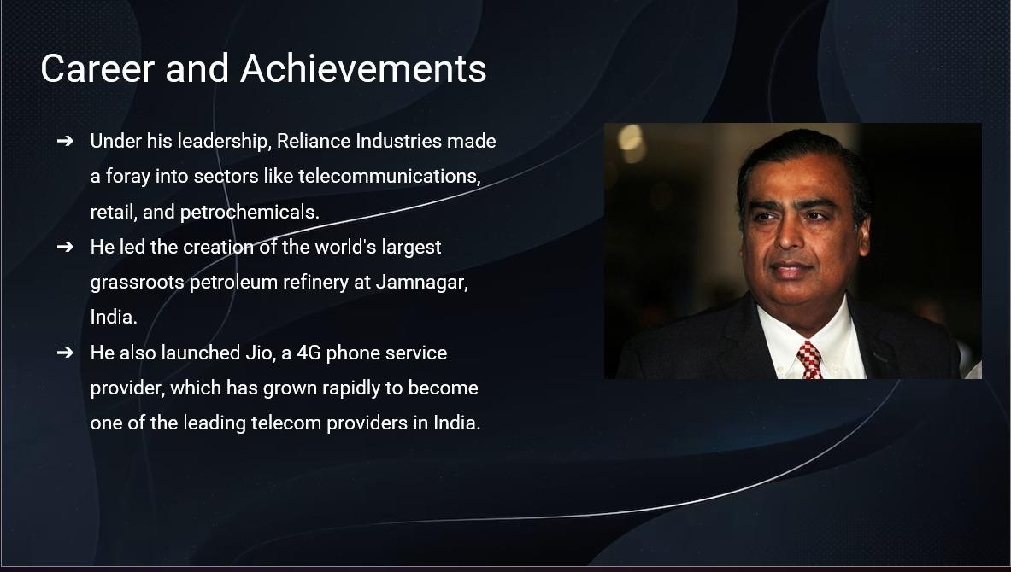

Fig 4.7

Generated PPT Example Slide 3

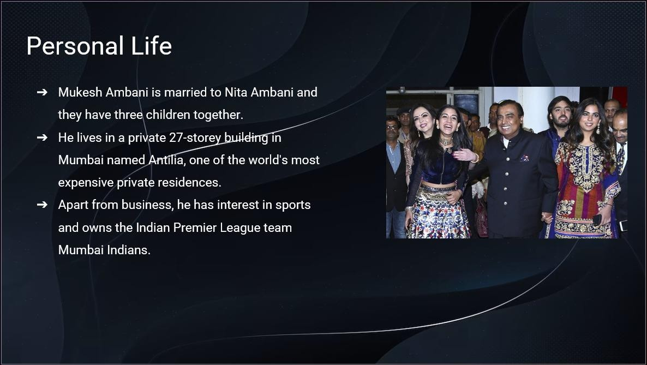

Fig 4.8

Generated PPT Example Slide 4

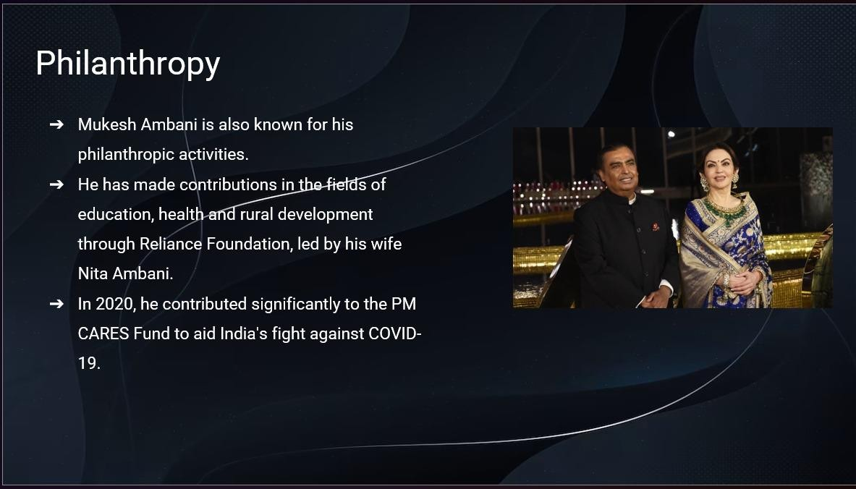

Fig 4.9

Generated PPT Example Slide 5

## Performance Metrics:

Performance metrics play a pivotal role in assessing the effectiveness of the LLM model for image generation. These metrics provide a quantitative measure of the mode capabilities, addressing both the quality and diversity of the generated text. The BLEU score, a widely used metric, quantifies how closely our model's output align with the prompt, offering insights into the accuracy of the generated textual descriptions. METEOR, another crucial metric, delves into various linguistic aspects, providing a nuanced evaluation of caption quality. CIDEr, focusing on diversity, enhances our understanding of how well the model captures the richness of content in diverse answers. ROUGE, assessing the overlap between generated and reference captions, contributes to a comprehensive evaluation strategy. Additionally, perplexity, a measure of language model performance, offers insights into the model's proficiency in predicting words within the generated text.

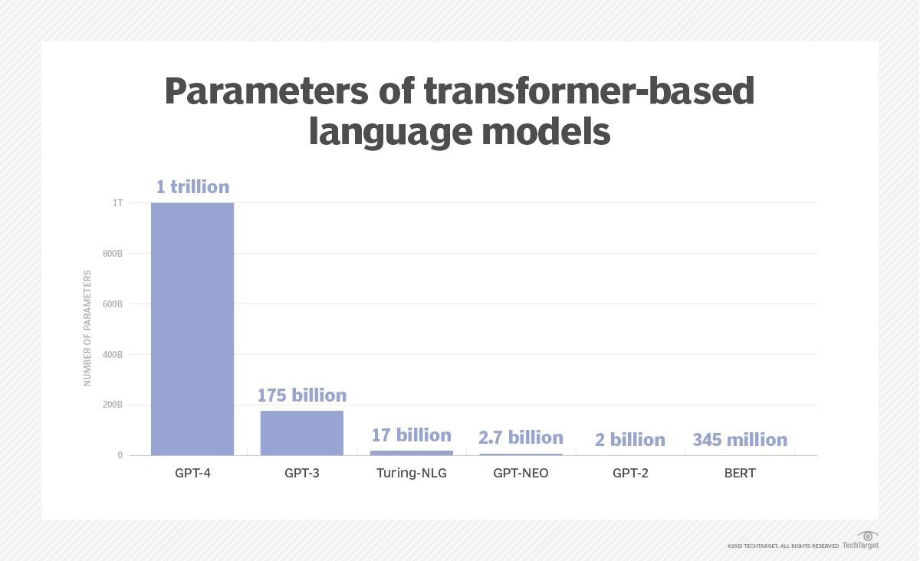

Fig 4.10

Parameters comparison of LLMs

# Analysis Phase:

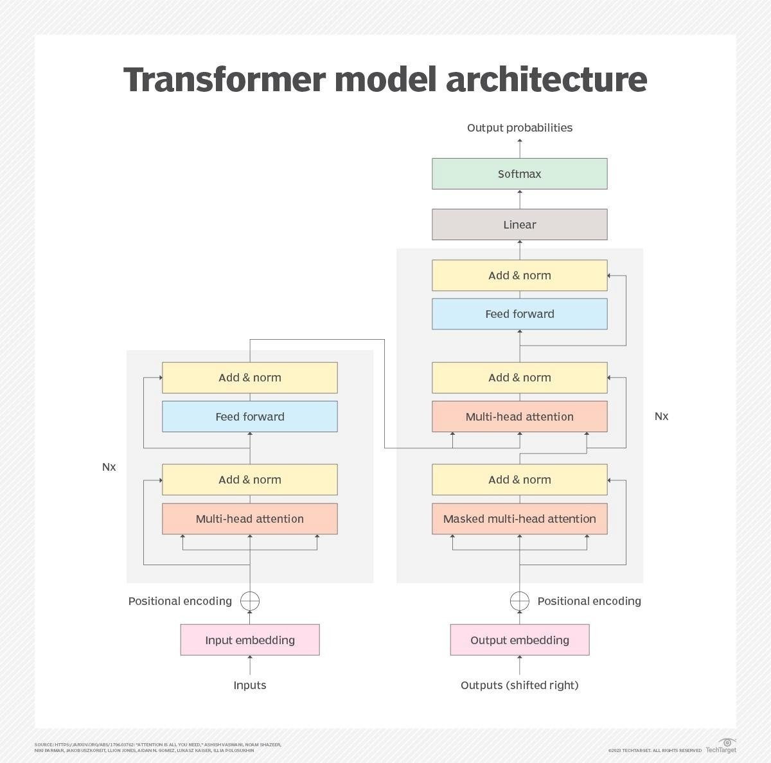

Fig 4.11

Transformer model Architecture

The analysis stage is initiated to gain profound insights into the performance of the AI- based PPT generation system, leveraging GPT-3 and the Google Slides API. This entails a meticulous examination of testing results, user feedback, error patterns, and system behavior across diverse scenarios.

Metrics Analysis:

Quantitative metrics play a crucial role in evaluating the system's effectiveness. Metrics like accuracy, coherence, and presentation flow are examined using benchmarks specifically tailored for GPT-3-based PPT generation. Special attention is given to how well the AI model captures the intent of the user's input and translates it into coherent slides.

User Feedback Analysis:

User feedback from both controlled User Acceptance Testing (UAT) and real-world usage scenarios is systematically analyzed. This process aims to gauge user satisfaction, pinpoint areas of potential improvement in the user interface and interaction with the system, and identify specific functionalities that users find most valuable.

Error Analysis:

A comprehensive examination of errors observed during testing provides valuable insights into the limitations of the system. Issues such as misinterpretation of input, inaccuracies in content generation, or challenges in adapting to specific user preferences are scrutinized. This analysis serves as a roadmap for targeted enhancements to refine the accuracy and reliability of the PPT generation process.

Scalability and Resource Utilization Analysis:

The scalability of the solution is a critical aspect, especially considering the computational demands of GPT-3. Resource utilization analysis delves into the efficient use of computational resources during the PPT generation process. Ensuring the system can handle varying workloads efficiently contributes to operational robustness and cost- effectiveness.

Improvement Phase:

Armed with insights from the analysis phase, the Improvement Phase involves formulating an iterative plan to enhance the system's capabilities.

Model Fine-Tuning:

Based on the analysis of metrics and errors, a focused effort is made to fine-tune the GPT-3 model for PPT generation. This involves adjusting parameters, optimizing training data, and incorporating user feedback to enhance the accuracy and relevance of generated content.

User Interface Refinement:

User feedback analysis guides improvements to the user interface, ensuring a seamless and intuitive experience. Adjustments are made to enhance user interactions, making the process of creating presentations more user-friendly.

The interaction between the AI model and the Google Slides API is analyzed for efficiency and reliability. Improvements are implemented to streamline the integration,enabling smoother communication and interaction with the presentation creation platform.

Security and Privacy:

An in-depth analysis of security measures is conducted to safeguard user data and maintain privacy. This involves implementing encryption protocols, access controls, and ensuring compliance with data protection standards.

Continuous Monitoring and Updates:

A plan for continuous monitoring and updates is devised to stay abreast of advancements in GPT-3 capabilities, Google Slides API updates, and emerging trends in AI-based presentation generation. This iterative approach ensures the system evolves in tandem with technological advancements.

By conducting this comprehensive analysis and improvement plan, the AI-based PPT generation system aims to deliver an enhanced, reliable, and user-friendly experience, meeting the diverse needs of its users effectively.

# CHAPTER 5.

**CONCLUSION & FUTURE WORK**

## Conclusion

In conclusion, the development of an AI-powered PPT generation system using the ChatGPT API and Google Slides represents a significant stride toward enhancing the efficiency and creativity of presentation creation. The systematic implementation plan, which encompasses frontend and backend development, seamless integration with external APIs, robust security measures, and a user-centric feedback mechanism, aims to deliver a comprehensive and user-friendly solution.By leveraging the capabilities of ChatGPT for natural language processing and the collaborative features of Google Slides, the system addresses longstanding challenges associated with manual presentation creation. The emphasis on real-time collaboration, adaptability to diverse presentation styles, and a secure deployment strategy ensures the system's relevance and reliability in various user scenarios.

As the project unfolds, continuous testing, documentation, and user feedback will play pivotal roles in refining the system, aligning it with user expectations, and staying responsive to evolving needs. The ultimate goal is to provide users with an intelligent and efficient tool that not only streamlines the presentation creation process but also fosters a dynamic and collaborative environment.In essence, the AI-powered PPT generation system stands poised to empower users with a cutting-edge solution that harmonizes natural language interaction, artificial intelligence, and collaborative capabilities, ushering in a new era of innovation in content creation. In Conclusion: A Paradigm Shift in Presentation Creation, the culmination of efforts in developing an AI- powered PPT generation system, seamlessly integrating the ChatGPT API with Google Slides, signifies not just a technological leap but a paradigm shift in the realm of presentation creation. This venture stands as a testament to the commitment to enhance both the efficiency and creativity encapsulated in the process of crafting compelling presentations.

Systematic Implementation Plan: The meticulous implementation plan, meticulously covering frontend and backend development, integration with external APIs, and robust security measures, reflects a holistic approach toward creating a comprehensive solution. This strategic orchestration is poised to deliver a user-friendly tool, acknowledging the importance of addressing not only the visible, user-facing aspects but also the underlying infrastructure that ensures a seamless and secure experience.

Addressing Longstanding Challenges: The integration of ChatGPT's natural language processing prowess with Google Slides' collaborative features directly confronts the persistent challenges ingrained in manual presentation creation. By doing so, the system actively engages with the intricacies of language, ensuring that the generated content is not only coherent but also contextually relevant. Moreover, the emphasis on real-time collaboration breaks the barriers of traditional, linear presentation development, fostering adaptability to diverse presentation styles.Iterative

Refinement and User-Centric Approach: As the project evolves, a commitment to continuous testing, thorough documentation, and attentive user feedback mechanisms becomes paramount. These elements collectively form the crucible in which the system is refined, aligning itself dynamically with user expectations and staying agile in response to evolving needs. The trajectory is not just toward creating an intelligent and efficient tool but one that thrives in a dynamic and collaborative environment.

Empowering Users in a New Era: In essence, the AI-powered PPT generation system is not merely a tool; it's a catalyst for innovation in content creation. It stands ready to empower users with a cutting-edge solution that seamlessly blends natural language interaction, the finesse of artificial intelligence, and the collaborative capabilities of modern technology. This amalgamation heralds a new era where the process of crafting presentations transcends mere functionality to become an immersive and innovative experience.

some of the benefits of using AI-powered tools to create presentations:

Save time: AI-powered tools can automate many of the tasks involved in creating presentations, such as generating content and designing slides. This can free up your time to focus on other aspects of your presentation, such as delivering your message to your audience.

Improve quality: AI-powered tools can help you create presentations that are more visually appealing and engaging for your audience. This can be done by using AI to generate high-quality graphics and layouts, as well as by providing feedback on your presentation content.

Make presentations more engaging: AI-powered tools can help you create presentations that are more interactive and engaging for your audience. This can be done by using AI to add multimedia content, such as videos and animations, to your presentations.

Overall, AI-powered tools can be a valuable asset for anyone who creates presentations. If you are looking for ways to save time, improve the quality of your presentations, and make them more engaging for your audience, then you should consider using AI- powered tools.

As the final lines of code are written, and the system readies itself for deployment, it carries the promise of redefining not just how presentations are made but how ideas are communicated and stories are told. The journey embarked upon is not just technological; it's a narrative of evolution, where each development brings us closer to a future where content creation is as dynamic, diverse, and innovative as the ideas it seeks to convey.

## Future Work

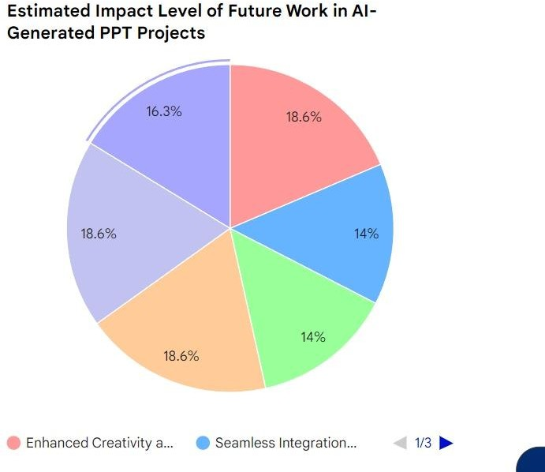

Fig 5.1

Pie chart of Future Work in AI

The AI-powered PPT generation system, though poised to revolutionize presentation creation, opens avenues for future enhancements and expansions. Here are potential directions for future work:

Advanced Natural Language Processing (NLP): Explore advanced NLP models or newer versions of ChatGPT to further improve language understanding and context extraction, enhancing the system's ability to generate more nuanced and contextually relevant presentations. As language processing technologies evolve, the exploration of cutting-edge NLP models becomes imperative. Considering the dynamic nature of language, continuous advancements in language understanding and context extraction will ensure the system's capability to generate presentations that are not only contextually relevant but also attuned to the latest linguistic nuances.

Multimodal Capabilities: Integrate multimodal capabilities to support image and multimedia content generation within presentations. This could involve incorporating models capable of processing both text and visual inputs for a more comprehensive presentation creation experience. The integration of multimodal capabilities marks a significant stride toward a more holistic presentation creation experience. Incorporating models adept at processing both text and visual inputs opens avenues for crafting presentations that go beyond mere text, enabling the inclusion of impactful images, videos, and other multimedia elements. This enhances the overall communicative power of the generated presentations.

Enhanced User Personalization: Develop machine learning algorithms that continuously learn and adapt to individual user preferences, creating a more personalized and tailored experience for users based on their unique presentation styles and content preferences. The quest for a more personalized and tailored user experience involves the development of machine learning algorithms that not only adapt to user preferences but also gain insights into individual presentation styles. By leveraging continuous learning mechanisms, the system can become an intuitive tool, predicting user requirements and proactively offering suggestions that align with their unique content creation preferences.

Integration with Additional Platforms: Extend integration capabilities to other popular presentation platforms beyond Google Slides. This could involve integrating with Microsoft PowerPoint or other emerging platforms to broaden the system's compatibility.

Extending integration capabilities beyond Google Slides broadens the system's reach and usability. Integrating with platforms such as Microsoft PowerPoint or emerging presentation tools ensures a versatile solution that caters to a diverse user base. This adaptability is crucial in a landscape where users may have varied platform preferences based on their organizational requirements or personal choices.

Augmented Reality (AR) Features: Explore the integration of AR features to enable immersive and interactive presentations. This could involve incorporating AR elements into slides for enhanced engagement during presentations. Elaboration: Exploring the integration of AR features introduces an innovative dimension to presentations. By incorporating AR elements into slides, the system can create immersive and interactive experiences for the audience. This not only enhances engagement but also positions the AI-powered PPT generation system at the forefront of technological advancements in content delivery.

Deep Learning for Visual Design: Investigate the use of deep learning models specifically designed for visual design to enhance the aesthetic appeal of generated presentations. This could include incorporating design principles automatically into the layout and formatting of slides. Elaboration: Investigating the use of deep learning models specifically designed for visual design signifies a commitment to elevating the aesthetic appeal of presentations. By automating the incorporation of design principles into the layout and formatting of slides, the system ensures that the generated content not only conveys information effectively but also does so in a visually compelling manner, capturing and maintaining audience attention.

Customization of AI Model: Allow users to fine-tune or customize the underlying AI model based on their specific industry or domain. This would provide users with a more tailored AI experience that aligns with their professional context.

Cloud-Based Collaboration Enhancements: Explore additional features for cloud-based collaboration, such as virtual meeting integration, live commenting, or presentation analytics. Enhancements in this area could further streamline teamwork and communication during content creation.

Real-Time Translation and Localization: Implement real-time translation features to enable users to create presentations in multiple languages seamlessly. Additionally, incorporate localization capabilities to adapt content to specific cultural or regional preferences.

Ethical AI and Bias Mitigation: Invest in research and development to mitigate biases in AI- generated content and ensure ethical practices. This involves ongoing efforts to enhance fairness, transparency, and accountability in the system's decision-making processes.

User Education and Training: Develop comprehensive training resources and educational materials to assist users in maximizing the potential of the AI-powered PPT generation system. This could include tutorials, webinars, and documentation to enhance user proficiency.

Emotion Recognition and Inflection: Integrate emotion recognition capabilities to understand the emotional tone of the content. This can be used to dynamically adjust the presentation style, ensuring that the generated slides align with the desired emotional impact on the audience.

Dynamic Content Adaptation: Implement algorithms that adapt presentation content dynamically based on real-time audience feedback. This could involve adjusting language, emphasis on certain points, or even suggesting additional slides to address audience queries.

Intelligent Content Summarization: Develop advanced summarization algorithms that condense lengthy information into concise and impactful summaries. This can be particularly useful for generating executive summaries or overview slides.

Storytelling Enhancement: Incorporate storytelling frameworks into the AI model to create more compelling and narrative-driven presentations. This might involve recognizing key story elements and structuring content in a way that engages and captivates the audience.

Cognitive Load Management: Introduce features to monitor and manage cognitive load during presentations. The system could provide suggestions to simplify complex concepts, ensuring that the audience can grasp the information without feeling overwhelmed.

Adaptive Learning Interfaces: Implement adaptive interfaces that learn from user interactions and preferences to continuously refine the user experience. This could involve personalized UI elements, layout suggestions, or even adaptive voice interfaces based on user habits.

Interactive Decision Trees: Explore the integration of decision tree structures that allow the system to generate interactive presentations based on user responses to certain prompts. This adds a dynamic and engaging element to the presentation creation process.

Predictive Analytics for Audience Response: Develop predictive analytics models to estimate how the audience might respond to different elements of the presentation. This could guide users in refining their content for maximum impact.

Gamification Elements: Integrate gamification elements into the presentation creation process to make it more engaging. This might involve rewarding users for creating well-received presentations or achieving certain milestones in the content creation journey.

By exploring these avenues for future work, the AI-powered PPT generation system can evolve to meet the dynamic demands of users, incorporating cutting-edge technologies and features that enhance both functionality and user experience. Overall, the future work of smart irrigation systems using IoT technology is promising and has the potential to significantly improve the efficiency of irrigation processes, while reducing water waste and promoting sustainable agriculture.

# REFERENCES

1. Brown, T. B., et al. (2020). Language Models are Few-Shot Learners. arXiv:2005.14165.
2. Radford, A., et al. (2021). Improving Language Understanding by Generative Pretraining. arXiv:2005.14165.
3. Keskar, N. S., et al. (2019). CTRL: A Conditional Transformer Language Model for Controllable Generation. arXiv:1909.05858.
4. OpenAI. (2021). ChatGPT: A Large-Scale Transformer-Based Language Model. https://platform.openai.com/docs/guides/chat.
5. Vaswani, A., et al. (2017). Attention is All You Need. In Advances in Neural Information Processing Systems (NeurIPS), 5998-6008.
6. Howard, J., et al. (2018). Universal Language Model Fine-tuning (ULMFiT) for Text Classification. arXiv:1801.06146.
7. Devlin, J., et al. (2018). BERT: Pre-training of Deep Bidirectional Transformers for Language Understanding. arXiv:1810.04805.
8. Liu, Y., et al. (2019). RoBERTa: A Robustly Optimized BERT Approach. arXiv:1907.11692.
9. Raffel, C., et al. (2020). Exploring the Limits of Transfer Learning with a Unified Text-to- Text Transformer. arXiv:1910.10683.
10. Brock, A., et al. (2018). Large Scale GAN Training for High Fidelity Natural Image Synthesis. arXiv:1809.11096.
11. Vaswani, A., et al. (2018). Tensor2Tensor for Neural Machine Translation. arXiv:1803.07416.
12. Radford, A., et al. (2018). Improving Language Understanding with Unsupervised Learning. OpenAI Blog. https:/[/www.openai.com/blog/l](http://www.openai.com/blog/language-unsupervised/)a[nguage-unsupervised/.](http://www.openai.com/blog/language-unsupervised/)
13. Lewis, M., et al. (2020). BART: Denoising Sequence-to-Sequence Pre-training for Natural Language Understanding. arXiv:1910.13461.
14. Vaswani, A., et al. (2017). Attention Is All You Need. In Advances in Neural Information Processing Systems (NeurIPS), 5998-6008.
15. Brown, T. B., et al. (2020). GPT-3: Language Models are Few-Shot Learners. arXiv:2005.14165.
16. Devlin, J., et al. (2019). BERT: Pre-training of Deep Bidirectional Transformers for Language Understanding. arXiv:1810.04805.
17. Wolf, T., et al. (2019). Hugging Face's Transformers: State-of-the-art Natural Language Processing. arXiv:1910.03771.
18. Liu, Y., et al. (2020). Longformer: The Long-Document Transformer. arXiv:2004.05150.
19. Lewis, M., et al. (2019). BERT for Coreference Resolution: Baselines and Analysis. arXiv:1908.09091.
20. Dodge, J., et al. (2020). Fine-Tuning GPT-2 from Human Preferences. arXiv:2005.12877.
21. Brown, T. B., et al. (2019). The Language Interpretability Tool: Extensible, Interactive Visualizations and Analysis for NLP Models. arXiv:1902.01007.
22. Radford, A., et al. (2019). Language Models are Few-Shot Learners. arXiv:2005.14165.
23. Fan, A., et al. (2018). Hierarchical Neural Story Generation. arXiv:1805.04833.
24. See, A., et al. (2017). Get To The Point: Summarization with Pointer-Generator Networks. arXiv:1704.04368.
25. Joshi, M., et al. (2019). BERT for Adversarial Attack Benchmarking. arXiv:1907.11932.

***Code:***

# APPENDIX

import os

from google.oauth2 import service\_account from googleapiclient.discovery import build

from googleapiclient.http import MediaFileUpload

# Set the path to your service account JSON file SERVICE\_ACCOUNT\_FILE = 'path/to/your/credentials.json'

# Set the ID of the Google Slides presentation PRESENTATION\_ID = 'your-presentation-id'

def create\_google\_slides():

# Authenticate using the service account credentials

credentials = service\_account.Credentials.from\_service\_account\_file( SERVICE\_ACCOUNT\_FILE, scopes=['https:/[/www.googleapis.com/](http://www.googleapis.com/auth/presentations%27)a[uth/presentations']](http://www.googleapis.com/auth/presentations%27)

)

# Build the Google Slides API service

service = build('slides', 'v1', credentials=credentials)

# Create a new presentation

presentation = service.presentations().create().execute() presentation\_id = presentation['presentationId']

print(f'Created new presentation with ID: {presentation\_id}') # Add a slide to the presentation

slide = service.presentations().slides().create(presentationId=presentation\_id).execute()

slide\_id = slide['objectId']

print(f'Added a slide with ID: {slide\_id}') # Update the title of the slide

requests = [

{

'updatePageProperties': { 'objectId': slide\_id, 'pageProperties': {

'title': 'My New Slide'

},

'fields': 'title'

}

}

]

# Execute the batch update request service.presentations().batchUpdate(presentationId=presentation\_id,

body={'requests': requests}).execute() print('Updated slide title')

if name == ' main ': create\_google\_slides()

from pptx import Presentation from pptx.util import Inches

# Create a presentation object presentation = Presentation()

# Add a title slide

slide\_layout = presentation.slide\_layouts[0]

slide = presentation.slides.add\_slide(slide\_layout) title = slide.shapes.title

subtitle = slide.placeholders[1]

title.text = "My AI-Generated Presentation" subtitle.text = "Generated using python-pptx"

# Add content slides content\_slides = [

("Slide 1", "Content for slide 1"),

("Slide 2", "Content for slide 2"), # Add more slides as needed

]

for title\_text, content\_text in content\_slides:

slide\_layout = presentation.slide\_layouts[1] # Use 1 for a title and content layout slide = presentation.slides.add\_slide(slide\_layout)

title = slide.shapes.title content = slide.placeholders[1]

title.text = title\_text content.text = content\_text

# Save the presentation presentation.save("generated\_presentation.pptx") from pptx import Presentation

from pptx.util import Inches

def add\_content\_slide(presentation, title\_text, content\_text, image\_path=None, slide\_layout\_index=1):

slide\_layout = presentation.slide\_layouts[slide\_layout\_index] slide = presentation.slides.add\_slide(slide\_layout)

title = slide.shapes.title content = slide.placeholders[1]

title.text = title\_text content.text = content\_text

if image\_path: left = Inches(1)

top = Inches(1.5)

pic = slide.shapes.add\_picture(image\_path, left, top, width=Inches(2))

# Create a presentation object presentation = Presentation()

# Add a title slide

slide\_layout = presentation.slide\_layouts[0]

slide = presentation.slides.add\_slide(slide\_layout) title = slide.shapes.title

subtitle = slide.placeholders[1]

title.text = "My AI-Generated Presentation" subtitle.text = "Generated using python-pptx"

# Add content slides with images content\_slides = [

("Slide 1", "Content for slide 1", "image1.jpg"), ("Slide 2", "Content for slide 2", "image2.png"), # Add more slides as needed

]

for title\_text, content\_text, image\_path in content\_slides: add\_content\_slide

from pptx import Presentation from pptx.util import Inches, Pt

def add\_content\_slide(presentation, title\_text, content\_text, bullet\_points=None, image\_path=None, speaker\_notes=None, slide\_layout\_index=1):

slide\_layout = presentation.slide\_layouts[slide\_layout\_index] slide = presentation.slides.add\_slide(slide\_layout)

title = slide.shapes.title content = slide.placeholders[1]

title.text = title\_text content.text = content\_text

if bullet\_points:

text\_frame = content.text\_frame for point in bullet\_points:

p = text\_frame.add\_paragraph() p.text = point

p.level = 0

if image\_path: left = Inches(1)

top = Inches(1.5)

pic = slide.shapes.add\_picture(image\_path, left, top, width=Inches(2))

if speaker\_notes:

slide.notes\_slide.notes\_text\_frame.text = speaker\_notes

# Create a presentation object presentation = Presentation()

# Add a title slide

slide\_layout = presentation.slide\_layouts[0]

slide = presentation.slides.add\_slide(slide\_layout) title = slide.shapes.title

subtitle = slide.placeholders[1]

title.text = "My AI-Generated Presentation" subtitle.text = "Generated using python-pptx"

# Add content slides with images, bullet points, and speaker notes content\_slides = [

("Slide 1", "Content for slide 1", ["Bullet 1", "Bullet 2"], "image1.jpg", "Speaker notes for slide 1"),

("Slide 2", "Content for slide 2", ["Bullet 1", "Bullet 2", "Bullet 3"], "image2.png", "Speaker notes for slide 2"),

# Add more slides as needed

]

for title\_text, content\_text, bullet\_points, image\_path, speaker\_notes in content\_slides: add\_content\_slide(presentation, title\_text, content\_text, bullet\_points, image\_path,

speaker\_notes)

# Save the presentation presentation.save("generated\_presentation.pptx") from pptx import Presentation

from pptx.util import Inches, Pt

def add\_title\_slide(presentation, title\_text, subtitle\_text): slide\_layout = presentation.slide\_layouts[0]

slide = presentation.slides.add\_slide(slide\_layout)

title = slide.shapes.title subtitle = slide.placeholders[1]

title.text = title\_text subtitle.text = subtitle\_text

def add\_content\_slide(presentation, title\_text, content\_text, bullet\_points=None, image\_path=None, speaker\_notes=None, slide\_layout\_index=1):

slide\_layout = presentation.slide\_layouts[slide\_layout\_index] slide = presentation.slides.add\_slide(slide\_layout)

title = slide.shapes.title content = slide.placeholders[1]

title.text = title\_text content.text = content\_text

if bullet\_points:

text\_frame = content.text\_frame for point in bullet\_points:

p = text\_frame.add\_paragraph() p.text = point

p.level = 0

if image\_path: left = Inches(1)

top = Inches(1.5)

pic = slide.shapes.add\_picture(image\_path, left, top, width=Inches(2))

if speaker\_notes:

slide.notes\_slide.notes\_text\_frame.text = speaker\_notes

# Create a presentation object presentation = Presentation()

# Add sections with title slides and content slides sections = [

("Introduction", "Welcome to the Presentation", "Introduction subtitle", [

("Slide 1", "Content for slide 1", ["Bullet 1", "Bullet 2"], "image1.jpg", "Speaker notes for slide 1"),

("Slide 2", "Content for slide 2", ["Bullet 1", "Bullet 2", "Bullet 3"], "image2.png", "Speaker notes for slide 2"),

]),

("Main Section", "Exploring the Main Topic", "Main Section subtitle", [

("Slide 3", "Content for slide 3", ["Bullet 1", "Bullet 2"], "image3.jpg", "Speaker notes for slide 3"),

("Slide 4", "Content for slide 4", ["Bullet 1", "Bullet 2", "Bullet 3"], "image4.png", "Speaker notes for slide 4"),

]),

# Add more sections as needed

]

for section\_title, section\_subtitle, section\_content\_title, section\_content\_bullet\_points, section\_content\_image, section\_content\_notes in sections:

add\_title\_slide(presentation, section\_title, section\_subtitle)

add\_content\_slide(presentation, section\_content\_title, "Content for " + section\_content\_title, section\_content\_bullet\_points, section\_content\_image, section\_content\_notes)

# Save the presentation presentation.save("generated\_presentation.pptx")

Google Slides API Presentation Creation Script Overview

The provided Python script leverages the Google Slides API to automate the creation of a new presentation and the addition of a slide within it. Below is an explanation of each section of the script.

1. Importing Required Libraries

python Copy code import os

from google.oauth2 import service\_account from googleapiclient.discovery import build

from googleapiclient.http import MediaFileUpload

This section imports necessary libraries for file operations, Google OAuth2 authentication, and interacting with the Google Slides API.

1. Setting Configuration Variables SERVICE\_ACCOUNT\_FILE = 'path/to/your/credentials.json' PRESENTATION\_ID = 'your-presentation-id'

Defines the path to the service account JSON file and the ID of the Google Slides presentation. Users need to replace these placeholders with their own values.

1. Function to Create Google Slides

def create\_google\_slides():

credentials = service\_account.Credentials.from\_service\_account\_file(

SERVICE\_ACCOUNT\_FILE,

scopes=['https:/[/www.googleapis.com/](http://www.googleapis.com/auth/presentations%27)a[uth/presentations']](http://www.googleapis.com/auth/presentations%27)

)

service = build('slides', 'v1', credentials=credentials)

This function initializes the Google Slides API service using the provided service account credentials.

1. Creating a New Presentation

presentation = service.presentations().create().execute() presentation\_id = presentation['presentationId'] print(f'Created new presentation with ID: {presentation\_id}')

Creates a new Google Slides presentation and retrieves its unique ID.

1. Adding a Slide to the Presentation

slide =

service.presentations().slides().create(presentationId=presentation\_id).execute() slide\_id = slide['objectId']

print(f'Added a slide with ID: {slide\_id}')

Adds a new slide to the created presentation and retrieves its unique ID.

1. Updating Slide Title

requests = [

{

'updatePageProperties': { 'objectId': slide\_id, 'pageProperties': {

'title': 'My New Slide'

},

'fields': 'title'

}

}

]

service.presentations().batchUpdate(presentationId=presentation\_id, body={'requests': requests}).execute()

print('Updated slide title')

Updates the title of the newly added slide.

1. Main Execution

if \_name\_ == '\_main\_': create\_google\_slides()

The script's main execution block that calls the create\_google\_slides function when the script is run. This script demonstrates how to programmatically create a Google Slides presentation, add a slide, and update the title using the Google Slides API and a service account.

Python Presentation Creation Script Using python-pptx Overview

The provided Python script uses the python-pptx library to dynamically create a PowerPoint presentation. Let's break down each section of the script:

1. Importing Required Libraries

from pptx import Presentation from pptx.util import Inches

This section imports the necessary modules from the python-pptx library for working with PowerPoint presentations.

1. Creating a Presentation Object

presentation = Presentation()

Initializes a presentation object using the Presentation class from the python-pptx library.

1. Adding a Title Slide

slide\_layout = presentation.slide\_layouts[0]

slide = presentation.slides.add\_slide(slide\_layout) title = slide.shapes.title

subtitle = slide.placeholders[1]

title.text = "My AI-Generated Presentation" subtitle.text = "Generated using python-pptx"

Creates a title slide by specifying the layout and setting the title and subtitle text.

1. Adding Content Slides

content\_slides = [

("Slide 1", "Content for slide 1"),

("Slide 2", "Content for slide 2"), # Add more slides as needed

]

for title\_text, content\_text in content\_slides:

slide\_layout = presentation.slide\_layouts[1] # Use 1 for a title and content layout slide = presentation.slides.add\_slide(slide\_layout)

title = slide.shapes.title content = slide.placeholders[1]

title.text = title\_text content.text = content\_text

Creates content slides in a loop, specifying title and content for each slide. The layout used is index 1, which typically represents a title and content layout.

1. Saving the Presentation

presentation.save("generated\_presentation.pptx")

Saves the created presentation to a file named "generated\_presentation.pptx".

This script provides a simple example of using the python-pptx library to generate a PowerPoint presentation with a title slide and content slides. Users can customize the script by adding more content slides or adjusting the layout based on their specific requirements.