TRON-CYCLES AUTOMANIA

- ABSTRACT
Do you remember the movie and video game from the 80's called Tron? Blazing cycles leaving a shiny trail. Now we let you play this game right here for Shaastra. This is the part of the game where you get to drive a light cycle and try to vanquish your opponent. For this Shaastra, we have made it so simple to code that now with very little effort you can drive a virtual light cycle, beat everyone and take glory.
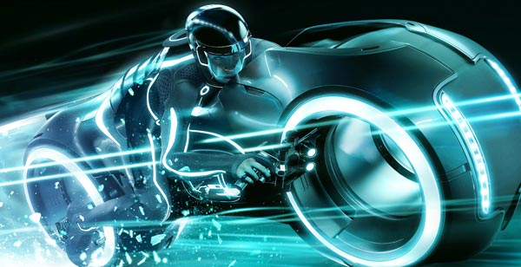
- GAME DESCRIPTION
The contest will be two playered. There will be an arena onto which both the players' tron cycles will be released. As your tron cycle moves through the arena, it will leave behind a trail. A tron cycle dies if it dashes into the trail left by any of the tron cycles or they collide into each other.
You and your opponent are pitted against each other and you should try to outsmart the other and get him killed. To understand the implementation details and to know how you could jump into coding right away we suggest you look at the tutorial provided. To give you a basic view of what is to be done:
Basically at each instant we provide you with the configuration of the map( 2D) and we ask you and your opponent to return the next move which you would like to make. You should analyze the map and decide what move to make next. We have made it easy for you to analyze the map(details provided in the tutorial). The participants can code in any of the following languages – Python, C++, Java.
Some features of the game are:
  - The map will be scattered with two kinds of power-ups.
    - Nitro: By taking this power-up your bot can move faster than before. You can take it as, being asked to choose a move more number of times than before.
    - Traverse-thru: With this power you can go thru the walls made by any tron cycle.
  - Reset: If a player reaches this position in the map, the map will be reset. The player will retain his power-ups but the trails will all vanish.
  - The arena is donut shaped. That is, there are no walls at the edges. You can go through one edge and reach the opposite.
  - The last person alive will be the winner.
- RULES & CONDITIONS-FOR-DISQUALIFICATION
  - The coordinators can modify the rules as and when required if they feel it fair and necessary.
  - Any code found to be jeopardizing the judge in anyway will call for immediate disqualification.
- SCORING

