Advanced Data Analysis and Visualization in Logistics
Week 3 Task Report
Exploratory Data Analysis, Visualization and Recommendations using Python
Prepared by: Sujeet Kumar
Tools: Python 3, pandas, NumPy, Matplotlib, Seaborn
October 2026

1. Introduction and Objectives
Logistics is a data-intensive function. Every shipment generates information about distance, weight, transport mode, carrier, cost, warehouse handling time and delivery performance. When this information is explored systematically, it reveals where money is being spent, where delays originate and which parts of the network need attention. This report documents an end-to-end analytical workflow for a hypothetical logistics operation using Python.
The objectives of this task are to:
- define and simulate a realistic logistics dataset covering delivery times, shipment volumes and transportation costs;
- carry out a thorough Exploratory Data Analysis (EDA) including central tendency, spread, distributions and correlations;
- produce ten visualizations, each chosen and justified for the question it answers;
- interpret the results to identify cost drivers, operational inefficiencies and bottlenecks; and
- translate the findings into practical, data-backed recommendations.
Important note on data: the dataset is simulated, so the patterns discussed (for example the effect of storms or of a particular carrier) are the result of assumptions built into the simulation. The value of the exercise lies in the method: the same workflow can be applied unchanged to a real shipment-level extract from a transport management system.

2. Data Simulation

2.1 Dataset structure
A dataset of 2,000 shipments covering calendar year 2025 was generated with a fixed random seed (42) so that every result in this report is reproducible. Each row represents one shipment. The table below lists the key variables.
Table 1: Dataset variables
Variable | Type | Description
shipment_id | Identifier | Unique shipment code (SHP100000 onwards)
order_date | Date | Date the order was placed (Jan to Dec 2025)
region | Categorical | Destination region: North, South, East, West, Central
carrier | Categorical | SwiftMove, RoadKing, CargoPro, BlueLine
transport_mode | Categorical | Road, Rail, Air, Sea
priority | Categorical | Standard, Express, Critical
weather | Categorical | Weather on route: Clear, Rain, Fog, Storm
distance_km | Numeric | Route distance in kilometres (depends on mode)
weight_kg | Numeric | Shipment weight (log-normal, right-skewed)
shipment_volume_m3 | Numeric | Shipment volume in cubic metres
warehouse_hours | Numeric | Processing time in the warehouse before dispatch
planned_days | Numeric | Promised delivery time in days
delay_days | Numeric | Actual minus planned delivery time (negative = early)
delivery_days | Numeric | Actual delivery time in days
on_time | Binary | 1 if delay is 0.5 days or less, otherwise 0
transport_cost | Numeric | Total transportation cost per shipment
fuel_cost | Numeric | Fuel component of cost
cost_per_km | Numeric | transport_cost divided by distance_km
customer_rating | Ordinal | Customer satisfaction score from 1 to 5

2.2 Simulation logic
The data was designed to behave like a real network rather than being purely random. Distance, planned speed and cost rate depend on the transport mode; delay is driven by weather, carrier performance, peak season (October to December), priority level and warehouse processing time; cost grows with distance, weight, mode and priority; and customer rating falls as delay increases. A small number of missing warehouse-hour values and extreme cost values were injected deliberately so that the cleaning step is realistic.
Python excerpt (full script: 01_generate_data.py):
rng = np.random.default_rng(42)
N = 2000
df["distance_km"] = [max(30, rng.normal(dist_base[m], dist_base[m]*0.35))
for m in df.transport_mode]
df["weight_kg"] = np.round(rng.lognormal(mean=5.5, sigma=0.8, size=N), 1)

# Delay drivers: weather, carrier, peak season, priority, warehouse hours
delay = (rng.gamma(1.5, 0.3, N) + weather_delay + carrier_delay + peak
+ prio_delay + 0.03*df.warehouse_hours - 1.15)
df["delay_days"] = np.round(np.clip(delay, -1, None), 1)
df["delivery_days"] = np.round(df.planned_days + df.delay_days, 1)
df["on_time"] = (df.delay_days <= 0.5).astype(int)

3. Methodology
The analysis followed a structured five-step process:
- Generate the simulated dataset and save it as logistics_data.csv.
- Inspect and clean the data: check shape, data types and missing values; treat outliers.
- Describe each numeric variable (mean, median, standard deviation, quartiles, skewness) and summarise performance by mode, carrier, region, weather, priority and month.
- Visualize distributions, trends, relationships and comparisons using Matplotlib and Seaborn, matching each chart type to its analytical question.
- Interpret the results and convert them into operational insights and recommendations.

3.1 Data cleaning
- Missing values: 25 records (1.25%) had no warehouse_hours value. These were filled with the median (7.3 hours), which is robust to the right-skew of the variable.
- Outliers: extreme cost values were detected using the 3 x IQR rule on cost_per_km, applied separately within each transport mode. Applying it across the whole dataset would wrongly remove genuine air freight, which is legitimately more expensive. 41 records were removed, leaving 1,959 shipments for analysis.
df["warehouse_hours"] = df.warehouse_hours.fillna(df.warehouse_hours.median())

def iqr_flag(s):
q1, q3 = s.quantile([.25, .75]); i = q3 - q1
return s > q3 + 3 * i
df["cost_outlier"] = df.groupby("transport_mode")["cost_per_km"].transform(iqr_flag)
clean = df[~df.cost_outlier].copy() # 1,959 rows retained

4. Exploratory Data Analysis

4.1 Central tendency and spread
Table 2 summarises the main numeric variables. In almost every case the mean is noticeably higher than the median, and skewness is positive. This is typical of logistics data: most shipments are small, short and cheap, while a minority are large, long-haul or air-freighted and pull the average upward.
Table 2: Descriptive statistics (n = 1,959)
Variable | Mean | Median | Std dev | Skewness
Distance (km) | 924.25 | 611.00 | 795.31 | 1.89
Weight (kg) | 320.26 | 240.40 | 261.37 | 1.91
Warehouse hours | 8.12 | 7.30 | 5.00 | 1.15
Delay (days) | 0.13 | 0.00 | 0.72 | 0.81
Delivery time (days) | 2.76 | 2.60 | 1.25 | 1.40
Transport cost | 1,174.16 | 368.33 | 2,340.81 | 4.04
Cost per km | 1.01 | 0.63 | 1.09 | 2.99

Three points stand out. First, transport cost is extremely right-skewed (skewness 4.04): the average of 1,174 is more than three times the median of 368, so the median is the more honest description of a typical shipment. Second, the median delay is exactly zero and the overall on-time rate is 74.7%, meaning roughly one shipment in four misses its promise by more than half a day. Third, warehouse processing averages 8.1 hours but can reach 38 hours, indicating a long tail of slow handling.

4.2 Performance by category
Grouped summaries show where performance differs across the network.
Table 3: Performance by transport mode
Mode | Shipments | Avg cost | Cost per km | Avg delay (days) | On-time
Air | 289 | 5,685.96 | 3.16 | 0.10 | 77%
Rail | 421 | 404.16 | 0.45 | 0.08 | 78%
Road | 1,077 | 336.68 | 0.77 | 0.16 | 73%
Sea | 172 | 722.04 | 0.29 | 0.16 | 71%

Table 4: Performance by carrier
Carrier | Shipments | Avg delay (days) | On-time rate | Avg rating
SwiftMove | 618 | -0.11 | 85% | 4.63
CargoPro | 467 | 0.02 | 79% | 4.60
RoadKing | 593 | 0.20 | 74% | 4.51
BlueLine | 281 | 0.71 | 46% | 4.35

Table 5: Performance by weather condition
Weather | Shipments | Avg delay (days) | On-time rate
Clear | 1,147 | -0.17 | 90%
Rain | 420 | 0.24 | 71%
Fog | 227 | 0.49 | 56%
Storm | 165 | 1.41 | 4%

4.3 Correlation analysis
Pearson correlations were computed for the key numeric variables. The strongest relationships were:
- transport_cost and fuel_cost: 0.95, so fuel is the dominant component of cost;
- distance and delivery time: 0.62 and distance and transport cost: 0.52, confirming distance as the primary structural driver;
- delay and customer rating: -0.52, showing that late delivery directly damages satisfaction;
- warehouse hours and delay: 0.18, a modest but real link between slow handling and late delivery; and
- weight and transport cost: 0.20, a weaker effect than distance.
Distance and weight are essentially uncorrelated (0.02), and cost is almost uncorrelated with delay (-0.01), which means that late shipments are not systematically more expensive, nor are expensive shipments systematically faster.
desc = clean[num_cols].describe().T
desc["median"] = clean[num_cols].median()
desc["skew"] = clean[num_cols].skew()

by_carrier = clean.groupby("carrier").agg(
shipments=("shipment_id", "count"), avg_delay=("delay_days", "mean"),
on_time=("on_time", "mean"), rating=("customer_rating", "mean")).round(2)

corr = clean[["distance_km","weight_kg","warehouse_hours","delay_days",
"delivery_days","transport_cost","fuel_cost","customer_rating"]].corr()

5. Visualizations and Interpretation
Each visualization below follows the same structure: why this chart type was chosen, the code used, and what the chart shows. All figures were produced with Matplotlib and Seaborn.

Figure 1: Distribution of delivery time
Why a histogram with KDE: the question is about the shape of delivery performance, not just its average. A histogram shows how many shipments fall in each time band, and the smoothed density curve makes skew and tails easier to see. Mean and median lines are added to expose the gap between them.
sns.histplot(clean.delivery_days, bins=35, kde=True, ax=ax)
ax.axvline(clean.delivery_days.mean(), color="red", ls="--")
ax.axvline(clean.delivery_days.median(), color="green", ls=":")

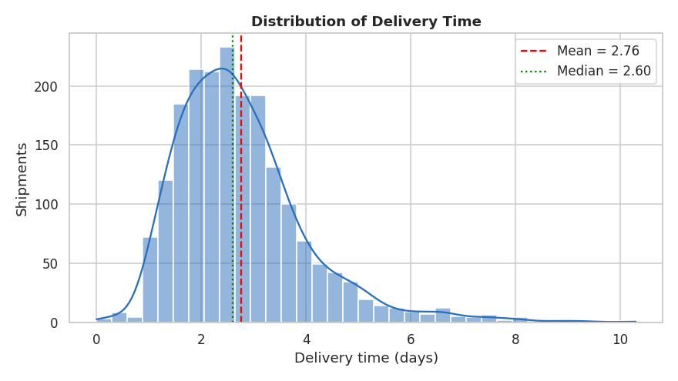
Figure 1: Distribution of delivery time
Interpretation: the distribution is right-skewed. About 77% of shipments arrive within 1.5 to 4 days, but a long tail extends beyond 6 days (49 shipments) and reaches over 10 days. The mean (2.76) sits above the median (2.60) because of that tail. Operationally, the tail matters more than the centre: those long-duration shipments generate most complaints and expedite costs.

Figure 2: Cost per kilometre by transport mode
Why a box plot: cost per km must be compared across four groups with very different scales and many extreme values. A box plot shows median, spread and outliers for each mode in a compact form, which a bar chart of averages would hide.
sns.boxplot(data=clean, x="transport_mode", y="cost_per_km",
order=["Sea", "Rail", "Road", "Air"], ax=ax)

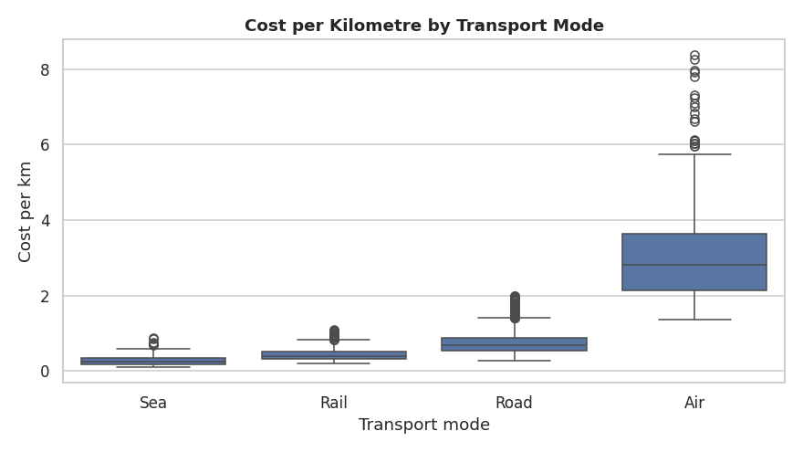
Figure 2: Cost per km by transport mode
Interpretation: there is a clear cost ladder. Sea (0.29 per km on average) and Rail (0.45) are cheapest, Road (0.77) sits in the middle and Air (3.16) is roughly four times more expensive than Road per kilometre. Air also shows the widest spread, so its cost is the least predictable. The practical implication is that every shipment moved by air that did not need to be is a direct, avoidable cost.

Figure 3: Monthly shipments and on-time rate
Why a bar and line combination (dual axis): the question is how demand and service quality move together over time. Bars show volume, while the line shows the on-time percentage on its own scale, so a drop in service can be compared against workload in a single view.
ax1.bar(monthly.index, monthly.shipments)
ax2 = ax1.twinx()
ax2.plot(monthly.index, monthly.on_time * 100, marker="o", color="crimson")

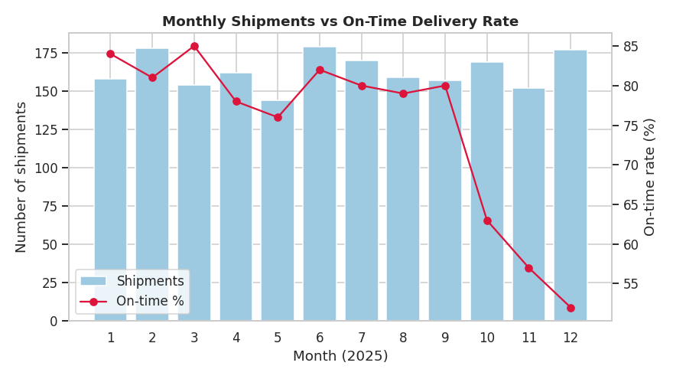
Figure 3: Monthly shipments vs on-time delivery rate
Interpretation: from January to September the on-time rate stays in a stable 76% to 85% band. In October it falls to 63%, then to 57% in November and 52% in December. Notably, neither shipment counts nor the weight shipped in Q4 (about 53,000 to 60,000 kg per month) are unusual compared with the rest of the year (about 45,000 to 58,000 kg), yet average delay jumps from about zero to roughly 0.55 days. The decline is therefore not explained by volume alone, which points to a peak-season capacity and handling problem rather than a simple demand spike.

Figure 4: Correlation heatmap
Why a heatmap: with eight numeric variables there are 28 pairwise relationships. A colour-coded matrix with printed coefficients lets the reader find the strong and weak relationships at a glance.
corr = clean[cols].corr()
sns.heatmap(corr, annot=True, fmt=".2f", cmap="coolwarm", center=0, square=True)

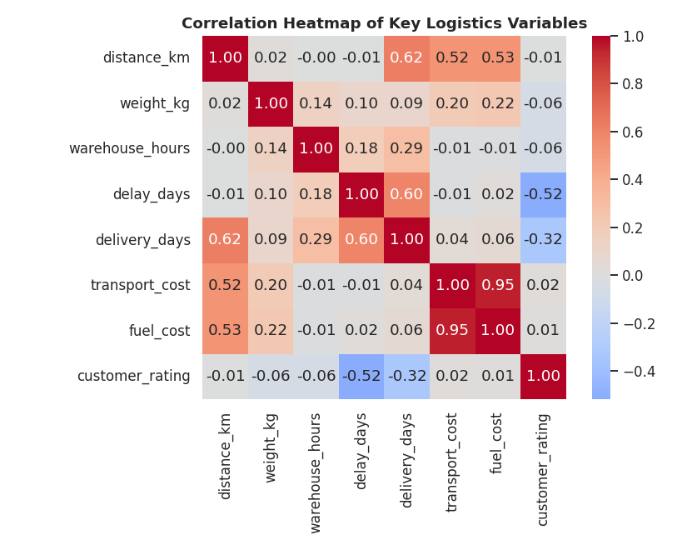
Figure 4: Correlation heatmap of key variables
Interpretation: the dark red block between transport cost and fuel cost (0.95) confirms that fuel dominates cost. Distance is positively related to both cost and delivery time. The notable negative cell is delay versus customer rating (-0.52). Because customer satisfaction responds to delay but not to cost or distance, punctuality, not price, is what customers feel.

Figure 5: Transportation cost versus distance
Why a scatter plot with colour by mode: this is a relationship between two continuous variables. Colour adds the transport mode as a third dimension, showing whether the cost-distance relationship is the same for every mode.
sns.scatterplot(data=clean, x="distance_km", y="transport_cost",
hue="transport_mode", alpha=0.6, s=25, ax=ax)

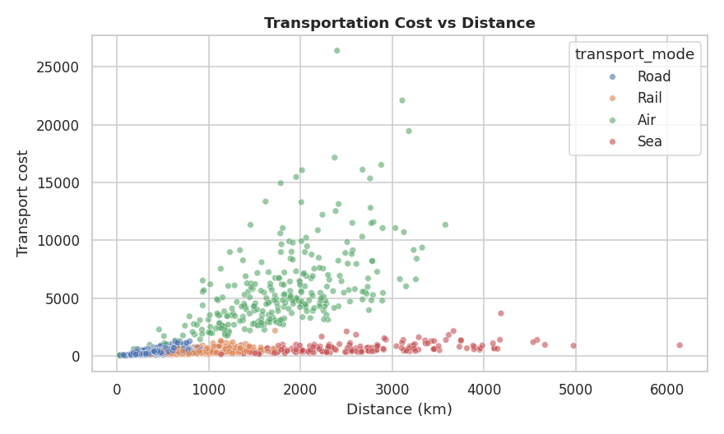
Figure 5: Transportation cost vs distance by mode
Interpretation: cost rises with distance for every mode, but the slope differs sharply. Air shipments form a steep band, while Sea and Rail rise slowly even over long distances. The overall correlation of 0.52 is moderate because mode, not distance alone, decides the cost per kilometre. Long-distance, non-urgent freight that is moving by road or air is the clearest opportunity to switch to rail or sea.

Figure 6: On-time rate by carrier
Why a bar chart: this is a straightforward comparison of one metric across four categories. Sorting the bars and labelling the values makes the ranking immediate.
order = by_carrier.sort_values("on_time", ascending=False).index
sns.barplot(x=by_carrier.loc[order].index, y=by_carrier.loc[order].on_time*100, ax=ax)

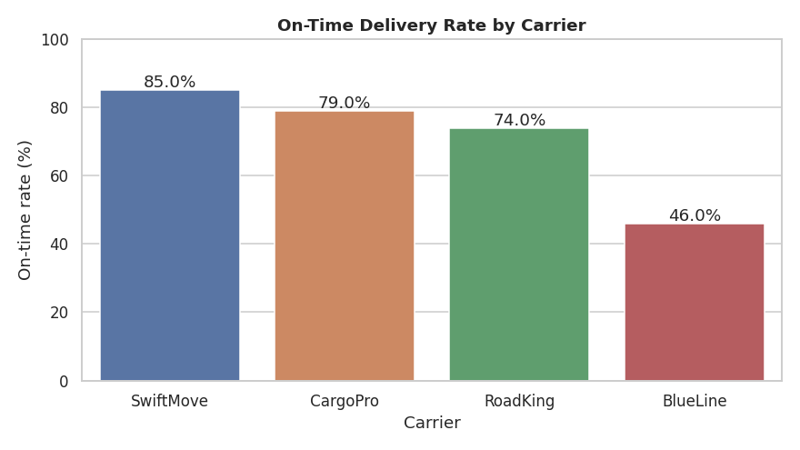
Figure 6: On-time delivery rate by carrier
Interpretation: SwiftMove leads with 85% on-time delivery, followed by CargoPro (79%) and RoadKing (74%). BlueLine is a clear outlier at only 46%, with an average delay of 0.71 days and the lowest customer rating (4.35). BlueLine handles 281 shipments, about 14% of the volume, so its weakness is a material source of network-wide lateness.

Figure 7: Average delay by region and weather
Why a heatmap with a sequential colour scale: two categorical variables (region and weather) are crossed to show a numeric outcome. A pivot-table heatmap exposes whether delay is a regional problem, a weather problem, or both.
pivot = clean.pivot_table(index="region", columns="weather",
values="delay_days", aggfunc="mean")
sns.heatmap(pivot[["Clear","Rain","Fog","Storm"]], annot=True, fmt=".2f", cmap="YlOrRd")

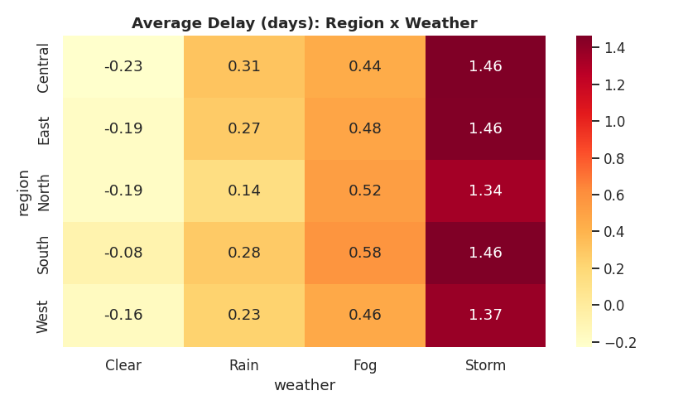
Figure 7: Average delay (days) by region and weather
Interpretation: colour changes strongly from left to right (weather) but only slightly from top to bottom (region). Under storm conditions the average delay is about 1.3 to 1.5 days in every region, and under fog about 0.5 days, compared with roughly zero or slightly early in clear weather. Regional differences under the same weather are small, so weather is the main driver and region is secondary. Overall, the South has the weakest on-time rate (69%) and the North the best (79%).

Figure 8: Correlation of variables with transport cost
Why a horizontal bar chart: to rank candidate cost drivers by strength of association with cost, a sorted horizontal bar chart is the clearest format and keeps variable names readable.
cost_corr = clean[["distance_km","weight_kg","warehouse_hours",
"delay_days","fuel_cost"]].corrwith(clean.transport_cost).sort_values()
cost_corr.plot(kind="barh", ax=ax)

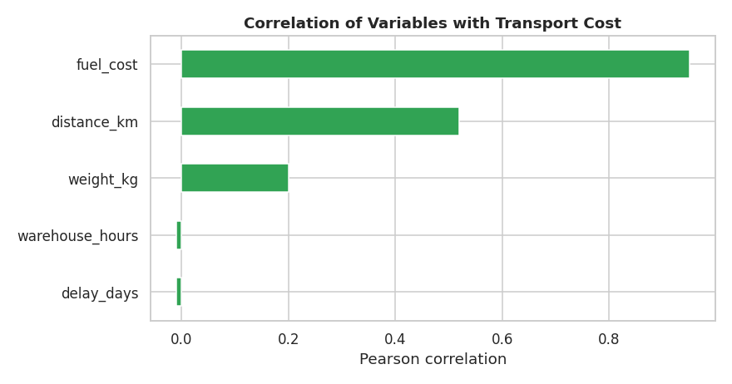
Figure 8: Correlation of variables with transport cost
Interpretation: fuel cost (0.95) is by far the strongest companion of total cost, followed by distance (0.52) and weight (0.20). Delay and warehouse hours have essentially no link to cost. This suggests that controlling cost means managing distance, mode choice and fuel, not chasing lateness or handling time.

Figure 9: Delay distribution by priority
Why a violin plot: a violin shows the full distribution shape and the quartiles for each priority level. It reveals both the centre and the spread, which a bar of average delay would not.
sns.violinplot(data=clean, x="priority", y="delay_days",
order=["Standard","Express","Critical"], inner="quartile", ax=ax)

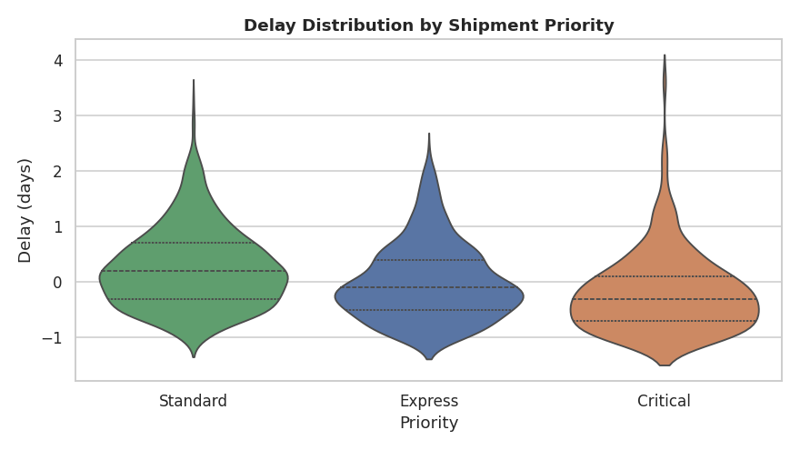
Figure 9: Delay distribution by shipment priority
Interpretation: the priority system works as intended. Critical shipments are on average 0.19 days early, Express arrive on schedule (0.00) and Standard shipments are 0.25 days late. This service premium has a visible price: average cost is 1,783 for Critical, 1,374 for Express and 975 for Standard. Standard freight is where most of the lateness sits, and it is also the largest group (1,184 shipments).

Figure 10: Customer rating versus delay
Why a box plot: customer rating is an ordinal variable with five levels, so a box plot of delay for each rating level is the right way to show how lateness distributes across satisfaction scores.
sns.boxplot(data=clean, x="customer_rating", y="delay_days", ax=ax)

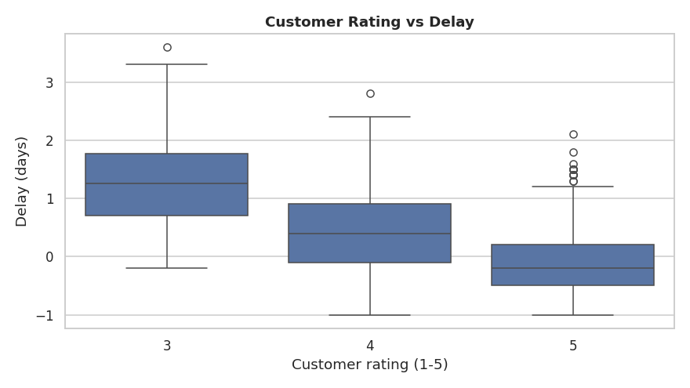
Figure 10: Customer rating vs delay
Interpretation: median delay rises steadily as the rating falls: about 0.2 days early for customers who gave 5, 0.4 days late for those who gave 4 and 1.25 days late for those who gave 3. (Ratings of 1 and 2 are almost absent in the simulated data, with only a single shipment rated 2, so the plot effectively compares ratings 3 to 5.) This closes the loop: delay is the operational metric that most directly predicts the customer-experience outcome.

6. Analytical Insights

6.1 Operational efficiency
- The network delivers 74.7% of shipments on time, with a typical (median) delivery time of 2.6 days. Performance is stable for nine months of the year and then deteriorates sharply.
- Weather is the largest single cause of delay. Only 4% of shipments in storm conditions arrive on time, against 90% in clear weather. Fog (56%) and rain (71%) also reduce performance.
- Carrier quality matters. The gap between SwiftMove (85%) and BlueLine (46%) is 39 percentage points, far larger than the gaps between modes or regions.
- Peak season is a stress point. The on-time rate falls from the 76% to 85% range to 52% in December.

6.2 Cost drivers
- Mode is the biggest lever. Air freight costs about 4 times as much per kilometre as Road and about 11 times as much as Sea.
- Fuel dominates the cost structure (correlation 0.95 with total cost), and distance is the main reason fuel use differs between shipments.
- Priority adds a clear premium. Critical shipments cost about 83% more on average than Standard ones (1,783 versus 975).
- Cost is heavily skewed, so a small number of expensive shipments account for a disproportionate share of spending. Reporting the median alongside the mean prevents this from being missed.

6.3 Potential bottlenecks
- Underperforming carrier: BlueLine's 46% on-time rate and 0.71-day average delay.
- Warehouse handling: the average processing time is 8.1 hours but the maximum is 38 hours, and longer handling correlates with delay (0.18). Heavy shipments are particularly affected.
- Q4 capacity: service falls although volume barely changes, which suggests fixed capacity and staffing are not scaled for the peak season.
- Weather exposure in every region: because a storm adds a similar delay everywhere, there appears to be no effective contingency routing or buffering.

7. How the Visualizations Help Interpret Logistics Performance
Each visualization type answers a different management question, and together they cover the main dimensions of logistics performance.
Table 6: Visualization purpose and the metric it clarifies
Visualization | Metric clarified | Management question answered
Histogram + KDE (Fig. 1) | Delivery time | How reliable and predictable is our delivery time, and how long is the tail?
Box plot (Fig. 2) | Cost per km | Which modes are expensive and how variable is their cost?
Bar + line (Fig. 3) | Volume and on-time % | When does service break down relative to workload?
Heatmap (Fig. 4) | Correlations | Which variables move together and which are independent?
Scatter (Fig. 5) | Cost vs distance | Does cost scale with distance equally for all modes?
Bar chart (Fig. 6) | On-time % by carrier | Which carriers meet commitments?
Heatmap (Fig. 7) | Delay by region and weather | Is lateness a regional or a weather problem?
Horizontal bar (Fig. 8) | Cost correlations | What should we manage to control cost?
Violin (Fig. 9) | Delay by priority | Does the priority premium deliver faster service?
Box plot (Fig. 10) | Rating vs delay | How much does lateness hurt the customer?

Visualization is valuable because averages alone hide the most important information. The on-time rate of 74.7% looks acceptable until the carrier chart shows that one carrier delivers only 46% on time, and the monthly chart shows service collapsing in the final quarter. Similarly, the mean transport cost of 1,174 conceals the fact that the typical shipment costs only 368. The charts make these hidden patterns visible so that decisions can be targeted.

8. Recommendations
- Review the BlueLine contract. Set a service-level target (for example 75% on-time or better), apply penalties for non-performance and shift volume towards SwiftMove and CargoPro until BlueLine improves.
- Introduce weather contingency planning. Add buffer days to promised delivery dates for shipments exposed to storm or fog forecasts, and prepare alternative routes or modes for high-risk lanes. Because storm delay is similar across regions, a single network-wide protocol is justified.
- Prepare for Q4 in advance. Secure additional carrier capacity, add warehouse shifts and pre-position inventory before October, since service quality drops sharply from that month.
- Optimise mode selection. Review air shipments that are not Express or Critical, and move long-distance, non-urgent freight from road to rail or sea. This targets the single largest cost lever.
- Reduce warehouse dwell time. Investigate the long tail of processing times, especially for heavy shipments, with measures such as separate handling lanes, better slotting and cut-off times.
- Track medians and percentiles, not only averages. Report median cost, 90th-percentile delivery time and on-time rate by carrier and month on a regular dashboard.
- Use delay as the primary customer-experience KPI. Delay shows a -0.52 correlation with rating, so proactive customer notification for delayed shipments is likely to protect satisfaction.

9. Limitations
- The dataset is simulated; the relationships found reflect the assumptions used to build it and should be validated on real operational data.
- Correlation does not prove causation. The analysis identifies strong associations that should be tested through pilots before major changes.
- The analysis uses a single year and does not include variables such as vehicle capacity, driver availability, customs delays or fuel price changes.

10. Conclusion
This project demonstrated a complete analytical workflow: simulating a realistic logistics dataset, cleaning it, exploring it statistically and communicating the results through ten purpose-chosen visualizations. The analysis shows that the logistics network is cost-driven by mode, distance and fuel, while its service problems are concentrated in one weak carrier, adverse weather and the Q4 peak season. Recommendations focus on carrier management, contingency planning, capacity preparation and mode optimisation. The same Python workflow can be reused directly on live shipment data to support evidence-based decision-making in logistics.

Appendix: Project Files
File | Purpose
01_generate_data.py | Simulates the 2,000-shipment dataset and saves logistics_data.csv
02_eda_and_visualizations.py | Cleaning, descriptive statistics, correlation analysis and all 10 charts
logistics_data.csv | Generated dataset
charts/ | The 10 exported PNG visualizations
eda_output.txt | Console output of the EDA script
requirements.txt | Python package dependencies

How to reproduce: install the packages in requirements.txt, run 01_generate_data.py, then run 02_eda_and_visualizations.py. The random seed is fixed, so every figure and table in this report is reproduced exactly.

