**PVCS-TFS Migration PowerShell Script – WMK**

In your VDI, C: Drive create below two folders as it is.

1. C:\ >>> “PvcsInput”
2. C:\ >>> “TfsOutput”

**(Type 1): Only Latest version conversion:**

1. Paste the latest version pvcs format folder in PvcsInput folder.

Example:

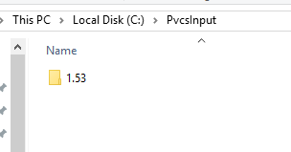

**(Type2) Multiple versions conversion:**

1. Paste the CI folder which contains multiple version pvcs format folders in PvcsInput folder.
2. Example:

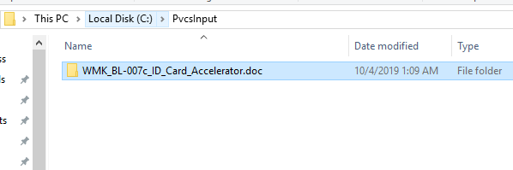

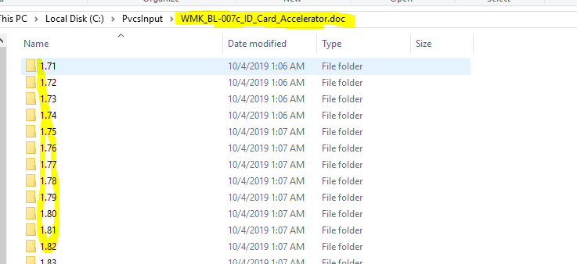

1. Run the PowerShell script :

Location: \\css-svc-nas-07.services.tzghosting.net\fixrepository\WMK_TFS_Migration\powershell_sujeet\ WMK_ps_script_SEPT

Script: WMK_ps_script_FOR_LATEST_VERSION_ONLY.ps1

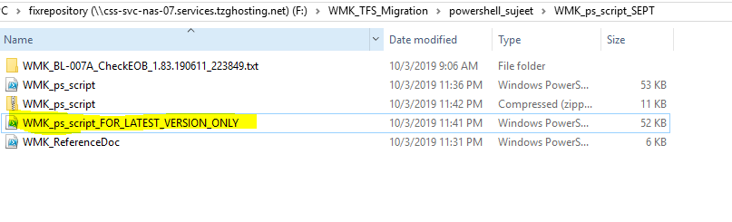

1. Right-Click >> Run with PowerShell.
2. Give security permission as yes “Y”

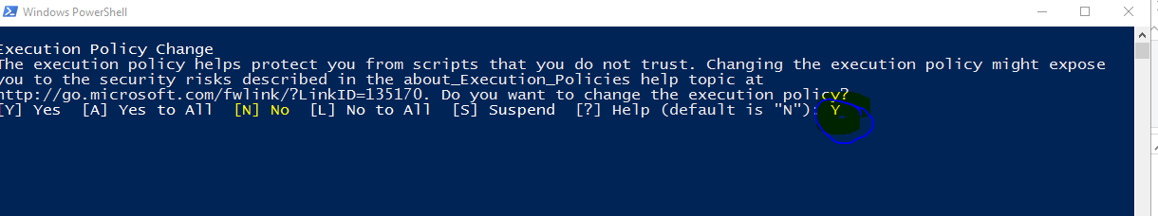

1. Input the TFS Folder Name provided by Client for the CI.

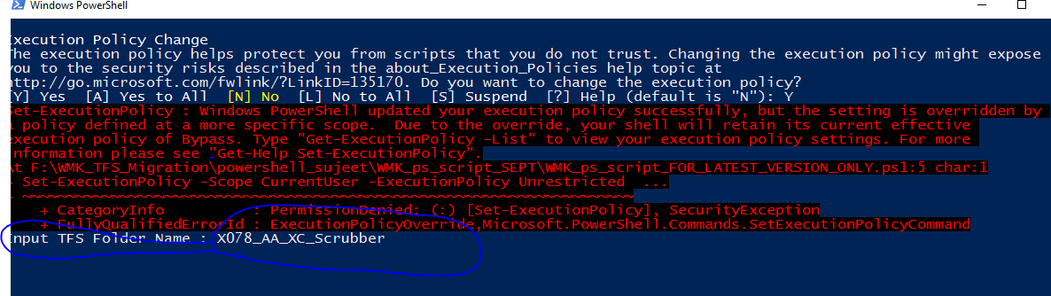

1. Wait till the console exits automatically after scrip runs.

*Once in a new moon if the PS console is stuck for more than a minute, hit enter again*

1. Go to C:\ >>> “TfsOutput” and validate the TFS folder structure.

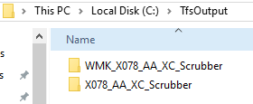

1. GO to “logs” folder inside the output and validate the Differences.txt log.

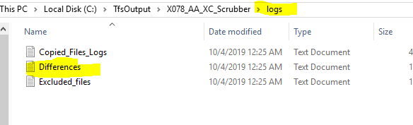

1. In Difference the.txt log, check if any required file is not copied:

**(Reach out to seniors before taking below actions)**

* Make sure it is not copied twice into target due to condition/logic in script overlapping. Decide accordingly where the file need to be present

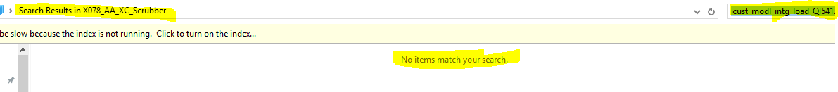

* If not copied, it might be due to conflict in condition/logic in script overlapping. Copy the artifacts manually.