**WMK_TFS_Migration_Reference_Doc_PS_Script**

1. Make sure Artifacts.xlsx is present inside your TFS folder structure output.
2. Run the PowerShell script:

**Location:** \\css-svc-nas- 07.services.tzghosting.net\fixrepository\WMK_TFS_Migration\powershell_sujeet\ WMK_ps_script_SEPT

**Script:** WMK_ReferenceDoc.ps1

1. Right-Click >> Run with PowerShell.
2. Give security permission as yes “Y

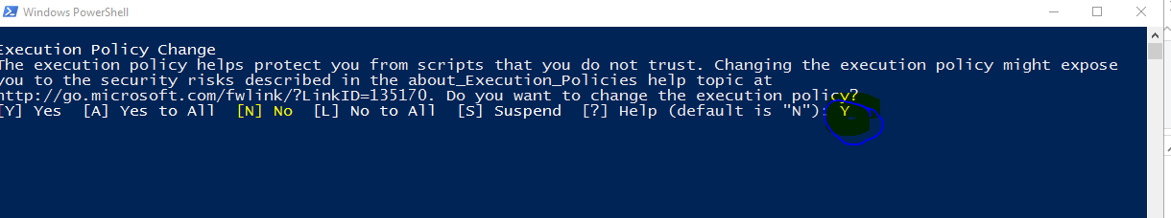

1. Input the Source path. (*Source path would be the path where Artifacts.xlsx is present and Reference doc will be generated* )

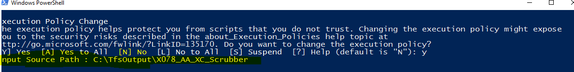

1. If your CI contains MSI, You will get pop-up in the console.

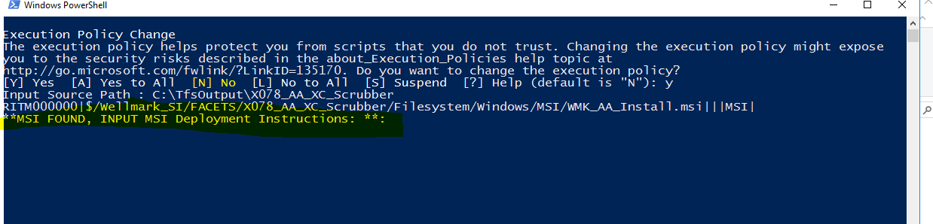

1. Open CI document and copy the MSI Deployment instructions and paste in the console and hit enter.