Assigning Values to Variables

Output:

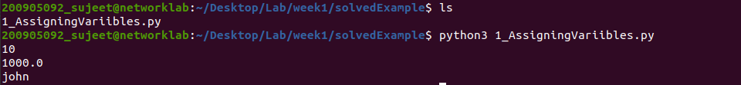

2.Multiple Assignment

Output:

Python Strings

Lists :

Code:

Output

Tuple:



Conditional Branches in Python

Eg.1

Code:

Output:

Eg.2

Code:

Eg. 3

Code:

Output:

Eg. 4

Code:

Eg 5:

Code:

Output:



Eg 6:

Code:



Usage of For-loop

Eg 1:

Code:

Output:

Eg 2:

Code:

Output:

Eg 3:

Code:

Eg 4:

Code:

Output:



Eg 5:

Code:

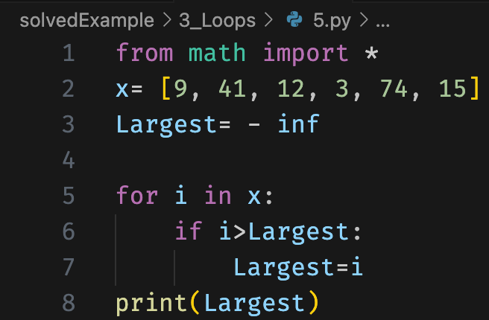



Eg 6:

Code:

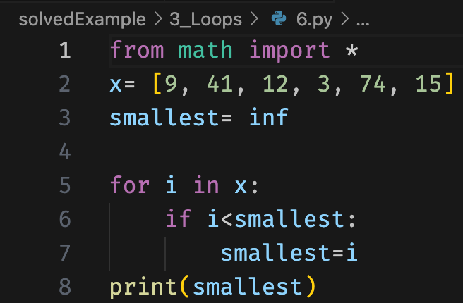

Output:



Eg 7:

Output:

Eg 8:

Code :

Output:

Eg 9:

Code:

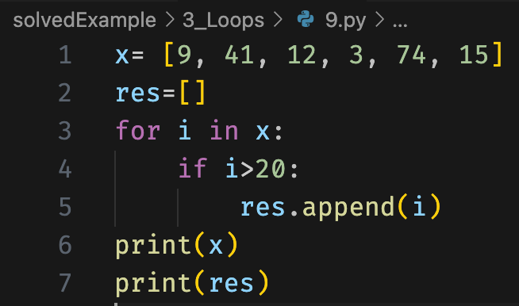



Eg 10:

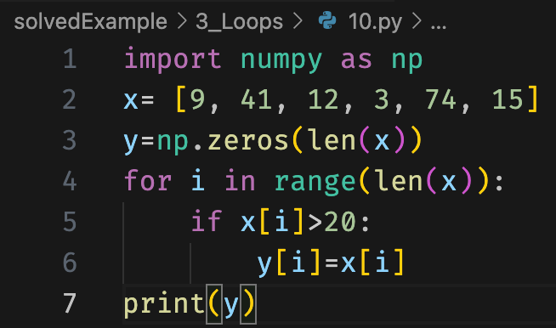



Eg 11:

Code:

Output:



Eg 12:

Eg 13:

