Question 1: Write a program to find the area of rectangle. Take input from user.

Code:

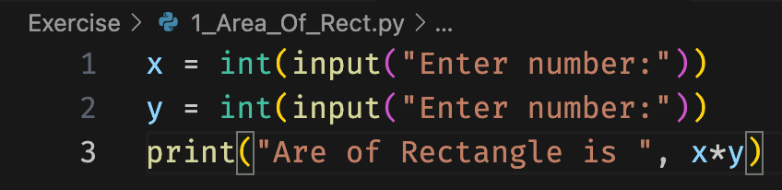

Output:



Question 2: Write a program to swap the values of two variables

Code:

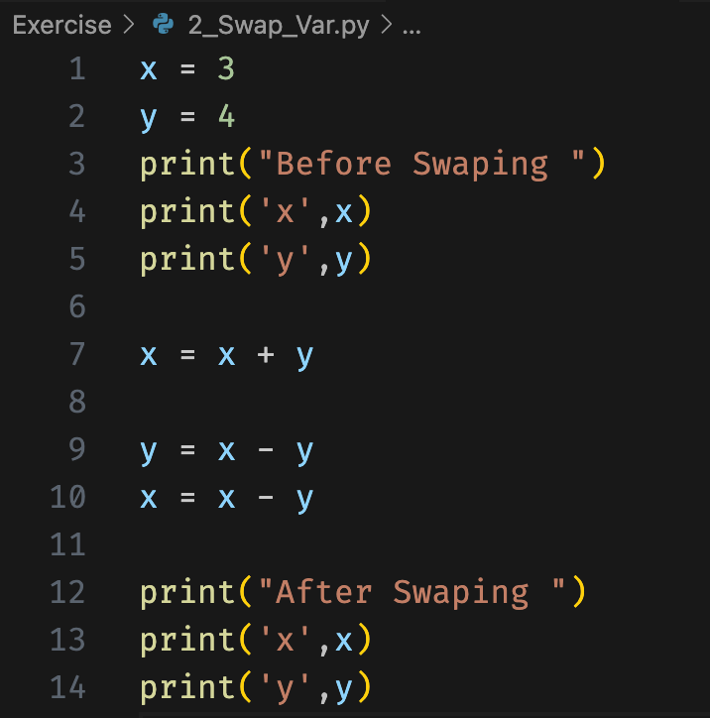

Output:

Question 3 : Write a program to find whether a number is even or odd.

Code:

Output:

Question 4: Write a program to check the largest among the given three numbers

Code:

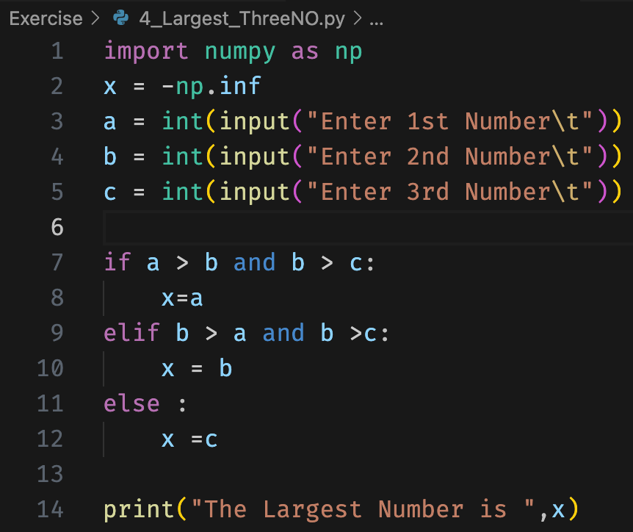

Output:

Question 5: Write a program to demonstrate List functions and operations

Question 6 : Consider the tuple(1,3,5,7,9,2,4,6,8,10). Write a program to print half its values in one line and the other half in the next line.

Code:

Output:

# Question 7: Consider the tuple (12, 7, 38, 56, 78 ). Write a program to print another tuple whose values are even number in the given tuple.

Code:

Output:



Question 8: Write a Python program to print negative Numbers in a List using for loop. Eg. [11, −21, 0, 45, 66, -93]

Code:

Output:



Question 9 : Write a Python program to count positive and negative numbers in a List.

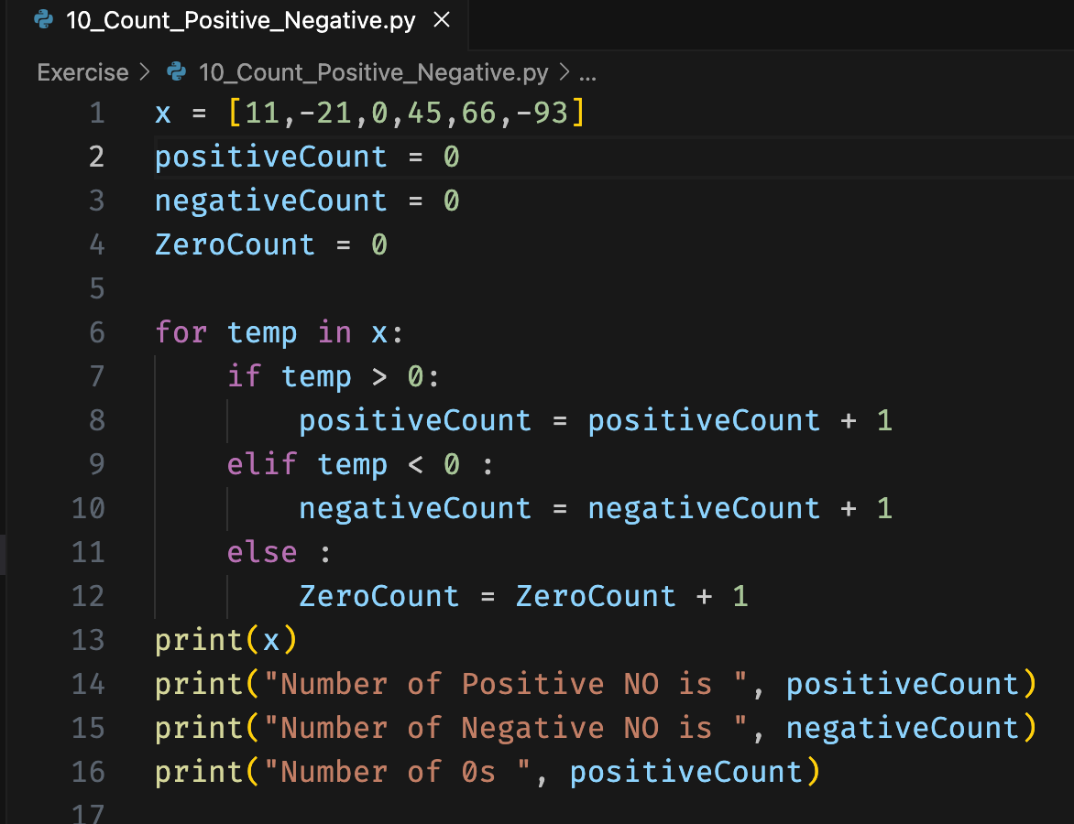

Output:

10. Write a Python program to remove all even elements from a list.

Code :

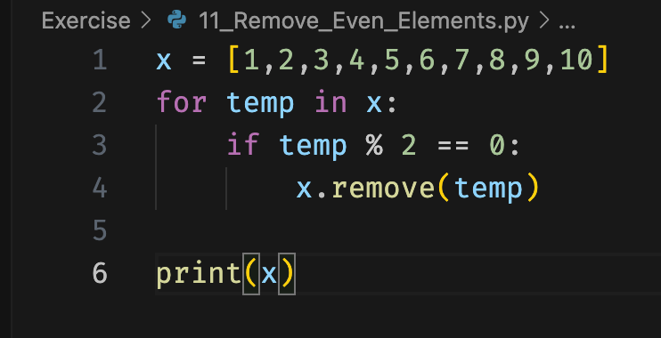

Output:

