Week 2:

11. Write a program to demonstrate while loop with else.

12. Write a program to print negative Numbers in a List using while loop.

13. Define a dictionary containing Students data {Name, Height, Qualification}.

a) Convert the dictionary into DataFrame

b) Declare a list that is to be converted into a new column (Address}

c) Using 'Address' as the column name and equate it to the list and display the result.

14. Define a dictionary containing Students data {Name, Height, Qualification}.

a) Convert the dictionary into DataFrame

b) Use DataFrame.insert() to add a column and display the result.

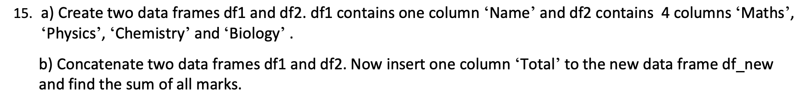

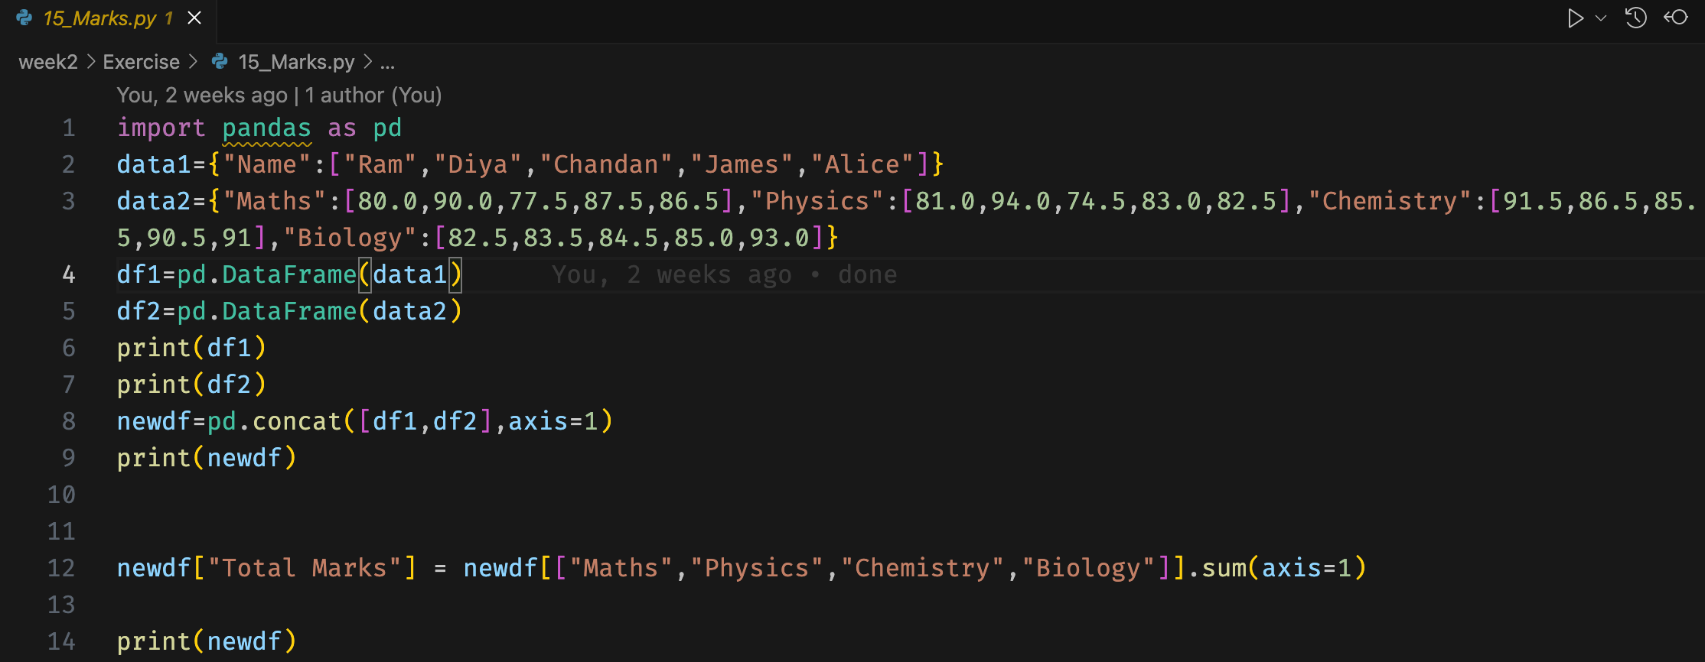

16. Create a data frame with column- Name, Quiz_1 /10, In-Sem_1 /15, Quiz_2 /10 and In-Sem_2 /15. Now insert a column

Total and find the total and mean as given in the below table.

