Code 1 :

Output:

Code 2:

Code 3:

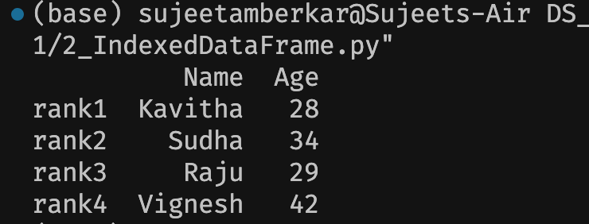

Code 4:

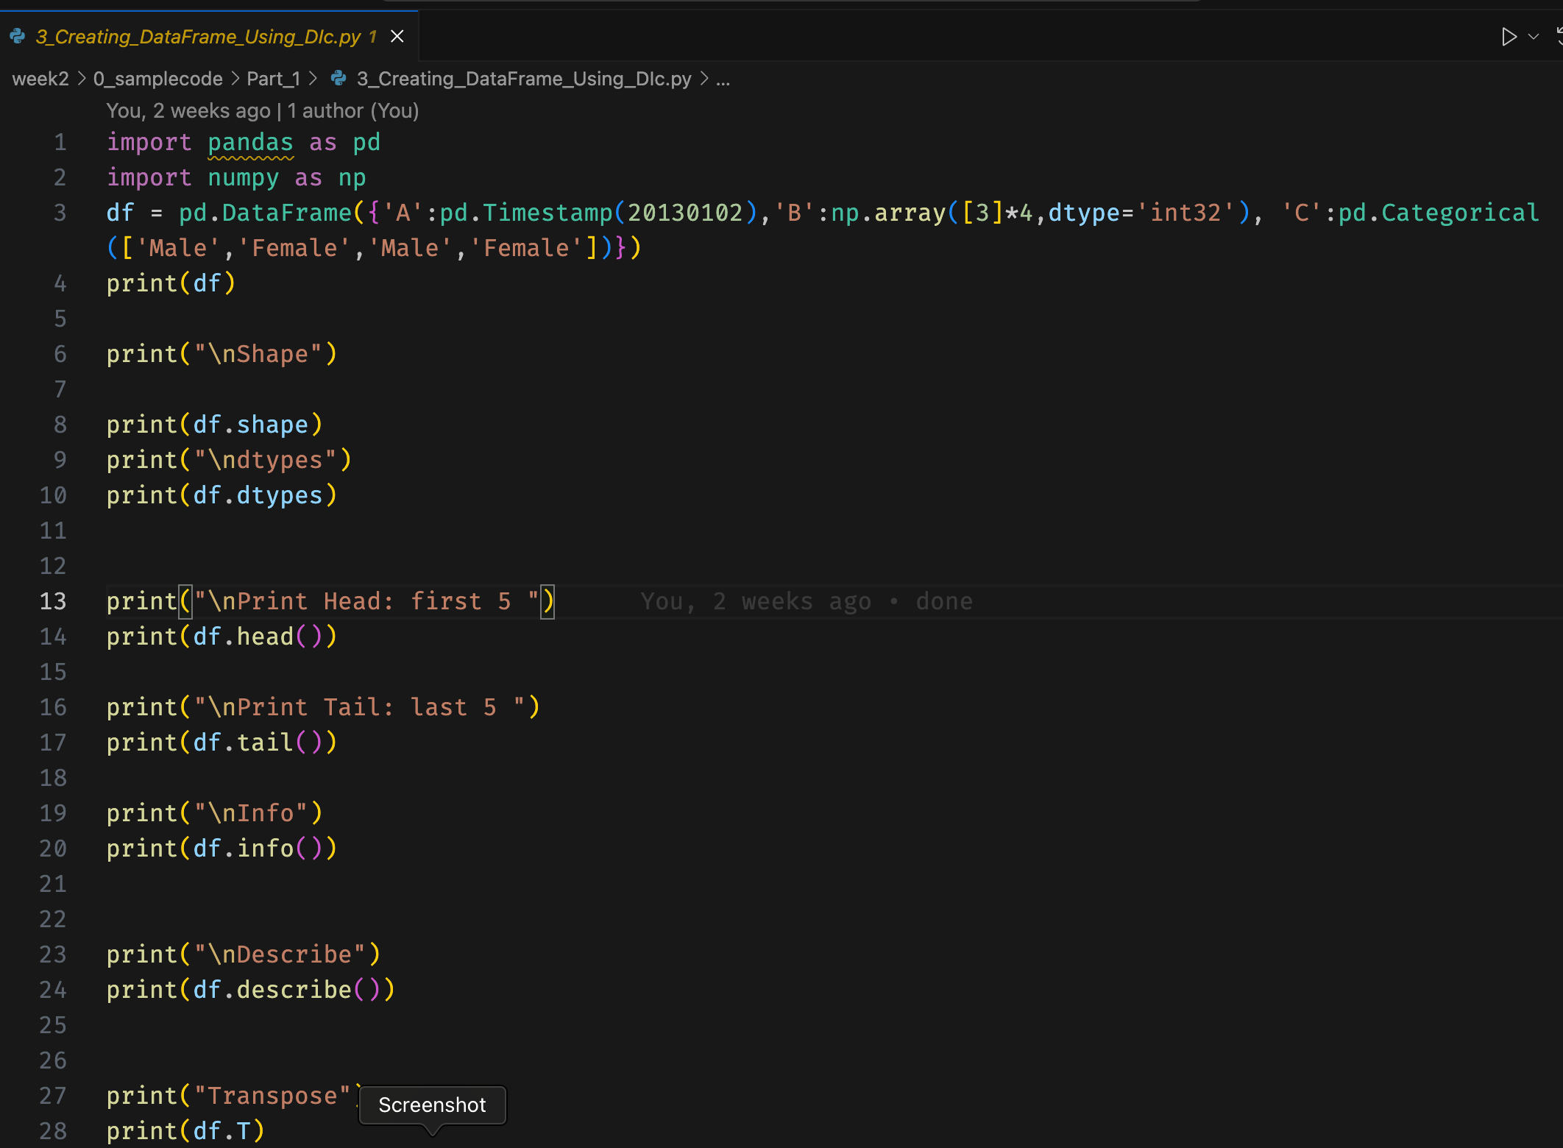

‘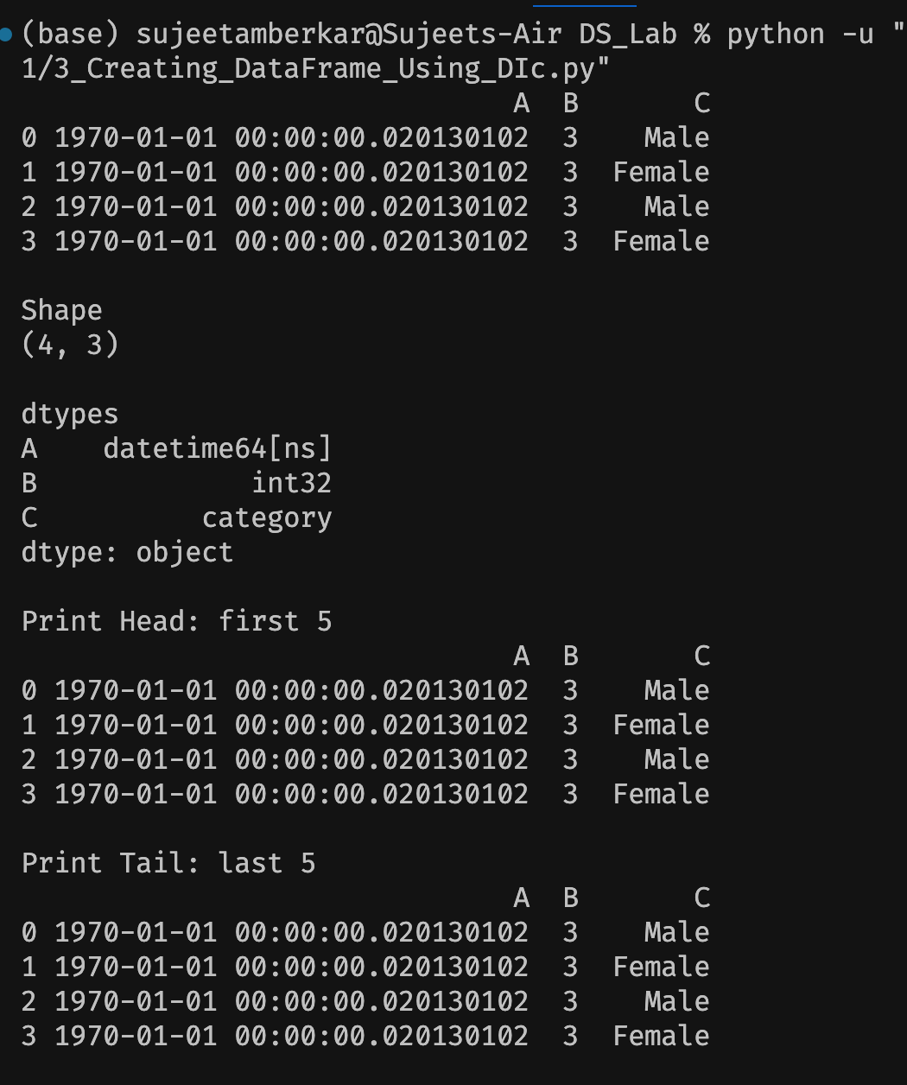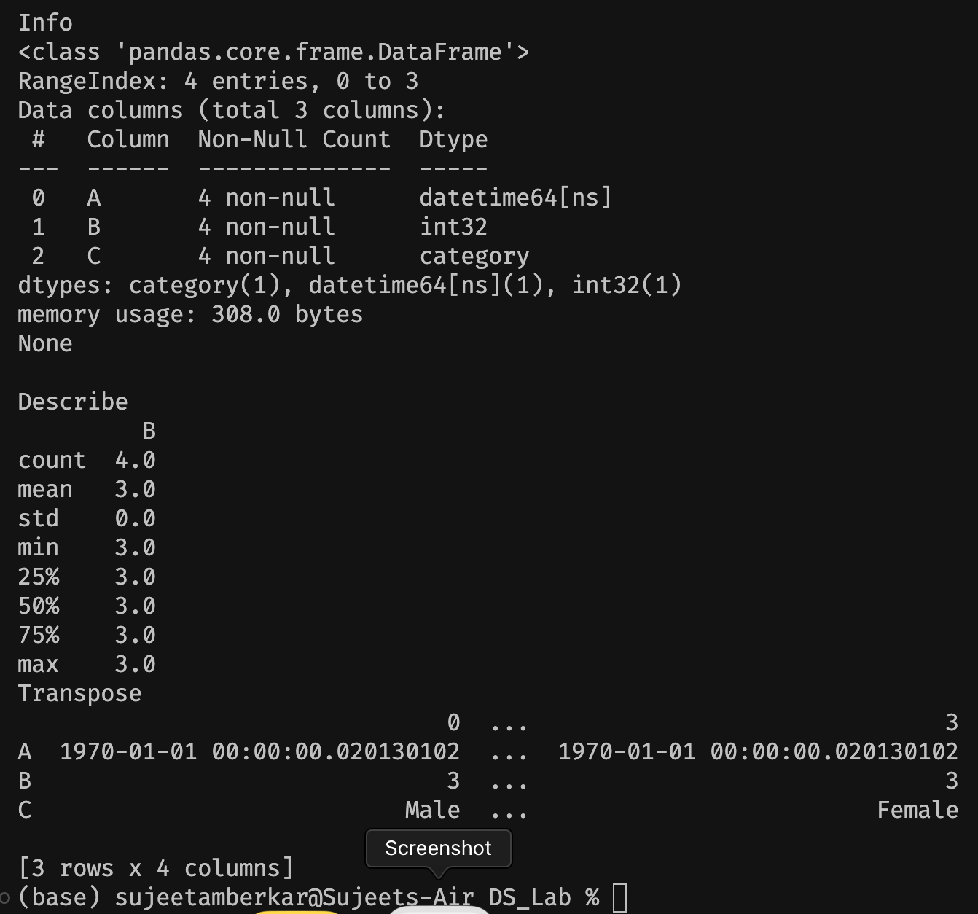

Code 5:

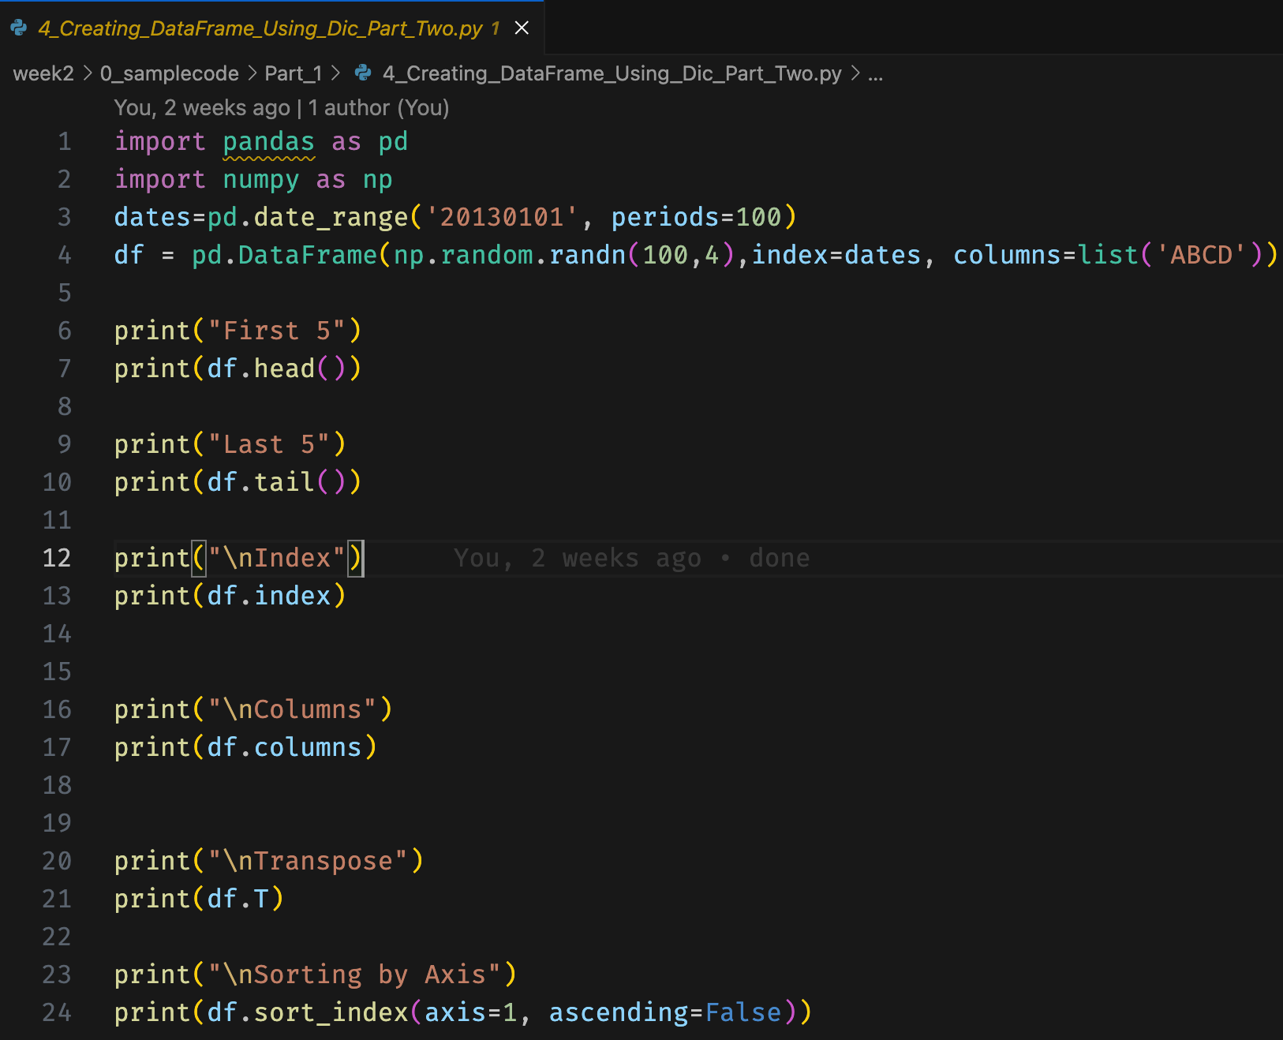

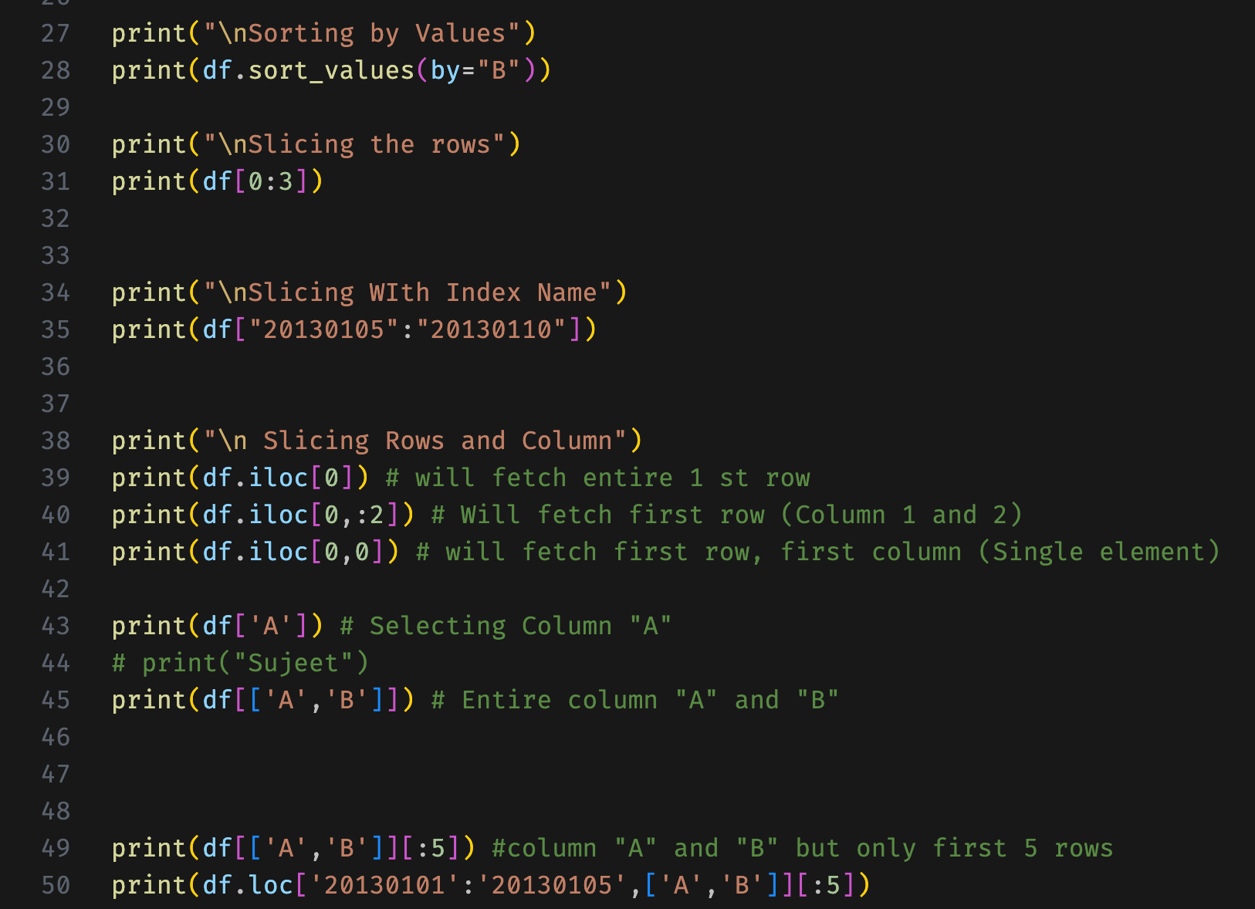

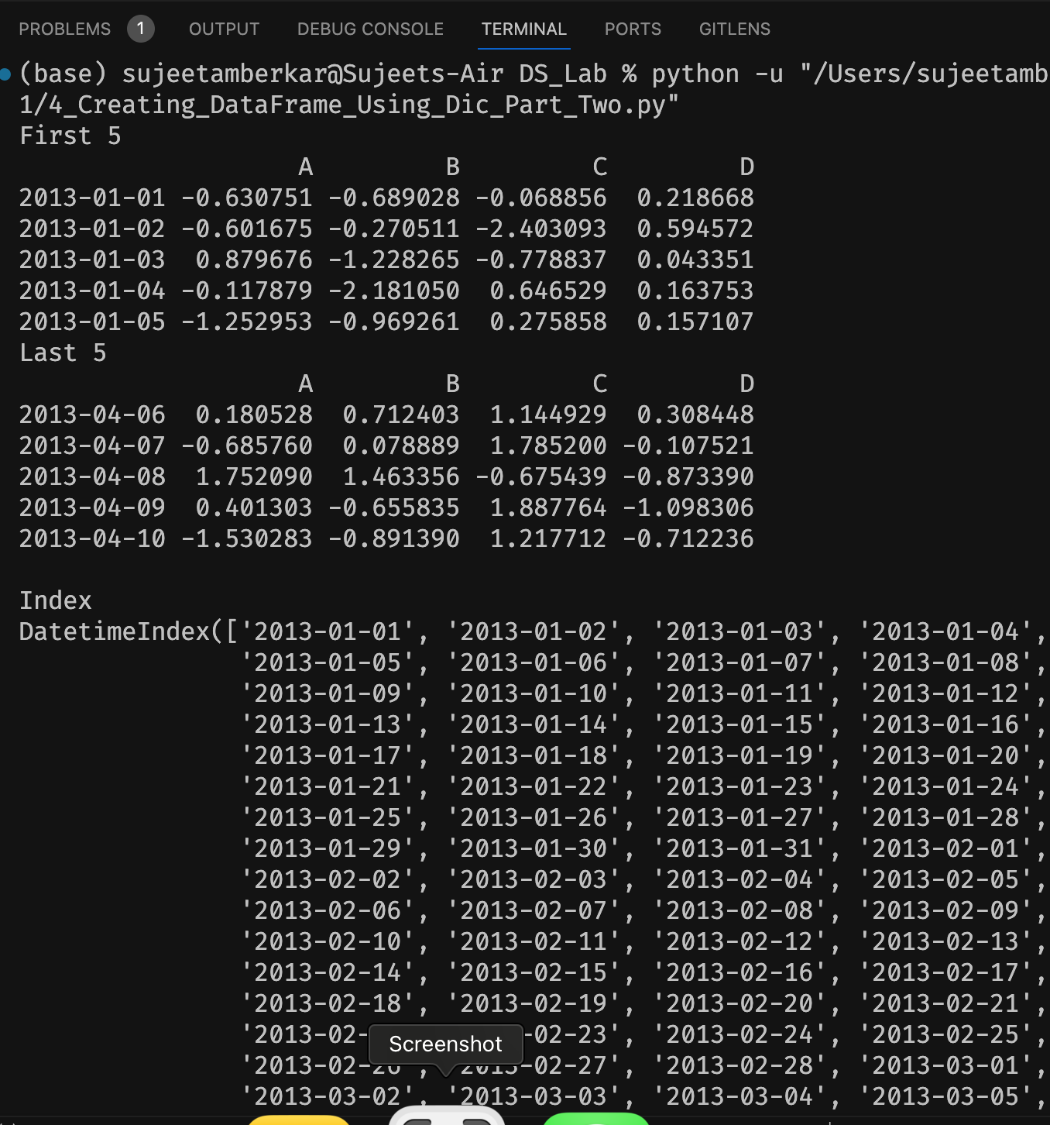

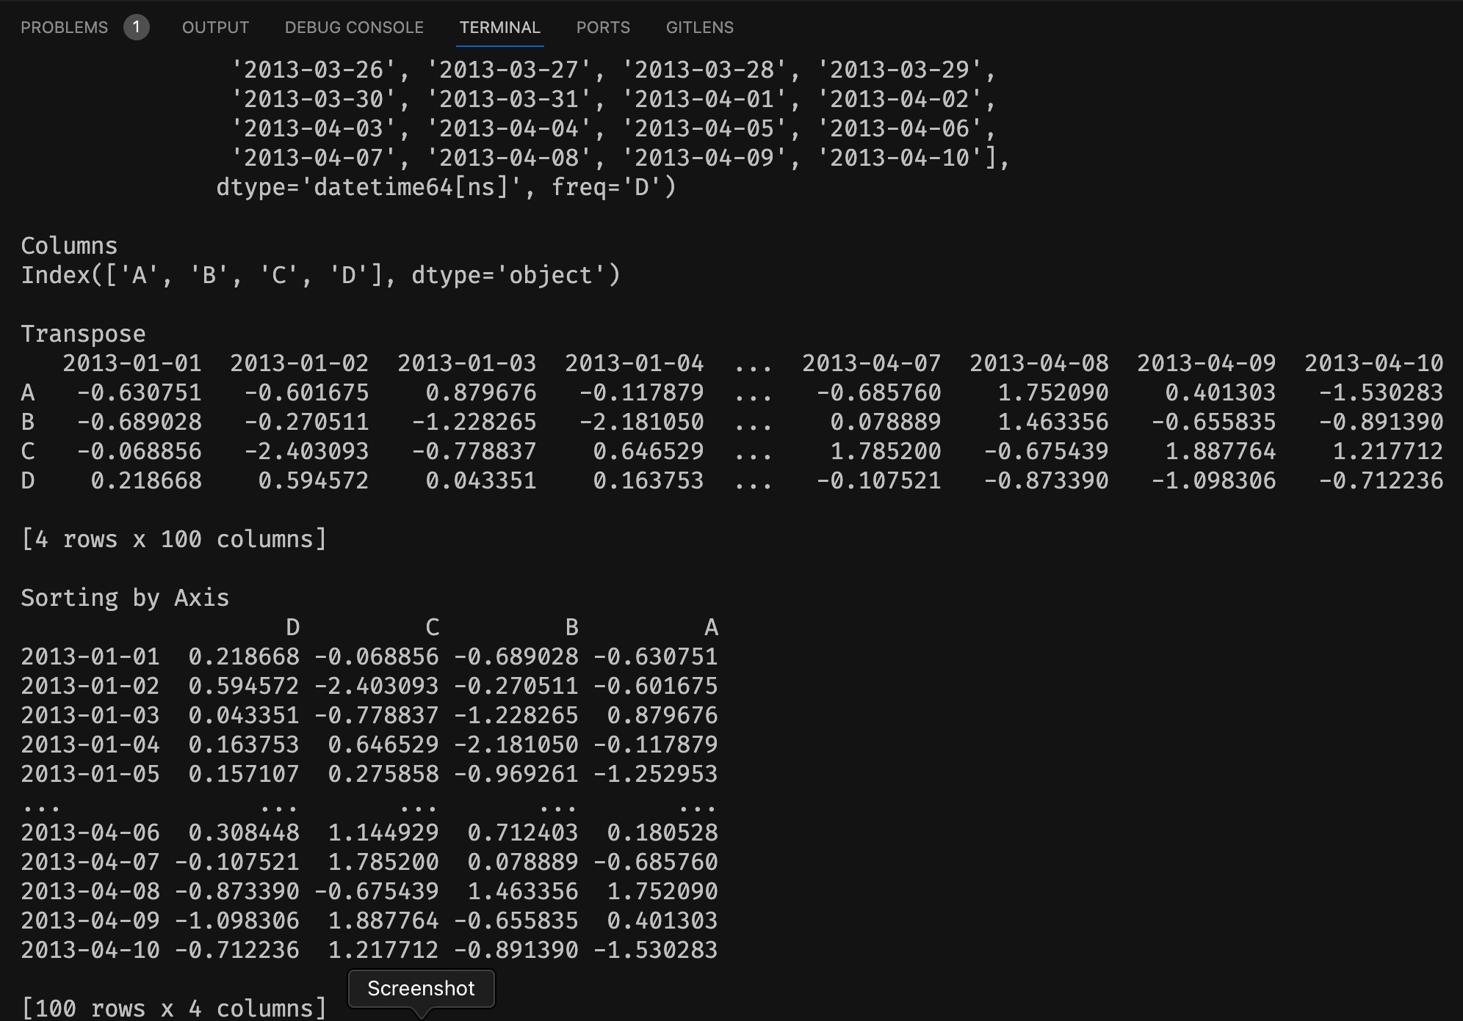

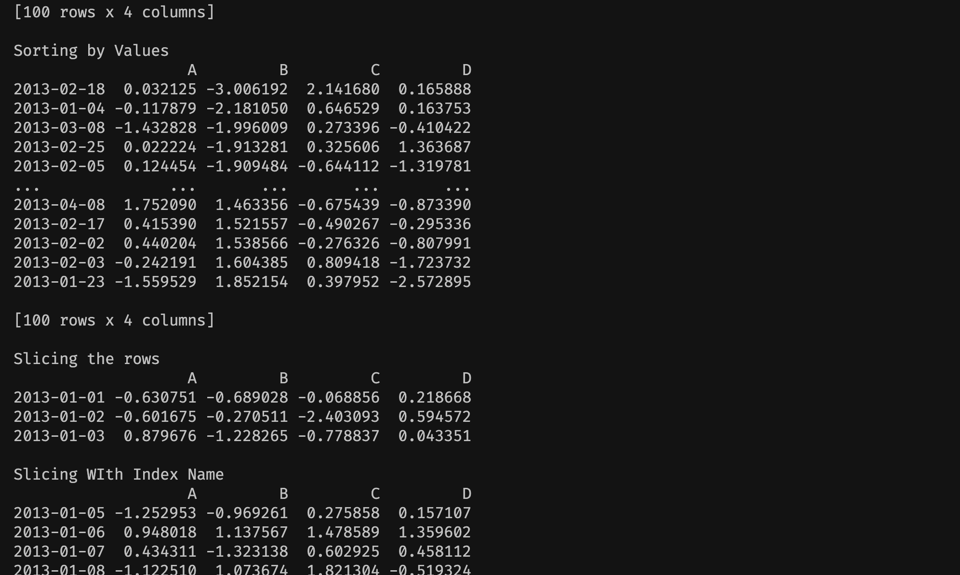

Code 6:

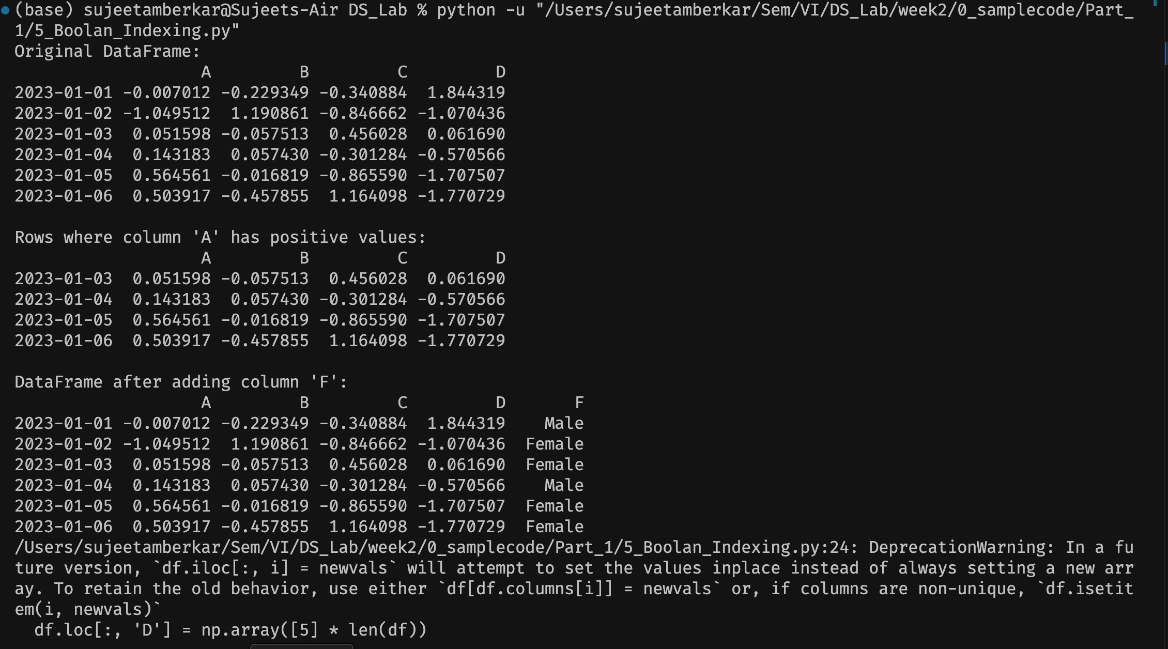

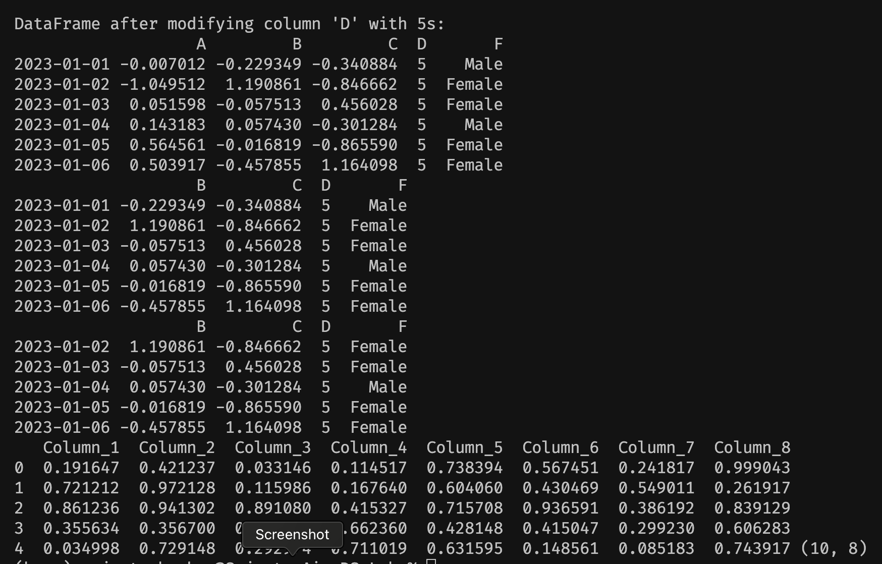

Code: 7

Code 8:

