Lab 3: Numpy

Q1) Write a program to find the factors of a given number (get input from user) using for loop.

2. Find the sum of columns and rows using axis.

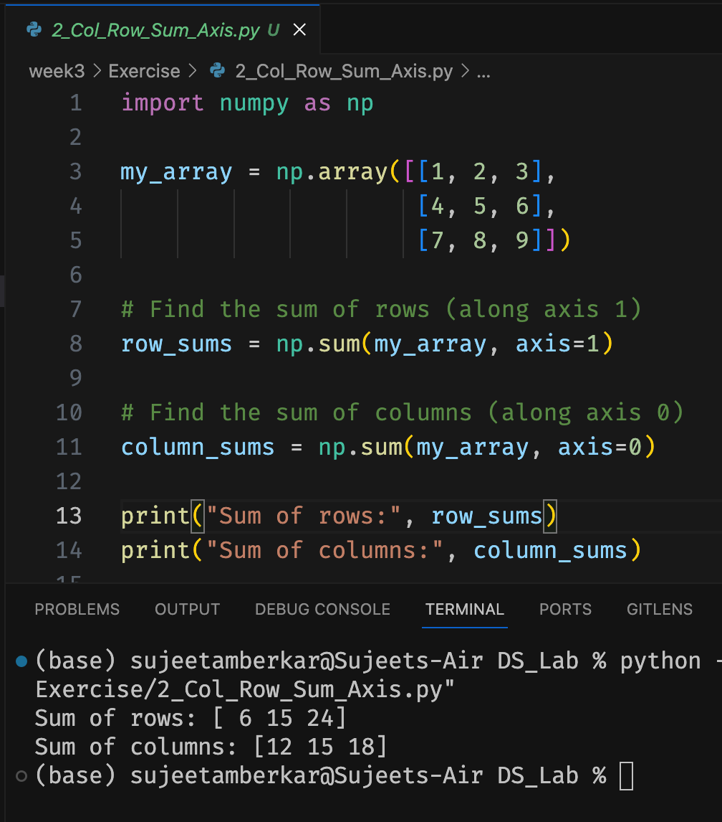

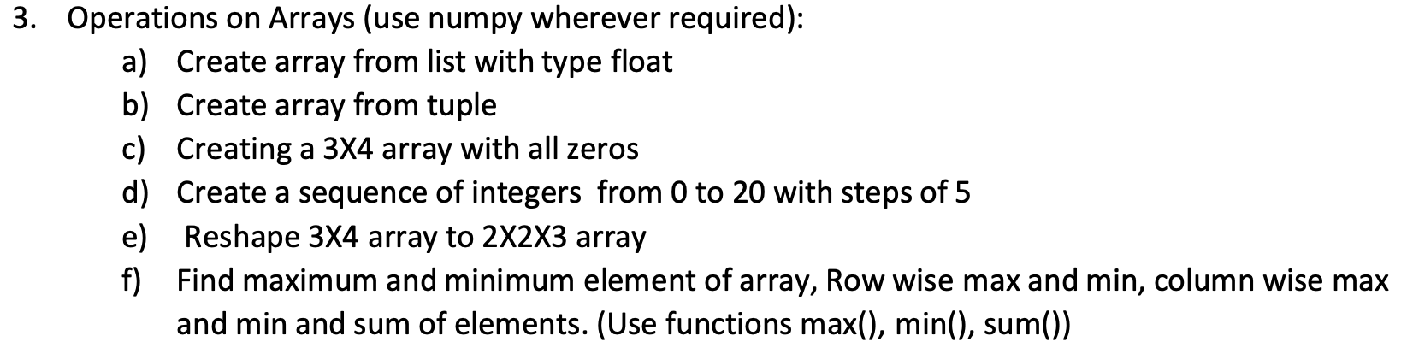

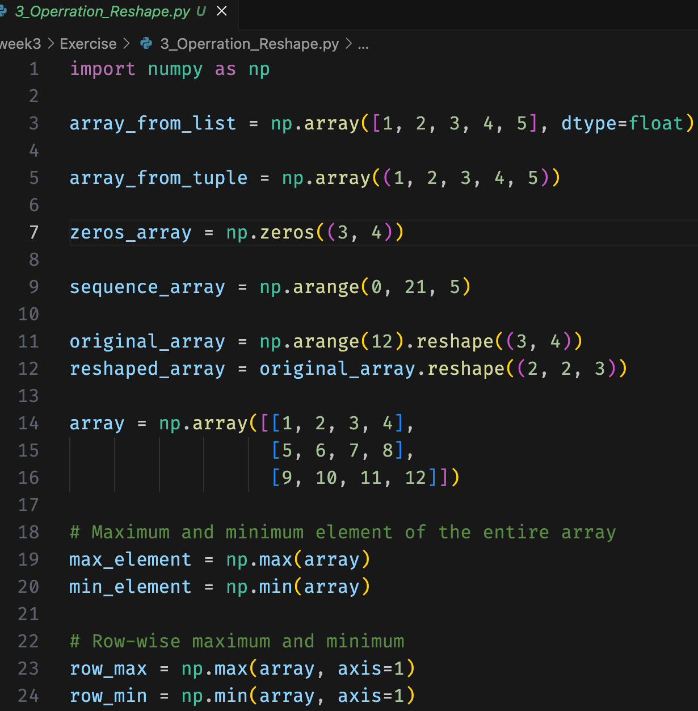

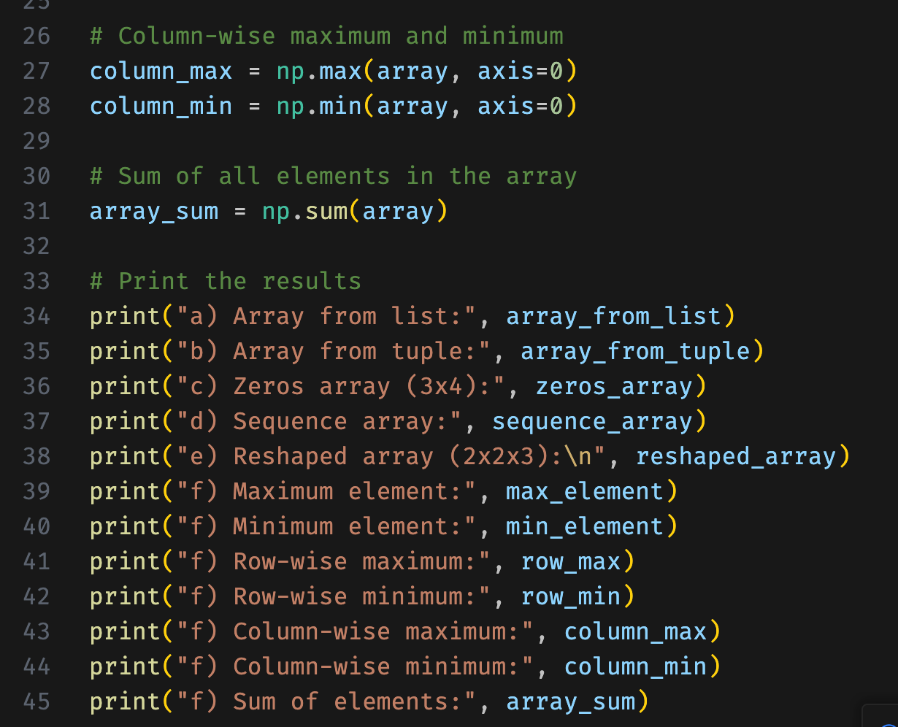

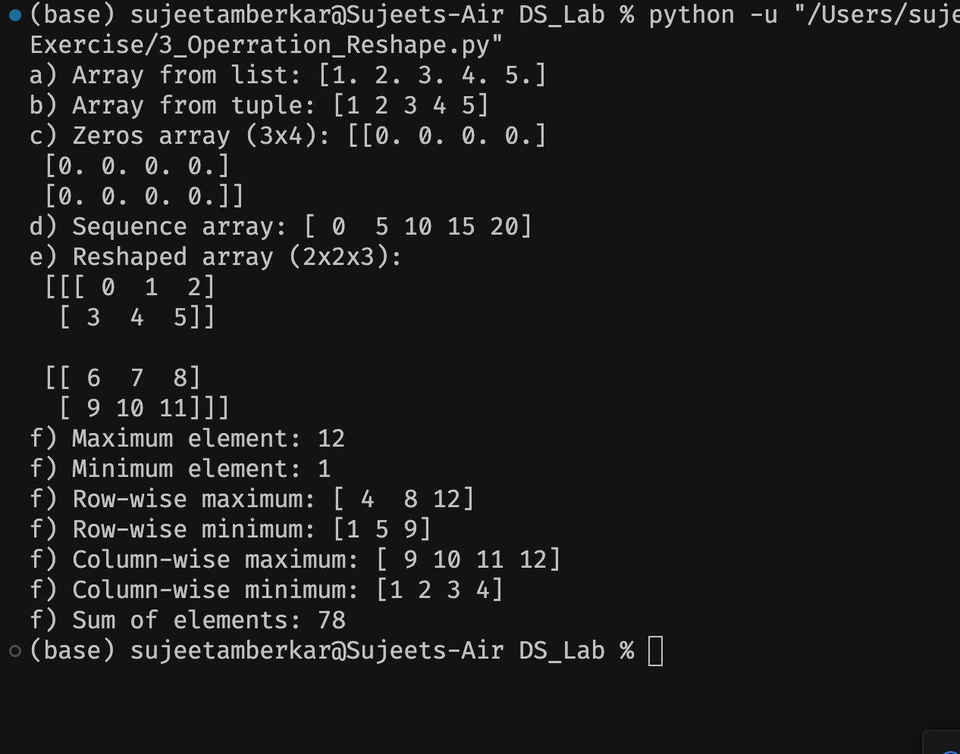

4. Write a program to transpose a given matrix.

5. Write a program to add two matrices.

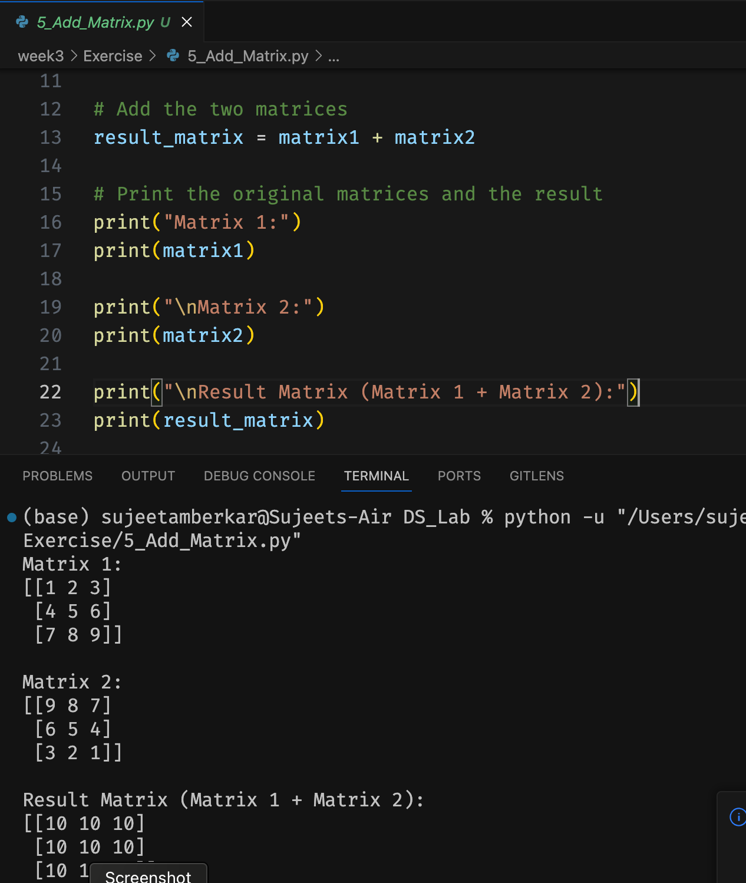

6. Write a program to find element wise product between two matrices.

