Code 1: Connection

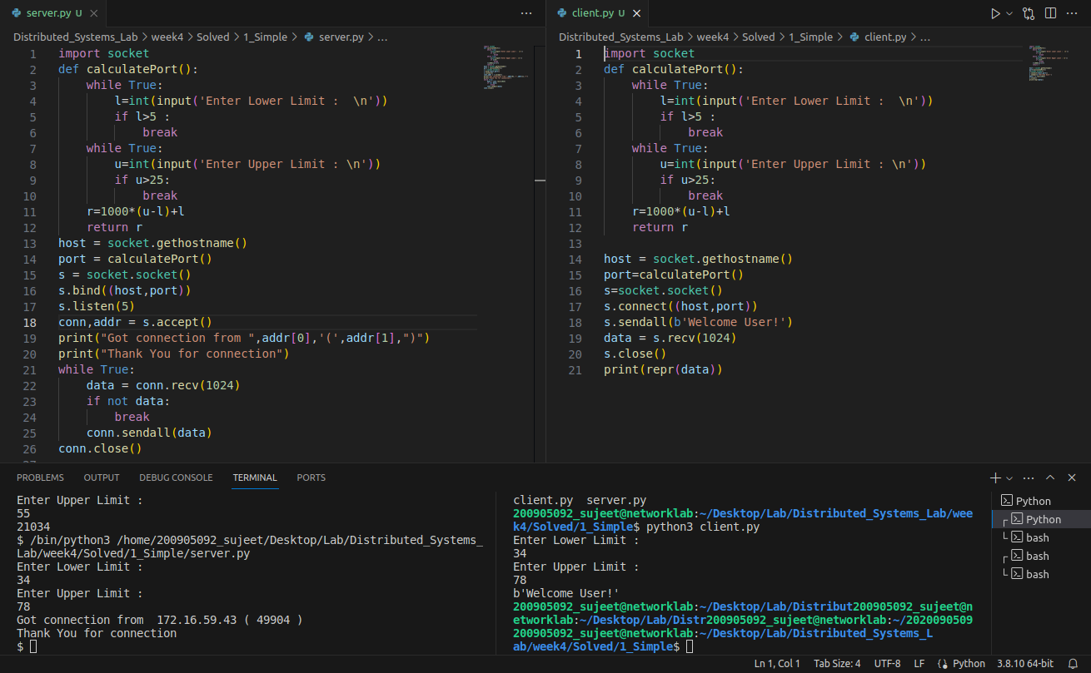

Code 2: Connectionless

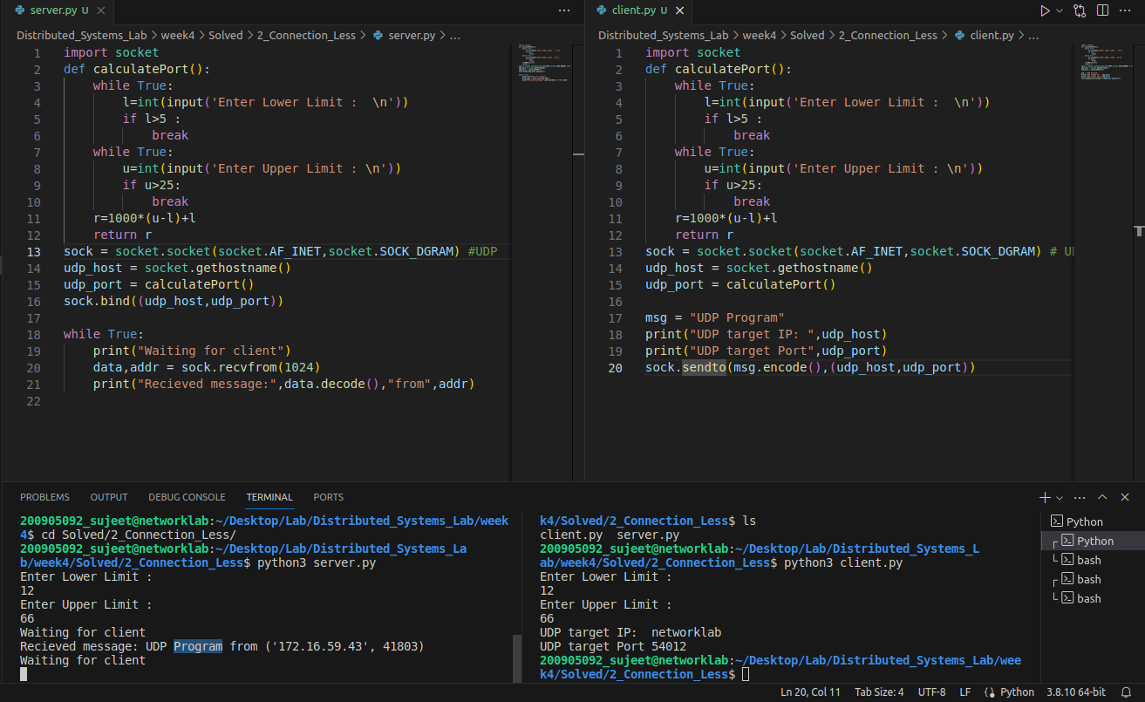

Practice Programs:

1A) Write a program where client can send a message to the server and the server can receive

the message and send, or echo, it back to the client.

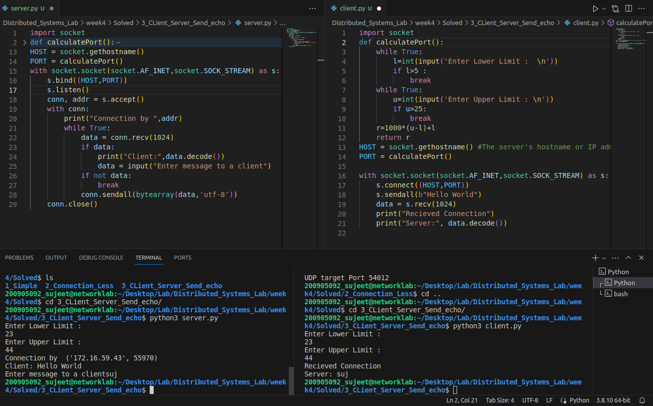2A) Write a program to create TCP time server in Python

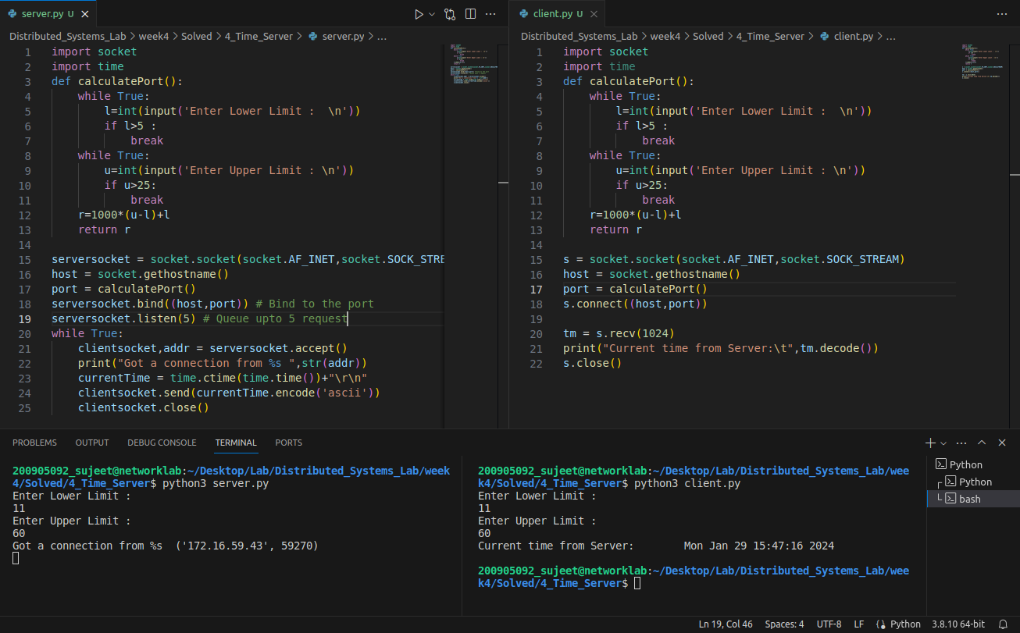

3A) Write a TCP chat server in python using socket programming.

