# Week 06

**4. Write a mapper and reducer program for word count by defining separator instead of using “\t”**

sepmap.py

sepred.py

**Exercise 4: Try to include separator using map reducing for the output of Heart Disease**

**dataset, covid_19_data dataset, example dataset and German Credit dataset.**

itemmap_expensive.py

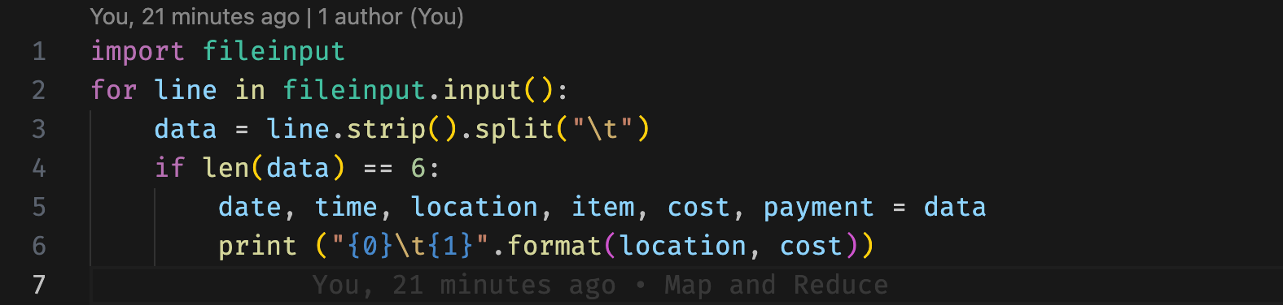

itemred_expensive.py

**5. Exercise 5: Try to apply finding max value using map reduce concept for the output of Heart**

**Disease dataset, covid_19_data dataset, example dataset and German Credit dataset.**

map.py

reduce.py  


