We have already learned how can we do Create, Read, Update and delete CRUD operation by using PHP PDO, Mysql and Ajax. But in this post we have discuss how can do this all CRUD operation by using PHP api with Ajax. So, here we will make simple PHP Restful Api step by step.

**What is REST Api in PHP?**

But First we need to know what is Restful Api and what is the use of this Api in web development. Here REST means "REpresentational State Transfer". It is a simple method for manage information on internet. REST ideas are referred to as simple resources and rendering of resources should be stateless. It is mainly displayed by JSON format.  
  
Same way API means "Application Programming Interface". This Api is place or guideline which allows one set of web application can be communicate with another. In that guidelines we can insert, update and delete data operation.  
  
Rest API allow you web application to communicate with one or various different application by using REST concepts. 

**Why should we need PHP Rest API?**

There are many PHP web application in which REST API is required because it is a simplest way to insert, update or delete data between various application over the internet by using HTTP protocol. REST API can be used by any type of web application which has been connected with internet. If any information from an web application has been inserted, updated or deleted by using another web application that means it has use REST API.  
  
Now we have make a RESTful web service in PHP for CRUD operations. The REST API has been used by creating HTTP GET or POST or PUT or DELETE operation from client to server or server to get or put data. The REST API based web services can be given output in different format like CSV JSON etc. In this tutorial we will learn how to make simple REST API by using PHP Mysql. Now let's start learn how to create API in PHP.

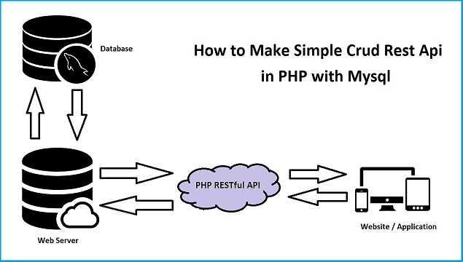

**File Structure**

Following are the file structure of PHP REST API for CRUD operation.

* **api //In this folder we have store PHP API File**
  + **Api.php**

**//This is API class for Insert Update Delete**

* + **test_api.php**

**//This file will handle API request.**

* **work //In this folder we will make file for send API request**
  + **index.php**
  + **fetch.php**
  + **action.php**

**How to Display or Fetch data by using PHP REST API**

First we want to learn how to select all or fetch all data from Mysql database and display on web page. For this we have use Ajax with PHP. For this we have make Ajax function and this function has send request to **fetch.php** page and this page has send request to API which we have make under **api/test_api.php**. This page received api request for API class which we have make.

**How to Insert or Add Data into Mysql table using PHP REST API**

If you have web application and if you want to make Android or IOS application then at that time from that application you want to Insert or Add data into your web application database then at that time PHP web services are use. PHP webservices has been created by using PHP api. So here we have learn how to insert or add data into Mysql table by using API from any mobile application. Here we have we have use Ajax for insert data into mysql table by using PHP api. For this we have send Ajax request to from **index.php** to **action.php** and on **action.php** we have send api request to **api/test_api.php** for insert or add data into mysql table. On **api/test_api.php** it has run method for insert or add data of **api/Api.php**. Below you can find complete code for insert data using PHP API.

**How to Update or Edit Mysql data using PHP API**

Above we have seen how to insert or add data using PHP API. But suppose we want to make some changes in data which we have inserted or store under mysql table from any Mobile application. Then at that time PHP API can we used by using PHP API we can edit or update our web application data remotly from any location and from any web device which has been connected with internet. We have to just send update or edit data request to PHP API. Below you can find complete source code for how to update or edit Mysql table data by using PHP Restful API.

**How to Delete or Remove data from Mysql using PHP API**

This is last operation of CRUD and here we want to learn how can we delete or remove Mysql table data by using PHP REST API. API we can access from any place and from any device just we have access key particular API. So, suppose we want to just delete or remove some information from wep application by using web device application. So, from application we have to just send request to API from delete or remove particular data from your database. API will remove or delete data and it will send request back to particular application from where it has received request. Below you find how to delete or remove Mysql table data by using PHP API with Ajax.