TABLE OF CONTENTS

- Abstract--------------------------------------------------------------------------------------2

- Introduction----------------------------------------------------------------------------------3

- Literature Survey----------------------------------------------------------------------------5

- Requirement Analysis ---------------------------------------------------------------------6

  - Software Requirement

  - Hardware Requirement

- Objective and Scope------------------------------------------------------------------------7

- Existing System------------------------------------------------------------------------------8

- Proposed System ----------------------------------------------------------------------------9

  - Features of Proposed System----------------------------------------------------10

  - Benefits of Proposed Model-----------------------------------------------------11

- Design and Implementation---------------------------------------------------------------12

  - Taking Input from User----------------------------------------------------------13

  - Validating Input and Generating Question Paper-----------------------------14

  - Generating random Number-----------------------------------------------------17

  - Checking Duplicate Entry--------------------------------------------------------18

  - Sorting------------------------------------------------------------------------------19

  - Display the Success Message----------------------------------------------------20

  - Getting Marks of the Question--------------------------------------------------21

  - Adding Marks---------------------------------------------------------------------22

  - Structure Used---------------------------------------------------------------------23

- Result and Screenshot---------------------------------------------------------------------24

- Conclusion----------------------------------------------------------------------------------30

- Reference------------------------------------------------------------------------------------31

- ABSTRACT

Examinations are important tools for assessing student performance. They are commonly used as a metric to determine the quality of the students, thus the nature of the exam questions would determine the quality of the students produced by the institutions, however Preparing the exam questions is very challenging preparation of quality examination questions is cumbersome and challenging especially for lecturers teaching new subjects. The problem becomes significant among novice lecturers. Usually, lecturers prepare complete sets of questions paper manually and store it in a Question bank. The glaring issue is how to auto-generate question papers. This project will investigate multi-constraints genetic algorithm approaches in designing Auto-Generator of Examination Questions (AGEQ). The requirement model for AGEQ will be discussed in detail. The analysis shows impressive results in the difference between the desired and actual AGEQ output.
Key terms – AGEQ (Automatic Question Paper Generator)

2. INTRODUCTION

With the onset of computer based technology there have been evolutionary changes in many areas of our professional environments. Most strangely e-education and e-learning is highly influenced. There is a shift from manual to automated systems for different aspects of education system. At every stage/level of education some admission procedure is present.
The fundamental to this admission procedure is a test paper.
However, the main problem is, a low quality of papers generated because of some human factors such as instability and relatively narrow scope of topics. Teachers need to invest a lot of time and energy in composing examination papers.
Also, the concern remains is how the current technologies would also help the instructors automatically generate the different sets of questions from time to time without being concern about repetition and duplication from the past exam while the exam bank keeps growing. Making assignment sheets, daily practice tests, weekly tests, test series, online tests, etc. is a repetitive and time consuming task which involves both teacher as well as computer operator. Using this software, the same action can be accomplished in minutes and even in absence of operators. The finest part of the software is that it takes intelligent decisions to eliminate repeated questions and checks even for the alternatives. Not only this, for formation of a question paper it is also possible to restrict the search to questions which have not been used at all or have been used less than specified number of times. This makes it greatly advantageous as the headache of manually avoiding repetition at the time of feeding is totally eradicated. These automated systems provide cost saving and time-efficient solutions.
Our project is automatic question paper generation system which will enable college authorities to automatically generate question papers out of existing question bank in the database. The system will have capability to process different unique sets of papers very automatically. It takes over the entire tedious task and does the manual, laborious work swiftly and efficiently. You can arrange the question bank according to subject, class, section and weightage. The paper generator is the one & only software for setting examination question paper. The software performs all tasks related to paper setting, starting from preparing question bank to printing paper. Software is very useful for small medium and large scale institutes. The software will empower the college with a powerful tool to generate question papers in a very short span of time thus saving a lot of their precious time. The authorities have the flexibility to generate class tests, unit tests, terminal tests, and final tests.
In this system we present a smart question paper generating system. In our system we allow administrator to input a set of questions. We also allow admin to provide weightage for each of these questions. After this the questions are stored in database along with their weightage. Now on question paper generating time the admin just has to select the weightage of the whole question, number of questions and weightage of each question. On this selection the system selects question randomly in a way their weightage makes up for specified marks. After this the question paper is saved into a text file.

3. LITERATURE SURVEY
Shikha garg, vishal goyal, System for Generating Questions Automatically from Given Punjabi Text, this paper introduces a system for generating questions automatically for Punjabi. The System transforms a declarative sentence into its interrogative counterpart. It accepts sentences as an input and produces a possible set of questions for the given input. Not much work has been done in the field of Question Generation for Indian Languages. The current paper represents the Question Generation System for Punjabi language to generate questions for the given input in Gurmukhi script. Proposed system cannot generate questions with "kuon" , "kive" etc. words.
Chin-Yew Lin:
Automatic Question Generation from Queries In this paper, author propose automatic generation of questions from queries as a shared task. With large amount of cQA data available online, together with real world query logs, and interests from both aca-demics and industry, author believe that the time is ripe for such endeavor. The results would change ways that people interact with information and provide new perspectives in natural language generation, information retrieval, and other related fields

4. REQUIREMENT ANALYSIS

4.1. HARDWARE REQUIREMENTS:
The hardware requirements are very minimal and the software can be made to run on most of the machines.

PROCESSOR : PENTIUM IV 2.6 GHz
RAM : 512 MB
HARD DISK : 20 GB

4.2. SOFTWARE REQUIREMENTS:
Operating system like Windows XP, Windows 7 and Windows 8 is the platform required to develop this software.

A Visual C++ compiler is required for compiling the source code to make the executable file (.exe) which can then be directly executed.

FRONT END : C/C++
BACK END : QUESTION PAPER STORED IN NOTEPAD
TOOLS USED : VISUAL STUDIO 2010

OPERATING SYSTEM : WINDOWS XP AND ABOVE
Platform:

The package is implemented using Microsoft visual C++ under the windows programming environment.

5. OBJECTIVE AND SCOPE

The objective of the project is to design automatic question paper generator software in c environment, which helps schools and Institutes to generate different set of questions without repetition and duplication. This application works in Windows environment.
The scope and future enhancement of the project is we can add many more options like difficulty level of question, subject categorization, administration login page, default schemes of question paper etc.

6. EXISTING SYSTEM

Presently manual generation of question paper is followed to generate a question one or the faculty have to sit for long hour and then he takes a decision which question he want to give for the examination but is quite ok but problem occurs when set of different question has to be generated for each student to do this a of time and hard work is required and has to be managed properly in terms of marks or in terms of difficulty level.

7. PROPOSED MODEL

Examiner

Question Bank
Enter Questions

Total Marks, Number of Questions

Question Paper
Generator

Generated Question Paper

Fig: Working of Question Paper Generation System

Automatic Question Paper Generator is special software which is useful to schools, Institutes, publishers and test paper setters who want to have a huge number of questions and generate test papers frequently with ease. It mainly deals with the gathering, sorting and administration of a large amount of questions about multi constraints. This paper introduces Automatic Generator Question Paper System (GQS) to overcome the mentioned problem. The main part is to provide randomization technique in question paper generation system, thus different sets question could be generated without repetition and duplication. Fig displays the general block diagram of Automatic Question Paper Generator System.

  - FEATURES OF PROPOSED MODEL
- Avoid repetition of questions
- Create variants or versions of a particular question or the whole question paper
- Easy to adapt and use, intuitive interface
- In-built question bank so the software can be used immediately after installation

  - BENEFITS OF PROPOSED MODEL
- Limited or unlimited no. of question papers
- Minimizes the dependency upon teachers, staff, etc.
- Create partially or fully different versions of the same question paper
- Save time, money, headache so that you can focus on other critical tasks in your business operations
8. DESIGN AND IMPLEMENTATION
Implementation is the stage of the project when the theoretical design is turned out into a working system. Thus it can be considered to be the most critical stage in achieving a successful new system and in giving the user, confidence that the new system will work and be effective.
The implementation stage involves careful planning, investigation of the existing system and its constraints on implementation, designing of methods to achieve changeover and evaluation of changeover methods.

- MODULES
- Taking inputs from user
- Validating inputs and generating question paper
- Generating random number
- Checking duplicate entry
- Displaying the detail about paper generated
- Getting marks of each selected question
- Finding total marks of paper generated

MODULES DESCRIPTION:

8.1. Taking inputs from user:
In this module which is sub module of main function itself the user is asked for inputs like location of the stored question bank, number of questions in question bank, location to save generated question paper and the number of the question it should contain.

cout << "\t\t\t\t\t\t\tEnter Address for file containing single Question:";
getline(std::cin, ifpath1);
cout << "\t\t\t\t\t\t\tEnter Address for file containing Multiple choice Question:";
getline(std::cin, ifpath2);
cout << "\n\t\t\t\t\t\t\tEnter the number of Single question it conatins?:";
cin >> n1;
cout << "\n\t\t\t\t\t\t\tEnter the number of Multiple Choice question it conatins?:";
cin >> n2;
fflush(stdin);
cout << "\n\t\t\t\t\t\t\tEnter Address for saving Question Paper:";
getline(std::cin, ofpath);
cout << "\n\t\t\t\t\t\t\thow many single question it should contain:";
cin >> qno1;
cout << "\n\t\t\t\t\t\t\thow many multiple choice question it should contain:";
cin >> qno2;

8.2. Validating inputs and generating question paper:
In this module the programs check for the correctness of the input like the specified path of the question bank exists or not and if exists then specified file is available or not and if available whether it contains set of questions in proper format or not etc.
It adds the header of the question paper like college name, subject name, subject code, timing, USN, maximum marks of the question and prints the selected random questions in the output file at location specified by the user.

void paper::generatePaper(string ifname1,string ifname2, string ofname, int qno1,int qno2)
{
cout << "start reached que" << endl;
int i=1,j=0;
ifstream in1 , in2;
in1.open(ifname1, ios::in | ios::_Nocreate);
in2.open(ifname2, ios::in | ios::_Nocreate);
ofstream out;
out.open(ofname, ios::out);
cout << "mid reached que" << endl;
if (!in1 || !in2 || !out)
{
cout << "can't open file" << endl;
cout << "Invalid file names" << endl;
exit(0);
}
out << "\t\t\t\t\t\t _____________________" << endl;
out << "\t\t\t\t\t\tUSN:| | | | | | | | | | |" << endl;
out << "\t\t\t\t\t\t --------------------- " << endl;
out << "\t\t\t!SJB INSTITUTE OF TECHNOLOGY!" << endl;
out << "\t\t Department:Computer Science & Engineering" << endl;
out << "\t\t\tTest-I" << endl;
out << "Sem :IV 'A'&'B'\t\t\t\t\tDate:" << __DATE__ << endl;
out << "Sub :Operating System\t\t\t\t\tTime:9:00-10:00" << endl;
out << "Sub code:10cs53\t\t\t\t\t\tMax Marks:" << (qno1+qno2) * 10 << endl;
out << endl;
while(!in1.eof())
{
in1>>s1[i];
getline(in1,strbuf[i]);
i++;
}
int ii = 0;
for (ii = 0; ii < qno1; ii++)
{
out <<"("<< ii + 1<<")" << strbuf[a[ii]]<<endl;
marks[ii] = getNum(strbuf[a[ii]]);
}
string mul[30][3];
j = i + 9;
cout << i << endl;
while(!in2.eof())
{
in2 >> s1[j];
getline(in2,mul[j][0]);
getline(in2, mul[j][1]);
getline(in2, mul[j][2]);
j++;
}
cout << "reached" << endl;
cout << j << endl;
int k = 0;
for(k=0;k<qno2;k++)
{
out << "("<<k+ii+1<<")" << mul[a[k+ii]][0] << endl;
out << mul[a[k+ii]][1] << endl;
out << mul[a[k+ii]][2] << endl;
marks[k+ii] = getNum(mul[a[k+ii]][0]);
}
out << endl << endl;
out << "\t\t ##########ALL THE BEST###############" << endl;
sum(k+ii);
in1.close();
in2.close();
out.close();
cout << "end reached que" << endl;
return;
}

8.3. Generating random numbers:
In this module the program generates the valid random number to select corresponding questions from the question bank.

int paper::random(int n,int qno,int count,int start)
{
cout << "start reached random" << endl;
int temp;
int index = count;
count = 0;
bool set = true;
srand((unsigned)time(0));
while (set == true)
{
temp = start + rand() % n;
if (!isvalid(temp,index))
continue;
else
{
a[index] = temp;
index = index + 1;
count = count + 1;
}
if (count == qno)
set = false;
}
//sort(count);
cout << "end reached random" << endl;
return index;
}

8.4. Checking duplicate entry:
In this module the program checks for the duplicate entry in the array if duplication found then it does not accepts that number.

int paper::isvalid(int num,int count)
{
for (int i = 0; i < count; i++)
{
if (num == a[i])
return 0;
}
return 1;
}

8.5. Sorting:
In this module the program sorts the array containing numbers selected randomly to generate or to select the respective question.
void paper::sort(int count)
{
cout << "reached" << endl;
int i, j, temp;
for (i = 1; i < count; i++)
{
for (j = 0; j < count - i; j++)
{
if (a[j]>=a[j + 1])
{
temp = a[j];
a[j] = a[j + 1];
a[j + 1] = temp;
}
}
}
}

8.6. Displaying the success or failure message:
In this module if the question generated successfully then the success message, location of the destination file, type of file, number of question it contains, total marks of the question generated and total time taken to generate the question paper is displayed on the output screen.

void paper::display(int a,int b,string ofname)
{
cout << "\t\t\t\t\t\t\t<----:your paper is generated sucessfully:---->" << endl;
cout << "\t\t\t\t\t\t\tlocation of paper is:" << ofname << endl;
cout << "\t\t\t\t\t\t\tfile type:" << "TEXT" << endl;
cout << "\t\t\t\t\t\t\tNumber of question it contains:" << a+b << endl;
cout << "\t\t\t\t\t\t\tTotal marks for selected question:" << total <<"M"<< endl;
cout << "\t\t\t\t\t\t\ttotal time taken to generate:" << totaltime << endl;;
cout << "\t\t\t\t\t\t\t\t<-----THANK YOU------>" << endl;
}

8.7. Getting marks of the questions:
In this section the marks of each selected question is found .
int paper::getNum(string s)
{
int ret = 0;
for (int i = 0; s[i]; ++i)
if (s[i] >= '0' && s[i] <= '9')
ret = ret * 10 + (s[i] - '0');
return ret;
}

8.8. Adding marks:

In this section we find the sum of all the selected question selected randomly using the random number generated in the array ‘a’ in “random” function.
void paper::sum(int ss)
{
for (int i = 0; i < ss; i++)
total = total+marks[i];
}

8.9 Structure Used:
In this module we design a class structure to overcome the data insecurity.
class paper
{
private:
int marks[MAX],total;
string s1[MAX], strbuf[MAX];
public:
paper()
{
system("color 0a");
a[100] = { -1 };
total = 0;
}
int a[MAX];
double totaltime;
void generatePaper(string ifname1, string ifname2, string ofname, int qno1,int qno2);
int random(int,int,int,int);
int isvalid(int,int);
void sort(int);
void display(int,int,string);
int getNum(string s);
void sum(int);
~paper(){}
};

9. RESULT AND SNAPSHOT

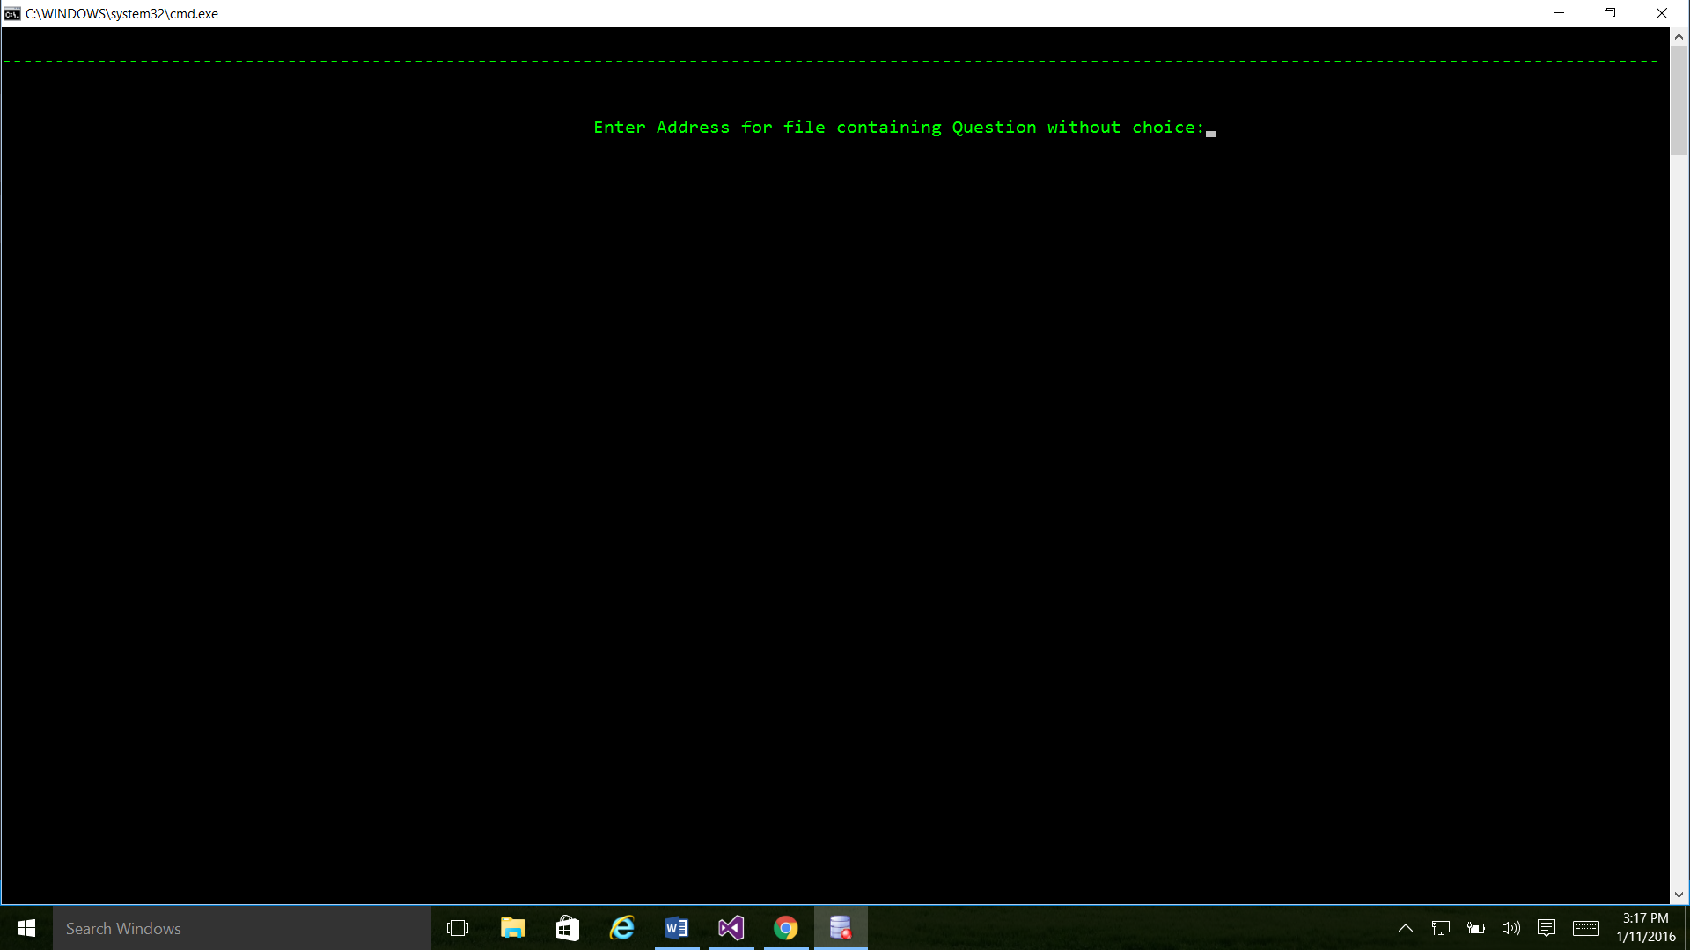

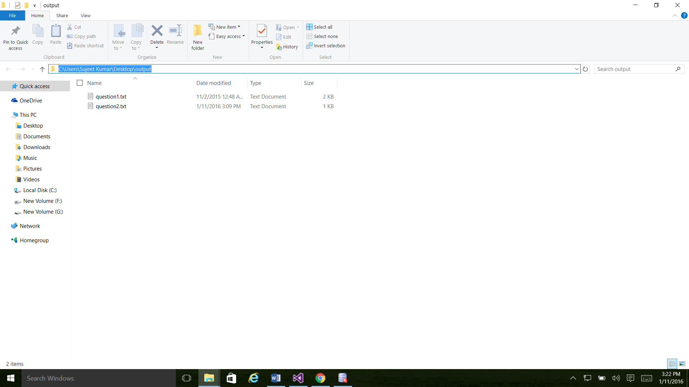

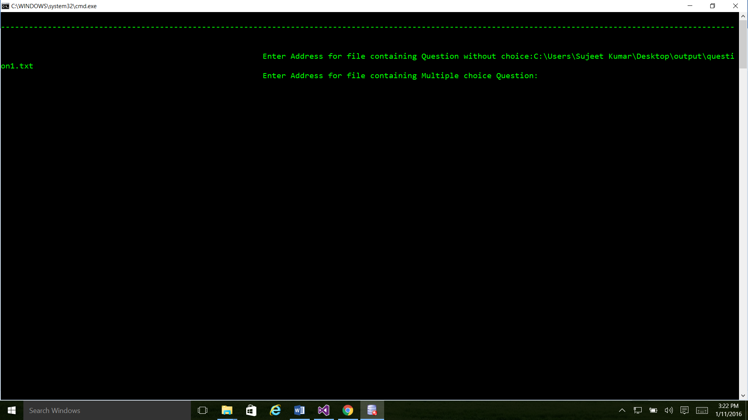

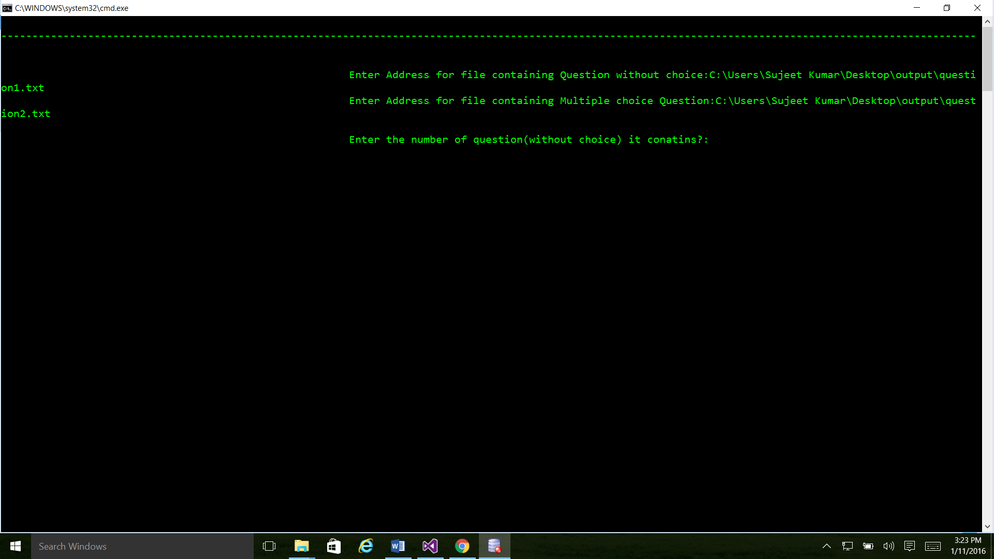

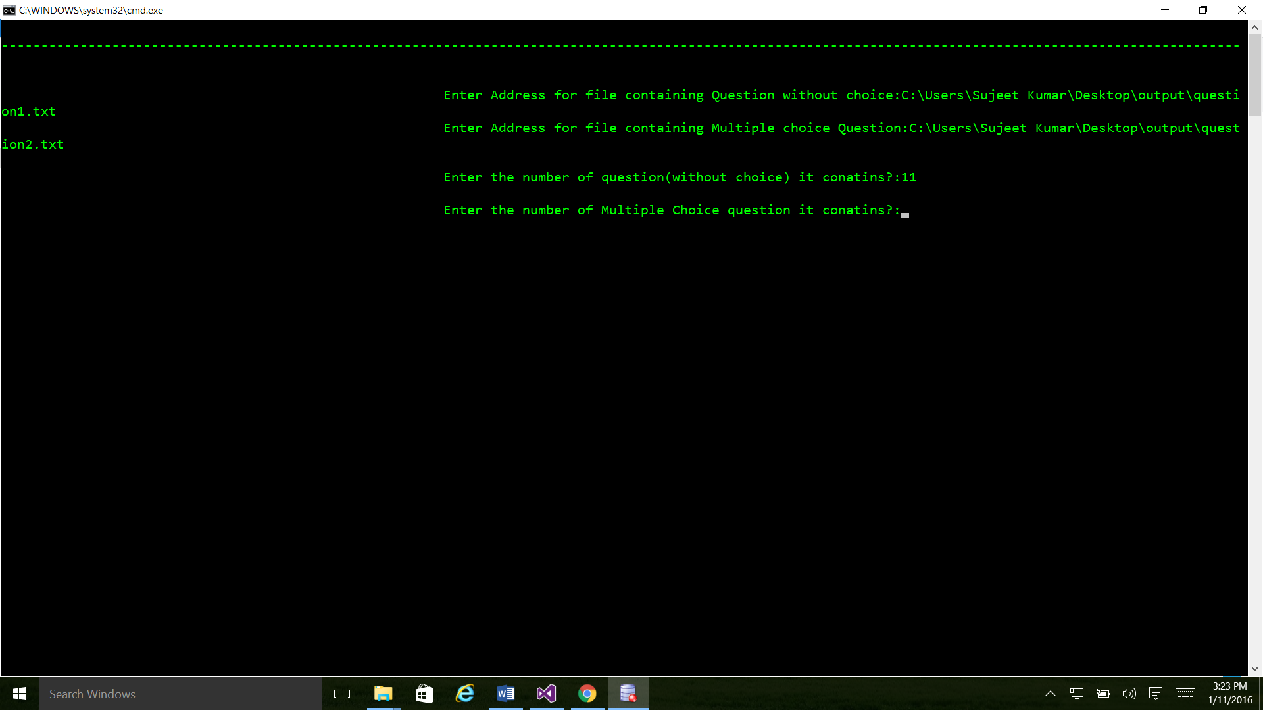

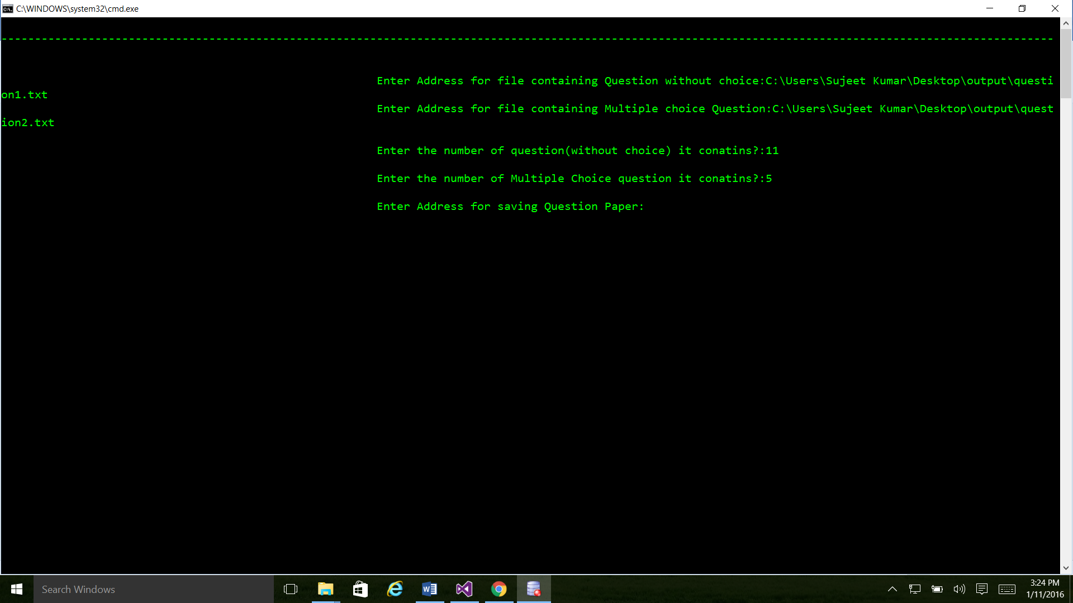

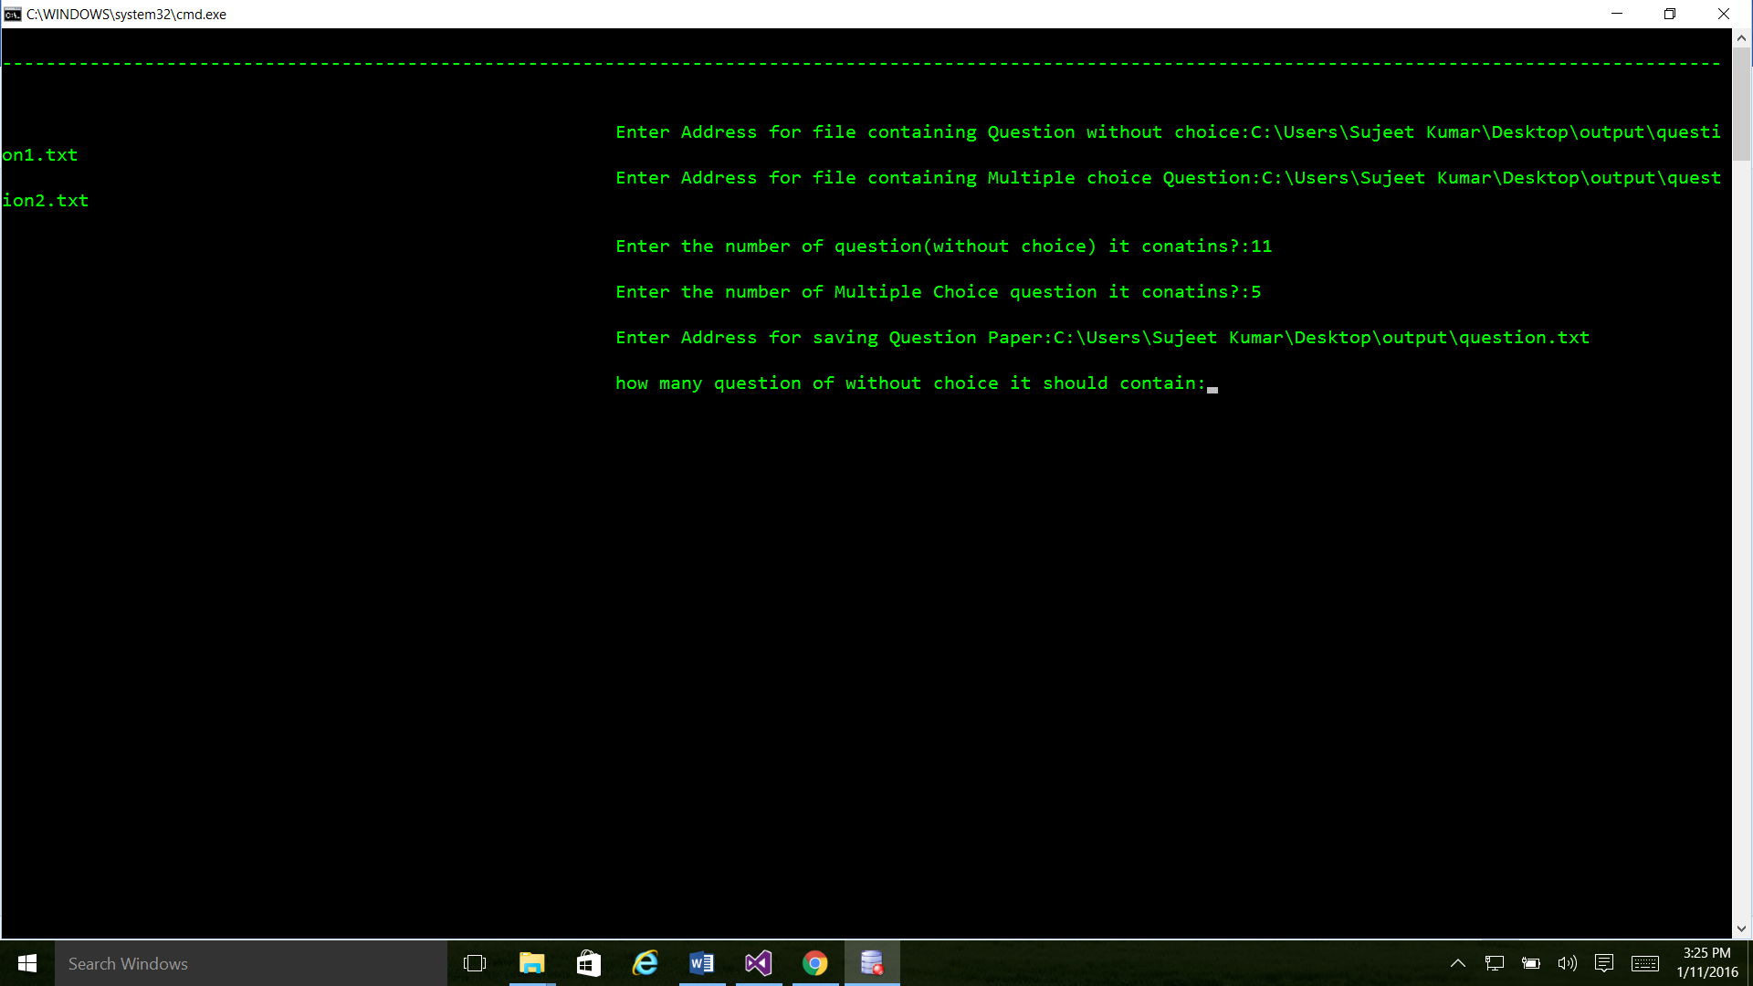

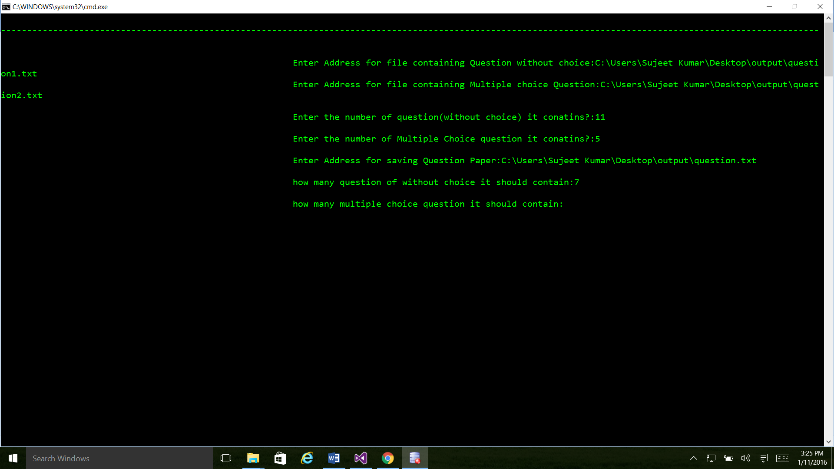

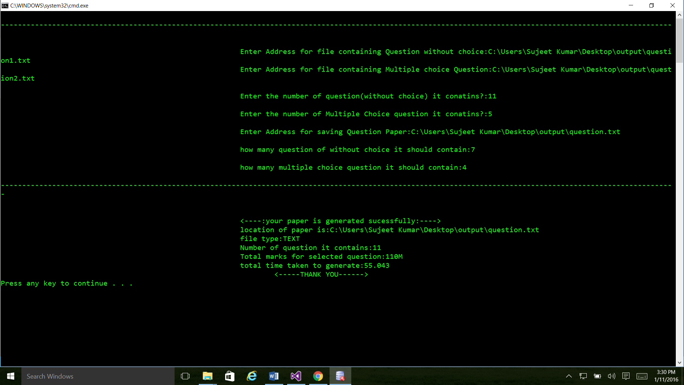

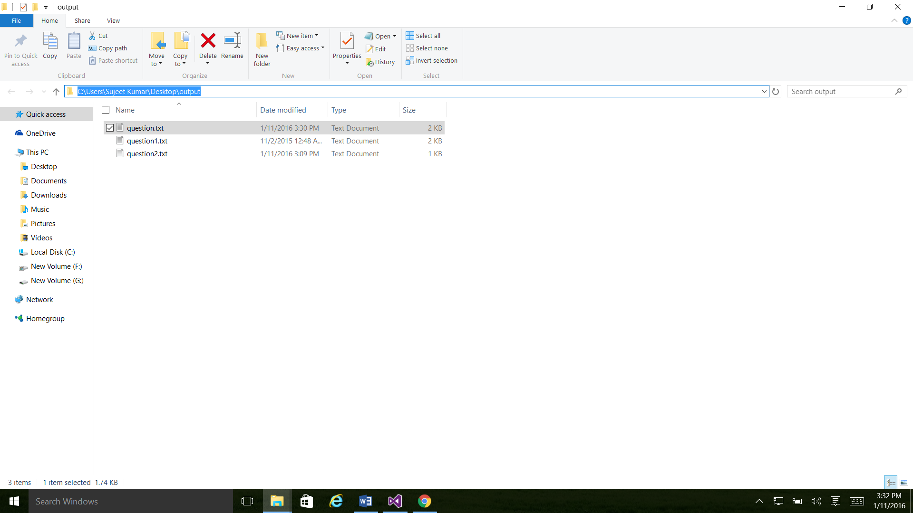

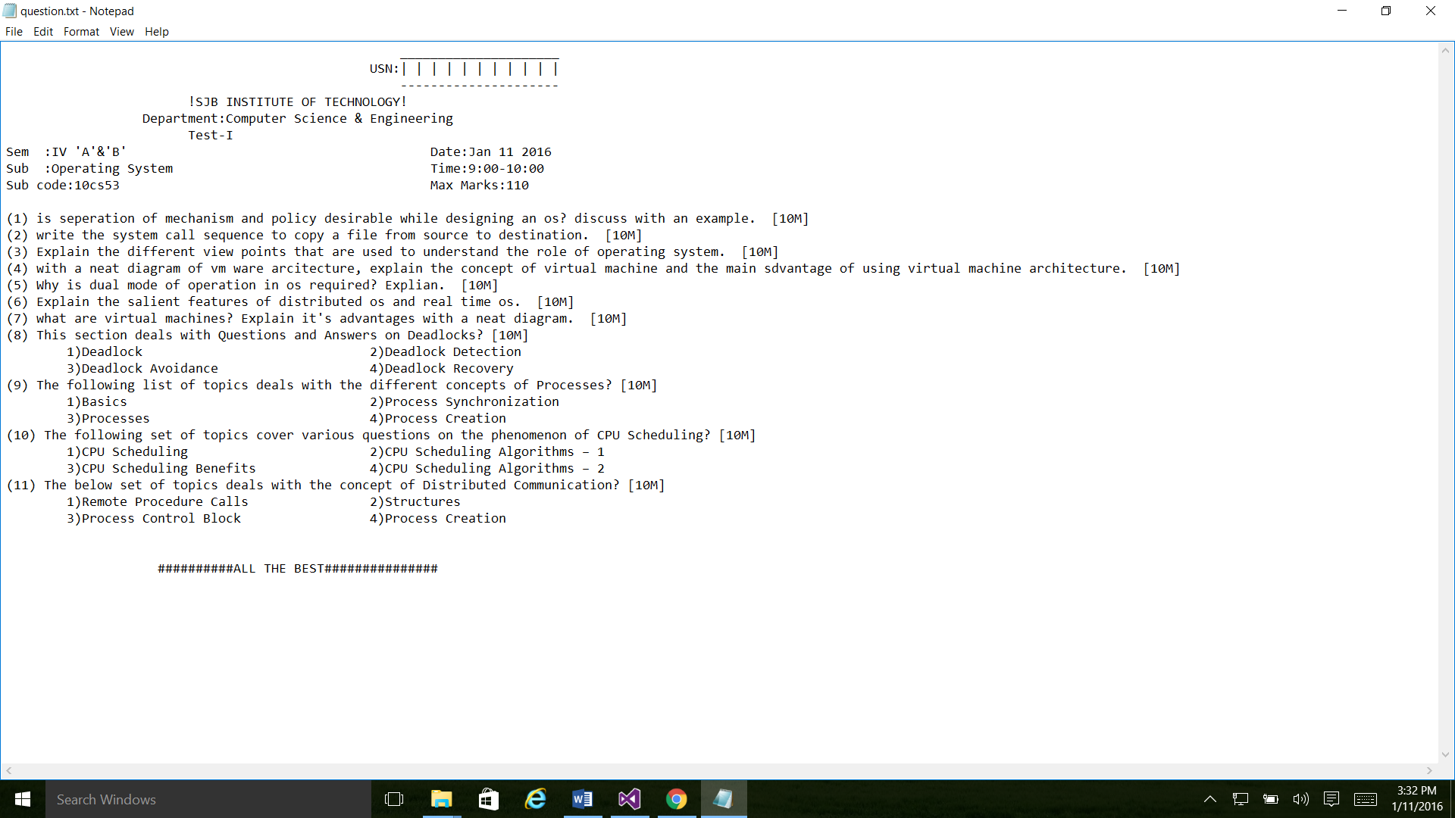

10. CONCLUSION

In this paper, I have presented a smart question generation system to generate question paper smartly and efficiently. The tool is based on the randomization technique using which we generate the random and different questions paper in each click it is very less time consuming, within few second we are able to generate question papers.
The question generated by the system for technical study are useful for students while preparing for their examination. The system is also helpful for teachers to ask questions to students to judge student’s knowledge and understanding of their subject study.
By studying and analyzing the literature, it was determined to develop a tool which gives an excellent IDE. With the help of this IDE teachers can use a computer for drawing question paper, which consist of various and different types of questions.

11. REFERENCES
Books:
1. Effective C++ and More Effective C++ by Scott Meyers
2. C++ How to Program by Deitel and Deitel
3. The C++ Programming Language and by Bjarne Stroustrup
Online resources:
www.cplusplus.com
www.tutorialspoint.com
www.stackoverflow.com

