 | Patient Tracker  Technical Design Document
   | Prepared By / Last Updated By | Reviewed By | Approved By
  Name | Sujeet Suman(2088072)  Niharika Pasupuleti(2088599)  Harini Pallanti(2088499)  Nelli Nandini(2088068)  Sripriya Dundigalla(2088395) | Trainer-Hussaini Khalleullah, Syed -[T-Syed]  Mentor- Sudharsan Ramarathinam
  Role | POD Leader  Member  Member  Member  Member | Trainer-Hussaini Khalleullah, Syed -[T-Syed]  Mentor- Sudharsan Ramarathinam | Mentor
  Signature
  Date
Table of Contents

1.0 Introduction 3
1.1 Purpose of this document 3
1.2 Project Overview 3
2.0 Solution Summary 3
2.1 Scope 3
2.2 Assumptions 5
2.3 Dependencies 5
3.0 Schematic Diagram 6
4.0 System Design 7
4.1 Proposed Design 7
4.2 Component Inventory 7
5.0 Database Design 9
5.1 Data Model 9
5.2 Table Structures 10
6.0 Appendices 15
6.1 Glossary 15
7.0 Terms & Conditions 15
8.0 Change Log 15

Introduction

Purpose of this document
The purpose of this document is to document the technical design, component details and Database design. This will also capture the scope, assumptions, risk, dependencies of this project.

Project overview
Patient Tracker is aimed to help patients and Doctors. As patients can register and they can check their results and they can view their updated diet plans and exercise recommendations. Doctors can register and they can check the patient details and their test results so that they can update their prescriptions, diet plans and as well as exercise recommendations. Clerk/Admin will maintain the patient details and updates it regularly and also clerk will create bill according to the stay, prescription, lab charges, nursing charges. Admin will approve/deny the registration or login if the credentials are insufficient and also they will update the test result.

Solution Summary

Scope
Req. No. | Req. Name | Req. Description
REQ_01 | User Module | User Module is a Middleware Microservice that performs following operations:  - Create User Account  - Define its type  - Track User Login Info
REQ_02 | Patient Module | Patients Module is a Middleware Microservice that performs the following operations:  - View Updated Test Results  - View Diet Plans  - View Exercise Recommendations
REQ_03 | Doctor Module | Doctor Module is a Middleware Microservice that performs the following operations:  - Getting all patient details  - View Test Results  - Updating Prescriptions  - Updating Diet Plans  - Updating Exercise Recommendations
REQ_04 | Admin Module | Admin Module is a Middleware Microservice that performs the following operations:  - Approve/Deny Registration or Login  - Able to update Test Results  - Maintain Patient Information  - Creating Bill Charges
REQ_05 | Clerk Module | Clerk Module is a Middleware Microservice that performs the following operations:  - Maintaining Patient Information  - Creating Bill Charges

Assumptions
- The website is designed to help patient to keep track of all the records.
- All users i.e., the patient, doctor, clerk and Admin need to register using their User id and password which will be used as the unique identifier for each registered user on the website.
- Admin registration:
- Database will be checked for the presence of a pre-existing user profile, in case, no user profile is found, user profile will be created.
- If pre-existing user profile is found then, Admin should login using pre-loaded data from database.
- Project will not change once the stakeholder signoff on the scope statements.
- Project will follow Agile Scrum Methodology throughout execution.

Dependencies
- MS SQL Server 2019
- Entity Framework Core 3.1.22

Schematic Diagram
A schematic, or schematic diagram, is a representation of the elements of a system using abstract, graphic symbols rather than realistic pictures. It gives an overview of overall system.
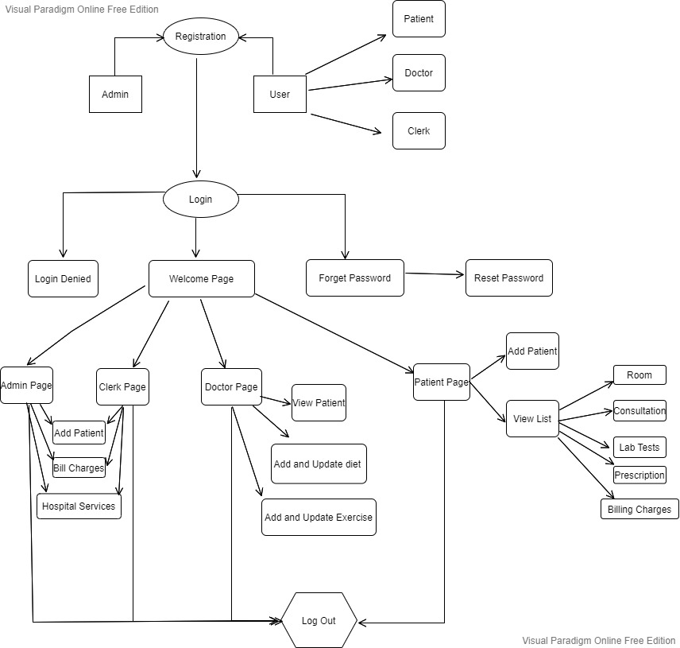

System Design

Proposed design
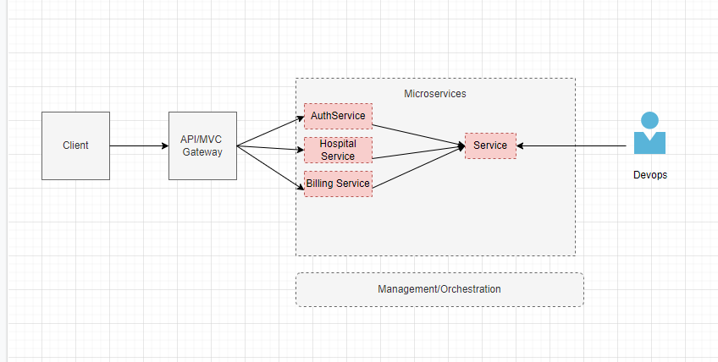

Component inventory
Application Tracking System |  | Authorization Microservice
Functional Requirements
Can assume that Patient is the only client to this Microservice. Enables the patient to login or register him for his sole purpose. This Microservice also works to register and login doctor and clerk. Only login for admin.

Entities
  - Patient_Register
<Details of First_Name,Last_Name,Date_Of_Birth,Gender,Contact_Number,Patient_Id,
Password, Confirm_Password, Address>
  - Patient_Log
<Details of Patient Login >
  - Doctor_Register
<Details of First_Name,Last_Name,Date_Of_Birth,Gender,Contact_Number,Doctor_Id,
Password, Confirm_Password, Qualification, Speciality, Address>
  - Doctor_Log
<Details of Doctor Login >
  - Clerk_Register
<Details of First_Name,Last_Name,Date_Of_Birth,Gender,Contact_Number,Clerk_Id,
Password, Confirm_Password, Address>
  - Clerk_Log
<Details of Clerk Login >
  - Admin_Log
<Details of Admin Login>
 | Application Tracking System |  | Hospital Service Microservice
Functional Requirements
In this Microservice we are having Lab Tests, Consultation Details, Room Details which will be provided to a particular patient.

Entities
- Lab_Tests
<Details of Lab Test Names>
- LabTest_Result
<Details of Test Results>
- LabTest_Charges
<Details of Test Charges >
- Room_Type
<Details of Room Names>
- Room_Charges
<Details of Room Charges >
- Doctor_Name
<Details of Doctor Name>
- Purpose
<Details of patient purpose>
- Consultation_Charges
<Details of Consultation Charges >

Application Tracking System | Billing Microservice
Functional Requirements
In this Microservice we will generate a bill for particular patient by using Hospital Services that the patient takes and it will generate total amount.

Entities
- Total_Amount
<Adding all the charges-Room, Lab Test, Consultation Charges>

Database Design

Data Model
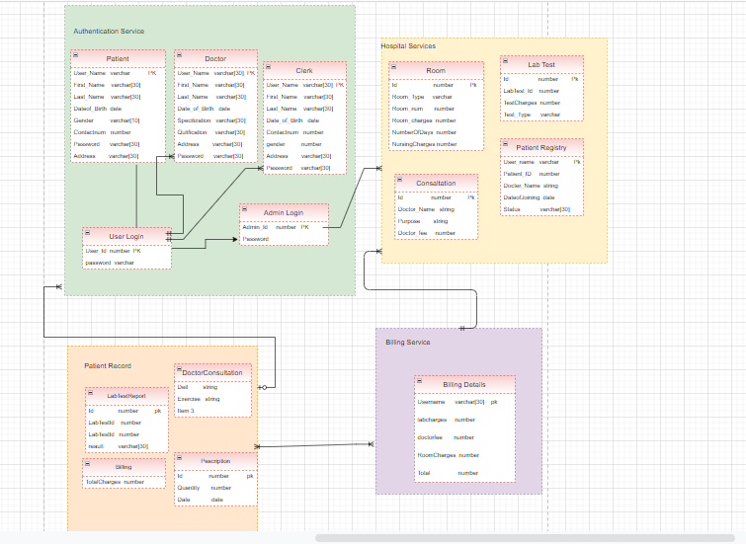

Tables Structure
5.21 : Authentication Service
Login User
User_name | number | PK
Password | varchar[10] | NN

Admin Login
Admin_id | number | PK
Password | varchar[10] | NN

Patient Account
User_Name | char | PK,FK
First_name | varchar[30] | NN
Last_name | varchar[30]
Date_of_birth | date
Contact_number | number | NN
Gender | char | NN
Age | number | NN
Address | varchar[100]

Doctor Account
User_Name | char | PK,FK
First_name | varchar[30] | NN
Last_name | varchar[30]
Date_of_birth | date
Age | number | NN
Gender | char | NN
Doctor_qualification | varchar
Specilization | varchar | NN
Address | varchar[100]
Contact_number | number | NN

Clerk Account
User_Name | char | PK,FK
First_name | varchar[30] | NN
Last_name | varchar[30]
Date_of_birth | date
Contact_number | number | NN
Gender | char | NN
Address | varchar[100] | NN
Date | date

Admin Account
User_Name | char | PK,FK
First_name | varchar[30] | NN
Last_name | Varchar[30]
Date_of_birth | date | NN
Age | number
Gender | char | NN
Address | varchar[100]
Contact_number | number | NN

5.22 : Hospitel Services
Patient Registry
User_Name | varchar[40] | PK,FK
Doctor_Name | string | NN
Patient_Id | number | NN
Date_of_Joining | date | NN
Status | varchar | NN

Room Service
Room_Number | number | PK
Number_of_Days | number | NN
Nursing_charges | number | NN
Room_Type | number | NN
Room_Charges | number | NN

LabTests Service
Lab_Test_Id | number | PK,FK
LabTestName | number | NN
LabTestResult | number | NN
Test_Charges | number | NN

Consultation
Doctor_Id | number | PK
Doctor_Name | number | NN
Doctor_Fee | number | NN
purpose | string | NN

5.23 :Billing Service
Billing Service
Id | number | PK,FK
Patient_Id | number | NN,FK
Lab_Charges | number | NN
Room_Charges | number | NN
Doctor_Fee | number | NN
Date | date | NN
Total_Amount | number | NN

Billing Service
Id | number | PK,FK
Patient_Id | number | NN,FK
Lab_Charges | number | NN
Room_Charges | number | NN
Doctor_Fee | number | NN
Date | date | NN
Total_Amount | number | NN

Pescription
Id | number | PK,FK
Pescription_Id | number | NN
Pescription | varchar[100] | NN
Quantity | number | NN

Appendices

Glossary
Acronyms | Definitions
PT | Patient Tracker

Terms & Conditions
Disclaimer: Please do not circulate or distribute this document outside of Cognizant Network, We have a Zero Tolerance Policy. Kindly adhere to 100% Compliance at all times.

Change Log
Please note that this table needs to be maintained even if a Configuration Management tool is used.
Version Number | Changes made
V<n.n> | <If the change details are not explicitly documented in the table below, reference should be provided here>
V<n.n> | Page no | Changed by | Effective date | Changes effected

